1 Relative to the graph of , what is the shift of the graph of 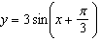?
1) | right | 3) | up
2) | left | 4) | down

2 A rabbit population doubles every 4 weeks. There are currently five rabbits in a restricted area. If t represents the time, in weeks, and is the population of rabbits with respect to time, about how many rabbits will there be in 98 days?
1) | 56 | 3) | 3688
2) | 152 | 4) | 81,920

3 When factored completely, is equivalent to
1) |  | 3)
2) |  | 4)

4 If , then M equals
1) | 32° | 3) | 68°
2) | 58° | 4) | 72°

5 What is the solution to the system of equations and where is defined by the function below?

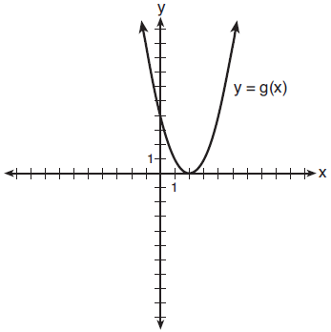
1) |  | 3)
2) |  | 4)

6 Which statement about statistical analysis is false?
1) | Experiments can suggest patterns and relationships in data. | 3) | Observational studies can determine cause and effect relationships.
2) | Experiments can determine cause and effect relationships. | 4) | Observational studies can suggest patterns and relationships in data.

7 The expression 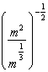 is equivalent to
1) |  | 3)
2) | 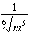 | 4) | 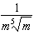

8 What is the inverse of the function ?
1) |  | 3)
2) |  | 4)

9 Gabriel performed an experiment to see if planting 13 tomato plants in black plastic mulch leads to larger tomatoes than if 13 plants are planted without mulch. He observed that the average weight of the tomatoes from tomato plants grown in black plastic mulch was 5 ounces greater than those from the plants planted without mulch. To determine if the observed difference is statistically significant, he rerandomized the tomato groups 100 times to study these random differences in the mean weights. The output of his simulation is summarized in the dotplot below.

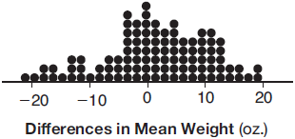

Given these results, what is an appropriate inference that can be drawn?
1) | There was no effect observed between the two groups. | 3) | There is strong evidence to support the hypothesis that tomatoes from plants planted in black plastic mulch are larger than those planted without mulch.
2) | There was an effect observed that could be due to the random assignment of plants to the groups. | 4) | There is strong evidence to support the hypothesis that tomatoes from plants planted without mulch are larger than those planted in black plastic mulch.

10 If and , then equals
1) |  | 3)
2) |  | 4)

11 The solution to the equation is
1) | 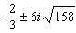 | 3) | 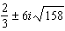
2) | 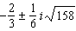 | 4) | 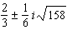

12 When 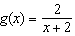 and are graphed on the same set of axes, which coordinates best approximate their point of intersection?
1) |  | 3)
2) |  | 4)

13 The price of a postage stamp in the years since the end of World War I is shown in the scatterplot below.

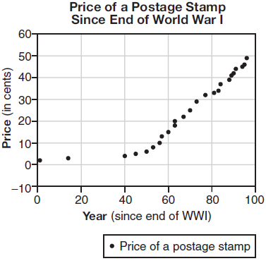

The equation that best models the price, in cents, of a postage stamp based on these data is
1) |  | 3)
2) |  | 4)

14 The eighth and tenth terms of a sequence are 64 and 100. If the sequence is either arithmetic or geometric, the ninth term can not be
1) | -82 | 3) | 80
2) | -80 | 4) | 82

15 The loudness of sound is measured in units called decibels (dB). These units are measured by first assigning an intensity to a very soft sound that is called the threshold sound. The sound to be measured is assigned an intensity, I, and the decibel rating, d, of this sound is found using 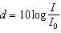. The threshold sound audible to the average person is (watts per square meter). Consider the following sound level classifications:

Moderate | 45-69 dB
Loud | 70-89 dB
Very loud | 90-109 dB
Deafening | >110 dB

How would a sound with intensity be classified?
1) | moderate | 3) | very loud
2) | loud | 4) | deafening

16 Pedro and Bobby each own an ant farm. Pedro starts with 100 ants and says his farm is growing exponentially at a rate of 15% per month. Bobby starts with 350 ants and says his farm is steadily decreasing by 5 ants per month. Assuming both boys are accurate in describing the population of their ant farms, after how many months will they both have approximately the same number of ants?
1) | 7 | 3) | 13
2) | 8 | 4) | 36

17 What is the solution, if any, of the equation 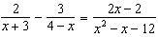?
1) | -1 | 3) | all real numbers
2) | -5 | 4) | no real solution

18 In 2013, approximately 1.6 million students took the Critical Reading portion of the SAT exam. The mean score, the modal score, and the standard deviation were calculated to be 496, 430, and 115, respectively. Which interval reflects 95% of the Critical Reading scores?
1) |  | 3)
2) |  | 4)

19 Which statement regarding the graphs of the functions below is untrue?
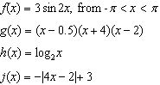
1) | and have a maximum y-value of 3. | 3) | and have the same end behavior as .
2) | , , and have one y-intercept. | 4) | , , and have rational zeros.

20 When is divided by , the remainder is 0. Given , which conclusion about is true?
1) |  | 3) | is a factor of .
2) |  | 4) | No conclusion can be made regarding .

21 Joelle has a credit card that has a 19.2% annual interest rate compounded monthly. She owes a total balance of B dollars after m months. Assuming she makes no payments on her account, the table below illustrates the balance she owes after m months.

m | B
0 | 100.00
10 | 1172.00
19 | 1352.00
36 | 1770.80
60 | 2591.90
69 | 2990.00
72 | 3135.80
73 | 3186.00

Over which interval of time is her average rate of change for the balance on her credit card account the greatest?
1) | month 10 to month 60 | 3) | month 36 to month 72
2) | month 19 to month 69 | 4) | month 60 to month 73

22 Which graph represents a cosine function with no horizontal shift, an amplitude of 2, and a period of ?
1) | 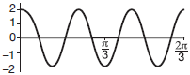
2) | 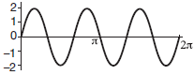
3) | 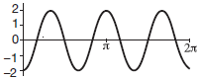
4) | 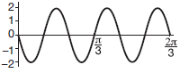

23 According to a pricing website, Indroid phones lose 58% of their cash value over 1.5 years. Which expression can be used to estimate the value of a $300 Indroid phone in 1.5 years?
1) |  | 3)
2) |  | 4)

24 A cardboard box manufacturing company is building boxes with length represented by , width by , and height by . The volume of the box is modeled by the function below.

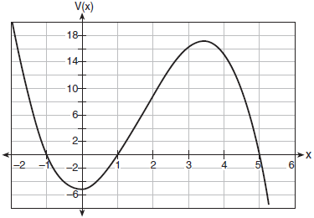

Over which interval is the volume of the box changing at the fastest average rate?
1) |  | 3) | [1,5]
2) | [1,3.5] | 4)

25 Express in form.

26 An orange-juice processing plant receives a truckload of oranges. The quality control team randomly chooses three pails of oranges, each containing 50 oranges, from the truckload. Identify the sample and the population in the given scenario. State one conclusion that the quality control team could make about the population if 5% of the sample was found to be unsatisfactory.

27 Using the unit circle below, explain why 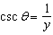.

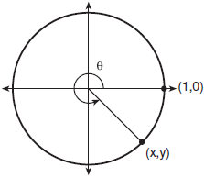

28 The function represents the mass of radium over time, t, in years.

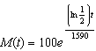

Determine if the function represents growth or decay. Explain your reasoning.

29 On the grid below, sketch a cubic polynomial whose zeros are 1, 3, and -2.



30 Given the equal terms and , determine and state y, in terms of x.

31 The results of a survey of the student body at Central High School about television viewing preferences are shown below.

 | Comedy Series | Drama Series | Reality Series | Total
Males | 95 | 65 | 70 | 230
Females | 80 | 70 | 110 | 260
Total | 175 | 135 | 180 | 490

Are the events “student is a male” and “student prefers reality series” independent of each other? Justify your answer.

32 Given and , state the quotient and remainder of , in the form 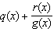.

33 Algebraically determine the values of h and k to correctly complete the identity stated below.

34 Elaina has decided to run the Buffalo half-marathon in May. She researched training plans on the Internet and is looking at two possible plans: Jillian’s 12-week plan and Josh’s 14-week plan. The number of miles run per week for each plan is plotted below.

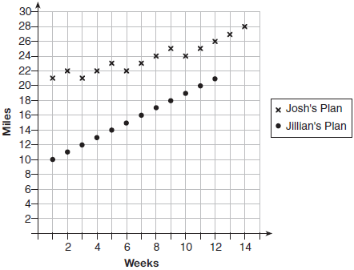

Which one of the plans follows an arithmetic pattern? Explain how you arrived at your answer. Write a recursive definition to represent the number of miles run each week for the duration of the plan you chose. Jillian’s plan has an alternative if Elaina wanted to train instead for a full 26-mile marathon. Week one would start at 13 miles and follow the same pattern for the half-marathon, but it would continue for 14 weeks. Write an explicit formula, in simplest form, to represent the number of miles run each week for the full-marathon training plan.

35 The guidance department has reported that of the senior class, 2.3% are members of key club, K, 8.6% are enrolled in AP Physics, P, and 1.9% are in both. Determine the probability of P given K, to the nearest tenth of a percent. The principal would like a basic interpretation of these results. Write a statement relating your calculated probabilities to student enrollment in the given situation.

36 Using the formula below, determine the monthly payment on a 5-year car loan with a monthly percentage rate of 0.625% for a car with an original cost of $21,000 and a $1000 down payment, to the nearest cent.
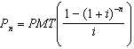
present amount borrowed
number of monthly pay periods
monthly payment
interest rate per month
The affordable monthly payment is $300 for the same time period. Determine an appropriate down payment, to the nearest dollar.

37 The speed of a tidal wave, s, in hundreds of miles per hour, can be modeled by the equation , where t represents the time from its origin in hours. Algebraically determine the time when . How much faster was the tidal wave traveling after 1 hour than 3 hours, to the nearest mile per hour? Justify your answer.
1 ANS: 2 PTS: 2 REF: 011701aii NAT: F.IF.B.4
TOP: Graphing Trigonometric Functions

2 ANS: 1
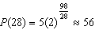

PTS: 2 REF: 011702aii NAT: F.LE.A.2 TOP: Modeling Exponential Functions
KEY: AII

3 ANS: 4

PTS: 2 REF: 011703aii NAT: A.SSE.A.2 TOP: Factoring Polynomials
KEY: higher power AII

4 ANS: 1 PTS: 2 REF: 011704aii NAT: F.TF.C.8
TOP: Simplifying Trigonometric Expressions

5 ANS: 4
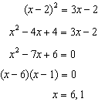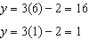

PTS: 2 REF: 011705aii NAT: A.REI.C.7 TOP: Quadratic-Linear Systems
KEY: AII

6 ANS: 3 PTS: 2 REF: 011706aii NAT: S.IC.B.3
TOP: Analysis of Data KEY: type

7 ANS: 2
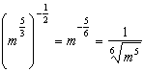

PTS: 2 REF: 011707aii NAT: N.RN.A.2 TOP: Radicals and Rational Exponents
KEY: variables

8 ANS: 3 PTS: 2 REF: 011708aii NAT: F.BF.B.4
TOP: Inverse of Functions KEY: equations

9 ANS: 2 PTS: 2 REF: 011709aii NAT: S.IC.B.5
TOP: Analysis of Data

10 ANS: 3 PTS: 2 REF: 011710aii NAT: F.BF.A.1
TOP: Operations with Functions

11 ANS: 4
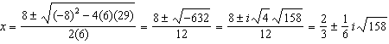

PTS: 2 REF: 011711aii NAT: A.REI.B.4 TOP: Solving Quadratics
KEY: complex solutions | quadratic formula

12 ANS: 2
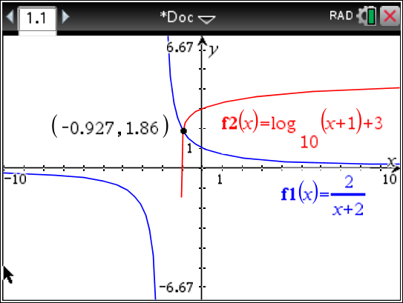

PTS: 2 REF: 011712aii NAT: A.REI.D.11 TOP: Other Systems
KEY: AII

13 ANS: 3
The pattern suggests an exponential pattern, not linear or sinusoidal. A 4% growth rate is accurate, while a 43% growth rate is not.

PTS: 2 REF: 011713aii NAT: S.ID.B.6 TOP: Regression
KEY: choose model

14 ANS: 1
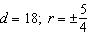

PTS: 2 REF: 011714aii NAT: F.IF.A.3 TOP: Sequences
KEY: term

15 ANS: 3
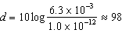

PTS: 2 REF: 011715aii NAT: F.IF.B.4 TOP: Evaluating Logarithmic Expressions

16 ANS: 2
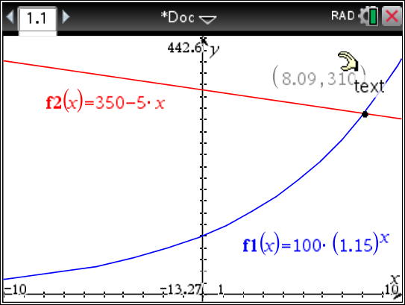

PTS: 2 REF: 011716aii NAT: A.REI.D.11 TOP: Other Systems
KEY: AII

17 ANS: 1
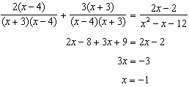

PTS: 2 REF: 011717aii NAT: A.REI.A.2 TOP: Solving Rationals
KEY: rational solutions

18 ANS: 4

PTS: 2 REF: 011718aii NAT: S.ID.A.4 TOP: Normal Distributions
KEY: interval

19 ANS: 2
does not have a y-intercept.

PTS: 2 REF: 011719aii NAT: F.IF.C.9 TOP: Comparing Functions

20 ANS: 2 PTS: 2 REF: 011720aii NAT: A.APR.B.2
TOP: Remainder Theorem

21 ANS: 4
(1) 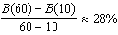 (2) 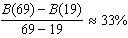 (3) 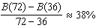 (4) 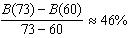

PTS: 2 REF: 011721aii NAT: F.IF.B.6 TOP: Rate of Change
KEY: AII

22 ANS: 3
(3) repeats 3 times over .

PTS: 2 REF: 011722aii NAT: F.IF.C.7 TOP: Graphing Trigonometric Functions
KEY: recognize

23 ANS: 1
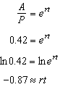

PTS: 2 REF: 011723aii NAT: F.BF.A.1 TOP: Modeling Exponential Functions
KEY: AII

24 ANS: 1
(1) 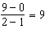 (2) 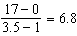 (3) 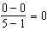 (4) 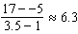

PTS: 2 REF: 011724aii NAT: F.IF.B.6 TOP: Rate of Change
KEY: AII

25 ANS:

PTS: 2 REF: 011725aii NAT: N.CN.A.2 TOP: Operations with Complex Numbers

26 ANS:
sample: pails of oranges; population: truckload of oranges. It is likely that about 5% of all the oranges are unsatisfactory.

PTS: 2 REF: 011726aii NAT: S.IC.A.2 TOP: Analysis of Data

27 ANS:
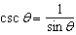, and on a unit circle represents the y value of a point on the unit circle. Since , .

PTS: 2 REF: 011727aii NAT: F.TF.A.2 TOP: Reciprocal Trigonometric Relationships

28 ANS:
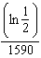 is negative, so represents decay.

PTS: 2 REF: 011728aii NAT: F.IF.C.8 TOP: Modeling Exponential Functions

29 ANS:
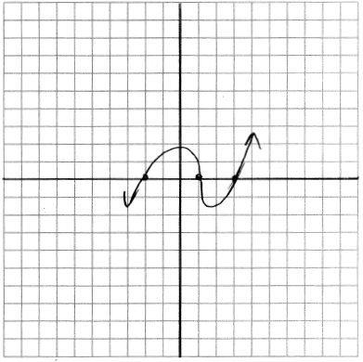

PTS: 2 REF: 011729aii NAT: A.APR.B.3 TOP: Zeros of Polynomials

30 ANS:
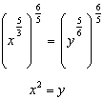

PTS: 2 REF: 011730aii NAT: N.RN.A.2 TOP: Radicals and Rational Exponents
KEY: variables

31 ANS:
No, because 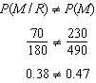

PTS: 2 REF: 011731aii NAT: S.CP.A.4 TOP: Conditional Probability

32 ANS:
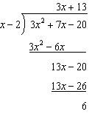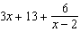

PTS: 2 REF: 011732aii NAT: A.APR.D.6 TOP: Rational Expressions

33 ANS:
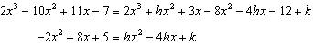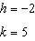

PTS: 4 REF: 011733aii NAT: A.APR.C.4 TOP: Polynomial Identities

34 ANS:
Jillian’s plan, because distance increases by one mile each week. 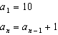

PTS: 4 REF: 011734aii NAT: F.LE.A.2 TOP: Sequences

35 ANS:
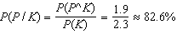 A key club member has an 82.6% probability of being enrolled in AP Physics.

PTS: 4 REF: 011735aii NAT: S.CP.B.6 TOP: Conditional Probability

36 ANS:
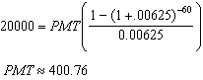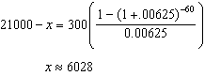

PTS: 4 REF: 011736aii NAT: A.SSE.B.4 TOP: Series

37 ANS:
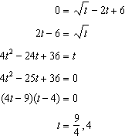 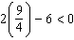, so is extraneous. 327 mph

PTS: 6 REF: 011737aii NAT: A.REI.A.2 TOP: Solving Radicals
KEY: context

