1 When factored, the expression is equivalent to
1) |  | 3)
2) |  | 4)

2 Which equation represents the line that passes through the points and ?
1) |  | 3)
2) |  | 4)

3 A geometric sequence is shown below.
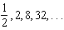
What is the common ratio?
1) |  | 3)
2) | 2 | 4) | 4

4 What is the constant term of the polynomial ?
1) | 5 | 3) | 3
2) | 2 | 4) | 4

5 A landscaping company charges a set fee for a spring cleanup, plus an hourly labor rate. The total cost is modeled by the function . In this function, what does the 55 represent?
1) | the set fee for the cleanup | 3) | the profit earned by the company for one cleanup
2) | the hourly labor rate for a cleanup | 4) | the number of hours of labor required for one cleanup

6 Which expression is equivalent to ?
1) |  | 3)
2) |  | 4)

7 A system of inequalities is graphed on the set of axes below.

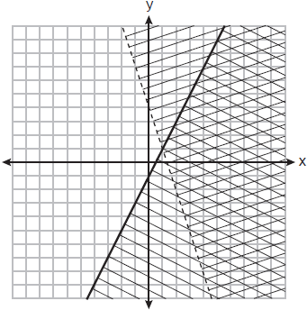

Which point is a solution to this system?
1) |  | 3)
2) |  | 4)

8 In an arithmetic sequence, the first term is 25 and the third term is 15. What is the tenth term in this sequence?
1) |  | 3) | 70
2) |  | 4) | 75

9 When the formula is solved for w, the result is
1) | 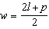 | 3) | 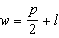
2) | 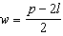 | 4) | 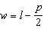

10 Market Street Pizza kept a record of pizza sales for the month of February. The results are shown in the table below.

Type | Plain | Veggie | Meat Only | The Works
Thin Crust | 300 | 80 | 120 | 100
Deep-dish | 200 | 25 | 105 | 70

Of all the pizzas sold in February, what percent were plain, deep-dish pizzas?
1) | 20% | 3) | 40%
2) | 30% | 4) | 50%

11 When solving 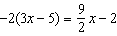 for x, the solution is
1) |  | 3)
2) |  | 4)

12 The expression is equivalent to
1) |  | 3)
2) |  | 4)

13 The inputs and outputs of a function are shown in the table below.

x | f(x)
0 | 0.0625
1 | 0.125
2 | 0.25
3 | 0.5
4 | 1
5 | 2

This function can best be described as
1) | linear | 3) | exponential
2) | quadratic | 4) | absolute value

14 Stephanie is solving the equation . Her first step is shown below.
Given:
Step 1:
Which property justifies her first step?
1) | associative property | 3) | distributive property
2) | commutative property | 4) | addition property of equality

15 What is the sum of and ?
1) |  | 3)
2) |  | 4)

16 The dot plots below represent test scores for 20 students on a math test.

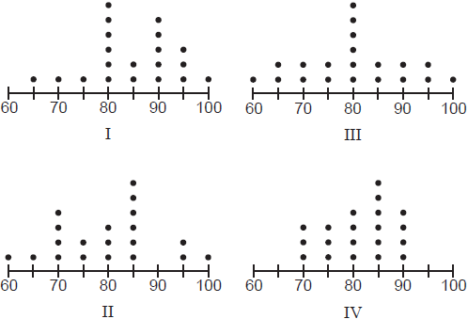

The mode for this math test is 80 and the median is 85. Which dot plot correctly represents this data?
1) | I | 3) | III
2) | II | 4) | IV

17 A function is graphed on the set of axes below.

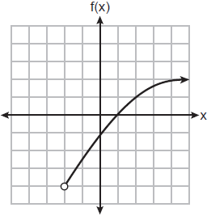

The domain of this function is
1) |  | 3)
2) |  | 4)

18 Which ordered pair is a solution to the equation 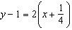?
1) |  | 3)
2) |  | 4)

19 Elena’s fastest time for the 50-meter dash is 7 seconds. She wants to know how fast this is in inches per minute. Which expression can Elena use for a correct conversion?
1) | 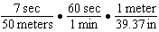 | 3) | 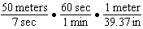
2) | 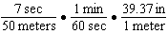 | 4) | 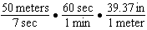

20 The table below shows the highest temperatures recorded in August for several years in one town.

Year | Temperature (ºF)
1990 | 86
1991 | 78
1992 | 84
1993 | 95
1994 | 81
1995 | 77
1996 | 88
1997 | 93

The interquartile range of these data is
1) | 7 | 3) | 11
2) | 10 | 4) | 18

21 The function is multiplied by k, where . Which graph could represent ?
1) | 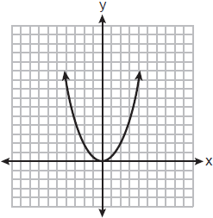 | 3) | 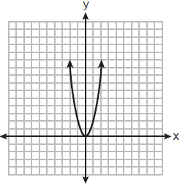
2) | 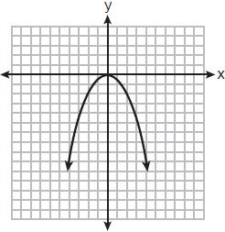 | 4) | 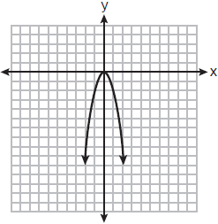

22 Which graph is the solution to the inequality ?
1) | 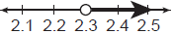 | 3) | 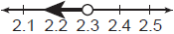
2) | 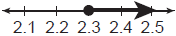 | 4) | 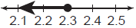

23 The number of fish in a pond is eight more than the number of frogs. The total number of fish and frogs in the pond is at least 20. If x represents the number of frogs, which inequality can be used to represent this situation?
1) |  | 3)
2) |  | 4)

24 Which graph below represents a function that is always decreasing over the entire interval ?
1) | 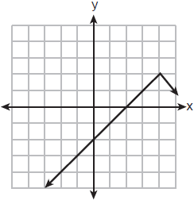 | 3) | 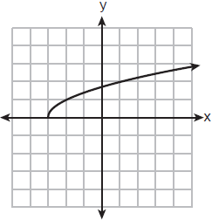
2) | 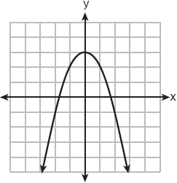 | 4) | 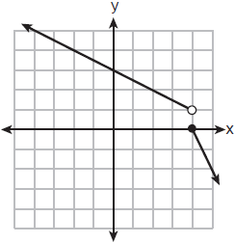

25 The graph below models Sally’s drive to the store.

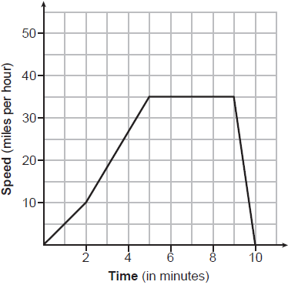

State an interval when Sally is traveling at a constant speed. Explain your reasoning.

26 Graph the function .

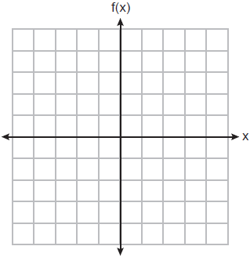

State the equation of the axis of symmetry of .

27 The function is shown in the table below.

x | 0 | 3 | 2 | 6 | 1 | 5 | 4 | m
f(x) | 6 | 2 | 7 | 5 | 8 | 4 | 3 | 9

State an appropriate value for m in the table, so that remains a function. Explain your reasoning.

28 Solve for x by completing the square.

29 If 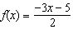, algebraically determine the value of x when .

30 Rationalize the denominator of the fraction below. Express the solution in simplest form.

31 Alex had $1.70 in nickels and dimes on his desk. There were 25 coins in all. Write a system of equations that could be used to determine both the number of nickels, n, and the number of dimes, d, that Alex had. Use your system of equations to algebraically determine both the number of nickels and the number of dimes that he had.

32 The table below shows the average heart rate, x, and Calories burned, y, for seven men on an Olympic rowing team during a one-hour workout class.

Average Heart Rate (x) | 135 | 147 | 150 | 144 | 146 | 153 | 143
Calories Burned (y) | 725 | 812 | 866 | 761 | 825 | 863 | 737

Write the linear regression equation that models these data, rounding all values to the nearest tenth. State the correlation coefficient, rounded to the nearest tenth. State what the correlation coefficient suggests about the linear fit of these data.

33 Using the quadratic formula, solve . Express your solution in simplest radical form.

34 Solve the following system of equations algebraically for all values of x and y:
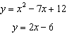

35 Anna plans to spend $30 on balloons and party hats for her daughter’s birthday party. Including tax, balloons cost $2 each and party hats cost $1.50 each. The number of party hats Anna needs is twice as many as the number of balloons. If x represents the number of balloons and y represents the number of party hats, write a system of equations that can be used to represent this situation. Graph your system of equations on the set of axes below.

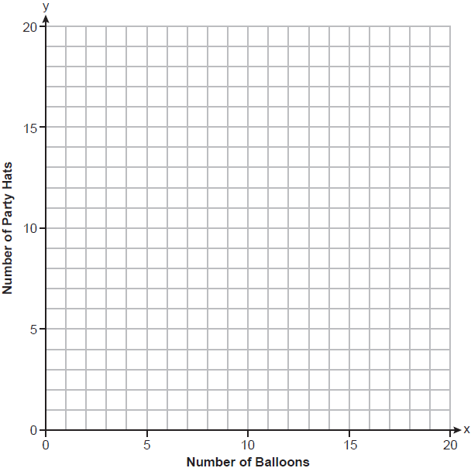

State the coordinates of the point of intersection of your lines. Explain what each coordinate means in the context of the problem.
1 ANS: 3

PTS: 2 REF: 012501ai NAT: A.SSE.A.2
TOP: Factoring the Difference of Perfect Squares

2 ANS: 1
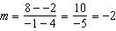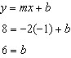

PTS: 2 REF: 012502ai NAT: A.REI.D.10 TOP: Writing Linear Equations
KEY: slope-intercept form

3 ANS: 4
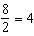

PTS: 2 REF: 012503ai NAT: F.IF.A.3 TOP: Sequences
KEY: difference or ratio

4 ANS: 1 PTS: 2 REF: 012504ai NAT: A.SSE.A.1
TOP: Modeling Expressions

5 ANS: 2 PTS: 2 REF: 012505ai NAT: F.LE.B.5
TOP: Modeling Linear Functions

6 ANS: 2 PTS: 2 REF: 012506ai NAT: A.APR.A.1
TOP: Operations with Polynomials KEY: subtraction

7 ANS: 4 PTS: 2 REF: 012507ai NAT: A.REI.D.12
TOP: Graphing Systems of Linear Inequalities

8 ANS: 1
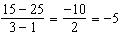

PTS: 2 REF: 012508ai NAT: F.BF.A.1 TOP: Sequences
KEY: explicit

9 ANS: 2
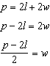

PTS: 2 REF: 012509ai NAT: A.CED.A.4 TOP: Transforming Formulas

10 ANS: 1
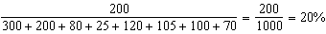

PTS: 2 REF: 012510ai NAT: S.ID.B.5 TOP: Frequency Tables
KEY: two-way

11 ANS: 1
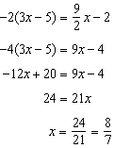

PTS: 2 REF: 012511ai NAT: A.REI.B.3 TOP: Solving Linear Equations

12 ANS: 3 PTS: 2 REF: 012512ai NAT: A.APR.A.1
TOP: Multiplication of Powers

13 ANS: 3 PTS: 2 REF: 012513ai NAT: F.LE.A.1
TOP: Families of Functions

14 ANS: 4 PTS: 2 REF: 012514ai NAT: A.REI.A.1
TOP: Identifying Properties

15 ANS: 4 PTS: 2 REF: 012515ai NAT: N.RN.B.3
TOP: Operations with Radicals KEY: addition

16 ANS: 1 PTS: 2 REF: 012516ai NAT: S.ID.A.1
TOP: Dot Plots

17 ANS: 1 PTS: 2 REF: 012517ai NAT: F.IF.B.5
TOP: Domain and Range KEY: graph

18 ANS: 2
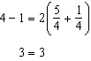

PTS: 2 REF: 012518ai NAT: A.REI.D.10 TOP: Identifying Solutions

19 ANS: 4 PTS: 2 REF: 012519ai NAT: N.Q.A.1
TOP: Conversions

20 ANS: 3
77 78 81 84 86 88 93 95
79.5 90.5
90.5-79.5=11

PTS: 2 REF: 012520ai NAT: S.ID.A.2 TOP: Dispersion
KEY: basic

21 ANS: 4 PTS: 2 REF: 012521ai NAT: F.BF.B.3
TOP: Transformations with Functions KEY: bimodalgraph

22 ANS: 4
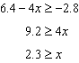

PTS: 2 REF: 012522ai NAT: A.REI.B.3 TOP: Solving Linear Inequalities

23 ANS: 2

PTS: 2 REF: 012523ai NAT: A.CED.A.1 TOP: Modeling Linear Inequalities

24 ANS: 4 PTS: 2 REF: 012524ai NAT: F.IF.C.7
TOP: Graphing Piecewise-Defined Functions

25 ANS:
5-6 minutes, as the speed remains at 35 mph during this interval.

PTS: 2 REF: 012525ai NAT: F.IF.B.4 TOP: Relating Graphs to Events

26 ANS:
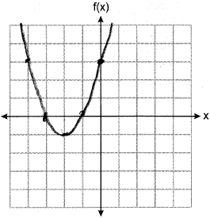

PTS: 2 REF: 012526ai NAT: F.IF.C.7 TOP: Graphing Quadratic Functions

27 ANS:
7, as for each value of x, there is a unique value of y.

PTS: 2 REF: 012527ai NAT: F.IF.A.1 TOP: Defining Functions

28 ANS:
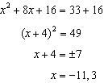

PTS: 2 REF: 012528ai NAT: A.REI.B.4 TOP: Solving Quadratics
KEY: completing the square

29 ANS:
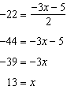
PTS: 2 REF: 012529ai NAT: F.IF.A.2 TOP: Functional Notation

30 ANS:
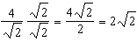
PTS: 2 REF: 012530ai NAT: N.RN.B.3 TOP: Operations with Radicals
KEY: division

31 ANS:
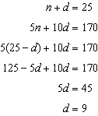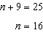
PTS: 4 REF: 012531ai NAT: A.CED.A.3 TOP: Modeling Linear Systems

32 ANS:
, 0.9, strong relationship
PTS: 4 REF: 012532ai NAT: S.ID.B.6 TOP: Regression
KEY: linear with correlation coefficient

33 ANS:
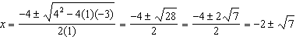
PTS: 4 REF: 012533ai NAT: A.REI.B.4 TOP: Solving Quadratics
KEY: quadratic formula

34 ANS:
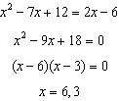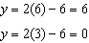
PTS: 4 REF: 012534ai NAT: A.REI.C.7 TOP: Quadratic-Linear Systems

35 ANS:
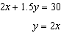 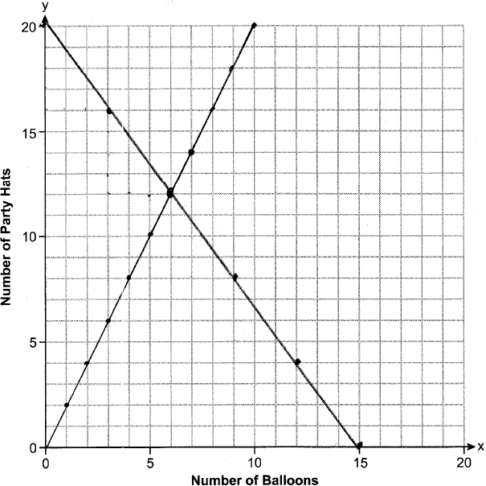 (6,12) is the intersection, meaning Anna bought 6 baloons and 12 hats.
PTS: 6 REF: 012535ai NAT: A.REI.C.6 TOP: Graphing Linear Systems

