1 Given the functions , , and shown below:

x | f(x)
0 | 1
1 | 2
2 | 5
3 | 7

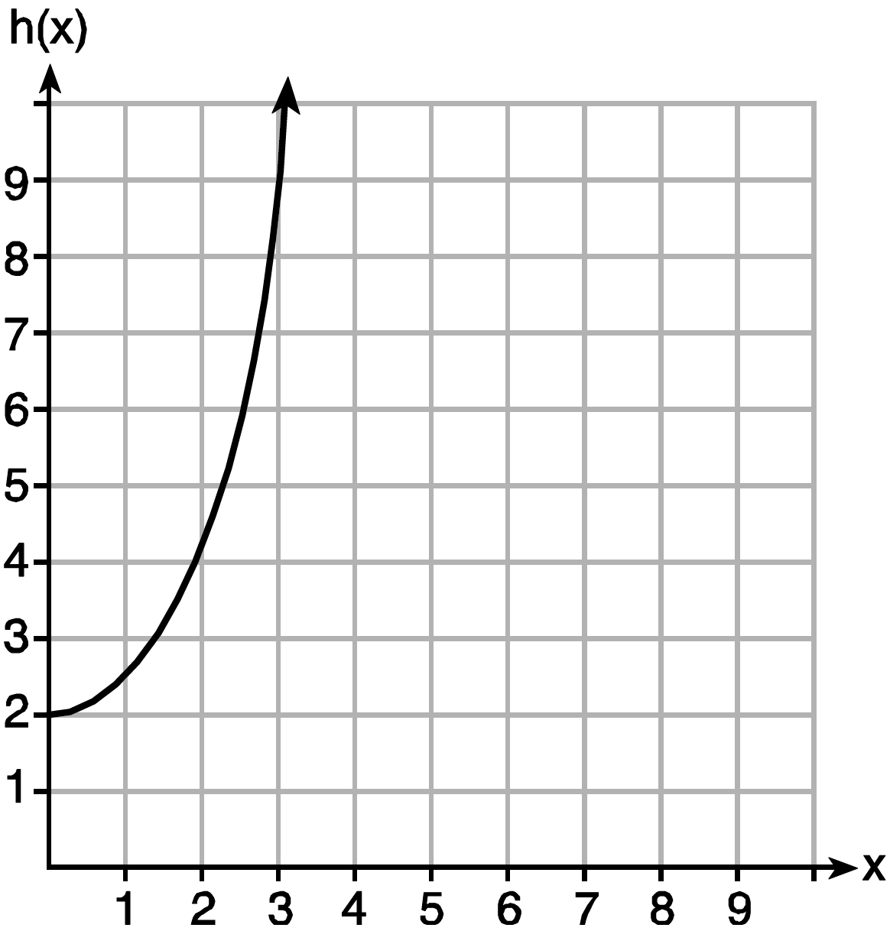

The correct list of functions ordered from greatest to least by average rate of change over the interval is
1) | , , | 3) | , ,
2) | , , | 4) | , ,

2 The graphs below represent functions defined by polynomials. For which function are the zeros of the polynomials 2 and ?
1) | 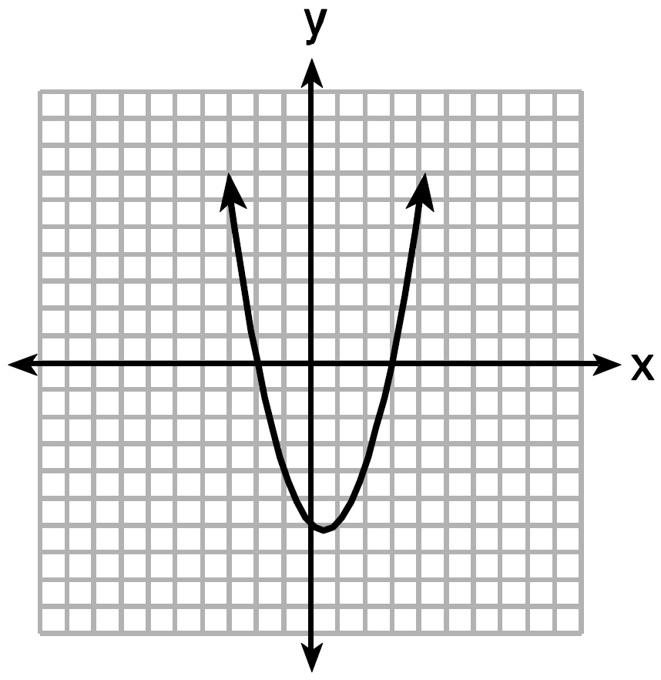 | 3) | 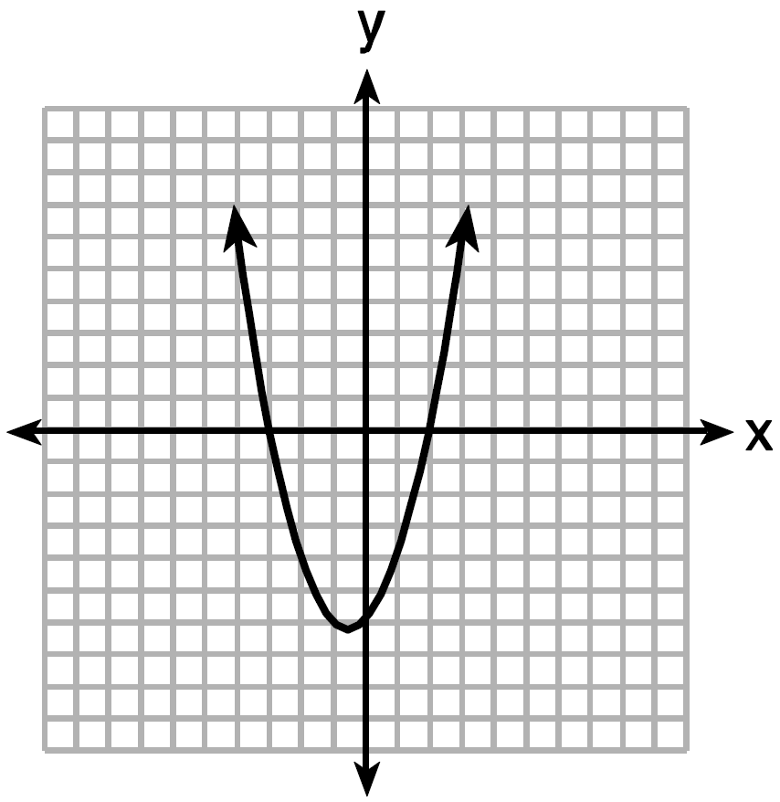
2) | 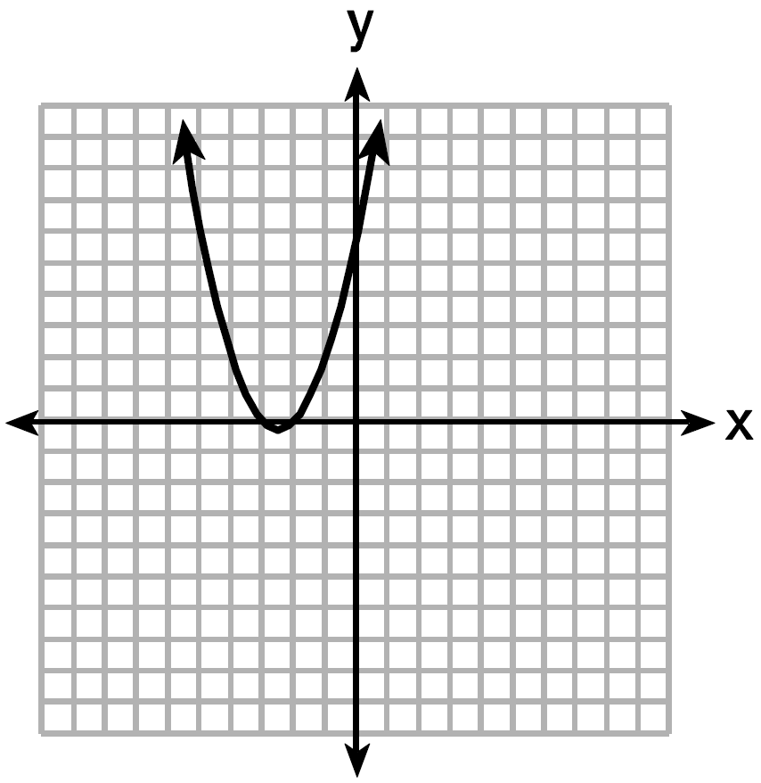 | 4) | 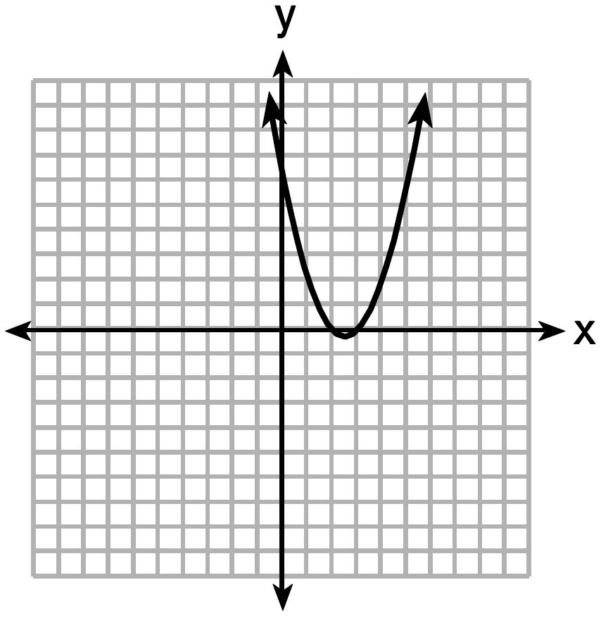

3 For which function defined by a polynomial are the zeros of the polynomial and ?
1) |  | 3)
2) |  | 4)

4 The length of the shortest side of a right triangle is 8 inches. The lengths of the other two sides are represented by consecutive odd integers. Which equation could be used to find the lengths of the other sides of the triangle?
1) |  | 3)
2) |  | 4)

5 Donna wants to make trail mix made up of almonds, walnuts and raisins. She wants to mix one part almonds, two parts walnuts, and three parts raisins. Almonds cost $12 per pound, walnuts cost $9 per pound, and raisins cost $5 per pound. Donna has $15 to spend on the trail mix. Determine how many pounds of trail mix she can make. [Only an algebraic solution can receive full credit.]

6 A high school drama club is putting on their annual theater production. There is a maximum of 800 tickets for the show. The costs of the tickets are $6 before the day of the show and $9 on the day of the show. To meet the expenses of the show, the club must sell at least $5,000 worth of tickets.
a) Write a system of inequalities that represent this situation.
b) The club sells 440 tickets before the day of the show. Is it possible to sell enough additional tickets on the day of the show to at least meet the expenses of the show? Justify your answer.

7 During a snowstorm, a meteorologist tracks the amount of accumulating snow. For the first three hours of the storm, the snow fell at a constant rate of one inch per hour. The storm then stopped for two hours and then started again at a constant rate of one-half inch per hour for the next four hours.
a) On the grid below, draw and label a graph that models the accumulation of snow over time using the data the meteorologist collected.



b) If the snowstorm started at 6 p.m., how much snow had accumulated by midnight?

8 Next weekend Marnie wants to attend either carnival A or carnival B. Carnival A charges $6 for admission and an additional $1.50 per ride. Carnival B charges $2.50 for admission and an additional $2 per ride.
a) In function notation, write to represent the total cost of attending carnival A and going on x rides. In function notation, write to represent the total cost of attending carnival B and going on x rides.
b) Determine the number of rides Marnie can go on such that the total cost of attending each carnival is the same. [Use of the set of axes below is optional.]
c) Marnie wants to go on five rides. Determine which carnival would have the lower total cost. Justify your answer.

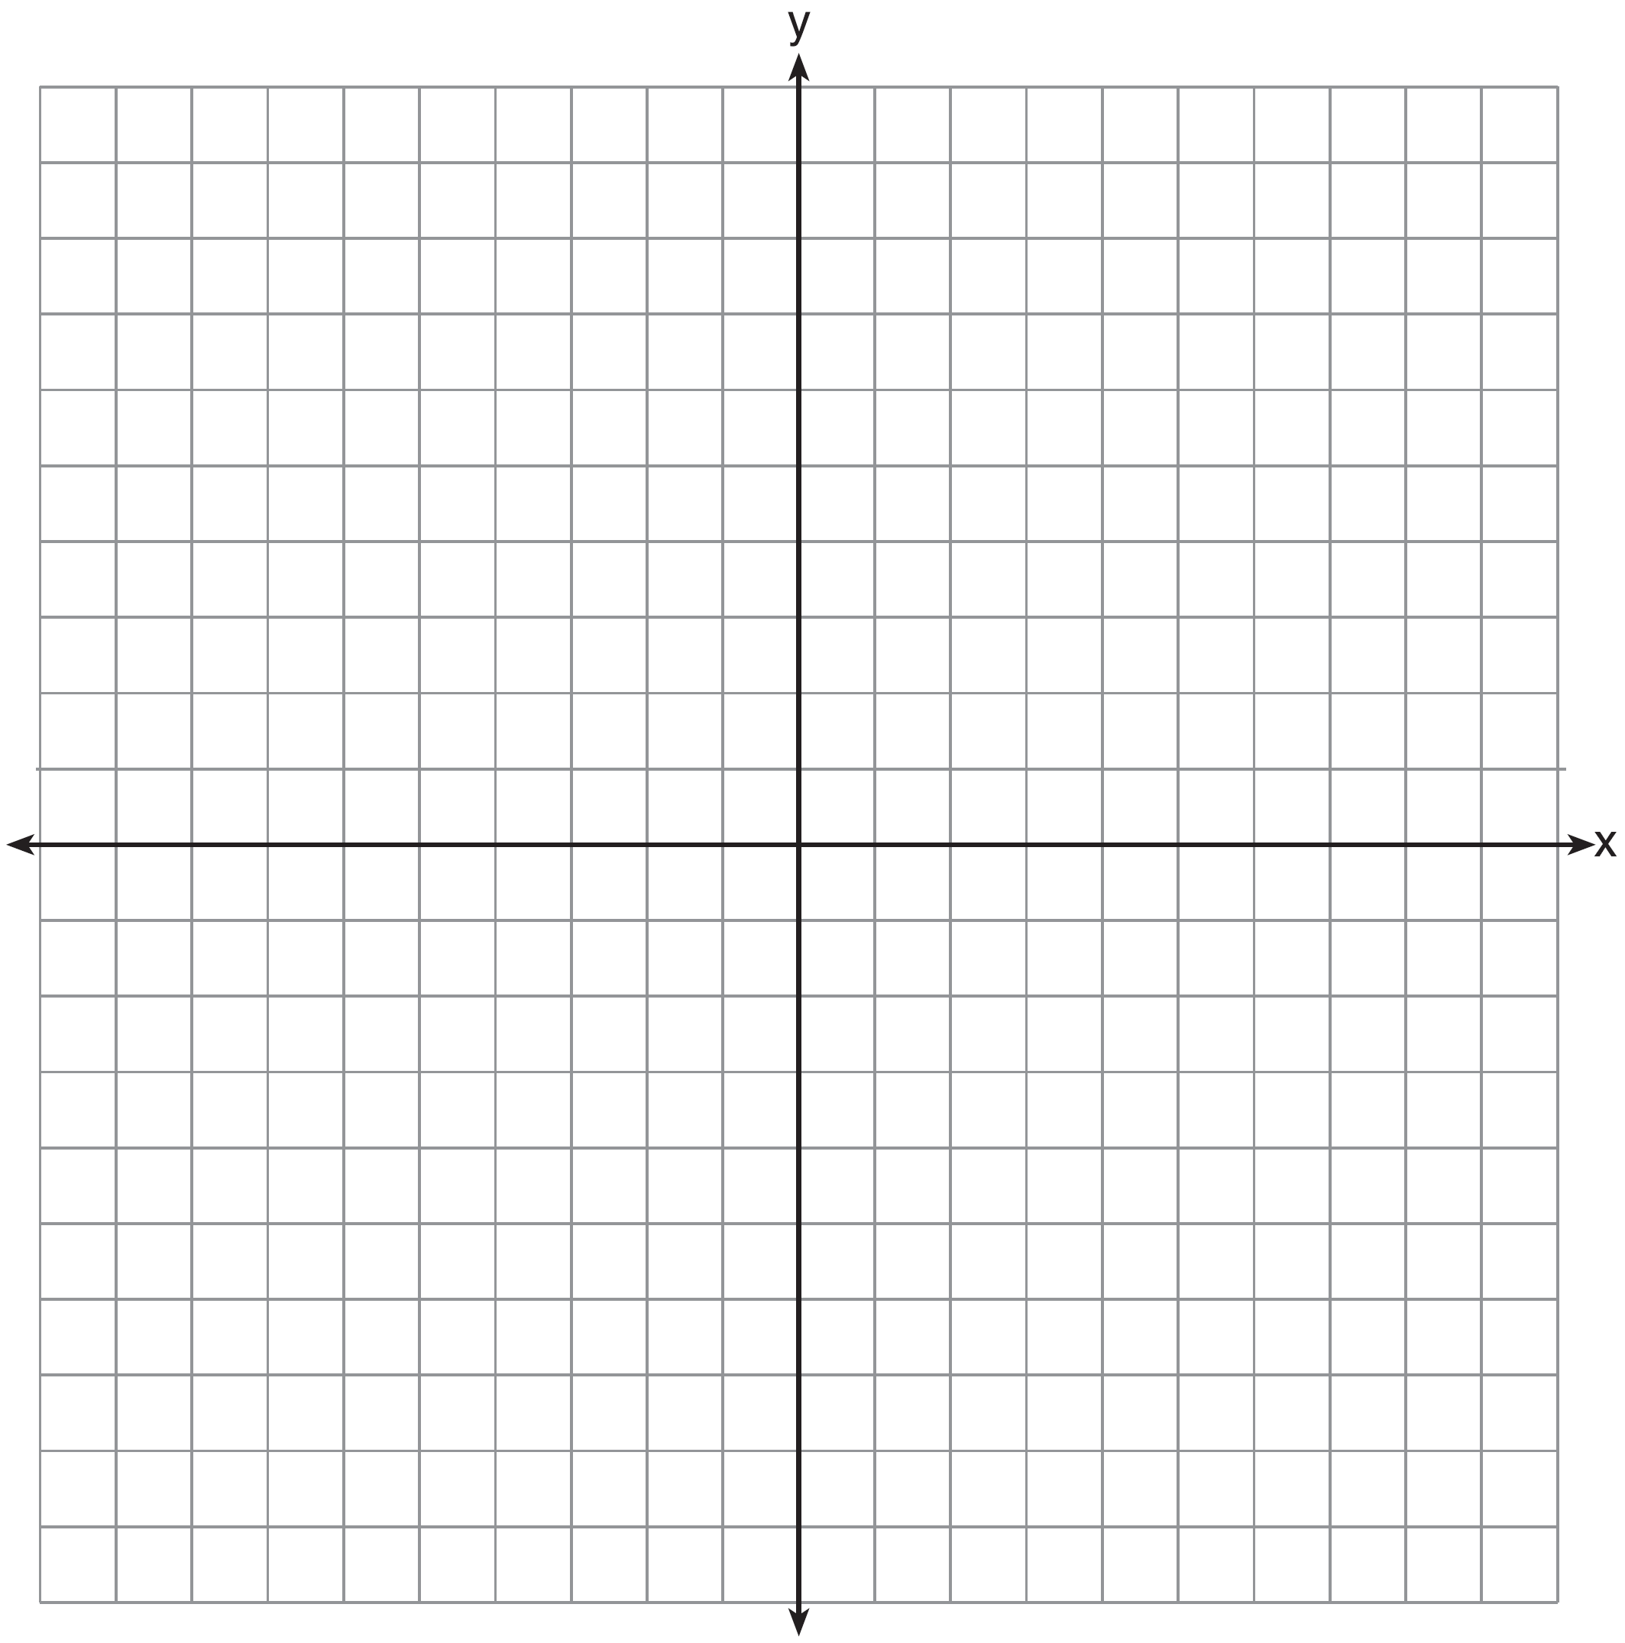

9 Which ordered pair is not in the solution set of 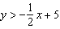 and ?
1) |  | 3)
2) |  | 4)

10 If the quadratic formula is used to find the roots of the equation , the correct roots are
1) |  | 3)
2) |  | 4)

11 Which statistic would indicate that a linear function would not be a good fit to model a data set?
1) |  | 3) | 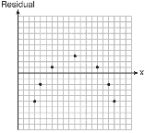
2) |  | 4) | 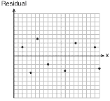

12 On the set of axes below, graph the function represented by for the domain .

13 Solve for m by factoring.

14 Ryker is given the graph of the function 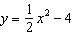. He wants to find the zeros of the function, but is unable to read them exactly from the graph.

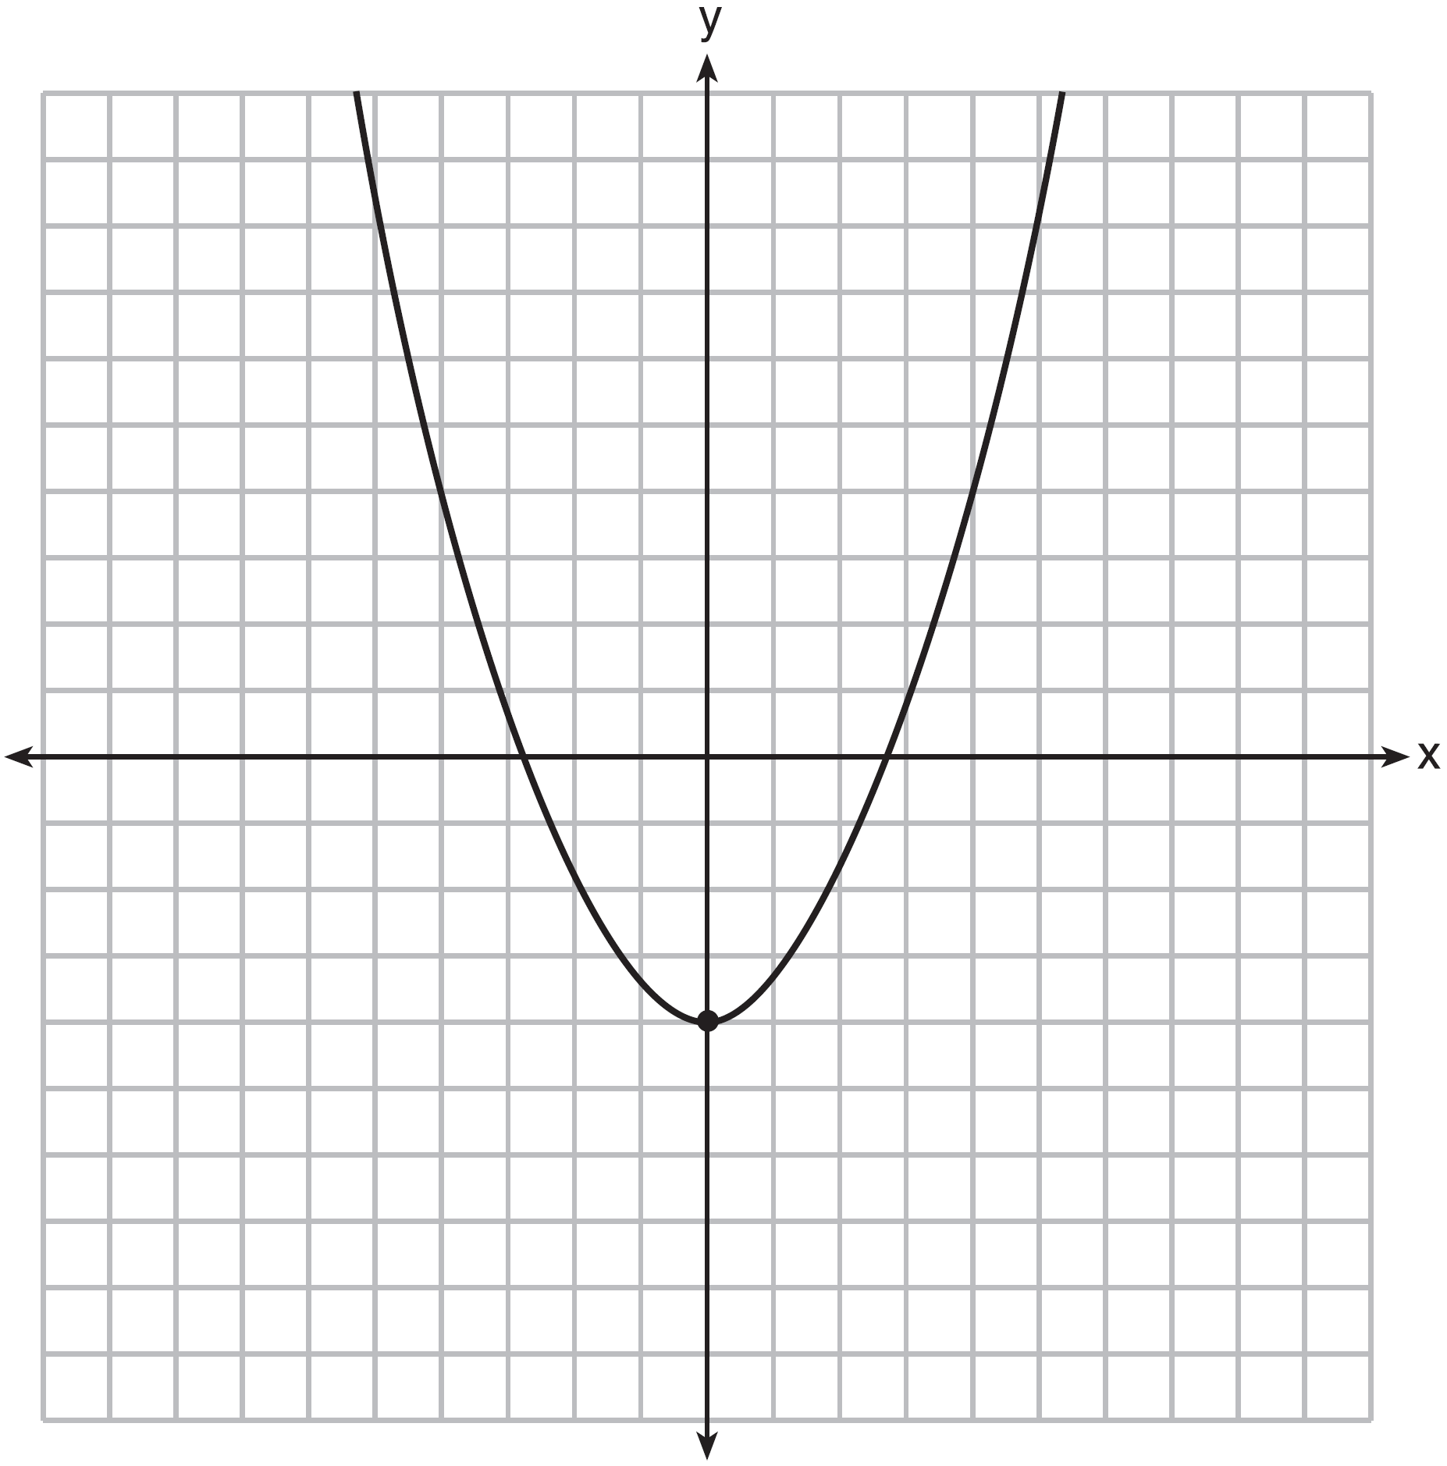

Find the zeros in simplest radical form.

15 Emma recently purchased a new car. She decided to keep track of how many gallons of gas she used on five of her business trips. The results are shown in the table below.

Miles Driven | Number of  Gallons Used
150 | 7
200 | 10
400 | 19
600 | 29
1000 | 51

Write the linear regression equation for these data where miles driven is the independent variable. (Round all values to the nearest hundredth.)

16 Max purchased a box of green tea mints. The nutrition label on the box stated that a serving of three mints contains a total of 10 Calories. On the axes below, graph the function, C, where represents the number of Calories in x mints.

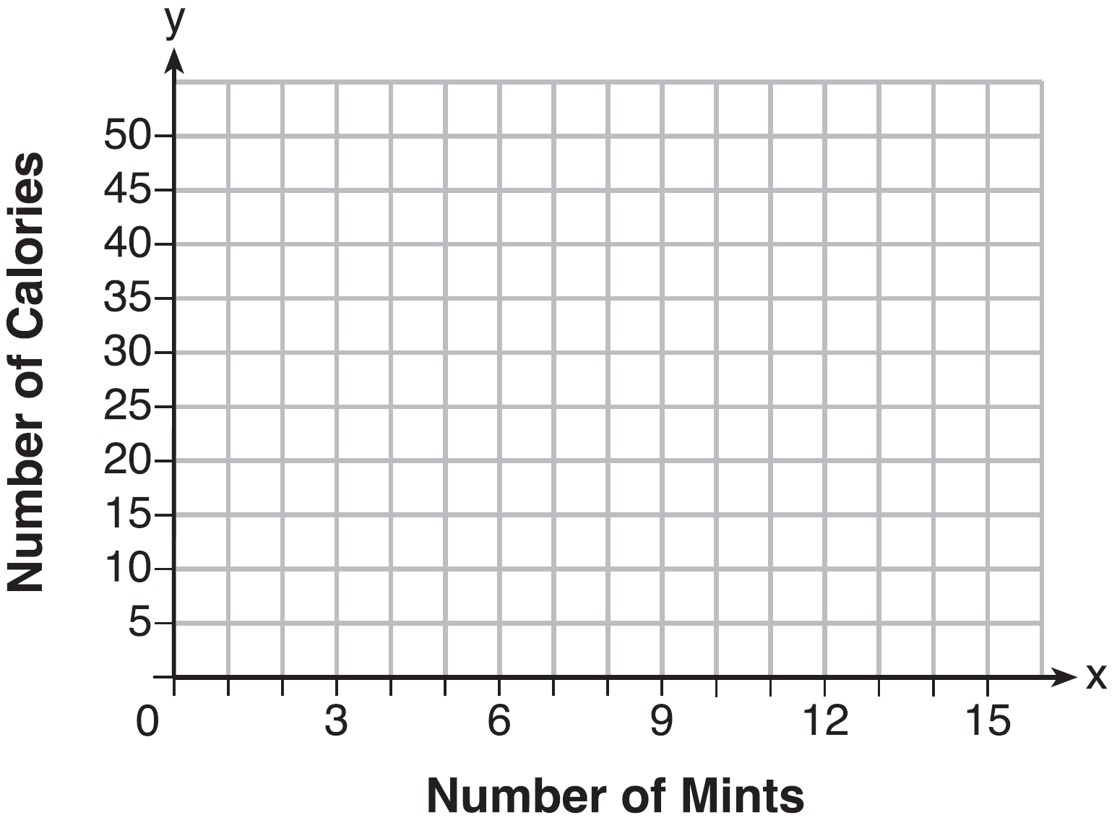

Write an equation that represents . A full box of mints contains 180 Calories. Use the equation to determine the total number of mints in the box.

17 David has two jobs. He earns $8 per hour babysitting his neighbor’s children and he earns $11 per hour working at the coffee shop. Write an inequality to represent the number of hours, x, babysitting and the number of hours, y, working at the coffee shop that David will need to work to earn a minimum of $200. David worked 15 hours at the coffee shop. Use the inequality to find the number of full hours he must babysit to reach his goal of $200.

18 On the set of axes below, graph the function .

State the range of the function. State the domain over which the function is increasing.

19 The table below lists the total cost for parking for a period of time on a street in Albany, N.Y. The total cost is for any length of time up to and including the hours parked. For example, parking for up to and including 1 hour would cost $1.25; parking for 3.5 hours would cost $5.75.

Hours  Parked | Total  Cost
1 | 1.25
2 | 2.50
3 | 4.00
4 | 5.75
5 | 7.75
6 | 10.00

Graph the step function that represents the cost for the number of hours parked.

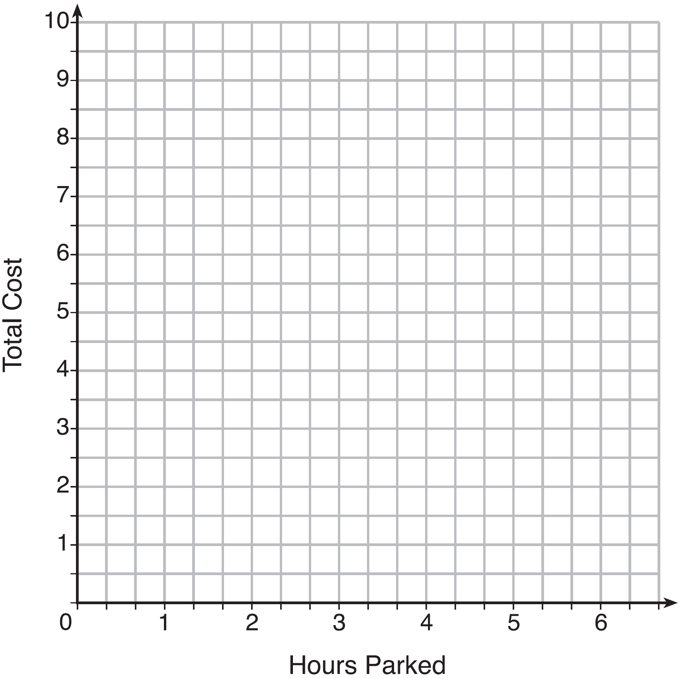

Explain how the cost per hour to park changes over the six-hour period.

20 At an office supply store, if a customer purchases fewer than 10 pencils, the cost of each pencil is $1.75. If a customer purchases 10 or more pencils, the cost of each pencil is $1.25. Let c be a function for which is the cost of purchasing x pencils, where x is a whole number.
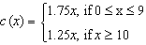
Create a graph of c on the axes below.

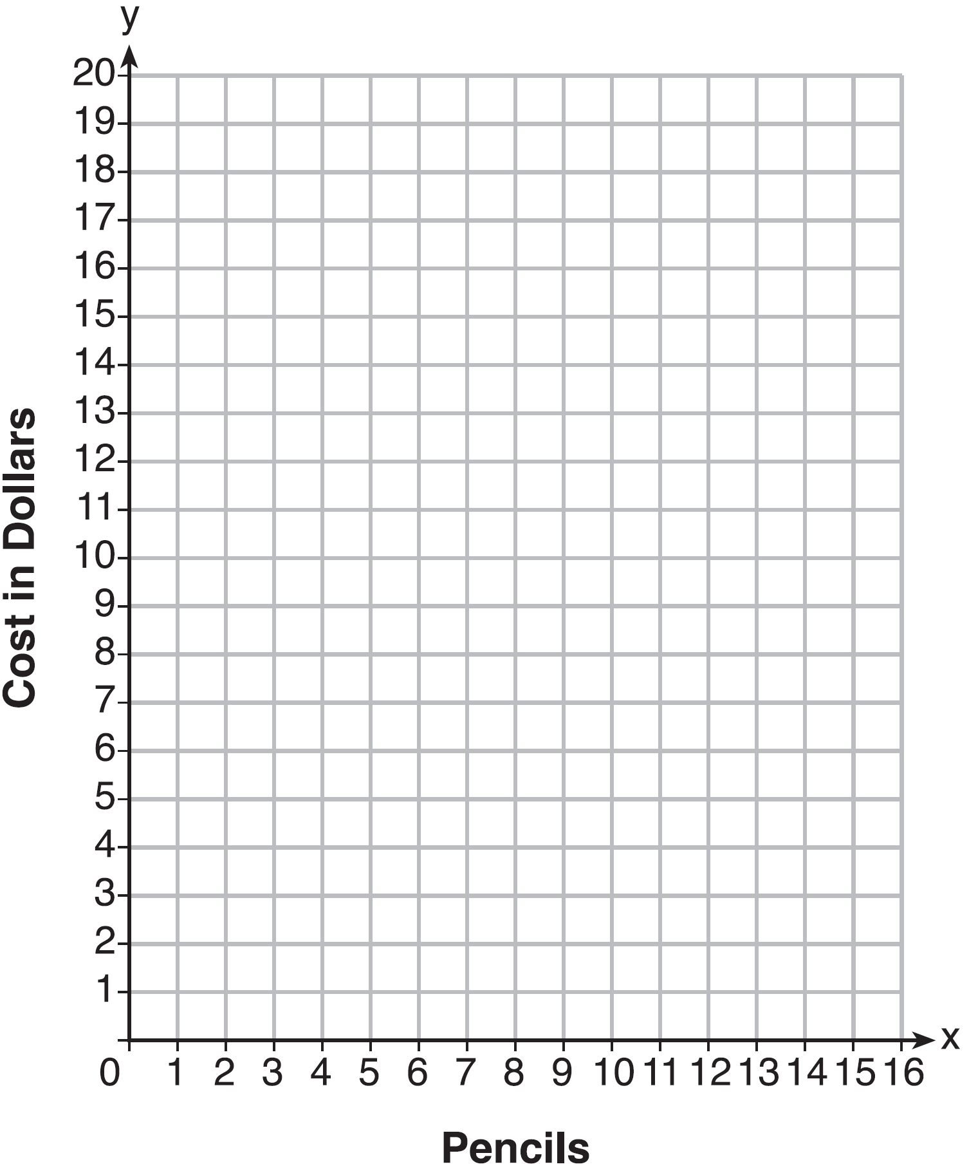

A customer brings 8 pencils to the cashier. The cashier suggests that the total cost to purchase 10 pencils would be less expensive. State whether the cashier is correct or incorrect. Justify your answer.

21 About a year ago, Joey watched an online video of a band and noticed that it had been viewed only 843 times. One month later, Joey noticed that the band’s video had 1708 views. Joey made the table below to keep track of the cumulative number of views the video was getting online.

Months Since First Viewing | Total Views
0 | 843
1 | 1708
2 | forgot to record
3 | 7124
4 | 14,684
5 | 29,787
6 | 62,381

a) Write a regression equation that best models these data. Round all values to the nearest hundredth. Justify your choice of regression equation. b) As shown in the table, Joey forgot to record the number of views after the second month. Use the equation from part a to estimate the number of full views of the online video that Joey forgot to record.

22 Use the data below to write the regression equation () for the raw test score based on the hours tutored. Round all values to the nearest hundredth.

Tutor  Hours, x | Raw Test  Score | Residual  (Actual-Predicted)
1 | 30 | 1.3
2 | 37 | 1.9
3 | 35
4 | 47
5 | 56 | 2.0
6 | 67 | 6.6
7 | 62

Equation: ___________________________

Create a residual plot on the axes below, using the residual scores in the table above.

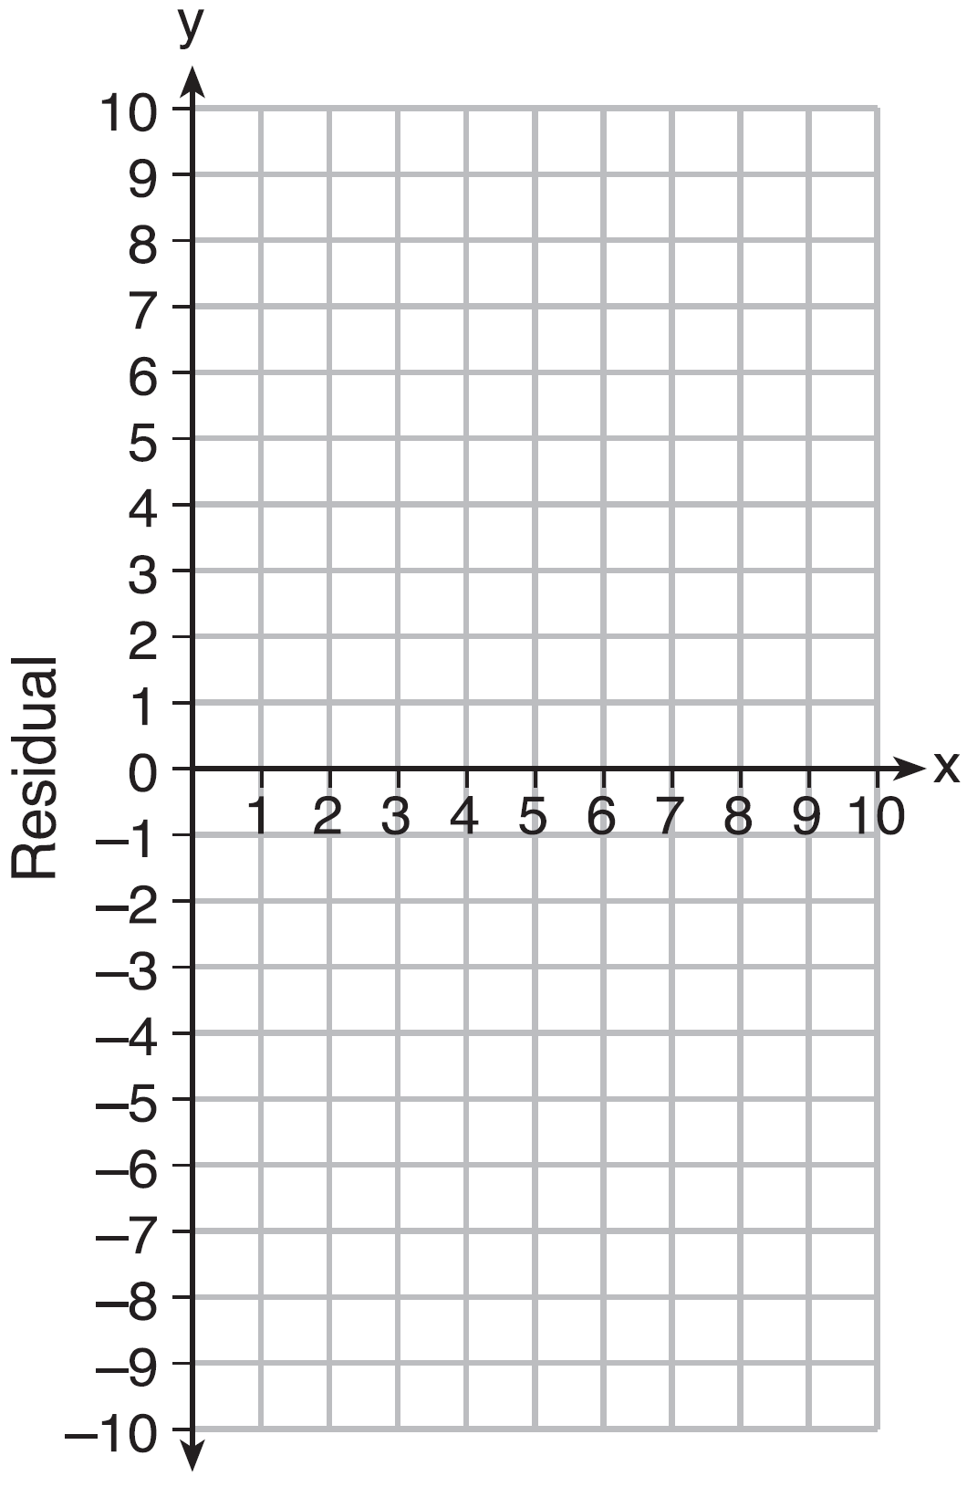

Based on the residual plot, state whether the equation is a good fit for the data. Justify your answer.

23 A local business was looking to hire a landscaper to work on their property. They narrowed their choices to two companies. Flourish Landscaping Company charges a flat rate of $120 per hour. Green Thumb Landscapers charges $70 per hour plus a $1600 equipment fee. Write a system of equations representing how much each company charges. Determine and state the number of hours that must be worked for the cost of each company to be the same. [The use of the grid below is optional.] If it is estimated to take at least 35 hours to complete the job, which company will be less expensive? Justify your answer.


1 ANS: 4
Over the interval , the average rate of change for 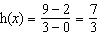, 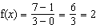, and 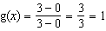.

PTS: 2 REF: spr1301ai NAT: F.IF.B.6 TOP: Rate of Change
KEY: AI

2 ANS: 3 PTS: 2 REF: spr1302ai NAT: A.APR.B.3
TOP: Zeros of Polynomials KEY: AI

3 ANS: 2
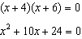

PTS: 2 REF: spr1303ai NAT: A.APR.B.3 TOP: Zeros of Polynomials
KEY: AI

4 ANS: 4 PTS: 2 REF: spr1304ai NAT: A.CED.A.1
TOP: Geometric Applications of Quadratics

5 ANS:
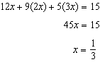 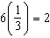 pounds

PTS: 2 REF: spr1305ai NAT: A.CED.A.1 TOP: Modeling Linear Equations

6 ANS:
a) 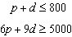b) 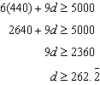 Since , it is possible.

PTS: 2 REF: spr1306ai NAT: A.CED.A.3 TOP: Modeling Systems of Linear Inequalities

7 ANS:
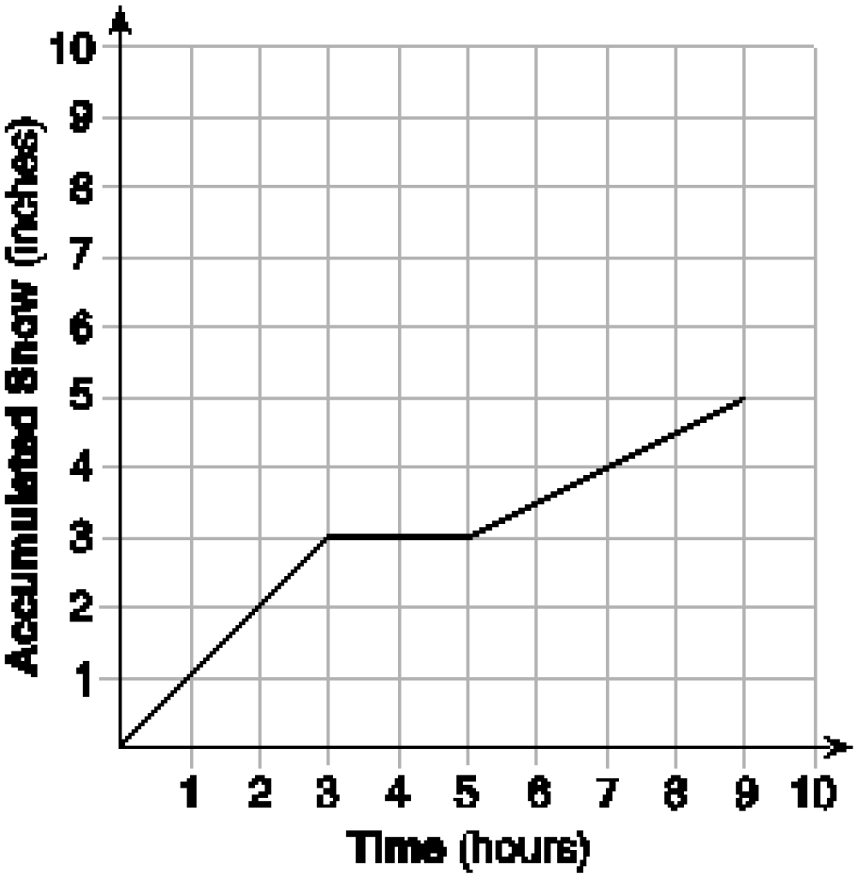 At 6 hours, inches of snow have fallen.

PTS: 4 REF: spr1307ai NAT: F.IF.B.4 TOP: Relating Graphs to Events

8 ANS:
a) 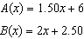 b) 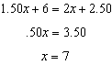 c) 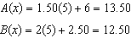 Carnival B has a lower cost.

PTS: 6 REF: spr1308ai NAT: A.REI.C.6 TOP: Graphing Linear Systems

9 ANS: 2
is on the boundary of , so is not a solution of the system.

PTS: 2 REF: fall1301ai NAT: A.REI.D.12 TOP: Graphing Systems of Linear Inequalities
KEY: solution set

10 ANS: 1
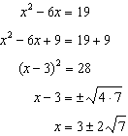

PTS: 2 REF: fall1302ai NAT: A.REI.B.4 TOP: Solving Quadratics
KEY: quadratic formula

11 ANS: 3
A correlation coefficient close to –1 or 1 indicates a good fit. For a residual plot, there should be no observable pattern and a similar distribution of residuals above and below the x-axis.

PTS: 2 REF: fall1303ai NAT: S.ID.B.6 TOP: Residuals

12 ANS:
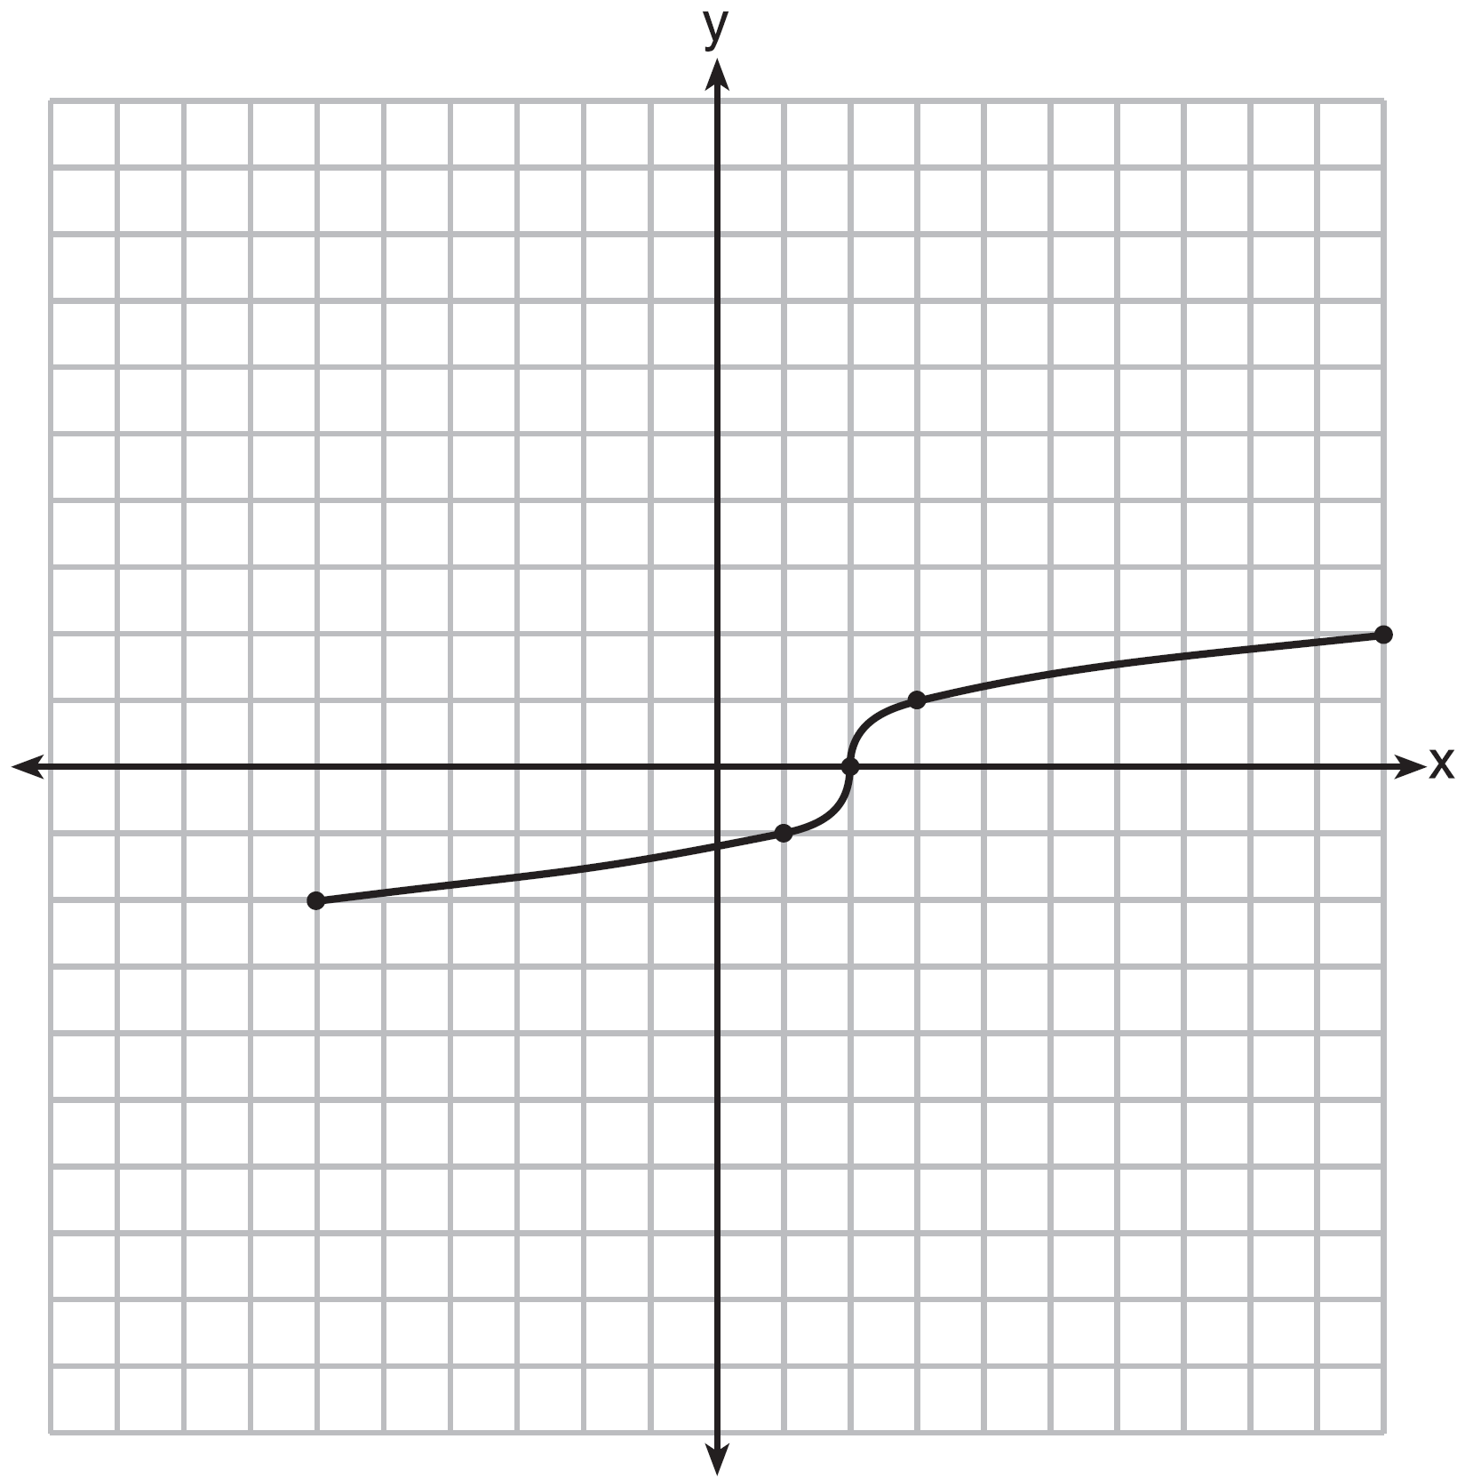

PTS: 2 REF: fall1304ai NAT: F.IF.C.7 TOP: Graphing Root Functions

13 ANS:
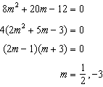

PTS: 2 REF: fall1305ai NAT: A.SSE.B.3 TOP: Solving Quadratics

14 ANS:
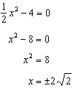

PTS: 2 REF: fall1306ai NAT: A.REI.B.4 TOP: Solving Quadratics
KEY: taking square roots

15 ANS:

PTS: 2 REF: fall1307ai NAT: S.ID.B.6 TOP: Regression
KEY: linear

16 ANS:
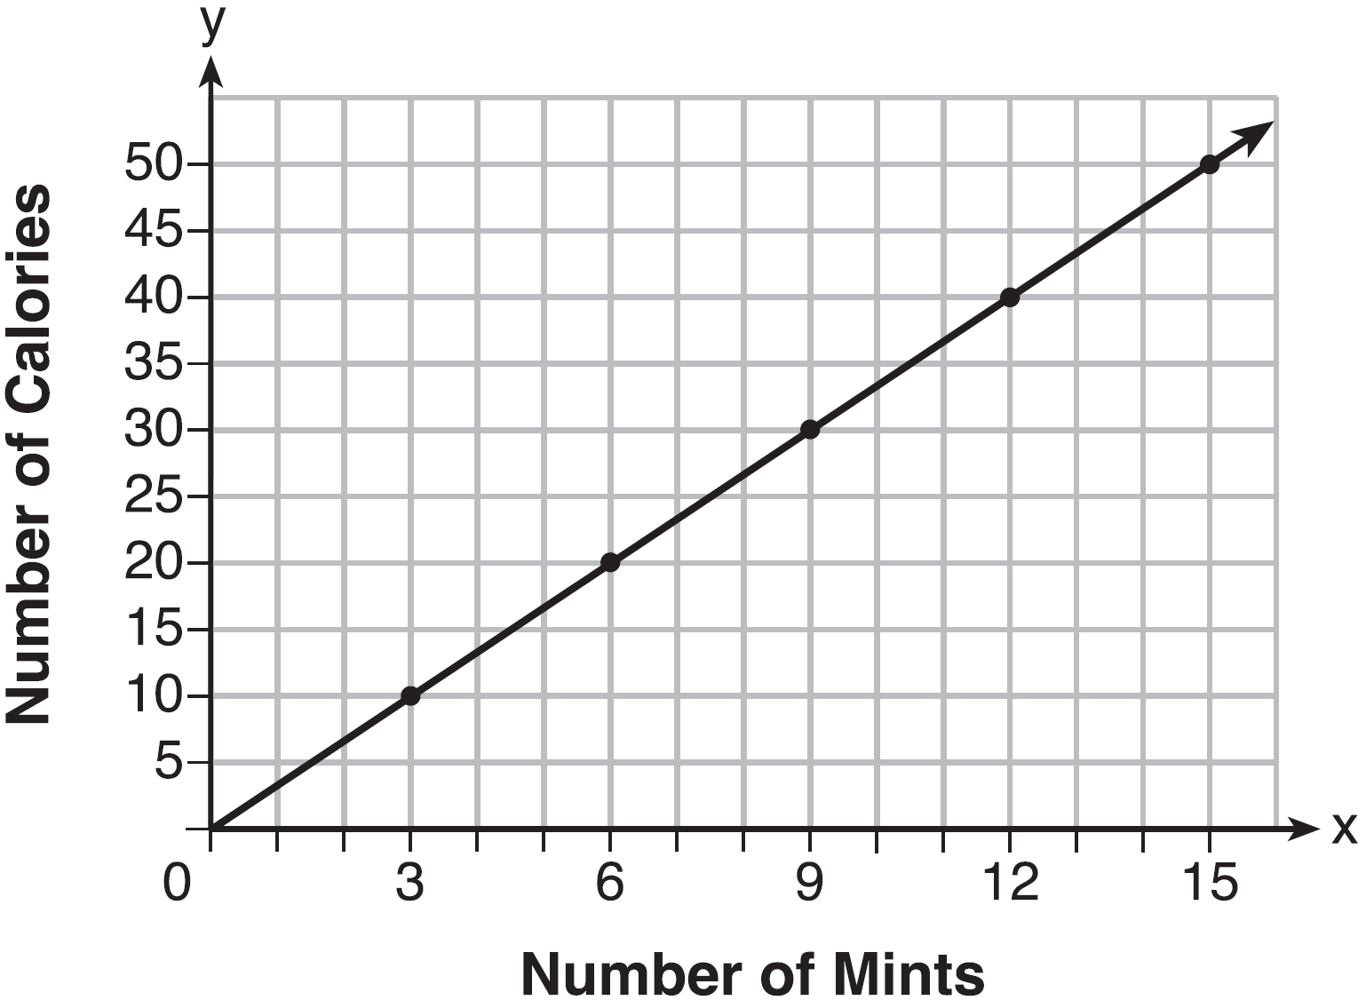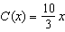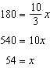

PTS: 4 REF: fall1308ai NAT: A.CED.A.2 TOP: Graphing Linear Functions

17 ANS:
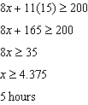

PTS: 4 REF: fall1309ai NAT: A.CED.A.3 TOP: Modeling Linear Inequalities

18 ANS:
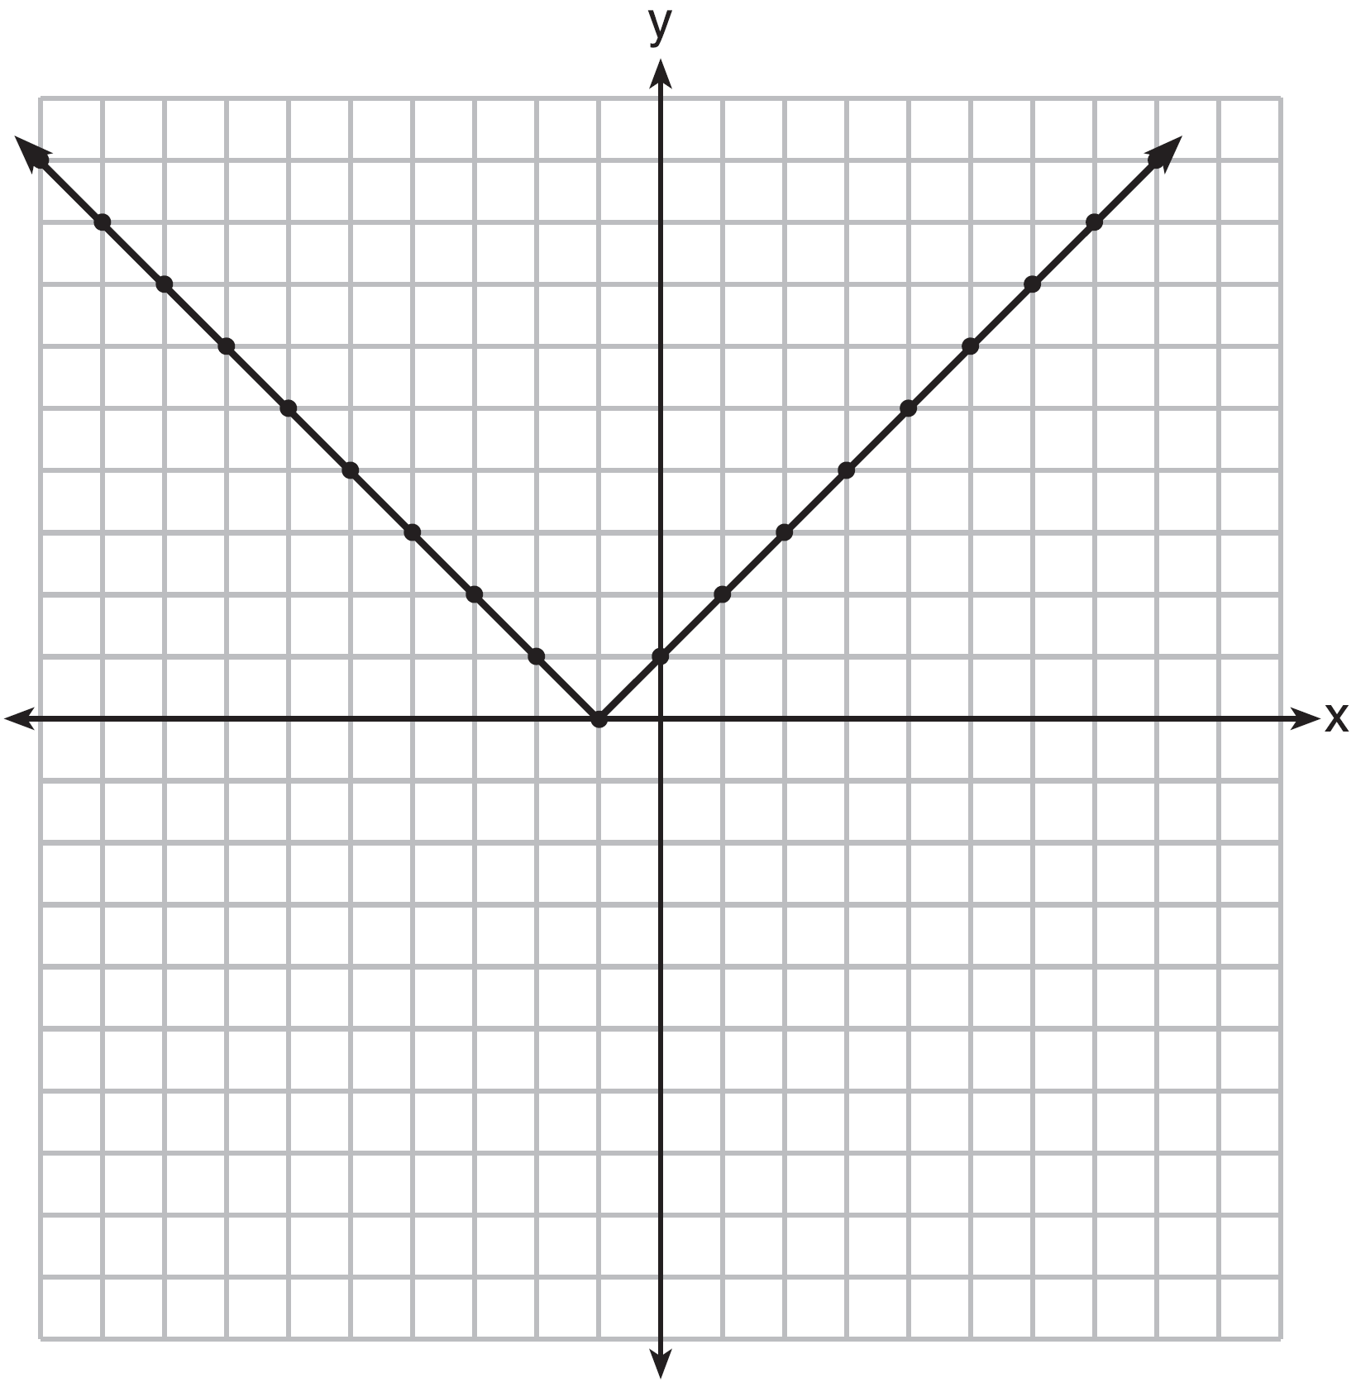Range: . The function is increasing for .

PTS: 4 REF: fall1310ai NAT: F.IF.C.7 TOP: Graphing Absolute Value Functions

19 ANS:
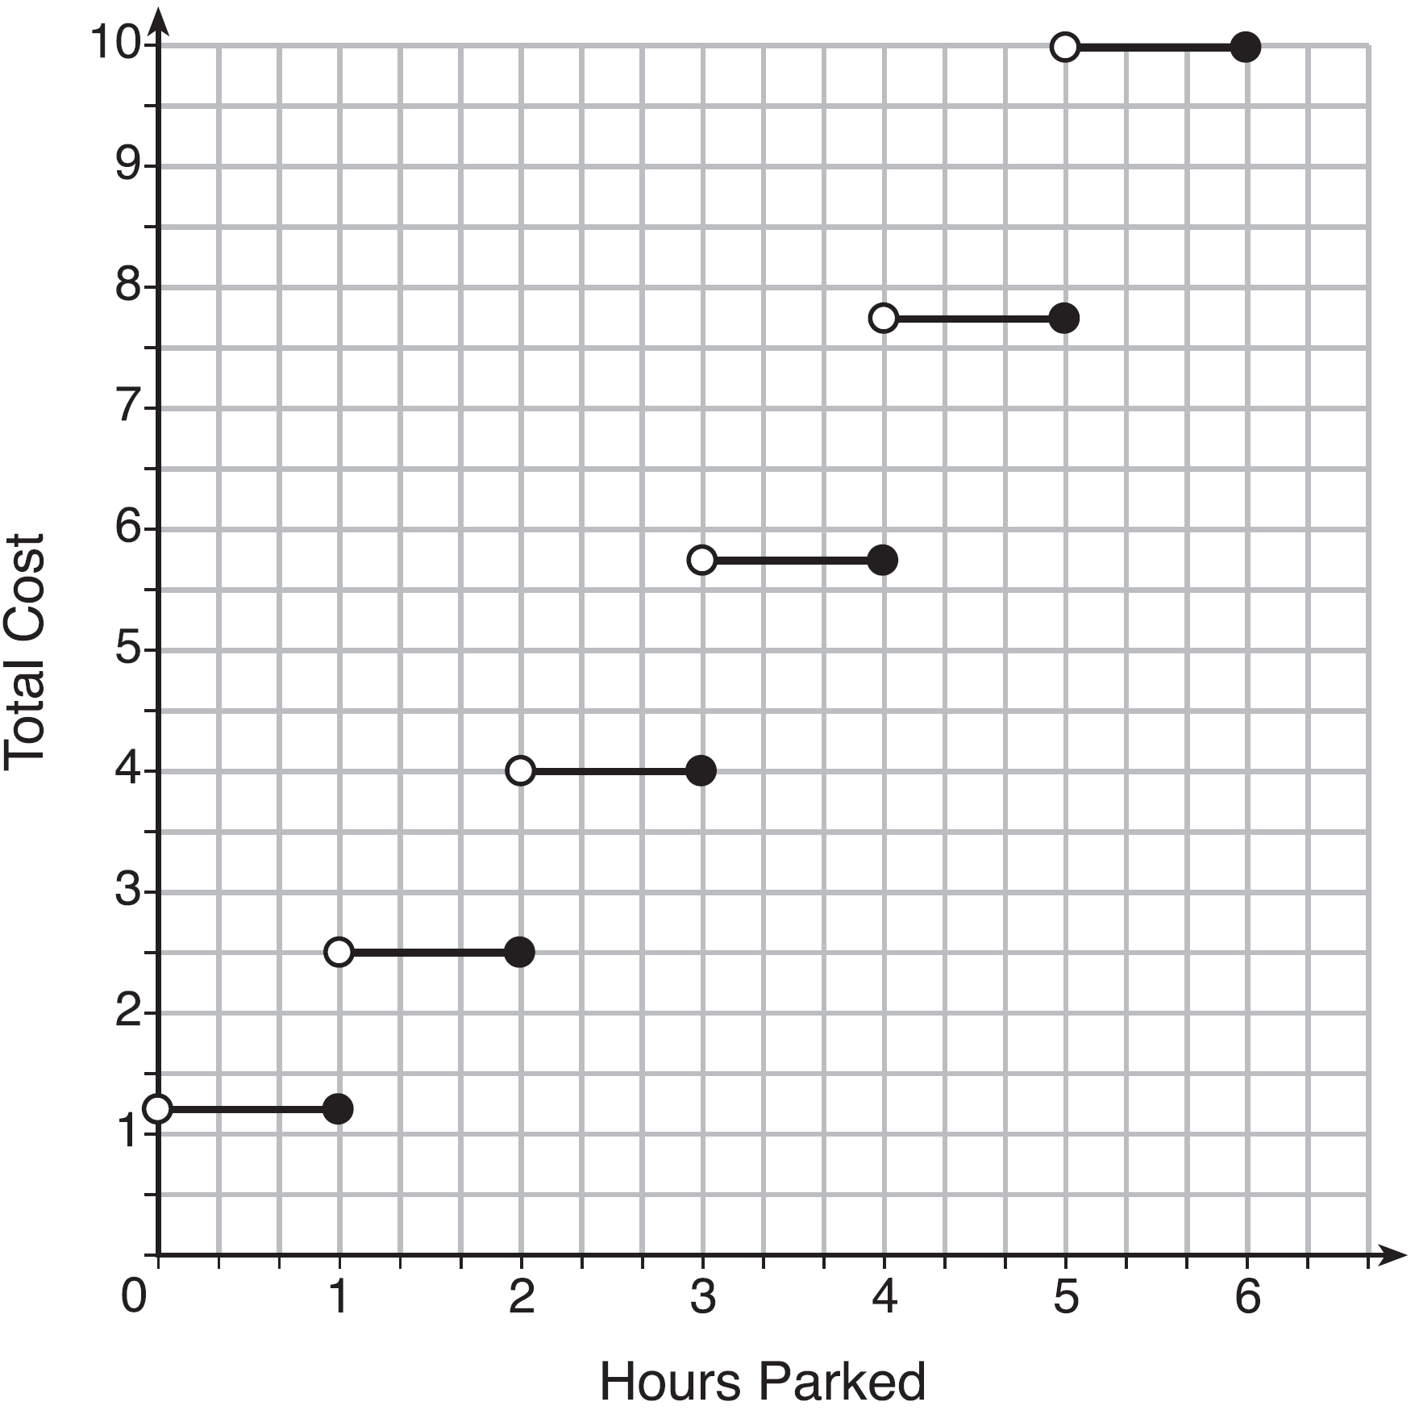 The cost for each additional hour increases after the first 2 hours.

PTS: 4 REF: fall1311ai NAT: F.IF.C.7 TOP: Graphing Step Functions

20 ANS:
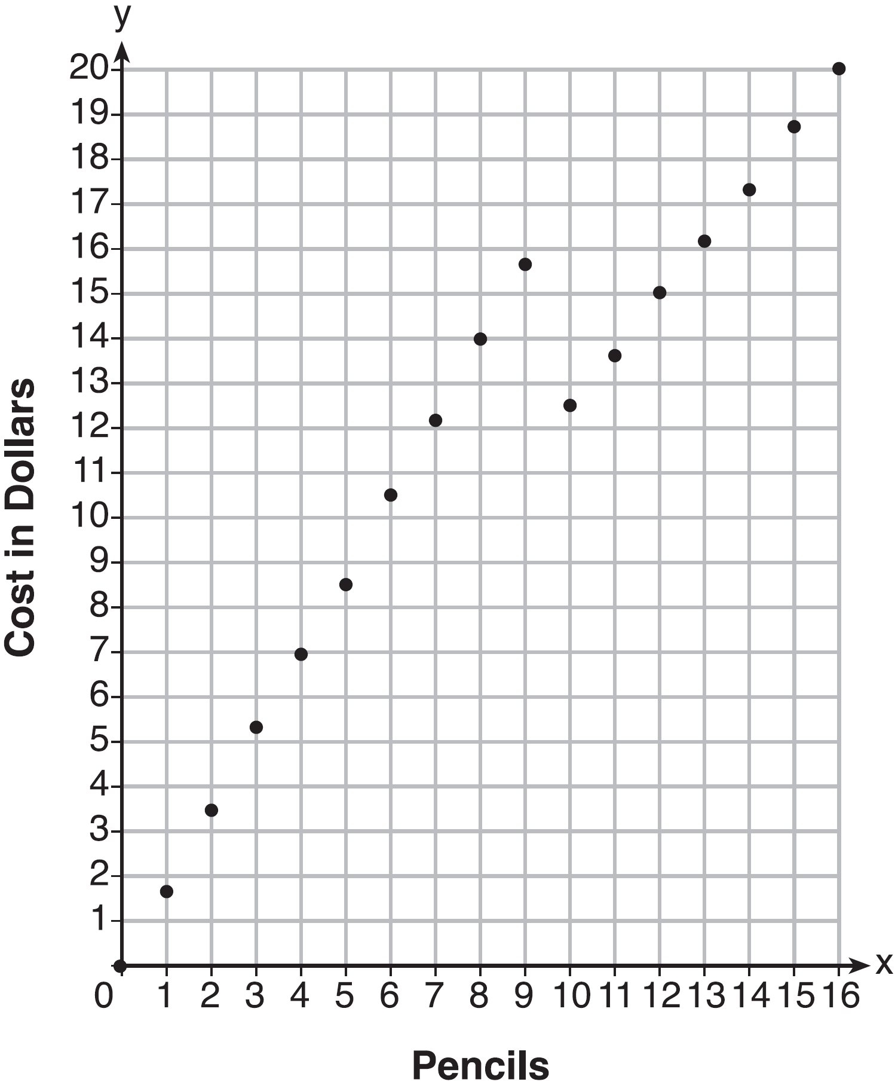Since according to the graph, 8 pencils cost $14 and 10 pencils cost $12.50, the cashier is correct.

PTS: 4 REF: fall1312ai NAT: F.IF.C.7 TOP: Graphing Piecewise-Defined Functions

21 ANS:
The data appear to grow at an exponential rate. .

PTS: 4 REF: fall1313ai NAT: S.ID.B.6 TOP: Regression
KEY: choose model

22 ANS:
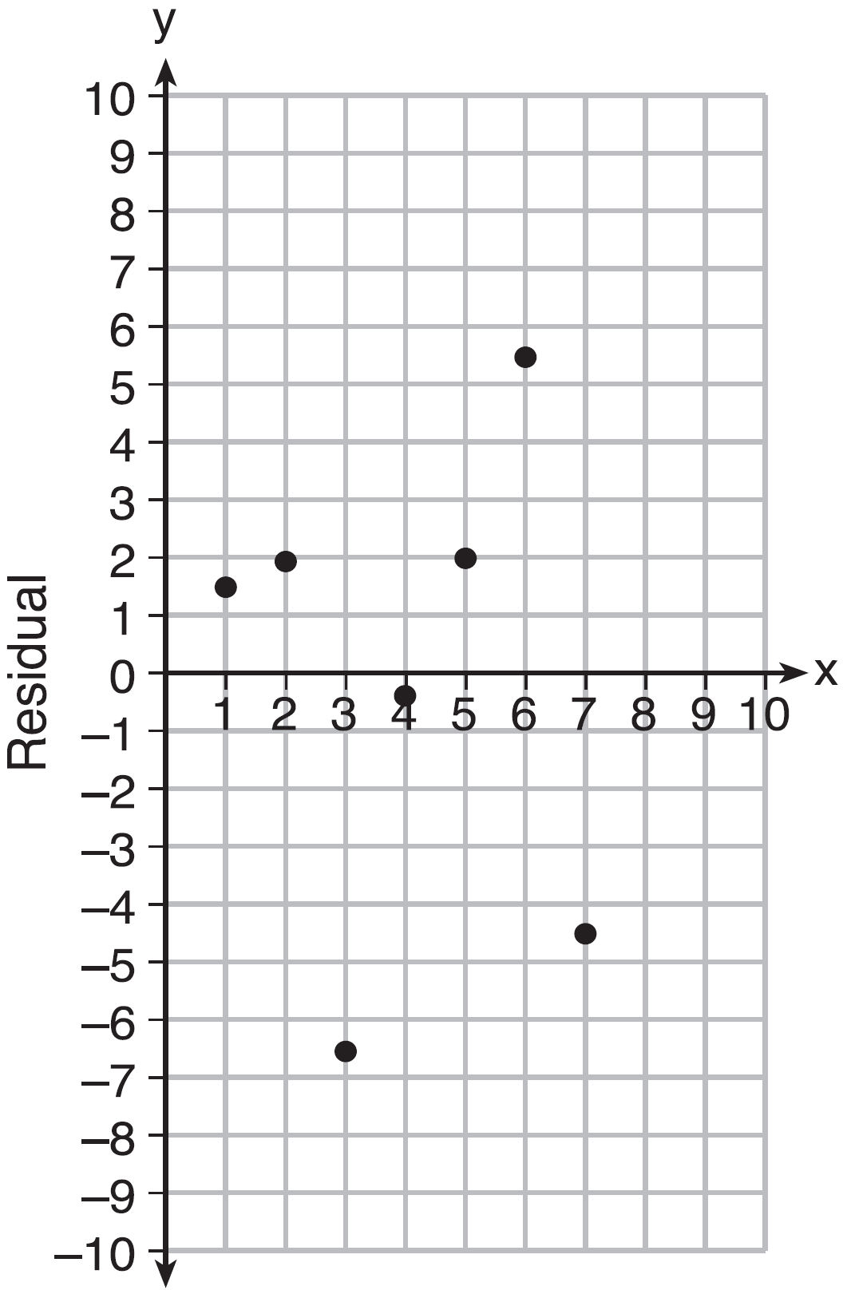Based on the residual plot, the equation is a good fit for the data because the residual values are scattered without a pattern and are fairly evenly distributed above and below the x-axis.

PTS: 4 REF: fall1314ai NAT: S.ID.B.6 TOP: Residuals

23 ANS:
and 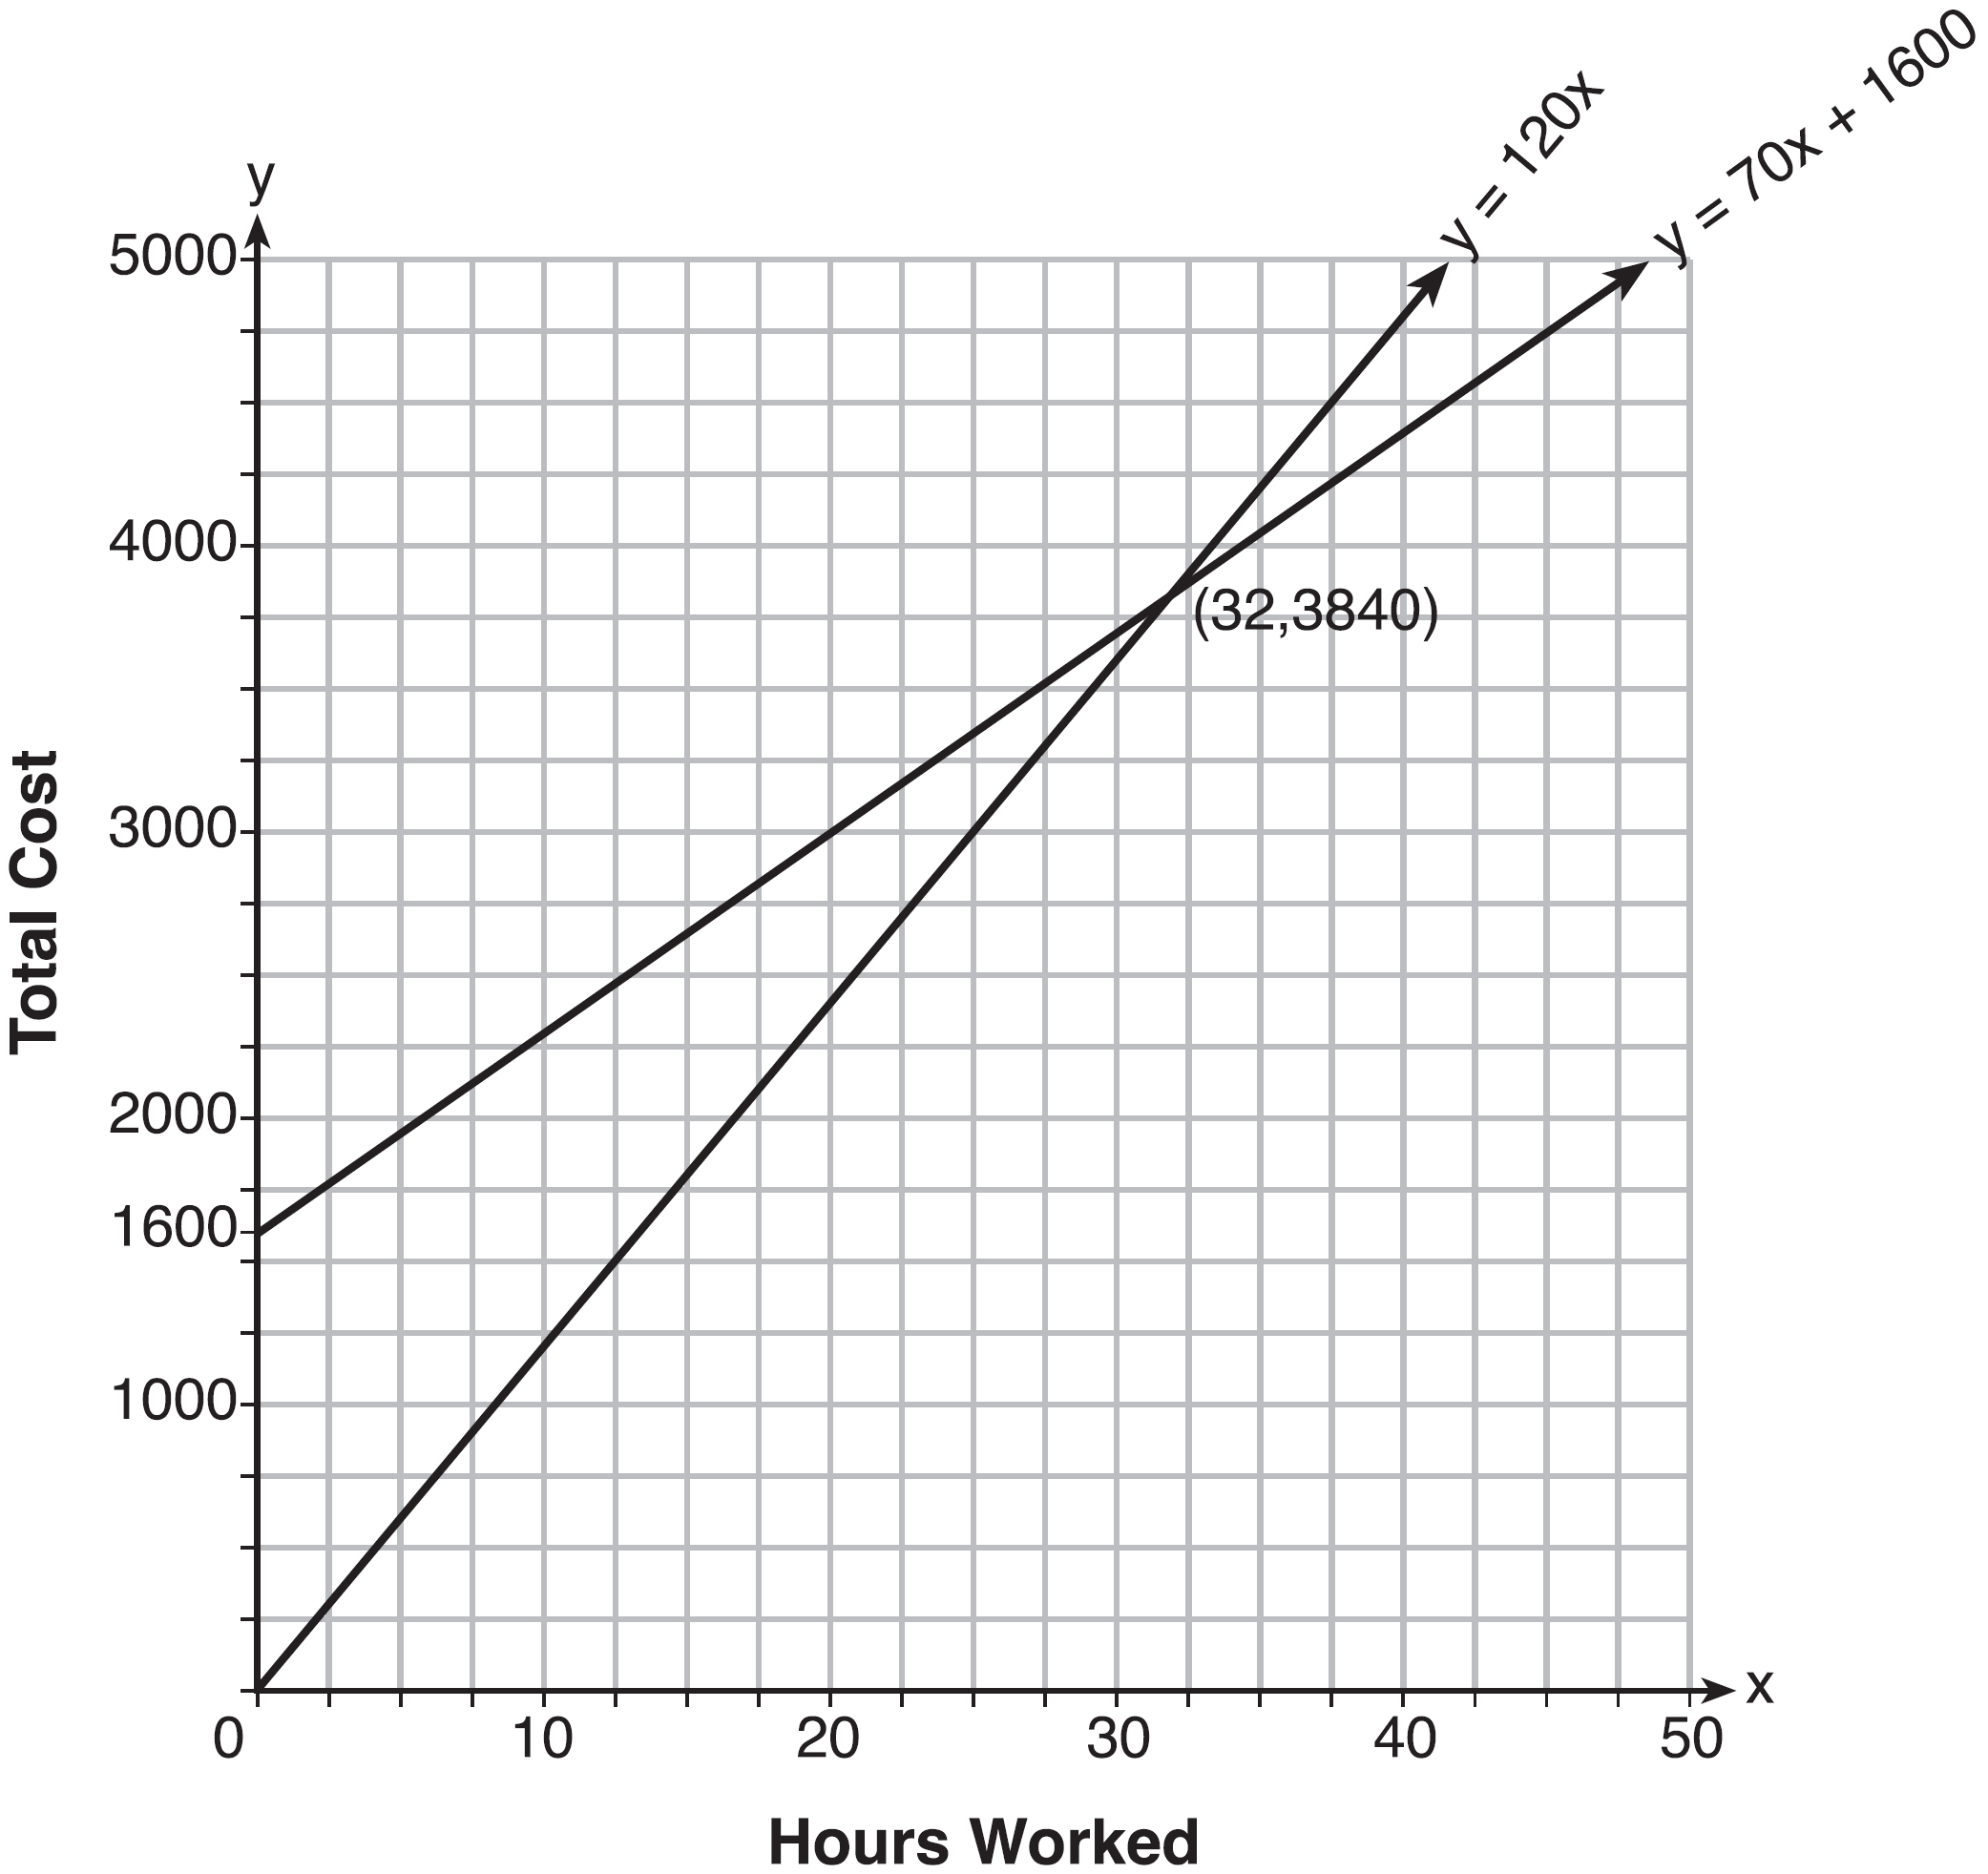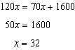 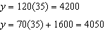 Green Thumb is less expensive.

PTS: 6 REF: fall1315ai NAT: A.REI.C.6 TOP: Graphing Linear Systems

