1 A café owner tracks the number of customers during business hours. The graph below models the data.

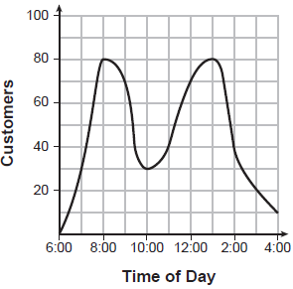

Based on the graph, the café owner saw a continual
1) | increase in customers from 6:00 to 11:00 | 3) | decrease in customers from 1:00 to 4:00
2) | increase in customers from 12:00 to 3:00 | 4) | decrease in customers from 11:00 to 2:00

2 The expression is equivalent to
1) |  | 3)
2) |  | 4)

3 Which point is a solution to ?
1) |  | 3)
2) |  | 4)

4 What is the value of x in the equation 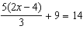?
1) | 1.9 | 3) | 5.3
2) | 3.5 | 4) | 8.9

5 The graph of is shown below.

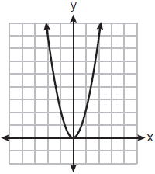

Which graph represents ?
1) | 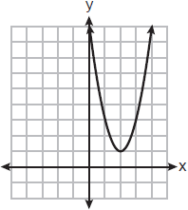 | 3) | 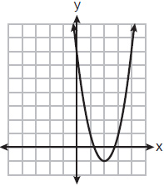
2) | 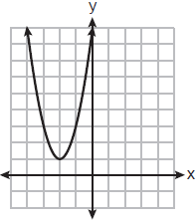 | 4) | 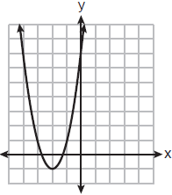

6 The length of a rectangular flat-screen television is six inches less than twice its width, x. If the area of the television screen is 1100 square inches, which equation can be used to determine the width, in inches?
1) |  | 3)
2) |  | 4)

7 A box plot is shown below.

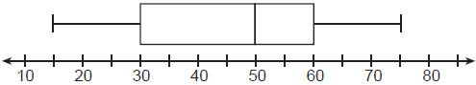

Which number represents the third quartile?
1) | 30 | 3) | `60
2) | 50 | 4) | 75

8 What is the product of and ?
1) |  | 3)
2) |  | 4)

9 What is the degree of the polynomial ?
1) | 1 | 3) | 3
2) | 2 | 4) | 4

10 What is the solution to ?
1) |  | 3)
2) |  | 4)

11 Three expressions are shown below.
I.
II.
III.
Which expressions are equivalent for all positive values of x?
1) | I and II, only | 3) | II and III, only
2) | I and III, only | 4) | I, II, and III

12 Jim uses the equation to find the amount of money in an account, A, of an investment, P, after t years. For this equation, which phrase describes the yearly rate of change?
1) | decreasing by 5% | 3) | increasing by 5%
2) | decreasing by 0.05% | 4) | increasing by 0.05%

13 What are the zeros of ?
1) | and 4, only | 3)
2) | and 8, only | 4)

14 For which function is the value of the y-intercept the smallest?
1) | 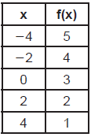 | 3) | 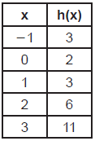
2) |  | 4)

15 The function f is graphed on the set of axes below.

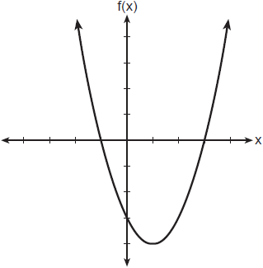

What is a possible factorization of this function?
1) |  | 3)
2) |  | 4)

16 The range of is the set of all real numbers
1) | less than or equal to | 3) | less than or equal to
2) | greater than or equal to | 4) | greater than or equal to

17 Tables of values for four functions are shown below.

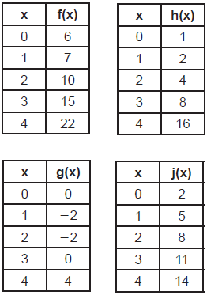

Which table best represents an exponential function?
1) |  | 3)
2) |  | 4)

18 If , then which statement is true?
1) |  | 3)
2) |  | 4)

19 Jack started a new fitness program. The first day he did 10 push-ups. The program required him to increase the number of push-ups each day by doing 9 less than twice the number from the previous day. Which recursive formula correctly models Jack’s new program, where n is the number of days and is the number of push-ups on the nth day?
1) | 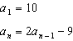 | 3) | 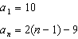
2) | 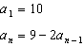 | 4) | 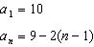

20 Which equation is equivalent to ?
1) |  | 3)
2) |  | 4)

21 What is the equation of the line that passes through the point and has a slope of ?
1) |  | 3)
2) |  | 4)

22 The function represents the amount of gasoline consumed by a car traveling m miles. An appropriate domain for this function would be
1) | integers | 3) | nonnegative integers
2) | rational numbers | 4) | nonnegative rational numbers

23 The table below shows the number of reported polio cases in Nigeria from 2006 to 2015.

Year | 2006 | 2007 | 2008 | 2009 | 2010 | 2011 | 2012 | 2013 | 2014 | 2015
Number of  Cases | 1129 | 285 | 798 | 388 | 21 | 62 | 122 | 53 | 60 | 0

What is the average rate of change, to the nearest hundredth, of the number of reported polio cases per year in Nigeria from 2006 to 2013?
1) |  | 3)
2) |  | 4)

24 Joe compared gas prices in England and New York State one day. In England, gas sold for 1.35 euros per liter, and one dollar equaled 0.622 euros. A correct way to figure out this cost, in dollars per gallon, is
1) | 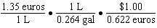 | 3) | 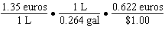
2) | 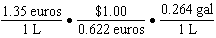 | 4) | 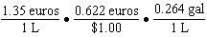

25 Classify the expression 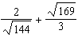 as rational or irrational. Explain your reasoning.

26 Julia surveyed 150 of her classmates at City Middle School to determine their favorite animals. Of the 150 students, 46% were male. Forty-two students said their favorite animal was a horse, and of those students were female. Of the 60 students who said dolphins were their favorite animal, 30% were male. Using this information, complete the two-way frequency table below.

 | Horse | Dolphin | Penguin | Total
Male
Female
Total

27 Bryan said that the piecewise function graphed below has a domain of all real numbers.

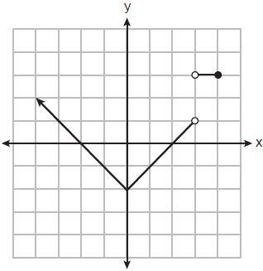

State two reasons why Bryan is incorrect.

28 The formula 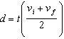 is used to calculate the distance, d, covered by an object in a given period of time, t. Solve the formula for , the final velocity, in terms of d, t, and , the initial velocity.

29 Solve algebraically for all values of x.

30 Determine the common difference of the arithmetic sequence in which and . Determine the 21st term of this sequence.

31 Factor completely.

32 Solve algebraically for all values of x. Round your answer to the nearest hundredth.

33 The senior class at Hills High School is purchasing sports drinks and bottled water to sell at the school field day. At the local discount store, a case of sports drinks costs $15.79, and a case of bottled water costs $5.69. The senior class has $125 to spend on the drinks. If x represents the number of cases of sports drinks and y represents the number of cases of bottled water purchased, write an inequality that models this situation. Nine cases of bottled water are purchased for this year’s field day. Use your inequality to determine algebraically the maximum number of full cases of sports drinks that can be purchased. Explain your answer.

34 The path of a rocket is modeled by the function , where h is the height, in meters, above the ground and t is the time, in seconds, after the rocket is launched. Sketch the graph on the set of axes below.

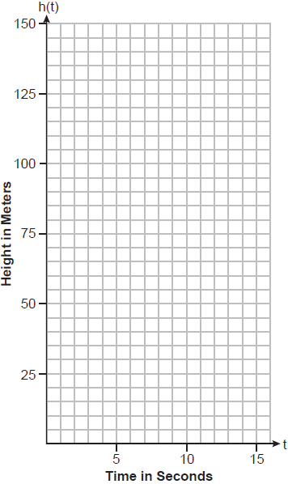

State the vertex of this function. Explain what the vertex means in the context of this situation.

35 A software company kept a record of their annual budget for advertising and their profit for each of the last eight years. These data are shown in the table below.

Annual  Advertising Budget  (in thousands, $)  (x) | Profit  (in millions, $)  (y)
10 | 2.2
13 | 2.4
14 | 3.2
16 | 4.6
19 | 5.7
24 | 6.9
24 | 7.9
28 | 9.3

Write the linear regression equation for this set of data. State, to the nearest hundredth, the correlation coefficient of these linear data. State what this correlation coefficient indicates about the linear fit of the data.

36 Graph the following system of inequalities on the set of axes below:
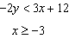
Label the solution set S.

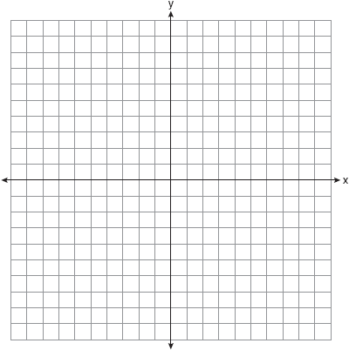

Allison thinks that is a solution to this system. Determine if Allison is correct. Justify your answer.

37 Lydia wants to take art classes. She compares the cost at two art centers. Center A charges $25 per hour and a registration fee of $25. Center B charges $15 per hour and a registration fee of $75. Lydia plans to take x hours of classes. Write an equation that models this situation, where A represents the total cost of Center A. Write an equation that models this situation, where B represents the total cost of Center B. If Lydia wants to take 10 hours of classes, use your equations to determine which center will cost less. Graph your equations for Center A and Center B on the set of axes below.

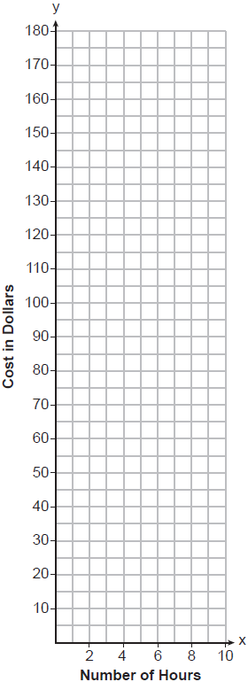

State the number of hours of classes when the centers will cost the same.
1 ANS: 3 PTS: 2 REF: 082301ai NAT: F.IF.B.4
TOP: Relating Graphs to Events

2 ANS: 3

PTS: 2 REF: 082302ai NAT: A.APR.A.1 TOP: Operations with Polynomials
KEY: addition

3 ANS: 1

PTS: 2 REF: 082303ai NAT: A.REI.D.10 TOP: Identifying Solutions

4 ANS: 2
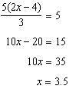

PTS: 2 REF: 082304ai NAT: A.REI.B.3 TOP: Solving Linear Equations

5 ANS: 1 PTS: 2 REF: 082305ai NAT: F.BF.B.3
TOP: Graphing Polynomial Functions KEY: bimodalgraph

6 ANS: 1 PTS: 2 REF: 082306ai NAT: A.CED.A.1
TOP: Geometric Applications of Quadratics

7 ANS: 3
The value of the third quartile is the last vertical line of the box.

PTS: 2 REF: 082307ai NAT: S.ID.A.1 TOP: Box Plots
KEY: interpret

8 ANS: 2

PTS: 2 REF: 082308ai NAT: A.APR.A.1 TOP: Operations with Polynomials
KEY: multiplication

9 ANS: 3 PTS: 2 REF: 082309ai NAT: A.SSE.A.1
TOP: Modeling Expressions

10 ANS: 2
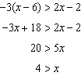

PTS: 2 REF: 082310ai NAT: A.REI.B.3 TOP: Solving Linear Inequalities

11 ANS: 4
Each expression equals .

PTS: 2 REF: 082311ai NAT: A.APR.A.1 TOP: Powers of Powers

12 ANS: 3 PTS: 2 REF: 082312ai NAT: F.LE.B.5
TOP: Modeling Exponential Functions

13 ANS: 3

PTS: 2 REF: 082313ai NAT: A.APR.B.3 TOP: Zeros of Polynomials

14 ANS: 4

PTS: 2 REF: 082314ai NAT: F.IF.C.9 TOP: Comparing Functions

15 ANS: 2 PTS: 2 REF: 082315ai NAT: F.IF.C.7
TOP: Graphing Quadratic Functions KEY: key features

16 ANS: 2
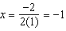;

PTS: 2 REF: 082316ai NAT: F.IF.A.2 TOP: Domain and Range

17 ANS: 3

PTS: 2 REF: 082317ai NAT: F.LE.A.1 TOP: Families of Functions

18 ANS: 4

PTS: 2 REF: 082318ai NAT: F.IF.A.2 TOP: Functional Notation

19 ANS: 1 PTS: 2 REF: 082319ai NAT: F.BF.A.1
TOP: Sequences KEY: recursive

20 ANS: 2
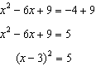

PTS: 2 REF: 082320ai NAT: A.REI.B.4 TOP: Solving Quadratics
KEY: completing the square

21 ANS: 1
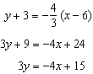

PTS: 2 REF: 082321ai NAT: A.REI.D.10 TOP: Writing Linear Equations
KEY: other forms

22 ANS: 4 PTS: 2 REF: 082322ai NAT: F.IF.B.5
TOP: Domain and Range KEY: context

23 ANS: 4
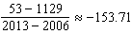

PTS: 2 REF: 082323ai NAT: F.IF.B.6 TOP: Rate of Change

24 ANS: 1 PTS: 2 REF: 082324ai NAT: N.Q.A.1
TOP: Conversions

25 ANS:
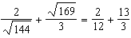 The sum of two rational numbers is rational.

PTS: 2 REF: 082325ai NAT: N.RN.B.3 TOP: Operations with Radicals
KEY: classify

26 ANS:

 | Horse | Dolphin | Penguin | Total
Male | 28 | 18 | 23 | 69
Female | 14 | 42 | 25 | 81
Total | 42 | 60 | 48 | 150

PTS: 2 REF: 082326ai NAT: S.ID.B.5 TOP: Frequency Tables
KEY: two-way

27 ANS:
The function is not defined at or .

PTS: 2 REF: 082327ai NAT: F.IF.A.2 TOP: Domain and Range

28 ANS:
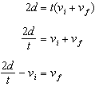

PTS: 2 REF: 082328ai NAT: A.CED.A.4 TOP: Transforming Formulas

29 ANS:
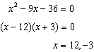

PTS: 2 REF: 082329ai NAT: A.REI.B.4 TOP: Solving Quadratics
KEY: factoring

30 ANS:
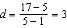;

PTS: 2 REF: 082330ai NAT: F.IF.A.3 TOP: Sequences
KEY: explicit

31 ANS:

PTS: 2 REF: 082331ai NAT: A.SSE.A.2
TOP: Factoring the Difference of Perfect Squares

32 ANS:
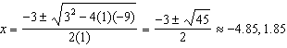

PTS: 2 REF: 082332ai NAT: A.REI.B.4 TOP: Solving Quadratics
KEY: quadratic formula

33 ANS:
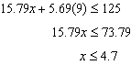 4 cases can be bought. Buying 5 cases totals more than $125.

PTS: 4 REF: 082333ai NAT: A.CED.A.3 TOP: Modeling Linear Inequalities

34 ANS:
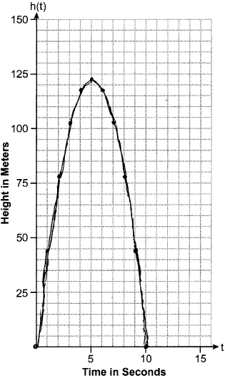 The rocket is at 122.5m at 5 sec.

PTS: 4 REF: 082334ai NAT: F.IF.B.4 TOP: Graphing Quadratic Functions
KEY: graph

35 ANS:
, 0.99, strong

PTS: 4 REF: 082335ai NAT: S.ID.B.6 TOP: Regression
KEY: linear with correlation coefficient

36 ANS:
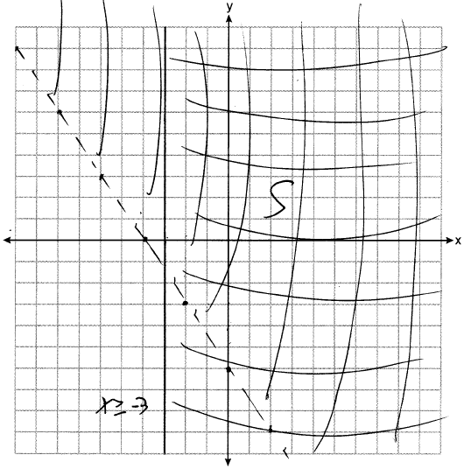 No, as .

PTS: 4 REF: 082336ai NAT: A.REI.D.12 TOP: Graphing Systems of Linear Inequalities

37 ANS:
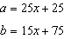; 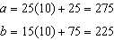 b will cost less; 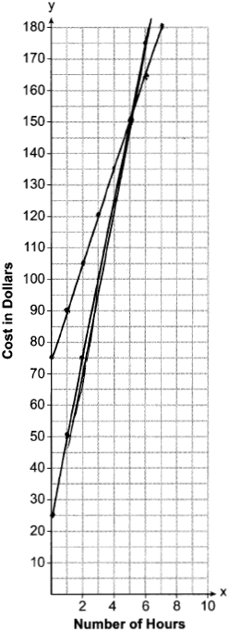; 5 hours

PTS: 6 REF: 082337ai NAT: A.REI.C.6 TOP: Graphing Linear Systems

