1 If 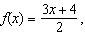 then is
1) | 21 | 3) | 14
2) | 16 | 4) | 4

2 If then the common ratio of the sequence is
1) |  | 3)
2) | 2 | 4)

3 The expression is equivalent to
1) |  | 3)
2) |  | 4)

4 Given the relation
Which value of x would make this relation a function?
1) |  | 3)
2) |  | 4)

5 If point lies on the line whose equation is , then the value of K is
1) |  | 3)
2) |  | 4)

6 The expression 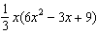 is equivalent to
1) |  | 3)
2) |  | 4)

7 The graphs below represent four polynomial functions. Which of these functions has zeros of 2 and ?
1) | 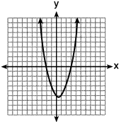 | 3) | 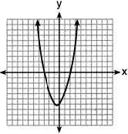
2) | 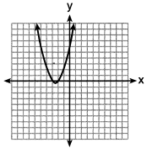 | 4) | 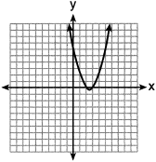

8 What is the constant term of the polynomial ?
1) | 6 | 3) | 3
2) | 2 | 4) | 4

9 Emily was given $600 for her high school graduation. She invested it in an account that earns 2.4% interest per year. If she does not make any deposits or withdrawals, which expression can be used to determine the amount of money that will be in the account after 4 years?
1) |  | 3)
2) |  | 4)

10 Different ways to represent data are shown below.

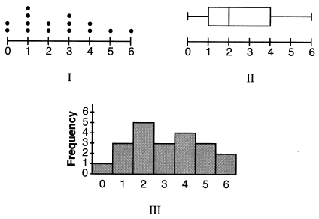

Which data representations have a median of 2?
1) | I and II, only | 3) | II and III, only
2) | I and III, only | 4) | I, II, and III

11 What would be the order of these quadratic functions when they are arranged from the narrowest graph to the widest graph?
1) |  | 3)
2) |  | 4)

12 At Berkeley Central High School, a survey was conducted to see if students preferred cheeseburgers, pizza, or hot dogs for lunch. The results of this survey are shown in the table below.

 | Cheeseburgers | Pizza | Hot Dogs
Females | 32 | 44 | 24
Males | 36 | 30 | 34

Based on this survey, what percent of the students preferred pizza?
1) | 30 | 3) | 44
2) | 37 | 4) | 74

13 Which situation could be modeled by a linear function?
1) | The value of a car depreciates by 7% annually. | 3) | The number of bacteria in a lab doubles weekly.
2) | A gym charges a $50 initial fee and then $30 monthly. | 4) | The amount of money in a bank account increases by 0.1 % monthly.

14 Which function has the smallest y-intercept value?
1) | 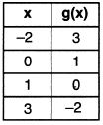 | 3) | 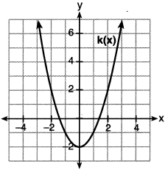
2) |  | 4)

15 When solving by completing the square, which equation is a step in the process?
1) |  | 3)
2) |  | 4)

16 When. is written in standard form, the leading coefficient is
1) | 7 | 3) | 3
2) | 2 | 4)

17 Which of the equations below have the same solution?
I.
II.
III. 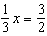
1) | I and II, only | 3) | II and III, only
2) | I and III, only | 4) | I, II, and III

18 In an organism, the number of cells, , after d days can be represented by the function . This function can also be expressed as
1) |  | 3)
2) |  | 4)

19 In the process of solving the equation , George wrote , followed by . Which properties justify George's process?
A. addition property of equality
B. division property of equality
C. commutative property of addition
D. distributive property
1) | A and C | 3) | D and C
2) | A and B | 4) | D and B

20 A sequence is defined recursively by
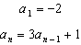
What is the value of ?
1) |  | 3) | 22
2) |  | 4) | 67

21 A swimmer set a world record in the women's 1500-meter freestyle, finishing the race in 15.42 minutes. If 1 meter is approximately 3.281 feet, which set of calculations could be used to convert her speed to miles per hour?
1) | 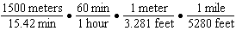
2) | 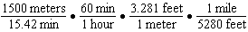
3) | 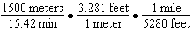
4) | 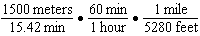

22 The diagram below shows the graph of , which models the height, in feet, of a rocket t seconds after it was shot into the air.

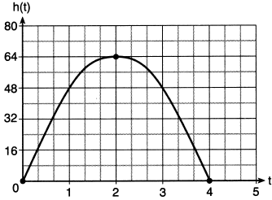

The domain of is
1) |  | 3)
2) |  | 4)

23 The table below shows the time, in hours, spent by students on electronic devices and their math test scores. The data collected model a linear regression.

Time Spent on an  Electronic Device (hours) | Math Test Score
3 | 85
1 | 99
4 | 81
0 | 98
3 | 90
7 | 65
5 | 78
2 | 90

What is the correlation coefficient, to the nearest hundredth, for these data?
1) |  | 3) | 0.98
2) |  | 4) | 0.95

24 The volume of a trapezoidal prism can be found using the formula 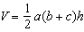. Which equation is correctly solved for b?
1) | 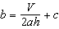 | 3) | 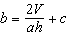
2) | 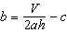 | 4) | 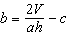

25 Graph on the set of axes below.

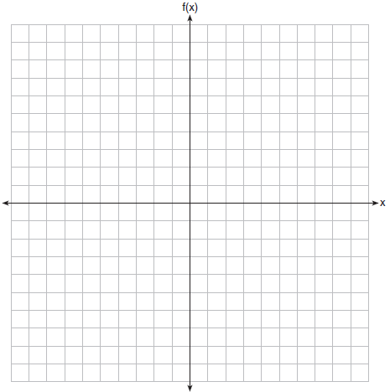

26 The table below shows the value of a particular car over time.

Time (years) | Value (dollars)
0 | 20,000
5 | 10,550
10 | 5570
15 | 2940
20 | 1550

Determine whether a linear or exponential function is more appropriate for modeling this data. Explain your choice.

27 Is the product of and rational or irrational? Justify your answer.

28 The ages of the last 16 United States presidents on their first inauguration day are shown in the table below.

51 | 54 | 51 | 60
62 | 43 | 55 | 56
61 | 52 | 69 | 64
46 | 54 | 47 | 70

Determine the interquartile range for this set of data.

29 The cost of one pound of grapes, g, is 15 cents more than one pound of apples, a. The cost of one pound of bananas, b, is twice as much as one pound of grapes. Write an equation that represents the cost of one pound of bananas in terms of the cost of one pound of apples.

30 A student is given the functions and . Describe the transformation that maps onto .

31 Solve algebraically for all values of x, rounding to the nearest tenth.

32 Factor completely:

33 Thomas took a 140-mile bus trip to visit his grandparents. His trip is outlined on the graph below.

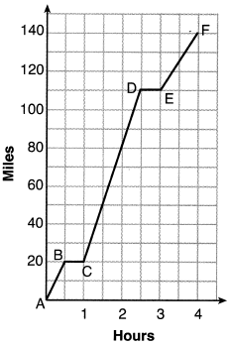

Explain what might have happened in the interval between D and E. State the interval in which the bus traveled the fastest. State how many miles per hour the bus was traveling during this interval. What was the average rate of speed, in miles per hour, for Thomas' entire bus trip?

34 Graph and on the set of axes below.
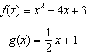

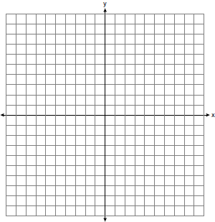

Based on your graph, state one value of x that satisfies . Explain your reasoning.

35 A store sells grapes for $1.99 per pound, strawberries for $2.50 per pound, and pineapples for $2.99 each. Jonathan has $25 to buy fruit. He plans to buy 2 more pounds of strawberries than grapes. He also plans to buy 2 pineapples. If x represents the number of pounds of grapes, write an inequality in one variable that models this scenario. Determine algebraically the maximum number of whole pounds of grapes he can buy.

36 Solve the system of inequalities graphically on the set of axes below. Label the solution set S.
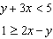

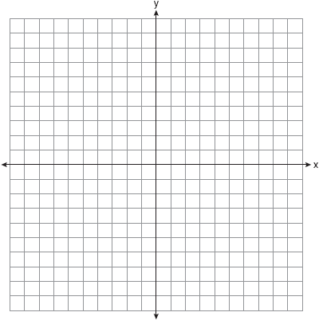

Is the point in the solution set? Explain your answer.

37 An ice cream shop sells small and large sundaes. One day, 30 small sundaes and 50 large sundaes were sold for $420. Another day, 15 small sundaes and 35 large sundaes were sold for $270. Sales tax is included in all prices. If x is the cost of a small sundae and y is the cost of a large sundae, write a system of equations to represent this situation. Peyton thinks that small sundaes cost $2.75 and large sundaes cost $6.75. Is Peyton correct? Justify your answer. Using your equations, determine algebraically the cost of one small sundae and the cost of one large sundae.
1 ANS: 3
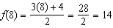

PTS: 2 REF: 082201ai NAT: F.IF.A.2 TOP: Functional Notation

2 ANS: 1
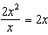

PTS: 2 REF: 082202ai NAT: F.IF.A.3 TOP: Sequences
KEY: difference or ratio

3 ANS: 3 PTS: 2 REF: 082203ai NAT: A.SSE.A.2
TOP: Factoring the Difference of Perfect Squares KEY: quadratic

4 ANS: 4 PTS: 2 REF: 082204ai NAT: F.IF.A.1
TOP: Defining Functions KEY: ordered pairs

5 ANS: 4
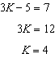

PTS: 2 REF: 082205ai NAT: A.REI.D.10 TOP: Identifying Solutions

6 ANS: 3 PTS: 2 REF: 082206ai NAT: A.APR.A.1
TOP: Operations with Polynomials KEY: multiplication

7 ANS: 3 PTS: 2 REF: 082207ai NAT: A.APR.B.3
TOP: Zeros of Polynomials

8 ANS: 1 PTS: 2 REF: 082208ai NAT: A.SSE.A.1
TOP: Modeling Expressions

9 ANS: 3 PTS: 2 REF: 082209ai NAT: F.BF.A.1
TOP: Modeling Exponential Functions

10 ANS: 1 PTS: 2 REF: 082210ai NAT: S.ID.A.1
TOP: Dot Plots

11 ANS: 4 PTS: 2 REF: 082211ai NAT: F.BF.B.3
TOP: Graphing Polynomial Functions

12 ANS: 2
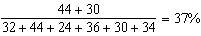

PTS: 2 REF: 082212ai NAT: S.ID.B.5 TOP: Frequency Tables
KEY: two-way

13 ANS: 2 PTS: 2 REF: 082213ai NAT: F.LE.A.1
TOP: Families of Functions

14 ANS: 2
1) 1; 2) -3; 3) -2; 4) -1

PTS: 2 REF: 082214ai NAT: F.IF.C.9 TOP: Comparing Functions

15 ANS: 1
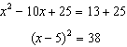

PTS: 2 REF: 082215ai NAT: A.REI.B.4 TOP: Solving Quadratics
KEY: completing the square

16 ANS: 2

PTS: 2 REF: 082216ai NAT: A.SSE.A.1 TOP: Modeling Expressions

17 ANS: 3
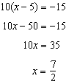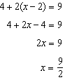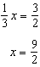

PTS: 2 REF: 082217ai NAT: A.REI.B.3 TOP: Solving Linear Equations

18 ANS: 4
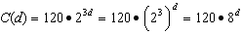

PTS: 2 REF: 082218ai NAT: A.SSE.B.3 TOP: Modeling Exponential Functions

19 ANS: 4 PTS: 2 REF: 082219ai NAT: A.REI.A.1
TOP: Identifying Properties

20 ANS: 1

PTS: 2 REF: 082220ai NAT: F.IF.A.3 TOP: Sequences
KEY: recursive

21 ANS: 2 PTS: 2 REF: 082221ai NAT: N.Q.A.1
TOP: Conversions

22 ANS: 2 PTS: 2 REF: 082222ai NAT: F.IF.A.2
TOP: Domain and Range

23 ANS: 1

PTS: 2 REF: 082223ai NAT: S.ID.C.8 TOP: Correlation Coefficient

24 ANS: 4
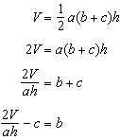

PTS: 2 REF: 082224ai NAT: A.CED.A.4 TOP: Transforming Formulas

25 ANS:
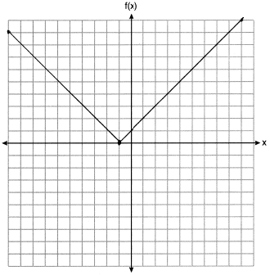

PTS: 2 REF: 082225ai NAT: F.IF.C.7 TOP: Graphing Absolute Value Functions

26 ANS:
Exponential, as the value decreases by about 47%/year.

PTS: 2 REF: 082226ai NAT: S.ID.B.6 TOP: Regression
KEY: choose model

27 ANS:
Rational, as , which is the ratio of two integers.

PTS: 2 REF: 082227ai NAT: N.RN.B.3 TOP: Operations with Radicals
KEY: classify

28 ANS:

PTS: 6 REF: 082228ai NAT: S.ID.A.2 TOP: Dispersion
KEY: basic

29 ANS:

PTS: 2 REF: 082229ai NAT: A.CED.A.2 TOP: Modeling Linear Equations

30 ANS:
translate 2 left

PTS: 2 REF: 082230ai NAT: F.BF.B.3 TOP: Graphing Polynomial Functions

31 ANS:
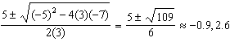

PTS: 2 REF: 082231ai NAT: A.REI.B.4 TOP: Solving Quadratics
KEY: quadratic formula

32 ANS:
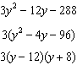

PTS: 2 REF: 082232ai NAT: A.SSE.A.2 TOP: Factoring Polynomials

33 ANS:
The bus stopped in the interval between D and E. The bus traveled the fastest in the interval between C and D at 60 mph. The average rate of speed was 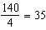 mph.

PTS: 4 REF: 082233ai NAT: F.IF.B.4 TOP: Relating Graphs to Events

34 ANS:
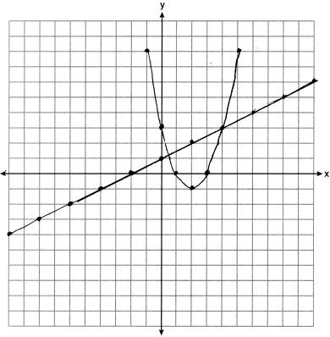At 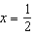, f intersects g.

PTS: 4 REF: 082234ai NAT: A.REI.D.11 TOP: Quadratic-Linear Systems

35 ANS:
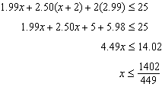 3 pounds of grapes

PTS: 4 REF: 082235ai NAT: A.CED.A.1 TOP: Modeling Linear Inequalities

36 ANS:
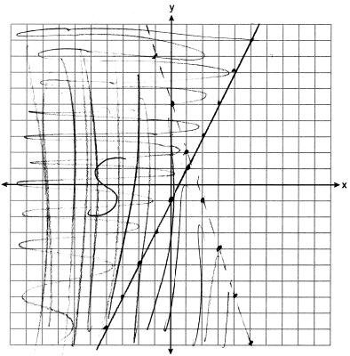 Yes, as 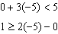

PTS: 4 REF: 082236ai NAT: A.REI.D.12 TOP: Graphing Systems of Linear Inequalities

37 ANS:
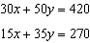 Peyton is wrong as . 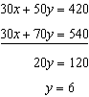 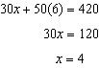

PTS: 6 REF: 082237ai NAT: A.CED.A.3 TOP: Modeling Linear Systems

