1 Bryan's hockey team is purchasing jerseys. The company charges $250 for a onetime set-up fee and $23 for each printed jersey. Which expression represents the total cost of x number of jerseys for the team?
1) |  | 3)
2) |  | 4)

2 Which table represents a function?
1) | 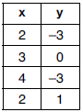 | 3) | 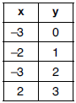
2) | 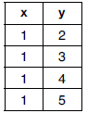 | 4) | 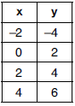

3 Which expression is equivalent to ?
1) |  | 3)
2) |  | 4)

4 The value of x that satisfies the equation 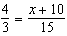 is
1) |  | 3) | 10
2) | 5 | 4) | 30

5 Josh graphed the function . He then graphed the function on the same coordinate plane. The vertex of is
1) | 7 units below the vertex of | 3) | 7 units to the right of the vertex of
2) | 7 units above the vertex of | 4) | 7 units to the left of the vertex of

6 A survey was given to 12th-grade students of West High School to determine the location for the senior class trip. The results are shown in the table below.
 | Niagara Falls | Darien Lake | New York City
Boys | 56 | 74 | 103
Girls | 71 | 92 | 88
To the nearest percent, what percent of the boys chose Niagara Falls?
1) | 12 | 3) | 44
2) | 24 | 4) | 56

7 Which type of function is shown in the graph below?

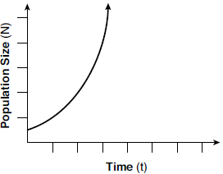
1) | linear | 3) | square root
2) | exponential | 4) | absolute value

8 The expression is equivalent to
1) |  | 3)
2) |  | 4)

9 The owner of a landscaping business wants to know how much time, on average, his workers spend mowing one lawn. Which is the most appropriate rate with which to calculate an answer to his question?
1) | lawns per employee | 3) | employee per lawns
2) | lawns per day | 4) | hours per lawn

10 A ball is thrown into the air from the top of a building. The height, , of the ball above the ground t seconds after it is thrown can be modeled by . How many seconds after being thrown will the ball hit the ground?
1) | 5 | 3) | 80
2) | 2 | 4) | 144

11 Which equation is equivalent to ?
1) |  | 3)
2) |  | 4)

12 When is expressed as a polynomial in standard form, which statement about the resulting polynomial is true?
1) | The constant term is 2. | 3) | The degree is 2.
2) | The leading coefficient is 2. | 4) | The number of terms is 2.

13 The population of a city can be modeled by , where is the population after t years. Which function is approximately equivalent to ?
1) |  | 3)
2) |  | 4)

14 The functions and are graphed on the set of axes below.
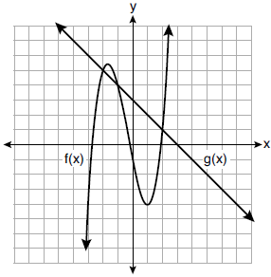
For which value of x is ?
1) |  | 3) | 3
2) | 2 | 4)

15 What is the range of the box plot shown below?
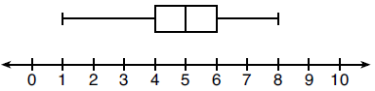
1) | 7 | 3) | 3
2) | 2 | 4) | 4

16 Which expression is not equivalent to ?
1) |  | 3)
2) |  | 4)

17 The quadratic functions and are given below.
x | r(x)
0
1 | 7

The function with the smaller minimum value is
1) | , and the value is | 3) | , and the value is
2) | , and the value is | 4) | , and the value is

18 A child is playing outside. The graph below shows the child's distance, , in yards from home over a period of time, t, in seconds.

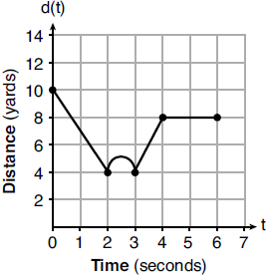

Which interval represents the child constantly moving closer to home?
1) |  | 3)
2) |  | 4)

19 If and , then equals
1) | 75 | 3) | 180
2) | 147 | 4) | 900

20 The length of a rectangular patio is 7 feet more than its width, w. The area of a patio, , can be represented by the function
1) |  | 3)
2) |  | 4)

21 A dolphin jumps out of the water and then back into the water. His jump could be graphed on a set of axes where x represents time and y represents distance above or below sea level. The domain for this graph is best represented using a set of
1) | integers | 3) | real numbers
2) | positive integers | 4) | positive real numbers

22 Which system of linear equations has the same solution as the one shown below?
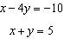
1) | 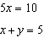 | 3) | 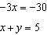
2) | 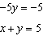 | 4) | 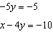

23 Which interval represents the range of the function ?
1) |  | 3)
2) |  | 4)

24 What is a common ratio of the geometric sequence whose first term is 5 and third term is 245?
1) | 7 | 3) | 120
2) | 49 | 4) | 240

25 If , determine .

26 A student is in the process of solving an equation. The original equation and the first step are shown below.
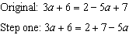
Which property did the student use for the first step? Explain why this property is correct.

27 On the set of axes below, graph the line whose equation is .
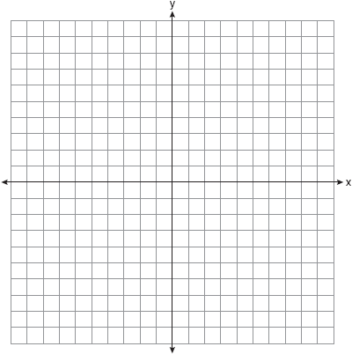

This linear equation contains the point . State the value of k.

28 The formula 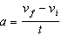 is used to calculate acceleration as the change in velocity over the period of time. Solve the formula for the final velocity, , in terms of initial velocity, , acceleration, a, and time, t.

29 Solve 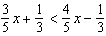 for x.

30 Is the product of two irrational numbers always irrational? Justify your answer.

31 Solve for the exact values of x.

32 Graph the function: 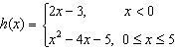

33 On the set of axes below, graph the following system of inequalities:
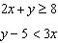

Determine if the point is in the solution set. Explain your answer.

34 On the day Alexander was born, his father invested $5000 in an account with a 1.2% annual growth rate. Write a function, , that represents the value of this investment t years after Alexander’s birth. Determine, to the nearest dollar, how much more the investment will be worth when Alexander turns 32 than when he turns 17.

35 Stephen collected data from a travel website. The data included a hotel's distance from Times Square in Manhattan and the cost of a room for one weekend night in August. A table containing these data appears below.

Distance From Times Square (city blocks) (x) | 0 | 0 | 1 | 1 | 3 | 4 | 7 | 11 | 14 | 19
Cost of a Room (dollars) (y) | 293 | 263 | 244 | 224 | 185 | 170 | 219 | 153 | 136 | 111

Write the linear regression equation for this data set. Round all values to the nearest hundredth. State the correlation coefficient for this data set, to the nearest hundredth. Explain what the sign of the correlation coefficient suggests in the context of the problem.

36 A snowstorm started at midnight. For the first 4 hours, it snowed at an average rate of one-half inch per hour. The snow then started to fall at an average rate of one inch per hour for the next 6 hours. Then it stopped snowing for 3 hours. Then it started snowing again at an average rate of one-half inch per hour for the next 4 hours until the storm was over. On the set of axes below, graph the amount of snow accumulated over the time interval of the storm.

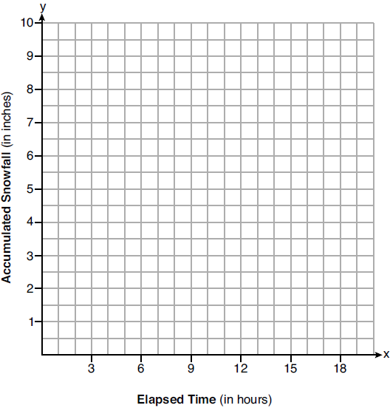

Determine the average rate of snowfall over the length of the storm. State the rate, to the nearest hundredth of an inch per hour.

37 Allysa spent $35 to purchase 12 chickens. She bought two different types of chickens. Americana chickens cost $3.75 each and Delaware chickens cost $2.50 each. Write a system of equations that can be used to determine the number of Americana chickens, A, and the number of Delaware chickens, D, she purchased. Determine algebraically how many of each type of chicken Allysa purchased. Each Americana chicken lays 2 eggs per day and each Delaware chicken lays 1 egg per day. Allysa only sells eggs by the full dozen for $2.50. Determine how much money she expects to take in at the end of the first week with her 12 chickens.
1 ANS: 3 PTS: 2 REF: 081901ai NAT: A.SSE.A.1
TOP: Modeling Expressions

2 ANS: 4 PTS: 2 REF: 081902ai NAT: F.IF.A.1
TOP: Defining Functions KEY: ordered pairs

3 ANS: 4

PTS: 2 REF: 081903ai NAT: A.APR.A.1 TOP: Operations with Polynomials
KEY: addition

4 ANS: 3
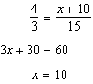

PTS: 2 REF: 081904ai NAT: A.REI.B.3 TOP: Solving Linear Equations
KEY: fractional expressions

5 ANS: 1

PTS: 2 REF: 081905ai NAT: F.BF.B.3 TOP: Graphing Polynomial Functions

6 ANS: 2
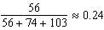

PTS: 2 REF: 081906ai NAT: S.ID.B.5 TOP: Frequency Tables
KEY: two-way

7 ANS: 2 PTS: 2 REF: 081907ai NAT: F.LE.A.1
TOP: Families of Functions

8 ANS: 3 PTS: 2 REF: 081908ai NAT: A.SSE.A.2
TOP: Factoring the Difference of Perfect Squares KEY: quadratic

9 ANS: 4 PTS: 2 REF: 081909ai NAT: N.Q.A.2
TOP: Using Rate

10 ANS: 1
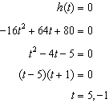

PTS: 2 REF: 081910ai NAT: F.IF.B.4 TOP: Graphing Quadratic Functions
KEY: context

11 ANS: 1
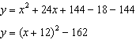

PTS: 2 REF: 081911ai NAT: F.IF.C.8 TOP: Vertex Form of a Quadratic

12 ANS: 2

PTS: 2 REF: 081912ai NAT: A.SSE.A.1 TOP: Modeling Expressions

13 ANS: 2

PTS: 2 REF: 081913ai NAT: A.SSE.B.3 TOP: Modeling Exponential Functions

14 ANS: 3 PTS: 2 REF: 081914ai NAT: A.REI.D.11
TOP: Other Systems

15 ANS: 1

PTS: 2 REF: 081915ai NAT: S.ID.A.1 TOP: Box Plots
KEY: interpret

16 ANS: 3

PTS: 2 REF: 081916ai NAT: A.SSE.A.2 TOP: Factoring Polynomials
KEY: quadratic

17 ANS: 3
The minimum of is . The minimum of is 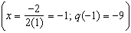.

PTS: 2 REF: 081917ai NAT: F.IF.C.9 TOP: Comparing Functions

18 ANS: 1 PTS: 2 REF: 081918ai NAT: F.IF.B.4
TOP: Relating Graphs to Events

19 ANS: 1

PTS: 2 REF: 081919ai NAT: F.IF.A.3 TOP: Sequences
KEY: recursive

20 ANS: 2

PTS: 2 REF: 081920ai NAT: A.CED.A.1 TOP: Geometric Applications of Quadratics

21 ANS: 4
Time is continuous and positive.

PTS: 2 REF: 081921ai NAT: F.IF.B.5 TOP: Domain and Range

22 ANS: 1
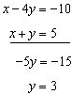 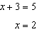 (1) 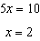 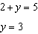

PTS: 2 REF: 081922ai NAT: A.REI.C.6 TOP: Solving Linear Systems

23 ANS: 4
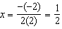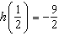

PTS: 2 REF: 081923ai NAT: F.IF.A.2 TOP: Domain and Range
KEY: real domain, quadratic

24 ANS: 1
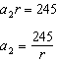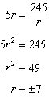

PTS: 2 REF: 081924ai NAT: F.IF.A.3 TOP: Sequences
KEY: difference or ratio

25 ANS:

PTS: 2 REF: 081925ai NAT: F.IF.A.2 TOP: Functional Notation

26 ANS:
Commutative, This property is correct because .

PTS: 2 REF: 081926ai NAT: A.REI.A.1 TOP: Identifying Properties

27 ANS:
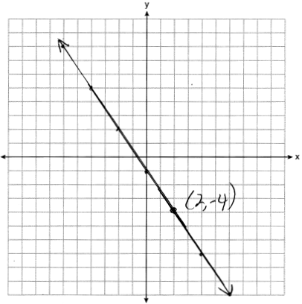

PTS: 2 REF: 081927ai NAT: F.IF.B.4 TOP: Graphing Linear Functions

28 ANS:
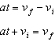

PTS: 2 REF: 081928ai NAT: A.CED.A.4 TOP: Transforming Formulas

29 ANS:
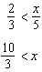

PTS: 2 REF: 081929ai NAT: A.REI.B.3 TOP: Solving Linear Inequalities

30 ANS:
No. The product of and , which are both irrational numbers, is , which is rational.

PTS: 2 REF: 081930ai NAT: N.RN.B.3 TOP: Operations with Radicals
KEY: classify

31 ANS:
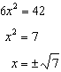

PTS: 2 REF: 081931ai NAT: A.REI.B.4 TOP: Solving Quadratics
KEY: taking square roots

32 ANS:
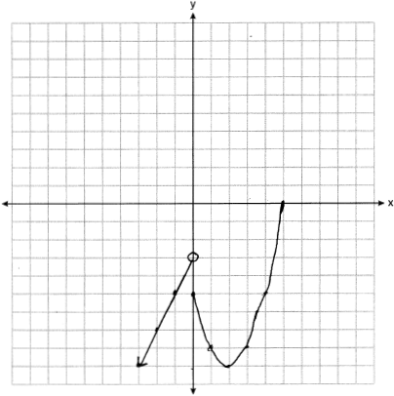

PTS: 2 REF: 081932ai NAT: F.IF.C.7 TOP: Graphing Piecewise-Defined Functions

33 ANS:
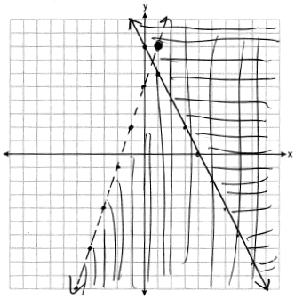 No, falls on the boundary line of , which is a strict inequality.

PTS: 4 REF: 081933ai NAT: A.REI.D.12 TOP: Graphing Systems of Linear Inequalities
KEY: graph

34 ANS:

PTS: 2 REF: 081934ai NAT: A.CED.A.1 TOP: Modeling Exponential Functions

35 ANS:
, As the distance from Times Square increases, the cost of a room decreases.

PTS: 4 REF: 081935ai NAT: S.ID.B.6 TOP: Regression
KEY: linear with correlation coefficient

36 ANS:
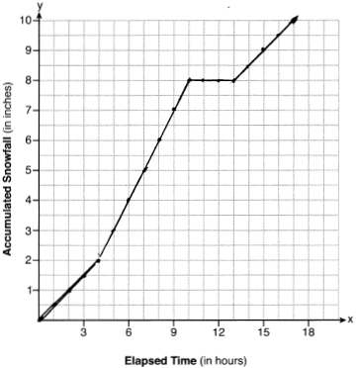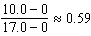

PTS: 4 REF: 081936ai NAT: F.IF.B.4 TOP: Relating Graphs to Events

37 ANS:
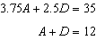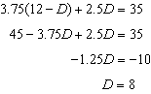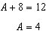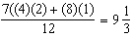

PTS: 6 REF: 081937ai NAT: A.CED.A.3 TOP: Modeling Linear Systems

