1 The number of bacteria grown in a lab can be modeled by , where t is the number of hours. Which expression is equivalent to ?
1) |  | 3)
2) |  | 4)

2 During physical education class, Andrew recorded the exercise times in minutes and heart rates in beats per minute (bpm) of four of his classmates. Which table best represents a linear model of exercise time and heart rate?
1) | 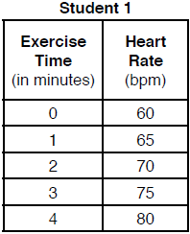 | 3) | 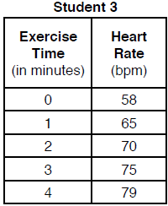
2) | 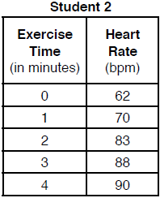 | 4) | 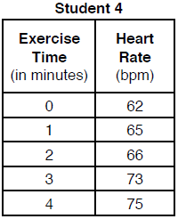

3 David correctly factored the expression . Which expression did he write?
1) |  | 3)
2) |  | 4)

4 The solution to is
1) |  | 3)
2) | 2 | 4)

5 The graph of is shown below.

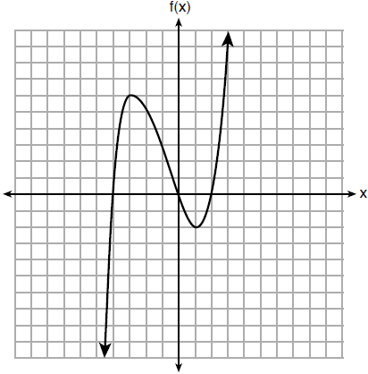

What is the value of ?
1) | 6 | 3)
2) | 2 | 4)

6 If the function has the domain , what is its range?
1) |  | 3)
2) |  | 4)

7 The expression is equivalent to
1) |  | 3)
2) |  | 4)

8 Compared to the graph of , the graph of is the result of translating
1) | 2 units up and 3 units right | 3) | 2 units right and 3 units up
2) | 2 units down and 3 units up | 4) | 2 units left and 3 units right

9 Lizzy has 30 coins that total $4.80. All of her coins are dimes, D, and quarters, Q. Which system of equations models this situation?
1) | 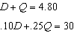 | 3) | 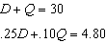
2) | 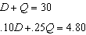 | 4) | 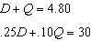

10 Gretchen has $50 that she can spend at the fair. Ride tickets cost $1.25 each and game tickets cost $2 each. She wants to go on a minimum of 10 rides and play at least 12 games. Which system of inequalities represents this situation when r is the number of ride tickets purchased and g is the number of game tickets purchased?
1) | 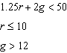 | 3) | 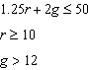
2) | 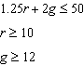 | 4) | 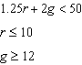

11 Three functions are shown below.
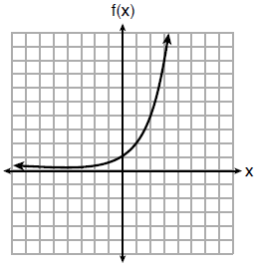

x | h(x)
 | 30
 | 14
 | 6
 | 2
 | 0
0
1
2

Which statement is true?
1) | The y-intercept for is greater than the y-intercept for . | 3) | The y-intercept for is greater than the y-intercept for both and .
2) | The y-intercept for is greater than the y-intercept for . | 4) | The y-intercept for is greater than the y-intercept for both and .

12 Olivia entered a baking contest. As part of the contest, she needs to demonstrate how to measure a gallon of milk if she only has a teaspoon measure. She converts the measurement using the ratios below:
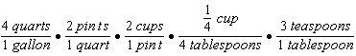
Which ratio is incorrectly written in Olivia's conversion?
1) | 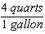 | 3) | 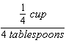
2) | 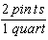 | 4) | 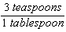

13 If and , which polynomial is equivalent to ?
1) |  | 3)
2) |  | 4)

14 An outdoor club conducted a survey of its members. The members were asked to state their preference between skiing and snowboarding. Each member had to pick one. Of the 60 males, 45 stated they preferred to snowboard. Twenty-two of the 60 females preferred to ski. What is the relative frequency that a male prefers to ski?
1) | 0.125 | 3)
2) | 0.25 | 4)

15 When the function 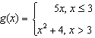 is graphed correctly, how should the points be drawn on the graph for an x-value of 3?
1) | open circles at and | 3) | an open circle at and a closed circle at
2) | closed circles at and | 4) | a closed circle at and an open circle at

16 If , which equation can be used to determine the zeros of the function?
1) |  | 3)
2) |  | 4)

17 Each day, a local dog shelter spends an average of $2.40 on food per dog. The manager estimates the shelter's daily expenses, assuming there is at least one dog in the shelter, using the function . Which statements regarding the function are correct?
I. x represents the number of dogs at the shelter per day.
II. x represents the number of volunteers at the shelter per day.
III. 30 represents the shelter's total expenses per day.
IV. 30 represents the shelter's nonfood expenses per day.
1) | I and III | 3) | II and III
2) | I and IV | 4) | II and IV

18 Which point is not in the solution set of the equation ?
1)
2)
3)
4)

19 The functions and are graphed below.

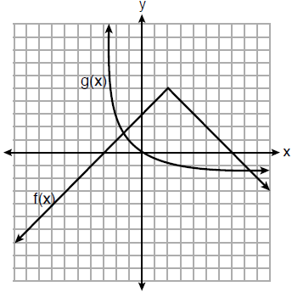

Based on the graph, the solutions to the equation are
1) | the x-intercepts | 3) | the x-values of the points of intersection
2) | the y-intercepts | 4) | the y-values of the points of intersection

20 For the sequence , the expression that defines the nth term where is
1) |  | 3)
2) |  | 4)

21 The data obtained from a random sample of track athletes showed that as the foot size of the athlete decreased, the average running speed decreased. Which statement is best supported by the data?
1) | Smaller foot sizes cause track athletes to run slower.
2) | The sample of track athletes shows a causal relationship between foot size and running speed.
3) | The sample of track athletes shows a correlation between foot size and running speed.
4) | There is no correlation between foot size and running speed in track athletes.

22 Which system of equations will yield the same solution as the system below?
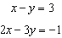
1) | 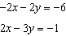 | 3) | 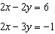
2) | 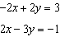 | 4) | 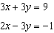

23 Which of the three situations given below is best modeled by an exponential function?
I. A bacteria culture doubles in size every day.
II. A plant grows by 1 inch every 4 days.
III. The population of a town declines by 5% every 3 years.
1) | I, only | 3) | I and II
2) | II, only | 4) | I and III

24 The length, width, and height of a rectangular box are represented by , , and , respectively. When the volume is expressed as a polynomial in standard form, what is the coefficient of the 2nd term?
1) |  | 3)
2) | 13 | 4) | 26

25 Explain how to determine the zeros of . State the zeros of the function.

26 Four relations are shown below.

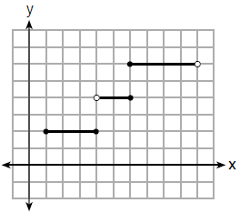
I

II

x | y
 | 1
0 | 3
4 | 5
6 | 6
III

IV

State which relation(s) are functions. Explain why the other relation(s) are not functions.

27 The table below represents the height of a bird above the ground during flight, with representing height in feet and t representing time in seconds.

t | P(t)
0 | 6.71
3 | 6.26
4 | 6
9 | 3.41

Calculate the average rate of change from 3 to 9 seconds, in feet per second.

28 Is the solution to the quadratic equation written below rational or irrational? Justify your answer.

29 The formula for converting degrees Fahrenheit (F) to degrees Kelvin (K) is:
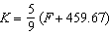
Solve for F, in terms of K.

30 Solve the following equation by completing the square:

31 The students in Mrs. Lankford's 4th and 6th period Algebra classes took the same test. The results of the scores are shown in the following table:

 |  |  | n | min |  | med |  | max
4th Period | 77.75 | 10.79 | 20 | 58 | 69 | 76.5 | 87.5 | 96
6th Period | 78.4 | 9.83 | 20 | 59 | 71.5 | 78 | 88 | 96

Based on these data, which class has the larger spread of test scores? Explain how you arrived at your answer.

32 Write the first five terms of the recursive sequence defined below.
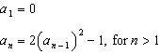

33 Sarah wants to buy a snowboard that has a total cost of $580, including tax. She has already saved $135 for it. At the end of each week, she is paid $96 for babysitting and is going to save three-quarters of that for the snowboard. Write an inequality that can be used to determine the minimum number of weeks Sarah needs to babysit to have enough money to purchase the snowboard. Determine and state the minimum number of full weeks Sarah needs to babysit to have enough money to purchase this snowboard.

34 A car was purchased for $25,000. Research shows that the car has an average yearly depreciation rate of 18.5%. Create a function that will determine the value, , of the car t years after purchase. Determine, to the nearest cent, how much the car will depreciate from year 3 to year 4.

35 Graph the following systems of inequalities on the set of axes below:
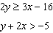

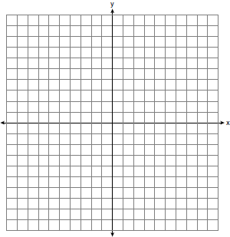

Based upon your graph, explain why is a solution to this system and why is not a solution to this system.

36 Paul plans to have a rectangular garden adjacent to his garage. He will use 36 feet of fence to enclose three sides of the garden. The area of the garden, in square feet, can be modeled by , where w is the width in feet. On the set of axes below, sketch the graph of .

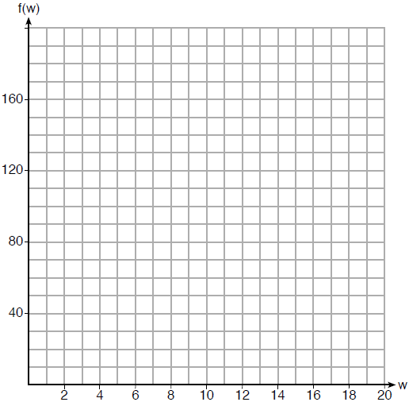

Explain the meaning of the vertex in the context of the problem.

37 At the present time, Mrs. Bee's age is six years more than four times her son's age. Three years ago, she was seven times as old as her son was then. If b represents Mrs. Bee's age now and s represents her son's age now, write a system of equations that could be used to model this scenario. Use this system of equations to determine, algebraically, the ages of both Mrs. Bee and her son now. Determine how many years from now Mrs. Bee will be three times as old as her son will be then.
1 ANS: 2 PTS: 2 REF: 081801ai NAT: A.SSE.B.3
TOP: Modeling Exponential Functions

2 ANS: 1 PTS: 2 REF: 081802ai NAT: S.ID.C.7
TOP: Modeling Linear Functions

3 ANS: 3 PTS: 2 REF: 081803ai NAT: A.SSE.A.2
TOP: Factoring Polynomials KEY: quadratic

4 ANS: 2
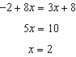

PTS: 2 REF: 081804ai NAT: A.REI.B.3 TOP: Solving Linear Equations
KEY: integral expressions

5 ANS: 1 PTS: 2 REF: 081805ai NAT: F.IF.A.2
TOP: Functional Notation

6 ANS: 2 PTS: 2 REF: 081806ai NAT: F.IF.A.2
TOP: Domain and Range KEY: limited domain

7 ANS: 3 PTS: 2 REF: 081807ai NAT: A.SSE.A.2
TOP: Factoring the Difference of Perfect Squares KEY: quadratic

8 ANS: 3 PTS: 2 REF: 081808ai NAT: F.BF.B.3
TOP: Graphing Polynomial Functions

9 ANS: 2 PTS: 2 REF: 081809ai NAT: A.CED.A.3
TOP: Modeling Linear Systems

10 ANS: 2 PTS: 2 REF: 081810ai NAT: A.CED.A.3
TOP: Modeling Systems of Linear Inequalities

11 ANS: 4
The y-intercept for is . The y-intercept for is . The y-intercept for is .

PTS: 2 REF: 081811ai NAT: F.IF.C.9 TOP: Comparing Functions

12 ANS: 3 PTS: 2 REF: 081812ai NAT: N.Q.A.1
TOP: Conversions KEY: dimensional analysis

13 ANS: 1

PTS: 2 REF: 081813ai NAT: A.APR.A.1 TOP: Operations with Polynomials
KEY: addition

14 ANS: 2
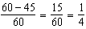

PTS: 2 REF: 081814ai NAT: S.ID.B.5 TOP: Frequency Tables
KEY: two-way

15 ANS: 4 PTS: 2 REF: 081815ai NAT: F.IF.C.7
TOP: Graphing Piecewise-Defined Functions

16 ANS: 2 PTS: 2 REF: 081816ai NAT: A.SSE.B.3
TOP: Solving Quadratics

17 ANS: 2 PTS: 2 REF: 081817ai NAT: F.LE.B.5
TOP: Modeling Linear Functions

18 ANS: 1
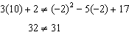

PTS: 2 REF: 081818ai NAT: A.REI.D.10 TOP: Identifying Solutions

19 ANS: 3 PTS: 2 REF: 081819ai NAT: A.REI.D.11
TOP: Other Systems KEY: AI

20 ANS: 4 PTS: 2 REF: 081820ai NAT: F.LE.A.2
TOP: Sequences

21 ANS: 3 PTS: 2 REF: 081821ai NAT: S.ID.C.9
TOP: Analysis of Data

22 ANS: 3
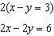

PTS: 2 REF: 081822ai NAT: A.REI.C.5 TOP: Solving Linear Systems

23 ANS: 4
II is linear.

PTS: 2 REF: 081823ai NAT: F.LE.A.1 TOP: Families of Functions

24 ANS: 3

PTS: 2 REF: 081824ai NAT: A.APR.A.1 TOP: Operations with Polynomials
KEY: multiplication

25 ANS:
Graph and find x-intercepts.

PTS: 2 REF: 081825ai NAT: A.APR.B.3 TOP: Zeros of Polynomials

26 ANS:
III and IV are functions. I, for , has two y-values. II, for , has two y-values.

PTS: 2 REF: 081826ai NAT: F.IF.A.1 TOP: Defining Functions
KEY: graphs

27 ANS:
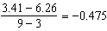

PTS: 2 REF: 081827ai NAT: F.IF.B.6 TOP: Rate of Change

28 ANS:
Irrational, as 89 is not a perfect square.

PTS: 2 REF: 081828ai NAT: A.REI.B.4 TOP: Using the Discriminant
KEY: AI

29 ANS:
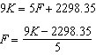

PTS: 2 REF: 081829ai NAT: A.CED.A.4 TOP: Transforming Formulas

30 ANS:
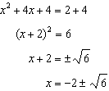

PTS: 2 REF: 081830ai NAT: A.REI.B.4 TOP: Solving Quadratics
KEY: completing the square

31 ANS:
4th because IQR and are greater for 4th Period.

PTS: 2 REF: 081831ai NAT: S.ID.A.2 TOP: Central Tendency and Dispersion

32 ANS:

PTS: 2 REF: 081832ai NAT: F.IF.A.3 TOP: Sequences
KEY: term

33 ANS:
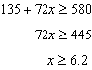 7

PTS: 4 REF: 081833ai NAT: A.CED.A.1 TOP: Modeling Linear Inequalities

34 ANS:

PTS: 4 REF: 081834ai NAT: A.CED.A.1 TOP: Modeling Exponential Functions

35 ANS:
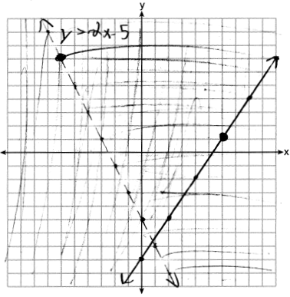 is on a solid line. is on a dashed line.

PTS: 4 REF: 081835ai NAT: A.REI.D.12 TOP: Graphing Systems of Linear Inequalities
KEY: graph

36 ANS:
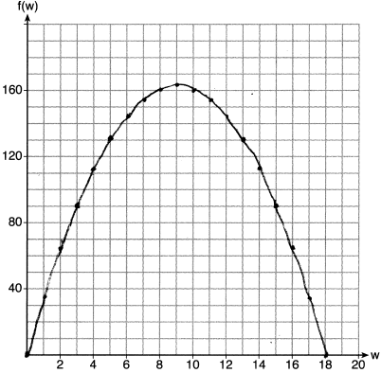 If the garden’s width is 9 ft, its area is 162 ft².

PTS: 4 REF: 081836ai NAT: F.IF.B.4 TOP: Graphing Quadratic Functions
KEY: context

37 ANS:
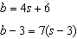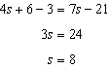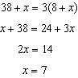

PTS: 6 REF: 081837ai NAT: A.CED.A.3 TOP: Modeling Linear Systems

