1 A part of Jennifer's work to solve the equation is shown below.
Given:
Step 1:
Which property justifies her first step?
1) | identity property of multiplication | 3) | commutative property of multiplication
2) | multiplication property of equality | 4) | distributive property of multiplication over subtraction

2 Which value of x results in equal outputs for and ?
1) |  | 3)
2) | 2 | 4) | 4

3 The expression is equivalent to
1) |  | 3)
2) |  | 4)

4 If 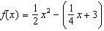, what is the value of ?
1) | 11 | 3) | 27
2) | 17 | 4) | 33

5 The graph below models the height of a remote-control helicopter over 20 seconds during flight.

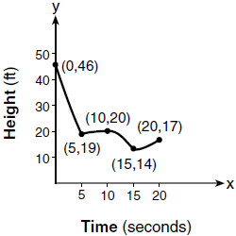

Over which interval does the helicopter have the slowest average rate of change?
1) | 0 to 5 seconds | 3) | 10 to 15 seconds
2) | 5 to 10 seconds | 4) | 15 to 20 seconds

6 In the functions and , k is a positive integer. If k is replaced by , which statement about these new functions is true?
1) | The graphs of both and become wider. | 3) | The graphs of both and shift vertically.
2) | The graph of becomes narrower and the graph of shifts left. | 4) | The graph of shifts left and the graph of becomes wider.

7 Wenona sketched the polynomial as shown on the axes below.

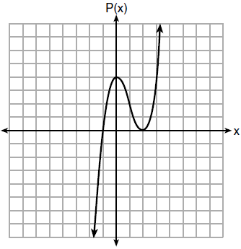

Which equation could represent ?
1) |  | 3)
2) |  | 4)

8 Which situation does not describe a causal relationship?
1) | The higher the volume on a radio, the louder the sound will be.
2) | The faster a student types a research paper, the more pages the paper will have.
3) | The shorter the distance driven, the less gasoline that will be used.
4) | The slower the pace of a runner, the longer it will take the runner to finish the race.

9 A plumber has a set fee for a house call and charges by the hour for repairs. The total cost of her services can be modeled by . Which statements about this function are true?
I. A house call fee costs $95.
II. The plumber charges $125 per hour.
III. The number of hours the job takes is represented by t.
1) | I and II, only | 3) | II and III, only
2) | I and III, only | 4) | I, II, and III

10 What is the domain of the relation shown below?
1) |  | 3)
2) |  | 4)

11 What is the solution to the inequality 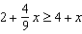?
1) | 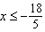 | 3) | 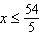
2) | 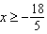 | 4) | 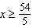

12 Konnor wants to burn 250 Calories while exercising for 45 minutes at the gym. On the treadmill, he can burn 6 Cal/min. On the stationary bike, he can burn 5 Cal/min. If t represents the number of minutes on the treadmill and b represents the number of minutes on the stationary bike, which expression represents the number of Calories that Konnor can burn on the stationary bike?
1) |  | 3)
2) |  | 4)

13 Which value of x satisfies the equation 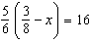?
1) |  | 3)
2) |  | 4)

14 If a population of 100 cells triples every hour, which function represents , the population after t hours?
1) |  | 3)
2) |  | 4)

15 A sequence of blocks is shown in the diagram below.

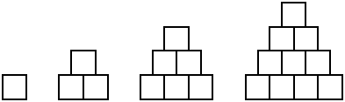

This sequence can be defined by the recursive function and . Assuming the pattern continues, how many blocks will there be when ?
1) | 13 | 3) | 28
2) | 21 | 4) | 36

16 Mario's $15,000 car depreciates in value at a rate of 19% per year. The value, V, after t years can be modeled by the function . Which function is equivalent to the original function?
1) |  | 3) | 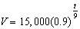
2) |  | 4) | 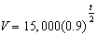

17 The highest possible grade for a book report is 100. The teacher deducts 10 points for each day the report is late. Which kind of function describes this situation?
1) | linear | 3) | exponential growth
2) | quadratic | 4) | exponential decay

18 The function , which is graphed below, and the function are given.

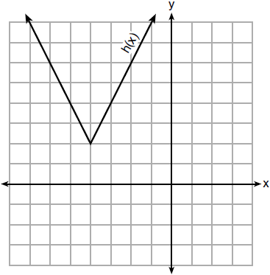

Which statements about these functions are true?
I. has a lower minimum value than .
II. For all values of x, .
III. For any value of x, .
1) | I and II, only | 3) | II and III, only
2) | I and III, only | 4) | I, II, and III

19 The zeros of the function are
1) |  | 3)
2) |  | 4)

20 How many of the equations listed below represent the line passing through the points and ?
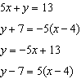
1) | 1 | 3) | 3
2) | 2 | 4) | 4

21 The Ebola virus has an infection rate of 11% per day as compared to the SARS virus, which has a rate of 4% per day. If there were one case of Ebola and 30 cases of SARS initially reported to authorities and cases are reported each day, which statement is true?
1) | At day 10 and day 53 there are more Ebola cases. | 3) | At day 10 there are more SARS cases, but at day 53 there are more Ebola cases.
2) | At day 10 and day 53 there are more SARS cases. | 4) | At day 10 there are more Ebola cases, but at day 53 there are more SARS cases.

22 The results of a linear regression are shown below.
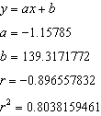
Which phrase best describes the relationship between x and y?
1) | strong negative correlation | 3) | weak negative correlation
2) | strong positive correlation | 4) | weak positive correlation

23 Abigail's and Gina's ages are consecutive integers. Abigail is younger than Gina and Gina's age is represented by x. If the difference of the square of Gina's age and eight times Abigail's age is 17, which equation could be used to find Gina's age?
1) |  | 3)
2) |  | 4)

24 Which system of equations does not have the same solution as the system below?
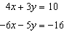
1) | 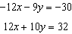 | 3) | 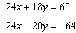
2) | 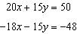 | 4) | 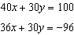

25 A teacher wrote the following set of numbers on the board:
Explain why is irrational, but is rational.

26 Determine and state whether the sequence displays exponential behavior. Explain how you arrived at your decision.

27 Using the formula for the volume of a cone, express r in terms of V, h, and .

28 The graph below models the cost of renting video games with a membership in Plan A and Plan B.

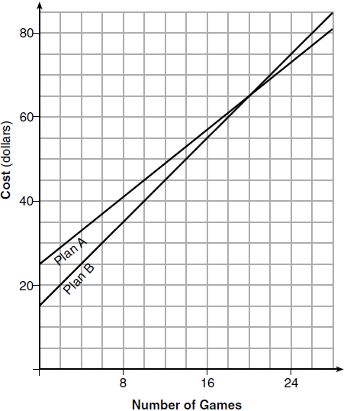

Explain why Plan B is the better choice for Dylan if he only has $50 to spend on video games, including a membership fee. Bobby wants to spend $65 on video games, including a membership fee. Which plan should he choose? Explain your answer.

29 Samantha purchases a package of sugar cookies. The nutrition label states that each serving size of 3 cookies contains 160 Calories. Samantha creates the graph below showing the number of cookies eaten and the number of Calories consumed.

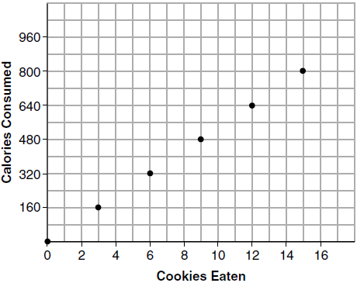

Explain why it is appropriate for Samantha to draw a line through the points on the graph.

30 A two-inch-long grasshopper can jump a horizontal distance of 40 inches. An athlete, who is five feet nine, wants to cover a distance of one mile by jumping. If this person could jump at the same ratio of body-length to jump-length as the grasshopper, determine, to the nearest jump, how many jumps it would take this athlete to jump one mile.

31 Write the expression as a polynomial in standard form.

32 Solve the equation by completing the square.

33 Loretta and her family are going on vacation. Their destination is 610 miles from their home. Loretta is going to share some of the driving with her dad. Her average speed while driving is 55 mph and her dad's average speed while driving is 65 mph. The plan is for Loretta to drive for the first 4 hours of the trip and her dad to drive for the remainder of the trip. Determine the number of hours it will take her family to reach their destination. After Loretta has been driving for 2 hours, she gets tired and asks her dad to take over. Determine, to the nearest tenth of an hour, how much time the family will save by having Loretta's dad drive for the remainder of the trip.

34 The heights, in feet, of former New York Knicks basketball players are listed below.
6.4 6.9 6.3 6.2 6.3 6.0 6.1 6.3 6.8 6.2
6.5 7.1 6.4 6.3 6.5 6.5 6.4 7.0 6.4 6.3
6.2 6.3 7.0 6.4 6.5 6.5 6.5 6.0 6.2
Using the heights given, complete the frequency table below.

Interval | Frequency
6.0-6.1
6.2-6.3
6.4-6.5
6.6-6.7
6.8-6.9
7.0-7.1

Based on the frequency table created, draw and label a frequency histogram on the grid below.



Determine and state which interval contains the upper quartile. Justify your response.

35 Solve the following system of inequalities graphically on the grid below and label the solution S.
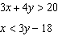



Is the point in the solution set? Explain your answer.

36 An Air Force pilot is flying at a cruising altitude of 9000 feet and is forced to eject from her aircraft. The function models the height, in feet, of the pilot above the ground, where t is the time, in seconds, after she is ejected from the aircraft. Determine and state the vertex of . Explain what the second coordinate of the vertex represents in the context of the problem. After the pilot was ejected, what is the maximum number of feet she was above the aircraft's cruising altitude? Justify your answer.

37 Zeke and six of his friends are going to a baseball game. Their combined money totals $28.50. At the game, hot dogs cost $1.25 each, hamburgers cost $2.50 each, and sodas cost $0.50 each. Each person buys one soda. They spend all $28.50 on food and soda. Write an equation that can determine the number of hot dogs, x, and hamburgers, y, Zeke and his friends can buy. Graph your equation on the grid below.



Determine how many different combinations, including those combinations containing zero, of hot dogs and hamburgers Zeke and his friends can buy, spending all $28.50. Explain your answer.
1 ANS: 4 PTS: 2 REF: 081701ai NAT: A.REI.A.1
TOP: Identifying Properties

2 ANS: 2
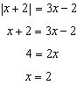

PTS: 2 REF: 081702ai NAT: A.REI.D.11 TOP: Other Systems
KEY: AI

3 ANS: 3 PTS: 2 REF: 081703ai NAT: A.SSE.A.2
TOP: Factoring the Difference of Perfect Squares KEY: quadratic

4 ANS: 3
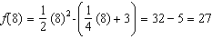

PTS: 2 REF: 081704ai NAT: F.IF.A.2 TOP: Functional Notation

5 ANS: 2
The slope of a line connecting and is lowest.

PTS: 2 REF: 081705ai NAT: F.IF.B.6 TOP: Rate of Change
KEY: AI

6 ANS: 1 PTS: 2 REF: 081706ai NAT: F.BF.B.3
TOP: Graphing Polynomial Functions

7 ANS: 1 PTS: 2 REF: 081707ai NAT: A.APR.B.3
TOP: Zeros of Polynomials KEY: AI

8 ANS: 2 PTS: 2 REF: 081708ai NAT: S.ID.C.9
TOP: Analysis of Data

9 ANS: 4 PTS: 2 REF: 081709ai NAT: F.LE.B.5
TOP: Modeling Linear Functions

10 ANS: 1 PTS: 2 REF: 081710ai NAT: F.IF.A.2
TOP: Domain and Range KEY: limited domain

11 ANS: 1
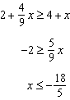

PTS: 2 REF: 081711ai NAT: A.REI.B.3 TOP: Solving Linear Inequalities

12 ANS: 2 PTS: 2 REF: 081712ai NAT: A.SSE.A.1
TOP: Modeling Expressions

13 ANS: 2
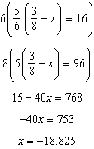

PTS: 2 REF: 081713ai NAT: A.REI.B.3 TOP: Solving Linear Equations
KEY: fractional expressions

14 ANS: 2 PTS: 2 REF: 081714ai NAT: F.LE.A.2
TOP: Families of Functions KEY: AI

15 ANS: 3
1, 3, 6, 10, 15, 21, 28, ...

PTS: 2 REF: 081715ai NAT: F.IF.A.3 TOP: Sequences
KEY: term

16 ANS: 2

PTS: 2 REF: 081716ai NAT: A.SSE.B.3 TOP: Modeling Exponential Functions

17 ANS: 1 PTS: 2 REF: 081717ai NAT: F.LE.A.1
TOP: Families of Functions

18 ANS: 2
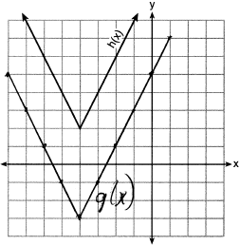

PTS: 2 REF: 081718ai NAT: F.IF.C.9 TOP: Comparing Functions

19 ANS: 3
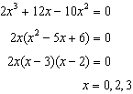

PTS: 2 REF: 081719ai NAT: A.APR.B.3 TOP: Zeros of Polynomials

20 ANS: 3
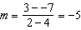 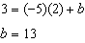 represents the line passing through the points and . The fourth equation may be rewritten as , so is a different line.

PTS: 2 REF: 081720ai NAT: A.REI.D.10 TOP: Writing Linear Equations
KEY: other forms

21 ANS: 3
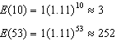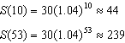

PTS: 2 REF: 081721ai NAT: F.LE.A.2 TOP: Modeling Exponential Functions

22 ANS: 1 PTS: 2 REF: 081722ai NAT: S.ID.C.8
TOP: Correlation Coefficient

23 ANS: 4 PTS: 2 REF: 081723ai NAT: A.CED.A.1
TOP: Modeling Quadratics

24 ANS: 4

PTS: 2 REF: 081724ai NAT: A.REI.C.5 TOP: Solving Linear Systems

25 ANS:
is irrational because it cannot be written as the ratio of two integers. is rational because it can be written as the ratio of two integers, .

PTS: 2 REF: 081725ai NAT: N.RN.B.3 TOP: Operations with Radicals
KEY: classify

26 ANS:
Yes, because the sequence has a common ratio, 3.

PTS: 2 REF: 081726ai NAT: F.LE.A.1 TOP: Families of Functions

27 ANS:
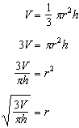

PTS: 2 REF: 081727ai NAT: A.CED.A.4 TOP: Transforming Formulas

28 ANS:
Plan A: , Plan B: . 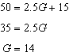 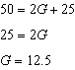 With Plan B, Dylan can rent 14 games, but with Plan A, Dylan can buy only 12. Bobby can choose either plan, as he could rent 20 games for $65 with both plans.

PTS: 2 REF: 081728ai NAT: A.CED.A.3 TOP: Modeling Linear Systems

29 ANS:
The data is continuous, i.e. a fraction of a cookie may be eaten.

PTS: 2 REF: 081729ai NAT: F.IF.B.4 TOP: Graphing Linear Functions

30 ANS:
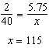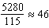

PTS: 2 REF: 081730ai NAT: N.Q.A.2 TOP: Using Rate

31 ANS:

PTS: 2 REF: 081731ai NAT: A.APR.A.1 TOP: Operations with Polynomials
KEY: multiplication

32 ANS:
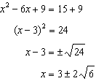

PTS: 2 REF: 081732ai NAT: A.REI.B.4 TOP: Solving Quadratics
KEY: completing the square

33 ANS:
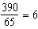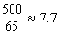

PTS: 4 REF: 081733ai NAT: A.CED.A.2 TOP: Speed

34 ANS:
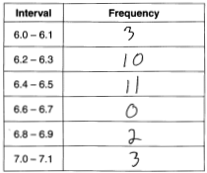 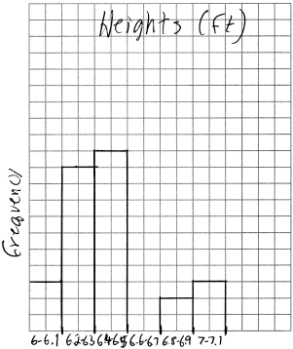 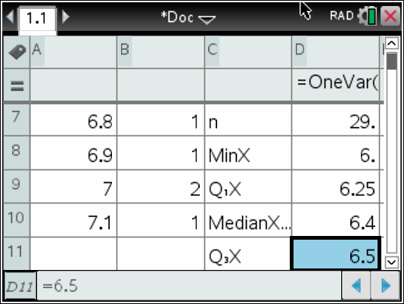 6.4-6.5

PTS: 4 REF: 081734ai NAT: S.ID.A.1 TOP: Frequency Histograms
KEY: frequency histograms

35 ANS:
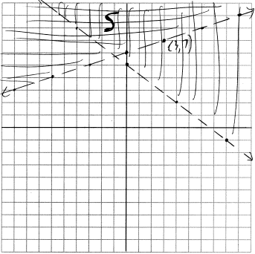 No, is on the boundary line, and not included in the solution set, because this is a strict inequality.

PTS: 4 REF: 081735ai NAT: A.REI.D.12 TOP: Graphing Systems of Linear Inequalities
KEY: graph

36 ANS:
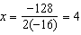 . The y coordinate represents the pilot’s height above the ground after ejection.

PTS: 4 REF: 081736ai NAT: F.IF.B.4 TOP: Graphing Quadratic Functions
KEY: context

37 ANS:
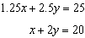 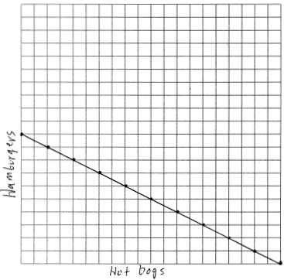 There are 11 combinations, as each dot represents a possible combination.

PTS: 6 REF: 081737ai NAT: A.REI.C.6 TOP: Graphing Linear Systems

