1 The graph below shows the distance in miles, m, hiked from a camp in h hours.

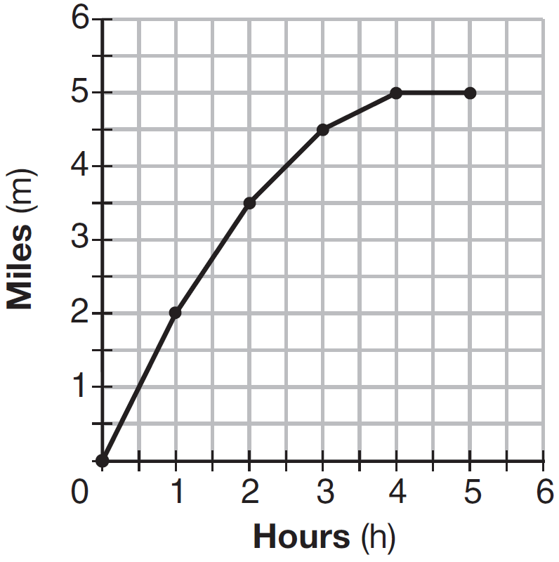

Which hourly interval had the greatest rate of change?
1) | hour 0 to hour 1 | 3) | hour 2 to hour 3
2) | hour 1 to hour 2 | 4) | hour 3 to hour 4

2 The solution of an equation with two variables, x and y, is
1) | the set of all x values that make | 3) | the set of all ordered pairs, , that make the equation true
2) | the set of all y values that make | 4) | the set of all ordered pairs, , where the graph of the equation crosses the y-axis

3 Which statistic can not be determined from a box plot representing the scores on a math test in Mrs. DeRidder's algebra class?
1) | the lowest score | 3) | the highest score
2) | the median score | 4) | the score that occurs most frequently

4 Which chart could represent the function ?
1) | 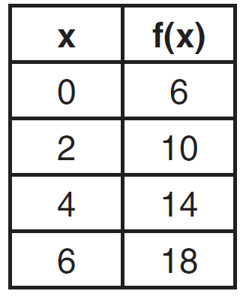 | 3) | 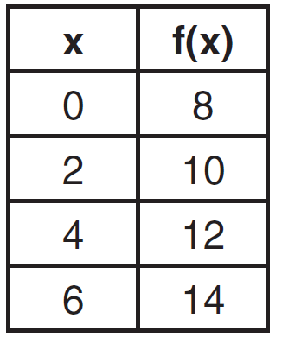
2) | 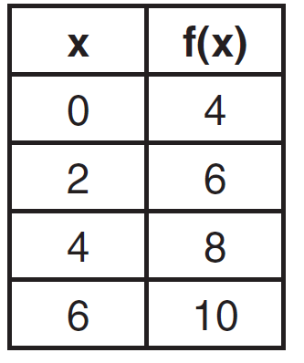 | 4) | 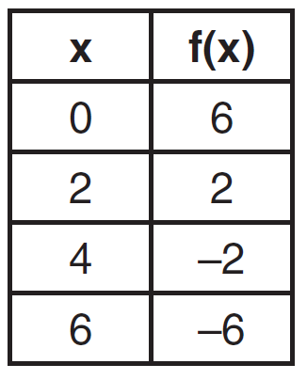

5 If , which statement is true?
1) |  | 3)
2) |  | 4)

6 The table below shows 6 students' overall averages and their averages in their math class.

Overall Student Average | 92 | 98 | 84 | 80 | 75 | 82
Math Class  Average | 91 | 95 | 85 | 85 | 75 | 78

If a linear model is applied to these data, which statement best describes the correlation coefficient?
1) | It is close to . | 3) | It is close to 0.
2) | It is close to 1. | 4) | It is close to 0.5.

7 What is the solution to
1) |  | 3)
2) | 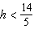 | 4) | 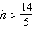

8 Which expression is equivalent to ?
1) |  | 3)
2) |  | 4)

9 Patricia is trying to compare the average rainfall of New York to that of Arizona. A comparison between these two states for the months of July through September would be best measured in
1) | feet per hour | 3) | inches per month
2) | inches per hour | 4) | feet per month

10 Which function defines the sequence , where ?
1) |  | 3)
2) |  | 4)

11 Which function has the greatest y-intercept?
1) |  | 3) | the line that has a slope of 2 and passes through
2) |  | 4) | 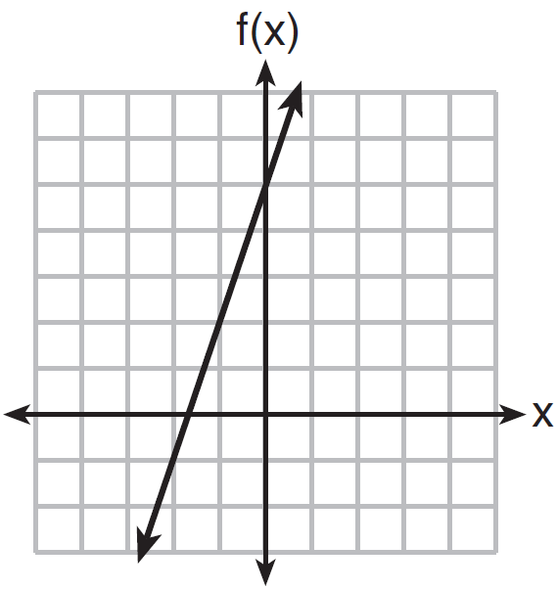

12 What is the product of and ?
1) |  | 3)
2) |  | 4)

13 The height of a rocket, at selected times, is shown in the table below.

Time (sec) | 0 | 1 | 2 | 3 | 4 | 5 | 6 | 7
Height (ft) | 180 | 260 | 308 | 324 | 308 | 260 | 180 | 68

Based on these data, which statement is not a valid conclusion?
1) | The rocket was launched from a height of 180 feet. | 3) | The rocket was in the air approximately 6 seconds before hitting the ground.
2) | The maximum height of the rocket occurred 3 seconds after launch. | 4) | The rocket was above 300 feet for approximately 2 seconds.

14 A parking garage charges a base rate of $3.50 for up to 2 hours, and an hourly rate for each additional hour. The sign below gives the prices for up to 5 hours of parking.

Parking Rates
2 hours | $3.50
3 hours | $9.00
4 hours | $14.50
5 hours | $20.00

Which linear equation can be used to find x, the additional hourly parking rate?
1) |  | 3)
2) |  | 4)

15 Which function has a constant rate of change equal to ?
1) | 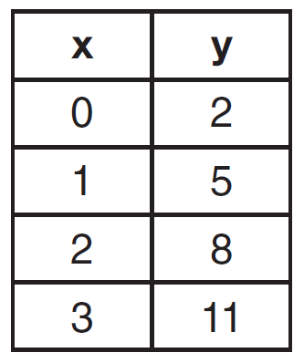 | 3) | 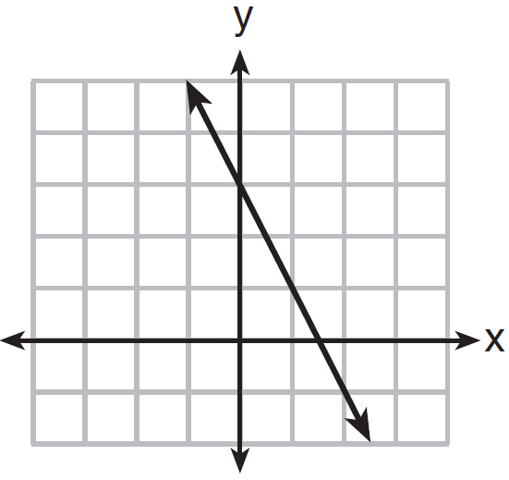
2) |  | 4)

16 Kendal bought x boxes of cookies to bring to a party. Each box contains 12 cookies. She decides to keep two boxes for herself. She brings 60 cookies to the party. Which equation can be used to find the number of boxes, x, Kendal bought?
1) |  | 3)
2) |  | 4)

17 The table below shows the temperature, , of a cup of hot chocolate that is allowed to chill over several minutes, m.

Time, m (minutes) | 0 | 2 | 4 | 6 | 8
Temperature, T(m)  (ºF) | 150 | 108 | 78 | 56 | 41

Which expression best fits the data for ?
1) |  | 3)
2) |  | 4)

18 As x increases beyond 25, which function will have the largest value?
1) |  | 3)
2) |  | 4)

19 What are the solutions to the equation ?
1) | and | 3) | and
2) | and 4 | 4) | and 2

20 An online company lets you download songs for $0.99 each after you have paid a $5 membership fee. Which domain would be most appropriate to calculate the cost to download songs?
1) | rational numbers greater than zero | 3) | integers less than or equal to zero
2) | whole numbers greater than or equal to one | 4) | whole numbers less than or equal to one

21 The function can be written in vertex form as
1) |  | 3)
2) |  | 4)

22 A system of equations is given below.
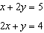
Which system of equations does not have the same solution?
1) | 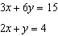 | 3) | 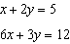
2) | 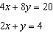 | 4) | 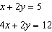

23 Based on the graph below, which expression is a possible factorization of ?

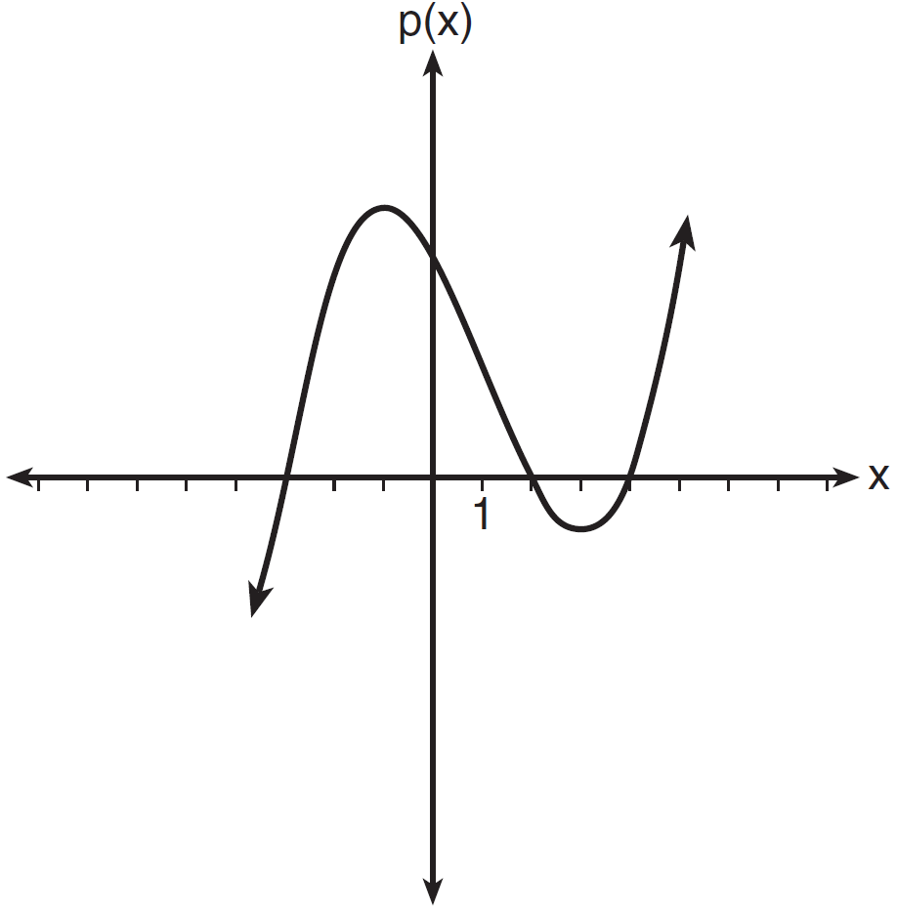
1) |  | 3)
2) |  | 4)

24 Milton has his money invested in a stock portfolio. The value, , of his portfolio can be modeled with the function , where x is the number of years since he made his investment. Which statement describes the rate of change of the value of his portfolio?
1) | It decreases 78% per year. | 3) | It increases 78% per year.
2) | It decreases 22% per year. | 4) | It increases 22% per year.

25 Graph the function on the set of axes below.

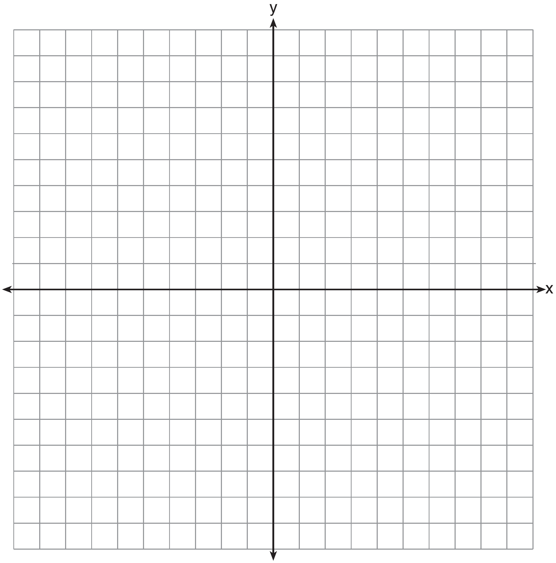

26 Richard is asked to transform the graph of below.

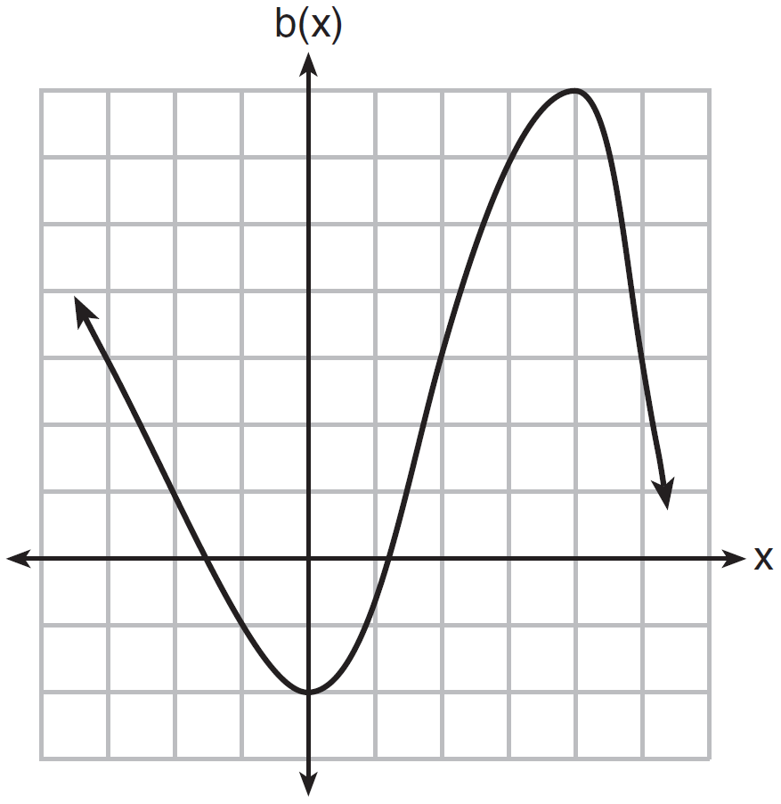

The graph of is transformed using the equation . Describe how the graph of changed to form the graph of .

27 Consider the pattern of squares shown below:

Which type of model, linear or exponential, should be used to determine how many squares are in the nth pattern? Explain your answer.

28 When multiplying polynomials for a math assignment, Pat found the product to be . He then had to state the leading coefficient of this polynomial. Pat wrote down . Do you agree with Pat's answer? Explain your reasoning.

29 Is the sum of and rational or irrational? Explain your answer.

30 The graph below shows two functions, and . State all the values of x for which .

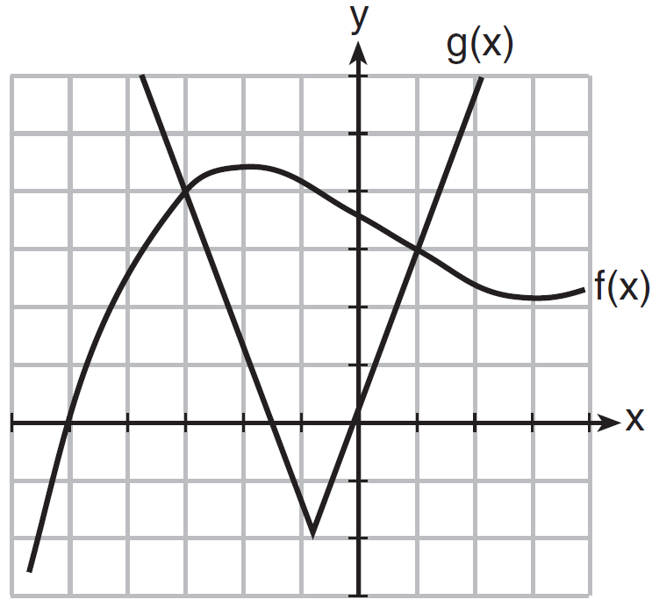

31 Find the zeros of , algebraically.

32 Solve the equation below for x in terms of a.

33 The data table below shows the median diameter of grains of sand and the slope of the beach for 9 naturally occurring ocean beaches.

Median Diameter of  Grains of Sand,  in Millimeters (x) | 0.17 | 0.19 | 0.22 | 0.235 | 0.235 | 0.3 | 0.35 | 0.42 | 0.85
Slope of Beach,  in Degrees (y) | 0.63 | 0.7 | 0.82 | 0.88 | 1.15 | 1.5 | 4.4 | 7.3 | 11.3

Write the linear regression equation for this set of data, rounding all values to the nearest thousandth. Using this equation, predict the slope of a beach, to the nearest tenth of a degree, on a beach with grains of sand having a median diameter of 0.65 mm.

34 Shawn incorrectly graphed the inequality as shown below.

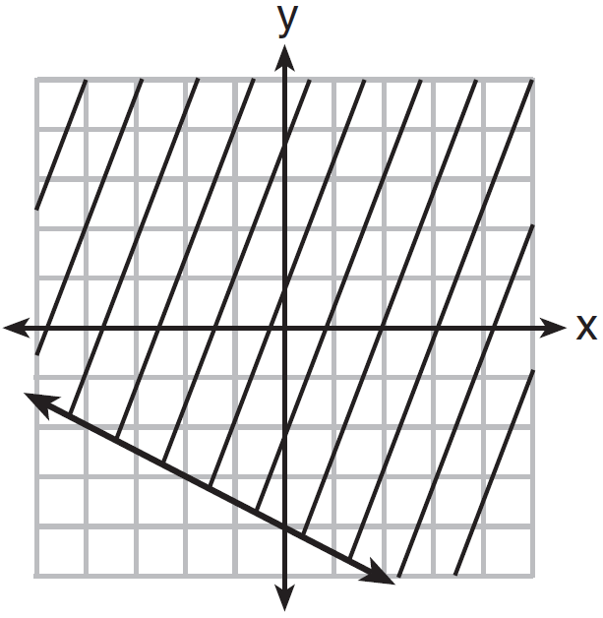

Explain Shawn's mistake. Graph the inequality correctly on the set of axes below.

35 A drama club is selling tickets to the spring musical. The auditorium holds 200 people. Tickets cost $12 at the door and $8.50 if purchased in advance. The drama club has a goal of selling at least $1000 worth of tickets to Saturday's show. Write a system of inequalities that can be used to model this scenario. If 50 tickets are sold in advance, what is the minimum number of tickets that must be sold at the door so that the club meets its goal? Justify your answer.

36 Janice is asked to solve . She begins the problem by writing the following steps:
Line 1
Line 2
Line 3
Use Janice's procedure to solve the equation for x. Explain the method Janice used to solve the quadratic equation.

37 For a class picnic, two teachers went to the same store to purchase drinks. One teacher purchased 18 juice boxes and 32 bottles of water, and spent $19.92. The other teacher purchased 14 juice boxes and 26 bottles of water, and spent $15.76. Write a system of equations to represent the costs of a juice box, j, and a bottle of water, w. Kara said that the juice boxes might have cost 52 cents each and that the bottles of water might have cost 33 cents each. Use your system of equations to justify that Kara's prices are not possible. Solve your system of equations to determine the actual cost, in dollars, of each juice box and each bottle of water.
1 ANS: 1
The graph is steepest between hour 0 and hour 1.

PTS: 2 REF: 081601ai NAT: F.IF.B.6 TOP: Rate of Change
KEY: AI

2 ANS: 3 PTS: 2 REF: 081602ai NAT: A.REI.D.10
TOP: Identifying Solutions

3 ANS: 4 PTS: 2 REF: 081603ai NAT: S.ID.A.1
TOP: Box Plots KEY: interpret

4 ANS: 4 PTS: 2 REF: 081604ai NAT: F.LE.A.2
TOP: Modeling Linear Functions

5 ANS: 2

PTS: 2 REF: 081605ai NAT: F.IF.A.2 TOP: Functional Notation

6 ANS: 2

PTS: 2 REF: 081606ai NAT: S.ID.C.8 TOP: Correlation Coefficient

7 ANS: 1
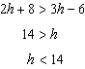

PTS: 2 REF: 081607ai NAT: A.REI.B.3 TOP: Solving Linear Inequalities

8 ANS: 2

PTS: 2 REF: 081608ai NAT: A.SSE.A.2
TOP: Factoring the Difference of Perfect Squares KEY: quadratic

9 ANS: 3 PTS: 2 REF: 081609ai NAT: N.Q.A.2
TOP: Using Rate

10 ANS: 1 PTS: 2 REF: 081610ai NAT: F.LE.A.2
TOP: Sequences

11 ANS: 4
1) ; 2) ; 3) ; 4)

PTS: 2 REF: 081611ai NAT: F.IF.C.9 TOP: Comparing Functions
KEY: AI

12 ANS: 3

PTS: 2 REF: 081612ai NAT: A.APR.A.1 TOP: Operations with Polynomials
KEY: multiplication

13 ANS: 3
The rocket was in the air more than 7 seconds before hitting the ground.

PTS: 2 REF: 081613ai NAT: F.IF.B.4 TOP: Graphing Quadratic Functions
KEY: context

14 ANS: 3 PTS: 2 REF: 081614ai NAT: A.CED.A.1
TOP: Modeling Linear Equations

15 ANS: 4
1) ; 2) 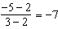; 3) ; 4)

PTS: 2 REF: 081615ai NAT: F.IF.B.6 TOP: Rate of Change

16 ANS: 3 PTS: 2 REF: 081616ai NAT: A.CED.A.1
TOP: Modeling Linear Equations

17 ANS: 1 PTS: 2 REF: 081617ai NAT: F.LE.A.2
TOP: Modeling Exponential Functions KEY: AI

18 ANS: 1 PTS: 2 REF: 081618ai NAT: F.LE.A.3
TOP: Families of Functions

19 ANS: 1
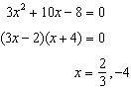

PTS: 2 REF: 081619ai NAT: A.REI.B.4 TOP: Solving Quadratics
KEY: factoring

20 ANS: 2 PTS: 2 REF: 081620ai NAT: F.IF.B.5
TOP: Domain and Range

21 ANS: 3
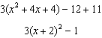

PTS: 2 REF: 081621ai NAT: F.IF.C.8 TOP: Vertex Form of a Quadratic

22 ANS: 4 PTS: 2 REF: 081622ai NAT: A.REI.C.5
TOP: Solving Linear Systems

23 ANS: 1 PTS: 2 REF: 081623ai NAT: A.APR.B.3
TOP: Zeros of Polynomials KEY: AI

24 ANS: 2 PTS: 2 REF: 081624ai NAT: F.LE.B.5
TOP: Modeling Exponential Functions

25 ANS:
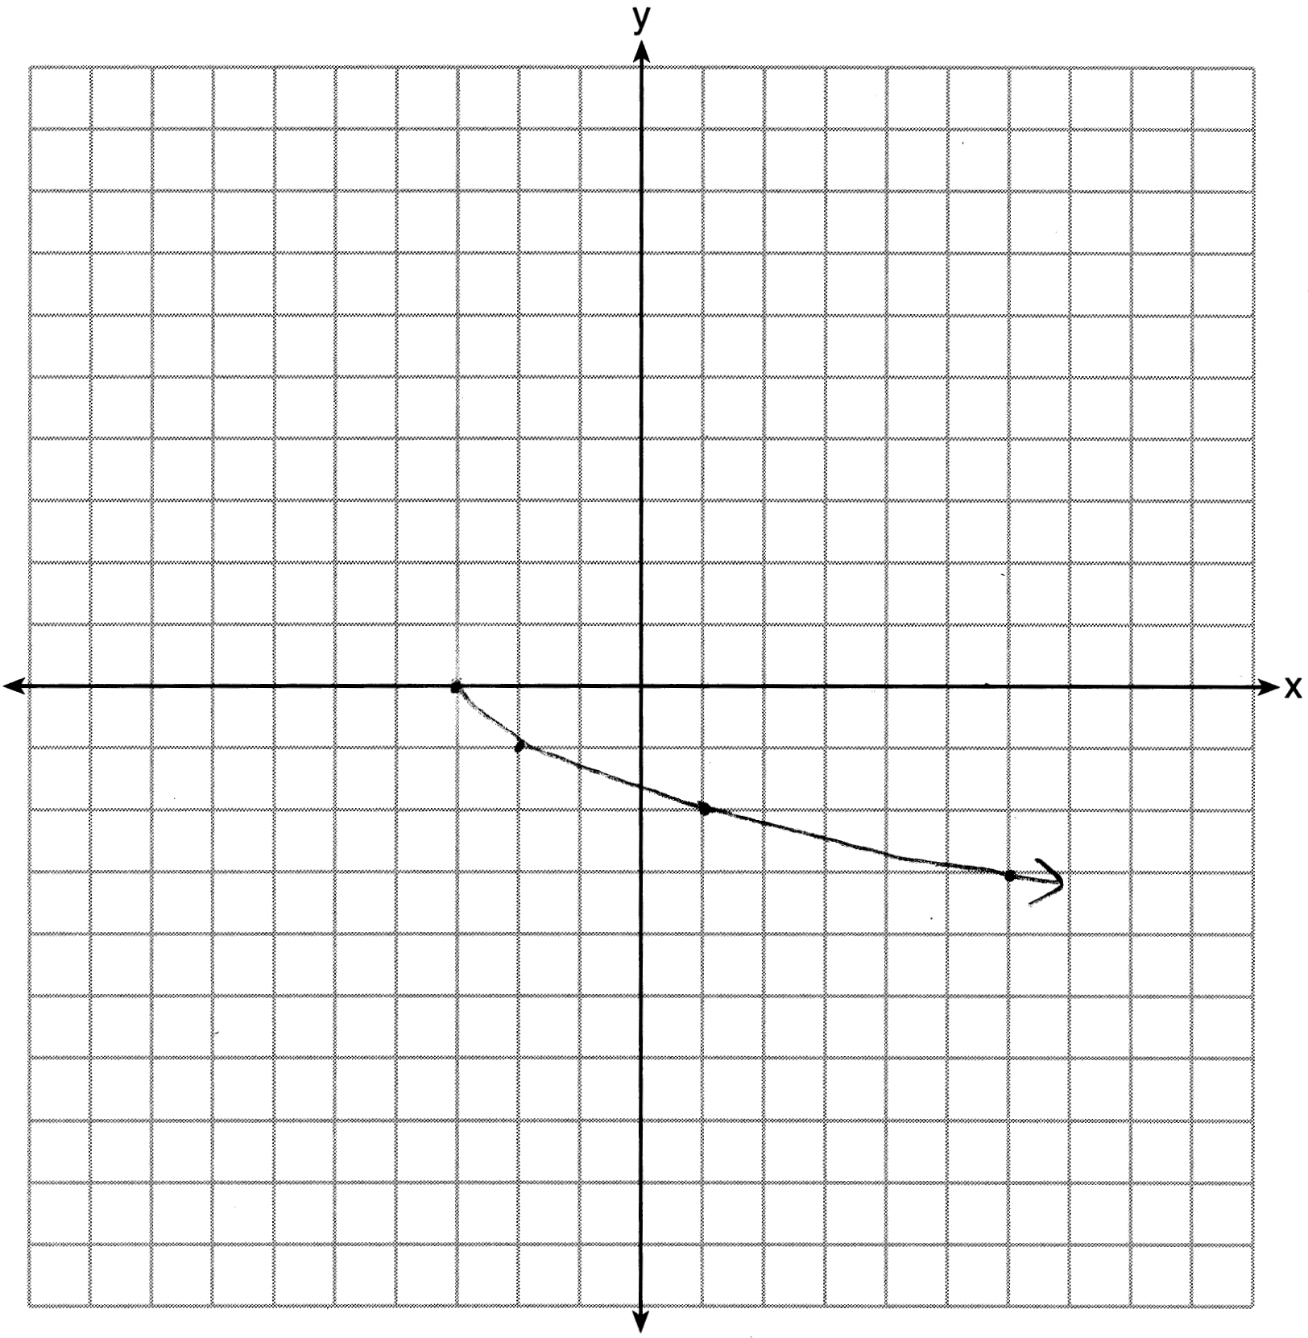

PTS: 2 REF: 081625ai NAT: F.IF.C.7 TOP: Graphing Root Functions

26 ANS:
2 units right and 3 units down.

PTS: 2 REF: 081626ai NAT: F.BF.B.3 TOP: Transformations with Functions

27 ANS:
Exponential, because the function does not have a constant rate of change.

PTS: 2 REF: 081627ai NAT: F.LE.A.1 TOP: Families of Functions

28 ANS:
No, is the coefficient of the term with the highest power.

PTS: 2 REF: 081628ai NAT: A.SSE.A.1 TOP: Modeling Expressions

29 ANS:
is irrational because it can not be written as the ratio of two integers.

PTS: 2 REF: 081629ai NAT: N.RN.B.3 TOP: Operations with Radicals
KEY: classify

30 ANS:

PTS: 2 REF: 081630ai NAT: A.REI.D.11 TOP: Other Systems
KEY: AI

31 ANS:
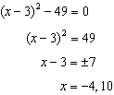

PTS: 2 REF: 081631ai NAT: A.REI.B.4 TOP: Solving Quadratics
KEY: taking square roots

32 ANS:
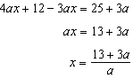

PTS: 2 REF: 081632ai NAT: A.CED.A.4 TOP: Transforming Formulas

33 ANS:
.

PTS: 4 REF: 081633ai NAT: S.ID.B.6 TOP: Regression
KEY: linear

34 ANS:
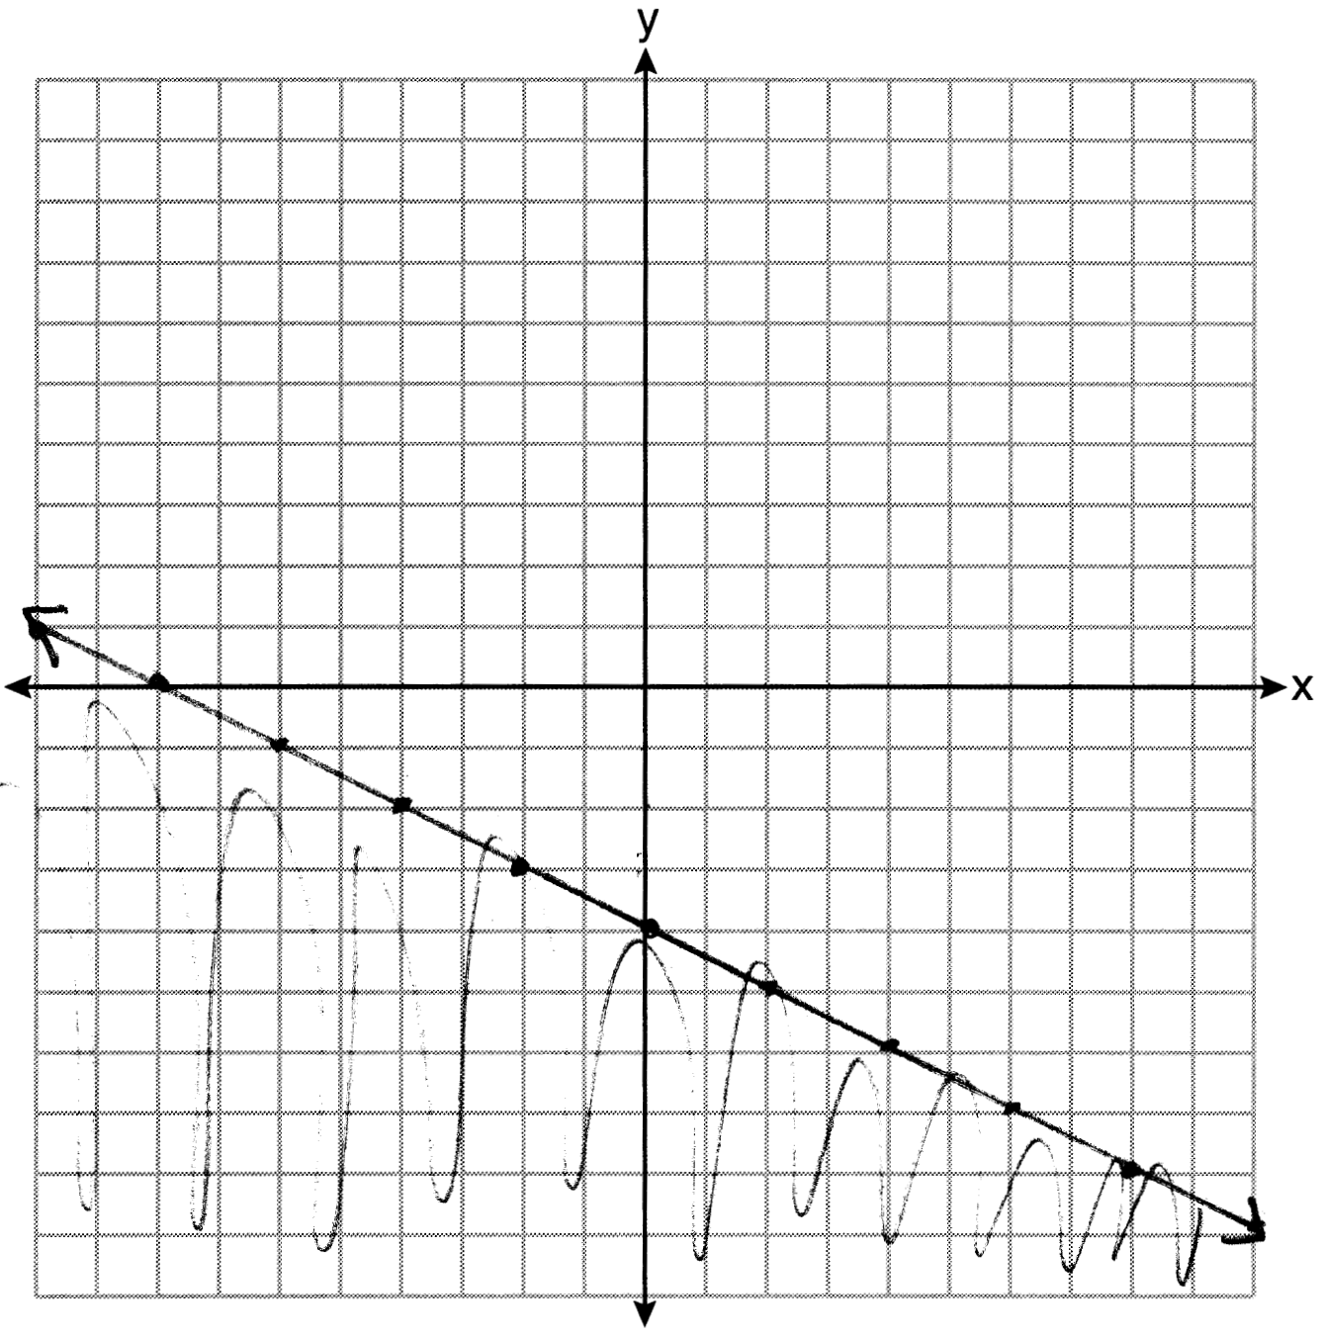

PTS: 4 REF: 081634ai NAT: A.REI.D.12 TOP: Graphing Linear Inequalities

35 ANS:
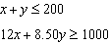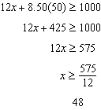

PTS: 4 REF: 081635ai NAT: A.CED.A.3 TOP: Modeling Systems of Linear Inequalities

36 ANS:
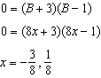 Janice substituted B for , resulting in a simpler quadratic. Once factored, Janice substituted for B.

PTS: 4 REF: 081636ai NAT: A.SSE.B.3 TOP: Solving Quadratics

37 ANS:
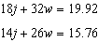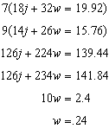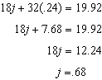

PTS: 6 REF: 081637ai NAT: A.CED.A.3 TOP: Modeling Linear Systems

