1 Given the graph of the line represented by the equation , if b is increased by 4 units, the graph of the new line would be shifted 4 units
1) | right | 3) | left
2) | up | 4) | down

2 Rowan has $50 in a savings jar and is putting in $5 every week. Jonah has $10 in his own jar and is putting in $15 every week. Each of them plots his progress on a graph with time on the horizontal axis and amount in the jar on the vertical axis. Which statement about their graphs is true?
1) | Rowan’s graph has a steeper slope than Jonah’s. | 3) | Jonah’s graph has a steeper slope than Rowan’s.
2) | Rowan’s graph always lies above Jonah’s. | 4) | Jonah’s graph always lies above Rowan’s.

3 To watch a varsity basketball game, spectators must buy a ticket at the door. The cost of an adult ticket is $3.00 and the cost of a student ticket is $1.50. If the number of adult tickets sold is represented by a and student tickets sold by s, which expression represents the amount of money collected at the door from the ticket sales?
1) |  | 3)
2) |  | 4)

4 The graph of is shown below.
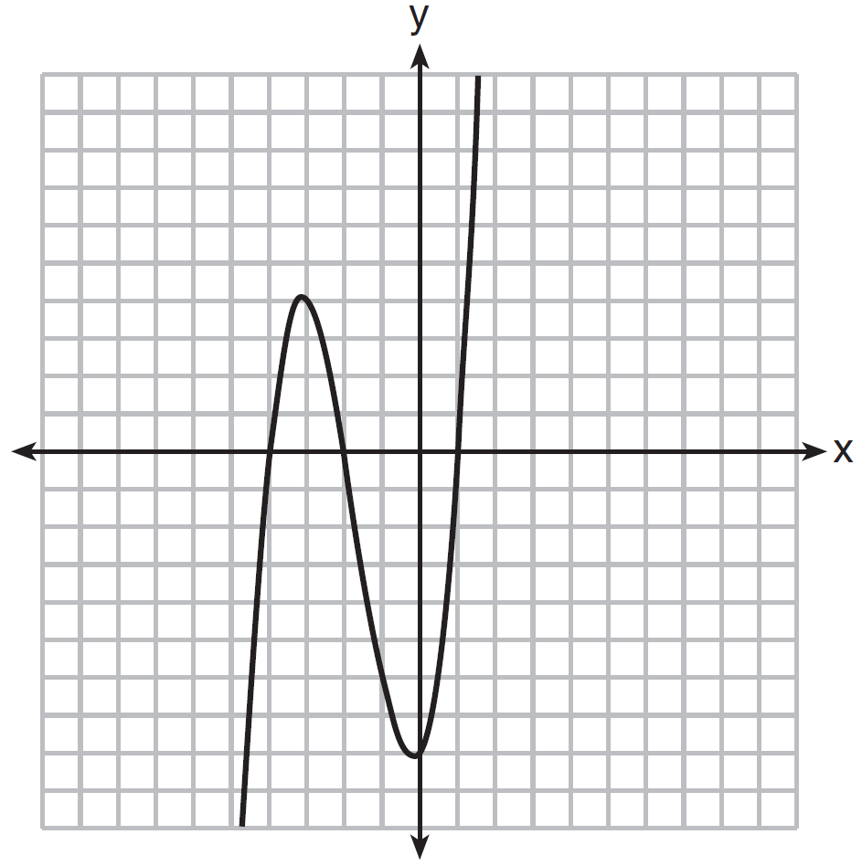

Which function could represent the graph of ?
1) |  | 3)
2) |  | 4)

5 The cost of a pack of chewing gum in a vending machine is $0.75. The cost of a bottle of juice in the same machine is $1.25. Julia has $22.00 to spend on chewing gum and bottles of juice for her team and she must buy seven packs of chewing gum. If b represents the number of bottles of juice, which inequality represents the maximum number of bottles she can buy?
1) |  | 3)
2) |  | 4)

6 Which graph represents the solution of and ?
1) | 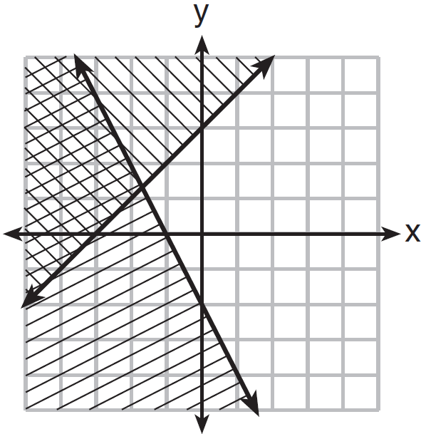 | 3) | 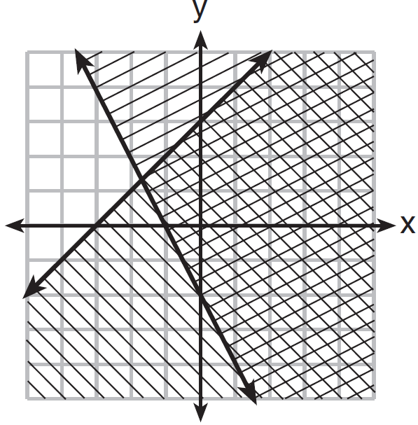
2) | 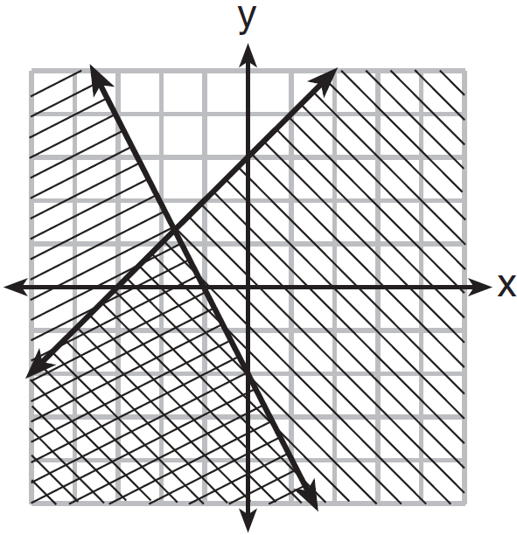 | 4) | 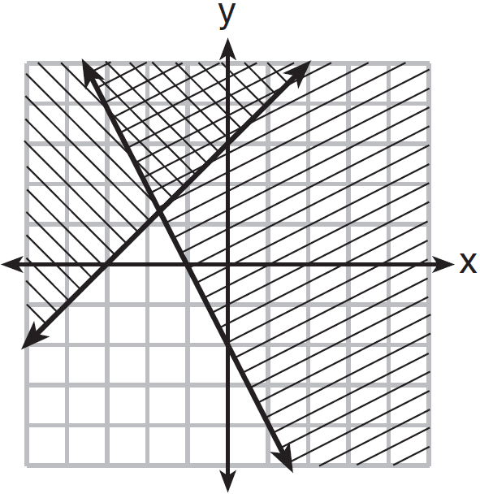

7 The country of Benin in West Africa has a population of 9.05 million people. The population is growing at a rate of 3.1% each year. Which function can be used to find the population 7 years from now?
1) |  | 3)
2) |  | 4)

8 A typical cell phone plan has a fixed base fee that includes a certain amount of data and an overage charge for data use beyond the plan. A cell phone plan charges a base fee of $62 and an overage charge of $30 per gigabyte of data that exceed 2 gigabytes. If C represents the cost and g represents the total number of gigabytes of data, which equation could represent this plan when more than 2 gigabytes are used?
1) |  | 3)
2) |  | 4)

9 Four expressions are shown below.
I
II
III
IV
The expression is equivalent to
1) | I and II, only | 3) | I, II, and IV
2) | II and IV, only | 4) | II, III, and IV

10 Last week, a candle store received $355.60 for selling 20 candles. Small candles sell for $10.98 and large candles sell for $27.98. How many large candles did the store sell?
1) | 6 | 3) | 10
2) | 8 | 4) | 12

11 Which representations are functions?
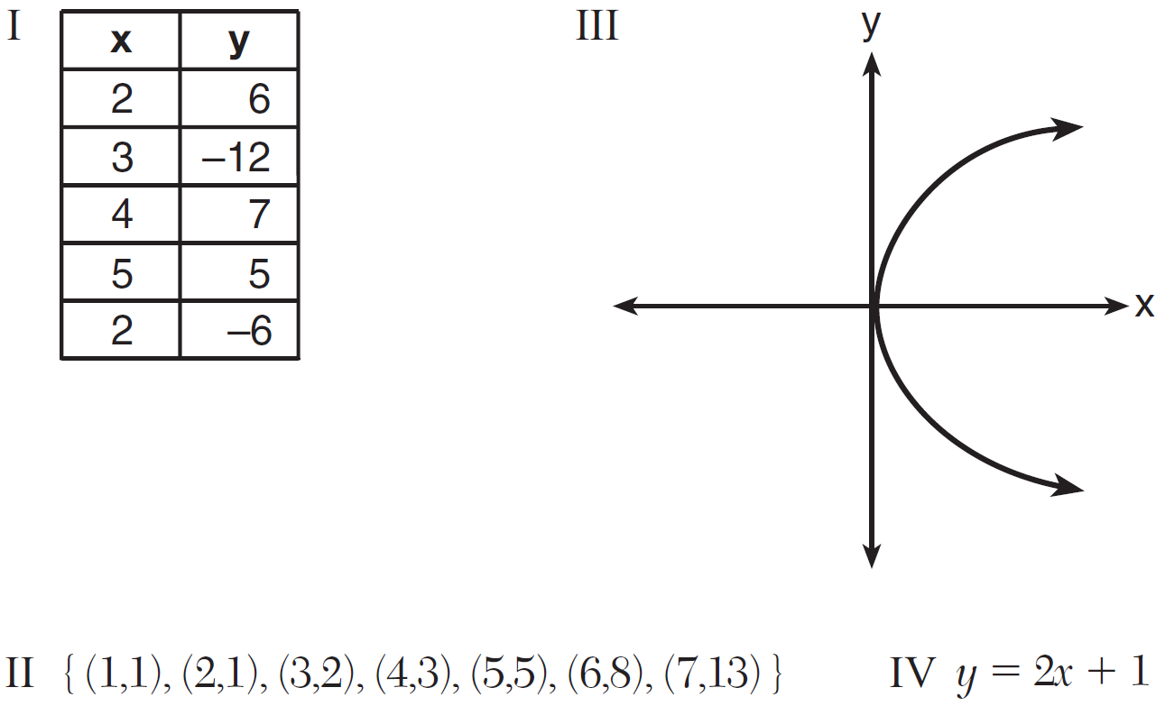
1) | I and II | 3) | III, only
2) | II and IV | 4) | IV, only

12 If 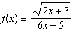, then 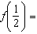
1) | 1 | 3)
2) |  | 4)

13 The zeros of the function are
1) | and | 3) | 1 and 2
2) | 1 and | 4) | and 2

14 Which recursively defined function has a first term equal to 10 and a common difference of 4?
1) | 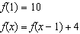 | 3) | 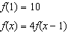
2) | 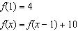 | 4) | 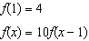

15 Firing a piece of pottery in a kiln takes place at different temperatures for different amounts of time. The graph below shows the temperatures in a kiln while firing a piece of pottery after the kiln is preheated to 200ºF.

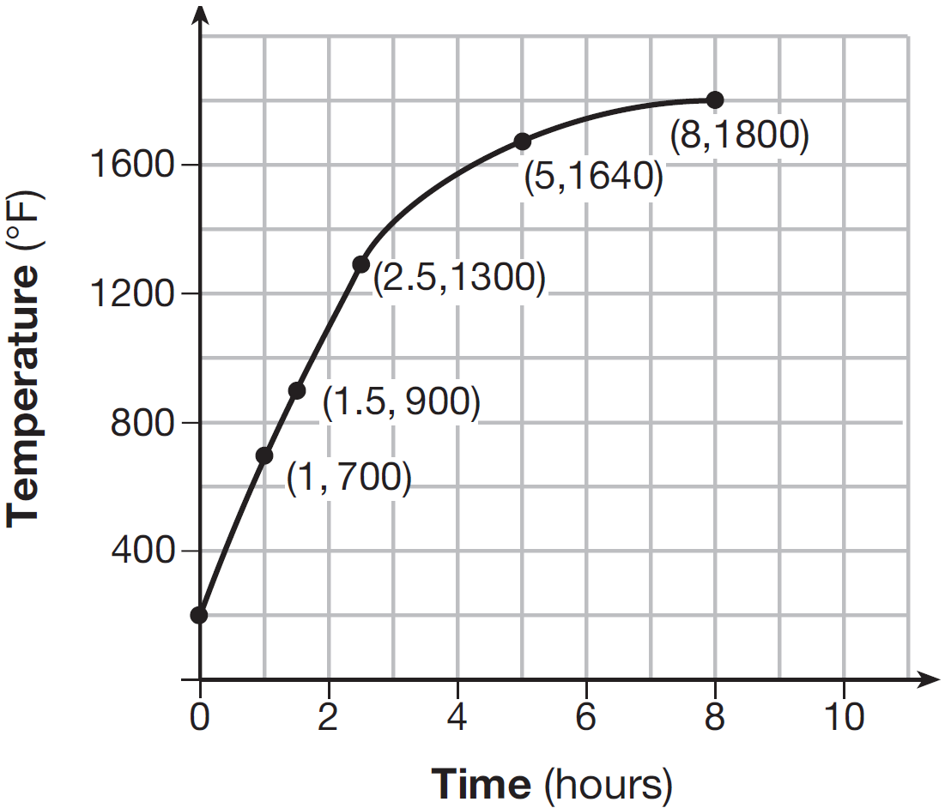

During which time interval did the temperature in the kiln show the greatest average rate of change?
1) | 0 to 1 hour | 3) | 2.5 hours to 5 hours
2) | 1 hour to 1.5 hours | 4) | 5 hours to 8 hours

16 Which graph represents 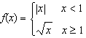?
1) | 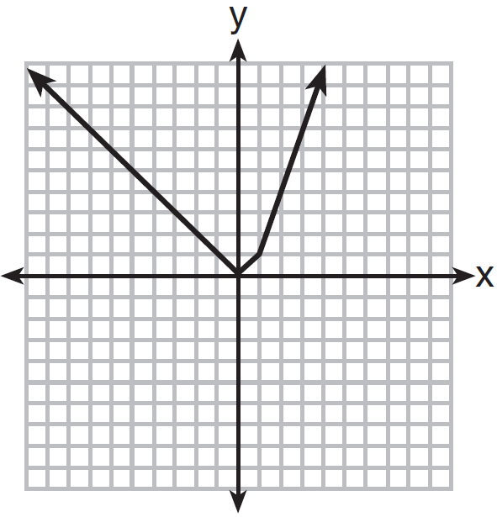 | 3) | 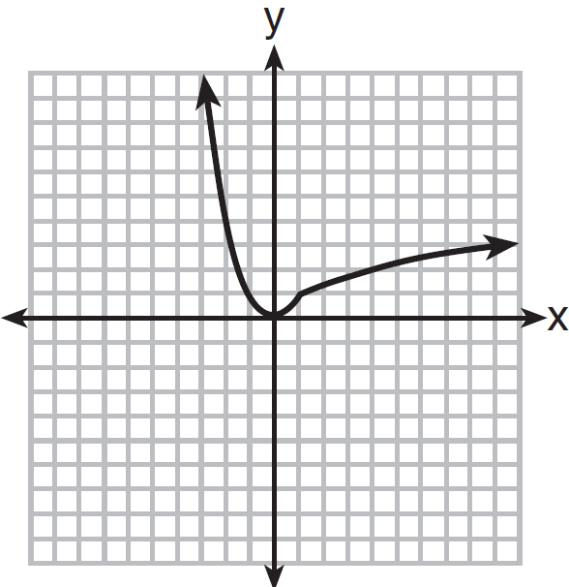
2) | 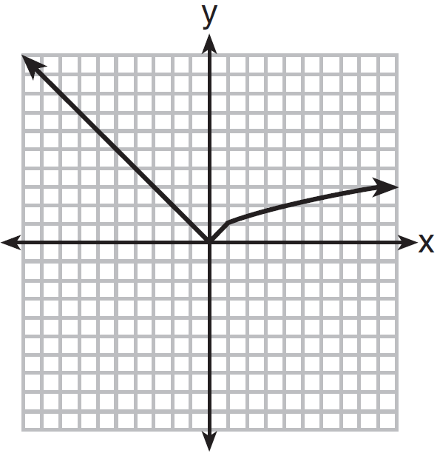 | 4) | 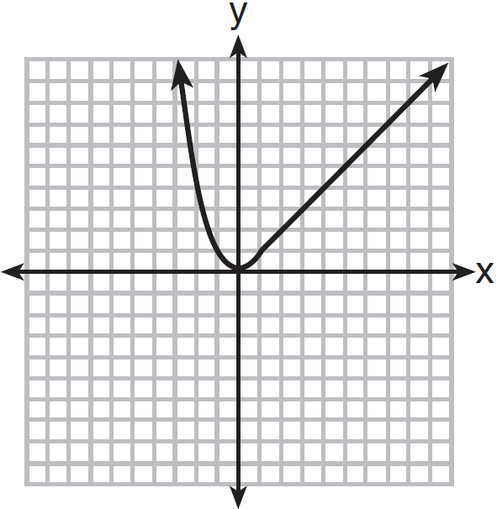

17 If and 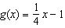, for which value of x is ?
1) | and | 3) | and 0
2) | and 4 | 4) | 4 and 0

18 Alicia has invented a new app for smart phones that two companies are interested in purchasing for a 2-year contract. Company A is offering her $10,000 for the first month and will increase the amount each month by $5000. Company B is offering $500 for the first month and will double their payment each month from the previous month. Monthly payments are made at the end of each month. For which monthly payment will company B’s payment first exceed company A’s payment?
1) | 6 | 3) | 8
2) | 7 | 4) | 9

19 The two sets of data below represent the number of runs scored by two different youth baseball teams over the course of a season.
Team A: 4, 8, 5, 12, 3, 9, 5, 2
Team B: 5, 9, 11, 4, 6, 11, 2, 7
Which set of statements about the mean and standard deviation is true?
1) |  | 3)
2) |  | 4)

20 If Lylah completes the square for in order to find the minimum, she must write in the general form . What is the value of a for ?
1) | 6 | 3) | 12
2) |  | 4)

21 Given the following quadratic functions:
and
x |  |  |  | 0 | 1 | 2 | 3 | 4 | 5
n(x) |  | 0 | 5 | 8 | 9 | 8 | 5 | 0

Which statement about these functions is true?
1) | Over the interval , the average rate of change for is less than that for . | 3) | The function has a greater maximum value than .
2) | The y-intercept of is greater than the y-intercept for . | 4) | The sum of the roots of is greater than the sum of the roots of .

22 For which value of P and W is a rational number?
1) | 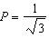 and 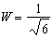 | 3) | 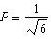 and 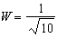
2) | 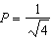 and 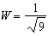 | 4) | 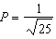 and 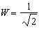

23 The solution of the equation is
1) |  | 3)
2) |  | 4)

24 Which trinomial is equivalent to ?
1) |  | 3)
2) |  | 4)

25 Each day Toni records the height of a plant for her science lab. Her data are shown in the table below.

Day (n) | 1 | 2 | 3 | 4 | 5
Height (cm) | 3.0 | 4.5 | 6.0 | 7.5 | 9.0

The plant continues to grow at a constant daily rate. Write an equation to represent , the height of the plant on the nth day.

26 On the set of axes below, graph the inequality .

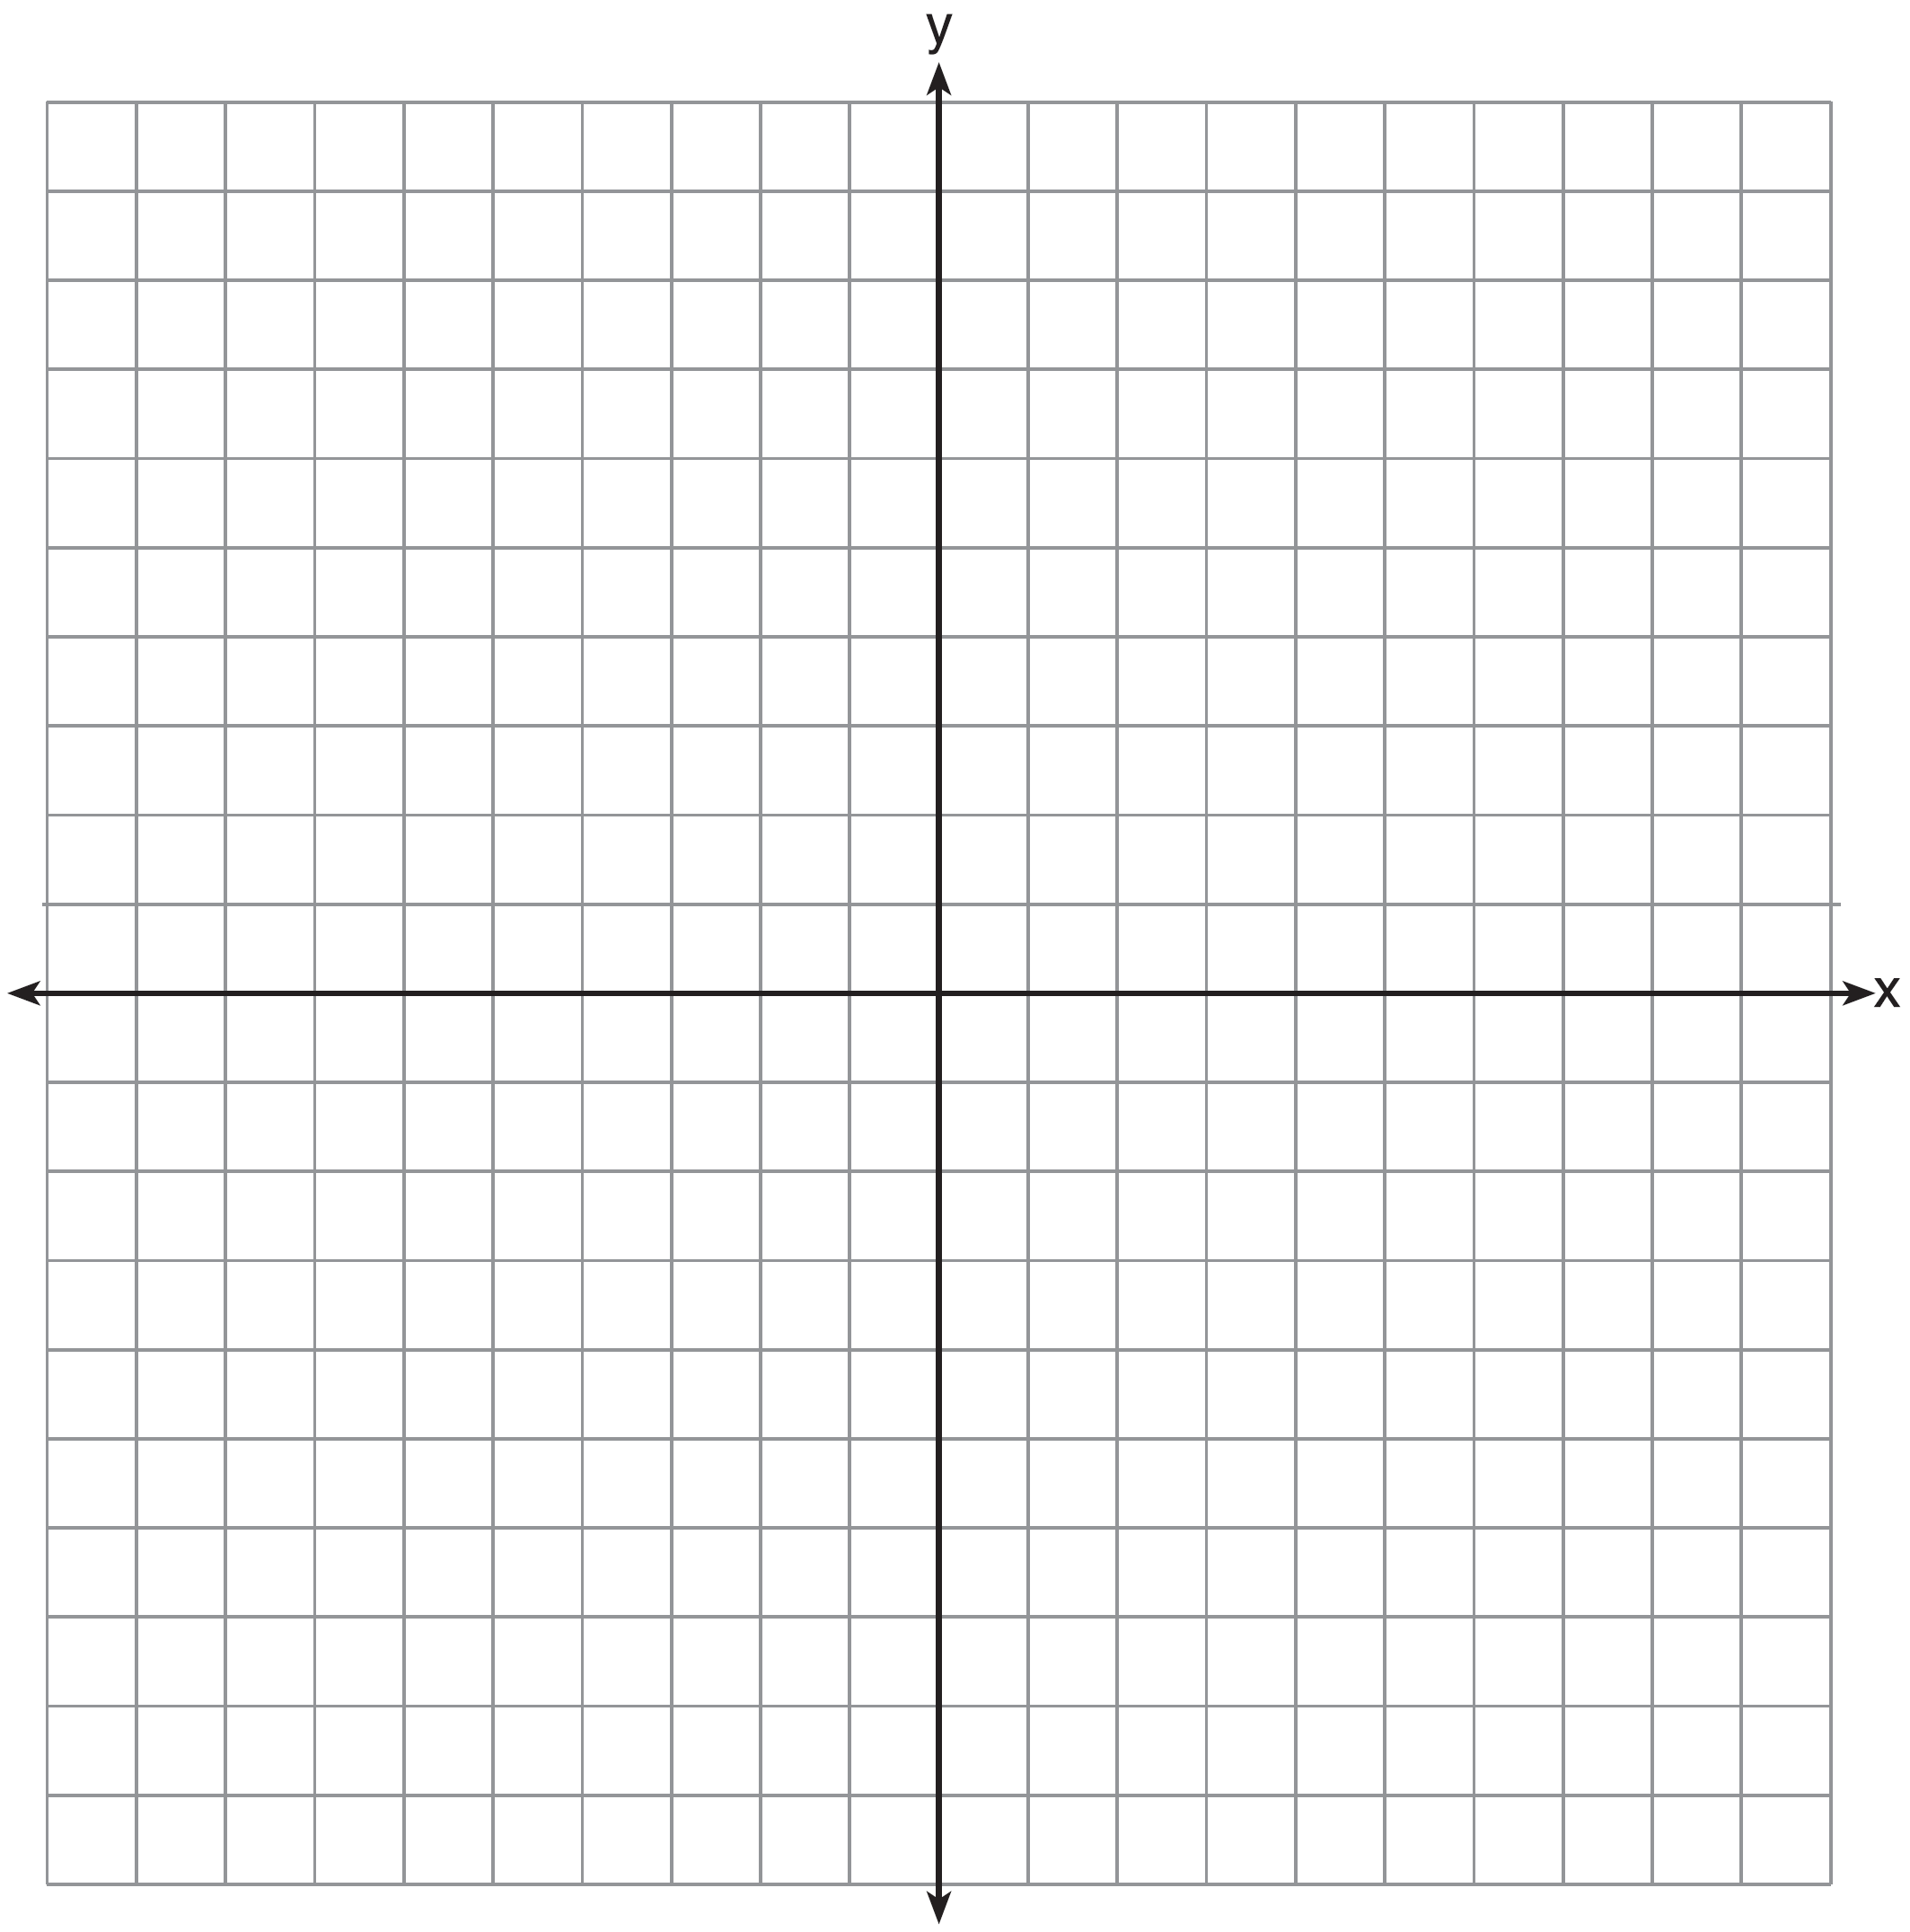

27 Rachel and Marc were given the information shown below about the bacteria growing in a Petri dish in their biology class.

Number of Hours, x | 1 | 2 | 3 | 4 | 5 | 6 | 7 | 8 | 9 | 10
Number of Bacteria, B(x) | 220 | 280 | 350 | 440 | 550 | 690 | 860 | 1070 | 1340 | 1680

Rachel wants to model this information with a linear function. Marc wants to use an exponential function. Which model is the better choice? Explain why you chose this model.

28 A driver leaves home for a business trip and drives at a constant speed of 60 miles per hour for 2 hours. Her car gets a flat tire, and she spends 30 minutes changing the tire. She resumes driving and drives at 30 miles per hour for the remaining one hour until she reaches her destination. On the set of axes below, draw a graph that models the driver’s distance from home.

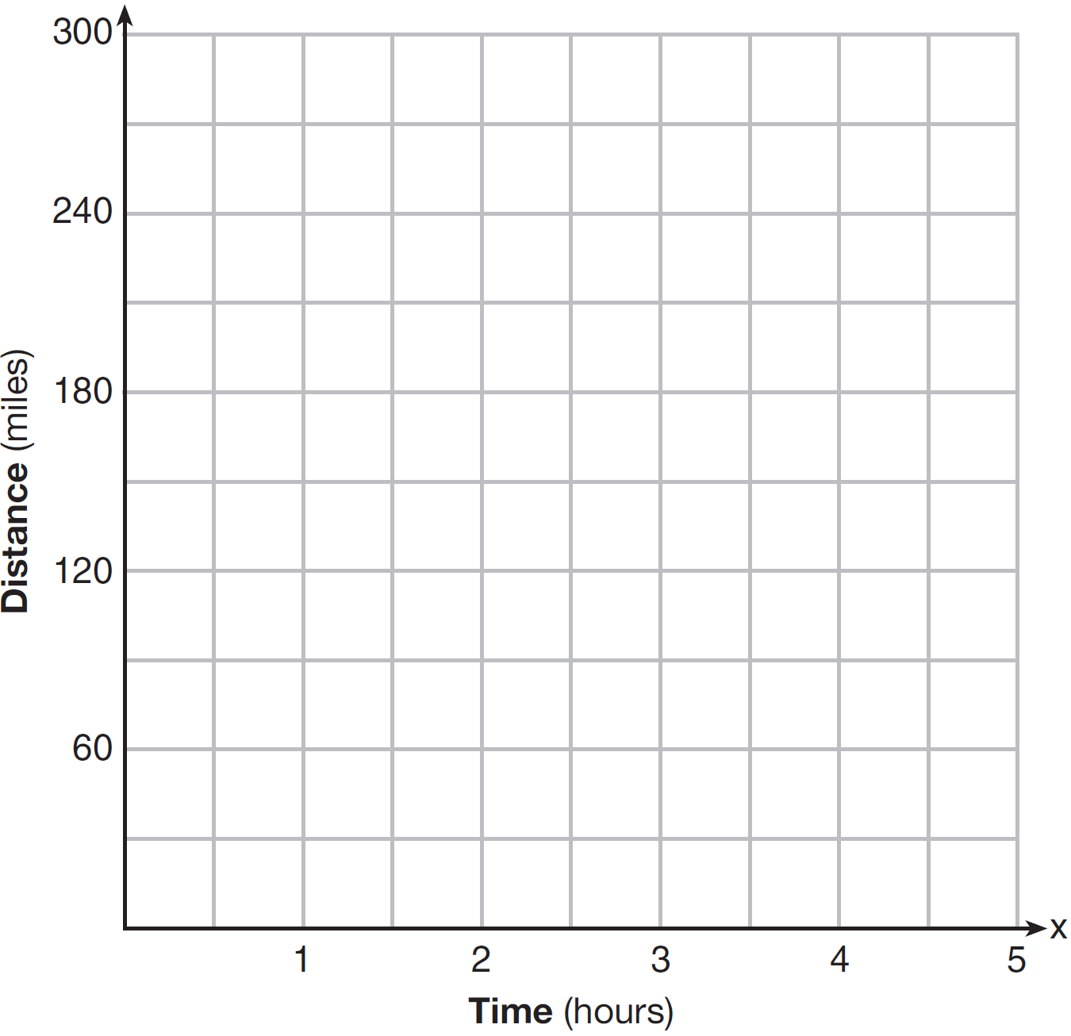

29 How many real solutions does the equation have? Justify your answer.

30 The number of carbon atoms in a fossil is given by the function , where x represents the number of years since being discovered. What is the percent of change each year? Explain how you arrived at your answer.

31 A toy rocket is launched from the ground straight upward. The height of the rocket above the ground, in feet, is given by the equation , where t is the time in seconds. Determine the domain for this function in the given context. Explain your reasoning.

32 Jackson is starting an exercise program. The first day he will spend 30 minutes on a treadmill. He will increase his time on the treadmill by 2 minutes each day. Write an equation for , the time, in minutes, on the treadmill on day d. Find , the minutes he will spend on the treadmill on day 6.

33 Graph and for on the set of axes below.

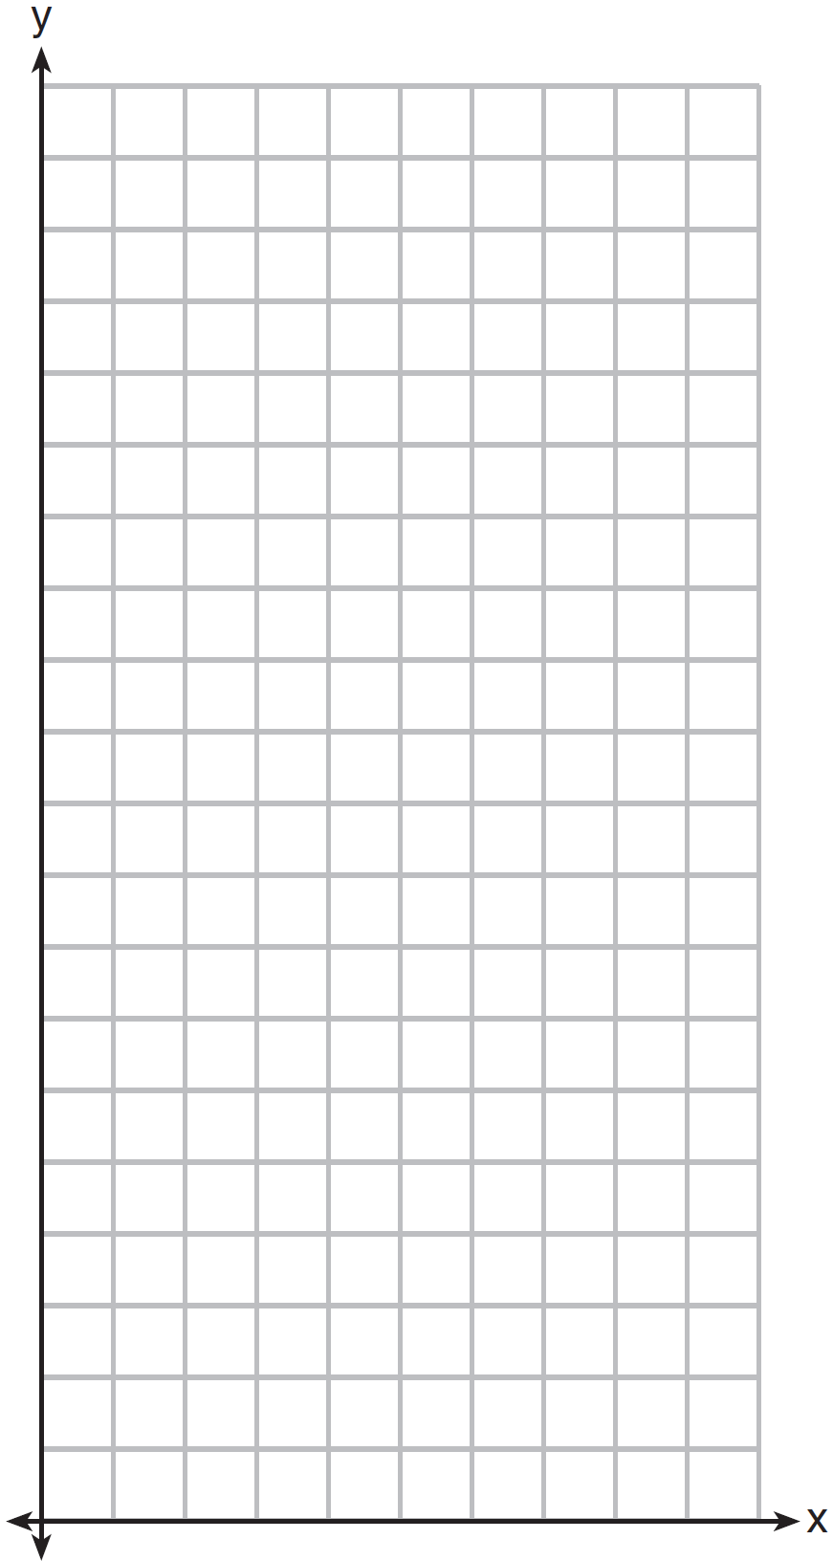

State which function, or , has a greater value when . Justify your reasoning.

34 Solve for x algebraically:
If x is a number in the interval , state all integers that satisfy the given inequality. Explain how you determined these values.

35 The volume of a large can of tuna fish can be calculated using the formula . Write an equation to find the radius, r, in terms of V and h. Determine the diameter, to the nearest inch, of a large can of tuna fish that has a volume of 66 cubic inches and a height of 3.3 inches.

36 The table below shows the attendance at a museum in select years from 2007 to 2013.

Attendance at Museum
Year | 2007 | 2008 | 2009 | 2011 | 2013
Attendance (millions) | 8.3 | 8.5 | 8.5 | 8.8 | 9.3

State the linear regression equation represented by the data table when is used to represent the year 2007 and y is used to represent the attendance. Round all values to the nearest hundredth. State the correlation coefficient to the nearest hundredth and determine whether the data suggest a strong or weak association.

37 A rectangular picture measures 6 inches by 8 inches. Simon wants to build a wooden frame for the picture so that the framed picture takes up a maximum area of 100 square inches on his wall. The pieces of wood that he uses to build the frame all have the same width. Write an equation or inequality that could be used to determine the maximum width of the pieces of wood for the frame Simon could create. Explain how your equation or inequality models the situation. Solve the equation or inequality to determine the maximum width of the pieces of wood used for the frame to the nearest tenth of an inch.
1 ANS: 2 PTS: 2 REF: 081501ai NAT: F.BF.B.3
TOP: Graphing Linear Functions

2 ANS: 3

PTS: 2 REF: 081502ai NAT: A.REI.C.6 TOP: Graphing Linear Systems

3 ANS: 4 PTS: 2 REF: 081503ai NAT: A.SSE.A.1
TOP: Modeling Expressions

4 ANS: 1

PTS: 2 REF: 081504ai NAT: A.APR.B.3 TOP: Zeros of Polynomials
KEY: AI

5 ANS: 4 PTS: 2 REF: 081505ai NAT: A.CED.A.1
TOP: Modeling Linear Inequalities

6 ANS: 3 PTS: 2 REF: 081506ai NAT: A.REI.D.12
TOP: Graphing Systems of Linear Inequalities KEY: bimodalgraph | graph

7 ANS: 3 PTS: 2 REF: 081507ai NAT: F.LE.A.2
TOP: Modeling Exponential Functions KEY: AI

8 ANS: 4 PTS: 2 REF: 081508ai NAT: A.CED.A.3
TOP: Modeling Linear Equations

9 ANS: 3 PTS: 2 REF: 081509ai NAT: A.SSE.A.2
TOP: Factoring Polynomials KEY: quadratic

10 ANS: 2
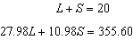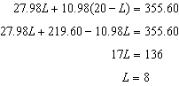

PTS: 2 REF: 081510ai NAT: A.CED.A.3 TOP: Modeling Linear Systems

11 ANS: 2 PTS: 2 REF: 081511ai NAT: F.IF.A.1
TOP: Defining Functions KEY: mixed

12 ANS: 3
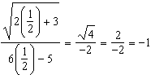

PTS: 2 REF: 081512ai NAT: F.IF.A.2 TOP: Functional Notation

13 ANS: 4
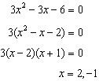

PTS: 2 REF: 081513ai NAT: A.SSE.B.3 TOP: Solving Quadratics

14 ANS: 1 PTS: 2 REF: 081514ai NAT: F.LE.A.2
TOP: Sequences

15 ANS: 1 PTS: 2 REF: 081515ai NAT: F.IF.B.6
TOP: Rate of Change KEY: AI

16 ANS: 2 PTS: 2 REF: 081516ai NAT: F.IF.C.7
TOP: Graphing Piecewise-Defined Functions KEY: bimodalgraph

17 ANS: 2
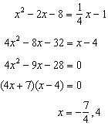

PTS: 2 REF: 081517ai NAT: A.REI.D.11 TOP: Quadratic-Linear Systems
KEY: AI

18 ANS: 3
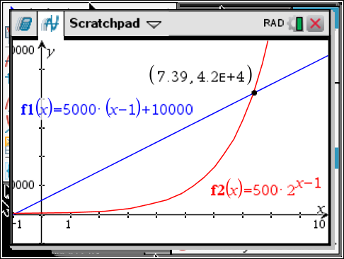

x
6 | 35,000 | 16,000
7 | 40,000 | 32,000
8 | 45,000 | 64,000
9 | 50,000 | 128,000

PTS: 2 REF: 081518ai NAT: F.LE.A.3 TOP: Families of Functions

19 ANS: 1

PTS: 2 REF: 081519ai NAT: S.ID.A.2 TOP: Central Tendency and Dispersion

20 ANS: 1
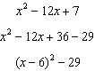

PTS: 2 REF: 081520ai NAT: F.IF.C.8 TOP: Vertex Form of a Quadratic

21 ANS: 4
1) 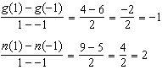 2) 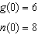 3) 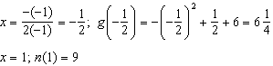
4) 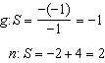

PTS: 2 REF: 081521ai NAT: F.IF.C.9 TOP: Comparing Functions
KEY: AI

22 ANS: 2
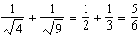

PTS: 2 REF: 081522ai NAT: N.RN.B.3 TOP: Operations with Radicals
KEY: classify

23 ANS: 3 PTS: 2 REF: 081523ai NAT: A.REI.B.4
TOP: Solving Quadratics KEY: taking square roots

24 ANS: 4

PTS: 2 REF: 081524ai NAT: A.APR.A.1 TOP: Operations with Polynomials
KEY: multiplication

25 ANS:

PTS: 2 REF: 081525ai NAT: F.LE.A.2 TOP: Modeling Linear Functions

26 ANS:
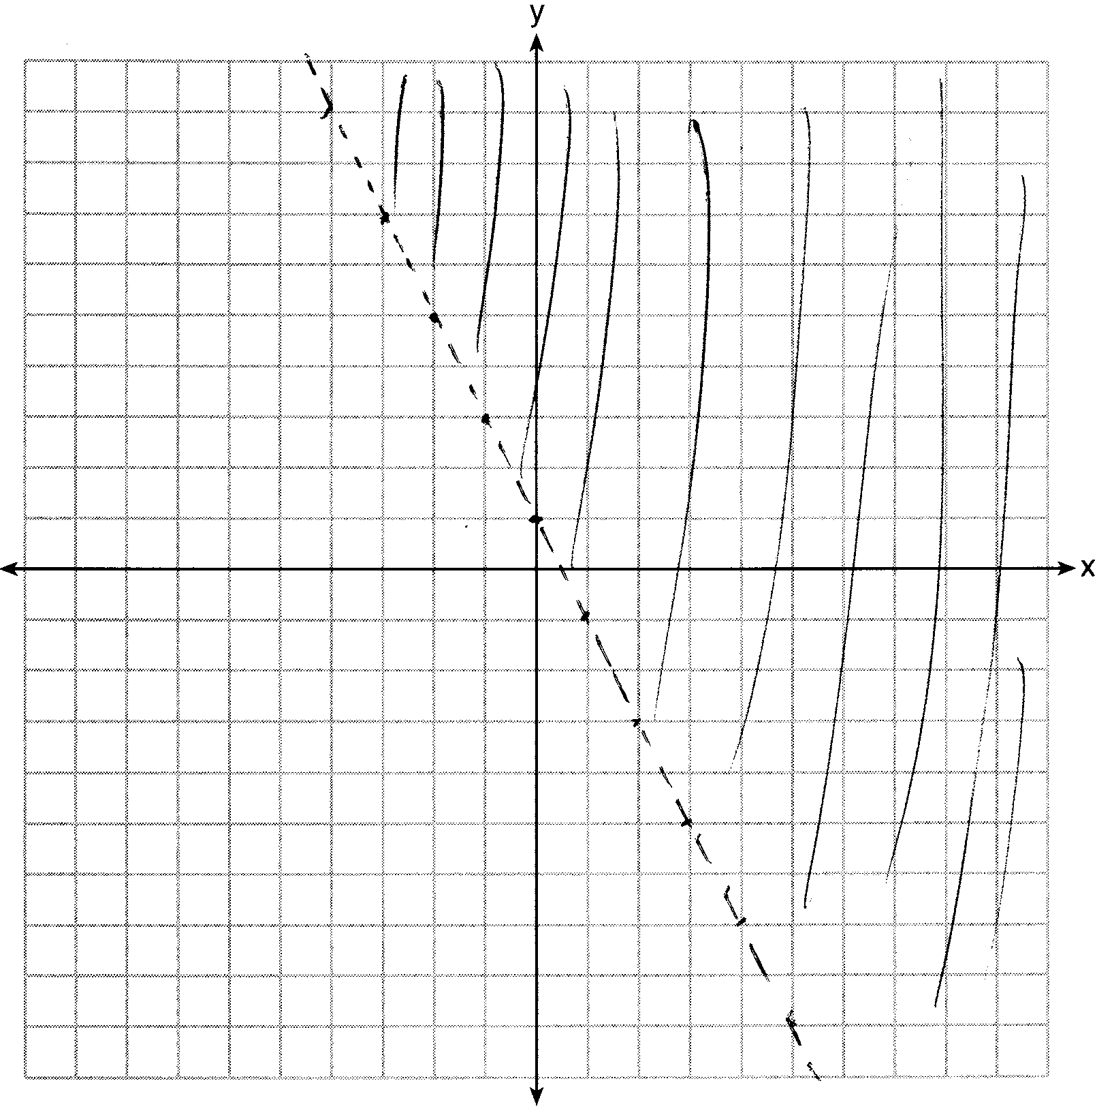

PTS: 2 REF: 081526ai NAT: A.REI.D.12 TOP: Graphing Linear Inequalities

27 ANS:
Exponential, because the function does not grow at a constant rate.

PTS: 2 REF: 081527ai NAT: F.LE.A.1 TOP: Families of Functions

28 ANS:
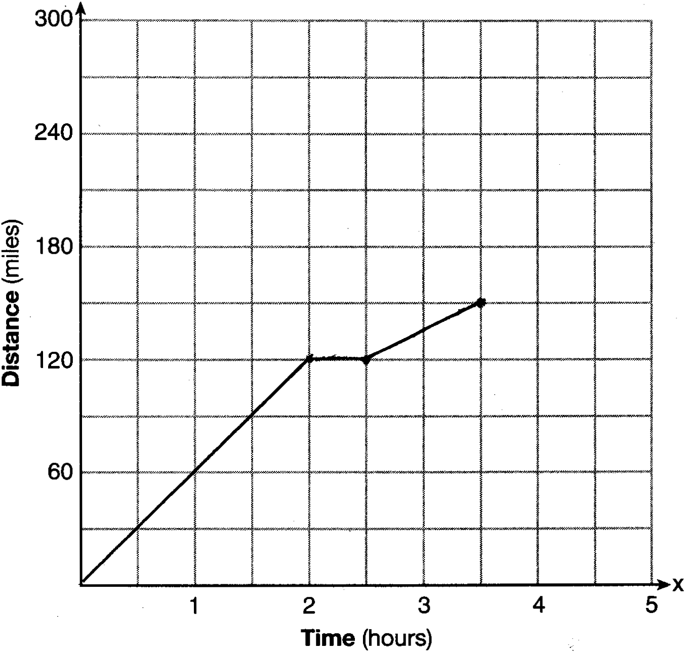

PTS: 2 REF: 081528ai NAT: F.IF.B.4 TOP: Relating Graphs to Events

29 ANS:
None

PTS: 2 REF: 081529ai NAT: A.REI.B.4 TOP: Using the Discriminant
KEY: AI

30 ANS:
To find the rate of change of an equation in the form , subtract b from 1.

PTS: 2 REF: 081530ai NAT: F.LE.B.5 TOP: Modeling Exponential Functions

31 ANS:
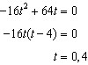 The rocket launches at and lands at

PTS: 2 REF: 081531ai NAT: F.IF.B.4 TOP: Graphing Quadratic Functions
KEY: context

32 ANS:

PTS: 2 REF: 081532ai NAT: F.BF.A.1 TOP: Modeling Linear Functions

33 ANS:
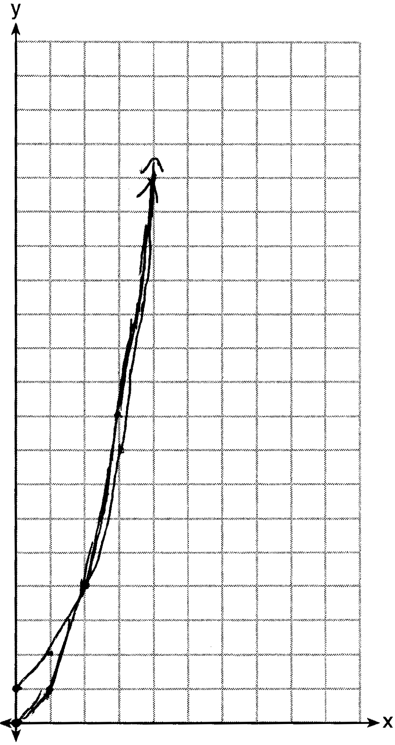 has a greater value:

PTS: 4 REF: 081533ai NAT: F.LE.A.3 TOP: Families of Functions

34 ANS:
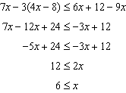 6, 7, 8 are the numbers greater than or equal to 6 in the interval.

PTS: 4 REF: 081534ai NAT: A.REI.B.3 TOP: Interpreting Solutions

35 ANS:
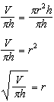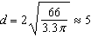

PTS: 4 REF: 081535ai NAT: A.CED.A.4 TOP: Transforming Formulas

36 ANS:
, which suggests a strong association.

PTS: 4 REF: 081536ai NAT: S.ID.B.6 TOP: Regression
KEY: linear with correlation coefficient

37 ANS:
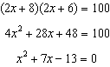 The frame has two parts added to each side, so must be added to the length and width. Multiply length and width to find area and set equal to 100. 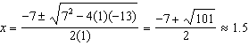

PTS: 6 REF: 081537ai NAT: A.CED.A.1 TOP: Geometric Applications of Quadratics

