1 Which statement is not always true?
1) | The product of two irrational numbers is irrational. | 3) | The sum of two rational numbers is rational.
2) | The product of two rational numbers is rational. | 4) | The sum of a rational number and an irrational number is irrational.

2 A satellite television company charges a one-time installation fee and a monthly service charge. The total cost is modeled by the function . Which statement represents the meaning of each part of the function?
1) | y is the total cost, x is the number of months of service, $90 is the installation fee, and $40 is the service charge per month. | 3) | x is the total cost, y is the number of months of service, $40 is the installation fee, and $90 is the service charge per month.
2) | y is the total cost, x is the number of months of service, $40 is the installation fee, and $90 is the service charge per month. | 4) | x is the total cost, y is the number of months of service, $90 is the installation fee, and $40 is the service charge per month.

3 If , the roots of the equation are
1) | and 25 | 3) | and 5
2) | , only | 4) | , only

4 Isaiah collects data from two different companies, each with four employees. The results of the study, based on each worker’s age and salary, are listed in the tables below.
Company 1
Worker’s  Age in  Years | Salary  in  Dollars
25 | 30,000
27 | 32,000
28 | 35,000
33 | 38,000

Company 2
Worker’s  Age in  Years | Salary  in  Dollars
25 | 29,000
28 | 35,500
29 | 37,000
31 | 65,000
Which statement is true about these data?
1) | The median salaries in both companies are greater than $37,000. | 3) | The salary range in company 2 is greater than the salary range in company 1.
2) | The mean salary in company 1 is greater than the mean salary in company 2. | 4) | The mean age of workers at company 1 is greater than the mean age of workers at company 2.

5 Which point is not on the graph represented by ?
1) |  | 3)
2) |  | 4)

6 A company produces x units of a product per month, where represents the total cost and represents the total revenue for the month. The functions are modeled by and . The profit is the difference between revenue and cost where . What is the total profit, , for the month?
1) |  | 3)
2) |  | 4)

7 What is one point that lies in the solution set of the system of inequalities graphed below?

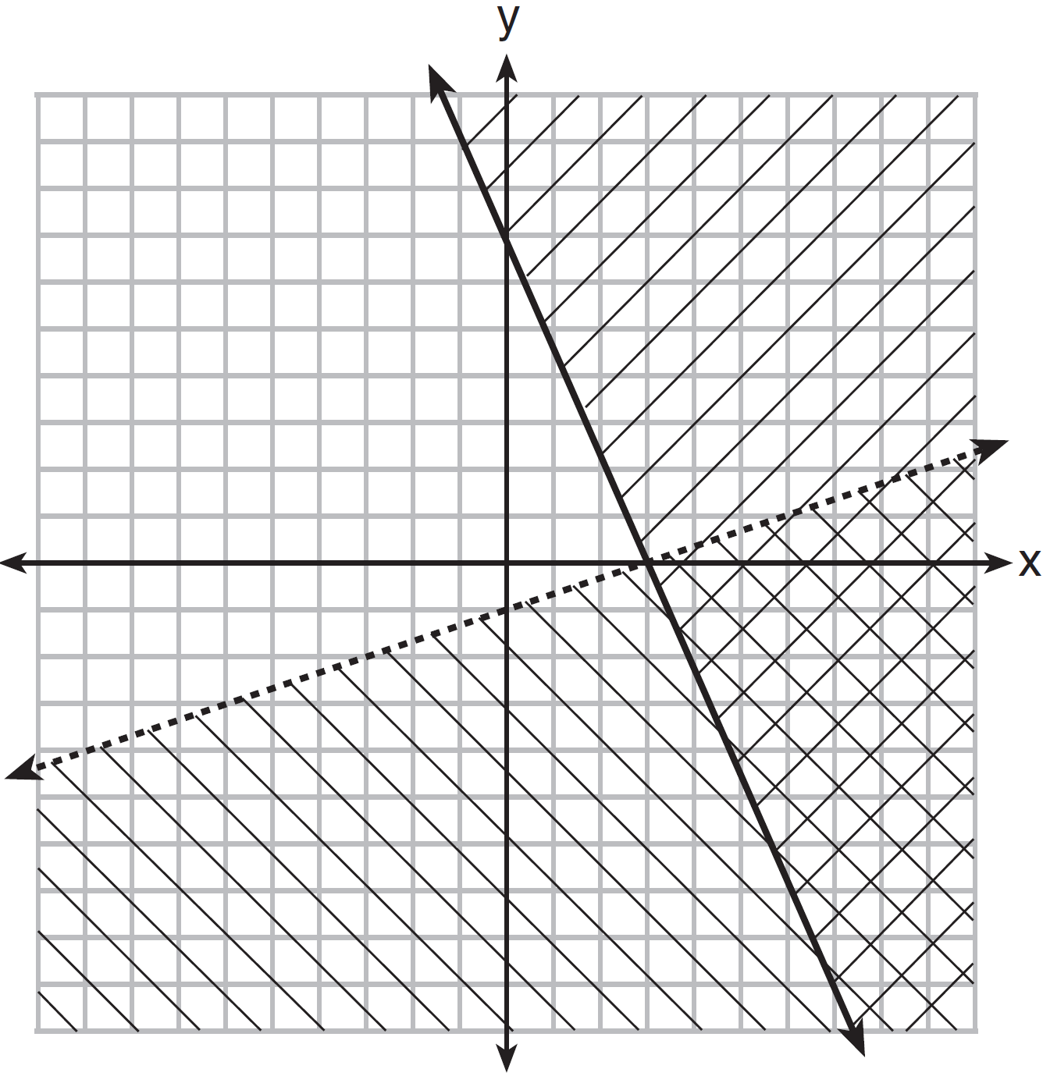
1) |  | 3)
2) |  | 4)

8 The value of the x-intercept for the graph of is
1) | 10 | 3)
2) |  | 4)

9 Sam and Jeremy have ages that are consecutive odd integers. The product of their ages is 783. Which equation could be used to find Jeremy’s age, j, if he is the younger man?
1) |  | 3)
2) |  | 4)

10 A population that initially has 20 birds approximately doubles every 10 years. Which graph represents this population growth?
1) | 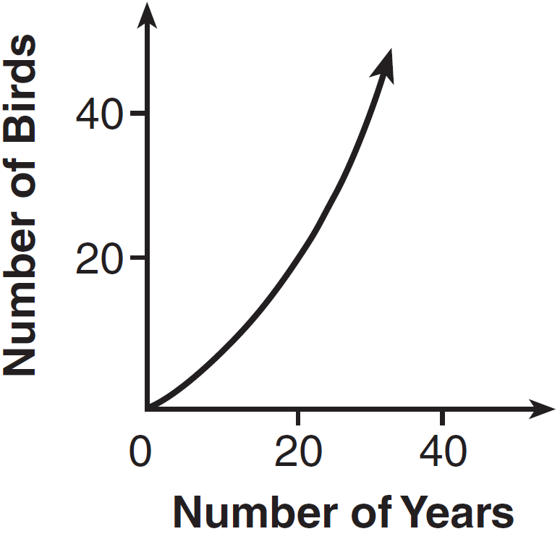 | 3) | 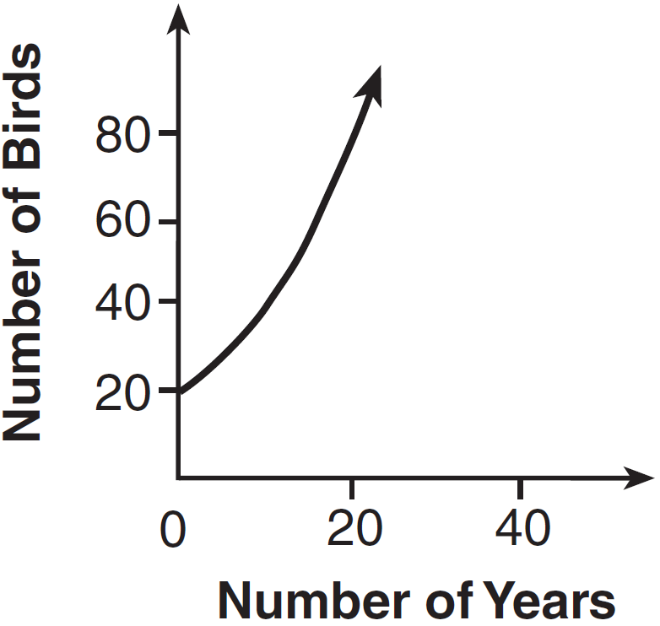
2) | 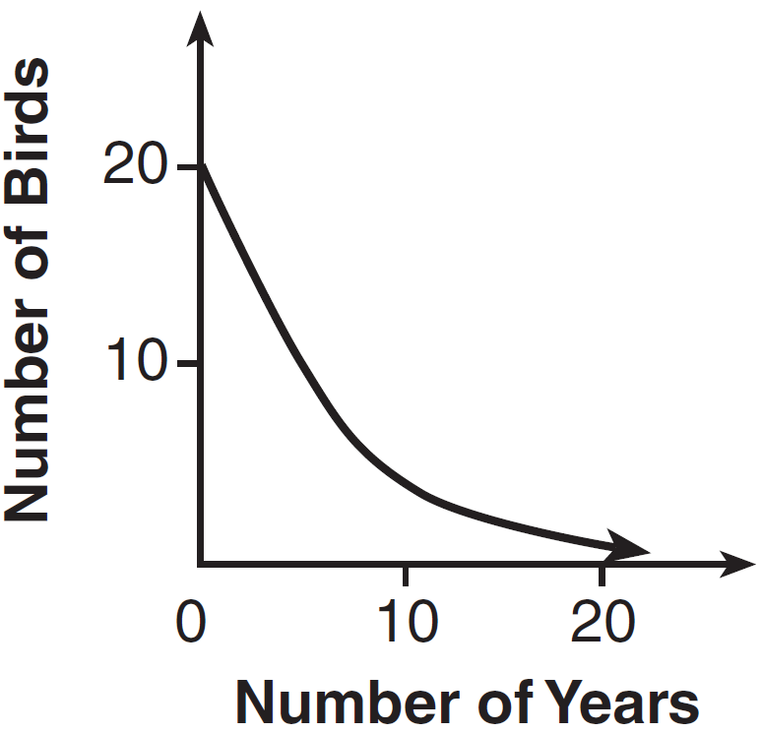 | 4) | 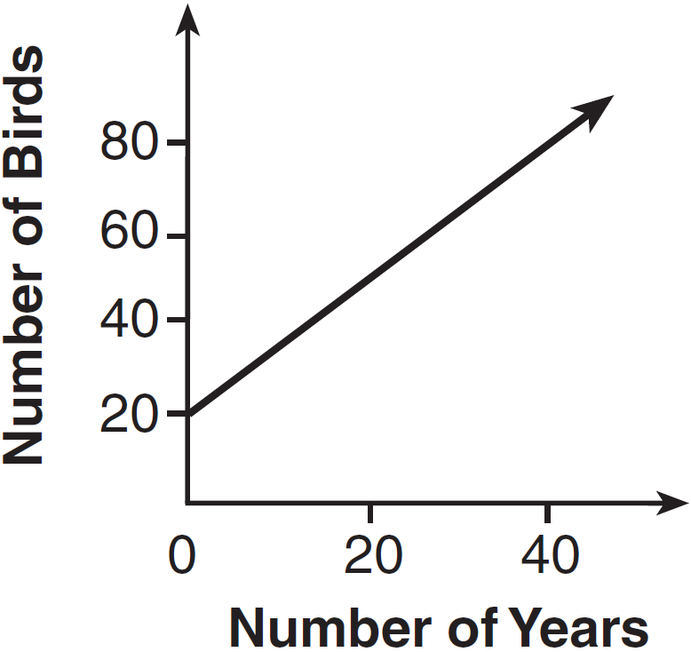

11 Let f be a function such that is defined on the domain . The range of this function is
1) |  | 3)
2) |  | 4)

12 Which situation could be modeled by using a linear function?
1) | a bank account balance that grows at a rate of 5% per year, compounded annually | 3) | the cost of cell phone service that charges a base amount plus 20 cents per minute
2) | a population of bacteria that doubles every 4.5 hours | 4) | the concentration of medicine in a person’s body that decays by a factor of one-third every hour

13 Which graph shows a line where each value of y is three more than half of x?
1) | 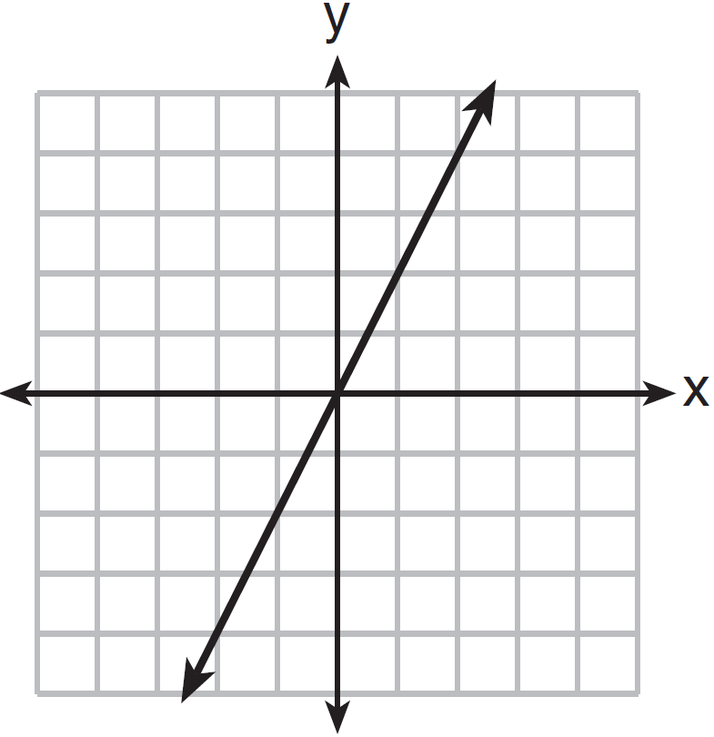 | 3) | 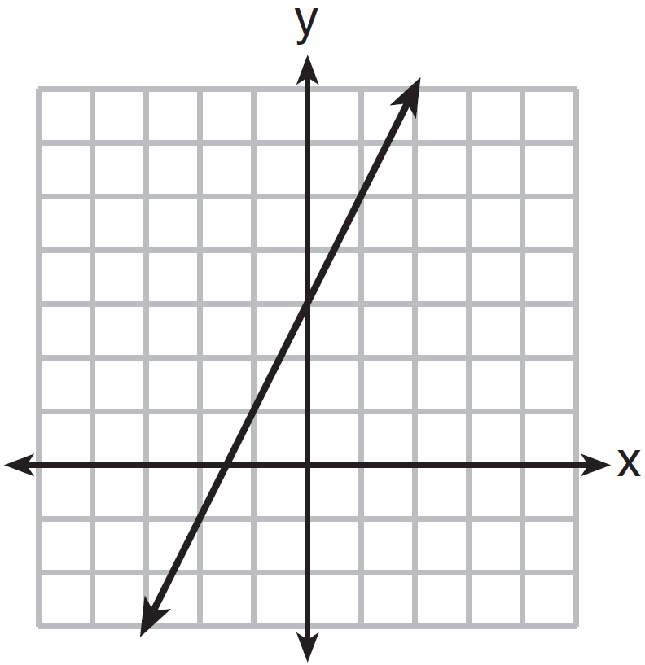
2) | 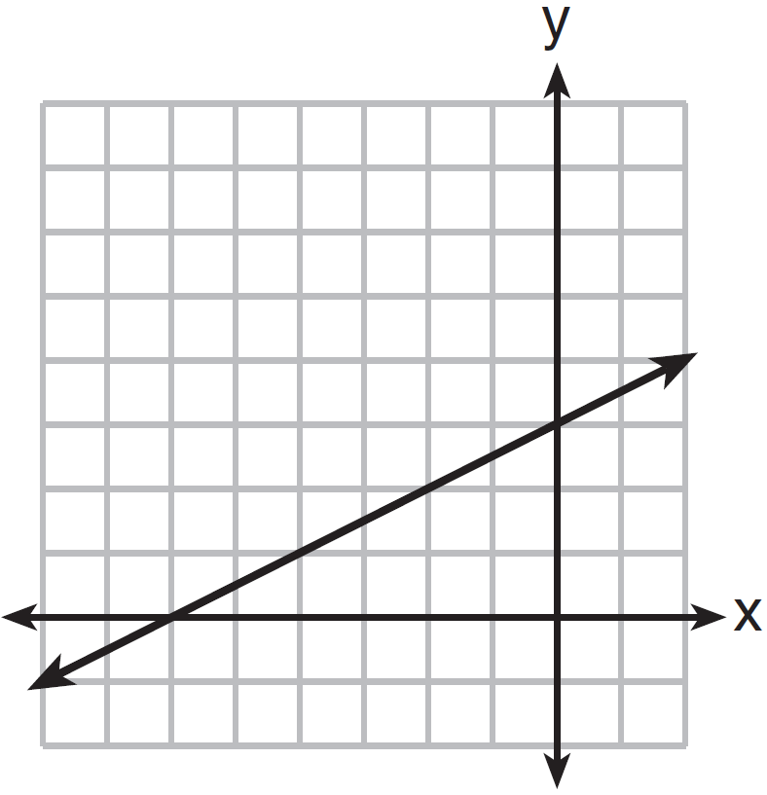 | 4) | 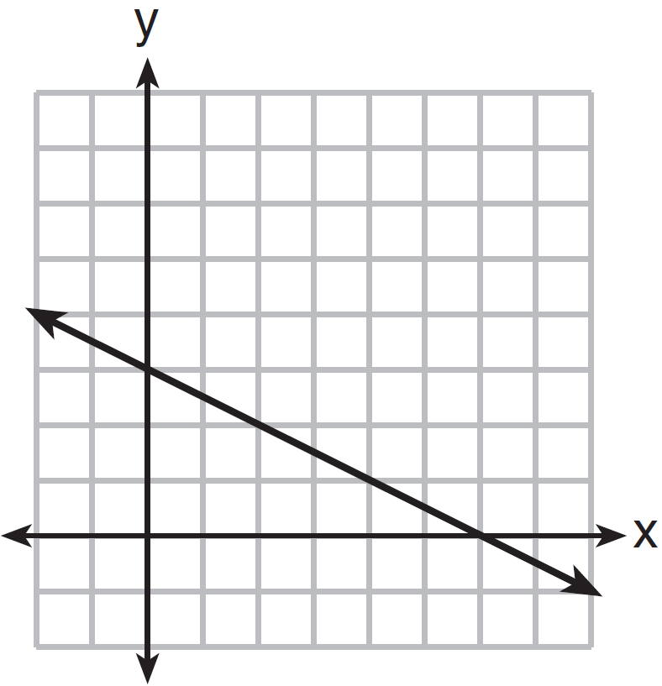

14 The table below shows the average diameter of a pupil in a person’s eye as he or she grows older.

Age  (years) | Average Pupil  Diameter (mm)
20 | 4.7
30 | 4.3
40 | 3.9
50 | 3.5
60 | 3.1
70 | 2.7
80 | 2.3

What is the average rate of change, in millimeters per year, of a person’s pupil diameter from age 20 to age 80?
1) | 2.4 | 3)
2) | 0.04 | 4)

15 Which expression is equivalent to ?
1) |  | 3)
2) |  | 4)

16 The third term in an arithmetic sequence is 10 and the fifth term is 26. If the first term is , which is an equation for the nth term of this sequence?
1) |  | 3)
2) |  | 4)

17 The graph of the equation is shown below.

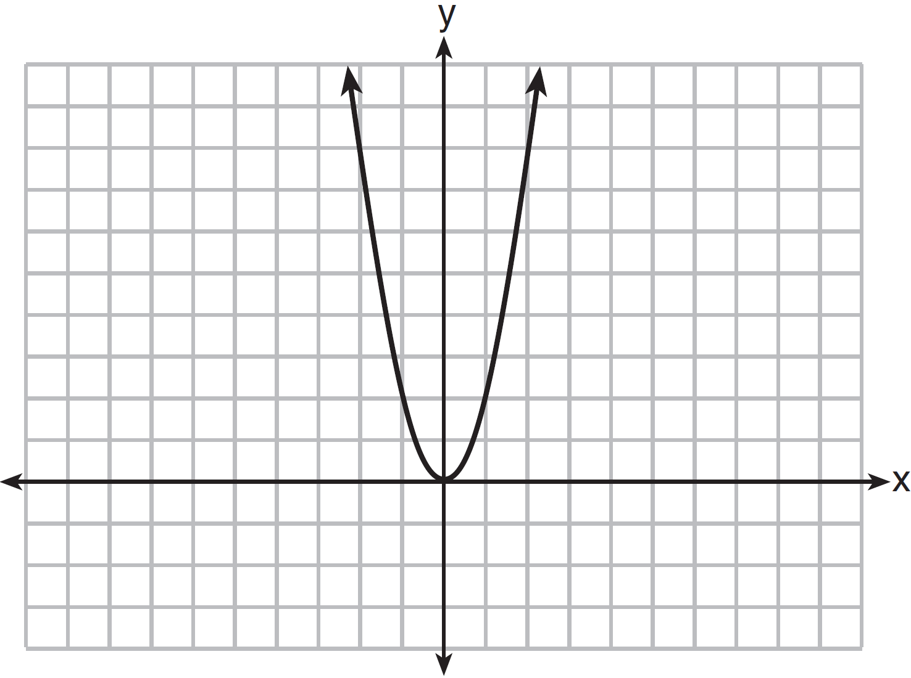

If a is multiplied by , the graph of the new equation is
1) | wider and opens downward | 3) | narrower and opens downward
2) | wider and opens upward | 4) | narrower and opens upward

18 The zeros of the function are
1) | and 5 | 3) | and 2
2) | and 7 | 4) | and 3

19 During the 2010 season, football player McGee’s earnings, m, were 0.005 million dollars more than those of his teammate Fitzpatrick’s earnings, f. The two players earned a total of 3.95 million dollars. Which system of equations could be used to determine the amount each player earned, in millions of dollars?
1) | 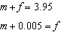 | 3) | 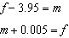
2) | 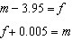 | 4) | 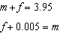

20 What is the value of x in the equation 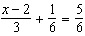?
1) | 4 | 3) | 8
2) | 6 | 4) | 11

21 The table below shows the number of grams of carbohydrates, x, and the number of Calories, y, of six different foods.
Carbohydrates (x) | Calories (y)
8 | 120
9.5 | 138
10 | 147
6 | 88
7 | 108
4 | 62

Which equation best represents the line of best fit for this set of data?
1) |  | 3)
2) |  | 4)

22 A function is graphed on the set of axes below.
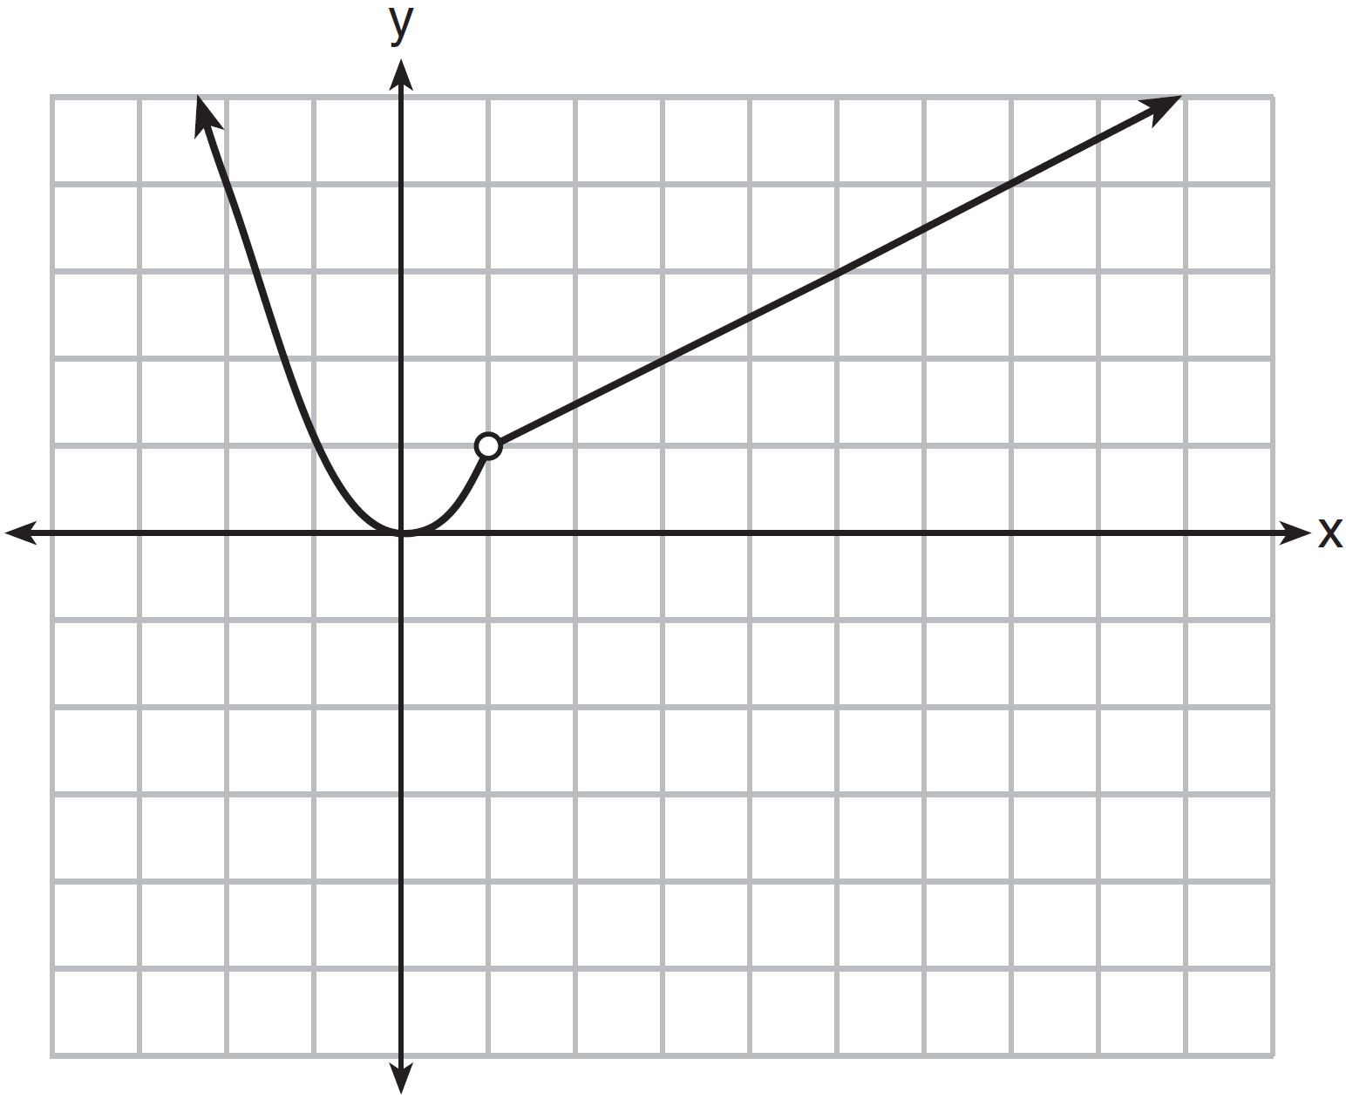

Which function is related to the graph?
1) | 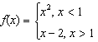 | 3) | 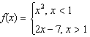
2) | 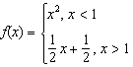 | 4) | 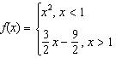

23 The function represents the height, , in feet, of an object from the ground at t seconds after it is dropped. A realistic domain for this function is
1) |  | 3)
2) |  | 4) | all real numbers

24 If and , then
1) |  | 3) | 21
2) | 11 | 4) | 43

25 In the equation , b is an integer. Find algebraically all possible values of b.

26 Rhonda deposited $3000 in an account in the Merrick National Bank, earning 4.2% interest, compounded annually. She made no deposits or withdrawals. Write an equation that can be used to find B, her account balance after t years.

27 Guy and Jim work at a furniture store. Guy is paid $185 per week plus 3% of his total sales in dollars, x, which can be represented by . Jim is paid $275 per week plus 2.5% of his total sales in dollars, x, which can be represented by . Determine the value of x, in dollars, that will make their weekly pay the same.

28 Express the product of and in standard form.

29 Let f be the function represented by the graph below.

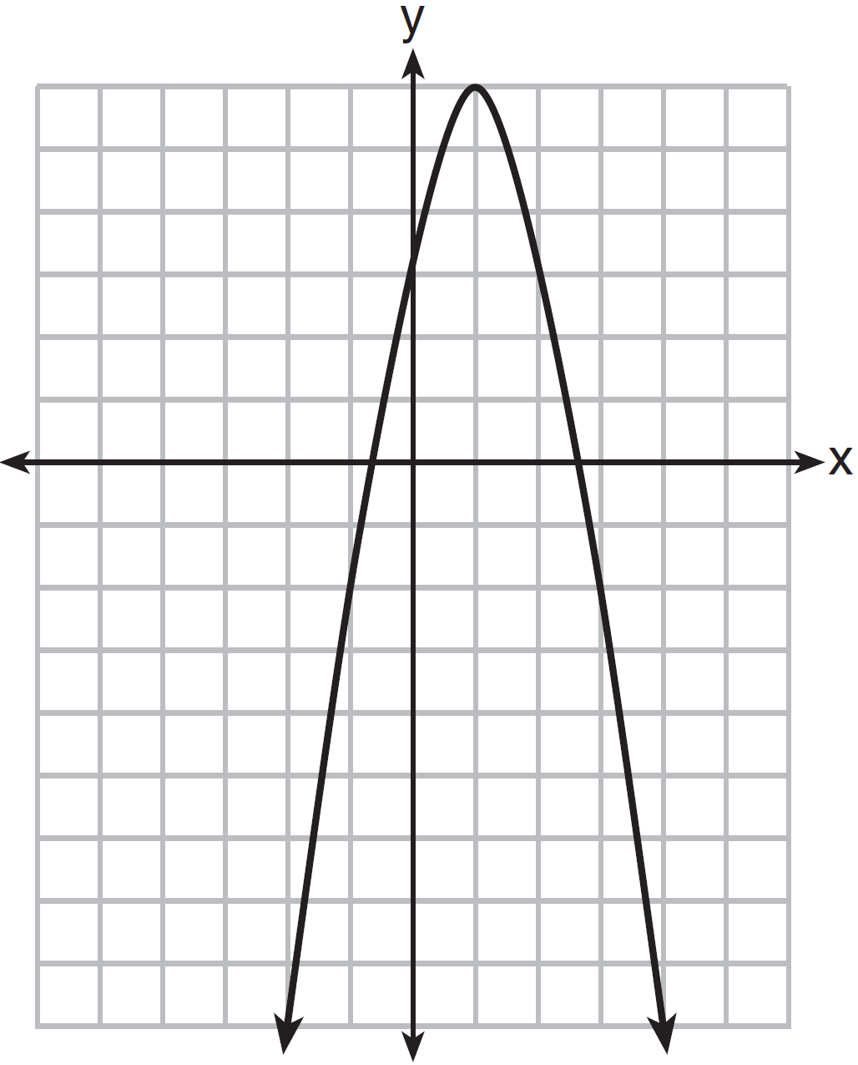

Let g be a function such that 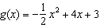. Determine which function has the larger maximum value. Justify your answer.

30 Solve the inequality below to determine and state the smallest possible value for x in the solution set.

31 The table below represents the residuals for a line of best fit.
x | 2 | 3 | 3 | 4 | 6 | 7 | 8 | 9 | 9 | 10
Residual | 2 | 1 |  |  |  |  |  | 2 | 0 | 3

Plot these residuals on the set of axes below.
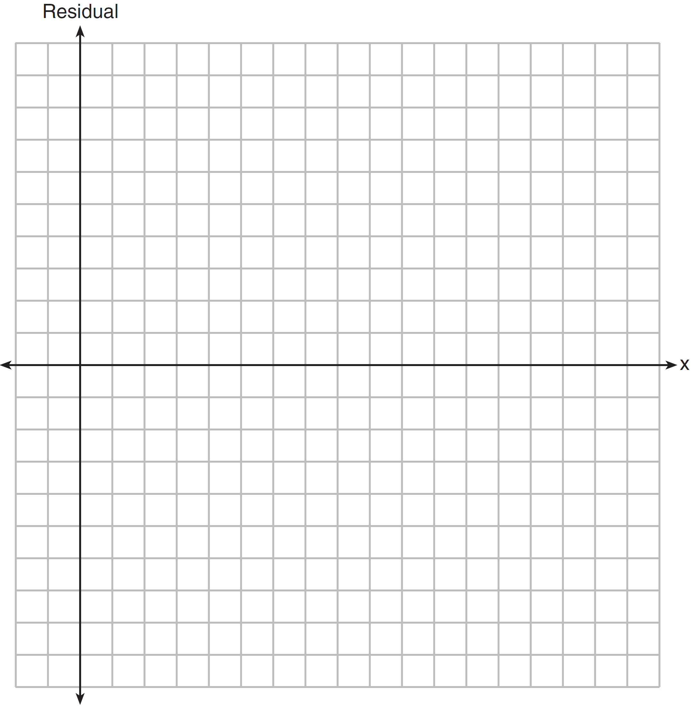

Using the plot, assess the fit of the line for these residuals and justify your answer.

32 A student was given the equation to solve by completing the square. The first step that was written is shown below.
The next step in the student’s process was . State the value of c that creates a perfect square trinomial. Explain how the value of c is determined.

33 On the axes below, graph .
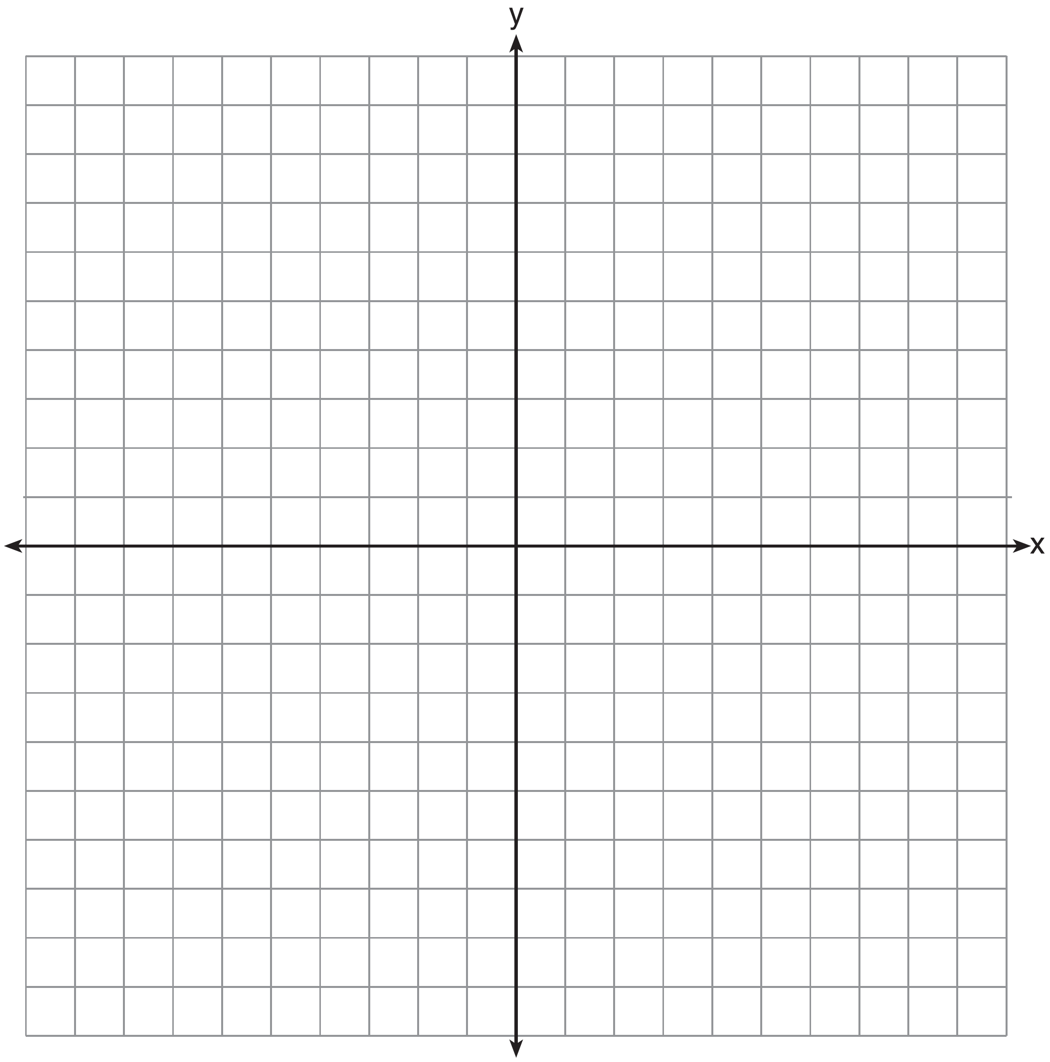

If , how is the graph of translated to form the graph of ? If , how is the graph of translated to form the graph of ?

34 The formula for the area of a trapezoid is 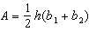. Express in terms of A, h, and . The area of a trapezoid is 60 square feet, its height is 6 ft, and one base is 12 ft. Find the number of feet in the other base.

35 Let and . On the set of axes below, draw the graphs of and .

Using this graph, determine and state all values of x for which .

36 A school is building a rectangular soccer field that has an area of 6000 square yards. The soccer field must be 40 yards longer than its width. Determine algebraically the dimensions of the soccer field, in yards.

37 Edith babysits for x hours a week after school at a job that pays $4 an hour. She has accepted a job that pays $8 an hour as a library assistant working y hours a week. She will work both jobs. She is able to work no more than 15 hours a week, due to school commitments. Edith wants to earn at least $80 a week, working a combination of both jobs. Write a system of inequalities that can be used to represent the situation. Graph these inequalities on the set of axes below.

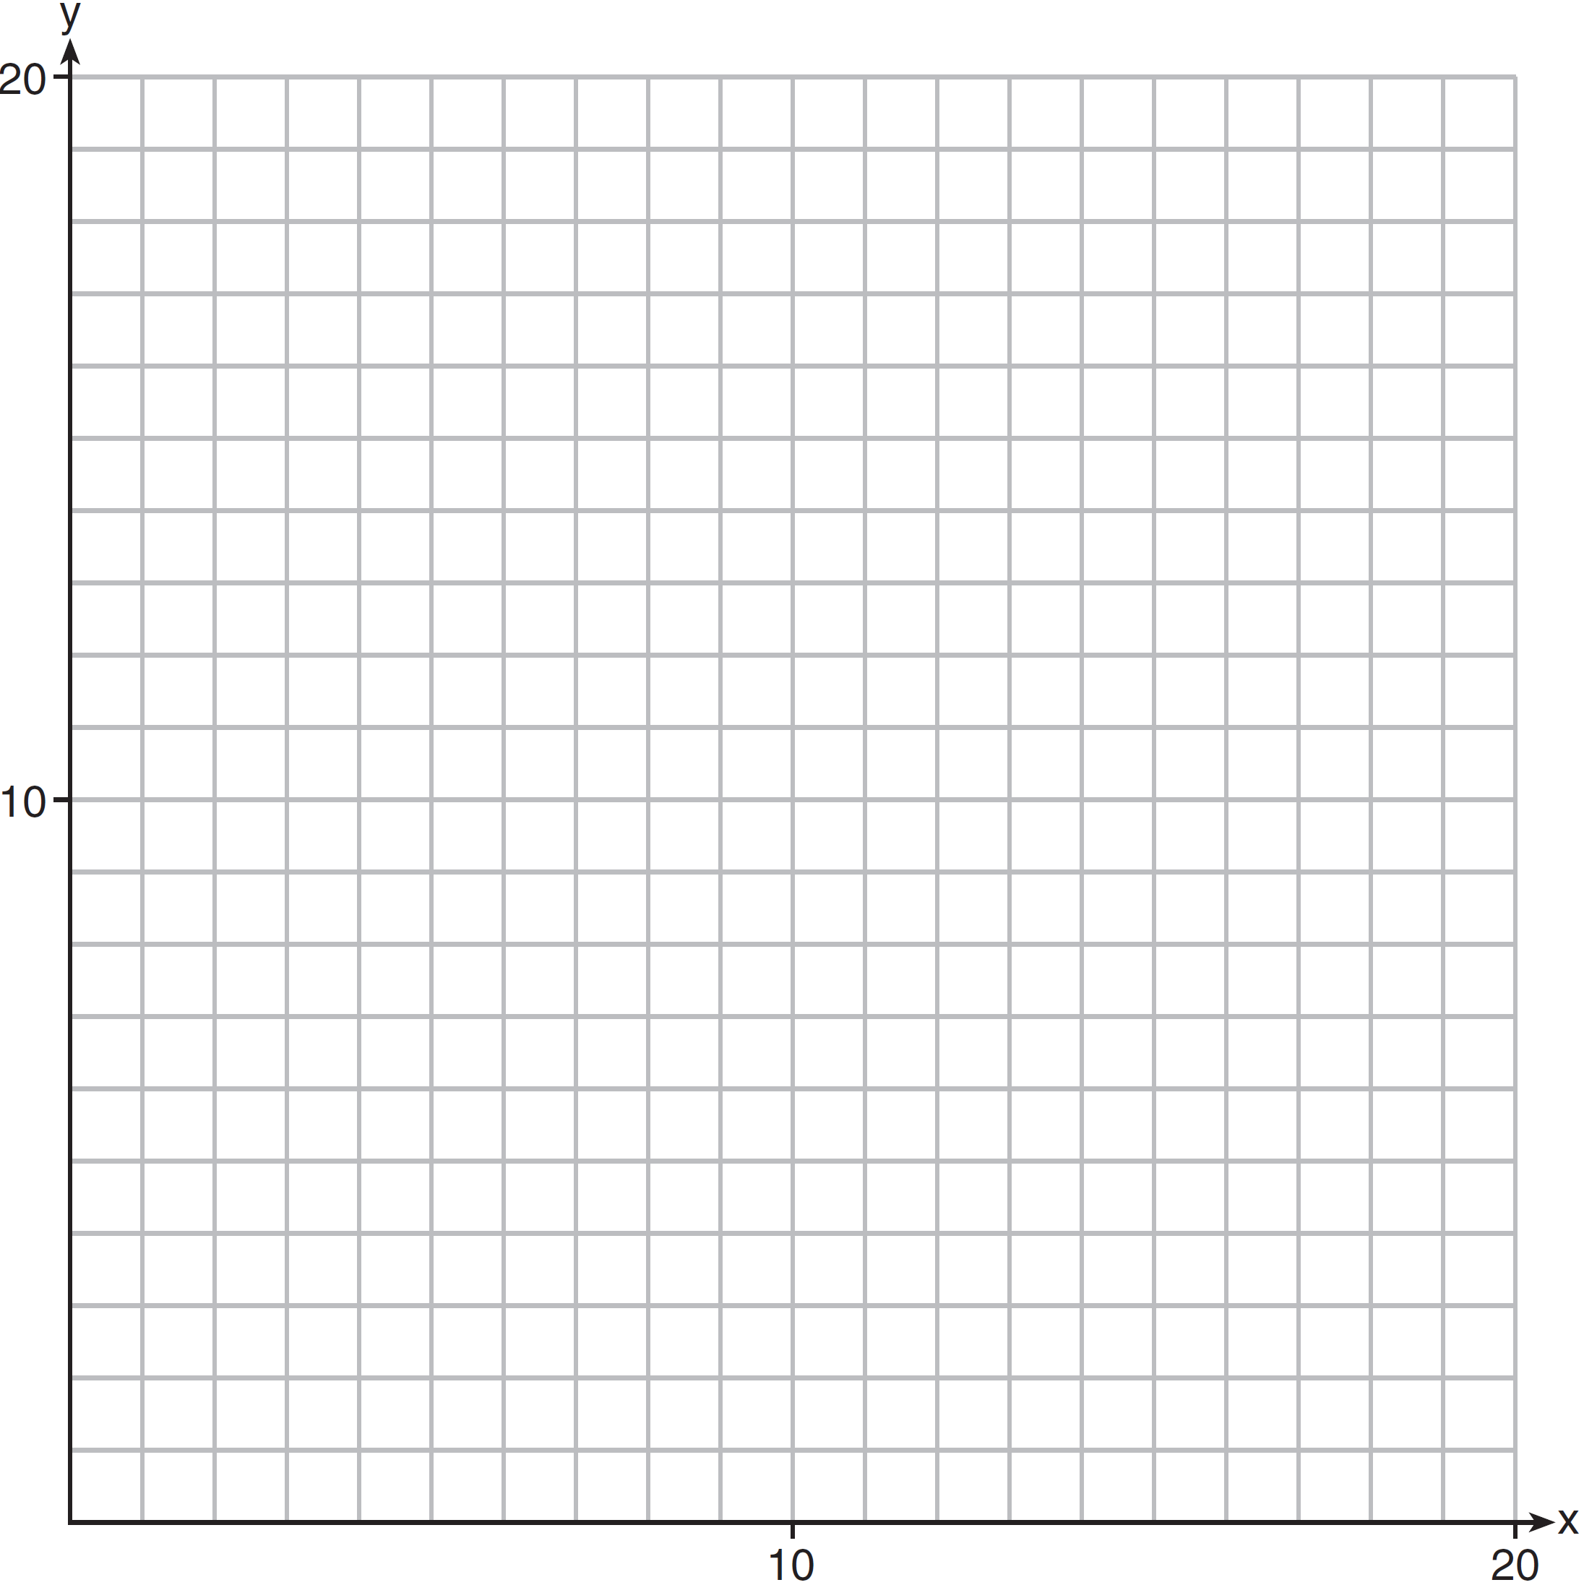

Determine and state one combination of hours that will allow Edith to earn at least $80 per week while working no more than 15 hours.
1 ANS: 1 PTS: 2 REF: 081401ai NAT: N.RN.B.3
TOP: Operations with Radicals KEY: classify

2 ANS: 2 PTS: 2 REF: 081402ai NAT: F.LE.B.5
TOP: Modeling Linear Functions

3 ANS: 3 PTS: 2 REF: 081403ai NAT: A.REI.B.4
TOP: Solving Quadratics KEY: taking square roots

4 ANS: 3
 |  | Company 1 | Company 2
1 | median salary | 33,500 | 36,250
2 | mean salary | 33,750 | 44,125
3 | salary range | 8,000 | 36,000
4 | mean age | 28.25 | 28.25

PTS: 2 REF: 081404ai NAT: S.ID.A.2 TOP: Central Tendency and Dispersion

5 ANS: 4 PTS: 2 REF: 081405ai NAT: F.IF.B.4
TOP: Graphing Quadratic Functions KEY: no context

6 ANS: 2

PTS: 2 REF: 081406ai NAT: F.BF.A.1 TOP: Operations with Functions

7 ANS: 1 PTS: 2 REF: 081407ai NAT: A.REI.D.12
TOP: Graphing Systems of Linear Inequalities KEY: solution set

8 ANS: 1
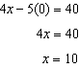

PTS: 2 REF: 081408ai NAT: F.IF.B.4 TOP: Graphing Linear Functions

9 ANS: 3 PTS: 2 REF: 081409ai NAT: A.CED.A.1
TOP: Modeling Quadratics

10 ANS: 3 PTS: 2 REF: 081410ai NAT: F.LE.A.1
TOP: Families of Functions KEY: bimodalgraph

11 ANS: 1
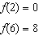

PTS: 2 REF: 081411ai NAT: F.IF.A.2 TOP: Domain and Range
KEY: limited domain

12 ANS: 3 PTS: 2 REF: 081412ai NAT: F.LE.A.1
TOP: Families of Functions

13 ANS: 2 PTS: 2 REF: 081413ai NAT: A.CED.A.2
TOP: Graphing Linear Functions KEY: bimodalgraph

14 ANS: 4
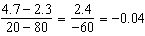.

PTS: 2 REF: 081414ai NAT: F.IF.B.6 TOP: Rate of Change
KEY: AI

15 ANS: 1 PTS: 2 REF: 081415ai NAT: A.SSE.A.2
TOP: Factoring Polynomials KEY: higher power AI

16 ANS: 2 PTS: 2 REF: 081416ai NAT: F.LE.A.2
TOP: Sequences

17 ANS: 1 PTS: 2 REF: 081417ai NAT: F.BF.B.3
TOP: Graphing Polynomial Functions

18 ANS: 4
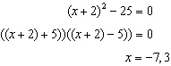

PTS: 2 REF: 081418ai NAT: A.APR.B.3 TOP: Zeros of Polynomials
KEY: AI

19 ANS: 4 PTS: 2 REF: 081419ai NAT: A.CED.A.3
TOP: Modeling Linear Systems

20 ANS: 1
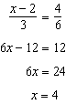

PTS: 2 REF: 081420ai NAT: A.REI.B.3 TOP: Solving Linear Equations
KEY: fractional expressions

21 ANS: 4 PTS: 2 REF: 081421ai NAT: S.ID.B.6
TOP: Regression KEY: linear

22 ANS: 2 PTS: 2 REF: 081422ai NAT: F.IF.C.7
TOP: Graphing Piecewise-Defined Functions

23 ANS: 2
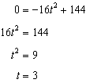

PTS: 2 REF: 081423ai NAT: F.IF.B.5 TOP: Domain and Range

24 ANS: 4

PTS: 2 REF: 081424ai NAT: F.IF.A.3 TOP: Sequences
KEY: term

25 ANS:
6 and 4

PTS: 2 REF: 081425ai NAT: A.SSE.B.3 TOP: Solving Quadratics

26 ANS:

PTS: 2 REF: 081426ai NAT: F.BF.A.1 TOP: Modeling Exponential Functions
KEY: AI

27 ANS:
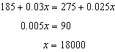

PTS: 2 REF: 081427ai NAT: A.REI.C.6 TOP: Solving Linear Systems
KEY: substitution

28 ANS:
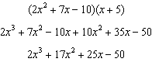

PTS: 2 REF: 081428ai NAT: A.APR.A.1 TOP: Operations with Polynomials
KEY: multiplication

29 ANS:
g. The maximum of f is 6. For g, the maximum is 11. 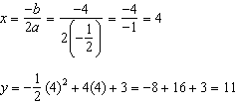

PTS: 2 REF: 081429ai NAT: F.IF.C.9 TOP: Comparing Functions
KEY: AI

30 ANS:
6. 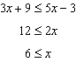

PTS: 2 REF: 081430ai NAT: A.REI.B.3 TOP: Interpreting Solutions

31 ANS:
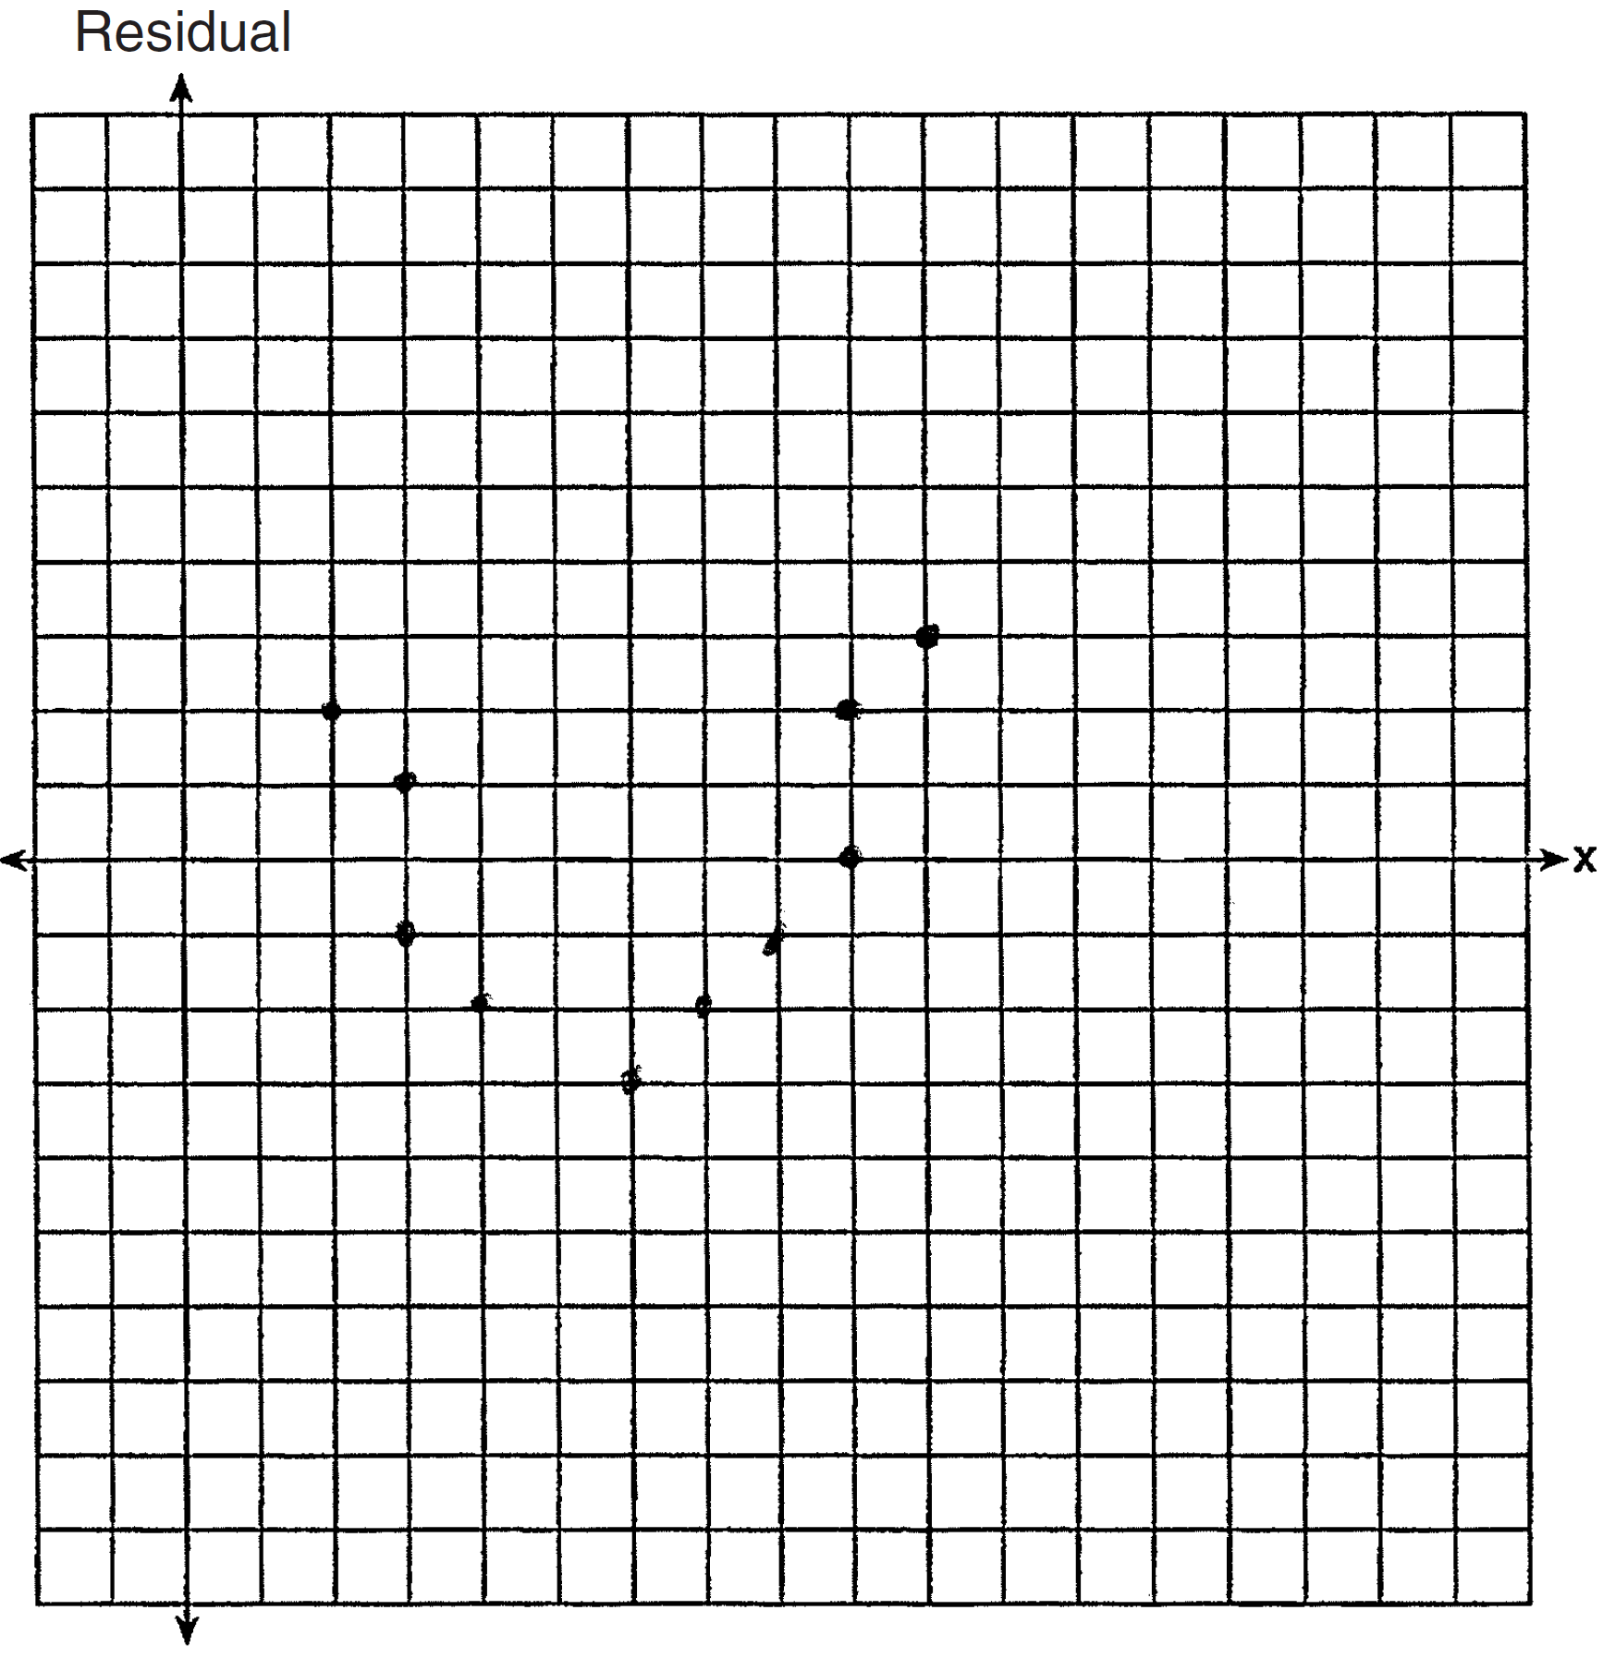 The line is a poor fit because the residuals form a pattern.

PTS: 2 REF: 081431ai NAT: S.ID.B.6 TOP: Residuals

32 ANS:
Since , p is half the coefficient of x, and the constant term is equal to . 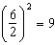

PTS: 2 REF: 081432ai NAT: A.REI.B.4 TOP: Solving Quadratics
KEY: completing the square

33 ANS:
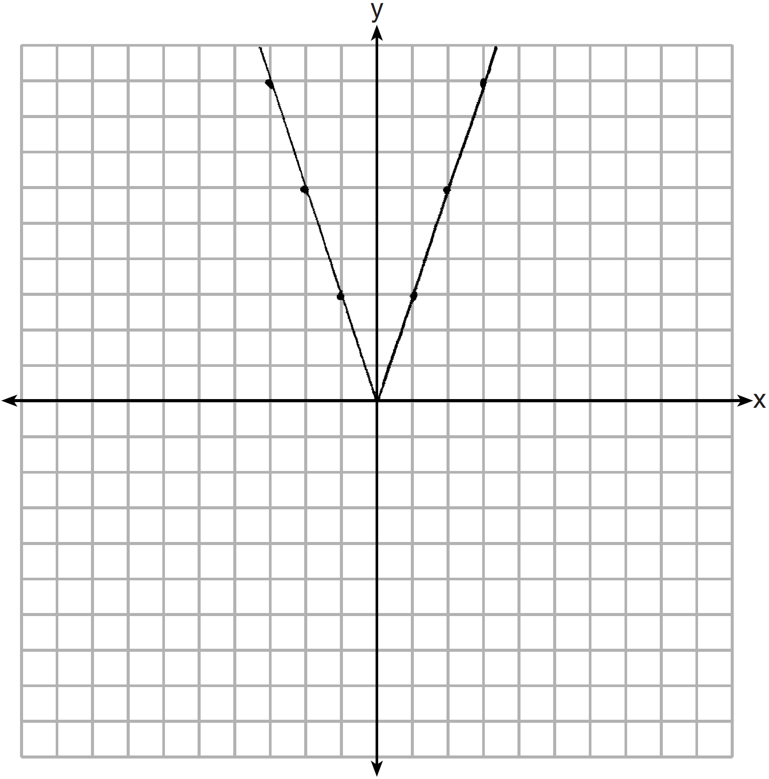 2 down. 4 right.

PTS: 4 REF: 081433ai NAT: F.BF.B.3 TOP: Graphing Absolute Value Functions

34 ANS:
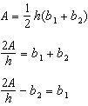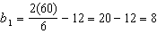

PTS: 4 REF: 081434ai NAT: A.CED.A.4 TOP: Transforming Formulas

35 ANS:
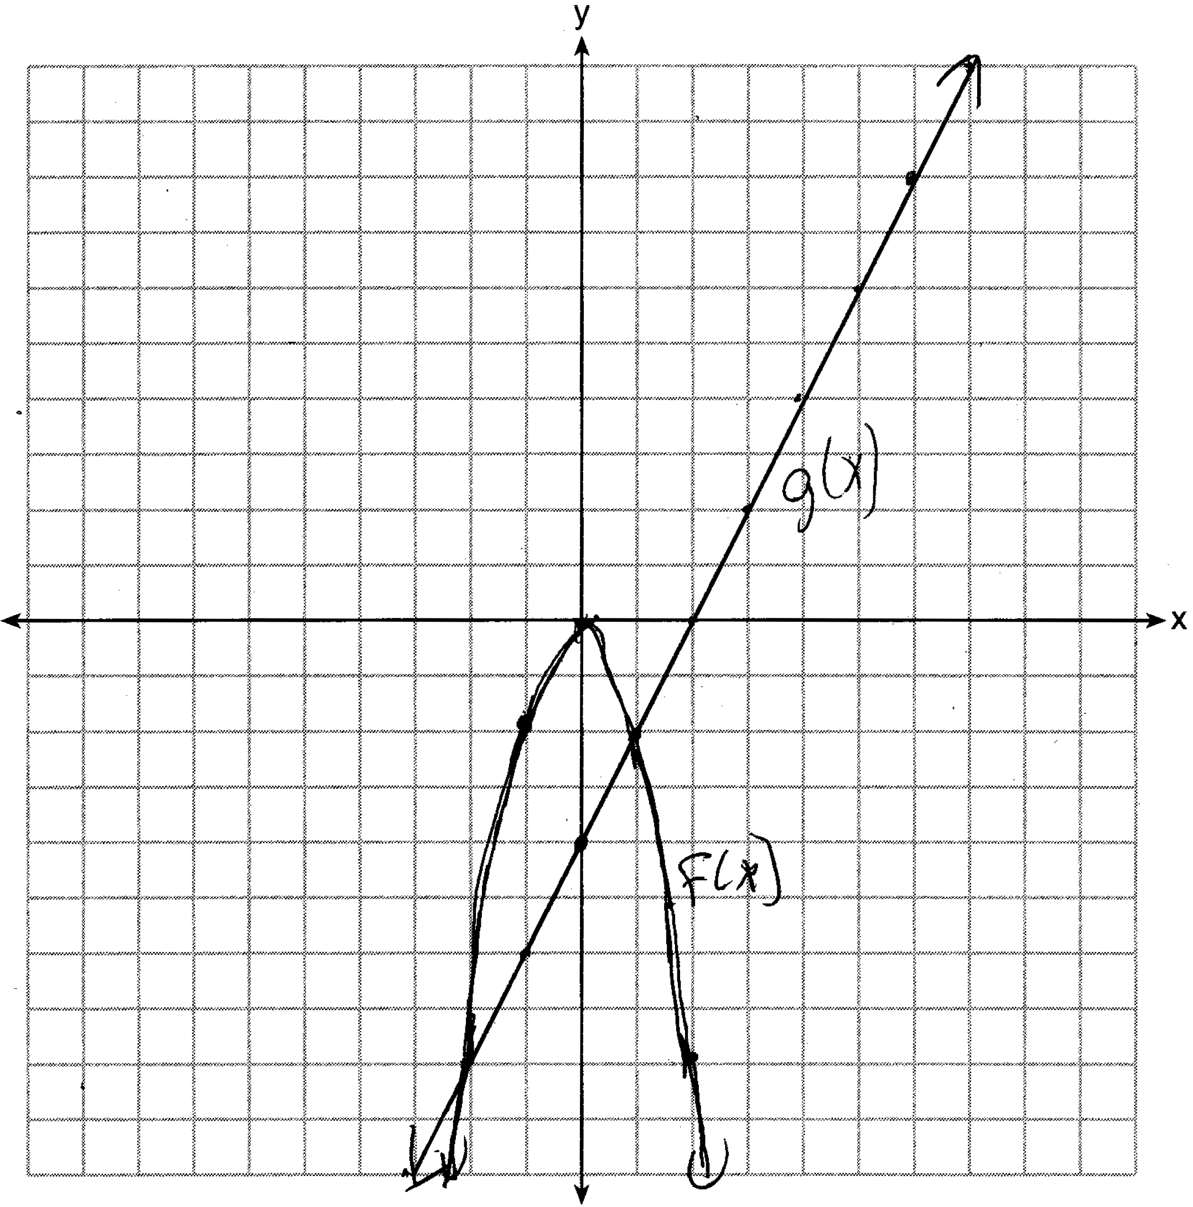

PTS: 4 REF: 081435ai NAT: A.REI.D.11 TOP: Quadratic-Linear Systems
KEY: AI

36 ANS:
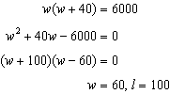

PTS: 4 REF: 081436ai NAT: A.CED.A.1 TOP: Geometric Applications of Quadratics

37 ANS:
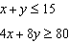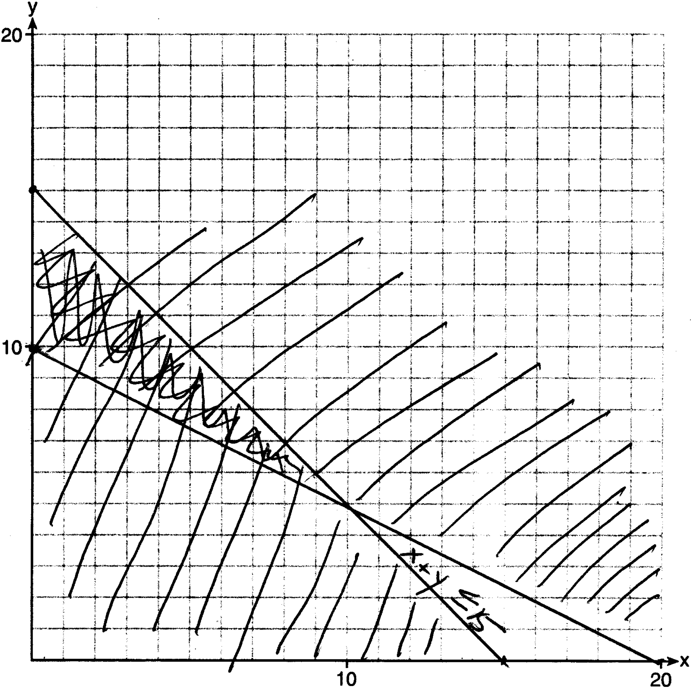 One hour at school and eleven hours at the library.

PTS: 6 REF: 081437ai NAT: A.CED.A.3 TOP: Modeling Systems of Linear Inequalities

