1 The expression is equivalent to
1) |  | 3)
2) |  | 4)

2 Which expression represents an irrational number?
1) |  | 3)
2) |  | 4)

3 Which linear equation represents a line that passes through the point ?
1) |  | 3)
2) |  | 4)

4 The expression is equivalent to
1) |  | 3)
2) |  | 4)

5 The 24th term of the sequence is
1) |  | 3) | 133
2) |  | 4) | 139

6 When completing the square for , which equation is a correct step in this process?
1) |  | 3)
2) |  | 4)

7 Which function will have the greatest value when ?
1) |  | 3)
2) |  | 4)

8 Mike uses the equation to determine the growth of bacteria in a laboratory setting. The exponent represents
1) | the total number of bacteria currently present | 3) | the initial amount of bacteria
2) | the percent at which the bacteria are growing | 4) | the number of time periods

9 A company ships an average of 30,000 items each week. The approximate number of items shipped each minute is calculated using the conversion
1) | 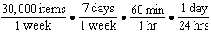 | 3) | 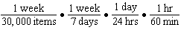
2) | 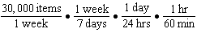 | 4) | 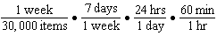

10 A function is graphed below.

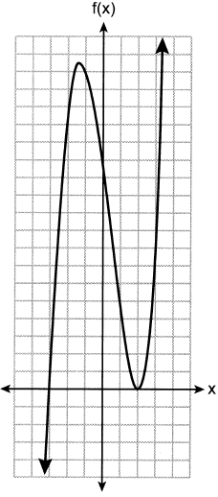

A possible equation for this function is
1) |  | 3)
2) |  | 4)

11 If then is equal to
1) |  | 3) | 17
2) |  | 4) | 25

12 A movie theater's popcorn box is a rectangular prism with a base that measures 6 inches by 4 inches and has a height of 8 inches. To create a larger box, both the length and the width will be increased by x inches. The height will remain the same. Which function represents the volume, , of the larger box?
1) |  | 3)
2) |  | 4)

13 The expression is equivalent to
1) |  | 3)
2) |  | 4)

14 Ashley only has 7 quarters and some dimes in her purse. She needs at least $3.00 to pay for lunch. Which inequality could be used to determine the number of dimes, d, she needs in her purse to be able to pay for lunch?
1) |  | 3)
2) |  | 4)

15 The formula for the area of a trapezoid is 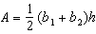. The height, h, of the trapezoid may be expressed as
1) |  | 3) | 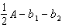
2) | 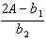 | 4) | 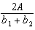

16 The function is multiplied by k to create the new function . Which statement is true about the graphs of and if 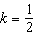?
1) | is a reflection of over the y-axis. | 3) | is wider than .
2) | is a reflection of over the x-axis. | 4) | is narrower than .

17 Some adults were surveyed to find out if they would prefer to buy a sports utility vehicle (SUV) or a sports car. The results of the survey are summarized in the table below.

 | SUV | Sports Car | Totals
Male | 21 | 38 | 59
Female | 135 | 46 | 181
Totals | 156 | 84 | 240

Of the number of adults that preferred sports cars, approximately what percent were males?
1) | 15.8 | 3) | 64.4
2) | 45.2 | 4) | 82.6

18 The solution to is
1) |  | 3)
2) |  | 4)

19 Three quadratic functions are given below.

I.

II.
x |  |  |  |  | 0 | 1
g(x) |  | 2 | 5 | 5 | 2

III.
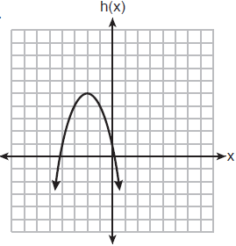

Which of these functions have the same vertex?
1) | I and II, only | 3) | I and III, only
2) | II and III, only | 4) | I, II, and III

20 The domain of the function is
1) |  | 3)
2) |  | 4)

21 A father makes a deal with his son regarding his weekly allowance. The first year, he agrees to pay his son a weekly allowance of $10. Every subsequent year, the allowance is recalculated by doubling the previous year's weekly allowance and then subtracting 8. Which recursive formula could be used to calculate the son's weekly allowance in future years?
1) |  | 3) | 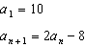
2) |  | 4) | 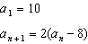

22 What is the solution to the inequality below?
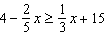
1) |  | 3)
2) |  | 4)

23 Which statement is correct about the polynomial ?
1) | It is a third-degree polynomial with a constant term of . | 3) | It is a second-degree polynomial with a constant term of 2.
2) | It is a third-degree polynomial with a leading coefficient of 3. | 4) | It is a second-degree polynomial with a leading coefficient of 3.

24 A store manager is trying to determine if they should continue to sell a particular brand of nails. To model their profit, they use the function , where n is the number of boxes of these nails sold in a day. A reasonable domain for this function would be
1) | nonnegative integers | 3) | real numbers
2) | rational numbers | 4) | integers

25 Solve the equation algebraically for x:

26 The function is graphed on the set of axes below.

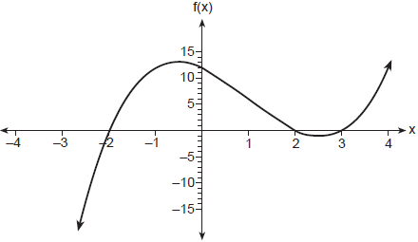

State the zeros of . Explain your reasoning.

27 Breanna creates the pattern of blocks below in her art class.

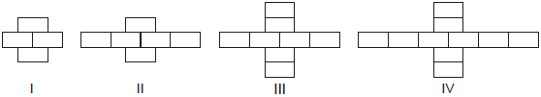

A friend tells her that the number of blocks in the pattern is increasing exponentially. Is her friend correct? Explain your reasoning.

28 The data set 20, 36, 52, 56, 24, 16, 40, 4, 28 represents the number of books purchased by nine book club members in a year. Construct a box plot for these data on the number line below.

29 Given:
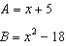
Express in standard form.

30 The two relations shown below are not functions.

Relation I:
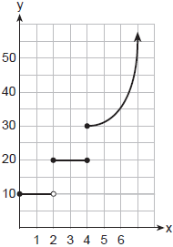

Relation II:

Explain how you could change each relation so that they each become a function.

31 Factor completely.

32 Solve algebraically for all values of d, rounding to the nearest tenth.

33 Graph and on the set of axes below.

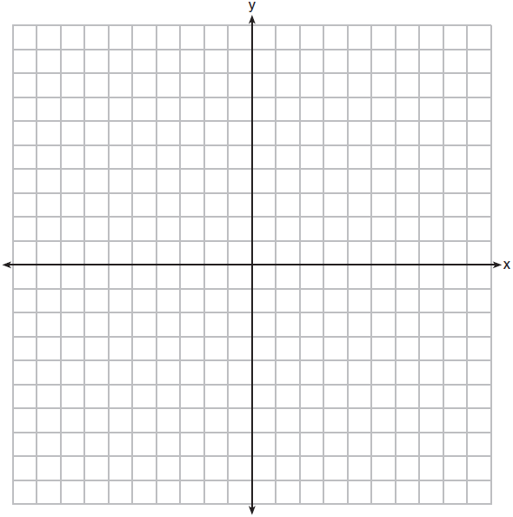

Based on your graph, determine all values of x for which .

34 Jean recorded temperatures over a 24-hour period one day in August in Syracuse, NY. Her results are shown in the table below.

Time (hour) | 0 | 3 | 6 | 9 | 12 | 15 | 18 | 21 | 24
Temperature (°F) | 80 | 75 | 70 | 78 | 92 | 89 | 85 | 80 | 74

Her data are modeled on the graph below.

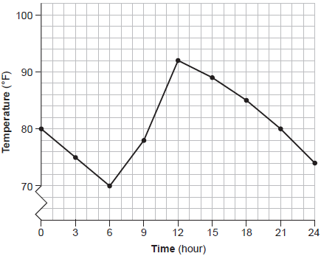

State the entire interval over which the temperature is increasing. State the three-hour interval that has the greatest rate of change in temperature. State the average rate of change from hour 12 to hour 24. Explain what this means in the context of the problem.

35 Solve the following system of inequalities graphically on the set of axes below.
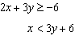
Label the solution set S.
.
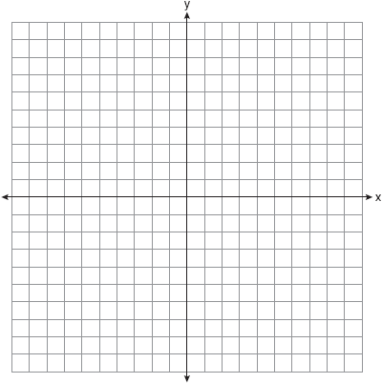

Is the point in the solution set? Explain your answer.

36 Suzanna collected information about a group of ponies and horses. She made a table showing the height, measured in hands (hh), and the weight, measured in pounds (lbs), of each pony and horse.

Height (hh)  x | Weight (lbs)  y
11 | 264
12 | 638
13 | 700
14 | 850
15 | 1000
16 | 1230
17 | 1495

Write the linear regression equation for this set of data. Round all values to the nearest hundredth. State the correlation coefficient for the linear regression. Round your answer to the nearest hundredth. Explain what the correlation coefficient indicates about the linear fit of the data in the context of the problem.

37 Dana went shopping for plants to put in her garden. She bought three roses and two daisies for $31.88. Later that day, she went back and bought two roses and one daisy for $18.92. If r represents the cost of one rose and d represents the cost of one daisy, write a system of equations that models this situation. Use your system of equations to algebraically determine both the cost of one rose and the cost of one daisy. If Dana had waited until the plants were on sale, she would have paid $4.50 for each rose and $6.50 for each daisy. Determine the total amount of money she would have saved by buying all of her flowers during the sale.
1 ANS: 1 PTS: 2 REF: 062301ai NAT: A.SSE.A.2
TOP: Factoring the Difference of Perfect Squares

2 ANS: 3 PTS: 2 REF: 062302ai NAT: N.RN.B.3
TOP: Operations with Radicals KEY: classify

3 ANS: 1 PTS: 2 REF: 062303ai NAT: A.REI.D.10
TOP: Identifying Solutions

4 ANS: 2

PTS: 2 REF: 062304ai NAT: A.APR.A.1 TOP: Operations with Polynomials
KEY: subtraction

5 ANS: 2

PTS: 2 REF: 062305ai NAT: F.IF.A.3 TOP: Sequences
KEY: explicit

6 ANS: 1
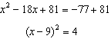

PTS: 2 REF: 062306ai NAT: A.REI.B.4 TOP: Solving Quadratics
KEY: completing the square

7 ANS: 1 PTS: 2 REF: 062307ai NAT: F.LE.A.3
TOP: Families of Functions

8 ANS: 4 PTS: 2 REF: 062308ai NAT: F.LE.B.5
TOP: Modeling Exponential Functions

9 ANS: 2 PTS: 2 REF: 062309ai NAT: N.Q.A.1
TOP: Conversions KEY: dimensional analysis

10 ANS: 3 PTS: 2 REF: 062310ai NAT: A.APR.B.3
TOP: Graphing Polynomial Functions

11 ANS: 2

PTS: 2 REF: 062311ai NAT: F.IF.A.2 TOP: Functional Notation

12 ANS: 2 PTS: 2 REF: 062312ai NAT: A.CED.A.2
TOP: Modeling Quadratics

13 ANS: 1 PTS: 2 REF: 062313ai NAT: A.SSE.B.3
TOP: Modeling Exponential Functions

14 ANS: 2 PTS: 2 REF: 062314ai NAT: A.CED.A.1
TOP: Modeling Linear Inequalities

15 ANS: 4
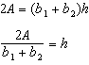

PTS: 2 REF: 062315ai NAT: A.CED.A.4 TOP: Transforming Formulas

16 ANS: 3 PTS: 2 REF: 062316ai NAT: F.BF.B.3
TOP: Graphing Absolute Value Functions

17 ANS: 2
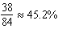

PTS: 2 REF: 062317ai NAT: S.ID.B.5 TOP: Frequency Tables
KEY: two-way

18 ANS: 4
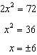

PTS: 2 REF: 062318ai NAT: A.REI.B.4 TOP: Solving Quadratics
KEY: taking square roots

19 ANS: 3
f and h’s vertex is . g’s axis of symmetry is .

PTS: 2 REF: 062319ai NAT: F.IF.C.9 TOP: Comparing Functions

20 ANS: 2 PTS: 2 REF: 062320ai NAT: F.IF.A.2
TOP: Domain and Range

21 ANS: 3 PTS: 2 REF: 062321ai NAT: F.LE.A.2
TOP: Sequences KEY: recursive

22 ANS: 3
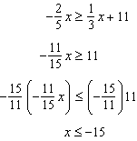

PTS: 2 REF: 062322ai NAT: A.REI.B.3 TOP: Solving Linear Inequalities

23 ANS: 4 PTS: 2 REF: 062323ai NAT: A.SSE.A.1
TOP: Modeling Expressions

24 ANS: 1 PTS: 2 REF: 062324ai NAT: F.IF.B.5
TOP: Domain and Range KEY: context

25 ANS:
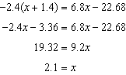

PTS: 2 REF: 062325ai NAT: A.REI.B.3 TOP: Solving Linear Equations

26 ANS:
are the x-intercepts of f.

PTS: 2 REF: 062326ai NAT: A.APR.B.3 TOP: Zeros of Polynomials

27 ANS:
No, because the number of blocks is increasing by a constant amount.

PTS: 2 REF: 062327ai NAT: F.LE.A.1 TOP: Families of Functions

28 ANS:
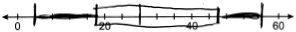

PTS: 4 REF: 062328ai NAT: S.ID.A.1 TOP: Box Plots
KEY: represent

29 ANS:

PTS: 2 REF: 062329ai NAT: A.APR.A.1 TOP: Operations with Polynomials
KEY: multiplication

30 ANS:
I: Change to an open circle. II: Remove .

PTS: 2 REF: 062330ai NAT: F.IF.A.1 TOP: Defining Functions

31 ANS:

PTS: 2 REF: 062331ai NAT: A.SSE.A.2 TOP: Factoring Polynomials

32 ANS:
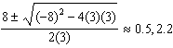

PTS: 2 REF: 062332ai NAT: A.REI.B.4 TOP: Solving Quadratics
KEY: quadratic formula

33 ANS:
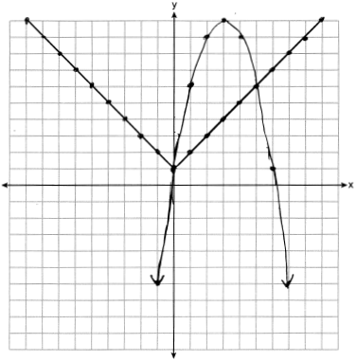

PTS: 4 REF: 062333ai NAT: A.REI.D.11 TOP: Other Systems

34 ANS:
6-12; 9-12; 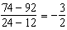; The temperature drops 3° every 2 hours.

PTS: 2 REF: 062334ai NAT: F.IF.B.6 TOP: Rate of Change

35 ANS:
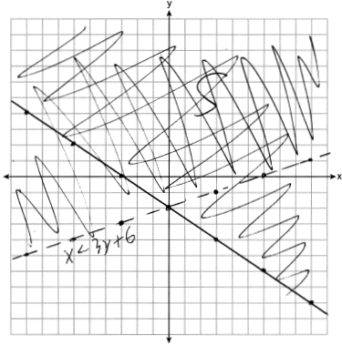; No, because is false.

PTS: 4 REF: 062335ai NAT: A.REI.D.12 TOP: Graphing Systems of Linear Inequalities

36 ANS:
, 0.99, As the height of the horse increases, the weight of the horse increases.

PTS: 4 REF: 062336ai NAT: S.ID.B.6 TOP: Regression
KEY: linear with correlation coefficient

37 ANS:
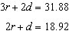; 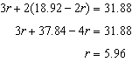; 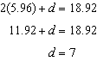; 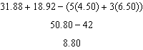

PTS: 6 REF: 062337ai NAT: A.CED.A.3 TOP: Modeling Linear Systems

