1 Which correlation shows a causal relationship?
1) | The more minutes an athlete is on the playing field, the more goals he scores. | 3) | The longer a shopper stays at the mall, the more purchases she makes.
2) | The more gasoline that you purchase at the pump, the more you pay. | 4) | As the price of a gift increases, the size of the gift box increases.

2 Given , which statement is true?
1) |  | 3)
2) |  | 4)

3 At Benny's Cafe, a mixed-greens salad costs $5.75. Additional toppings can be added for $0.75 each. Which function could be used to determine the cost, c(s), in dollars, of a salad with s additional toppings?
1) |  | 3)
2) |  | 4)

4 Which expression is equivalent to ?
1) |  | 3)
2) |  | 4)

5 Peter has $100 to spend on drinks for his party. Bottles of lemonade cost $2 each, and juice boxes cost $0.50 each. If x is the number of bottles of lemonade and y is the number of juice boxes, which inequality models this situation?
1) |  | 3)
2) |  | 4)

6 Which domain is most appropriate for a function that represents the number of items, f(x), placed into a laundry basket each day, x, for the month of January?
1) | integers | 3) | rational numbers
2) | whole numbers | 4) | irrational numbers

7 What is the solution to 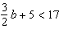?
1) |  | 3)
2) |  | 4)

8 Which table of values represents an exponential relationship?
1) | 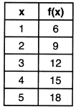 | 3) | 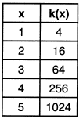
2) | 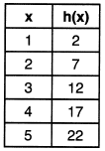 | 4) | 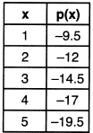

9 Which expression is not equivalent to 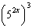?
1) | 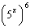 | 3) | 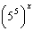
2) | 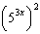 | 4) | 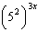

10 Which relation is a function?
1) | 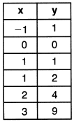 | 3) | 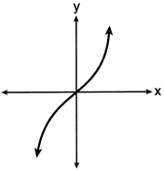
2) | 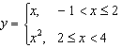 | 4)

11 The formula represents the equation of a line in standard form. Which expression represents y in terms of A, B, C, and x?
1) | 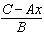 | 3) | 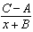
2) | 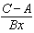 | 4) | 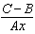

12 What are the zeros of ?
1) | 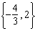 | 3) | 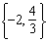
2) |  | 4)

13 Joe has dimes and nickels in his piggy bank totaling $1.45. The number of nickels he has is 5 more than twice the number of dimes, d. Which equation could be used to find the number of dimes he has?
1) |  | 3)
2) |  | 4)

14 Donna and Andrew compared their math final exam scores from grade 8 through grade 12. Their scores are shown below.

Donna
8th | 90
9th | 92
10th | 87
11th | 94
12th | 95

Andrew
8th | 78
9th | 96
10th | 87
11th | 94
12th | 93

Which statement about their final exam scores is correct?
1) | Andrew has a higher mean than Donna. | 3) | Andrew has a larger interquartile range than Donna.
2) | Donna and Andrew have the same median. | 4) | The 3rd quartile for Donna is greater than the 3rd quartile for Andrew.

15 The first term in a sequence is 5 and the fifth term is 17. What is the common difference?
1) | 2.4 | 3) | 3
2) | 12 | 4) | 4

16 A quadratic function and a linear function are graphed on the same set of axes. Which situation is not possible?
1) | The graphs do not intersect. | 3) | The graphs intersect in two points.
2) | The graphs intersect in one point. | 4) | The graphs intersect in three points.

17 The expression is equivalent to
1) |  | 3)
2) |  | 4)

18 Mrs. Rossano asked her students to explain why is a solution to . Three student responses are given below.
Andrea:
“When the equation is graphed on a calculator, the point can be found within its table."
Bill:
"Substituting and into the equation makes it true."
Christine:
"The graph of the line passes through the point ."
Which students are correct?
1) | Andrea and Bill, only | 3) | Andrea and Christine, only
2) | Bill and Christine, only | 4) | Andrea, Bill, and Christine

19 Four quadratic functions are shown below.
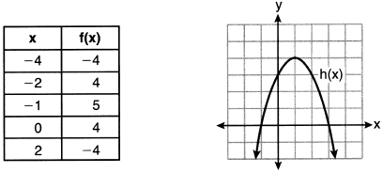

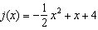
Which statement is true?
1) | The maximum of f(x) is less than the maximum of j(x). | 3) | The maximum of f(x) equals the maximum of g(x).
2) | The maximum of g(x) is less than the maximum of h(x). | 4) | The maximum of h(x) equals the maximum of j(x).

20 An example of a sixth-degree polynomial with a leading coefficient of seven and a constant term of four is
1) |  | 3)
2) |  | 4)

21 In the equation , A is the total amount, P is the principal amount, r is the annual interest rate, and t is the time in years. Which statement correctly relates information regarding the annual interest rate for each given equation?
1) | For , the principal amount of money is increasing at a 25% interest rate. | 3) | For , the principal amount of money is decreasing at a 14% interest rate.
2) | For , the principal amount of money is increasing at a 52% interest rate. | 4) | For , the principal amount of money is decreasing at a 68% interest rate.

22 It takes Tim 4.5 hours to run 50 kilometers. Which expression will allow him to change this rate to minutes per mile?
1) | 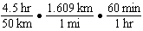 | 3) | 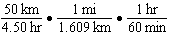
2) | 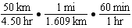 | 4) | 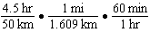

23 When the equation 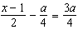 is solved for x in terms of a, the solution is
1) | 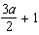 | 3) | 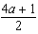
2) |  | 4)

24 If a sequence is defined recursively as and , then is
1) |  | 3) | 55
2) |  | 4) | 67

25 Is the product of and rational or irrational? Explain your reasoning.

26 Describe the transformations performed on the graph of to obtain the graph of when .

27 The total profit earned at a garage sale during the first five hours is modeled by the graph shown below.

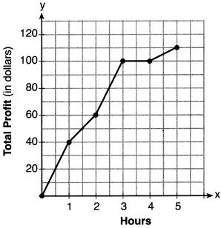

Determine the average rate of change, in dollars per hour, over the interval .

28 Subtract from and express your answer as a monomial.

29 A function is graphed on the set of axes below.

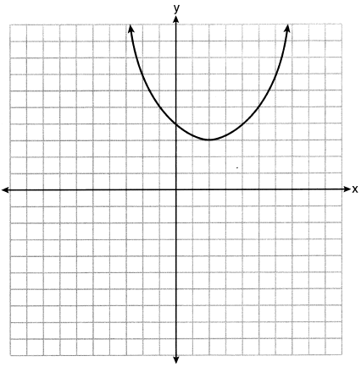

State the domain of this function. State the range of this function.

30 Solve algebraically for the exact values of x.

31 Factor the expression completely.

32 Determine the exact values of x for by completing the square.

33 The graph below models the height of Sam's kite over a period of time.

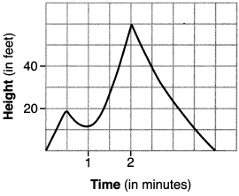

Explain what the zeros of the graph represent in the context of the situation. State the time intervals over which the height of the kite is increasing. State the maximum height, in feet, that the kite reaches.

34 On the set of axes below, graph and .

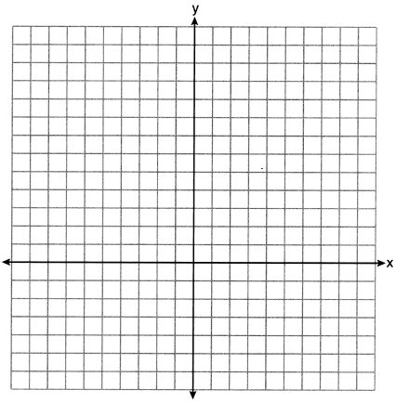

Based on your graph, for how many values of x does ? Explain your reasoning.

35 An insurance agent is looking at records to determine if there is a relationship between a driver's age and percentage of accidents caused by speeding. The table below shows his data.

Age (x) | 17 | 18 | 21 | 25 | 30 | 35 | 40 | 45 | 50 | 55 | 60 | 65
Percentage of Accidents Caused by Speeding (y) | 49 | 49 | 48 | 38 | 31 | 33 | 24 | 25 | 16 | 10 | 5 | 6

State the linear regression equation that models the relationship between the driver's age, x, and the percentage of accidents caused by speeding, y. Round all values to the nearest hundredth. State the value of the correlation coefficient to the nearest hundredth. Explain what this means in the context of the problem.

36 Solve the system of inequalities graphically on the set of axes below. Label the solution set S.
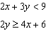

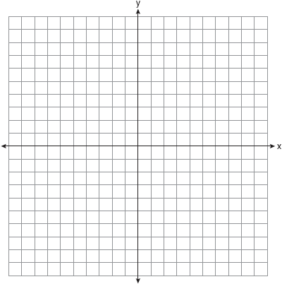

Determine if the point is a solution to this system of inequalities. Justify your answer.

37 At an amusement park, the cost for an adult admission is a, and for a child the cost is c. For a group of six that included two children, the cost was $325.94. For a group of five that included three children, the cost was $256.95. All ticket prices include tax. Write a system of equations, in terms of a and c, that models this situation. Use your system of equations to determine the exact cost of each type of ticket algebraically. Determine the cost for a group of four that includes three children.
1 ANS: 2 PTS: 2 REF: 062201ai NAT: S.ID.C.9
TOP: Analysis of Data

2 ANS: 2

PTS: 2 REF: 062202ai NAT: F.IF.A.2 TOP: Functional Notation

3 ANS: 2 PTS: 2 REF: 062203ai NAT: F.BF.A.1
TOP: Modeling Linear Functions

4 ANS: 4 PTS: 2 REF: 062204ai NAT: A.SSE.A.2
TOP: Factoring Polynomials KEY: quadratic

5 ANS: 3 PTS: 2 REF: 062205ai NAT: A.CED.A.3
TOP: Modeling Linear Inequalities

6 ANS: 2 PTS: 2 REF: 062206ai NAT: F.IF.B.5
TOP: Domain and Range

7 ANS: 1
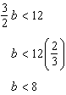

PTS: 2 REF: 062207ai NAT: A.REI.B.3 TOP: Solving Linear Inequalities

8 ANS: 3

PTS: 2 REF: 062208ai NAT: F.LE.A.1 TOP: Families of Functions

9 ANS: 3 PTS: 2 REF: 062209ai NAT: A.APR.A.1
TOP: Powers of Powers

10 ANS: 3 PTS: 2 REF: 062210ai NAT: F.IF.A.1
TOP: Defining Functions KEY: mixed

11 ANS: 1
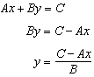

PTS: 2 REF: 062211ai NAT: A.CED.A.4 TOP: Transforming Formulas

12 ANS: 1
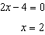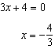

PTS: 2 REF: 062212ai NAT: A.APR.B.3 TOP: Zeros of Polynomials

13 ANS: 1 PTS: 2 REF: 062213ai NAT: A.CED.A.1
TOP: Modeling Linear Equations

14 ANS: 3
 | Donna | Andrew
mean | 91.6 | 89.6
median | 92 | 93
IQR | 6 | 12.5
3rd Q | 94.5 | 95

PTS: 2 REF: 062214ai NAT: S.ID.A.2 TOP: Central Tendency and Dispersion

15 ANS: 3
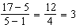

PTS: 2 REF: 062215ai NAT: F.IF.A.3 TOP: Sequences
KEY: difference or ratio

16 ANS: 4
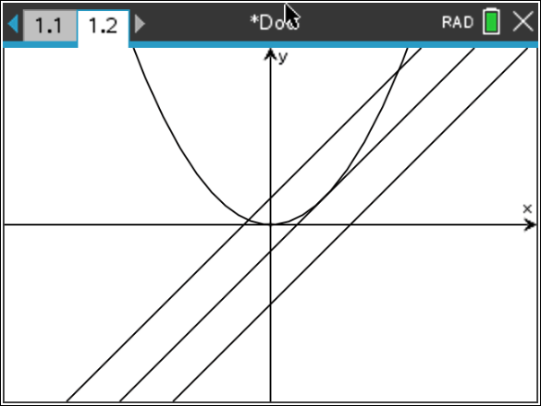

PTS: 2 REF: 062216ai NAT: A.REI.D.11 TOP: Quadratic-Linear Systems
KEY: AI

17 ANS: 3 PTS: 2 REF: 062217ai NAT: A.APR.A.1
TOP: Operations with Polynomials KEY: multiplication

18 ANS: 4 PTS: 2 REF: 062218ai NAT: A.REI.D.10
TOP: Identifying Solutions

19 ANS: 3
Maximum of Maximum of Maximum of 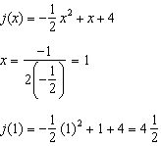

PTS: 2 REF: 062219ai NAT: F.IF.C.9 TOP: Comparing Functions

20 ANS: 2 PTS: 2 REF: 062220ai NAT: A.SSE.A.1
TOP: Modeling Expressions

21 ANS: 3 PTS: 2 REF: 062221ai NAT: F.LE.B.5
TOP: Modeling Exponential Functions

22 ANS: 1 PTS: 2 REF: 062222ai NAT: N.Q.A.1
TOP: Conversions KEY: dimensional analysis

23 ANS: 4
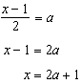

PTS: 2 REF: 062223ai NAT: A.CED.A.4 TOP: Transforming Formulas

24 ANS: 4

PTS: 2 REF: 062224ai NAT: F.IF.A.3 TOP: Sequences
KEY: recursive

25 ANS:
Rational, as, which is the ratio of two integers, 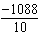.

PTS: 2 REF: 062225ai NAT: N.RN.B.3 TOP: Operations with Radicals
KEY: classify

26 ANS:
3 right and 4 down.

PTS: 2 REF: 062226ai NAT: F.BF.B.3 TOP: Graphing Polynomial Functions

27 ANS:
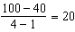

PTS: 2 REF: 062227ai NAT: F.IF.B.6 TOP: Rate of Change

28 ANS:

PTS: 2 REF: 062228ai NAT: A.APR.A.1 TOP: Operations with Polynomials
KEY: subtraction

29 ANS:
Domain is reals. Range is .

PTS: 2 REF: 062229ai NAT: F.IF.A.2 TOP: Domain and Range

30 ANS:
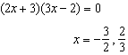

PTS: 2 REF: 062230ai NAT: A.REI.B.4 TOP: Solving Quadratics
KEY: factoring

31 ANS:

PTS: 2 REF: 062231ai NAT: A.SSE.A.2
TOP: Factoring the Difference of Perfect Squares KEY: higher power

32 ANS:
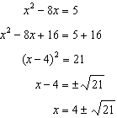

PTS: 2 REF: 062232ai NAT: A.REI.B.4 TOP: Solving Quadratics
KEY: completing the square

33 ANS:
The zeros represent when the height of the kite is 0. The height of the kite is increasing over 0-0.5 and 1-2 minutes. The maximum height of the kite is 60 feet.

PTS: 4 REF: 062233ai NAT: F.IF.B.4 TOP: Relating Graphs to Events

34 ANS:
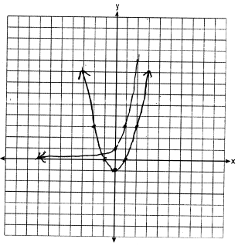 for one value of x because the graphs intersect once.

PTS: 4 REF: 062234ai NAT: A.REI.D.11 TOP: Other Systems

35 ANS:
, . There is a strong correlation between the driver’s age and the percentage of accidents caused by speeding.

PTS: 4 REF: 062235ai NAT: S.ID.B.6 TOP: Regression
KEY: linear with correlation coefficient

36 ANS:
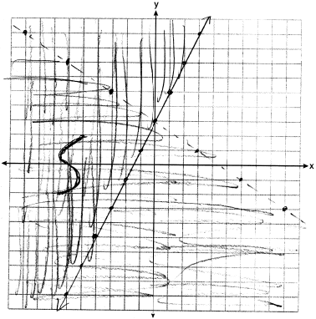 No, as .

PTS: 4 REF: 062236ai NAT: A.REI.D.12 TOP: Graphing Systems of Linear Inequalities

37 ANS:
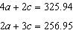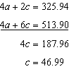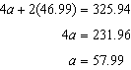

PTS: 6 REF: 062237ai NAT: A.CED.A.3 TOP: Modeling Linear Systems

