1 A high school club is researching a tour package offered by the Island Kayak Company. The company charges $35 per person and $245 for the tour guide. Which function represents the total cost, , of this kayak tour package for x club members?
1) |  | 3)
2) |  | 4)

2 The expression is equivalent to
1) |  | 3)
2) |  | 4)

3 A function is defined as . The value of is
1) |  | 3)
2) |  | 4)

4 Which relation is not a function?
1) | 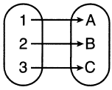 | 3) | 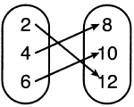
2) | 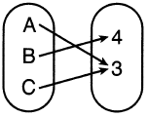 | 4) | 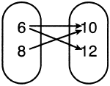

5 The value of Tony's investment was $1140 on January 1st. On this date three years later, his investment was worth $1824. The average rate of change for this investment was $19 per
1) | day | 3) | quarter
2) | month | 4) | year

6 The solution to is
1) |  | 3)
2) | 28 | 4)

7 An ice cream shop sells ice cream cones, c, and milkshakes, m. Each ice cream cone costs $1.50 and each milkshake costs $2.00. Donna has $19.00 to spend on ice cream cones and milkshakes. If she must buy 5 ice cream cones, which inequality could be used to determine the maximum number of milkshakes she can buy?
1) |  | 3)
2) |  | 4)

8 When written in standard form, the product of and is
1) |  | 3)
2) |  | 4)

9 If , , and , which expression results in a rational number?
1) |  | 3)
2) |  | 4)

10 Which product is equivalent to ?
1) |  | 3)
2) |  | 4)

11 Given: 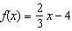 and 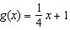
Four statements about this system are written below.
I.
II. When , .
III. The graphs of and intersect at .
IV. The graphs of and intersect at .
Which statement(s) are true?
1) | II, only | 3) | I and IV
2) | IV, only | 4) | II and III

12 Which sketch represents the polynomial function ?
1) | 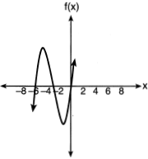 | 3) | 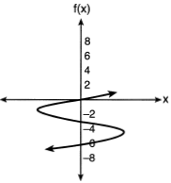
2) | 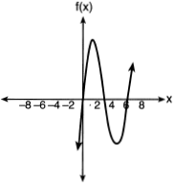 | 4) | 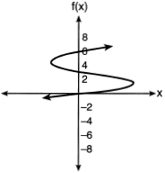

13 If the parent function of is then the graph of the function where would be a shift of
1) | k units to the left and a move of 5 units up | 3) | k units to the right and a move of 5 units up
2) | k units to the left and a move of 5 units down | 4) | k units to the right and a move of 5 units down

14 Which expression is equivalent to ?
1) |  | 3)
2) |  | 4)

15 Which function has the smallest y-intercept?
1) |  | 3)
2) | 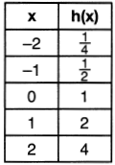 | 4) | 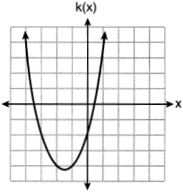

16 Which domain would be the most appropriate to use for a function that compares the number of emails sent (x) to the amount of data used for a cell phone plan (y)?
1) | integers | 3) | rational numbers
2) | whole numbers | 4) | irrational numbers

17 Eric deposits $500 in a bank account that pays 3.5% interest, compounded yearly. Which type of function should he use to determine how much money he will have in the account at the end of 10 years?
1) | linear | 3) | absolute value
2) | quadratic | 4) | exponential

18 Given: the sequence
When using the arithmetic sequence formula to determine the 10th term, which variable would be replaced with the number 3?
1) |  | 3)
2) | n | 4) | d

19 Below are two representations of data.

A:

B: 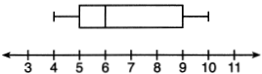

Which statement about A and B is true?
1) | median of A > median of B | 3) | upper quartile of A < upper quartile of B
2) | range of A < range of B | 4) | lower quartile of A > lower quartile of B

20 Which system has the same solution as the system below?
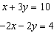
1) | 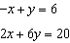 | 3) | 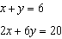
2) | 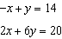 | 4) | 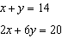

21 Given the pattern below, which recursive formula represents the number of triangles in this sequence?

1) |  | 3) | 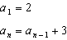
2) |  | 4) | 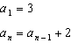

22 Students were asked to write an expression which had a leading coefficient of 3 and a constant term of . Which response is correct?
1) |  | 3)
2) |  | 4)

23 Sarah travels on her bicycle at a speed of 22.7 miles per hour. What is Sarah's approximate speed, in kilometers per minute?
1) | 0.2 | 3) | 36.5
2) | 0.6 | 4) | 36.6

24 Which ordered pair does not fall on the line formed by the other three?
1) |  | 3)
2) |  | 4)

25 Solve algebraically for y:

26 Graph the function 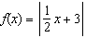 over the interval .

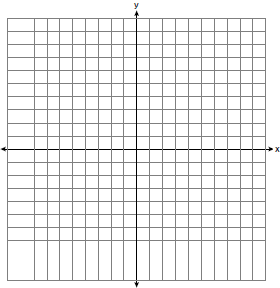

27 The table below shows the height in feet, , of a hot-air balloon and the number of minutes, t, the balloon is in the air.

Time (min) | 2 | 5 | 7 | 10 | 12
Height (ft) | 64 | 168 | 222 | 318 | 369

The function can be used to model this data table. Explain the meaning of the slope in the context of the problem. Explain the meaning of the y-intercept in the context of the problem.

28 Factor completely.

29 Mike knows that and are points on the graph of an exponential function, , and he wants to find another point on the graph of this function. First, he subtracts 6.5 from 17.55 to get 11.05. Next, he adds 11.05 and 17.55 to get 28.6. He states that is a point on . Is he correct? Explain your reasoning.

30 Use the method of completing the square to determine the vertex of . State the coordinates of the vertex.

31 The temperature inside a cooling unit is measured in degrees Celsius, C. Josh wants to find out how cold it is in degrees Fahrenheit, F. Solve the formula 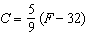 for F so that Josh can convert Celsius to Fahrenheit.

32 Solve algebraically for w, to the nearest hundredth.

33 Joey recorded his heart rate, in beats per minute (bpm), after doing different numbers of jumping jacks. His results are shown in the table below.

Number of Jumping Jacks  x | Heart Rate  (bpm)  y
0 | 68
10 | 84
15 | 104
20 | 100
30 | 120

State the linear regression equation that estimates the heart rate per number of jumping jacks. State the correlation coefficient of the linear regression equation, rounded to the nearest hundredth. Explain what the correlation coefficient suggests in the context of this problem.

34 Hannah went to the school store to buy supplies and spent $16. She bought four more pencils than pens and two fewer erasers than pens. Pens cost $1.25 each, pencils cost $0.55 each, and erasers cost $0.75 each. If x represents the number of pens Hannah bought, write an equation in terms of x that can be used to find how many of each item she bought. Use your equation to determine algebraically how many pens Hannah bought.

35 Graph the system of inequalities on the set of axes below:
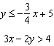

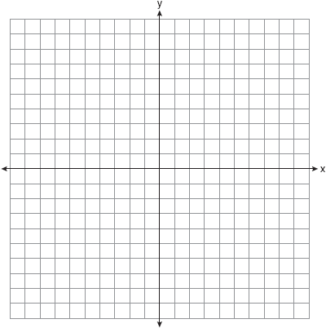

Is a solution to the system of inequalities? Explain your answer.

36 A ball is projected up into the air from the surface of a platform to the ground below. The height of the ball above the ground, in feet, is modeled by the function , where t is the time, in seconds, after the ball is projected. State the height of the platform, in feet. State the coordinates of the vertex. Explain what it means in the context of the problem. State the entire interval over which the ball's height is decreasing.

37 At a local garden shop, the price of plants includes sales tax. The cost of 4 large plants and 8 medium plants is $40. The cost of 5 large plants and 2 medium plants is $28. If l is the cost of a large plant and m is the cost of a medium plant, write a system of equations that models this situation. Could the cost of one large plant be $5.50 and the cost of one medium plant be $2.25? Justify your answer. Determine algebraically both the cost of a large plant and the cost of a medium plant.
1 ANS: 2 PTS: 2 REF: 062101ai NAT: F.BF.A.1
TOP: Modeling Linear Functions

2 ANS: 1

PTS: 2 REF: 062102ai NAT: A.APR.A.1 TOP: Operations with Polynomials
KEY: subtraction

3 ANS: 2

PTS: 2 REF: 062103ai NAT: F.IF.A.2 TOP: Functional Notation

4 ANS: 4 PTS: 2 REF: 062104ai NAT: F.IF.A.1
TOP: Defining Functions KEY: ordered pairs

5 ANS: 2
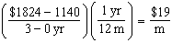

PTS: 2 REF: 062105ai NAT: F.IF.B.6 TOP: Rate of Change

6 ANS: 4
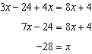

PTS: 2 REF: 062106ai NAT: A.REI.B.3 TOP: Solving Linear Equations
KEY: integral expressions

7 ANS: 2 PTS: 2 REF: 062107ai NAT: A.CED.A.1
TOP: Modeling Linear Inequalities

8 ANS: 2
(d) is the product, but not written in standard form.

PTS: 2 REF: 062108ai NAT: A.APR.A.1 TOP: Operations with Polynomials
KEY: multiplication

9 ANS: 3
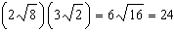

PTS: 2 REF: 062109ai NAT: N.RN.B.3 TOP: Operations with Radicals
KEY: classify

10 ANS: 3 PTS: 2 REF: 062110ai NAT: A.SSE.A.2
TOP: Factoring Polynomials KEY: quadratic

11 ANS: 4
I. 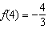 and ; II. and

PTS: 2 REF: 062111ai NAT: A.REI.D.11 TOP: Other Systems

12 ANS: 1
The zeros of f are -6, -3 and 0.

PTS: 2 REF: 062112ai NAT: A.APR.B.3 TOP: Graphing Polynomial Functions
KEY: bimodalgraph

13 ANS: 3 PTS: 2 REF: 062113ai NAT: F.BF.B.3
TOP: Graphing Polynomial Functions

14 ANS: 3 PTS: 2 REF: 062114ai NAT: A.APR.A.1
TOP: Powers of Powers

15 ANS: 1
1) -6; 2) 1; 3) -2; 4) -2

PTS: 2 REF: 062115ai NAT: F.IF.C.9 TOP: Comparing Functions

16 ANS: 2 PTS: 2 REF: 062116ai NAT: F.IF.B.5
TOP: Domain and Range

17 ANS: 4 PTS: 2 REF: 062117ai NAT: F.LE.A.1
TOP: Families of Functions

18 ANS: 4

PTS: 2 REF: 062118ai NAT: F.LE.A.2 TOP: Sequences
KEY: explicit

19 ANS: 3 PTS: 2 REF: 062119ai NAT: S.ID.A.1
TOP: Box Plots KEY: interpret

20 ANS: 2
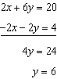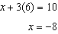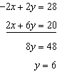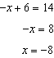

PTS: 2 REF: 062120ai NAT: A.REI.C.6 TOP: Solving Linear Systems

21 ANS: 4 PTS: 2 REF: 062121ai NAT: F.LE.A.2
TOP: Sequences KEY: recursive

22 ANS: 4

PTS: 2 REF: 062122ai NAT: A.SSE.A.1 TOP: Modeling Expressions

23 ANS: 2
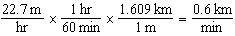

PTS: 2 REF: 062123ai NAT: N.Q.A.1 TOP: Conversions
KEY: dimensional analysis

24 ANS: 1
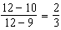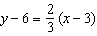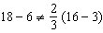

PTS: 2 REF: 062124ai NAT: A.REI.D.10 TOP: Identifying Solutions

25 ANS:
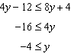

PTS: 2 REF: 062125ai NAT: A.REI.B.3 TOP: Solving Linear Inequalities

26 ANS:
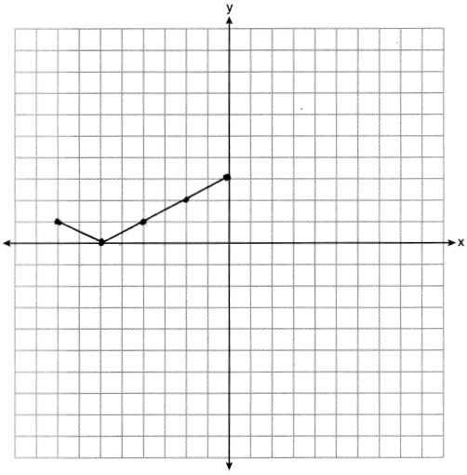

PTS: 2 REF: 062126ai NAT: F.IF.C.7 TOP: Graphing Absolute Value Functions

27 ANS:
The height of the balloon increases 30.5 ft per min. The balloon starts at a height of 8.7 ft.

PTS: 2 REF: 062127ai NAT: S.ID.C.7 TOP: Modeling Linear Functions

28 ANS:

PTS: 2 REF: 062128ai NAT: A.SSE.A.2
TOP: Factoring the Difference of Perfect Squares KEY: higher power AI

29 ANS:
No. He found another point if were a linear function.

PTS: 2 REF: 062129ai NAT: F.LE.A.2 TOP: Modeling Exponential Functions

30 ANS:

PTS: 2 REF: 062130ai NAT: F.IF.C.8 TOP: Vertex Form of a Quadratic

31 ANS:
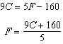

PTS: 2 REF: 062131ai NAT: A.CED.A.4 TOP: Transforming Formulas

32 ANS:
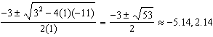

PTS: 2 REF: 062132ai NAT: A.REI.B.4 TOP: Solving Quadratics
KEY: quadratic formula

33 ANS:
, 0.97, high, positive correlation between the number of jumping jacks and heart rate

PTS: 4 REF: 062133ai NAT: S.ID.B.6 TOP: Regression
KEY: linear with correlation coefficient

34 ANS:
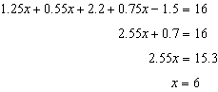

PTS: 4 REF: 062134ai NAT: A.CED.A.1 TOP: Modeling Linear Equations

35 ANS:
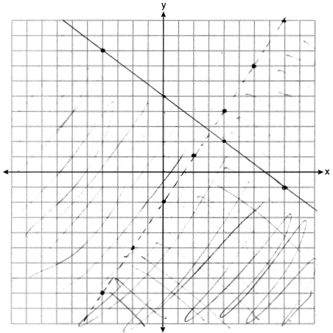 No, as does not lie in the solution set.

PTS: 4 REF: 062135ai NAT: A.REI.D.12 TOP: Graphing Systems of Linear Inequalities
KEY: graph

36 ANS:
112; (3,256); At , the ball is 256 ft high; 3-7 seconds

PTS: 4 REF: 062136ai NAT: F.IF.B.4 TOP: Graphing Quadratic Functions
KEY: context

37 ANS:
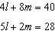 No, since 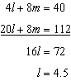 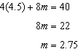

PTS: 6 REF: 062137ai NAT: A.CED.A.3 TOP: Modeling Linear Systems

