1 The expression is equivalent to
1) |  | 3)
2) |  | 4)

2 If , what is the value of ?
1) |  | 3) | 17
2) |  | 4) | 4

3 Which relation is not a function?
1) | 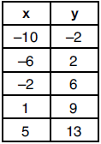 | 3) | 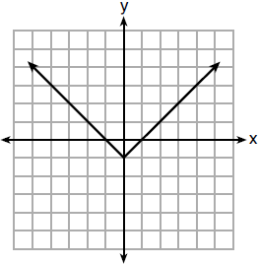
2) |  | 4) | 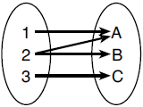

4 Given:
When compared to the graph of the graph of is
1) | shifted 3 units to the left | 3) | shifted 5 units to the left
2) | shifted 3 units to the right | 4) | shifted 5 units to the right

5 Students were asked to write in standard form. Shown below are four student responses.
Anne:
Bob:
Carrie:
Dylan:
Which student is correct?
1) | Anne | 3) | Carrie
2) | Bob | 4) | Dylan

6 The function f is shown in the table below.

x | f(x)
0 | 1
1 | 3
2 | 9
3 | 27

Which type of function best models the given data?
1) | exponential growth function | 3) | linear function with positive rate of change
2) | exponential decay function | 4) | linear function with negative rate of change

7 Which expression results in a rational number?
1) |  | 3)
2) |  | 4)

8 A polynomial function is graphed below.
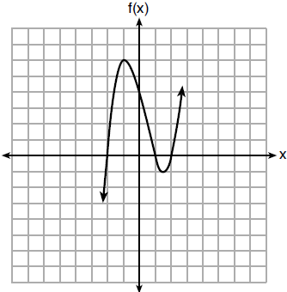
Which function could represent this graph?
1) |  | 3)
2) |  | 4)

9 When solving , Kate wrote . The property she used is
1) | the associative property | 3) | the distributive property
2) | the commutative property | 4) | the addition property of equality

10 David wanted to go on an amusement park ride. A sign posted at the entrance read "You must be greater than 42 inches tall and no more than 57 inches tall for this ride." Which inequality would model the height, x, required for this amusement park ride?
1) |  | 3)
2) |  | 4)

11 Which situation can be modeled by a linear function?
1) | The population of bacteria triples every day. | 3) | An amusement park allows 50 people to enter every 30 minutes.
2) | The value of a cell phone depreciates at a rate of 3.5% each year. | 4) | A baseball tournament eliminates half of the teams after each round.

12 Jenna took a survey of her senior class to see whether they preferred pizza or burgers. The results are summarized in the table below.

 | Pizza | Burgers
Male | 23 | 42
Female | 31 | 26
Of the people who preferred burgers, approximately what percentage were female?
1) | 21.3 | 3) | 45.6
2) | 38.2 | 4) | 61.9

13 When is solved for a, the result is
1) |  | 3)
2) |  | 4)

14 Three functions are shown below.
A: 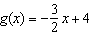
B:
C: 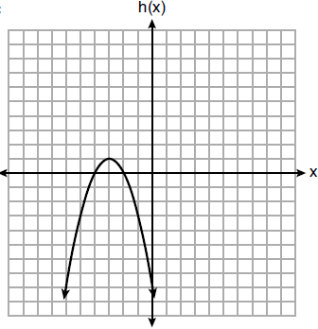
Which statement is true?
1) | B and C have the same zeros. | 3) | B has a minimum and C has a maximum.
2) | A and B have the same y-intercept. | 4) | C has a maximum and A has a minimum.

15 Nicci's sister is 7 years less than twice Nicci's age, a. The sum of Nicci's age and her sister's age is 41. Which equation represents this relationship?
1) |  | 3)
2) |  | 4)

16 The population of a small town over four years is recorded in the chart below, where 2013 is represented by . [Population is rounded to the nearest person]

Year | 2013 | 2014 | 2015 | 2016
Population | 3810 | 3943 | 4081 | 4224

The population, , for these years can be modeled by the function where b is rounded to the nearest thousandth. Which statements about this function are true?
I.
II.
III.
IV.
1) | I and III | 3) | II and III
2) | I and IV | 4) | II and IV

17 When written in factored form, is equivalent to
1) |  | 3)
2) |  | 4)

18 Which ordered pair does not represent a point on the graph of ?
1) |  | 3)
2) |  | 4)

19 Given the following three sequences:
I.
II.
III.
Which ones are arithmetic sequences?
1) | I and II, only | 3) | II and III, only
2) | I and III, only | 4) | I, II, and III

20 A grocery store sells packages of beef. The function represents the cost, in dollars, of a package of beef weighing w pounds. The most appropriate domain for this function would be
1) | integers | 3) | positive integers
2) | rational numbers | 4) | positive rational numbers

21 The roots of are
1) | 1 and 4 | 3) | and
2) | 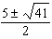 | 4) | 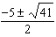

22 The following table shows the heights, in inches, of the players on the opening-night roster of the 2015-2016 New York Knicks.

84 | 80 | 87 | 75 | 77 | 79 | 80 | 74 | 76 | 80 | 80 | 82 | 82

The population standard deviation of these data is approximately
1) | 3.5 | 3) | 79.7
2) | 13 | 4) | 80

23 A population of bacteria can be modeled by the function , where t represents the time since the population started decaying, and represents the population of the remaining bacteria at time t. What is the rate of decay for this population?
1) | 98% | 3) | 0.98%
2) | 2% | 4) | 0.02%

24 Bamboo plants can grow 91 centimeters per day. What is the approximate growth of the plant, in inches per hour?
1) | 1.49 | 3) | 9.63
2) | 3.79 | 4) | 35.83

25 Solve algebraically for x:
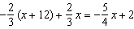

26 If , find the trinomial that represents C when and .

27 Graph the following piecewise function on the set of axes below.
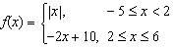

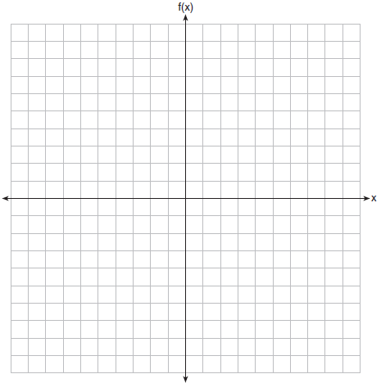

28 Solve algebraically.

29 A blizzard occurred on the East Coast during January, 2016. Snowfall totals from the storm were recorded for Washington, D.C. and are shown in the table below.

Washington, D.C.
Time | Snow (inches)
1 a.m. | 1
3 a.m. | 5
6 a.m. | 11
12 noon | 33
3 p.m. | 36

Which interval, 1 a.m. to 12 noon or 6 a.m. to 3 p.m., has the greater rate of snowfall, in inches per hour? Justify your answer.

30 The formula for the volume of a cone is 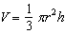. Solve the equation for h in terms of V, r, and .

31 Given the recursive formula:

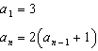

State the values of , , and for the given recursive formula.

32 Determine and state the vertex of using the method of completing the square.

33 A school plans to have a fundraiser before basketball games selling shirts with their school logo. The school contacted two companies to find out how much it would cost to have the shirts made. Company A charges a $50 set-up fee and $5 per shirt. Company B charges a $25 set-up fee and $6 per shirt. Write an equation for Company A that could be used to determine the total cost, A, when x shirts are ordered. Write a second equation for Company B that could be used to determine the total cost, B, when x shirts are ordered. Determine algebraically and state the minimum number of shirts that must be ordered for it to be cheaper to use Company A.

34 Graph and on the set of axes below.

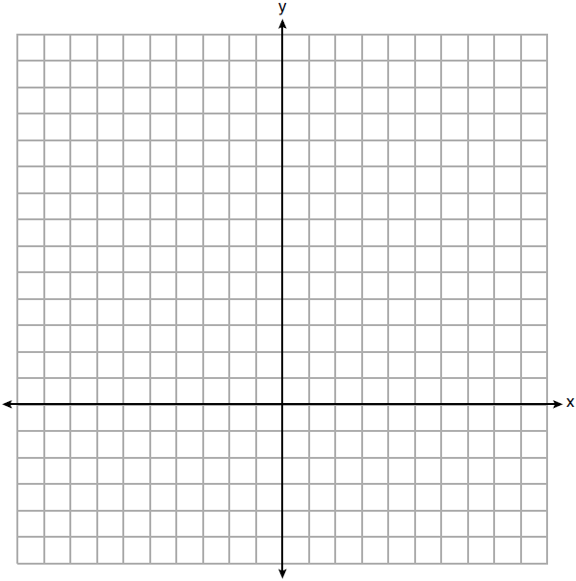

Determine and state all values of x for which .

35 The table below shows the number of hours ten students spent studying for a test and their scores.

Hours Spent Studying (x) | 0 | 1 | 2 | 4 | 4 | 4 | 6 | 6 | 7 | 8
Test Scores (y) | 35 | 40 | 46 | 65 | 67 | 70 | 82 | 88 | 82 | 95

Write the linear regression equation for this data set. Round all values to the nearest hundredth. State the correlation coefficient of this line, to the nearest hundredth. Explain what the correlation coefficient suggests in the context of the problem.

36 A system of inequalities is graphed on the set of axes below.

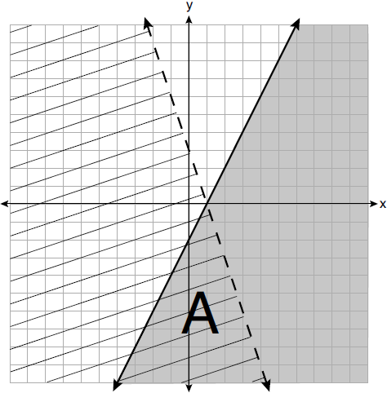

State the system of inequalities represented by the graph. State what region A represents. State what the entire gray region represents.

37 When visiting friends in a state that has no sales tax, two families went to a fast-food restaurant for lunch. The Browns bought 4 cheeseburgers and 3 medium fries for $16.53. The Greens bought 5 cheeseburgers and 4 medium fries for $21.11. Using c for the cost of a cheeseburger and f for the cost of medium fries, write a system of equations that models this situation. The Greens said that since their bill was $21.11, each cheeseburger must cost $2.49 and each order of medium fries must cost $2.87 each. Are they correct? Justify your answer. Using your equations, algebraically determine both the cost of one cheeseburger and the cost of one order of medium fries.
1 ANS: 4 PTS: 2 REF: 061901ai NAT: A.SSE.A.2
TOP: Factoring the Difference of Perfect Squares KEY: higher power AI

2 ANS: 2

PTS: 2 REF: 061902ai NAT: F.IF.A.2 TOP: Functional Notation

3 ANS: 4 PTS: 2 REF: 061903ai NAT: F.IF.A.1
TOP: Defining Functions KEY: mixed

4 ANS: 2 PTS: 2 REF: 061904ai NAT: F.BF.B.3
TOP: Graphing Polynomial Functions

5 ANS: 1 PTS: 2 REF: 061905ai NAT: A.SSE.A.1
TOP: Modeling Expressions

6 ANS: 1 PTS: 2 REF: 061906ai NAT: F.LE.A.1
TOP: Families of Functions

7 ANS: 1
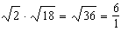 may be expressed as the ratio of two integers.

PTS: 2 REF: 061907ai NAT: N.RN.B.3 TOP: Operations with Radicals
KEY: classify

8 ANS: 3

PTS: 2 REF: 061908ai NAT: A.APR.B.3 TOP: Graphing Polynomial Functions

9 ANS: 4 PTS: 2 REF: 061909ai NAT: A.REI.A.1
TOP: Identifying Properties

10 ANS: 1 PTS: 2 REF: 061910ai NAT: A.CED.A.1
TOP: Modeling Linear Inequalities

11 ANS: 3 PTS: 2 REF: 061911ai NAT: F.LE.A.1
TOP: Families of Functions

12 ANS: 2
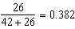

PTS: 2 REF: 061912ai NAT: S.ID.B.5 TOP: Frequency Tables
KEY: two-way

13 ANS: 4
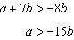

PTS: 2 REF: 061913ai NAT: A.REI.B.3 TOP: Solving Linear Inequalities

14 ANS: 3
1) B’s zeros are and and C’s zeros are and ; 2) A’s y-intercept is 4 and B’s y-intercept is 12; 3) B in standard form, and C in standard form, ; d) A has no minimum

PTS: 2 REF: 061914ai NAT: F.IF.C.9 TOP: Comparing Functions

15 ANS: 2 PTS: 2 REF: 061915ai NAT: A.CED.A.1
TOP: Modeling Linear Equations

16 ANS: 2 PTS: 2 REF: 061916ai NAT: S.ID.B.6
TOP: Regression KEY: exponential

17 ANS: 3 PTS: 2 REF: 061917ai NAT: A.SSE.A.2
TOP: Factoring Polynomials KEY: quadratic

18 ANS: 3

PTS: 2 REF: 061918ai NAT: A.REI.D.10 TOP: Identifying Solutions

19 ANS: 2 PTS: 2 REF: 061919ai NAT: F.IF.A.3
TOP: Sequences KEY: difference or ratio

20 ANS: 4 PTS: 2 REF: 061920ai NAT: F.IF.B.5
TOP: Domain and Range

21 ANS: 2
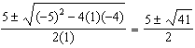

PTS: 2 REF: 061921ai NAT: A.REI.B.4 TOP: Solving Quadratics
KEY: quadratic formula

22 ANS: 1 PTS: 2 REF: 061922ai NAT: S.ID.A.2
TOP: Dispersion KEY: basic

23 ANS: 2 PTS: 2 REF: 061923ai NAT: F.LE.B.5
TOP: Modeling Exponential Functions

24 ANS: 1
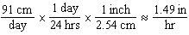

PTS: 2 REF: 061924ai NAT: N.Q.A.1 TOP: Conversions
KEY: dimensional analysis

25 ANS:
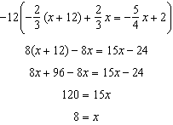

PTS: 2 REF: 061925ai NAT: A.REI.B.3 TOP: Solving Linear Equations
KEY: fractional expressions

26 ANS:

PTS: 2 REF: 061926ai NAT: A.APR.A.1 TOP: Operations with Polynomials
KEY: subtraction

27 ANS:
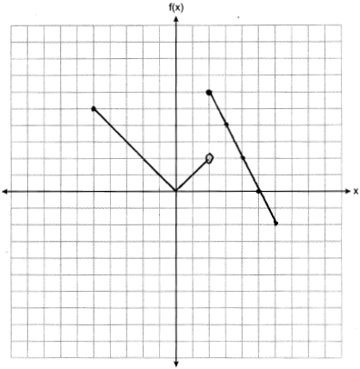

PTS: 2 REF: 061927ai NAT: F.IF.C.7 TOP: Graphing Piecewise-Defined Functions

28 ANS:
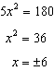

PTS: 2 REF: 061928ai NAT: A.REI.B.4 TOP: Solving Quadratics
KEY: taking square roots

29 ANS:
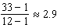 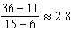 The interval 1 a.m. to 12 noon has the greater rate.

PTS: 2 REF: 061929ai NAT: F.IF.B.6 TOP: Rate of Change

30 ANS:
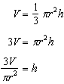

PTS: 2 REF: 061930ai NAT: A.CED.A.4 TOP: Transforming Formulas

31 ANS:

PTS: 2 REF: 061931ai NAT: F.IF.A.3 TOP: Sequences
KEY: recursive

32 ANS:

PTS: 2 REF: 061932ai NAT: F.IF.C.8 TOP: Vertex Form of a Quadratic

33 ANS:
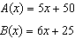 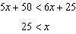 26 shirts

PTS: 4 REF: 061933ai NAT: A.CED.A.3 TOP: Modeling Linear Inequalities

34 ANS:
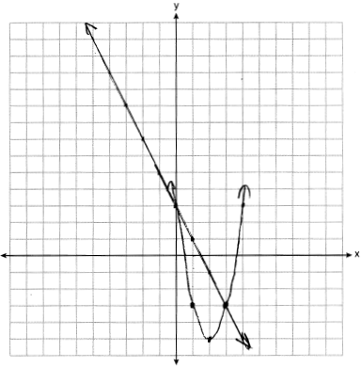

PTS: 4 REF: 061934ai NAT: A.REI.D.11 TOP: Quadratic-Linear Systems

35 ANS:
high, positive correlation between hours spent studying and test scores

PTS: 4 REF: 061935ai NAT: S.ID.B.6 TOP: Regression
KEY: linear with correlation coefficient

36 ANS:
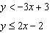 Region A represents the solution set of the system. The gray region represents the solution set of .

PTS: 4 REF: 061936ai NAT: A.CED.A.3 TOP: Modeling Systems of Linear Inequalities

37 ANS:
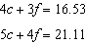 No, because . 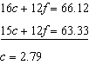 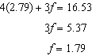

PTS: 6 REF: 061937ai NAT: A.CED.A.3 TOP: Modeling Linear Systems

