1 The solution to is
1) |  | 3)
2) |  | 4)

2 If , then is
1) | 315 | 3) | 159
2) | 307 | 4) | 153

3 The expression is equivalent to
1) |  | 3)
2) |  | 4)

4 The zeros of the function are
1) | and 3 | 3) | and 6
2) | and 4 | 4) | and 8

5 The box plot below summarizes the data for the average monthly high temperatures in degrees Fahrenheit for Orlando, Florida.
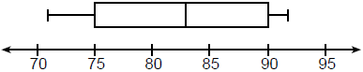
The third quartile is
1) | 92 | 3) | 83
2) | 90 | 4) | 71

6 Joy wants to buy strawberries and raspberries to bring to a party. Strawberries cost $1.60 per pound and raspberries cost $1.75 per pound. If she only has $10 to spend on berries, which inequality represents the situation where she buys x pounds of strawberries and y pounds of raspberries?
1) |  | 3)
2) |  | 4)

7 On the main floor of the Kodak Hall at the Eastman Theater, the number of seats per row increases at a constant rate. Steven counts 31 seats in row 3 and 37 seats in row 6. How many seats are there in row 20?
1) | 65 | 3) | 69
2) | 67 | 4) | 71

8 Which ordered pair below is not a solution to ?
1)
2)
3)
4)

9 Students were asked to name their favorite sport from a list of basketball, soccer, or tennis. The results are shown in the table below.

 | Basketball | Soccer | Tennis
Girls | 42 | 58 | 20
Boys | 84 | 41 | 5

What percentage of the students chose soccer as their favorite sport?
1) | 39.6% | 3) | 50.4%
2) | 41.4% | 4) | 58.6%

10 The trinomial can be expressed as
1) |  | 3)
2) |  | 4)

11 A function is defined as . Isaac is asked to create one more ordered pair for the function. Which ordered pair can he add to the set to keep it a function?
1) |  | 3)
2) |  | 4)

12 The quadratic equation is rewritten in the form , where q is a constant. What is the value of p?
1) |  | 3)
2) |  | 4) | 9

13 Which of the quadratic functions below has the smallest minimum value?
1) |  | 3)
2) | 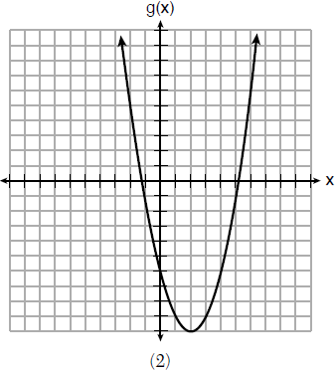 | 4) | 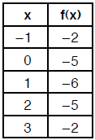

14 Which situation is not a linear function?
1) | A gym charges a membership fee of $10.00 down and $10.00 per month. | 3) | A restaurant employee earns $12.50 per hour.
2) | A cab company charges $2.50 initially and $3.00 per mile. | 4) | A $12,000 car depreciates 15% per year.

15 The Utica Boilermaker is a 15-kilometer road race. Sara is signed up to run this race and has done the following training runs:
I. 10 miles
II. 44,880 feet
III. 15,560 yards
Which run(s) are at least 15 kilometers?
1) | I, only | 3) | I and III
2) | II, only | 4) | II and III

16 If , which interval describes the range of this function?
1) |  | 3)
2) |  | 4)

17 The amount Mike gets paid weekly can be represented by the expression , where a is the number of cell phone accessories he sells that week. What is the constant term in this expression and what does it represent?
1) | , the amount he is guaranteed to be paid each week | 3) | 290, the amount he is guaranteed to be paid each week
2) | , the amount he earns when he sells a accessories | 4) | 290, the amount he earns when he sells a accessories

18 A cubic function is graphed on the set of axes below.

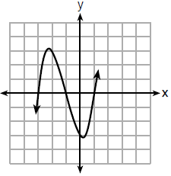

Which function could represent this graph?
1) |  | 3)
2) |  | 4)

19 Mrs. Allard asked her students to identify which of the polynomials below are in standard form and explain why.
I.
II.
III.
Which student's response is correct?
1) | Tyler said I and II because the coefficients are decreasing. | 3) | Fred said II and III because the exponents are decreasing.
2) | Susan said only II because all the numbers are decreasing. | 4) | Alyssa said II and III because they each have three terms.

20 Which graph does not represent a function that is always increasing over the entire interval ?
1) | 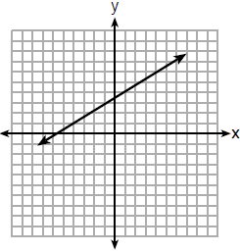 | 3) | 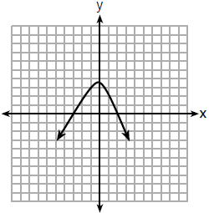
2) | 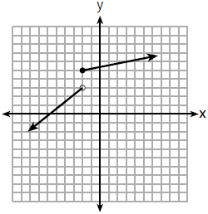 | 4) | 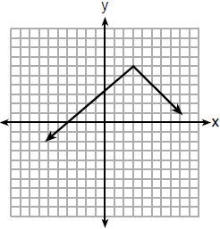

21 At an ice cream shop, the profit, , is modeled by the function , where c represents the number of ice cream cones sold. An appropriate domain for this function is
1) | an integer | 3) | a rational number
2) | an integer | 4) | a rational number

22 How many real-number solutions does have?
1) | one
2) | two
3) | zero
4) | infinitely many

23 Students were asked to write a formula for the length of a rectangle by using the formula for its perimeter, . Three of their responses are shown below.
I. 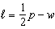
II. 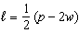
III. 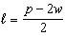
Which responses are correct?
1) | I and II, only | 3) | I and III, only
2) | II and III, only | 4) | I, II, and III

24 If and , what is the value of ?
1) | 5 | 3) | 120
2) | 20 | 4) | 720

25 Graph over the domain .

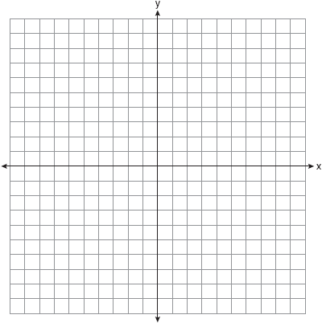

26 Caleb claims that the ordered pairs shown in the table below are from a nonlinear function.

x | f(x)
0 | 2
1 | 4
2 | 8
3 | 16

State if Caleb is correct. Explain your reasoning.

27 Solve for x to the nearest tenth: .

28 The graph of the function is represented below. On the same set of axes, sketch the function .

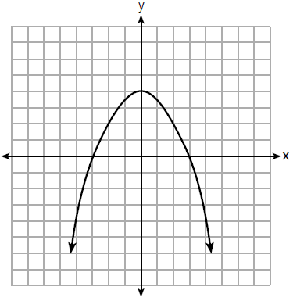

29 When an apple is dropped from a tower 256 feet high, the function models the height of the apple, in feet, after t seconds. Determine, algebraically, the number of seconds it takes the apple to hit the ground.

30 Solve the equation below algebraically for the exact value of x.
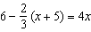

31 Is the product of and rational or irrational? Explain your reasoning.

32 On the set of axes below, graph the piecewise function:
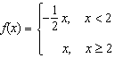

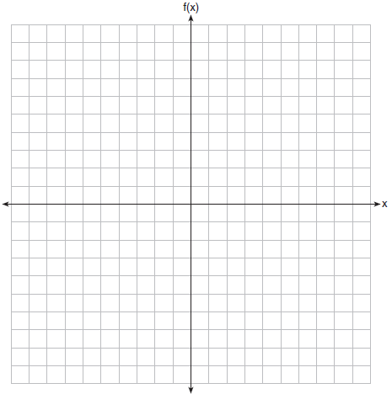

33 A population of rabbits in a lab, , can be modeled by the function , where x represents the number of days since the population was first counted. Explain what 20 and 1.014 represent in the context of the problem. Determine, to the nearest tenth, the average rate of change from day 50 to day 100.

34 There are two parking garages in Beacon Falls. Garage A charges $7.00 to park for the first 2 hours, and each additional hour costs $3.00. Garage B charges $3.25 per hour to park. When a person parks for at least 2 hours, write equations to model the cost of parking for a total of x hours in Garage A and Garage B. Determine algebraically the number of hours when the cost of parking at both garages will be the same.

35 On the set of axes below, graph the following system of inequalities:
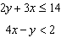

Determine if the point is in the solution set. Explain your answer.

36 The percentage of students scoring 85 or better on a mathematics final exam and an English final exam during a recent school year for seven schools is shown in the table below.

Percentage of Students Scoring 85 or Better
Mathematics, x | English, y
27 | 46
12 | 28
13 | 45
10 | 34
30 | 56
45 | 67
20 | 42

Write the linear regression equation for these data, rounding all values to the nearest hundredth. State the correlation coefficient of the linear regression equation, to the nearest hundredth. Explain the meaning of this value in the context of these data.

37 Dylan has a bank that sorts coins as they are dropped into it. A panel on the front displays the total number of coins inside as well as the total value of these coins. The panel shows 90 coins with a value of $17.55 inside of the bank. If Dylan only collects dimes and quarters, write a system of equations in two variables or an equation in one variable that could be used to model this situation. Using your equation or system of equations, algebraically determine the number of quarters Dylan has in his bank. Dylan's mom told him that she would replace each one of his dimes with a quarter. If he uses all of his coins, determine if Dylan would then have enough money to buy a game priced at $20.98 if he must also pay an 8% sales tax. Justify your answer.
1 ANS: 4
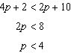

PTS: 2 REF: 061801ai NAT: A.REI.B.3 TOP: Solving Linear Inequalities

2 ANS: 4

PTS: 2 REF: 061802ai NAT: F.IF.A.2 TOP: Functional Notation

3 ANS: 2

PTS: 2 REF: 061803ai NAT: A.APR.A.1 TOP: Operations with Polynomials
KEY: subtraction

4 ANS: 3
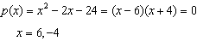

PTS: 2 REF: 061804ai NAT: A.APR.B.3 TOP: Zeros of Polynomials

5 ANS: 2 PTS: 2 REF: 061805ai NAT: S.ID.A.1
TOP: Box Plots KEY: interpret

6 ANS: 1 PTS: 2 REF: 061806ai NAT: A.CED.A.3
TOP: Modeling Linear Inequalities

7 ANS: 1
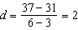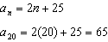

PTS: 2 REF: 061807ai NAT: F.IF.A.3 TOP: Sequences
KEY: explicit

8 ANS: 4

PTS: 2 REF: 061808ai NAT: A.REI.D.10 TOP: Identifying Solutions

9 ANS: 1
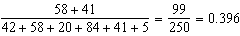

PTS: 2 REF: 061809ai NAT: S.ID.B.5 TOP: Frequency Tables
KEY: two-way

10 ANS: 1 PTS: 2 REF: 061810ai NAT: A.SSE.A.2
TOP: Factoring Polynomials KEY: quadratic

11 ANS: 4 PTS: 2 REF: 061811ai NAT: F.IF.A.1
TOP: Defining Functions KEY: ordered pairs

12 ANS: 3
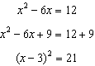

PTS: 2 REF: 061812ai NAT: A.REI.B.4 TOP: Solving Quadratics
KEY: completing the square

13 ANS: 2
1) 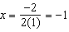, ; 2) ; 3) 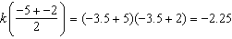; 4)

PTS: 2 REF: 061813ai NAT: F.IF.C.9 TOP: Comparing Functions

14 ANS: 4 PTS: 2 REF: 061814ai NAT: F.LE.A.1
TOP: Families of Functions

15 ANS: 1
I. 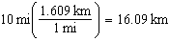; II. 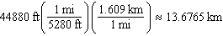; III. 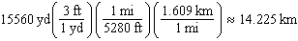

PTS: 2 REF: 061815ai NAT: N.Q.A.1 TOP: Conversions
KEY: dimensional analysis

16 ANS: 3 PTS: 2 REF: 061816ai NAT: F.IF.A.2
TOP: Domain and Range KEY: real domain, quadratic

17 ANS: 3 PTS: 2 REF: 061817ai NAT: F.LE.B.5
TOP: Modeling Linear Functions

18 ANS: 2 PTS: 2 REF: 061818ai NAT: A.APR.B.3
TOP: Graphing Polynomial Functions

19 ANS: 3 PTS: 2 REF: 061819ai NAT: A.SSE.A.1
TOP: Modeling Expressions

20 ANS: 3 PTS: 2 REF: 061820ai NAT: F.IF.C.9
TOP: Comparing Functions

21 ANS: 2 PTS: 2 REF: 061821ai NAT: F.IF.B.5
TOP: Domain and Range

22 ANS: 3

PTS: 2 REF: 061822ai NAT: A.REI.B.4 TOP: Using the Discriminant

23 ANS: 4 PTS: 2 REF: 061823ai NAT: A.CED.A.4
TOP: Transforming Formulas

24 ANS: 3
, , ,

PTS: 2 REF: 061824ai NAT: F.IF.A.3 TOP: Sequences
KEY: recursive

25 ANS:
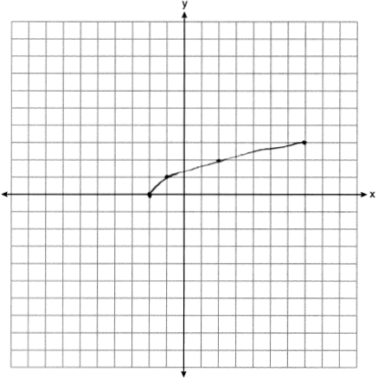

PTS: 2 REF: 061825ai NAT: F.IF.C.7 TOP: Graphing Root Functions

26 ANS:
Yes, because does not have a constant rate of change.

PTS: 2 REF: 061826ai NAT: F.LE.A.1 TOP: Families of Functions

27 ANS:
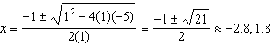

PTS: 2 REF: 061827ai NAT: A.REI.B.4 TOP: Solving Quadratics
KEY: quadratic formula

28 ANS:
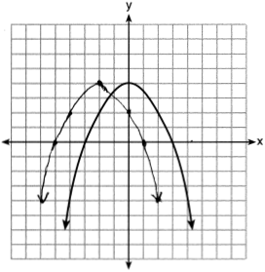

PTS: 2 REF: 061828ai NAT: F.BF.B.3 TOP: Transformations with Functions

29 ANS:
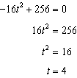

PTS: 2 REF: 061829ai NAT: F.IF.B.4 TOP: Graphing Quadratic Functions
KEY: context

30 ANS:
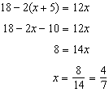

PTS: 3 REF: 061830ai NAT: A.REI.B.3 TOP: Solving Linear Equations
KEY: fractional expressions

31 ANS:
Rational, as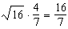, which is the ratio of two integers.

PTS: 2 REF: 061831ai NAT: N.RN.B.3 TOP: Operations with Radicals
KEY: classify

32 ANS:
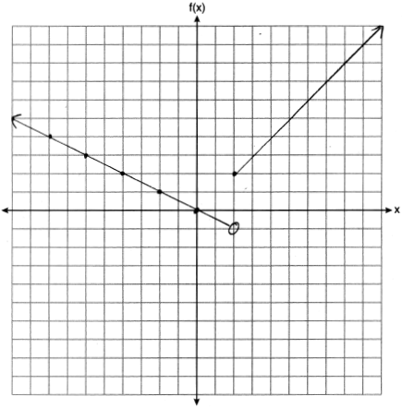

PTS: 2 REF: 061832ai NAT: F.IF.C.7 TOP: Graphing Piecewise-Defined Functions

33 ANS:
There are 20 rabbits at and they are growing 1.4% per day. 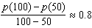

PTS: 2 REF: 061833ai NAT: F.IF.B.6 TOP: Rate of Change

34 ANS:
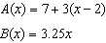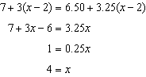

PTS: 4 REF: 061834ai NAT: A.CED.A.3 TOP: Modeling Linear Systems

35 ANS:
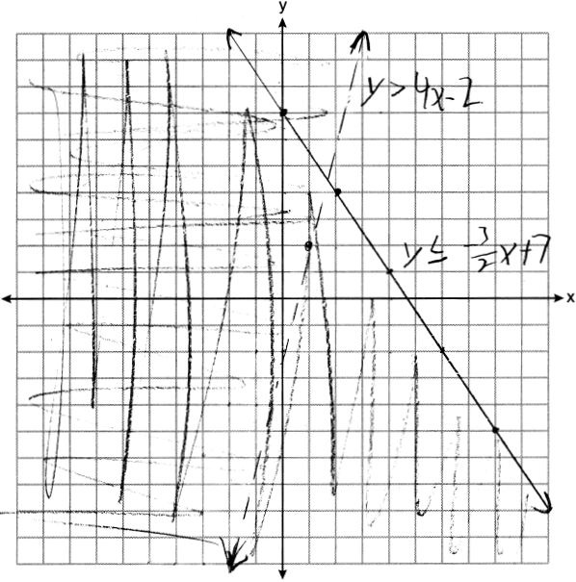 (1,2) is not in the solution set since it does not fall in an area where the shadings overlap.

PTS: 4 REF: 061835ai NAT: A.REI.D.12 TOP: Graphing Systems of Linear Inequalities
KEY: graph

36 ANS:
, 0.92, high, positive correlation between scores 85 or better on the math and English exams.

PTS: 4 REF: 061836ai NAT: S.ID.B.6 TOP: Regression
KEY: linear with correlation coefficient

37 ANS:
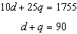, 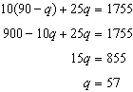, no, because

PTS: 6 REF: 061837ai NAT: A.CED.A.3 TOP: Modeling Linear Systems

