1 To keep track of his profits, the owner of a carnival booth decided to model his ticket sales on a graph. He found that his profits only declined when he sold between 10 and 40 tickets. Which graph could represent his profits?
1) | 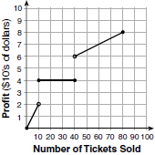 | 3) | 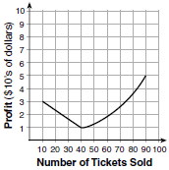
2) | 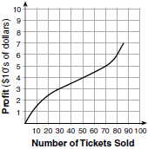 | 4) | 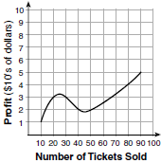

2 The formula for the surface area of a right rectangular prism is , where l, w, and h represent the length, width, and height, respectively. Which term of this formula is not dependent on the height?
1) | A | 3) | 2hw
2) | 2lw | 4) | 2lh

3 Which graph represents ?
1) | 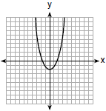 | 3) | 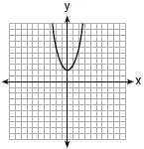
2) | 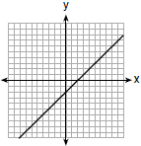 | 4) | 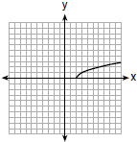

4 A student plotted the data from a sleep study as shown in the graph below.

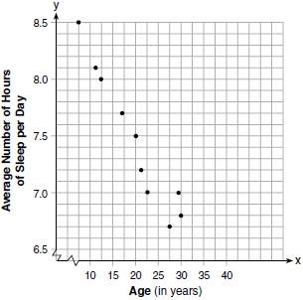

The student used the equation of the line to model the data. What does the rate of change represent in terms of these data?
1) | The average number of hours of sleep per day increases 0.09 hour per year of age. | 3) | The average number of hours of sleep per day increases 9.24 hours per year of age.
2) | The average number of hours of sleep per day decreases 0.09 hour per year of age. | 4) | The average number of hours of sleep per day decreases 9.24 hours per year of age.

5 Lynn, Jude, and Anne were given the function , and they were asked to find . Lynn's answer was 14, Jude's answer was 4, and Anne's answer was ±4. Who is correct?
1) | Lynn, only | 3) | Anne, only
2) | Jude, only | 4) | Both Lynn and Jude

6 Which expression is equivalent to ?
1) |  | 3)
2) |  | 4)

7 Vinny collects population data, , about a specific strain of bacteria over time in hours, h, as shown in the graph below.

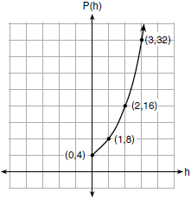

Which equation represents the graph of ?
1) |  | 3)
2) | 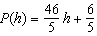 | 4) | 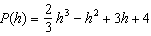

8 What is the solution to the system of equations below?
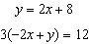
1) | no solution | 3)
2) | infinite solutions | 4) | 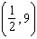

9 A mapping is shown in the diagram below.

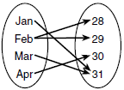

This mapping is
1) | a function, because Feb has two outputs, 28 and 29 | 3) | not a function, because Feb has two outputs, 28 and 29
2) | a function, because two inputs, Jan and Mar, result in the output 31 | 4) | not a function, because two inputs, Jan and Mar, result in the output 31

10 Which polynomial function has zeros at , 0, and 4?
1) |  | 3)
2) |  | 4)

11 Jordan works for a landscape company during his summer vacation. He is paid $12 per hour for mowing lawns and $14 per hour for planting gardens. He can work a maximum of 40 hours per week, and would like to earn at least $250 this week. If m represents the number of hours mowing lawns and g represents the number of hours planting gardens, which system of inequalities could be used to represent the given conditions?
1) | 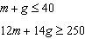 | 3) | 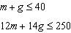
2) | 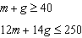 | 4) | 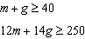

12 Anne invested $1000 in an account with a 1.3% annual interest rate. She made no deposits or withdrawals on the account for 2 years. If interest was compounded annually, which equation represents the balance in the account after the 2 years?
1) |  | 3)
2) |  | 4)

13 Which value would be a solution for x in the inequality ?
1) |  | 3) | 10
2) |  | 4) | 11

14 Bella recorded data and used her graphing calculator to find the equation for the line of best fit. She then used the correlation coefficient to determine the strength of the linear fit. Which correlation coefficient represents the strongest linear relationship?
1) | 0.9 | 3) | -0.3
2) | 0.5 | 4) | -0.8

15 The heights, in inches, of 12 students are listed below.
61,67,72,62,65,59,60,79,60,61,64,63
Which statement best describes the spread of these data?
1) | The set of data is evenly spread. | 3) | The set of data is skewed because 59 is the only value below 60.
2) | The median of the data is 59.5. | 4) | 79 is an outlier, which would affect the standard deviation of these data.

16 The graph of a quadratic function is shown below.

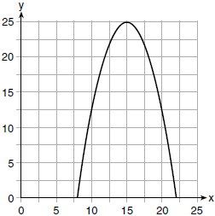

An equation that represents the function could be
1) | 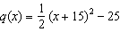 | 3) | 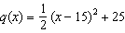
2) | 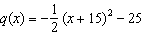 | 4) | 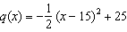

17 Which statement is true about the quadratic functions , shown in the table below, and ?

x | g(x)
0 | 4
1
2
3
4
5
6 | 4

1) | They have the same vertex. | 3) | They have the same axis of symmetry.
2) | They have the same zeros. | 4) | They intersect at two points.

18 Given the function defined by the following:
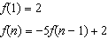
Which set could represent the range of the function?
1) |  | 3)
2) |  | 4)

19 An equation is given below.
The solution to the equation is
1) | 8.3 | 3) | 3
2) | 8.7 | 4) | -3

20 A construction worker needs to move 120 ft³ of dirt by using a wheelbarrow. One wheelbarrow load holds 8 ft³ of dirt and each load takes him 10 minutes to complete. One correct way to figure out the number of hours he would need to complete this job is
1) | 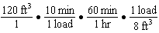 | 3) | 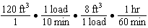
2) | 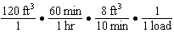 | 4) | 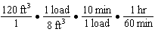

21 One characteristic of all linear functions is that they change by
1) | equal factors over equal intervals | 3) | equal differences over equal intervals
2) | unequal factors over equal intervals | 4) | unequal differences over equal intervals

22 What are the solutions to the equation ?
1) |  | 3)
2) |  | 4)

23 The formula for blood flow rate is given by 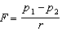, where F is the flow rate, the initial pressure, the final pressure, and r the resistance created by blood vessel size. Which formula can not be derived from the given formula?
1) |  | 3)
2) |  | 4) | 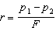

24 Morgan throws a ball up into the air. The height of the ball above the ground, in feet, is modeled by the function , where t represents the time, in seconds, since the ball was thrown. What is the appropriate domain for this situation?
1) |  | 3)
2) |  | 4)

25 Express in simplest form:

26 Graph the function on the set of axes below.

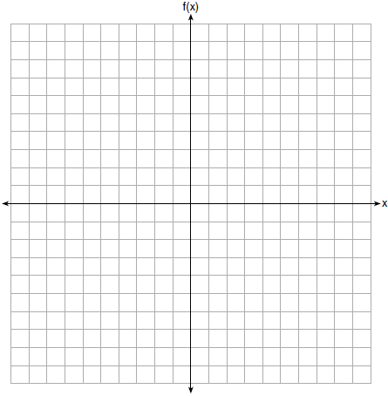

State the coordinates of the vertex of the graph.

27 State whether is rational or irrational. Explain your answer.

28 The value, , of a car depreciates according to the function , where P is the purchase price of the car and t is the time, in years, since the car was purchased. State the percent that the value of the car decreases by each year. Justify your answer.

29 A survey of 100 students was taken. It was found that 60 students watched sports, and 34 of these students did not like pop music. Of the students who did not watch sports, 70% liked pop music. Complete the two-way frequency table.

 | Watch Sports | Don’t Watch Sports | Total
Like Pop
Don’t Like Pop
Total

30 Graph the inequality on the set of axes below.

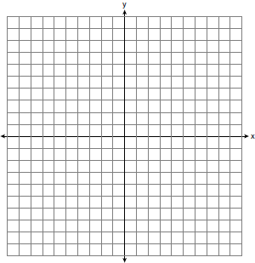

31 If and , determine the value(s) of x that satisfy the equation .

32 Describe the effect that each transformation below has on the function , where .

33 The function is defined by the expression . Use factoring to determine the zeros of . Explain what the zeros represent on the graph of .

34 The graph below models Craig's trip to visit his friend in another state. In the course of his travels, he encountered both highway and city driving.

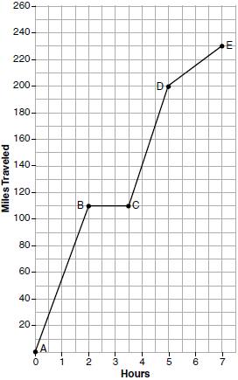

Based on the graph, during which interval did Craig most likely drive in the city? Explain your reasoning. Explain what might have happened in the interval between B and C. Determine Craig's average speed, to the nearest tenth of a mile per hour, for his entire trip.

35 Given: 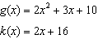
Solve the equation algebraically for x, to the nearest tenth. Explain why you chose the method you used to solve this quadratic equation.

36 Michael has $10 in his savings account. Option 1 will add $100 to his account each week. Option 2 will double the amount in his account at the end of each week. Write a function in terms of x to model each option of saving. Michael wants to have at least $700 in his account at the end of 7 weeks to buy a mountain bike. Determine which option(s) will enable him to reach his goal. Justify your answer.

37 Central High School had five members on their swim team in 2010. Over the next several years, the team increased by an average of 10 members per year. The same school had 35 members in their chorus in 2010. The chorus saw an increase of 5 members per year. Write a system of equations to model this situation, where x represents the number of years since 2010. Graph this system of equations on the set of axes below.



Explain in detail what each coordinate of the point of intersection of these equations means in the context of this problem.
1 ANS: 3 PTS: 2 REF: 061701ai NAT: F.IF.B.4
TOP: Relating Graphs to Events

2 ANS: 2 PTS: 2 REF: 061702ai NAT: A.SSE.A.1
TOP: Dependent and Independent Variables

3 ANS: 4 PTS: 2 REF: 061703ai NAT: F.IF.C.7
TOP: Graphing Root Functions KEY: bimodalgraph

4 ANS: 2 PTS: 2 REF: 061704ai NAT: S.ID.C.7
TOP: Modeling Linear Functions

5 ANS: 1

PTS: 2 REF: 061705ai NAT: F.IF.A.2 TOP: Functional Notation

6 ANS: 3 PTS: 2 REF: 061706ai NAT: A.SSE.A.2
TOP: Factoring the Difference of Perfect Squares KEY: higher power

7 ANS: 1 PTS: 2 REF: 061707ai NAT: F.LE.A.2
TOP: Families of Functions

8 ANS: 1
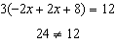

PTS: 2 REF: 061708ai NAT: A.REI.C.6 TOP: Solving Linear Systems
KEY: substitution

9 ANS: 3 PTS: 2 REF: 061709ai NAT: F.IF.A.1
TOP: Defining Functions KEY: ordered pairs

10 ANS: 3 PTS: 2 REF: 061710ai NAT: A.APR.B.3
TOP: Zeros of Polynomials

11 ANS: 1 PTS: 2 REF: 061711ai NAT: A.CED.A.3
TOP: Modeling Systems of Linear Inequalities

12 ANS: 2 PTS: 2 REF: 061712ai NAT: F.BF.A.1
TOP: Modeling Exponential Functions

13 ANS: 4
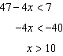

PTS: 2 REF: 061713ai NAT: A.REI.B.3 TOP: Interpreting Solutions

14 ANS: 1 PTS: 2 REF: 061714ai NAT: S.ID.C.8
TOP: Correlation Coefficient

15 ANS: 4
(1) The box plot indicates the data is not evenly spread. (2) The median is 62.5. (3) The data is skewed because the mean does not equal the median. (4) an outlier is greater than .
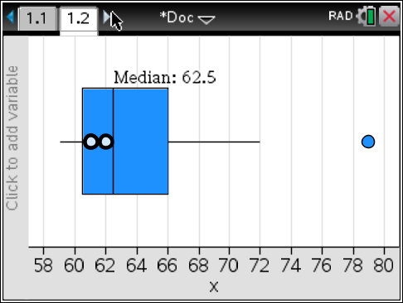

PTS: 2 REF: 061715ai NAT: S.ID.A.3 TOP: Central Tendency and Dispersion

16 ANS: 4
Vertex , point 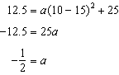

PTS: 2 REF: 061716ai NAT: F.IF.C.8 TOP: Vertex Form of a Quadratic

17 ANS: 3

PTS: 2 REF: 061717ai NAT: F.IF.C.9 TOP: Comparing Functions

18 ANS: 2
; ; ;

PTS: 2 REF: 061718ai NAT: F.IF.A.3 TOP: Sequences
KEY: recursive

19 ANS: 1
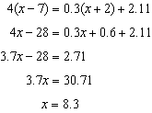

PTS: 2 REF: 061719ai NAT: A.REI.B.3 TOP: Solving Linear Equations
KEY: decimals

20 ANS: 4 PTS: 2 REF: 061720ai NAT: N.Q.A.1
TOP: Conversions KEY: dimensional analysis

21 ANS: 3 PTS: 2 REF: 061721ai NAT: F.LE.A.1
TOP: Families of Functions

22 ANS: 2
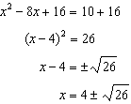

PTS: 2 REF: 061722ai NAT: A.REI.B.4 TOP: Solving Quadratics
KEY: completing the square

23 ANS: 3 PTS: 2 REF: 061723ai NAT: A.CED.A.4
TOP: Transforming Formulas

24 ANS: 1
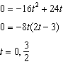

PTS: 2 REF: 061724ai NAT: F.IF.B.4 TOP: Graphing Quadratic Functions
KEY: context

25 ANS:

PTS: 2 REF: 061725ai NAT: A.APR.A.1 TOP: Operations with Polynomials
KEY: subtraction

26 ANS:
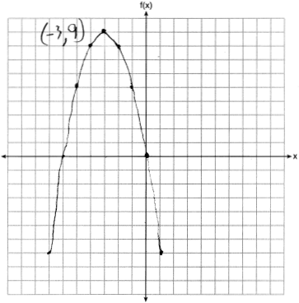

PTS: 2 REF: 061726ai NAT: F.IF.B.4 TOP: Graphing Quadratic Functions
KEY: no context

27 ANS:
is irrational because it can not be written as the ratio of two integers.

PTS: 2 REF: 061727ai NAT: N.RN.B.3 TOP: Operations with Radicals
KEY: classify

28 ANS:
To find the rate of change of an equation in the form , subtract b from 1.

PTS: 2 REF: 061728ai NAT: F.LE.B.5 TOP: Modeling Exponential Functions

29 ANS:
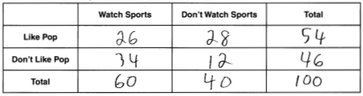

PTS: 2 REF: 061729ai NAT: S.ID.B.5 TOP: Frequency Tables
KEY: two-way

30 ANS:
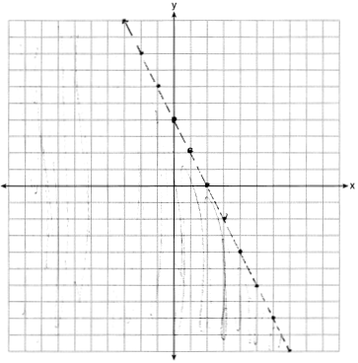

PTS: 2 REF: 061730ai NAT: A.REI.D.12 TOP: Graphing Linear Inequalities

31 ANS:
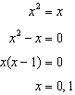

PTS: 2 REF: 061731ai NAT: A.REI.D.11 TOP: Quadratic-Linear Systems

32 ANS:
is shifted right by a, is shifted down by a.

PTS: 2 REF: 061732ai NAT: F.BF.B.3 TOP: Graphing Absolute Value Functions

33 ANS:
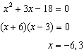 The zeros are the x-intercepts of .

PTS: 4 REF: 061733ai NAT: A.APR.B.3 TOP: Zeros of Polynomials

34 ANS:
D-E, because his speed was slower. Craig may have stayed at a rest stop during B-C. 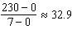

PTS: 4 REF: 061734ai NAT: F.IF.B.4 TOP: Relating Graphs to Events

35 ANS:
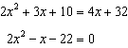 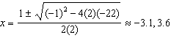. Quadratic formula, because the answer must be to the nearest tenth.

PTS: 4 REF: 061735ai NAT: A.REI.D.11 TOP: Quadratic-Linear Systems

36 ANS:
, ; both, since and

PTS: 4 REF: 061736ai NAT: F.LE.A.3 TOP: Families of Functions

37 ANS:
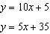 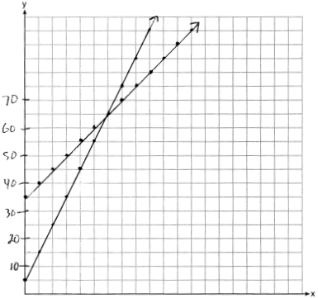 In 2016, the swim team and chorus will each have 65 members.

PTS: 6 REF: 061737ai NAT: A.REI.C.6 TOP: Graphing Linear Systems

