1 The expression is equivalent to
1) |  | 3)
2) |  | 4)

2 An expression of the fifth degree is written with a leading coefficient of seven and a constant of six. Which expression is correctly written for these conditions?
1) |  | 3)
2) |  | 4)

3 The table below shows the year and the number of households in a building that had high-speed broadband internet access.

Number of  Households | 11 | 16 | 23 | 33 | 42 | 47
Year | 2002 | 2003 | 2004 | 2005 | 2006 | 2007

For which interval of time was the average rate of change the smallest?
1) | 2002 - 2004 | 3) | 2004 - 2006
2) | 2003 - 2005 | 4) | 2005 - 2007

4 The scatterplot below compares the number of bags of popcorn and the number of sodas sold at each performance of the circus over one week.

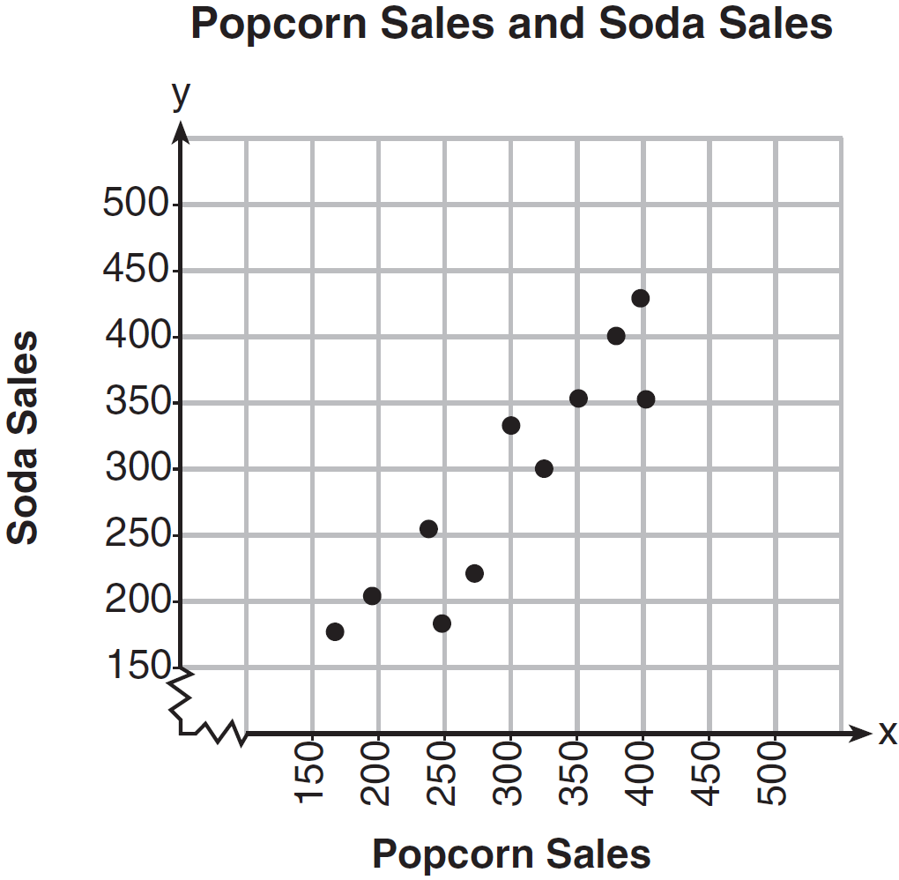

Which conclusion can be drawn from the scatterplot?
1) | There is a negative correlation between popcorn sales and soda sales. | 3) | There is no correlation between popcorn sales and soda sales.
2) | There is a positive correlation between popcorn sales and soda sales. | 4) | Buying popcorn causes people to buy soda.

5 The Celluloid Cinema sold 150 tickets to a movie. Some of these were child tickets and the rest were adult tickets. A child ticket cost $7.75 and an adult ticket cost $10.25. If the cinema sold $1470 worth of tickets, which system of equations could be used to determine how many adult tickets, a, and how many child tickets, c, were sold?
1) | 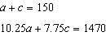 | 3) | 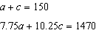
2) | 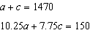 | 4) | 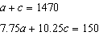

6 The tables below show the values of four different functions for given values of x.

x | f(x) |  | x | g(x) |  | x | h(x) |  | x | k(x)
1 | 12 |  | 1 |  |  | 1 | 9 |  | 1
2 | 19 |  | 2 | 1 |  | 2 | 12 |  | 2 | 4
3 | 26 |  | 3 | 5 |  | 3 | 17 |  | 3 | 14
4 | 33 |  | 4 | 13 |  | 4 | 24 |  | 4 | 28

Which table represents a linear function?·
1) |  | 3)
2) |  | 4)

7 The acidity in a swimming pool is considered normal if the average of three pH readings, p, is defined such that . If the first two readings are 7.2 and 7.6, which value for the third reading will result in an overall rating of normal?
1) | 6.2 | 3) | 8.6
2) | 7.3 | 4) | 8.8

8 Dan took 12.5 seconds to run the 100-meter dash. He calculated the time to be approximately
1) | 0.2083 minute | 3) | 0.2083 hour
2) | 750 minutes | 4) | 0.52083 hour

9 When is solved for x, the solution is
1) |  | 3)
2) |  | 4)

10 The expression is equivalent to
1) |  | 3)
2) |  | 4)

11 The range of the function is all real numbers
1) | less than or equal to | 3) | less than or equal to
2) | greater than or equal to | 4) | greater than or equal to

12 The zeros of the function are
1) | and 6 | 3) | 2 and
2) | 1 and | 4) | and 3

13 In a sequence, the first term is 4 and the common difference is 3. The fifth term of this sequence is
1) |  | 3) | 16
2) |  | 4) | 19

14 The growth of a certain organism can be modeled by , where is the total number of cells after t hours. Which function is approximately equivalent to ?
1) |  | 3)
2) |  | 4) | 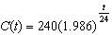

15 A public opinion poll was taken to explore the relationship between age and support for a candidate in an election. The results of the poll are summarized in the table below.

Age | For | Against | No Opinion
21-40 | 30 | 12 | 8
41-60 | 20 | 40 | 15
Over 60 | 25 | 35 | 15

What percent of the 21-40 age group was for the candidate?
1) | 15 | 3) | 40
2) | 25 | 4) | 60

16 Which equation and ordered pair represent the correct vertex form and vertex for ?
1) |  | 3)
2) |  | 4)

17 A student invests $500 for 3 years in a savings account that earns 4% interest per year. No further deposits or withdrawals are made during this time. Which statement does not yield the correct balance in the account at the end of 3 years?
1) |  | 3)
2) |  | 4)

18 The line represented by the equation shares a solution point with the line represented by the table below.
x | y
 | 3.2
 | 3.8
2 | 4.6
4 | 5
11 | 6.4

The solution for this system is
1) |  | 3)
2) |  | 4)

19 What is the solution of the equation ?
1) | 6, only | 3) | 2 and
2) | 2, only | 4) | 6 and

20 The dot plot shown below represents the number of pets owned by students in a class.

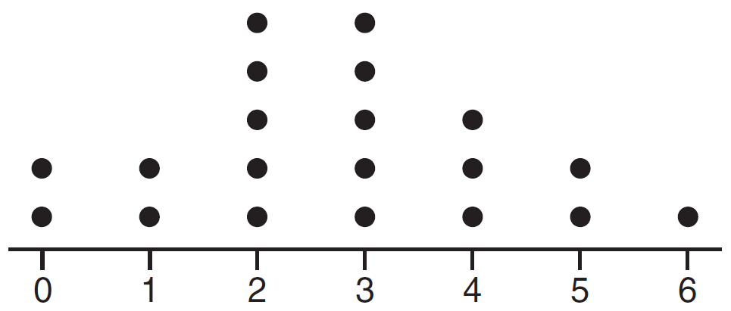

Which statement about the data is not true?
1) | The median is 3. | 3) | The mean is 3.
2) | The interquartile range is 2. | 4) | The data contain no outliers.

21 What is the largest integer, x, for which the value of will be greater than the value of ?
1) | 7 | 3) | 9
2) | 8 | 4) | 10

22 The graphs of the functions and are drawn. Which statement about these functions is true?
1) | The solution to is 3. | 3) | The graphs intersect when .
2) | The solution to is 1. | 4) | The graphs intersect when .

23 A store sells self-serve frozen yogurt sundaes. The function represents the cost, in dollars, of a sundae weighing w ounces. An appropriate domain for the function would be
1) | integers | 3) | nonnegative integers
2) | rational numbers | 4) | nonnegative rational numbers

24 Sara was asked to solve this word problem: "The product of two consecutive integers is 156. What are the integers?" What type of equation should she create to solve this problem?
1) | linear | 3) | exponential
2) | quadratic | 4) | absolute value

25 Given that , find if .

26 Determine if the product of and is rational or irrational. Explain your answer.

27 On the set of axes below, draw the graph of .

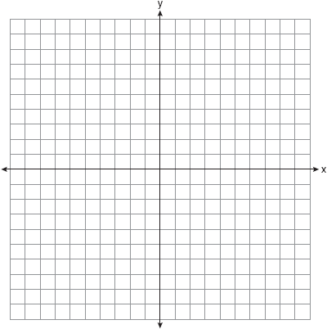

State the equation of the axis of symmetry.

28 Amy solved the equation . She stated that the solutions to the equation were and . Do you agree with Amy's solutions? Explain why or why not.

29 Sue and Kathy were doing their algebra homework. They were asked to write the equation of the line that passes through the points and . Sue wrote 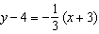 and Kathy wrote 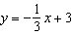. Justify why both students are correct.

30 During a recent snowstorm in Red Hook, NY, Jaime noted that there were 4 inches of snow on the ground at 3:00 p.m., and there were 6 inches of snow on the ground at 7:00 p.m. If she were to graph these data, what does the slope of the line connecting these two points represent in the context of this problem?

31 The formula for the sum of the degree measures of the interior angles of a polygon is . Solve for n, the number of sides of the polygon, in terms of S.

32 In the diagram below, is graphed. Also graphed is , the result of a translation of .
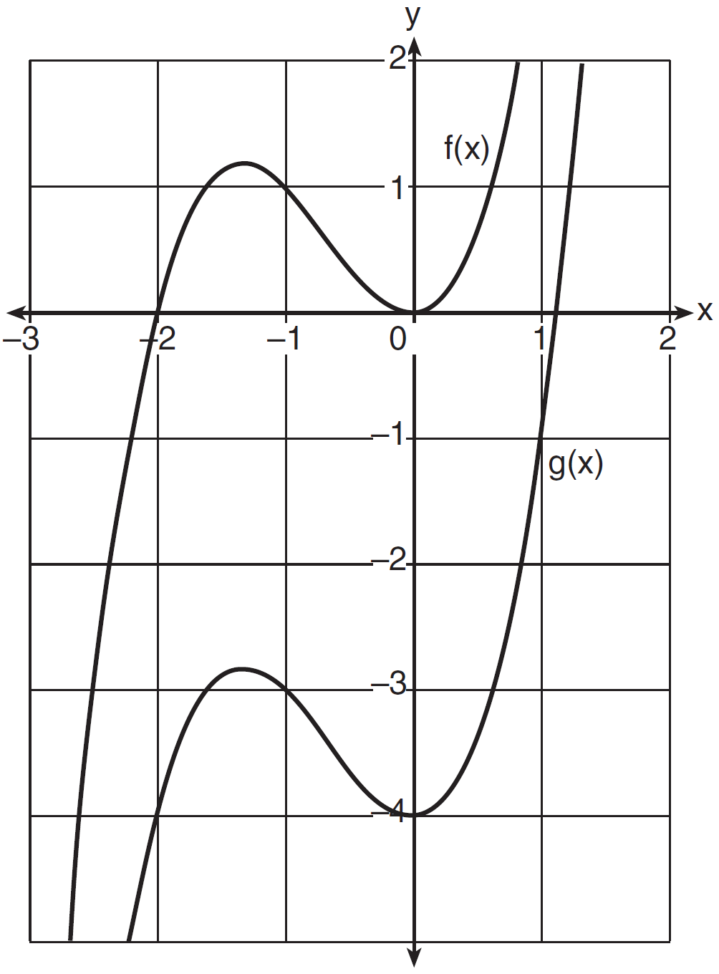
Determine an equation of . Explain your reasoning.

33 The height, H, in feet, of an object dropped from the top of a building after t seconds is given by . How many feet did the object fall between one and two seconds after it was dropped? Determine, algebraically, how many seconds it will take for the object to reach the ground.

34 The sum of two numbers, x and y, is more than 8. When you double x and add it to y, the sum is less than 14. Graph the inequalities that represent this scenario on the set of axes below.
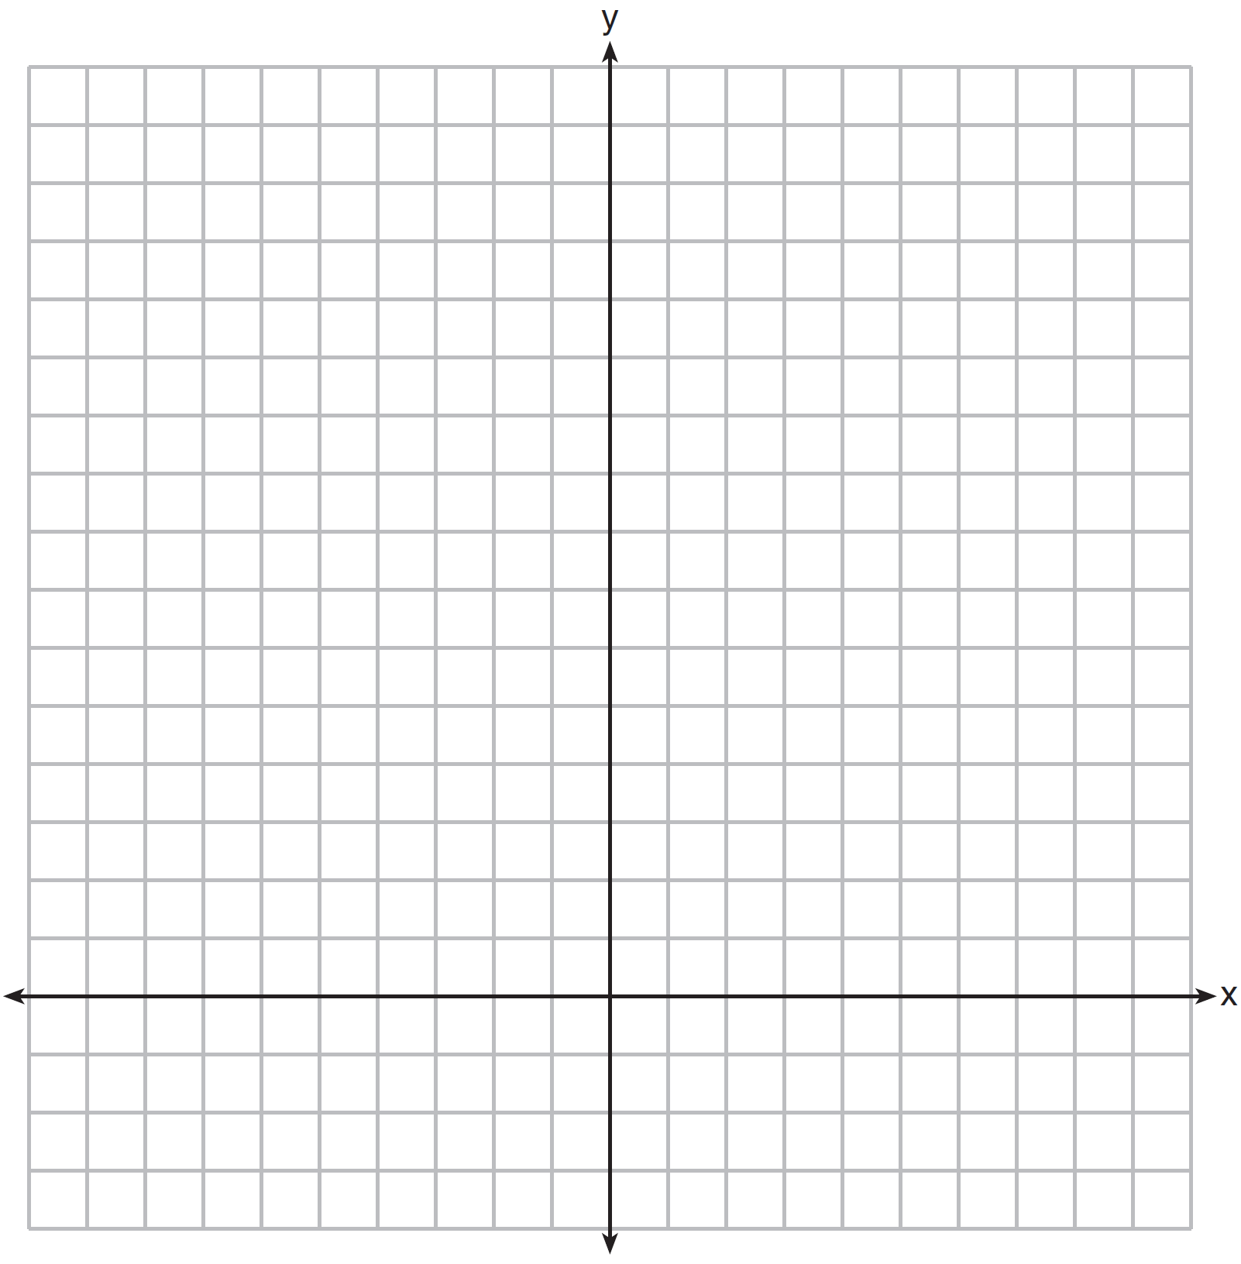

Kai says that the point is a solution to this system. Determine if he is correct and explain your reasoning.

35 An airplane leaves New York City and heads toward Los Angeles. As it climbs, the plane gradually increases its speed until it reaches cruising altitude, at which time it maintains a constant speed for several hours as long as it stays at cruising altitude. After flying for 32 minutes, the plane reaches cruising altitude and has flown 192 miles. After flying for a total of 92 minutes, the plane has flown a total of 762 miles. Determine the speed of the plane, at cruising altitude, in miles per minute. Write an equation to represent the number of miles the plane has flown, y, during x minutes at cruising altitude, only. Assuming that the plane maintains its speed at cruising altitude, determine the total number of miles the plane has flown 2 hours into the flight.

36 On the set of axes below, graph
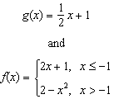

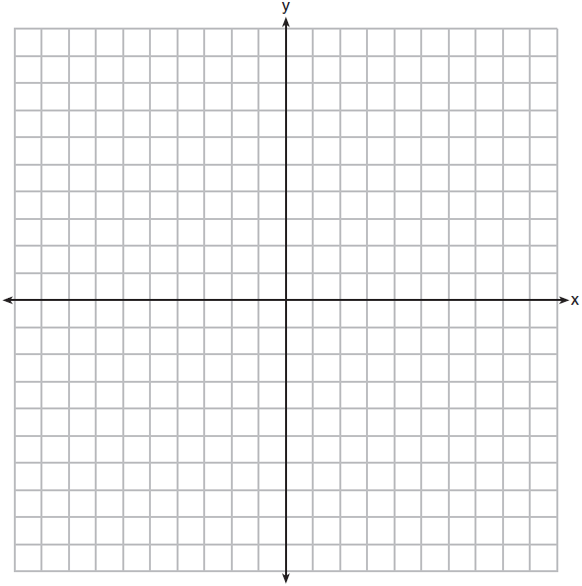

How many values of x satisfy the equation ? Explain your answer, using evidence from your graphs.

37 Franco and Caryl went to a bakery to buy desserts. Franco bought 3 packages of cupcakes and 2 packages of brownies for $19. Caryl bought 2 packages of cupcakes and 4 packages of brownies for $24. Let x equal the price of one package of cupcakes and y equal the price of one package of brownies. Write a system of equations that describes the given situation. On the set of axes below, graph the system of equations.

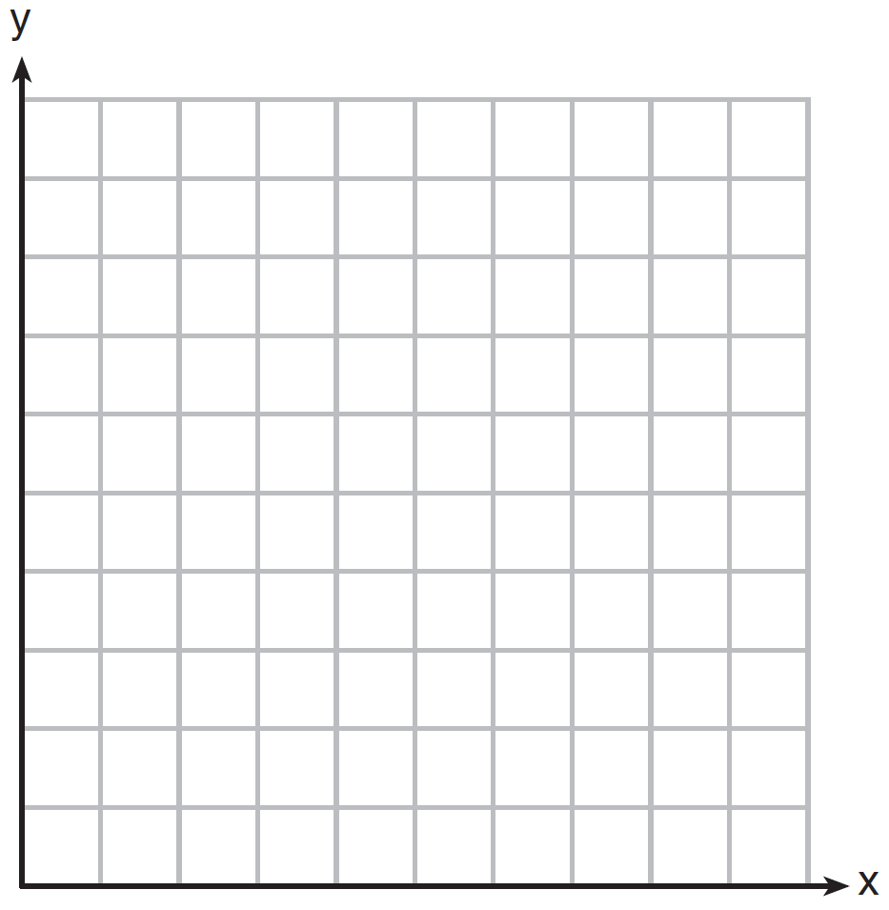

Determine the exact cost of one package of cupcakes and the exact cost of one package of brownies in dollars and cents. Justify your solution.
1 ANS: 3 PTS: 2 REF: 061601ai NAT: A.SSE.A.2
TOP: Factoring the Difference of Perfect Squares KEY: higher power

2 ANS: 4 PTS: 2 REF: 061602ia NAT: A.SSE.A.1
TOP: Modeling Expressions

3 ANS: 1 PTS: 2 REF: 061603ai NAT: F.IF.B.6
TOP: Rate of Change

4 ANS: 2 PTS: 2 REF: 061604ai NAT: S.ID.C.8
TOP: Correlation Coefficient

5 ANS: 1 PTS: 2 REF: 061605ai NAT: A.CED.A.3
TOP: Modeling Linear Systems

6 ANS: 1 PTS: 2 REF: 061606ai NAT: F.LE.A.1
TOP: Families of Functions

7 ANS: 2
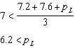 and 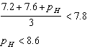

PTS: 2 REF: 061607ai NAT: A.CED.A.1 TOP: Modeling Linear Inequalities

8 ANS: 1
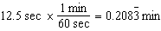

PTS: 2 REF: 061608ai NAT: N.Q.A.1 TOP: Conversions
KEY: dimensional analysis

9 ANS: 4
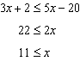

PTS: 2 REF: 061609ai NAT: A.REI.B.3 TOP: Solving Linear Inequalities

10 ANS: 2
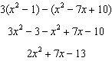

PTS: 2 REF: 061610ai NAT: A.APR.A.1 TOP: Operations with Polynomials
KEY: subtraction

11 ANS: 2

PTS: 2 REF: 061611ai NAT: F.IF.A.2 TOP: Domain and Range
KEY: real domain, quadratic

12 ANS: 1
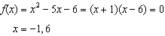

PTS: 2 REF: 061612ai NAT: A.APR.B.3 TOP: Zeros of Polynomials

13 ANS: 3
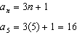

PTS: 2 REF: 061613ai NAT: F.IF.A.3 TOP: Sequences
KEY: explicit

14 ANS: 3

PTS: 2 REF: 061614ai NAT: A.SSE.B.3 TOP: Modeling Exponential Functions

15 ANS: 4
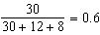

PTS: 2 REF: 061615ai NAT: S.ID.B.5 TOP: Frequency Tables
KEY: two-way

16 ANS: 3
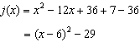

PTS: 2 REF: 061616ai NAT: F.IF.C.8 TOP: Vertex Form of a Quadratic

17 ANS: 2 PTS: 2 REF: 061617ai NAT: F.BF.A.1
TOP: Modeling Exponential Functions

18 ANS: 4
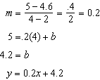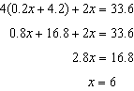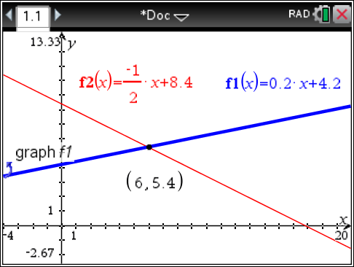

PTS: 2 REF: 061618ai NAT: A.REI.C.6 TOP: Solving Linear Systems
KEY: substitution

19 ANS: 3
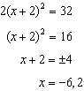

PTS: 2 REF: 061619ai NAT: A.REI.B.4 TOP: Solving Quadratics
KEY: taking square roots

20 ANS: 3
, , . An outlier is outside the interval . 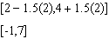

PTS: 2 REF: 061620ai NAT: S.ID.A.1 TOP: Dot Plots

21 ANS: 3
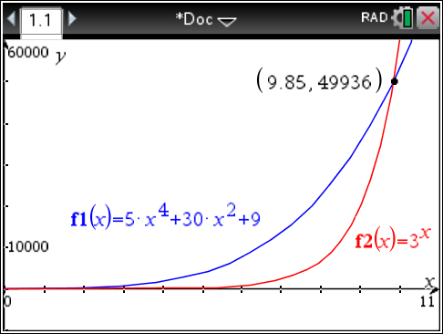

PTS: 2 REF: 061621ai NAT: F.LE.A.3 TOP: Families of Functions

22 ANS: 2
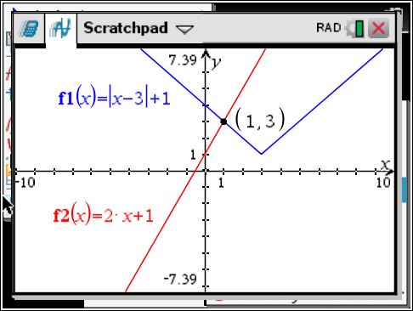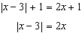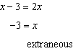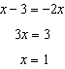

PTS: 2 REF: 061622ai NAT: A.REI.D.11 TOP: Other Systems

23 ANS: 4 PTS: 2 REF: 061623ai NAT: F.IF.B.5
TOP: Domain and Range

24 ANS: 2 PTS: 2 REF: 061624ai NAT: F.LE.A.1
TOP: Families of Functions

25 ANS:

PTS: 2 REF: 061625ai NAT: F.BF.A.1 TOP: Operations with Functions

26 ANS:
is rational, as it can be written as the ratio of two integers.

PTS: 2 REF: 061626ai NAT: N.RN.B.3 TOP: Operations with Radicals
KEY: classify

27 ANS:
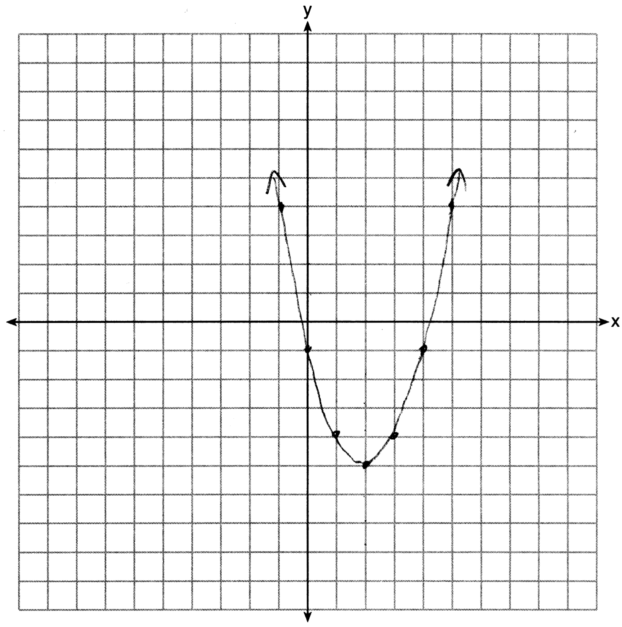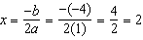

PTS: 2 REF: 061627ai NAT: F.IF.B.4 TOP: Graphing Quadratic Functions
KEY: no context

28 ANS:
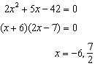 Agree, as shown by solving the equation by factoring.

PTS: 2 REF: 061628ai NAT: A.REI.B.4 TOP: Solving Quadratics
KEY: factoring

29 ANS:
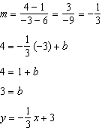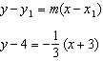

PTS: 2 REF: 061629ai NAT: A.REI.D.10 TOP: Writing Linear Equations
KEY: other forms

30 ANS:
There is 2 inches of snow every 4 hours.

PTS: 2 REF: 061630ai NAT: S.ID.C.7 TOP: Modeling Linear Functions

31 ANS:
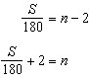

PTS: 2 REF: 061631ai NAT: A.CED.A.4 TOP: Transforming Formulas

32 ANS:
, because is a translation down 4 units.

PTS: 2 REF: 061632ai NAT: F.BF.B.3 TOP: Graphing Polynomial Functions

33 ANS:
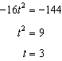

PTS: 4 REF: 061633ai NAT: A.REI.B.4 TOP: Solving Quadratics
KEY: taking square roots

34 ANS:
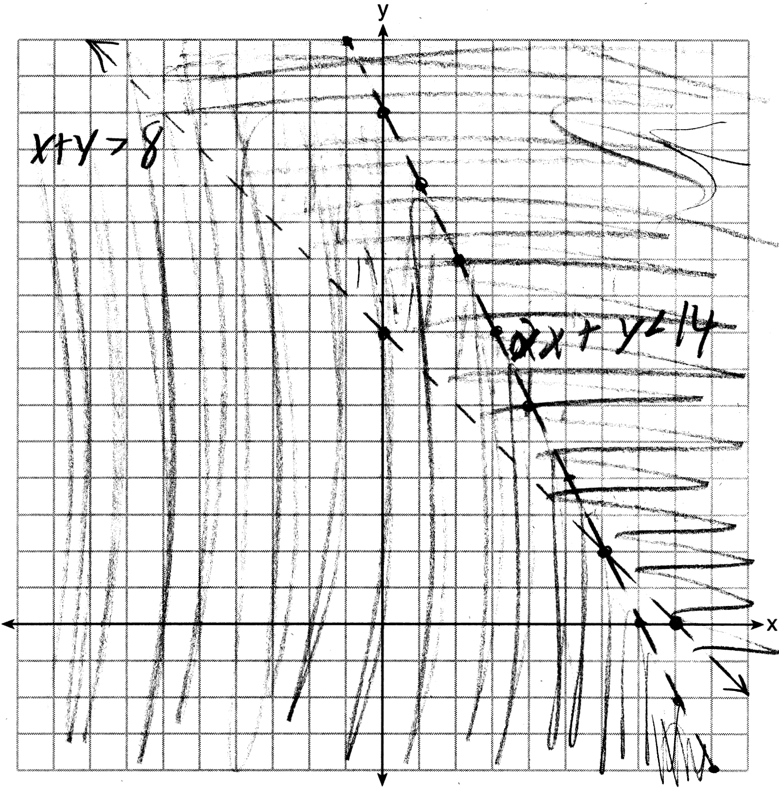 is not a solution as its falls on the edge of each inequality.

PTS: 4 REF: 061634ai NAT: A.REI.D.12 TOP: Graphing Systems of Linear Inequalities
KEY: graph

35 ANS:
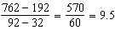

PTS: 4 REF: 061635ai NAT: A.CED.A.2 TOP: Speed

36 ANS:
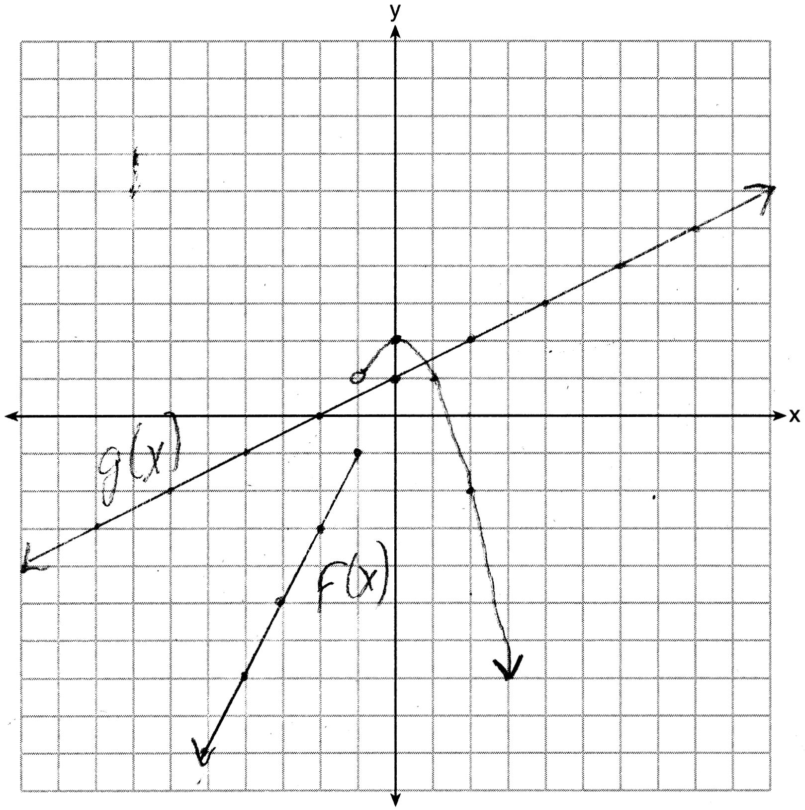 1, because the graphs only intersect once.

PTS: 4 REF: 061636ai NAT: A.REI.D.11 TOP: Other Systems

37 ANS:
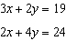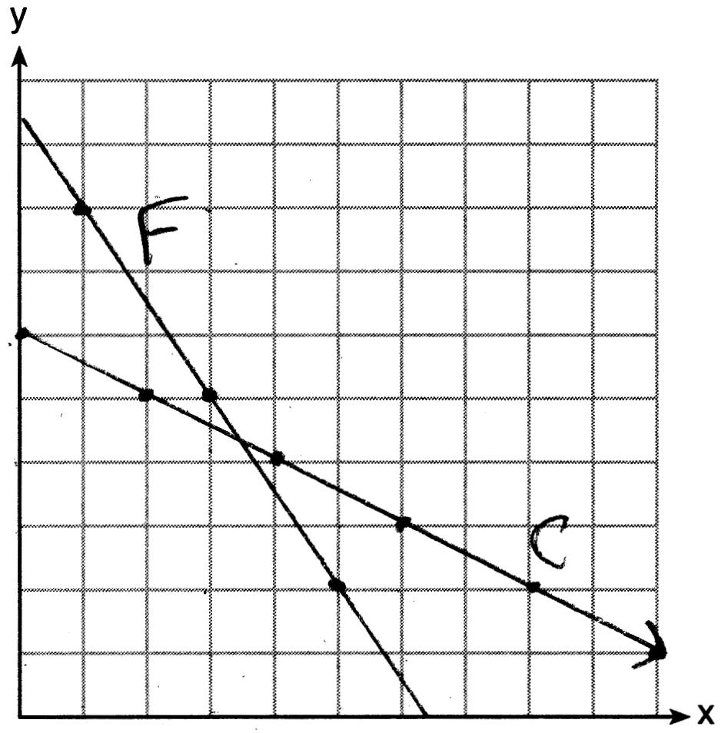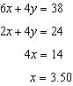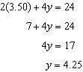

PTS: 6 REF: 061637ai NAT: A.REI.C.6 TOP: Graphing Linear Systems

