1 The cost of airing a commercial on television is modeled by the function , where n is the number of times the commercial is aired. Based on this model, which statement is true?
1) | The commercial costs $0 to produce and $110 per airing up to $900. | 3) | The commercial costs $900 to produce and $110 each time it is aired.
2) | The commercial costs $110 to produce and $900 each time it is aired. | 4) | The commercial costs $1010 to produce and can air an unlimited number of times.

2 The graph below represents a jogger's speed during her 20-minute jog around her neighborhood.

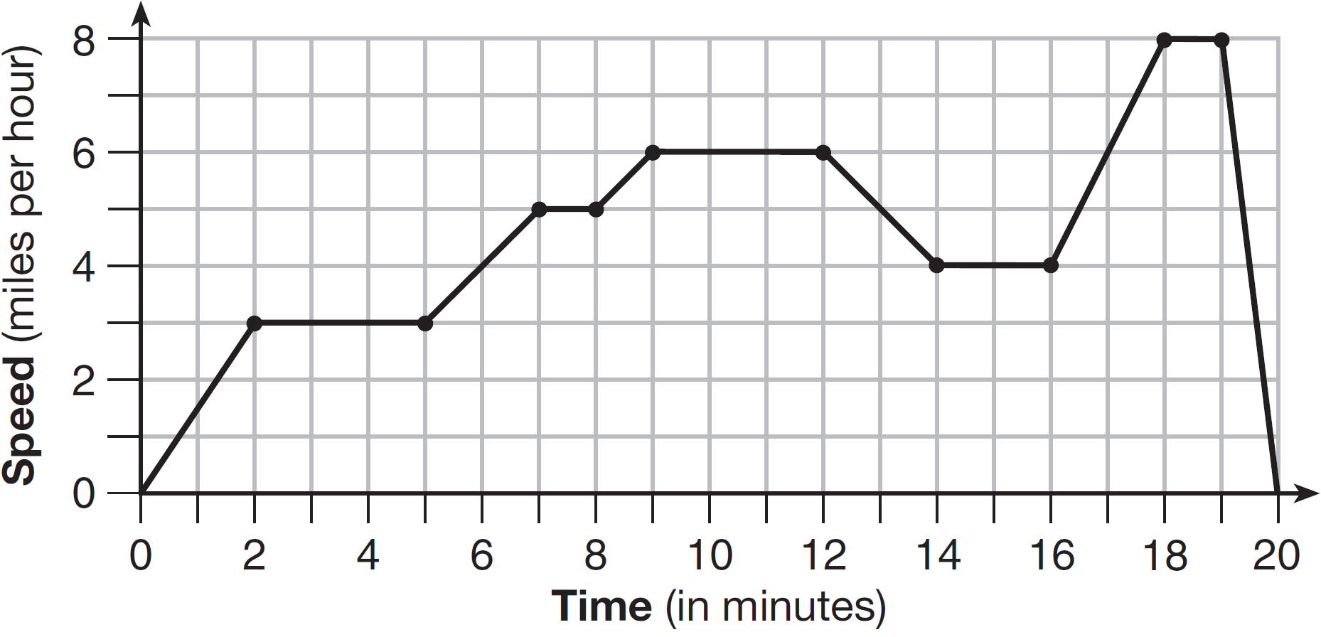

Which statement best describes what the jogger was doing during the minute interval of her jog?
1) | She was standing still. | 3) | She was decreasing her speed.
2) | She was increasing her speed. | 4) | She was jogging at a constant rate.

3 If the area of a rectangle is expressed as , then the product of the length and the width of the rectangle could be expressed as
1) |  | 3)
2) |  | 4)

4 Which table represents a function?
1) | 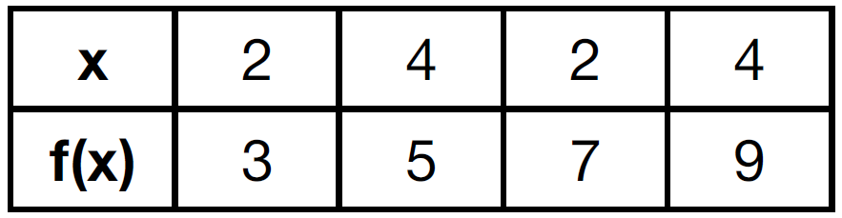 | 3) | 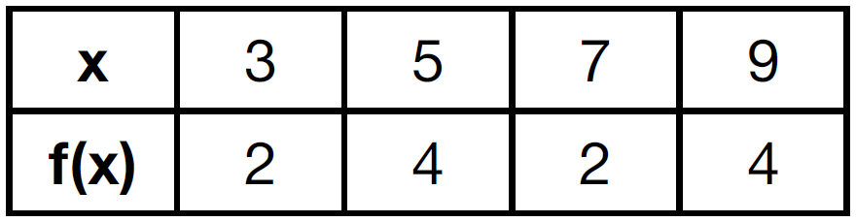
2) | 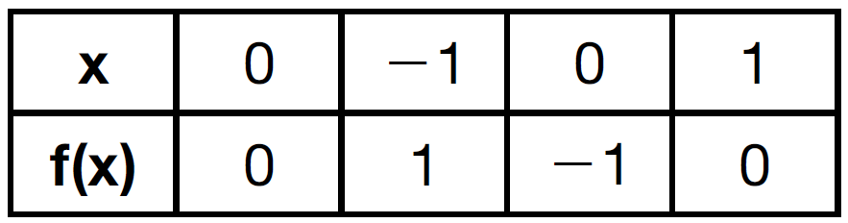 | 4) | 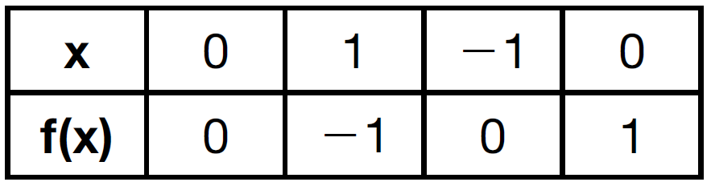

5 Which inequality is represented in the graph below?

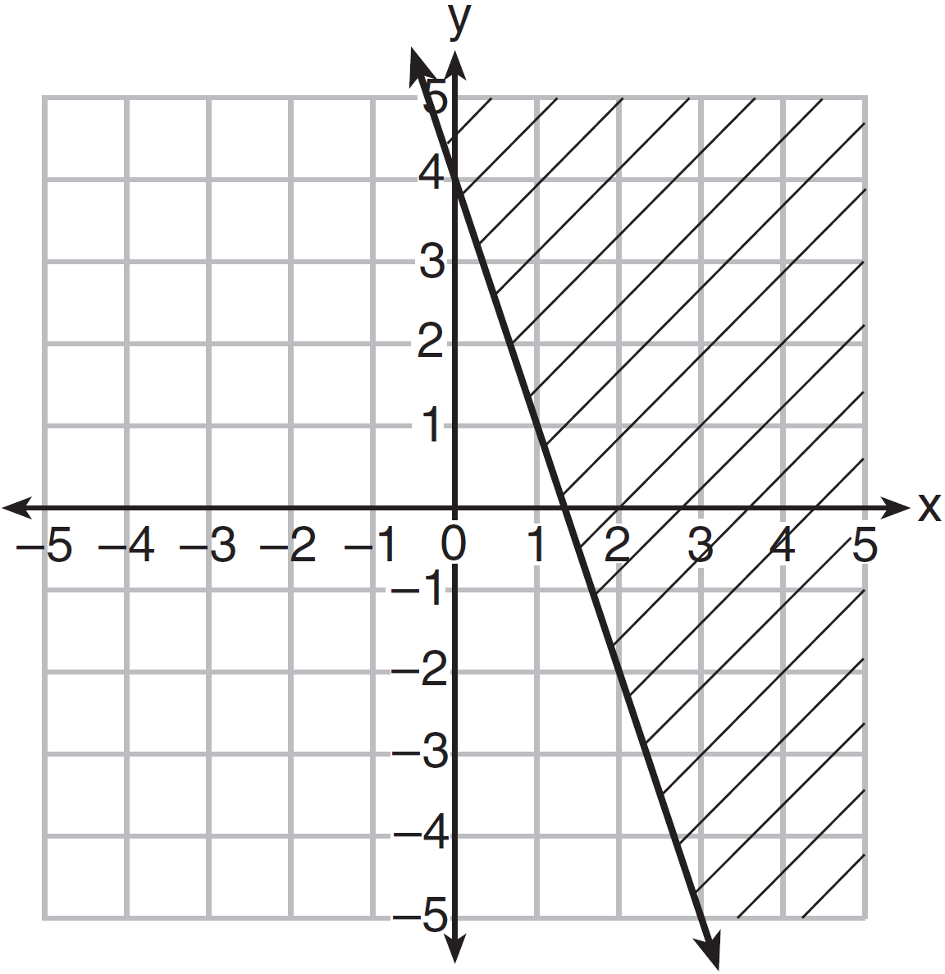
1) |  | 3)
2) |  | 4)

6 Mo's farm stand sold a total of 165 pounds of apples and peaches. She sold apples for $1.75 per pound and peaches for $2.50 per pound. If she made $337.50, how many pounds of peaches did she sell?
1) | 11 | 3) | 65
2) | 18 | 4) | 100

7 Morgan can start wrestling at age 5 in Division 1. He remains in that division until his next odd birthday when he is required to move up to the next division level. Which graph correctly represents this information?
1) | 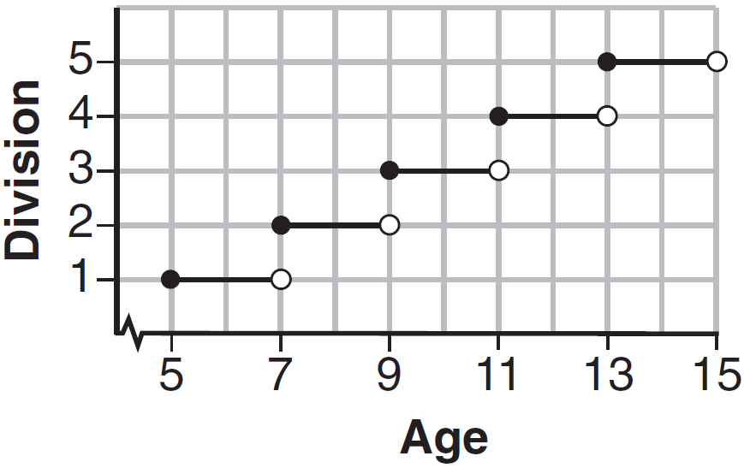 | 3) | 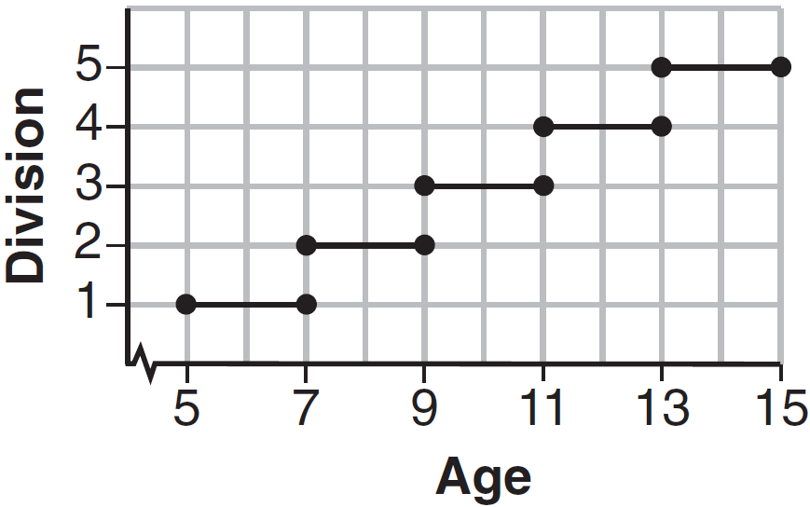
2) | 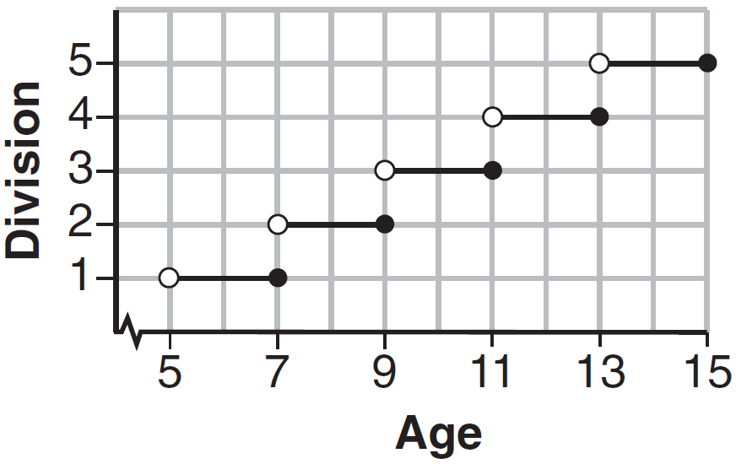 | 4) | 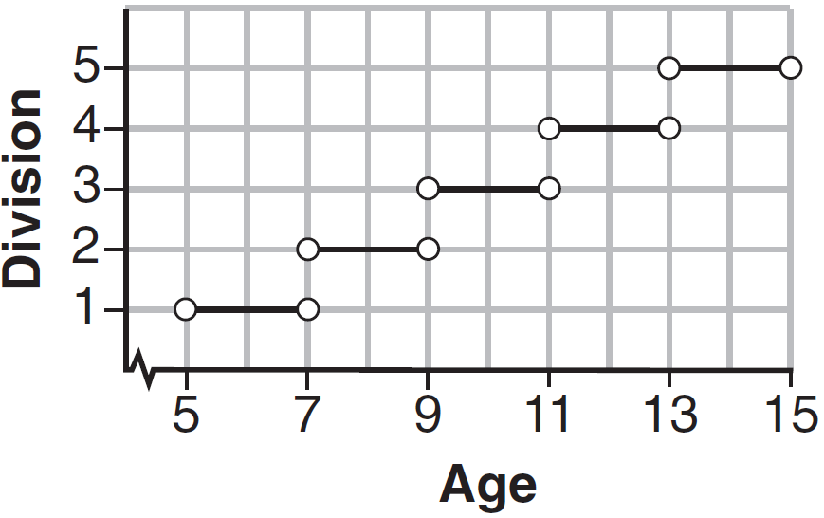

8 Which statement is not always true?
1) | The sum of two rational numbers is rational. | 3) | The sum of a rational number and an irrational number is irrational.
2) | The product of two irrational numbers is rational. | 4) | The product of a nonzero rational number and an irrational number is irrational.

9 The graph of the function is shown below.

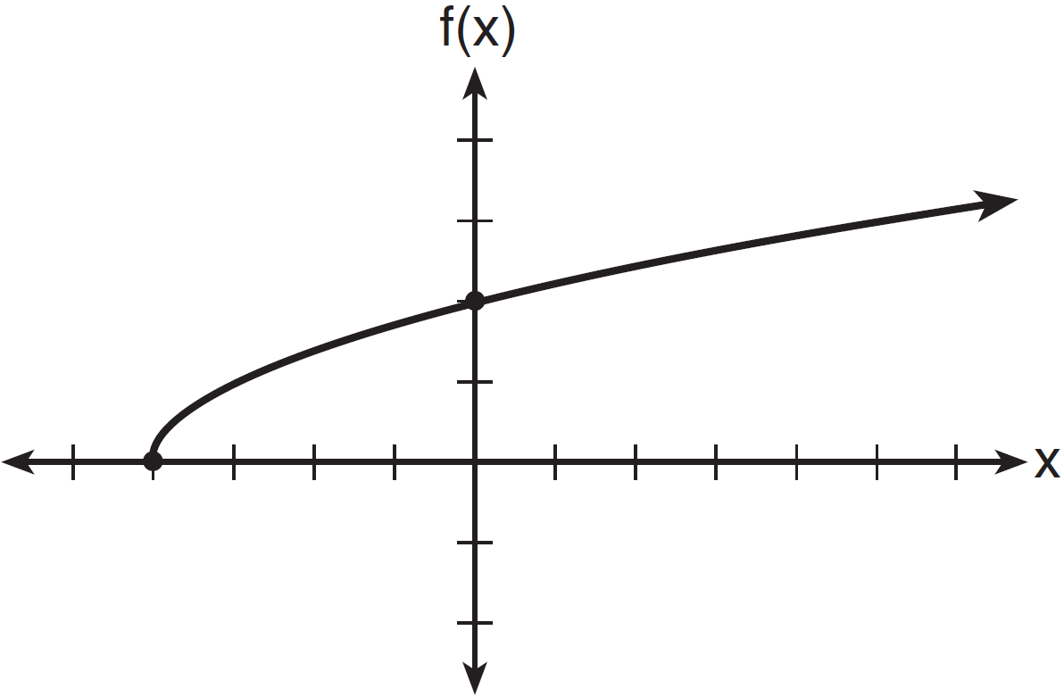

The domain of the function is
1) |  | 3)
2) |  | 4)

10 What are the zeros of the function ?
1) | and 3 | 3) | and 2
2) | 10 and | 4) | 15 and

11 Joey enlarged a 3-inch by 5-inch photograph on a copy machine. He enlarged it four times. The table below shows the area of the photograph after each enlargement.

Enlargement | 0 | 1 | 2 | 3 | 4
Area (square inches) | 15 | 18.8 | 23.4 | 29.3 | 36.6

What is the average rate of change of the area from the original photograph to the fourth enlargement, to the nearest tenth?
1) | 4.3 | 3) | 5.4
2) | 4.5 | 4) | 6.0

12 Which equation(s) represent the graph below?
I
II
III

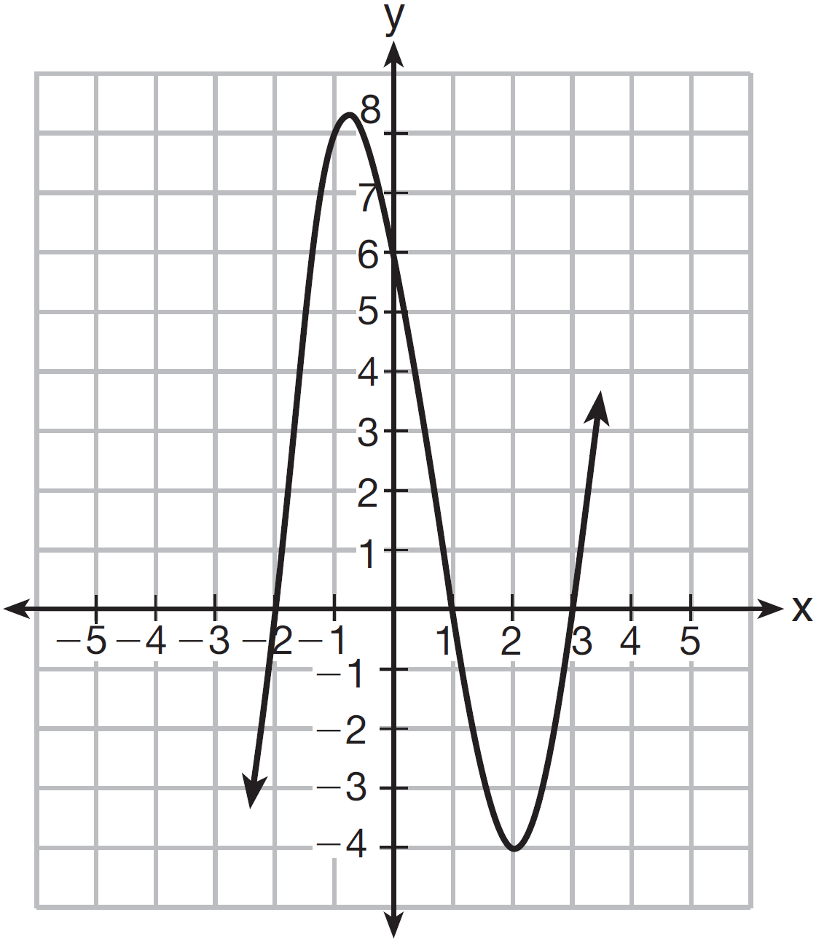
1) | I, only | 3) | I and II
2) | II, only | 4) | II and III

13 A laboratory technician studied the population growth of a colony of bacteria. He recorded the number of bacteria every other day, as shown in the partial table below.

t (time, in days) | 0 | 2 | 4
f(t) (bacteria) | 25 | 15,625 | 9,765,625

Which function would accurately model the technician's data?
1) |  | 3)
2) |  | 4)

14 Which quadratic function has the largest maximum?
1) |  | 3)
2) | 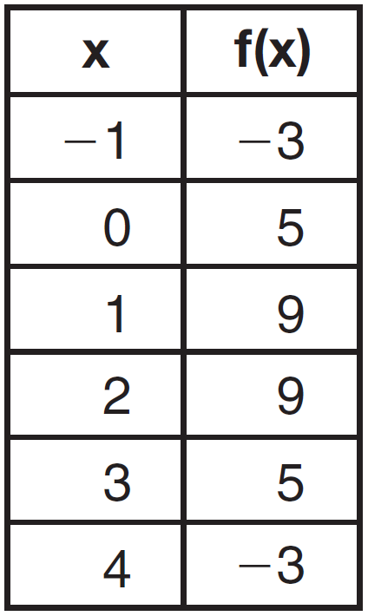 | 4) | 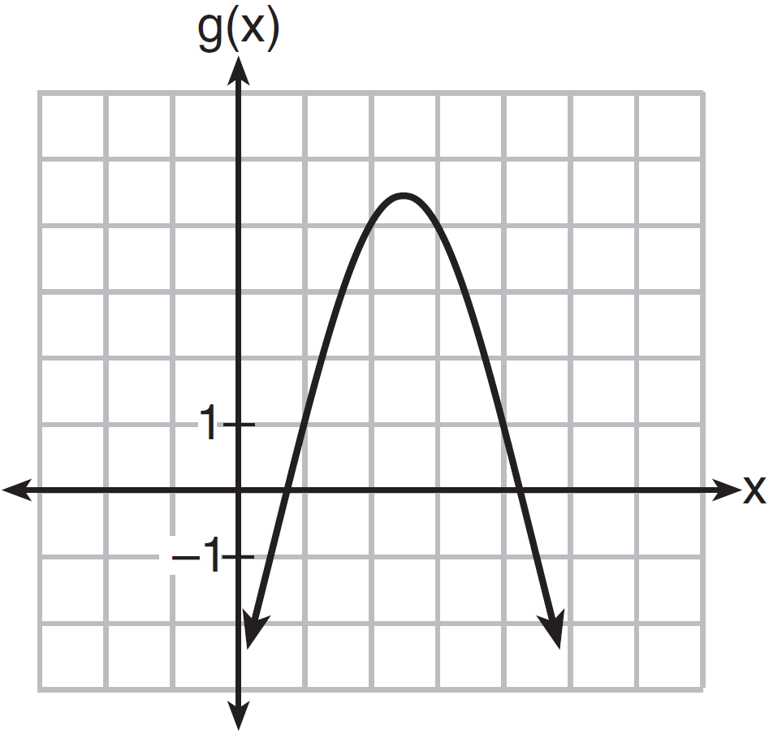

15 If and , at which value of x is ?
1) |  | 3)
2) | 2 | 4) | 4

16 Beverly did a study this past spring using data she collected from a cafeteria. She recorded data weekly for ice cream sales and soda sales. Beverly found the line of best fit and the correlation coefficient, as shown in the diagram below.

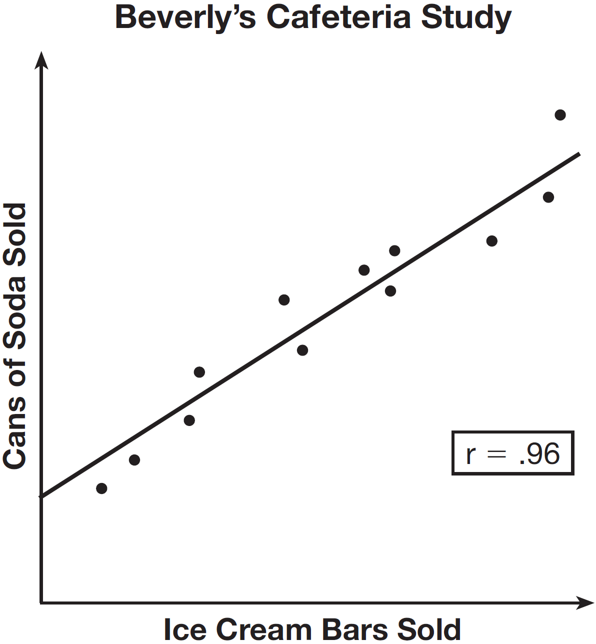

Given this information, which statement(s) can correctly be concluded?
I. Eating more ice cream causes a person to become thirsty.
II. Drinking more soda causes a person to become hungry.
III. There is a strong correlation between ice cream sales and soda sales.
1) | I, only | 3) | I and III
2) | III, only | 4) | II and III

17 The function represents the value , in dollars, of a comic book t years after its purchase. The yearly rate of appreciation of the comic book is
1) | 17% | 3) | 1.017%
2) | 1.7% | 4) | 0.017%

18 When directed to solve a quadratic equation by completing the square, Sam arrived at the equation 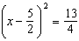. Which equation could have been the original equation given to Sam?
1) |  | 3)
2) |  | 4)

19 The distance a free falling object has traveled can be modeled by the equation 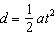, where a is acceleration due to gravity and t is the amount of time the object has fallen. What is t in terms of a and d?
1) | 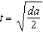 | 3) | 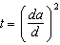
2) | 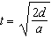 | 4) | 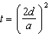

20 The table below shows the annual salaries for the 24 members of a professional sports team in terms of millions of dollars.

0.5 | 0.5 | 0.6 | 0.7 | 0.75 | 0.8
1.0 | 1.0 | 1.1 | 1.25 | 1.3 | 1.4
1.4 | 1.8 | 2.5 | 3.7 | 3.8 | 4
4.2 | 4.6 | 5.1 | 6 | 6.3 | 7.2

The team signs an additional player to a contract worth 10 million dollars per year. Which statement about the median and mean is true?
1) | Both will increase. | 3) | Only the mean will increase.
2) | Only the median will increase. | 4) | Neither will change.

21 A student is asked to solve the equation . The student's solution to the problem starts as 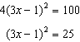
A correct next step in the solution of the problem is
1) |  | 3)
2) |  | 4)

22 A pattern of blocks is shown below.
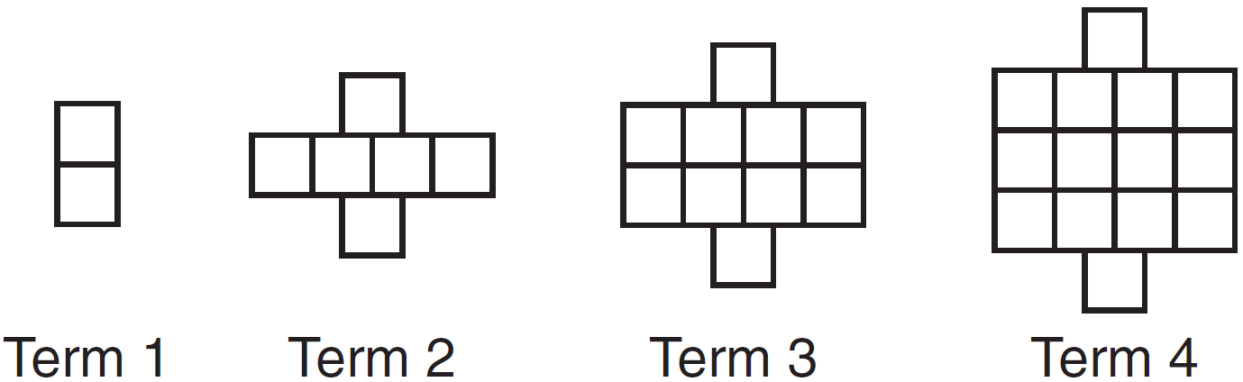
If the pattern of blocks continues, which formula(s) could be used to determine the number of blocks in the nth term?

I | II | III
 | 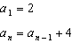

1) | I and II | 3) | II and III
2) | I and III | 4) | III, only

23 What are the solutions to the equation ?
1) |  | 3)
2) |  | 4)

24 Natasha is planning a school celebration and wants to have live music and food for everyone who attends. She has found a band that will charge her $750 and a caterer who will provide snacks and drinks for $2.25 per person. If her goal is to keep the average cost per person between $2.75 and $3.25, how many people, p, must attend?
1) |  | 3)
2) |  | 4)

25 Graph the function on the set of axes below.

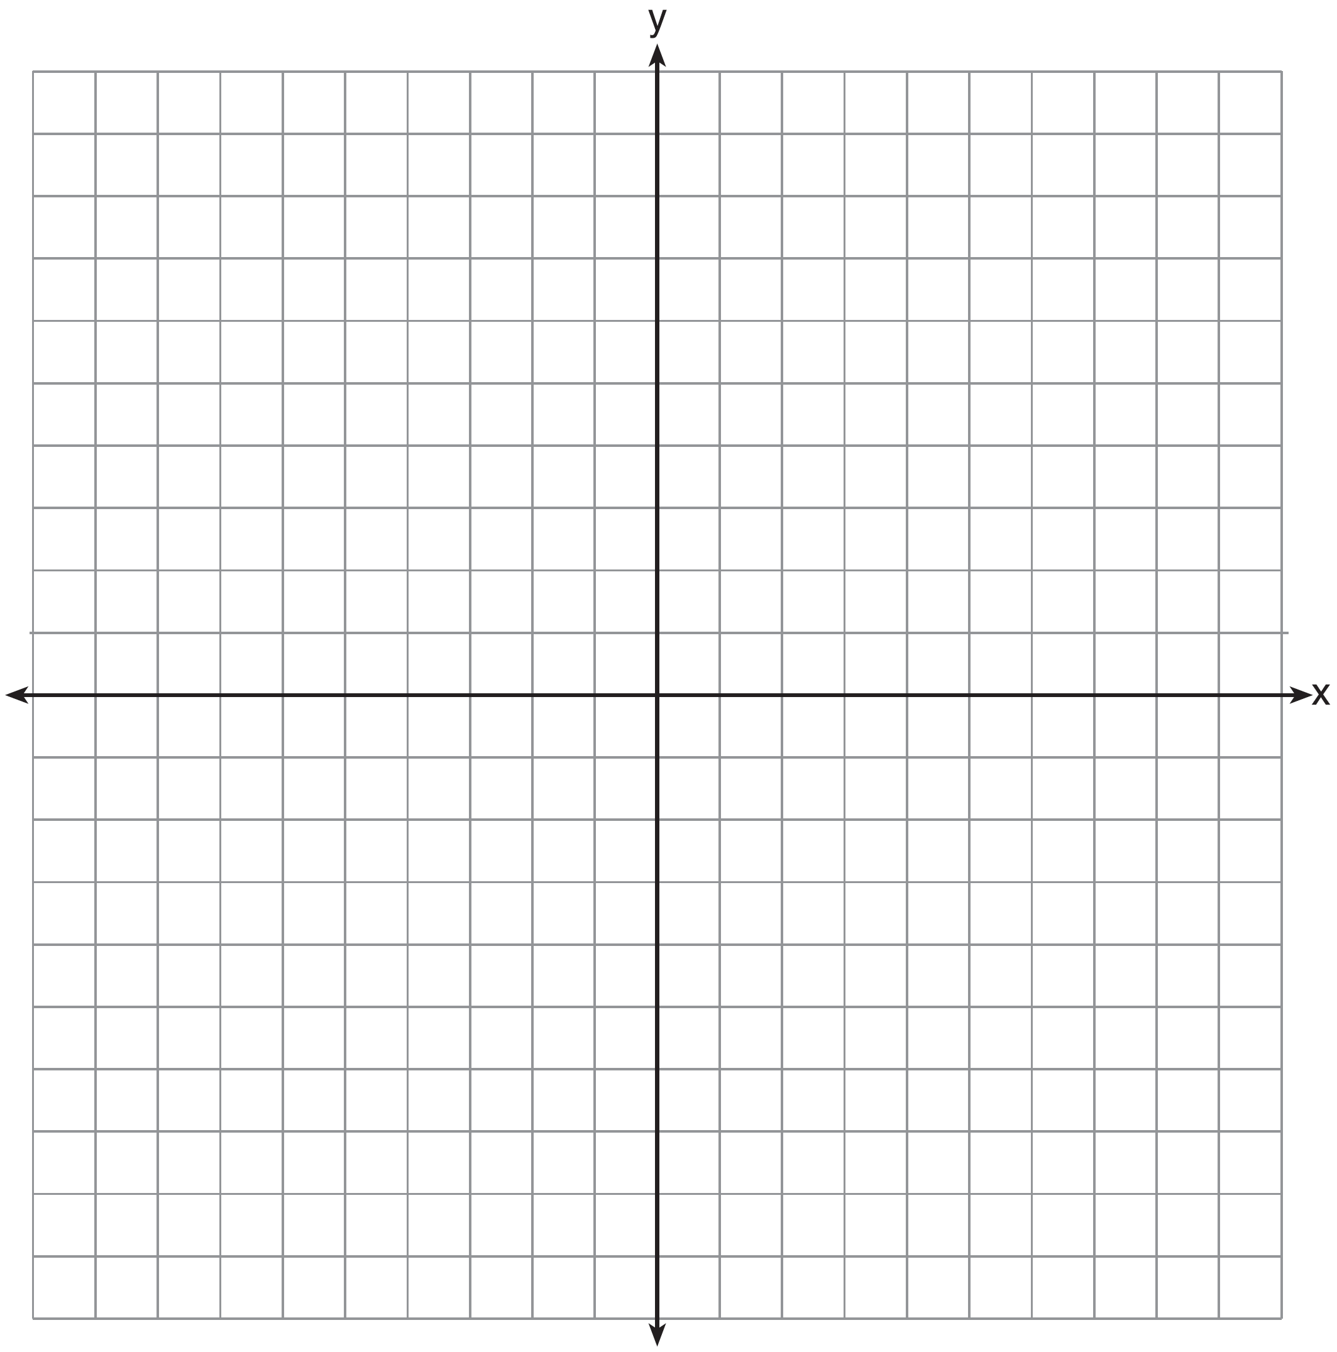

Explain how the graph of has changed from the related graph .

26 Alex is selling tickets to a school play. An adult ticket costs $6.50 and a student ticket costs $4.00. Alex sells x adult tickets and 12 student tickets. Write a function, , to represent how much money Alex collected from selling tickets.

27 John and Sarah are each saving money for a car. The total amount of money John will save is given by the function . The total amount of money Sarah will save is given by the function . After how many weeks, x, will they have the same amount of money saved? Explain how you arrived at your answer.

28 If the difference is multiplied by , what is the result, written in standard form?

29 Dylan invested $600 in a savings account at a 1.6% annual interest rate. He made no deposits or withdrawals on the account for 2 years. The interest was compounded annually. Find, to the nearest cent, the balance in the account after 2 years.

30 Determine the smallest integer that makes true.

31 The residual plots from two different sets of bivariate data are graphed below.

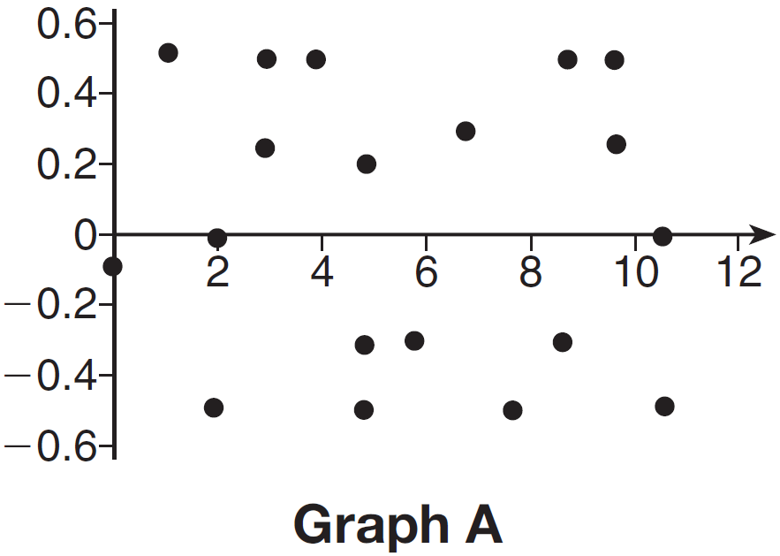

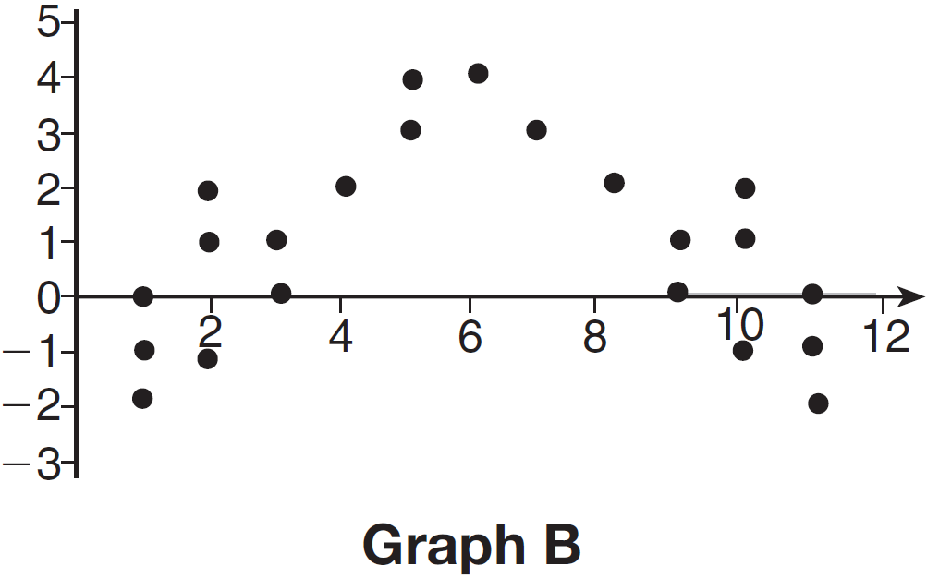

Explain, using evidence from graph A and graph B, which graph indicates that the model for the data is a good fit.

32 A landscaper is creating a rectangular flower bed such that the width is half of the length. The area of the flower bed is 34 square feet. Write and solve an equation to determine the width of the flower bed, to the nearest tenth of a foot.

33 Albert says that the two systems of equations shown below have the same solutions.

First System | Second System
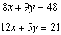 | 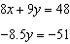

Determine and state whether you agree with Albert. Justify your answer.

34 The equation to determine the weekly earnings of an employee at The Hamburger Shack is given by , where x is the number of hours worked.
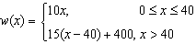
Determine the difference in salary, in dollars, for an employee who works 52 hours versus one who works 38 hours. Determine the number of hours an employee must work in order to earn $445. Explain how you arrived at this answer.

35 An on-line electronics store must sell at least $2500 worth of printers and computers per day. Each printer costs $50 and each computer costs $500. The store can ship a maximum of 15 items per day. On the set of axes below, graph a system of inequalities that models these constraints.

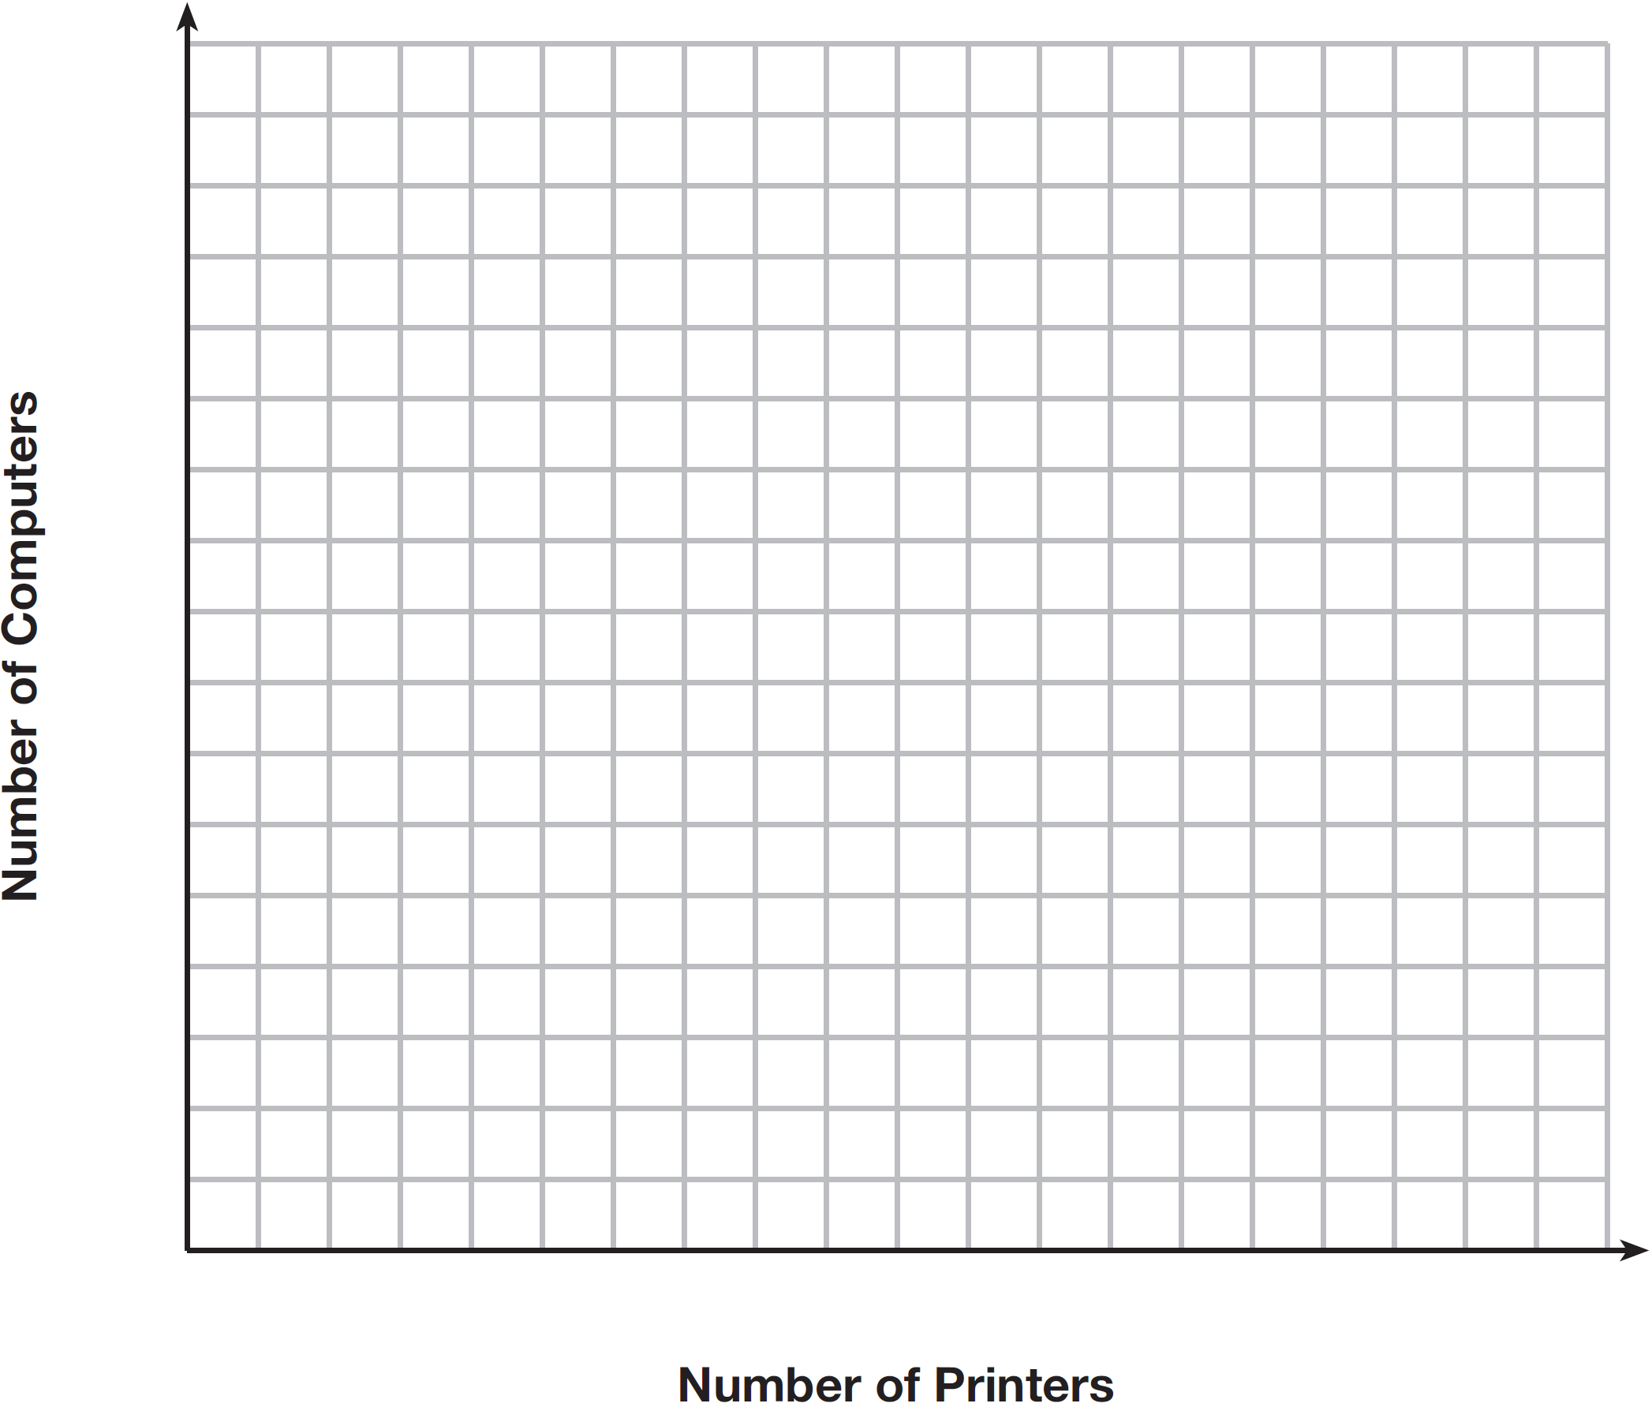

Determine a combination of printers and computers that would allow the electronics store to meet all of the constraints. Explain how you obtained your answer.

36 An application developer released a new app to be downloaded. The table below gives the number of downloads for the first four weeks after the launch of the app.

Number of Weeks | 1 | 2 | 3 | 4
Number of Downloads | 120 | 180 | 270 | 405

Write an exponential equation that models these data. Use this model to predict how many downloads the developer would expect in the 26th week if this trend continues. Round your answer to the nearest download. Would it be reasonable to use this model to predict the number of downloads past one year? Explain your reasoning.

37 A football player attempts to kick a football over a goal post. The path of the football can be modeled by the function 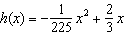, where x is the horizontal distance from the kick, and is the height of the football above the ground, when both are measured in feet. On the set of axes below, graph the function over the interval .

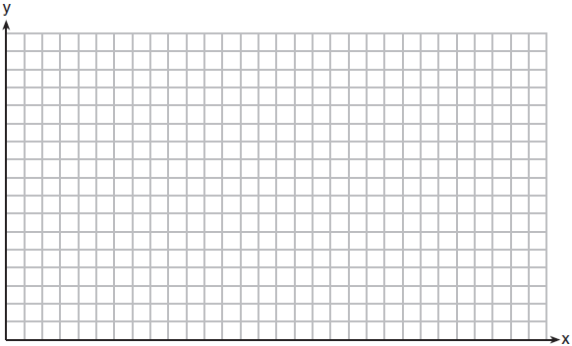

Determine the vertex of . Interpret the meaning of this vertex in the context of the problem. The goal post is 10 feet high and 45 yards away from the kick. Will the ball be high enough to pass over the goal post? Justify your answer.
1 ANS: 3 PTS: 2 REF: 061501ai NAT: F.LE.B.5
TOP: Modeling Linear Functions

2 ANS: 4 PTS: 2 REF: 061502ai NAT: F.IF.B.4
TOP: Relating Graphs to Events

3 ANS: 2 PTS: 2 REF: 061503ai NAT: A.SSE.A.2
TOP: Factoring the Difference of Perfect Squares KEY: multivariable

4 ANS: 3 PTS: 2 REF: 061504ai NAT: F.IF.A.1
TOP: Defining Functions KEY: ordered pairs

5 ANS: 1 PTS: 2 REF: 061505ai NAT: A.REI.D.12
TOP: Graphing Linear Inequalities

6 ANS: 3
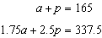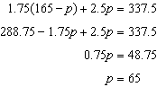

PTS: 2 REF: 061506ai NAT: A.CED.A.3 TOP: Modeling Linear Systems

7 ANS: 1 PTS: 2 REF: 061507ai NAT: F.IF.C.7
TOP: Graphing Step Functions KEY: bimodalgraph

8 ANS: 2 PTS: 2 REF: 061508ai NAT: N.RN.B.3
TOP: Operations with Radicals KEY: classify

9 ANS: 4 PTS: 2 REF: 061509ai NAT: F.IF.A.2
TOP: Domain and Range KEY: graph

10 ANS: 4
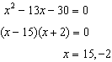

PTS: 2 REF: 061510ai NAT: A.APR.B.3 TOP: Zeros of Polynomials

11 ANS: 3
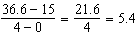

PTS: 2 REF: 061511ai NAT: F.IF.B.6 TOP: Rate of Change

12 ANS: 2

PTS: 2 REF: 061512ai NAT: A.APR.B.3 TOP: Graphing Polynomial Functions

13 ANS: 2 PTS: 2 REF: 061513ai NAT: F.LE.A.2
TOP: Families of Functions

14 ANS: 3
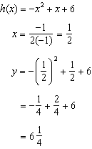Maximum of 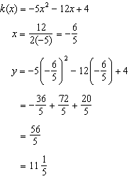 Maximum of

PTS: 2 REF: 061514ai NAT: F.IF.C.9 TOP: Comparing Functions

15 ANS: 1
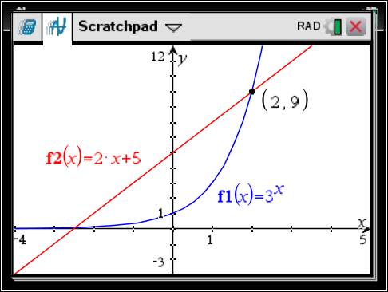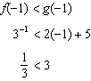

PTS: 2 REF: 061515ai NAT: F.LE.A.3 TOP: Families of Functions

16 ANS: 2 PTS: 2 REF: 061516ai NAT: S.ID.C.9
TOP: Analysis of Data

17 ANS: 2 PTS: 2 REF: 061517ai NAT: F.LE.B.5
TOP: Modeling Exponential Functions

18 ANS: 4
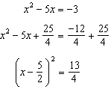

PTS: 2 REF: 061518ai NAT: A.REI.B.4 TOP: Solving Quadratics
KEY: completing the square

19 ANS: 2
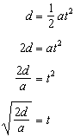

PTS: 2 REF: 061519ai NAT: A.CED.A.4 TOP: Transforming Formulas

20 ANS: 3
Median remains at 1.4.

PTS: 2 REF: 061520ai NAT: S.ID.A.3 TOP: Central Tendency and Dispersion

21 ANS: 1 PTS: 2 REF: 061521ai NAT: A.REI.B.4
TOP: Solving Quadratics KEY: taking square roots

22 ANS: 3 PTS: 2 REF: 061522ai NAT: F.LE.A.2
TOP: Sequences KEY: recursive

23 ANS: 1
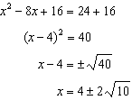

PTS: 2 REF: 061523ai NAT: A.REI.B.4 TOP: Solving Quadratics
KEY: completing the square

24 ANS: 4
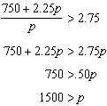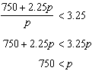

PTS: 2 REF: 061524ai NAT: A.CED.A.1 TOP: Modeling Linear Inequalities

25 ANS:
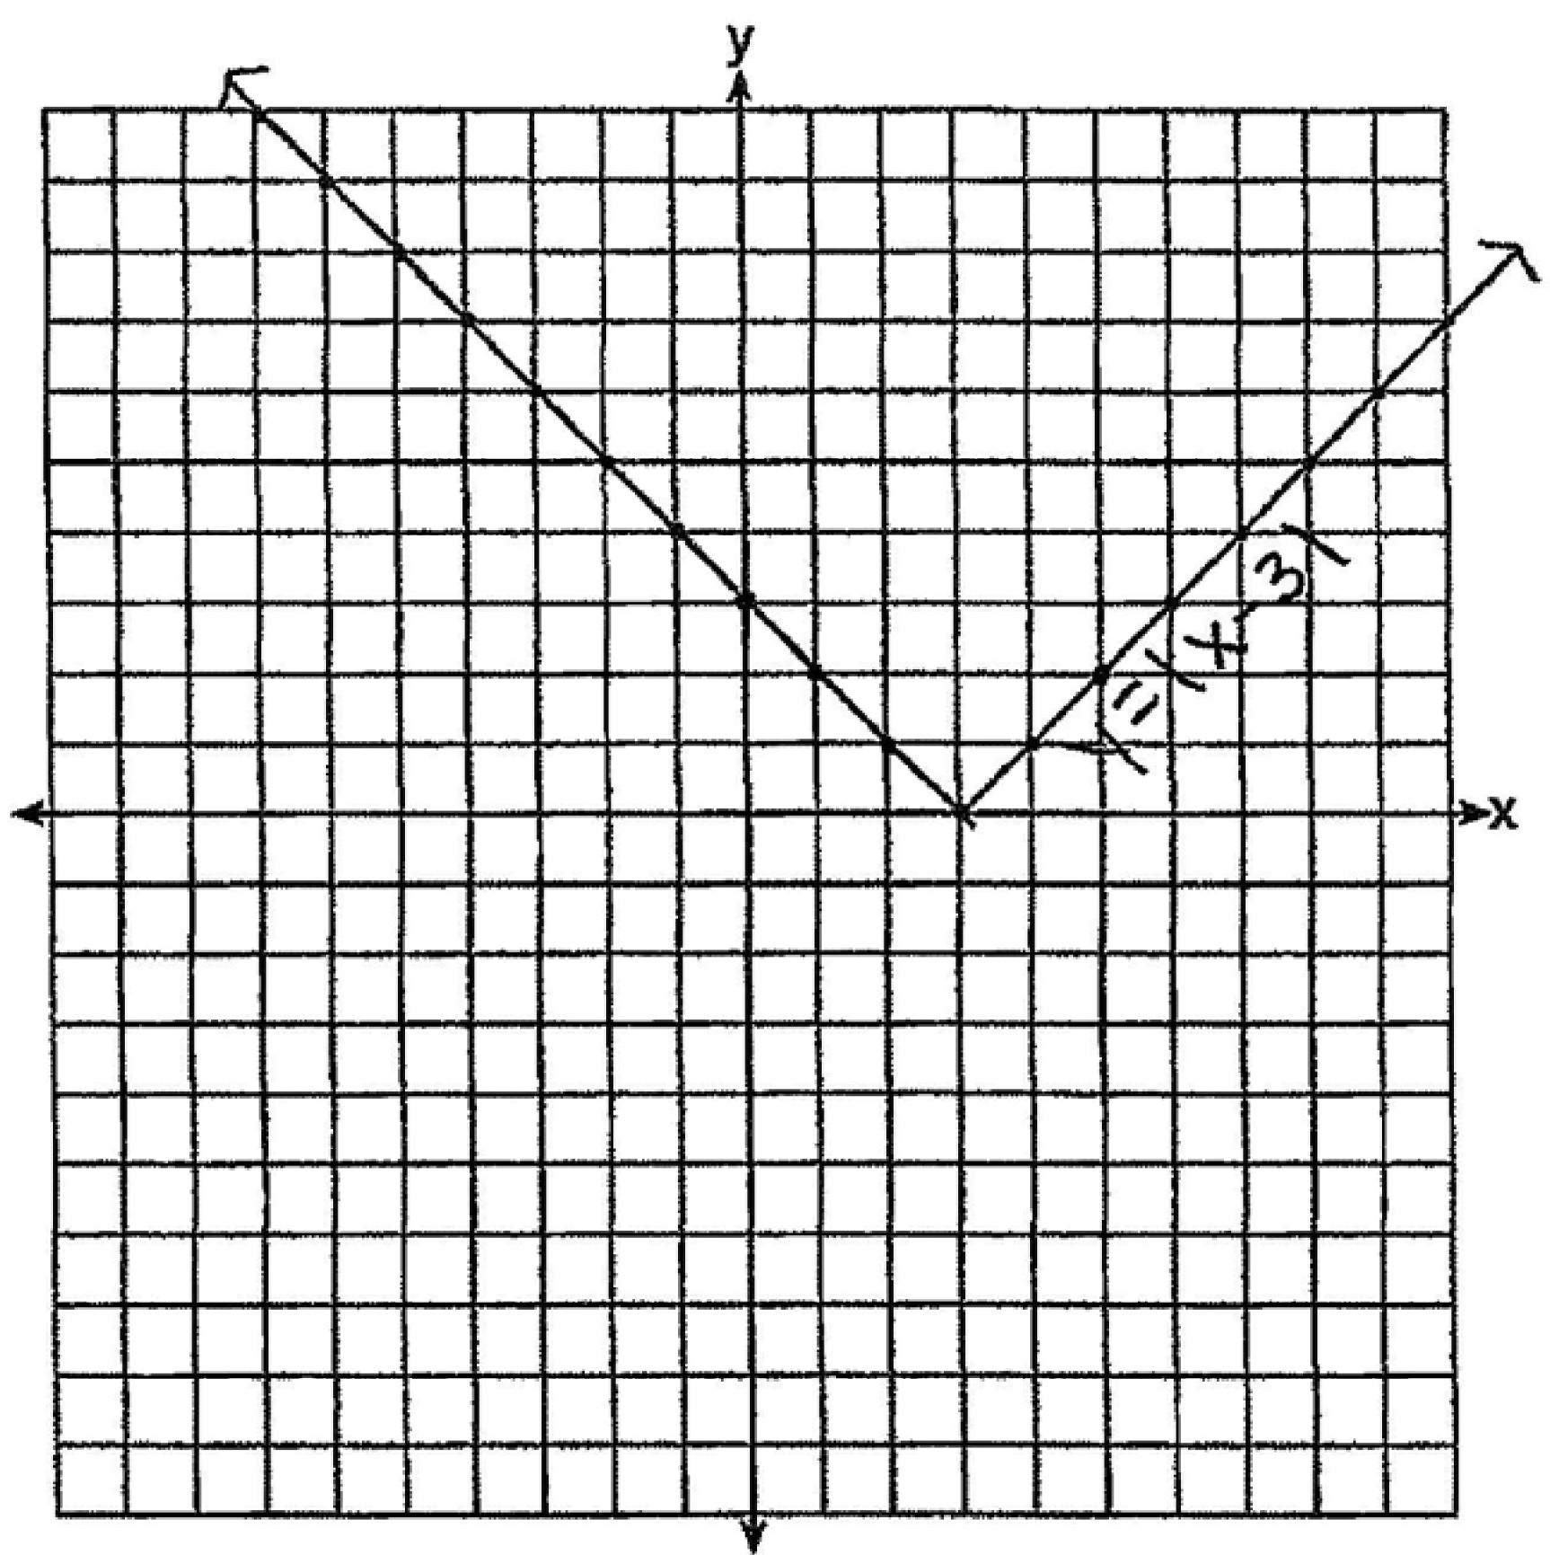 The graph has shifted three units to the right.

PTS: 2 REF: 061525ai NAT: F.BF.B.3 TOP: Graphing Absolute Value Functions

26 ANS:

PTS: 2 REF: 061526ai NAT: F.BF.A.1 TOP: Modeling Linear Functions

27 ANS:
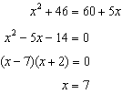 John and Sarah will have the same amount of money saved at 7 weeks. I set the expressions representing their savings equal to each other and solved for the positive value of x by factoring.

PTS: 2 REF: 061527ai NAT: A.REI.D.11 TOP: Quadratic-Linear Systems

28 ANS:
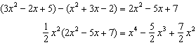

PTS: 2 REF: 061528ai NAT: A.APR.A.1 TOP: Operations with Polynomials
KEY: multiplication

29 ANS:

PTS: 2 REF: 061529ai NAT: A.CED.A.1 TOP: Modeling Exponential Functions

30 ANS:
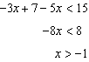 0 is the smallest integer.

PTS: 2 REF: 061530ai NAT: A.REI.B.3 TOP: Interpreting Solutions

31 ANS:
Graph A is a good fit because it does not have a clear pattern, whereas Graph B does.

PTS: 2 REF: 061531ai NAT: S.ID.B.6 TOP: Residuals

32 ANS:
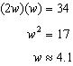

PTS: 2 REF: 061532ai NAT: A.CED.A.1 TOP: Geometric Applications of Quadratics

33 ANS:
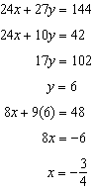 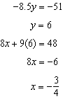 Agree, as both systems have the same solution.

PTS: 4 REF: 061533ai NAT: A.REI.C.6 TOP: Solving Linear Systems

34 ANS:
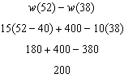 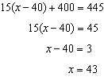 Since , . I substituted 445 for and solved for x.

PTS: 4 REF: 061534ai NAT: F.IF.A.2 TOP: Functional Notation

35 ANS:
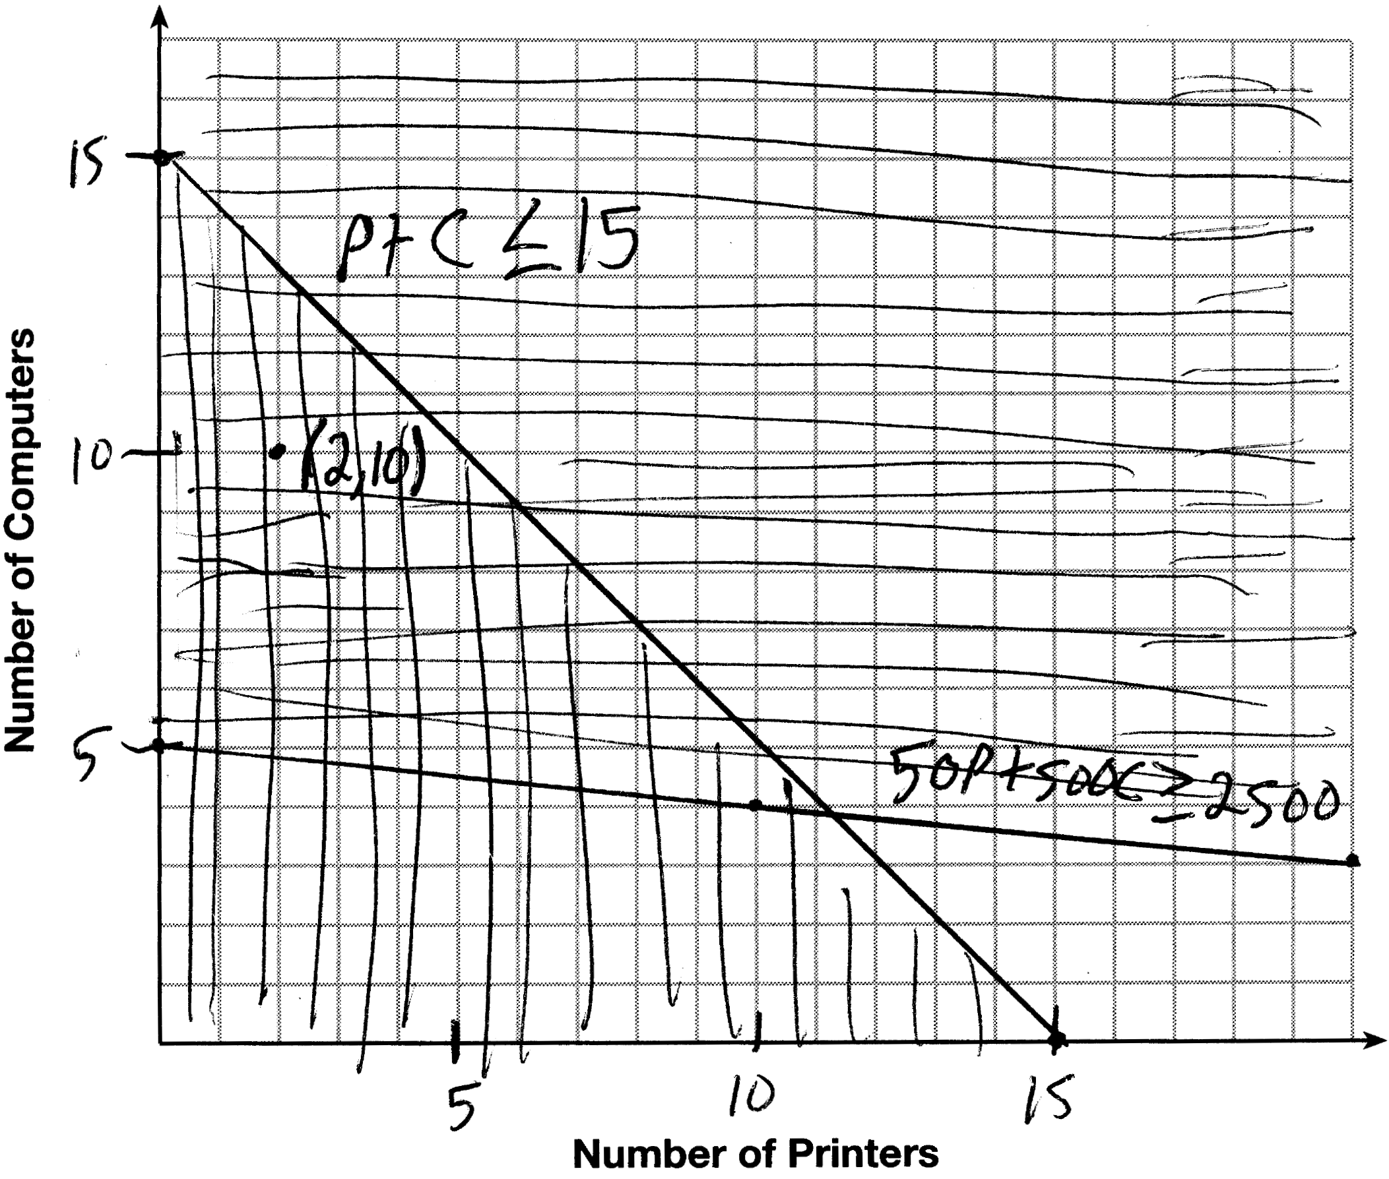 A combination of 2 printers and 10 computers meets all the constraints because is in the solution set of the graph.

PTS: 4 REF: 061535ai NAT: A.CED.A.3 TOP: Modeling Systems of Linear Inequalities

36 ANS:
. No, because the prediction at is already too large.

PTS: 4 REF: 061536ai NAT: S.ID.B.6 TOP: Regression
KEY: exponential

37 ANS:
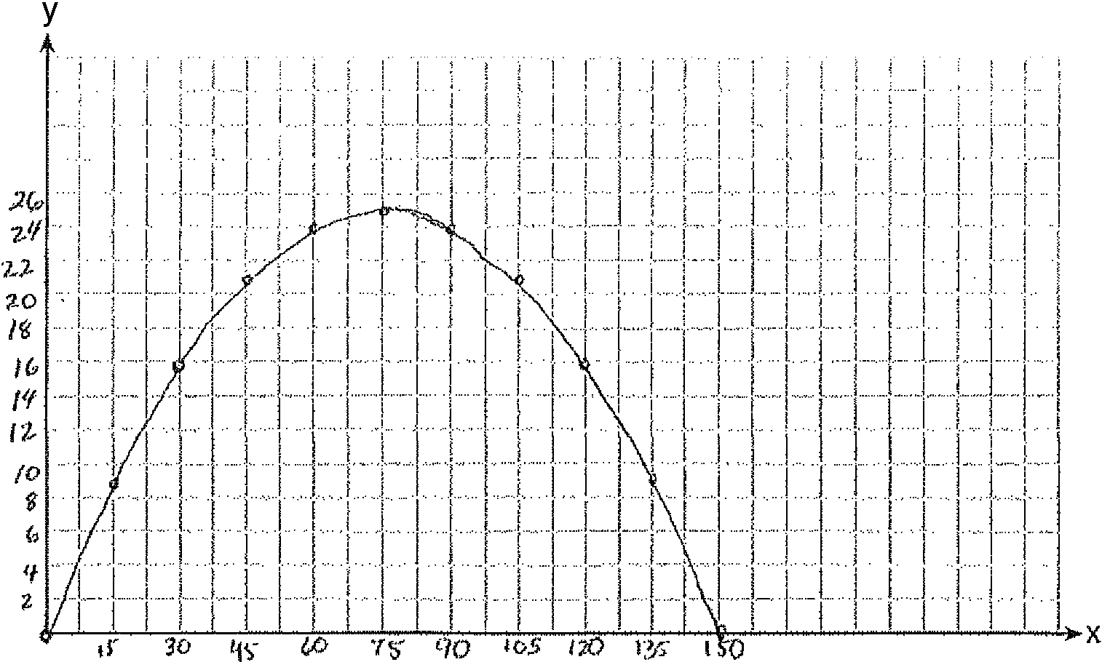 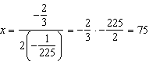 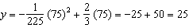 (75,25) represents the horizontal distance (75) where the football is at its greatest height (25). No, because the ball is less than 10 feet high 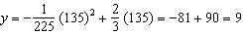

PTS: 6 REF: 061537ai NAT: F.IF.B.4 TOP: Graphing Quadratic Functions
KEY: context

