1 When solving the equation , Emily wrote as her first step. Which property justifies Emily's first step?
1) | addition property of equality | 3) | multiplication property of equality
2) | commutative property of addition | 4) | distributive property of multiplication over addition

2 Officials in a town use a function, C, to analyze traffic patterns. represents the rate of traffic through an intersection where n is the number of observed vehicles in a specified time interval. What would be the most appropriate domain for the function?
1) |  | 3) | 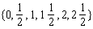
2) |  | 4)

3 If and , then equals
1) |  | 3)
2) |  | 4)

4 Given: 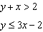
Which graph shows the solution of the given set of inequalities?
1) | 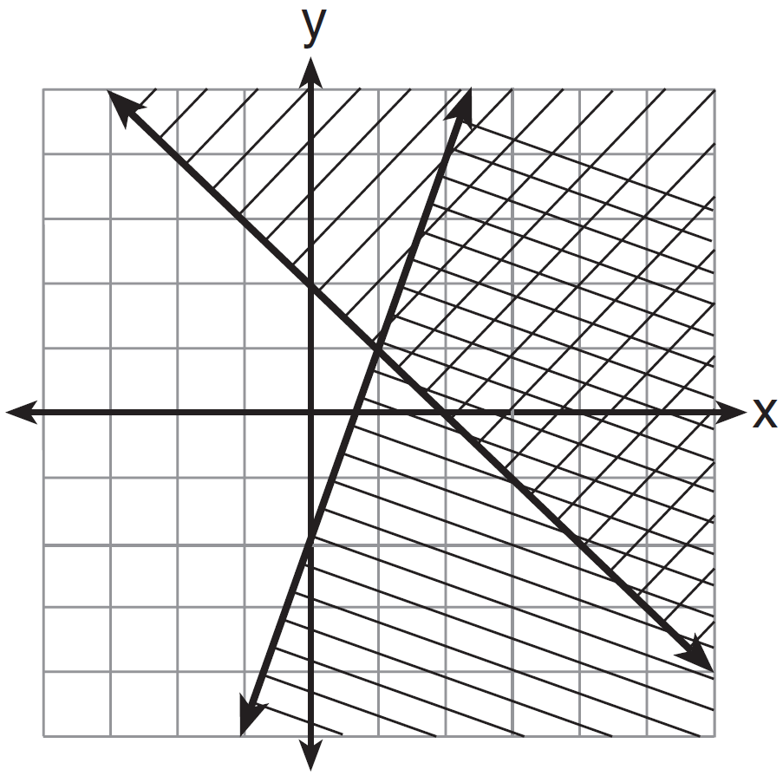 | 3) | 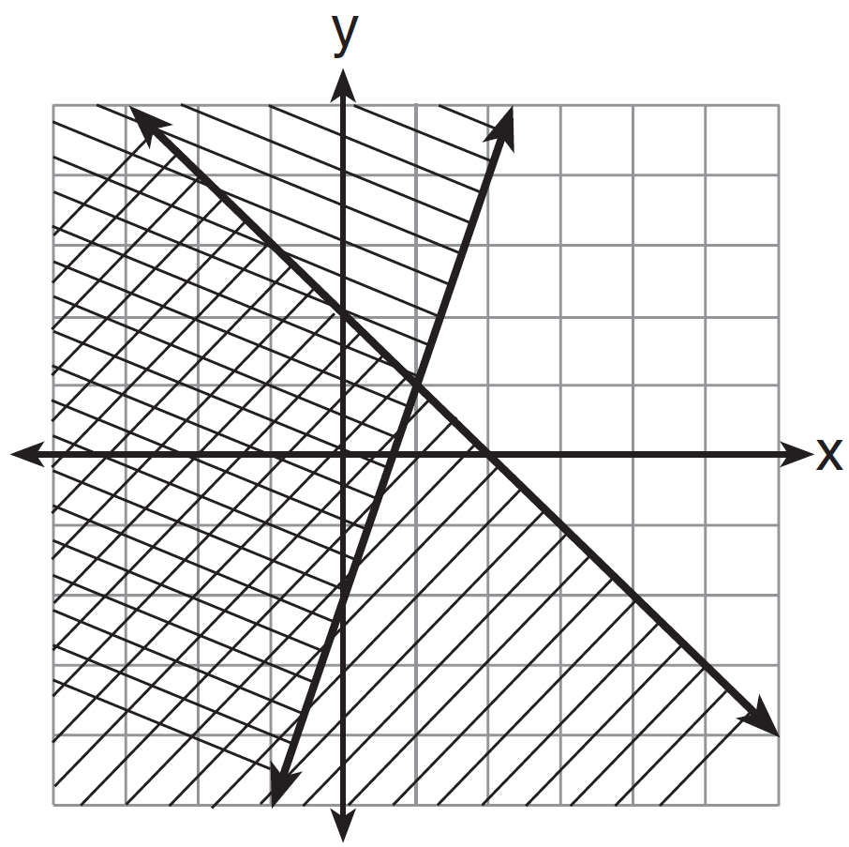
2) | 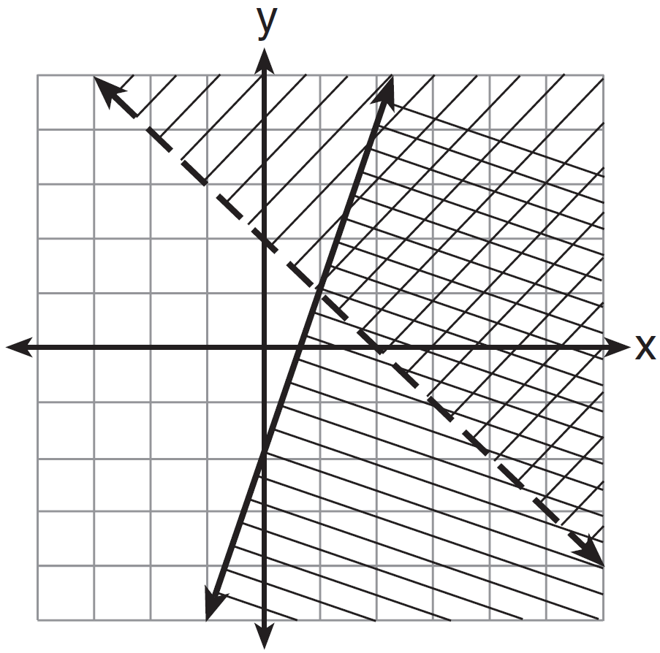 | 4) | 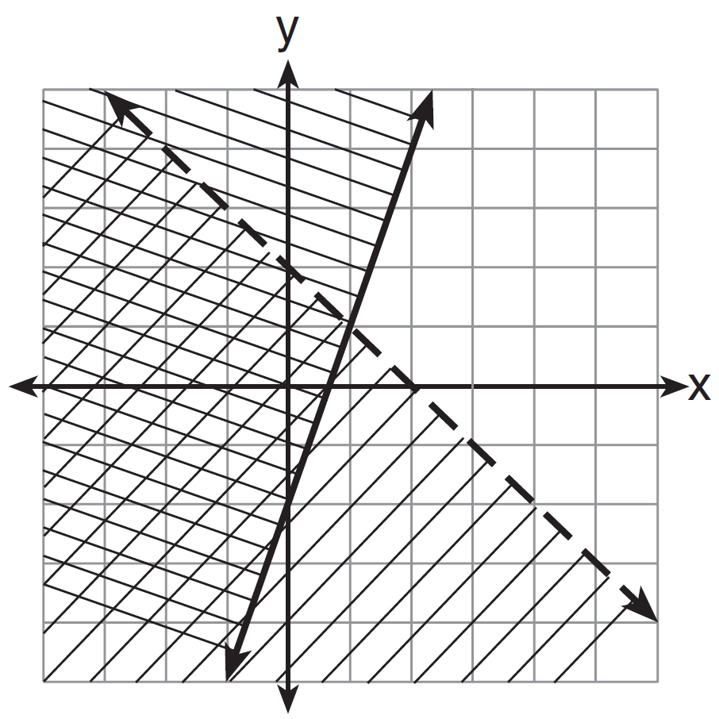

5 Which value of x satisfies the equation 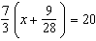?
1) | 8.25 | 3) | 19.25
2) | 8.89 | 4) | 44.92

6 The table below shows the average yearly balance in a savings account where interest is compounded annually. No money is deposited or withdrawn after the initial amount is deposited.

Year | Balance, in Dollars
0 | 380.00
10 | 562.49
20 | 832.63
30 | 1232.49
40 | 1824.39
50 | 2700.54

Which type of function best models the given data?
1) | linear function with a negative rate of change | 3) | exponential decay function
2) | linear function with a positive rate of change | 4) | exponential growth function

7 A company that manufactures radios first pays a start-up cost, and then spends a certain amount of money to manufacture each radio. If the cost of manufacturing r radios is given by the function , then the value 5.25 best represents
1) | the start-up cost | 3) | the amount spent to manufacture each radio
2) | the profit earned from the sale of one radio | 4) | the average number of radios manufactured

8 Which equation has the same solution as ?
1) |  | 3)
2) |  | 4)

9 A ball is thrown into the air from the edge of a 48-foot-high cliff so that it eventually lands on the ground. The graph below shows the height, y, of the ball from the ground after x seconds.

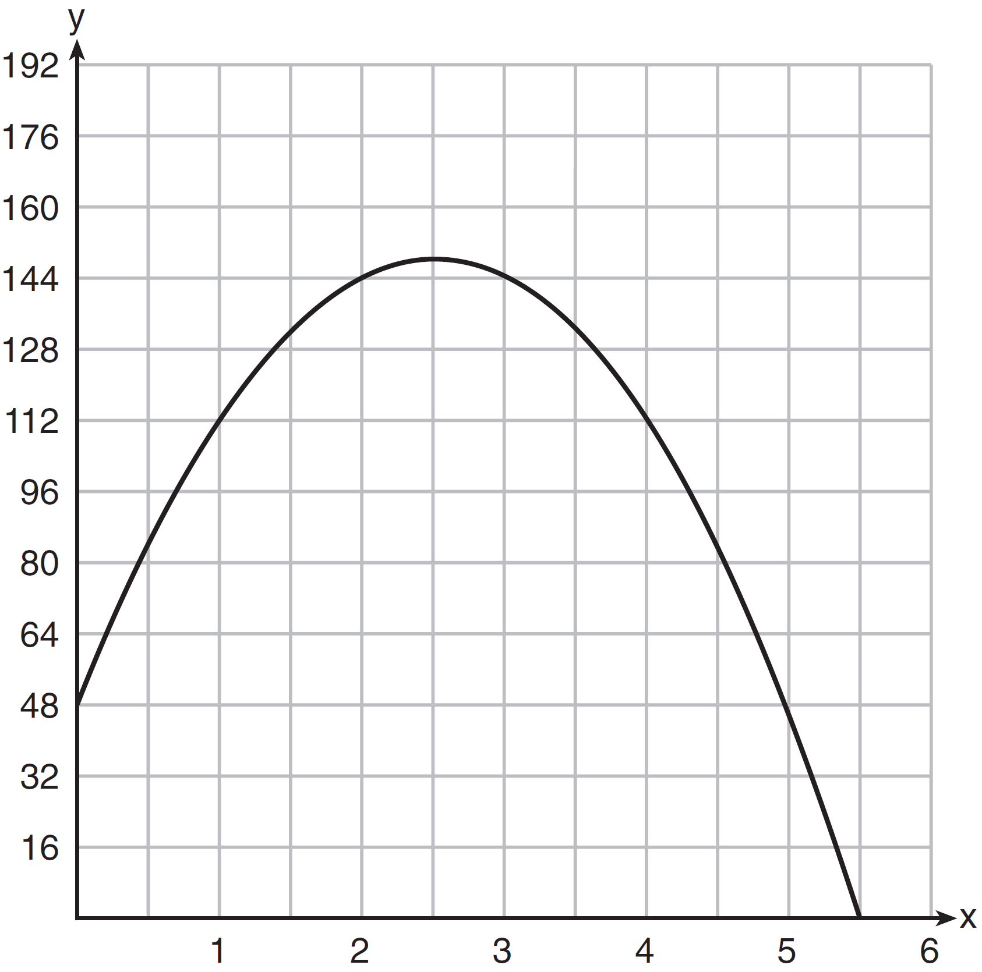

For which interval is the ball's height always decreasing?
1) |  | 3)
2) |  | 4)

10 What are the roots of the equation ?
1) |  | 3)
2) |  | 4)

11 What is the correlation coefficient of the linear fit of the data shown below, to the nearest hundredth?

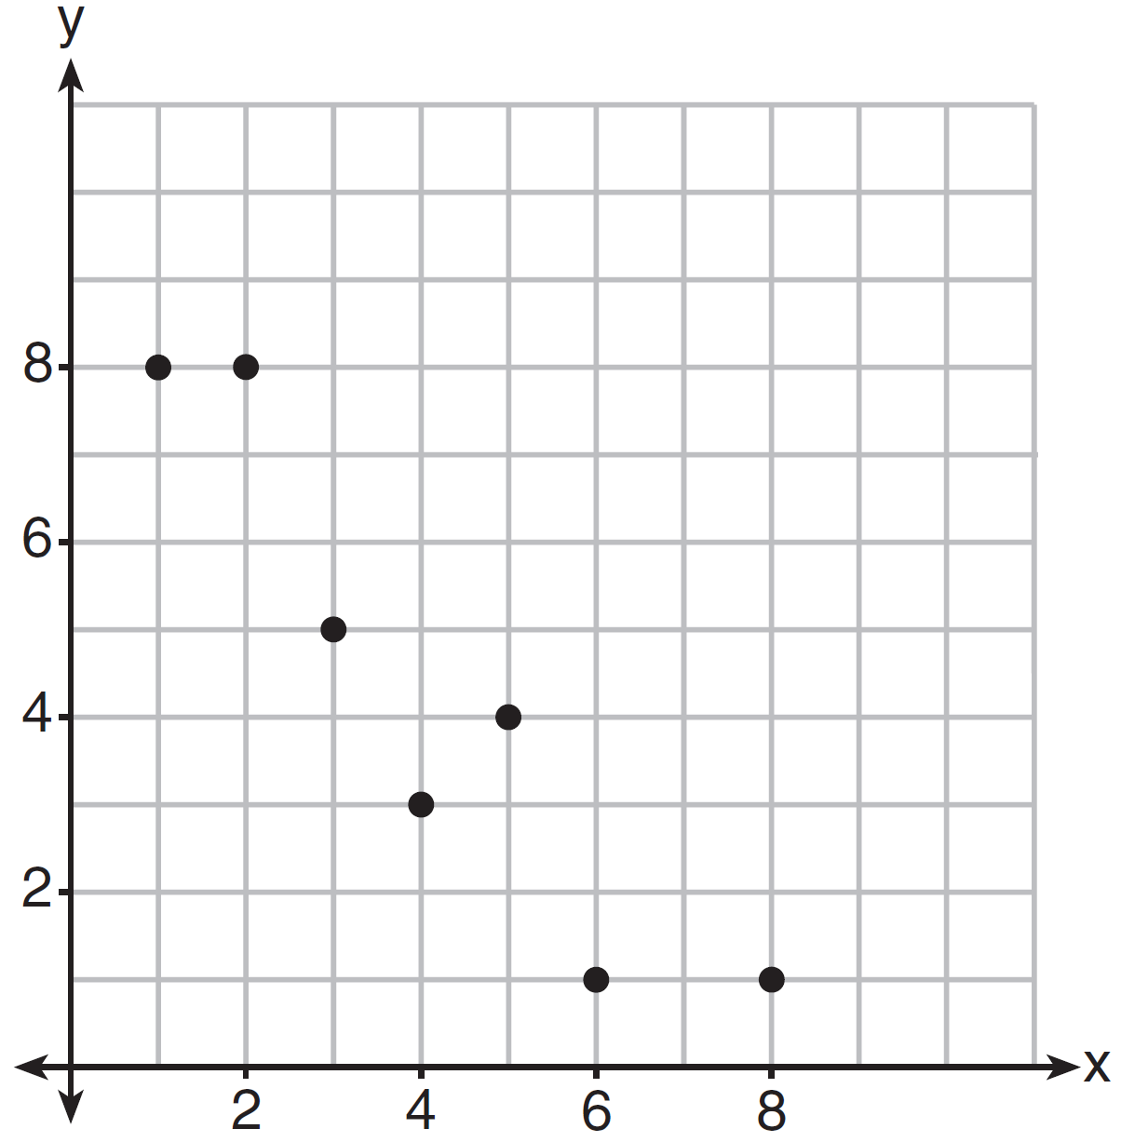
1) | 1.00 | 3)
2) | 0.93 | 4)

12 Keith determines the zeros of the function to be and 5. What could be Keith's function?
1) |  | 3)
2) |  | 4)

13 Given: 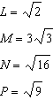
Which expression results in a rational number?
1) |  | 3)
2) |  | 4)

14 Which system of equations has the same solution as the system below?
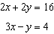
1) | 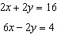 | 3) | 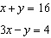
2) | 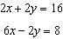 | 4) | 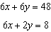

15 The table below represents the function F.

x | 3 | 4 | 6 | 7 | 8
F(x) | 9 | 17 | 65 | 129 | 257

The equation that represents this function is
1) |  | 3)
2) |  | 4)

16 John has four more nickels than dimes in his pocket, for a total of $1.25. Which equation could be used to determine the number of dimes, x, in his pocket?
1) |  | 3)
2) |  | 4)

17 If 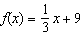, which statement is always true?
1) |  | 3) | If , then
2) |  | 4) | If , then

18 The Jamison family kept a log of the distance they traveled during a trip, as represented by the graph below.
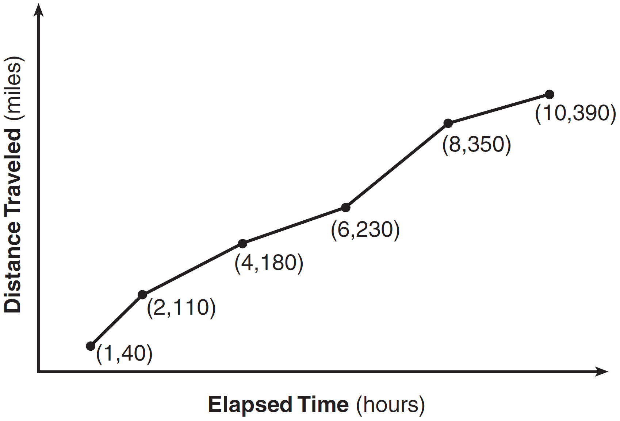
During which interval was their average speed the greatest?
1) | the first hour to the second hour | 3) | the sixth hour to the eighth hour
2) | the second hour to the fourth hour | 4) | the eighth hour to the tenth hour

19 Christopher looked at his quiz scores shown below for the first and second semester of his Algebra class.
Semester 1: 78, 91, 88, 83, 94
Semester 2: 91, 96, 80, 77, 88, 85, 92
Which statement about Christopher's performance is correct?
1) | The interquartile range for semester 1 is greater than the interquartile range for semester 2. | 3) | The mean score for semester 2 is greater than the mean score for semester 1.
2) | The median score for semester 1 is greater than the median score for semester 2. | 4) | The third quartile for semester 2 is greater than the third quartile for semester 1.

20 The graph of is shown below.
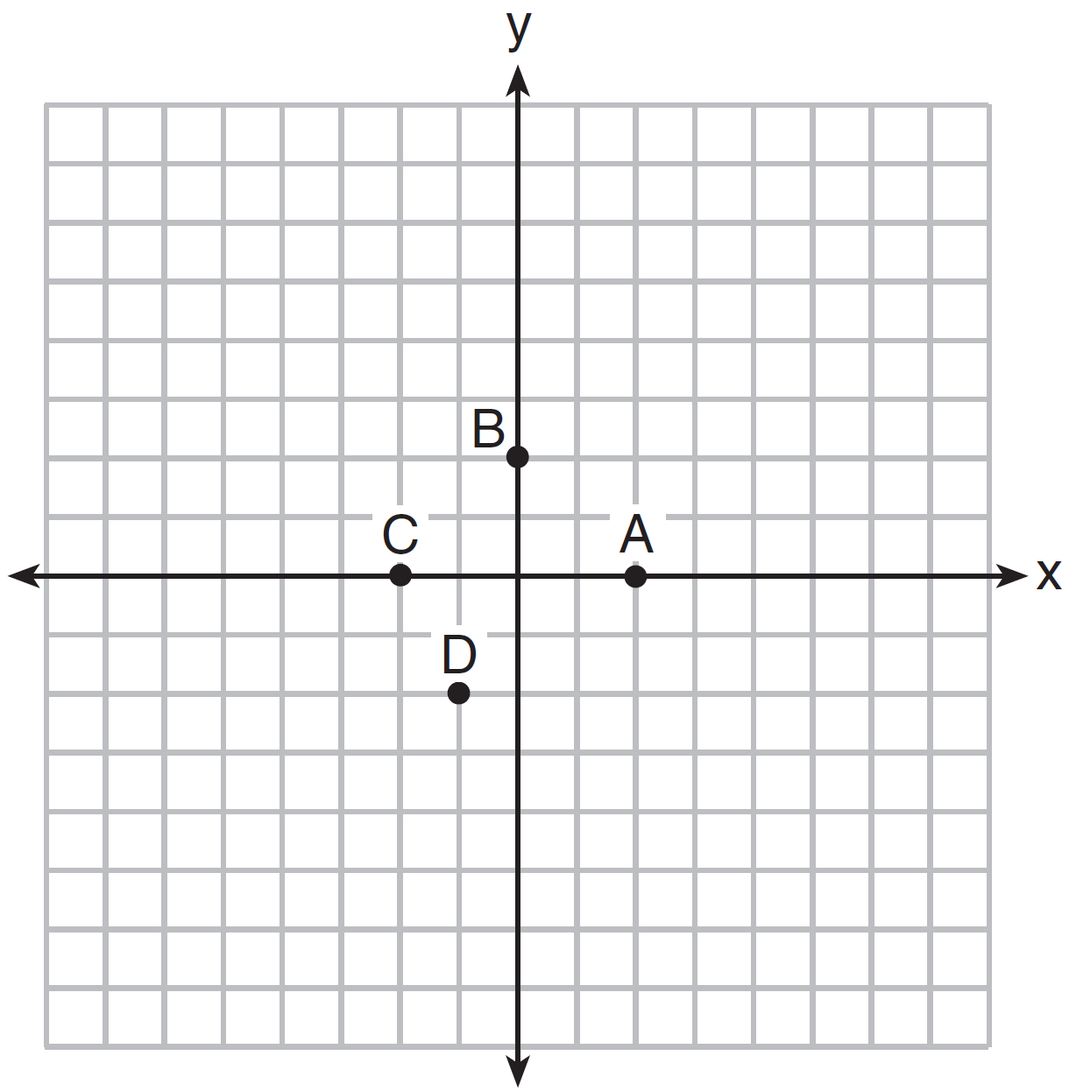
Which point could be used to find ?
1) | A | 3) | C
2) | B | 4) | D

21 A sunflower is 3 inches tall at week 0 and grows 2 inches each week. Which function(s) shown below can be used to determine the height, , of the sunflower in n weeks?
I.
II.
III.
1) | I and II | 3) | III, only
2) | II, only | 4) | I and III

22 A cell phone company charges $60.00 a month for up to 1 gigabyte of data. The cost of additional data is $0.05 per megabyte. If d represents the number of additional megabytes used and c represents the total charges at the end of the month, which linear equation can be used to determine a user's monthly bill?
1) |  | 3)
2) |  | 4)

23 The formula for the volume of a cone is 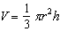. The radius, r, of the cone may be expressed as
1) | 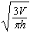 | 3) | 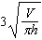
2) | 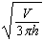 | 4) | 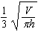

24 The diagrams below represent the first three terms of a sequence.

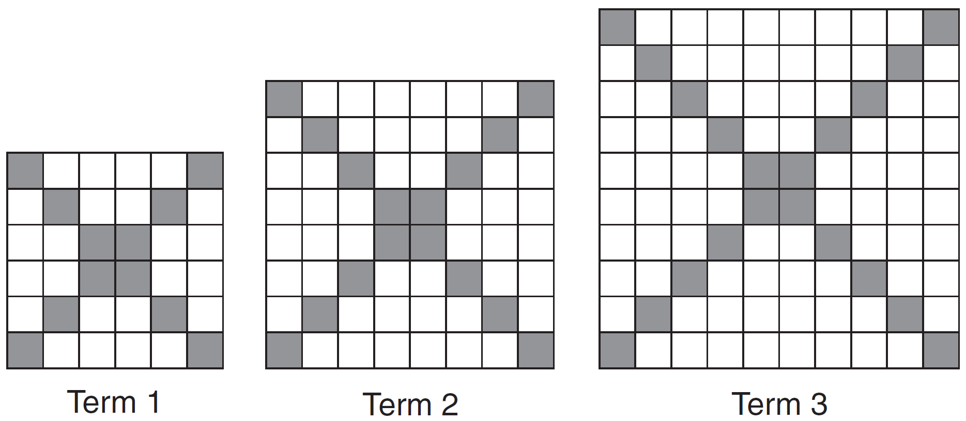

Assuming the pattern continues, which formula determines , the number of shaded squares in the nth term?
1) |  | 3)
2) |  | 4)

25 Draw the graph of on the set of axes below.

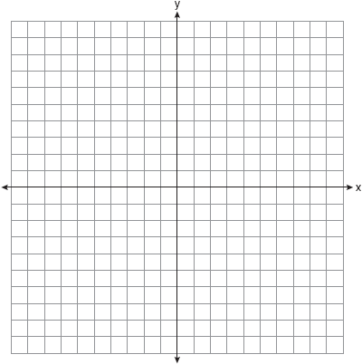

26 The breakdown of a sample of a chemical compound is represented by the function , where represents the number of milligrams of the substance and t represents the time, in years. In the function , explain what 0.5 and 300 represent.

27 Given , determine the largest integer value of a when .

28 The vertex of the parabola represented by has coordinates . Find the coordinates of the vertex of the parabola defined by . Explain how you arrived at your answer. [The use of the set of axes below is optional.]

29 On the set of axes below, draw the graph of the equation 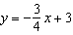.

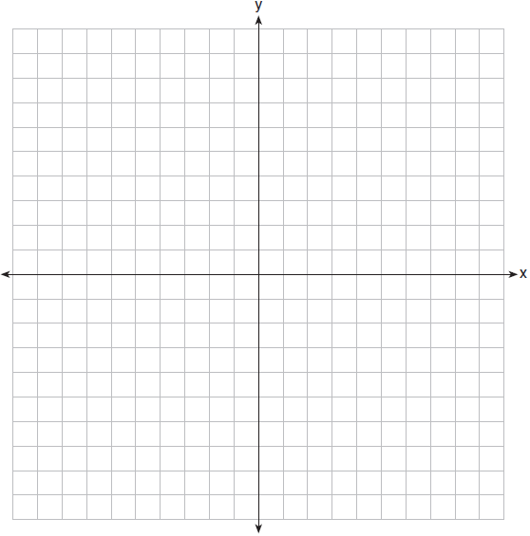

Is the point a solution to the equation? Explain your answer based on the graph drawn.

30 The function f has a domain of and a range of . Could f be represented by ? Justify your answer.

31 Factor the expression completely.

32 Robin collected data on the number of hours she watched television on Sunday through Thursday nights for a period of 3 weeks. The data are shown in the table below.

 | Sun | Mon | Tues | Wed | Thurs
Week 1 | 4 | 3 | 3.5 | 2 | 2
Week 2 | 4.5 | 5 | 2.5 | 3 | 1.5
Week 3 | 4 | 3 | 1 | 1.5 | 2.5

Using an appropriate scale on the number line below, construct a box plot for the 15 values.

33 Write an equation that defines as a trinomial where . Solve for x when .

34 A rectangular garden measuring 12 meters by 16 meters is to have a walkway installed around it with a width of x meters, as shown in the diagram below. Together, the walkway and the garden have an area of 396 square meters.

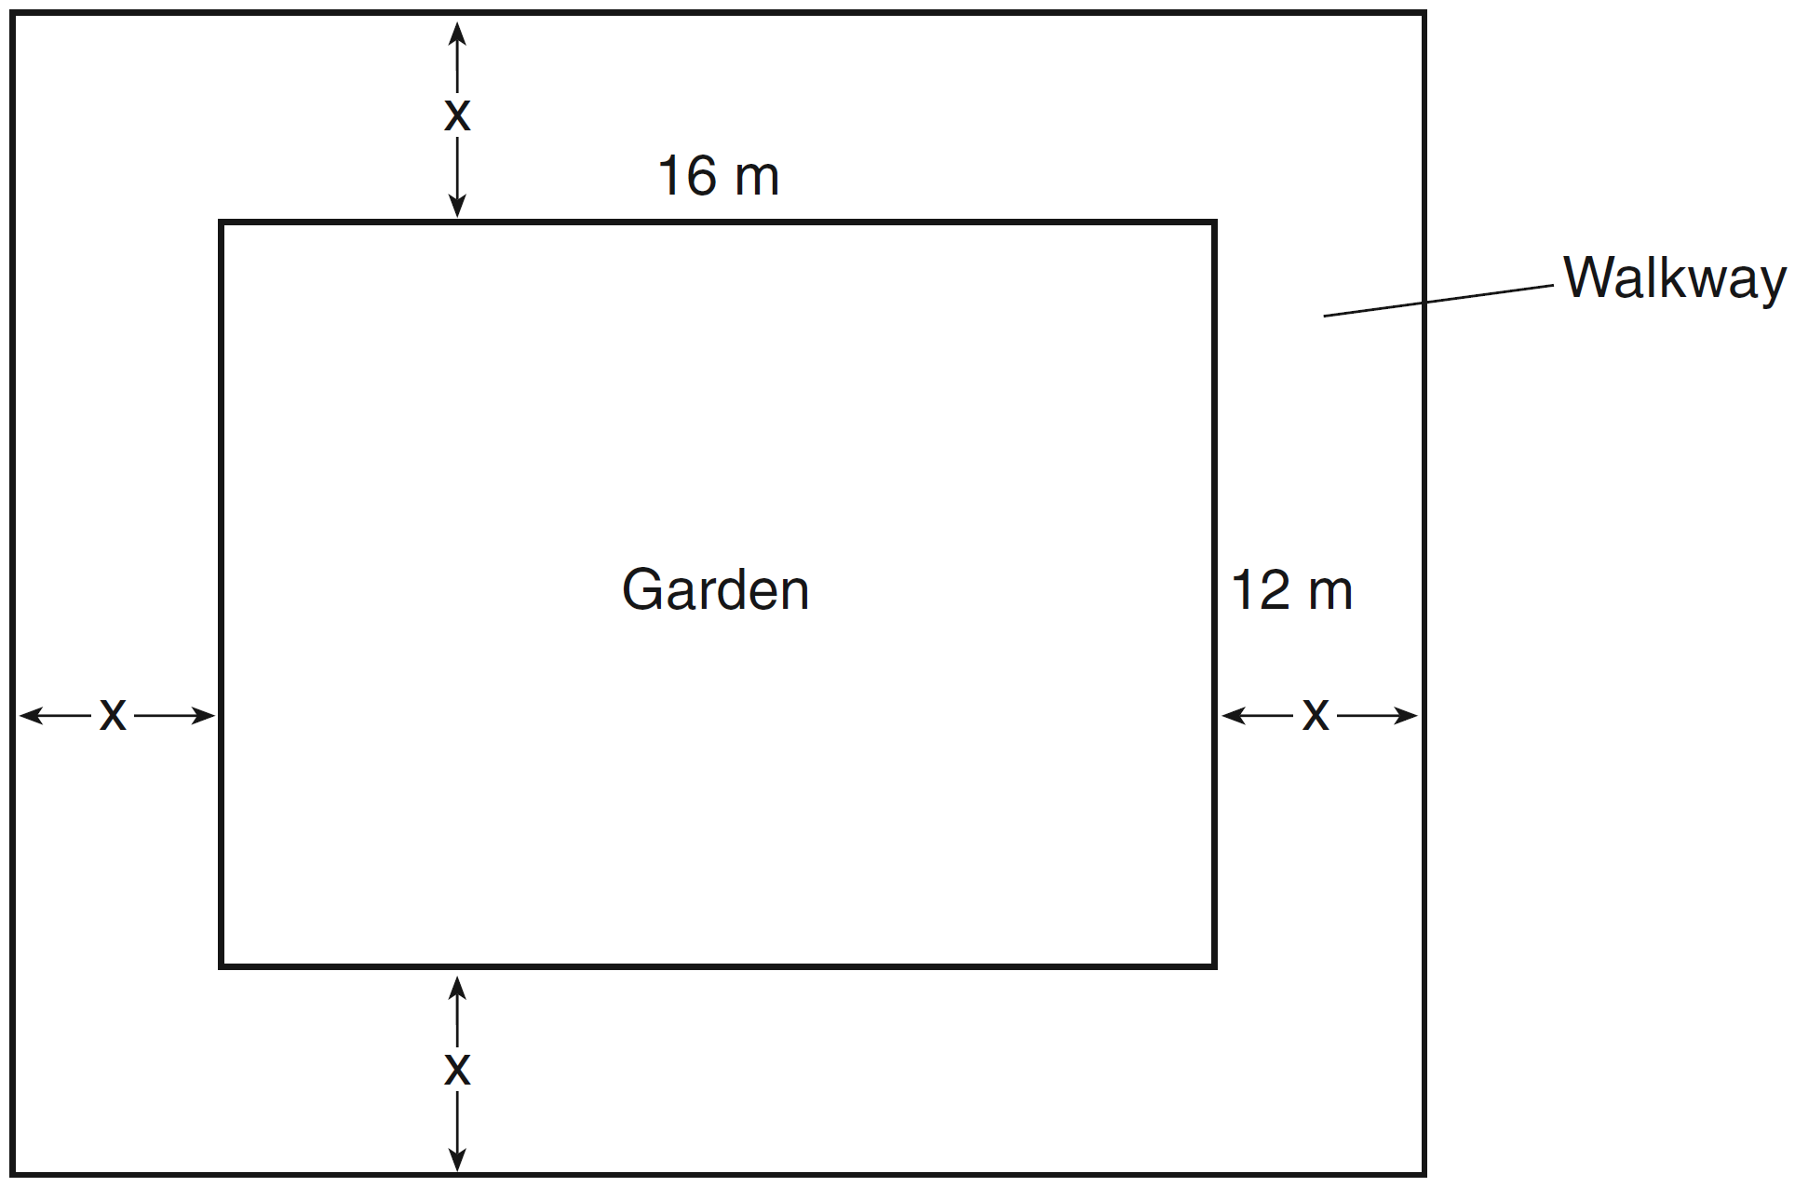

Write an equation that can be used to find x, the width of the walkway. Describe how your equation models the situation. Determine and state the width of the walkway, in meters.

35 Caitlin has a movie rental card worth $175. After she rents the first movie, the card’s value is $172.25. After she rents the second movie, its value is $169.50. After she rents the third movie, the card is worth $166.75. Assuming the pattern continues, write an equation to define , the amount of money on the rental card after n rentals. Caitlin rents a movie every Friday night. How many weeks in a row can she afford to rent a movie, using her rental card only? Explain how you arrived at your answer.

36 An animal shelter spends $2.35 per day to care for each cat and $5.50 per day to care for each dog. Pat noticed that the shelter spent $89.50 caring for cats and dogs on Wednesday. Write an equation to represent the possible numbers of cats and dogs that could have been at the shelter on Wednesday. Pat said that there might have been 8 cats and 14 dogs at the shelter on Wednesday. Are Pat’s numbers possible? Use your equation to justify your answer. Later, Pat found a record showing that there were a total of 22 cats and dogs at the shelter on Wednesday. How many cats were at the shelter on Wednesday?

37 A company is considering building a manufacturing plant. They determine the weekly production cost at site A to be while the production cost at site B is , where x represents the number of products, in hundreds, and and are the production costs, in hundreds of dollars. Graph the production cost functions on the set of axes below and label them site A and site B.

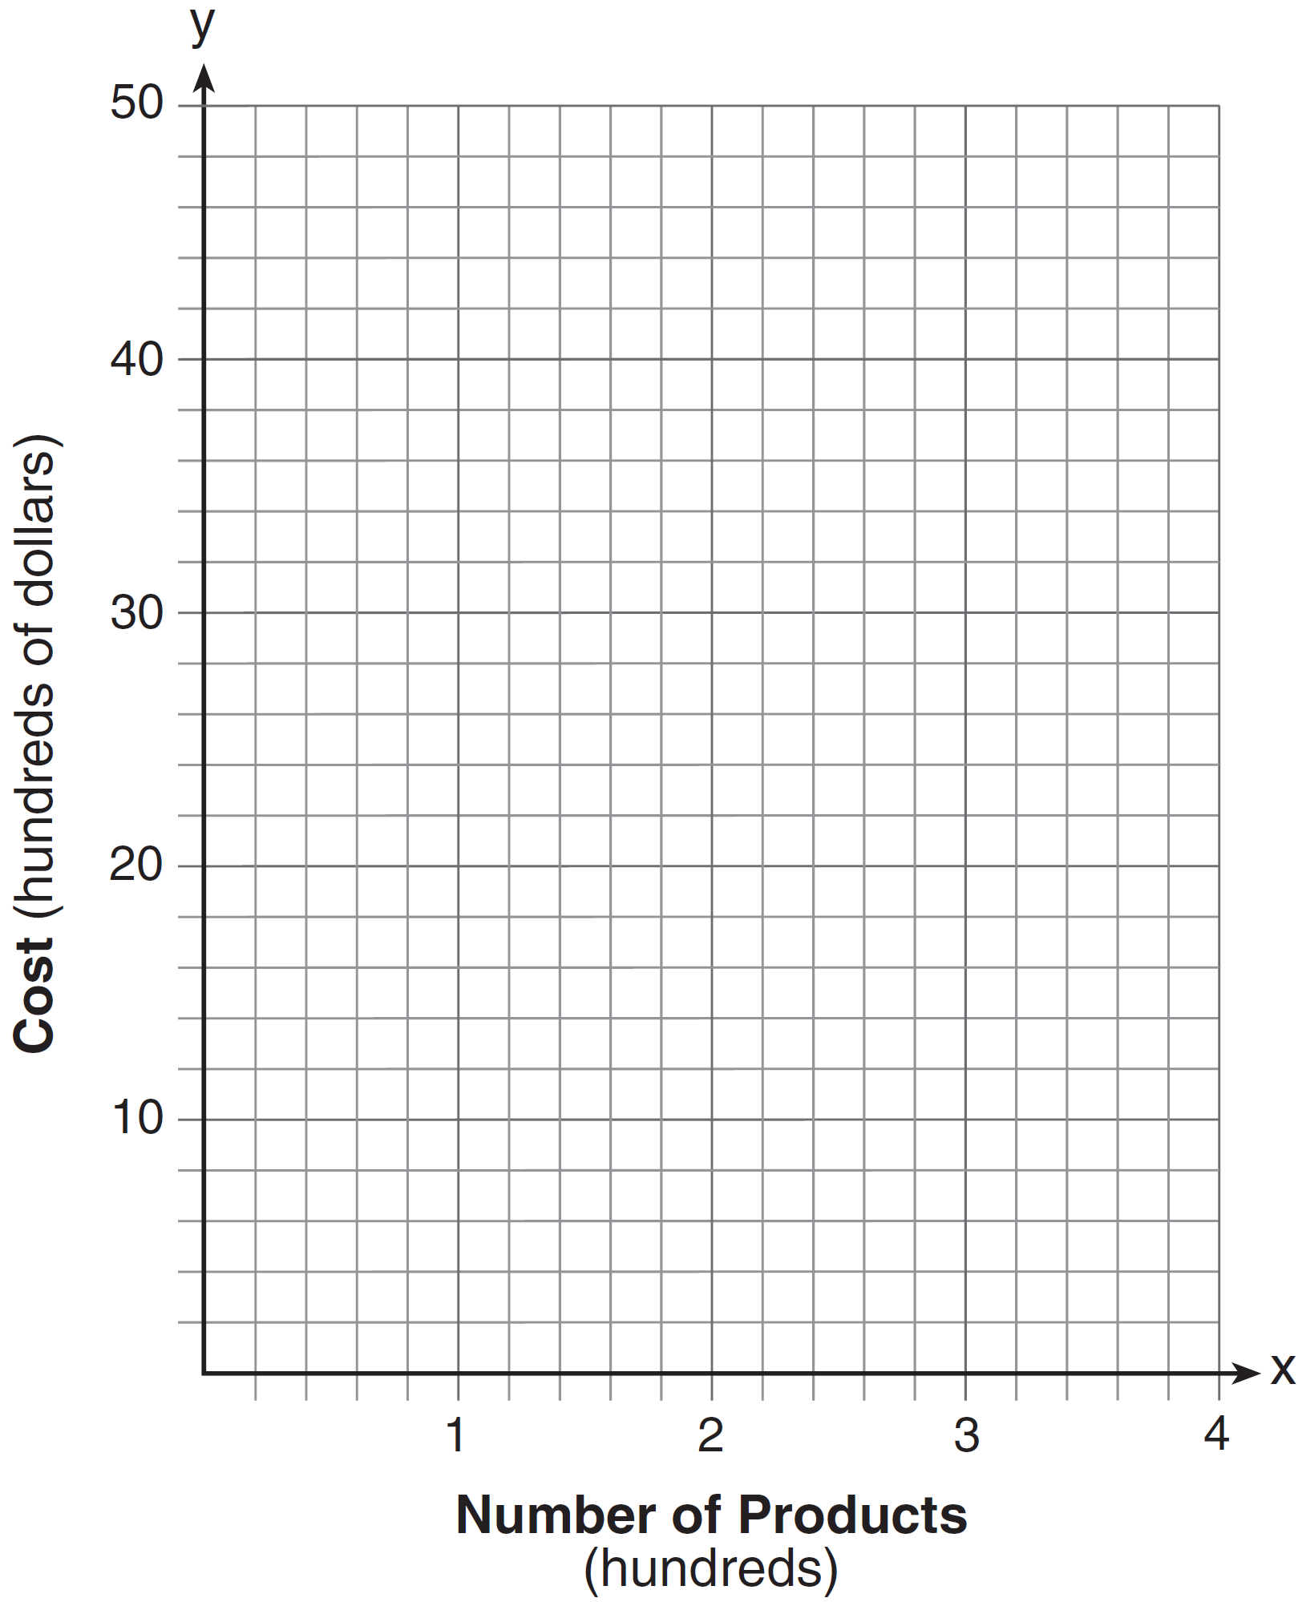

State the positive value(s) of x for which the production costs at the two sites are equal. Explain how you determined your answer. If the company plans on manufacturing 200 products per week, which site should they use? Justify your answer.
1 ANS: 1 PTS: 2 REF: 061401ai NAT: A.REI.A.1
TOP: Identifying Properties

2 ANS: 4
There are no negative or fractional cars.

PTS: 2 REF: 061402ai NAT: F.IF.B.5 TOP: Domain and Range

3 ANS: 2 PTS: 2 REF: 061403ai NAT: A.APR.A.1
TOP: Operations with Polynomials KEY: subtraction

4 ANS: 2 PTS: 2 REF: 061404ai NAT: A.REI.D.12
TOP: Graphing Systems of Linear Inequalities KEY: bimodalgraph | graph

5 ANS: 1
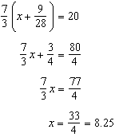

PTS: 2 REF: 061405ai NAT: A.REI.B.3 TOP: Solving Linear Equations
KEY: fractional expressions

6 ANS: 4 PTS: 2 REF: 061406ai NAT: F.LE.A.1
TOP: Families of Functions

7 ANS: 3 PTS: 2 REF: 061407ai NAT: F.LE.B.5
TOP: Modeling Linear Functions

8 ANS: 2
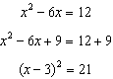

PTS: 2 REF: 061408ai NAT: A.REI.B.4 TOP: Solving Quadratics
KEY: completing the square

9 ANS: 3 PTS: 2 REF: 061409ai NAT: F.IF.B.4
TOP: Graphing Quadratic Functions KEY: context

10 ANS: 2
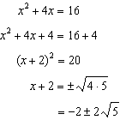

PTS: 2 REF: 061410ai NAT: A.REI.B.4 TOP: Solving Quadratics
KEY: completing the square

11 ANS: 3 PTS: 2 REF: 061411ai NAT: S.ID.C.8
TOP: Correlation Coefficient

12 ANS: 3 PTS: 2 REF: 061412ai NAT: A.APR.B.3
TOP: Zeros of Polynomials

13 ANS: 3
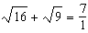 may be expressed as the ratio of two integers.

PTS: 2 REF: 061413ai NAT: N.RN.B.3 TOP: Operations with Radicals
KEY: classify

14 ANS: 2
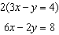

PTS: 2 REF: 061414ai NAT: A.REI.C.6 TOP: Solving Linear Systems

15 ANS: 3 PTS: 2 REF: 061415ai NAT: F.LE.A.2
TOP: Families of Functions

16 ANS: 2 PTS: 2 REF: 061416ai NAT: A.CED.A.1
TOP: Modeling Linear Equations

17 ANS: 4
of a positive number is a positive number.

PTS: 2 REF: 061417ai NAT: F.IF.A.2 TOP: Domain and Range
KEY: real domain, linear

18 ANS: 1
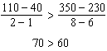

PTS: 2 REF: 061418ai NAT: F.IF.B.6 TOP: Rate of Change

19 ANS: 3
 | Mean | Q1 | Median | Q3 | IQR
Semester 1 | 86.8 | 80.5 | 88 | 92.5 | 12
Semester 2 | 87 | 80 | 88 | 92 | 12

PTS: 2 REF: 061419ai NAT: S.ID.A.2 TOP: Central Tendency and Dispersion

20 ANS: 1 PTS: 2 REF: 061420ai NAT: F.IF.A.2
TOP: Functional Notation

21 ANS: 4 PTS: 2 REF: 061421ai NAT: F.LE.A.2
TOP: Sequences KEY: recursive

22 ANS: 4 PTS: 2 REF: 061422ai NAT: A.CED.A.2
TOP: Modeling Linear Equations

23 ANS: 1
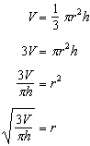

PTS: 2 REF: 061423ai NAT: A.CED.A.4 TOP: Transforming Formulas

24 ANS: 2 PTS: 2 REF: 061424ai NAT: F.LE.A.2
TOP: Sequences KEY: explicit

25 ANS:
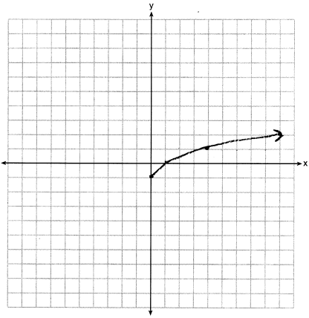

PTS: 2 REF: 061425ai NAT: F.IF.C.7 TOP: Graphing Root Functions

26 ANS:
0.5 represents the rate of decay and 300 represents the initial amount of the compound.

PTS: 2 REF: 061426ai NAT: F.LE.B.5 TOP: Modeling Exponential Functions

27 ANS:
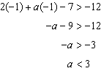

PTS: 2 REF: 061427ai NAT: A.REI.B.3 TOP: Interpreting Solutions

28 ANS:
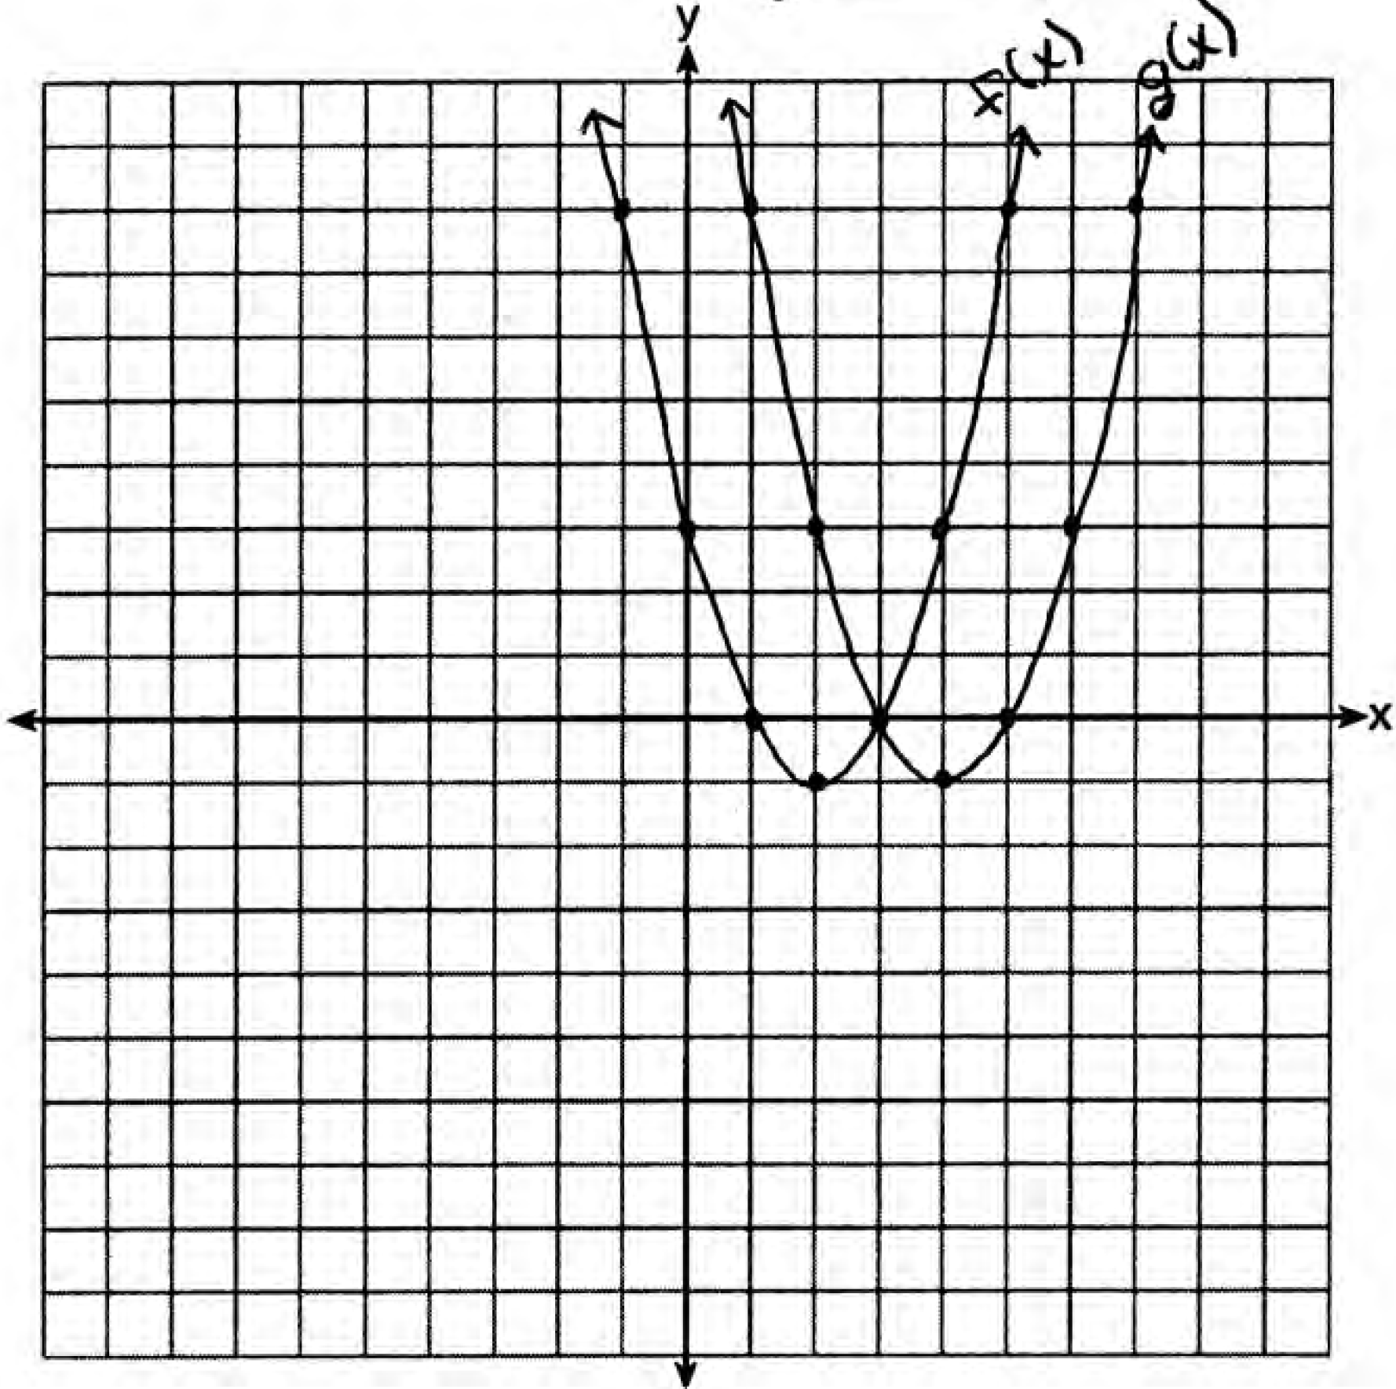 . is a horizontal shift two units to the right.

PTS: 2 REF: 061428ai NAT: F.BF.B.3 TOP: Graphing Polynomial Functions

29 ANS:
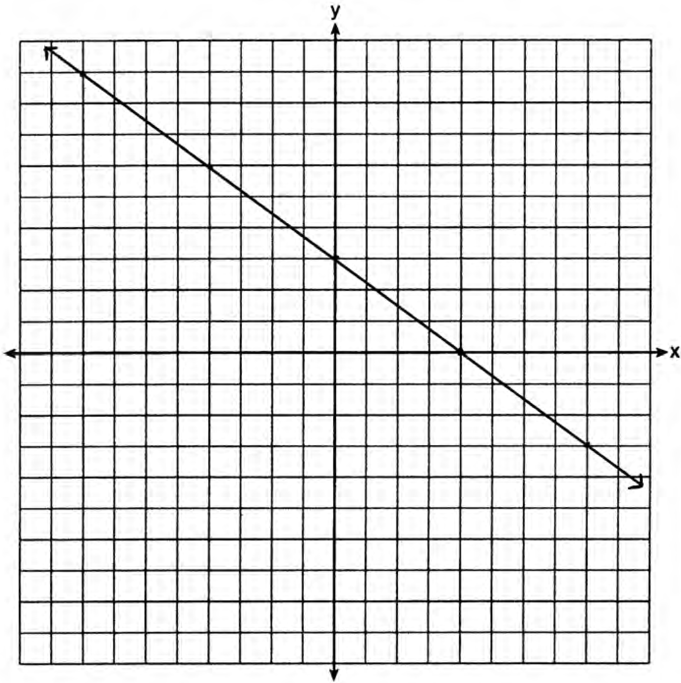No, because is not on the graph.

PTS: 2 REF: 061429ai NAT: F.IF.B.4 TOP: Graphing Linear Functions

30 ANS:
Yes, because every element of the domain is assigned one unique element in the range.

PTS: 2 REF: 061430ai NAT: F.IF.A.1 TOP: Defining Functions
KEY: ordered pairs

31 ANS:
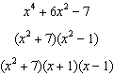

PTS: 2 REF: 061431ai NAT: A.SSE.A.2
TOP: Factoring the Difference of Perfect Squares KEY: higher power

32 ANS:
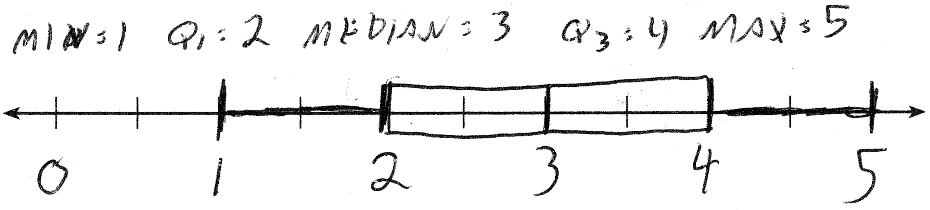

PTS: 2 REF: 061432ai NAT: S.ID.A.1 TOP: Box Plots
KEY: represent

33 ANS:
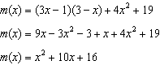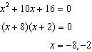

PTS: 4 REF: 061433ai NAT: A.REI.B.4 TOP: Solving Quadratics
KEY: factoring

34 ANS:
. The length, , and the width, , are multiplied and set equal to the area. 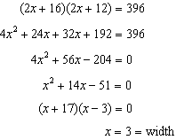

PTS: 4 REF: 061434ai NAT: A.CED.A.1 TOP: Geometric Applications of Quadratics

35 ANS:
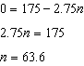 After 63 weeks, Caitlin will not have enough money to rent another movie.

PTS: 4 REF: 061435ai NAT: F.BF.A.1 TOP: Modeling Linear Functions

36 ANS:
Pat’s numbers are not possible: 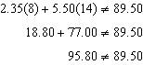 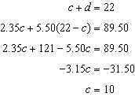

PTS: 4 REF: 061436ai NAT: A.CED.A.3 TOP: Modeling Linear Systems

37 ANS:
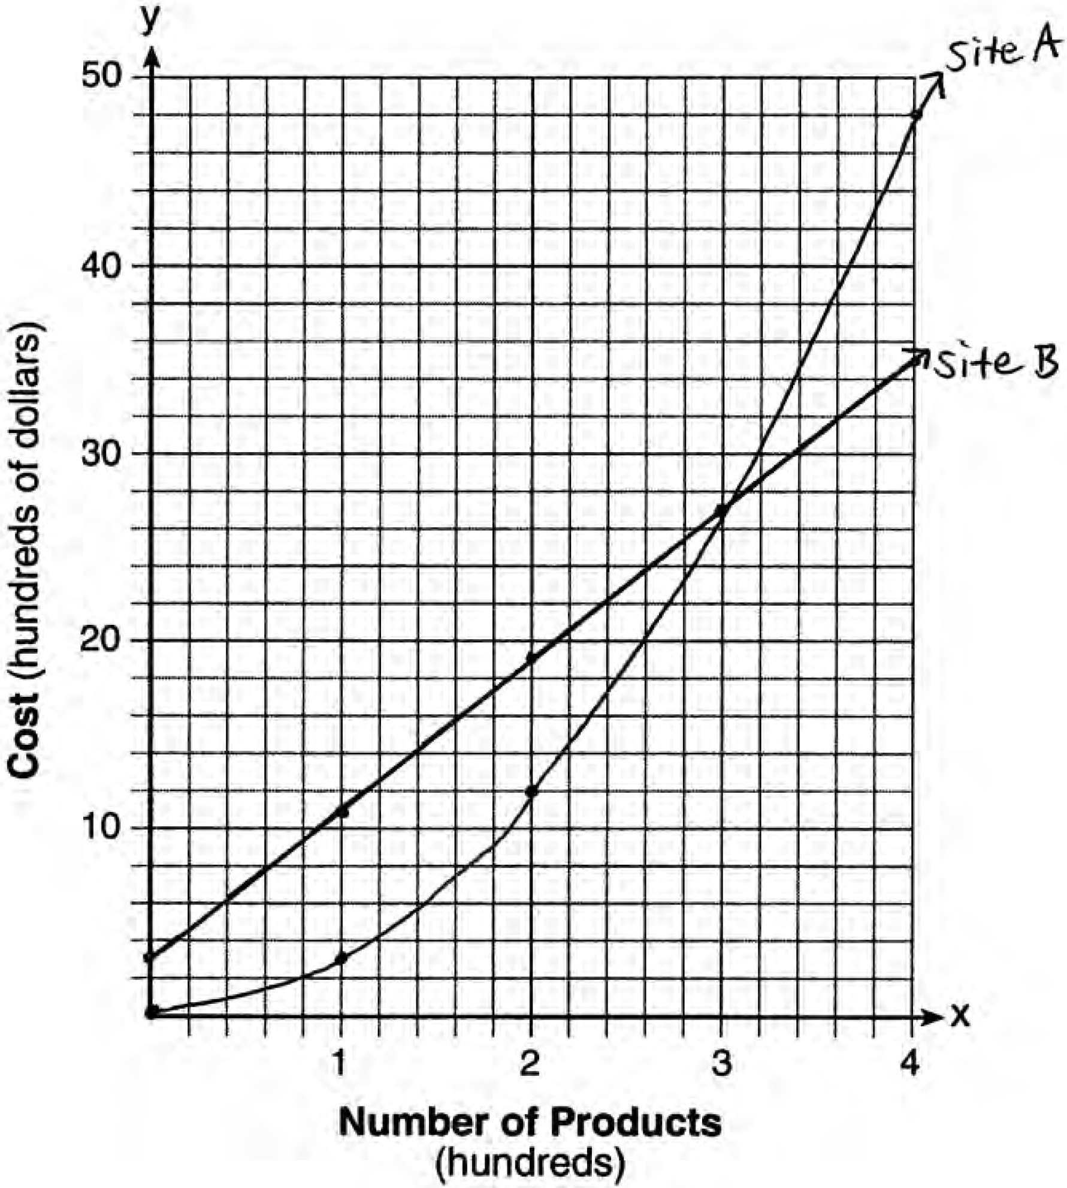The graphs of the production costs intersect at . The company should use Site A, because the cost of Site A is lower at .

PTS: 6 REF: 061437ai NAT: A.REI.D.11 TOP: Quadratic-Linear Systems

