1 The graph below represents a dog walker's speed during his 30-minute walk around the neighborhood.

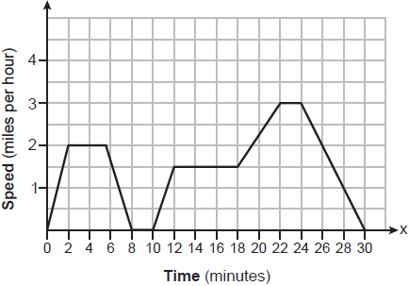

Which statement best describes what the dog walker was doing during the 12-18 minute interval of his walk?
1) | He was walking at a constant rate. | 3) | He was decreasing his speed.
2) | He was increasing his speed. | 4) | He was standing still.

2 Given the relation:
Which value of x will make this relation a function?
1) | 0 | 3) | 6
2) | 2 | 4) | 4

3 The Speedy Jet Ski Rental Company charges an insurance fee and an hourly rental rate. The total cost is modeled by the function . Based on this model, which statements are true?
I. represents the total cost.
II. x is the number of hours rented.
III. $40 is the insurance fee.
IV. $30 is the hourly rental rate.
1) | I, only | 3) | I, III, and IV, only
2) | I and II, only | 4) | I, II, III, and IV

4 The eleventh term of the sequence , is
1) |  | 3) | 3072
2) |  | 4) | 6144

5 Which situation represents exponential growth?
1) | Aidan adds $10 to a jar each week. | 3) | Ella earns $20 per hour babysitting.
2) | A pine tree grows 1.5 feet per year. | 4) | The number of people majoring in computer science doubles every 5 years.

6 The expression is equivalent to
1) |  | 3)
2) |  | 4)

7 If , which function is the result of shifting 3 units left and 2 units down?
1) |  | 3)
2) |  | 4)

8 An equation used to find the velocity of an object is given as , where u is the initial velocity, v is the final velocity, a is the acceleration of the object, and s is the distance traveled. When this equation is solved for a, the result is
1) | 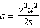 | 3)
2) | 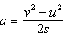 | 4)

9 Mrs. Smith's math class surveyed students to determine their favorite flavors of soft ice cream. The results are shown in the table below.

 | Chocolate | Vanilla | Twist
Juniors | 42 | 27 | 45
Seniors | 67 | 42 | 21

Of the students who preferred chocolate, approximately what percentage were seniors?
1) | 27.5 | 3) | 51.5
2) | 44.7 | 4) | 61.5

10 If and , then what is the value of ?
1) | 10 | 3)
2) | 8 | 4)

11 Which function has the largest y-intercept?
1) |  | 3)
2) | 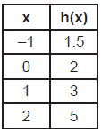 | 4) | 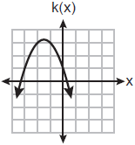

12 Two texting plans are advertised. Plan A has a monthly fee of $15 with a charge of $0.08 per text. Plan B has a monthly fee of $3 with a charge of $0.12 per text. If t represents the number of text messages in a month, which inequality should be used to show that the cost of Plan A is less than the cost of Plan B?
1) |  | 3)
2) |  | 4)

13 The function is graphed on the set of axes below.

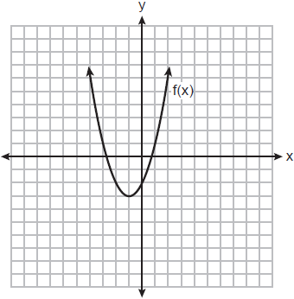

What is the equation of the axis of symmetry for ?
1) |  | 3)
2) |  | 4)

14 What is the degree of the polynomial ?
1) | 1 | 3) | 3
2) | 2 | 4) | 5

15 The product of and is
1) |  | 3)
2) |  | 4)

16 The solution to 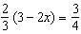 is
1) |  | 3)
2) |  | 4)

17 If and are graphed on the same coordinate plane, for which value of x is ?
1) | 6 | 3)
2) | 2 | 4)

18 What is the solution to the inequality ?
1) |  | 3)
2) |  | 4)

19 Three expressions are written below.
A.
B.
C.
Which expressions are equivalent to ?
1) | A and B, only | 3) | A and C, only
2) | B and C, only | 4) | A, B, and C

20 Joe deposits $4000 into a certificate of deposit (CD) at his local bank. The CD earns 3% interest, compounded annually. The value of the CD in x years can be found using the function
1) |  | 3)
2) |  | 4)

21 When factored completely, is
1) |  | 3)
2) |  | 4)

22 When the temperature is 59°F, the speed of sound at sea level is 1225 kilometers per hour. Which process could be used to convert this speed into feet per second?
1) | 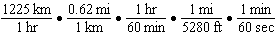
2) | 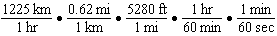
3) | 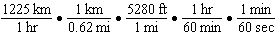
4) | 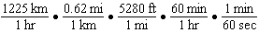

23 The zeros of a polynomial function are , 4, and 0. What are all the factors of this function?
1) |  | 3)
2) |  | 4)

24 What is the range of the function ?
1) |  | 3)
2) |  | 4)

25 Student scores on a recent test are shown in the table below.

85 | 96 | 92 | 82 | 90
90 | 88 | 95 | 85 | 88
90 | 87 | 96 | 82 | 85
92 | 96 | 85 | 92 | 87

On the number line below, create a dot plot to model the data.

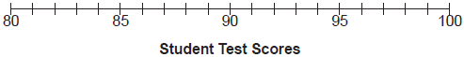

State the median test score for the data set.

26 State whether is rational or irrational. Explain your answer.

27 The table below shows data from a recent car trip for the Burke family.

Hours After Leaving (x) | 1 | 2 | 3 | 4 | 5
Miles from Home (y) | 45 | 112 | 178 | 238 | 305

State the average rate of change for the distance traveled between hours 2 and 4. Include appropriate units.

28 On the set of axes below, graph the equation .

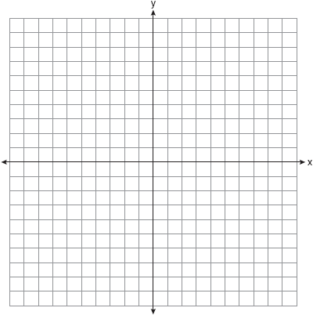

Explain why is a solution to the equation.

29 Using the quadratic formula, solve for all values of x. Round your answers to the nearest hundredth.

30 The piecewise function is given below.

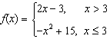

State the value of . Justify your answer.

31 Express the equation in the form .

32 Factor completely.

33 While playing golf, Laura hit her ball from the ground. The height, in feet, of her golf ball can be modeled by , where t is the time in seconds. Graph on the set of axes below.

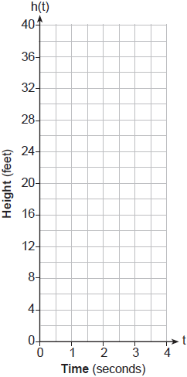

What is the maximum height, in feet, that the golf ball reaches on this hit? How many seconds does it take the golf ball to hit the ground?

34 The table below shows the number of SAT prep classes five students attended and the scores they received on the test.

Number of Prep Classes Attended (x) | 3 | 1 | 6 | 7 | 6
Math SAT Score (y) | 500 | 410 | 620 | 720 | 500

State the linear regression equation for this data set, rounding all values to the nearest hundredth. State the correlation coefficient, rounded to the nearest hundredth. State what this correlation coefficient indicates about the linear fit of the data.

35 Julia is 4 years older than twice Kelly's age, x. The product of their ages is 96. Write an equation that models this situation. Determine Kelly's age algebraically. State the difference between Julia's and Kelly's ages, in years.

36 On the set of axes below, graph the following system of inequalities:
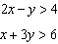
Label the solution set S.

Is a solution to this system? Justify your answer.

37 Jim had a bag of coins. The number of nickels, n, and the number of quarters, q, totaled 28 coins. The combined value of the coins was $4. Write a system of equations that models this situation. Use your system of equations to algebraically determine both the number of quarters, q, and the number of nickels, n, that Jim had in the bag. Jim was given an additional $3.00 that was made up of equal numbers of nickels and quarters. How many of each coin was he given? Justify your answer.
1 ANS: 1 PTS: 2 REF: 012401ai NAT: F.IF.B.4
TOP: Relating Graphs to Events

2 ANS: 3 PTS: 2 REF: 012402ai NAT: F.IF.A.1
TOP: Defining Functions

3 ANS: 2 PTS: 2 REF: 012403ai NAT: F.LE.B.5
TOP: Modeling Linear Functions

4 ANS: 3

PTS: 2 REF: 012404ai NAT: F.BF.A.1 TOP: Sequences
KEY: explicit

5 ANS: 4 PTS: 2 REF: 012405ai NAT: F.LE.A.1
TOP: Families of Functions

6 ANS: 2 PTS: 2 REF: 012406ai NAT: A.APR.A.1
TOP: Operations with Polynomials KEY: subtraction

7 ANS: 3 PTS: 2 REF: 012407ai NAT: F.BF.B.3
TOP: Graphing Polynomial Functions

8 ANS: 2
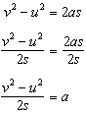

PTS: 2 REF: 012408ai NAT: A.CED.A.4 TOP: Transforming Formulas

9 ANS: 4
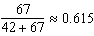

PTS: 2 REF: 012409ai NAT: S.ID.B.5 TOP: Frequency Tables
KEY: two-way

10 ANS: 3
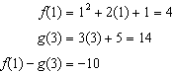

PTS: 2 REF: 012410ai NAT: F.IF.A.2 TOP: Functional Notation

11 ANS: 3
1) -1; 2) 2; 3) 3; 4) 1

PTS: 2 REF: 012411ai NAT: F.IF.C.9 TOP: Comparing Functions

12 ANS: 1 PTS: 2 REF: 012412ai NAT: A.CED.A.1
TOP: Modeling Linear Inequalities

13 ANS: 1 PTS: 2 REF: 012413ai NAT: F.IF.C.7
TOP: Graphing Quadratic Functions

14 ANS: 3 PTS: 2 REF: 012414ai NAT: A.SSE.A.1
TOP: Modeling Expressions

15 ANS: 1

PTS: 2 REF: 012415ai NAT: A.APR.A.1 TOP: Operations with Polynomials
KEY: multiplication

16 ANS: 4
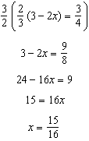

PTS: 2 REF: 012416ai NAT: A.REI.B.3 TOP: Solving Linear Equations

17 ANS: 3
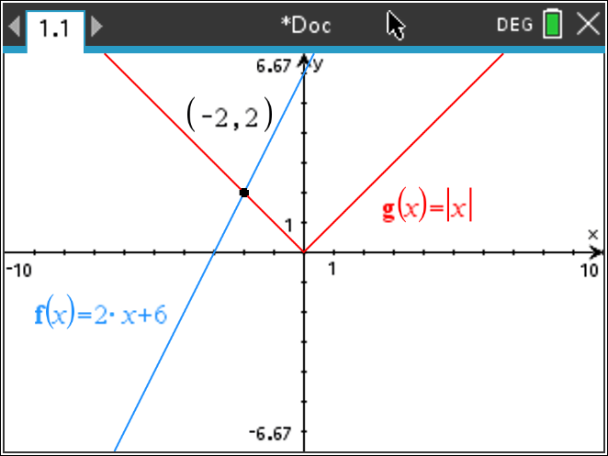

PTS: 2 REF: 012417ai NAT: A.REI.D.11 TOP: Other Systems

18 ANS: 4
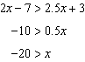

PTS: 2 REF: 012418ai NAT: A.REI.B.3 TOP: Solving Linear Inequalities

19 ANS: 1

PTS: 2 REF: 012419ai NAT: A.APR.A.1 TOP: Powers of Powers

20 ANS: 4 PTS: 2 REF: 012420ai NAT: F.BF.A.1
TOP: Modeling Exponential Functions

21 ANS: 3

PTS: 2 REF: 012421ai NAT: A.SSE.A.2 TOP: Factoring Polynomials

22 ANS: 2 PTS: 2 REF: 012422ai NAT: N.Q.A.1
TOP: Conversions

23 ANS: 3 PTS: 2 REF: 012423ai NAT: A.APR.B.3
TOP: Zeros of Polynomials

24 ANS: 4
Vertex

PTS: 2 REF: 012424ai NAT: F.IF.A.2 TOP: Domain and Range

25 ANS:
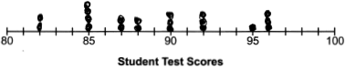 89

PTS: 2 REF: 012425ai NAT: S.ID.A.1 TOP: Dot Plots

26 ANS:
is irrational because it can not be written as the ratio of two integers.

PTS: 2 REF: 012426ai NAT: N.RN.B.3 TOP: Operations with Radicals
KEY: classify

27 ANS:
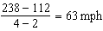

PTS: 2 REF: 012427ai NAT: F.IF.B.6 TOP: Rate of Change

28 ANS:
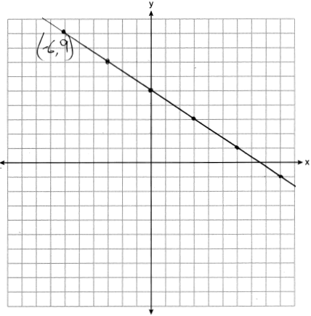 is a solution to the equation because it falls on the line.

PTS: 2 REF: 012428ai NAT: F.IF.B.4 TOP: Graphing Linear Functions

29 ANS:
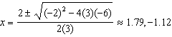

PTS: 2 REF: 012429ai NAT: A.REI.B.4 TOP: Solving Quadratics
KEY: quadratic formula

30 ANS:

PTS: 2 REF: 012430ai NAT: F.IF.A.2 TOP: Functional Notation

31 ANS:
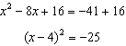

PTS: 2 REF: 012431ai NAT: A.REI.B.4 TOP: Solving Quadratics
KEY: completing the square

32 ANS:

PTS: 2 REF: 012432ai NAT: A.SSE.A.2
TOP: Factoring the Difference of Perfect Squares

33 ANS:
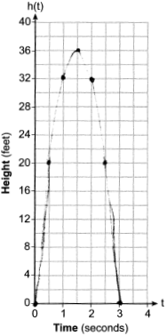 36, 3

PTS: 4 REF: 012433ai NAT: F.IF.B.4 TOP: Graphing Quadratic Functions
KEY: graph

34 ANS:
, , strong

PTS: 4 REF: 012434ai NAT: S.ID.B.6 TOP: Regression
KEY: linear with correlation coefficient

35 ANS:
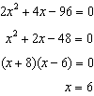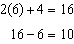

PTS: 4 REF: 012435ai NAT: A.CED.A.1 TOP: Modeling Quadratics

36 ANS:
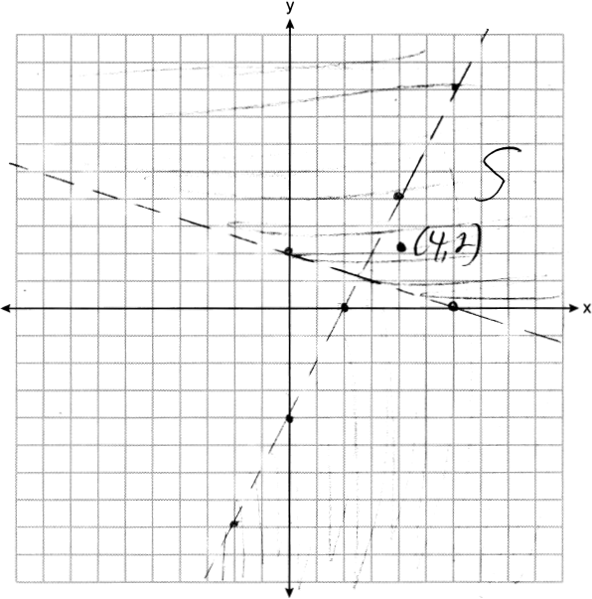 Yes, as falls within S.

PTS: 4 REF: 012436ai NAT: A.REI.D.12 TOP: Graphing Systems of Linear Inequalities

37 ANS:
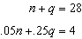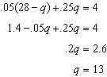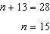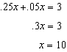

PTS: 6 REF: 012437ai NAT: A.CED.A.3 TOP: Modeling Linear Systems

