1 When the expression is written in simplest form, the result is
1) |  | 3)
2) |  | 4)

2 The point is on the graph of . What is the value of w?
1) |  | 3) | 10
2) |  | 4) | 13

3 Students were asked to write in standard form. Four student responses are shown below.
Alexa:
Carol:
Ryan:
Eric:
Which student’s response is correct?
1) | Alexa | 3) | Ryan
2) | Carol | 4) | Eric

4 Given , what is the value of ?
1) |  | 3) | 22
2) |  | 4) | 46

5 Which relation is a function?
1) |  | 3) | 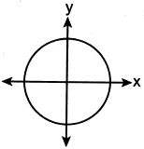
2) | 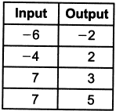 | 4) | 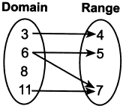

6 What is the value of the third quartile in the box plot shown below?

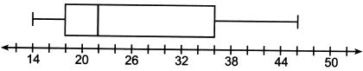
1) | 18 | 3) | 36
2) | 22 | 4) | 46

7 What is the solution to ?
1) |  | 3)
2) |  | 4)

8 One Saturday afternoon, three friends decided to keep track of the number of text messages they received each hour from 8 a.m. to noon. The results are shown below.
Emily said that the number of messages she received increased by 8 each hour.
Jessica said that the number of messages she received doubled every hour.
Chris said that he received 3 messages the first hour, 10 the second hour, none the third hour, and 15 the last hour.
Which of the friends' responses best classifies the number of messages they received each hour as a linear function?
1) | Emily, only | 3) | Emily and Chris
2) | Jessica, only | 4) | Jessica and Chris

9 Which expression is equivalent to ?
1) |  | 3)
2) |  | 4)

10 Caitlin graphs the function , where a is a positive integer. If Caitlin multiplies a by , when compared to , the new graph will become
1) | narrower and open downward
2) | narrower and open upward
3) | wider and open downward
4) | wider and open upward

11 Sunny purchases a new car for $29,873. The car depreciates 20% annually. Which expression can be used to determine the value of the car after t years?
1) |  | 3)
2) |  | 4)

12 If and , for which values of x is ?
1) | and 6 | 3) | and
2) | and | 4) | 2 and 3

13 Skyler mows lawns in the summer. The function is used to model the amount of money earned, where x is the number of lawns completely mowed. A reasonable domain for this function would be
1) | real numbers | 3) | irrational numbers
2) | rational numbers | 4) | natural numbers

14 Which expression is equivalent to ?
1) |  | 3)
2) |  | 4)

15 Ian throws a ball up in the air and lets it fall to the ground. The height of the ball, , is modeled by the equation , with measured in feet, and time, t, measured in seconds. The number 3 in represents
1) | the maximum height of the ball | 3) | the number of seconds it takes for the ball to reach the ground
2) | the height from which the ball is thrown | 4) | the number of seconds it takes for the ball to reach its maximum height

16 Thirty-two teams are participating in a basketball tournament. Only the winning teams in each round advance to the next round, as shown in the table below.

Number of Rounds Completed, x | 0 | 1 | 2 | 3 | 4 | 5
Number of Teams Remaining, f(x) | 32 | 16 | 8 | 4 | 2 | 1

Which function type best models the relationship between the number of rounds completed and the number of teams remaining?
1) | absolute value | 3) | linear
2) | exponential | 4) | quadratic

17 In a geometric sequence, the first term is 4 and the common ratio is . The fifth term of this sequence is
1) | 324 | 3)
2) | 108 | 4)

18 The amount of energy, Q, in joules, needed to raise the temperature of m grams of a substance is given by the formula , where C is the specific heat capacity of the substance. If its initial temperature is , an equation to find its final temperature, , is
1) | 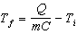 | 3) | 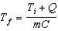
2) | 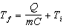 | 4) | 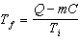

19 When using the method of completing the square, which equation is equivalent to ?
1) |  | 3)
2) |  | 4)

20 Which quadratic function has the smallest minimum value?
1) |  | 3)
2) | 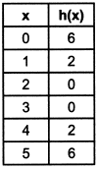 | 4) | 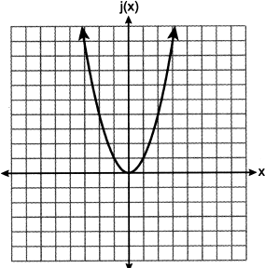

21 Which representation yields the same outcome as the sequence defined recursively below?
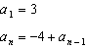
1) |  | 3)
2) |  | 4)

22 If the zeros of the function are , which function could represent ?
1) |  | 3)
2) |  | 4)

23 Morgan read that a snail moves about 72 feet per day. He performs the calculation 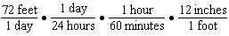 to convert this rate to different units. What are the units for the converted rate?
1) | hours/inch | 3) | inches/hour
2) | minutes/inch | 4) | inches/minute

24 During summer vacation, Ben decides to sell hot dogs and pretzels on a food cart in Manhattan. It costs Ben $0.50 for each hot dog and $0.40 for each pretzel. He has only $100 to spend each day on hot dogs and pretzels. He wants to sell at least 200 items each day. If h is the number of hot dogs and p is the number of pretzels, which inequality would be part of a system of inequalities used to determine the total number of hot dogs and pretzels Ben can sell?
1) |  | 3)
2) |  | 4)

25 Graph the function on the set of axes below.

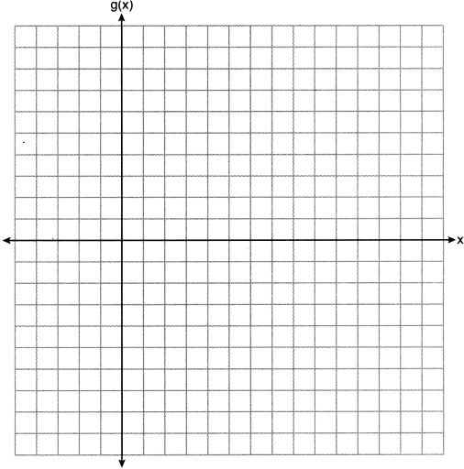

26 The sixth-grade classes at West Road Elementary School were asked to vote on the location of their class trip. The results are shown in the table below.

 | Playland | Splashdown | Fun Central
Boys | 38 | 53 | 25
Girls | 39 | 46 | 37

Determine, to the nearest percent, the percentage of girls who voted for Splashdown.

27 Solve the inequality 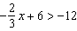 algebraically for x.

28 Determine the common difference of the arithmetic sequence in which and .

29 Given: and
Explain why is irrational. Explain why is rational.

30 Use the quadratic formula to solve for x. Round the solutions to the nearest hundredth.

31 Factor completely:

32 The function g is defined as
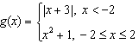
On the set of axes below, graph .

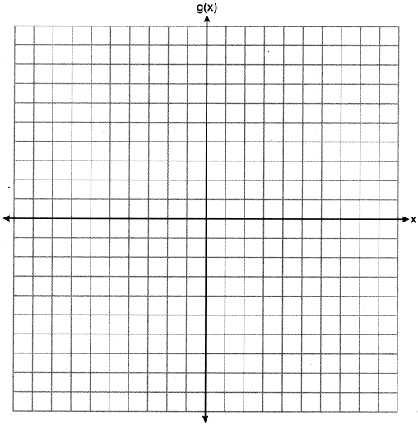

33 Anessa is studying the changes in population in a town. The graph below shows the population over 50 years.

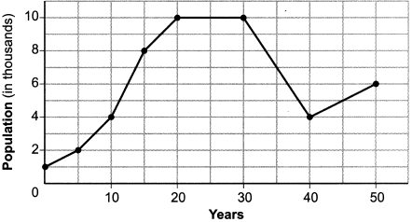

State the entire interval during which the population remained constant. State the maximum population of the town over the 50-year period. Determine the average rate of change from year 30 to year 40. Explain what your average rate of change means from year 30 to year 40 in the context of the problem.

34 The table below shows the number of math classes missed during a school year for nine students, and their final exam scores.

Number of Classes Missed (x) | 2 | 10 | 3 | 22 | 15 | 2 | 20 | 18 | 9
Final Exam Score (y) | 99 | 72 | 90 | 35 | 60 | 80 | 40 | 43 | 75

Write the linear regression equation for this data set. Round all values to the nearest hundredth. State the correlation coefficient for your linear regression. Round your answer to the nearest hundredth. State what the correlation coefficient indicates about the linear fit of the data.

35 A fence was installed around the edge of a rectangular garden. The length, l, of the fence was 5 feet less than 3 times its width, w. The amount of fencing used was 90 feet. Write a system of equations or write an equation using one variable that models this situation. Determine algebraically the dimensions, in feet, of the garden.

36 Given: 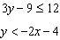
Graph the system of inequalities on the set of axes below.
.
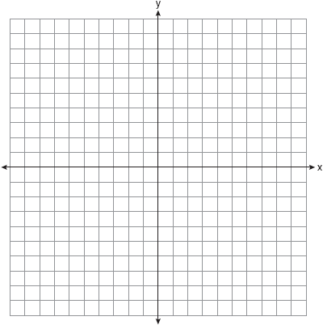

State the coordinates of a point that satisfies both inequalities. Justify your answer.

37 Aidan and his sister Ella are having a race. Aidan runs at a rate of 10 feet per second. Ella runs at a rate of 6 feet per second. Since Ella is younger, Aidan is letting her begin 30 feet ahead of the starting line. Let y represent the distance from the starting line and x represent the time elapsed, in seconds. Write an equation to model the distance Aidan traveled. Write an equation to model the distance Ella traveled. On the set of axes below, graph your equations.

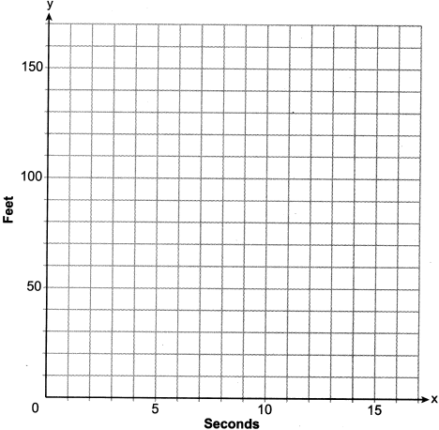

Exactly how many seconds does it take Aidan to catch up to Ella? Justify your answer.
1 ANS: 1
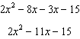

PTS: 2 REF: 012301ai NAT: A.APR.A.1 TOP: Operations with Polynomials
KEY: subtraction

2 ANS: 4

PTS: 2 REF: 012302ai NAT: A.REI.D.10 TOP: Identifying Solutions

3 ANS: 3 PTS: 2 REF: 012303ai NAT: A.SSE.A.1
TOP: Modeling Expressions

4 ANS: 2

PTS: 2 REF: 012304ai NAT: F.IF.A.2 TOP: Functional Notation

5 ANS: 1 PTS: 2 REF: 012305ai NAT: F.IF.A.1
TOP: Defining Functions KEY: mixed

6 ANS: 3
The value of the third quartile is the last vertical line of the box.

PTS: 2 REF: 012306ai NAT: S.ID.A.1 TOP: Box Plots
KEY: interpret

7 ANS: 2
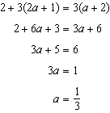

PTS: 2 REF: 012307ai NAT: A.REI.B.3 TOP: Solving Linear Equations

8 ANS: 1 PTS: 2 REF: 012308ai NAT: F.LE.A.1
TOP: Families of Functions

9 ANS: 2 PTS: 2 REF: 012309ai NAT: A.APR.A.1
TOP: Operations with Polynomials KEY: multiplication

10 ANS: 1 PTS: 2 REF: 012310ai NAT: F.BF.B.3
TOP: Graphing Polynomial Functions

11 ANS: 3 PTS: 2 REF: 012311ai NAT: F.BF.A.1
TOP: Modeling Exponential Functions

12 ANS: 4
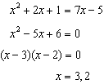

PTS: 2 REF: 012312ai NAT: A.REI.D.11 TOP: Quadratic-Linear Systems

13 ANS: 4 PTS: 2 REF: 012313ai NAT: F.IF.B.5
TOP: Domain and Range

14 ANS: 1 PTS: 2 REF: 012314ai NAT: A.SSE.A.2
TOP: Factoring Polynomials

15 ANS: 2 PTS: 2 REF: 012315ai NAT: F.IF.B.4
TOP: Graphing Quadratic Functions

16 ANS: 2 PTS: 2 REF: 012316ai NAT: F.LE.A.1
TOP: Families of Functions

17 ANS: 1

PTS: 2 REF: 012317ai NAT: F.IF.A.3 TOP: Sequences
KEY: explicit

18 ANS: 2
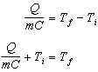

PTS: 2 REF: 012318ai NAT: A.CED.A.4 TOP: Transforming Formulas

19 ANS: 4
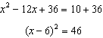

PTS: 2 REF: 012319ai NAT: A.REI.B.4 TOP: Solving Quadratics
KEY: completing the square

20 ANS: 1
1) 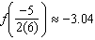; 2) ; 3) ; 4) 0

PTS: 2 REF: 012320ai NAT: F.IF.C.9 TOP: Comparing Functions

21 ANS: 2

PTS: 2 REF: 012321ai NAT: F.LE.A.2 TOP: Sequences
KEY: recursive

22 ANS: 3 PTS: 2 REF: 012322ai NAT: A.APR.B.3
TOP: Zeros of Polynomials

23 ANS: 4 PTS: 2 REF: 012323ai NAT: N.Q.A.1
TOP: Conversions

24 ANS: 2 PTS: 2 REF: 012324ai NAT: A.CED.A.3
TOP: Modeling Systems of Linear Inequalities

25 ANS:
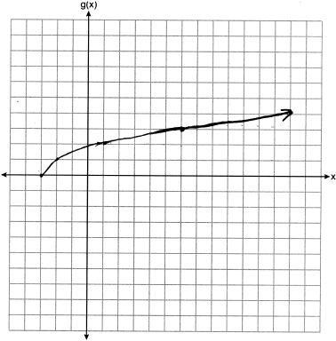

PTS: 2 REF: 012325ai NAT: F.IF.C.7 TOP: Graphing Root Functions

26 ANS:
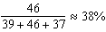

PTS: 2 REF: 012326ai NAT: S.ID.B.5 TOP: Frequency Tables
KEY: two-way

27 ANS:
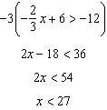

PTS: 2 REF: 012327ai NAT: A.REI.B.3 TOP: Solving Linear Inequalities

28 ANS:
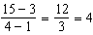

PTS: 2 REF: 012328ai NAT: F.IF.A.3 TOP: Sequences
KEY: difference or ratio

29 ANS:
is irrational because cannot be written as the ratio of two integers. is rational because 99 can be written as the ratio of two integers.

PTS: 2 REF: 012329ai NAT: N.RN.B.3 TOP: Operations with Radicals
KEY: classify

30 ANS:
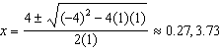

PTS: 2 REF: 012330ai NAT: A.REI.B.4 TOP: Solving Quadratics
KEY: quadratic formula

31 ANS:

PTS: 2 REF: 012331ai NAT: A.SSE.A.2
TOP: Factoring the Difference of Perfect Squares KEY: higher power

32 ANS:
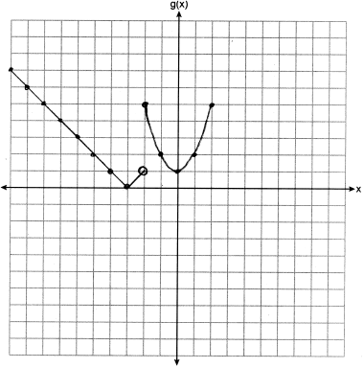

PTS: 2 REF: 012332ai NAT: F.IF.C.7 TOP: Graphing Piecewise-Defined Functions

33 ANS:
20-30; 10000; 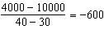. The population decreases by 600 each year.

PTS: 4 REF: 012333ai NAT: F.IF.B.4 TOP: Relating Graphs to Events

34 ANS:
, , strong

PTS: 4 REF: 012334ai NAT: S.ID.B.6 TOP: Regression
KEY: linear with correlation coefficient

35 ANS:
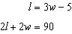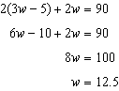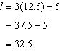

PTS: 4 REF: 012335ai NAT: A.CED.A.3 TOP: Modeling Linear Systems

36 ANS:
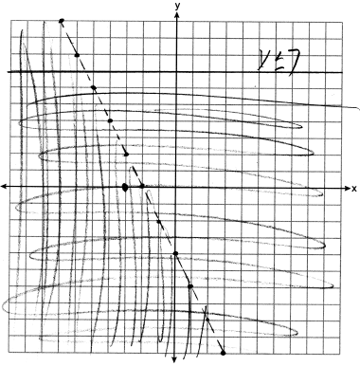 falls within the double-shaded area.

PTS: 4 REF: 012336ai NAT: A.REI.D.12 TOP: Graphing Systems of Linear Inequalities

37 ANS:
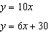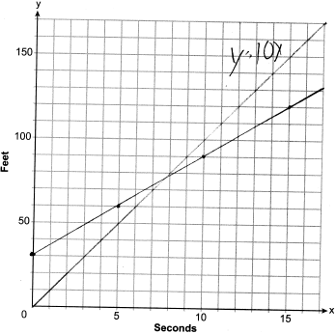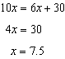

PTS: 6 REF: 012337ai NAT: A.CED.2 TOP: Speed

