1 If , what is the value of ?
1) | 13 | 3) | 37
2) | 19 | 4) | 54

2 A high school sponsored a badminton tournament. After each round, one-half of the players were eliminated. If there were 64 players at the start of the tournament, which equation models the number of players left after 3 rounds?
1) |  | 3)
2) |  | 4)

3 Given , which number is not in the solution set?
1) | 6 | 3) | 10
2) | 8 | 4) | 12

4 Which table could represent a function?
1) | 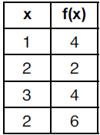 | 3) | 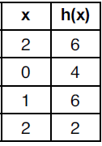
2) | 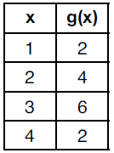 | 4) | 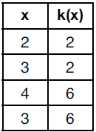

5 Which value of x makes 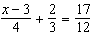 true?
1) | 8 | 3) | 0
2) | 6 | 4) | 4

6 Which expression is equivalent to ?
1) |  | 3)
2) |  | 4)

7 The functions and are graphed below.

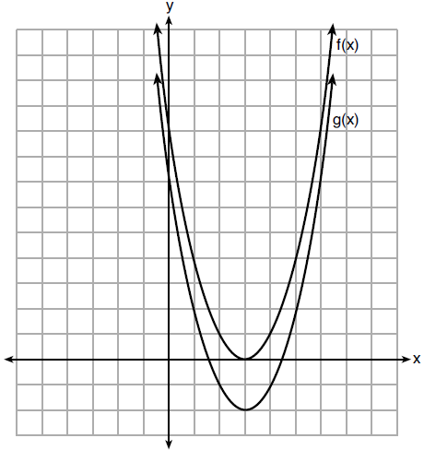

Which value of k would result in the graph of ?
1) | 0 | 3)
2) | 2 | 4)

8 The shaded boxes in the figures below represent a sequence.

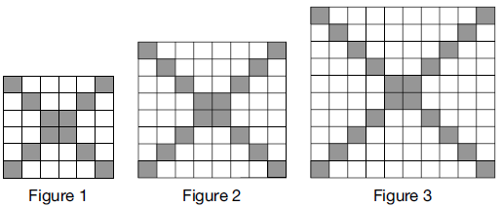

If figure 1 represents the first term and this pattern continues, how many shaded blocks will be in figure 35?
1) | 55 | 3) | 420
2) | 148 | 4) | 805

9 The zeros of the function are
1) | 9, only | 3) | 0 and 3, only
2) | 0 and 9 | 4) | , 0, and 3

10 A middle school conducted a survey of students to determine if they spent more of their time playing games or watching videos on their tablets. The results are shown in the table below.
 | Playing  Games | Watching  Videos | Total
Boys | 138 | 46 | 184
Girls | 54 | 142 | 196
Total | 192 | 188 | 380
Of the students who spent more time playing games on their tablets, approximately what percent were boys?
1) | 41 | 3) | 72
2) | 56 | 4) | 75

11 Which statement best describes the solutions of a two-variable equation?
1) | The ordered pairs must lie on the graphed equation. | 3) | The ordered pairs must have for one coordinate.
2) | The ordered pairs must lie near the graphed equation. | 4) | The ordered pairs must have for one coordinate.

12 The expression is equivalent to
1) |  | 3)
2) |  | 4)

13 Which statement is true about the functions and , given below?
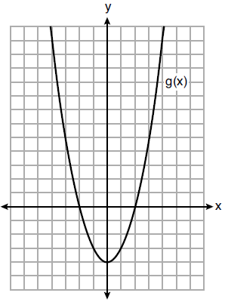
1) | The minimum value of is greater than the maximum value of . | 3) | and have the same roots.
2) | and have the same y-intercept. | 4) | when .

14 The equation represents the value of a motorcycle t years after it was purchased. Which statement is true?
1) | The motorcycle cost $9000 when purchased. | 3) | The motorcycle's value is decreasing at a rate of 75% each year.
2) | The motorcycle cost $12,000 when purchased. | 4) | The motorcycle's value is decreasing at a rate of 0.25% each year.

15 The solutions to are
1) |  | 3) | and
2) |  | 4) | 1 and 7

16 Which expression is not equivalent to ?
1) |  | 3)
2) |  | 4)

17 Which situation could be modeled as a linear equation?
1) | The value of a car decreases by 10% every year. | 3) | Two liters of water evaporate from a pool every day.
2) | The number of fish in a lake doubles every 5 years. | 4) | The amount of caffeine in a person's body decreases by every 2 hours.

18 The range of the function is
1) |  | 3)
2) |  | 4)

19 A laboratory technician used the function to model her research. Consider the following expressions:
I. II. III.
The function is equivalent to
1) | I, only | 3) | I and III
2) | II, only | 4) | II and III

20 Which system of equations has the same solutions as the system below?
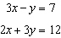
1) | 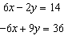 | 3) | 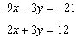
2) | 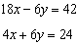 | 4) | 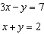

21 A population of paramecia, P, can be modeled using the exponential function , where t is the number of days since the population was first observed. Which domain is most appropriate to use to determine the population over the course of the first two weeks?
1) |  | 3)
2) |  | 4)

22 Given the following data set:

Which representations are correct for this data set?

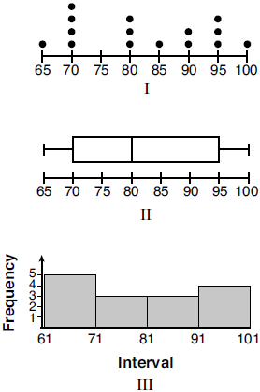
1) | I and II | 3) | II and III, only
2) | I and III, only | 4) | I, II, and III

23 A recursively defined sequence is shown below.
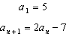
The value of is
1) |  | 3) | 8
2) |  | 4) | 15

24 Which polynomial has a leading coefficient of 4 and a degree of 3?
1) |  | 3)
2) |  | 4)

25 Graph on the set of axes below.

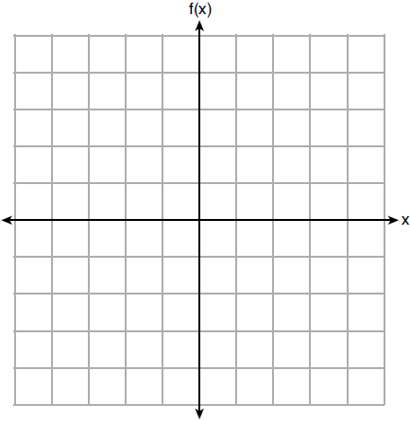

26 Maria orders T-shirts for her volleyball camp. Adult-sized T-shirts cost $6.25 each and youth-sized T-shirts cost $4.50 each. Maria has $550 to purchase both adult-sized and youth-sized T-shirts. If she purchases 45 youth-sized T-shirts, determine algebraically the maximum number of adult-sized T-shirts she can purchase.

27 A news report suggested that an adult should drink a minimum of 4 pints of water per day. Based on this report, determine the minimum amount of water an adult should drink, in fluid ounces, per week.

28 Express 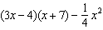 as a trinomial in standard form.

29 John was given the equation to solve. Some of the steps and their reasons have already been completed. State a property of numbers for each missing reason.

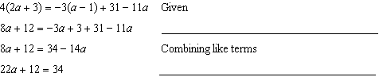

30 State whether the product of and is rational or irrational. Explain your answer.

31 Use the method of completing the square to determine the exact values of x for the equation .

32 A formula for determining the finite sum, S, of an arithmetic sequence of numbers is 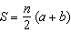, where n is the number of terms, a is the first term, and b is the last term. Express b in terms of a, S, and n.

33 Michael threw a ball into the air from the top of a building. The height of the ball, in feet, is modeled by the equation , where t is the elapsed time, in seconds. Graph this equation on the set of axes below.

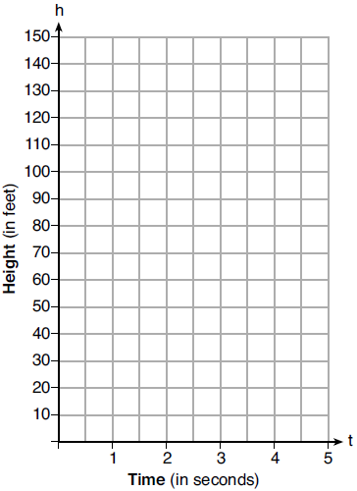

Determine the average rate of change, in feet per second, from when Michael released the ball to when the ball reached its maximum height.

34 Graph the system of inequalities:
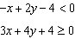

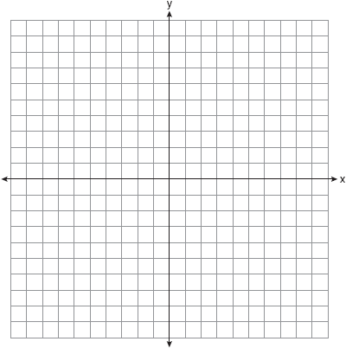

Stephen says the point is a solution to this system. Determine if he is correct, and explain your reasoning.

35 The following table represents a sample of sale prices, in thousands of dollars, and number of new homes available at that price in 2017.

Sale Price, p  (in thousands of dollars) | 160 | 180 | 200 | 220 | 240 | 260 | 280
Number of New Homes Available  f(p) | 126 | 103 | 82 | 75 | 82 | 40 | 20

State the linear regression function, , that estimates the number of new homes available at a specific sale price, p. Round all values to the nearest hundredth. State the correlation coefficient of the data to the nearest hundredth. Explain what this means in the context of the problem.

36 The length of a rectangular sign is 6 inches more than half its width. The area of this sign is 432 square inches. Write an equation in one variable that could be used to find the number of inches in the dimensions of this sign. Solve this equation algebraically to determine the dimensions of this sign, in inches.

37 Two families went to Rollercoaster World. The Brown family paid $170 for 3 children and 2 adults. The Peckham family paid $360 for 4 children and 6 adults. If x is the price of a child's ticket in dollars and y is the price of an adult's ticket in dollars, write a system of equations that models this situation. Graph your system of equations on the set of axes below.

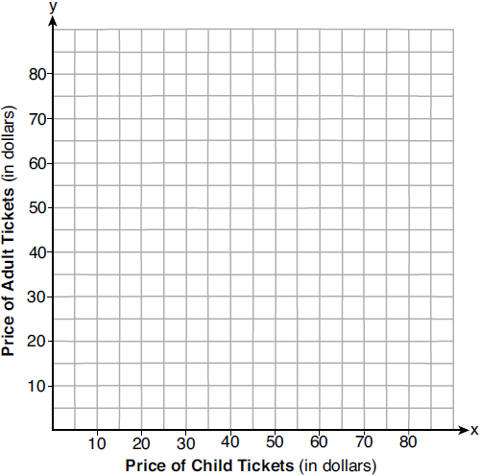

State the coordinates of the point of intersection. Explain what each coordinate of the point of intersection means in the context of the problem.
1 ANS: 2

PTS: 2 REF: 012001ai NAT: F.IF.A.2 TOP: Functional Notation

2 ANS: 1 PTS: 2 REF: 012002ai NAT: F.BF.A.1
TOP: Modeling Exponential Functions KEY: AI

3 ANS: 1
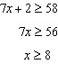

PTS: 2 REF: 012003ai NAT: A.REI.B.3 TOP: Interpreting Solutions

4 ANS: 2 PTS: 2 REF: 012004ai NAT: F.IF.A.1
TOP: Defining Functions KEY: ordered pairs

5 ANS: 2
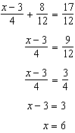

PTS: 2 REF: 012005ai NAT: A.REI.B.3 TOP: Solving Linear Equations
KEY: fractional expressions

6 ANS: 3

PTS: 2 REF: 012006ai NAT: A.SSE.A.2
TOP: Factoring the Difference of Perfect Squares KEY: quadratic

7 ANS: 4 PTS: 2 REF: 012007ai NAT: F.BF.B.3
TOP: Graphing Polynomial Functions

8 ANS: 2
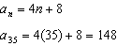

PTS: 2 REF: 012008ai NAT: F.IF.A.3 TOP: Sequences
KEY: explicit

9 ANS: 2
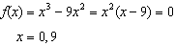

PTS: 2 REF: 012009ai NAT: A.APR.B.3 TOP: Zeros of Polynomials

10 ANS: 3
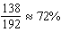

PTS: 2 REF: 012010ai NAT: S.ID.B.5 TOP: Frequency Tables
KEY: two-way

11 ANS: 1 PTS: 2 REF: 012011ai NAT: A.REI.D.10
TOP: Identifying Solutions

12 ANS: 4 PTS: 2 REF: 012012ai NAT: A.SSE.A.2
TOP: Factoring Polynomials KEY: quadratic

13 ANS: 2
The y-intercept of both and is .

PTS: 2 REF: 012013ai NAT: F.IF.C.9 TOP: Comparing Functions

14 ANS: 2 PTS: 2 REF: 012014ai NAT: F.LE.B.5
TOP: Modeling Exponential Functions

15 ANS: 3
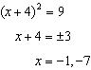

PTS: 2 REF: 012015ai NAT: A.REI.B.4 TOP: Solving Quadratics
KEY: taking square roots

16 ANS: 2

PTS: 2 REF: 012016ai NAT: A.APR.A.1 TOP: Operations with Polynomials
KEY: multiplication

17 ANS: 3 PTS: 2 REF: 012017ai NAT: F.LE.A.1
TOP: Families of Functions

18 ANS: 1 PTS: 2 REF: 012018ai NAT: F.IF.A.2
TOP: Domain and Range KEY: real domain, absolute value

19 ANS: 3

PTS: 2 REF: 012019ai NAT: A.SSE.B.3 TOP: Modeling Exponential Functions

20 ANS: 2
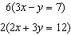

PTS: 2 REF: 012020ai NAT: A.REI.C.6 TOP: Solving Linear Systems

21 ANS: 4 PTS: 2 REF: 012021ai NAT: F.IF.B.5
TOP: Domain and Range

22 ANS: 4 PTS: 2 REF: 012022ai NAT: S.ID.A.1
TOP: Dot Plots

23 ANS: 1

PTS: 2 REF: 012023ai NAT: F.IF.A.3 TOP: Sequences
KEY: recursive

24 ANS: 4

PTS: 2 REF: 012024ai NAT: A.SSE.A.1 TOP: Modeling Expressions

25 ANS:
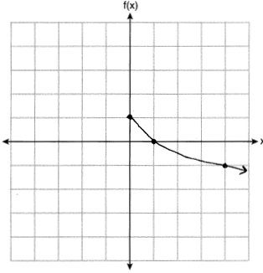

PTS: 2 REF: 012025ai NAT: F.IF.C.7 TOP: Graphing Root Functions

26 ANS:
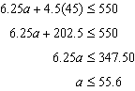 55 shirts

PTS: 2 REF: 012026ai NAT: A.CED.A.1 TOP: Modeling Linear Inequalities

27 ANS:
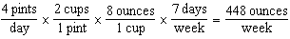

PTS: 2 REF: 012027ai NAT: N.Q.A.1 TOP: Conversions
KEY: dimensional analysis

28 ANS:
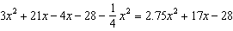

PTS: 2 REF: 012028ai NAT: A.APR.A.1 TOP: Operations with Polynomials
KEY: multiplication

29 ANS:
Distributive and Addition Property of Equality

PTS: 2 REF: 012029ai NAT: A.REI.A.1 TOP: Identifying Properties

30 ANS:
The product is irrational because can not be written as the ratio of two integers.

PTS: 2 REF: 012030ai NAT: N.RN.B.3 TOP: Operations with Radicals
KEY: classify

31 ANS:
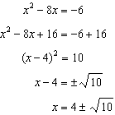

PTS: 2 REF: 012031ai NAT: A.REI.B.4 TOP: Solving Quadratics
KEY: completing the square

32 ANS:
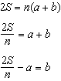

PTS: 2 REF: 012032ai NAT: A.CED.A.4 TOP: Transforming Formulas

33 ANS:
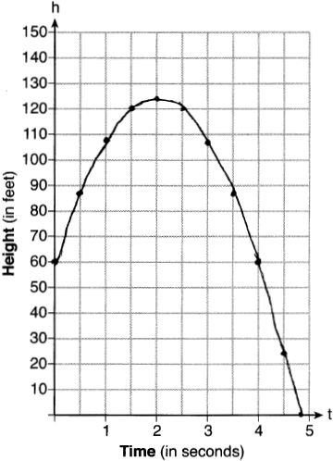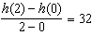

PTS: 4 REF: 012033ai NAT: F.IF.B.4 TOP: Graphing Quadratic Functions
KEY: context

34 ANS:
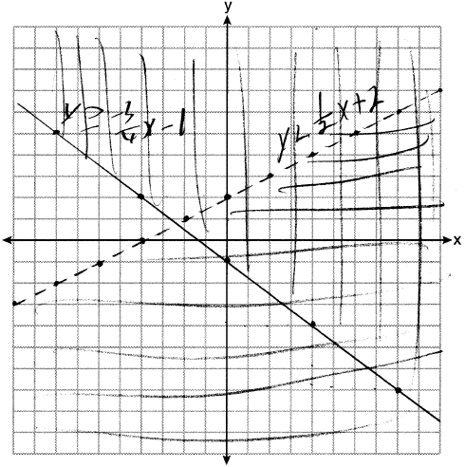 Correct, as 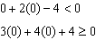

PTS: 4 REF: 012034ai NAT: A.REI.D.12 TOP: Graphing Systems of Linear Inequalities
KEY: graph

35 ANS:
There is a strong negative correlation as the higher the sales price, the fewer number of new homes available.

PTS: 4 REF: 012035ai NAT: S.ID.B.6 TOP: Regression
KEY: linear with correlation coefficient

36 ANS:
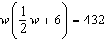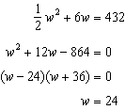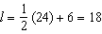

PTS: 4 REF: 012036ai NAT: A.CED.A.1 TOP: Geometric Applications of Quadratics

37 ANS:
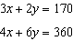 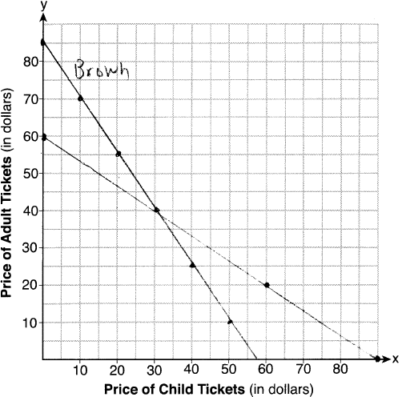 The price of a child’s ticket is $30 and the price of an adult’s ticket is $40.

PTS: 6 REF: 012037ai NAT: A.REI.C.6 TOP: Graphing Linear Systems

