1 The scatter plot below shows the relationship between the number of members in a family and the amount of the family's weekly grocery bill.

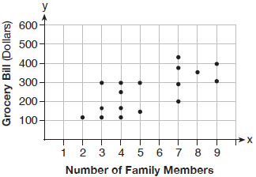

The most appropriate prediction of the grocery bill for a family that consists of six members is
1) | $100 | 3) | $400
2) | $300 | 4) | $500

2 The function is defined as . The value of is
1) |  | 3) | 27
2) |  | 4) | 45

3 Which expression results in a rational number?
1) |  | 3)
2) |  | 4)

4 The math department needs to buy new textbooks and laptops for the computer science classroom. The textbooks cost $116.00 each, and the laptops cost $439.00 each. If the math department has $6500 to spend and purchases 30 textbooks, how many laptops can they buy?
1) | 6 | 3) | 11
2) | 7 | 4) | 12

5 What is the solution to the equation 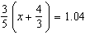?
1) |  | 3)
2) | 0.4 | 4)

6 The area of a rectangle is represented by . Which expression can also be used to represent the area of the same rectangle?
1) |  | 3)
2) |  | 4)

7 Which relation does not represent a function?
1) | 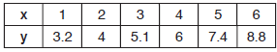 | 3)
2) | 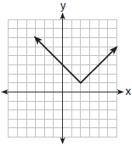 | 4) | 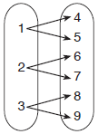

8 Britney is solving a quadratic equation. Her first step is shown below.
Problem:
Step 1:
Which two properties did Britney use to get to step 1?
I. addition property of equality
II. commutative property of addition
III. multiplication property of equality
IV. distributive property of multiplication over addition
1) | I and III | 3) | II and III
2) | I and IV | 4) | II and IV

9 The graph of 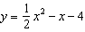 is shown below. The points , , and lie on this graph.

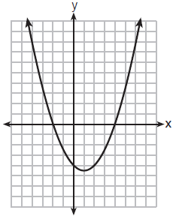

Which of these points can determine the zeros of the equation ?
1) | A, only | 3) | A and C, only
2) | B, only | 4) | A, B, and C

10 Given the parent function , the function is the result of a shift of
1) | 1 unit left and 2 units down | 3) | 1 unit right and 2 units down
2) | 1 unit left and 2 units up | 4) | 1 unit right and 2 units up

11 If and , then equals
1) |  | 3)
2) |  | 4)

12 Marc bought a new laptop for $1250. He kept track of the value of the laptop over the next three years, as shown in the table below.

Years After Purchase | Value in Dollars
1 | 1000
2 | 800
3 | 640

Which function can be used to determine the value of the laptop for x years after the purchase?
1) |  | 3)
2) |  | 4)

13 The height of a ball Doreen tossed into the air can be modeled by the function , where x is the time elapsed in seconds, and is the height in meters. The number 5 in the function represents
1) | the initial height of the ball | 3) | the time at which the ball was at its highest point
2) | the time at which the ball reaches the ground | 4) | the maximum height the ball attained when thrown in the air

14 The function has a domain consisting of the integers from to 1, inclusive. Which set represents the corresponding range values for ?
1) |  | 3)
2) |  | 4)

15 Which equation has the same solution as ?
1) |  | 3)
2) |  | 4)

16 The table below shows the weights of Liam's pumpkin, , and Patricia's pumpkin, , over a four-week period where w represents the number of weeks. Liam's pumpkin grows at a constant rate. Patricia's pumpkin grows at a weekly rate of approximately 52%.

Weeks  w | Weight in Pounds  l(w) | Weight in Pounds  p(w)
6 | 2.4 | 2.5
7 | 5.5 | 3.8
8 | 8.6 | 5.8
9 | 11.7 | 8.8

Assume the pumpkins continue to grow at these rates through week 13. When comparing the weights of both Liam's and Patricia's pumpkins in week 10 and week 13, which statement is true?
1) | Liam's pumpkin will weigh more in week 10 and week 13. | 3) | Liam's pumpkin will weigh more in week 10, and Patricia's pumpkin will weigh more in week 13.
2) | Patricia's pumpkin will weigh more in week 10 and week 13. | 4) | Patricia's pumpkin will weigh more in week 10, and Liam's pumpkin will weigh more in week 13.

17 The function is graphed below.

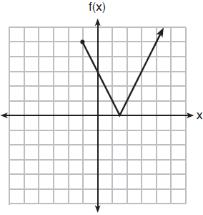

The domain of this function is
1) | all positive real numbers | 3)
2) | all positive integers | 4)

18 Which pair of equations would have as a solution?
1) | and | 3) | and
2) | and | 4) | and 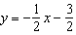

19 Which function could be used to represent the sequence , given that ?
1) |  | 3)
2) |  | 4)

20 The formula for electrical power, P, is , where I is current and R is resistance. The formula for I in terms of P and R is
1) | 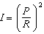 | 3)
2) | 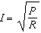 | 4)

21 The functions and are shown below.
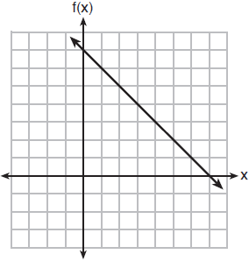
x | p(x)
2 | 5
3 | 4
4 | 3
5 | 4
6 | 5

When the input is 4, which functions have the same output value?
1) | and only | 3) | and , only
2) | and , only | 4) | and

22 Using the substitution method, Vito is solving the following system of equations algebraically:
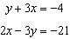
Which equivalent equation could Vito use?
1) |  | 3)
2) |  | 4)

23 Materials A and B decay over time. The function for the amount of material A is and for the amount of material B is , where t represents time in days. On which day will the amounts of material be equal?
1) | initial day, only | 3) | day 5, only
2) | day 2, only | 4) | every day

24 The following conversion was done correctly:
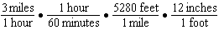
What were the final units for this conversion?
1) | minutes per foot | 3) | feet per minute
2) | minutes per inch | 4) | inches per minute

25 Solve algebraically for x:

26 The number of people who attended a school's last six basketball games increased as the team neared the state sectional games. The table below shows the data.

Game | 13 | 14 | 15 | 16 | 17 | 18
Attendance | 348 | 435 | 522 | 609 | 696 | 783

State the type of function that best fits the given data. Justify your choice of a function type.

27 Solve algebraically. Explain the first step you used to solve the given equation.

28 The graph of models the height, in feet, that a bee is flying above the ground with respect to the time it traveled in t seconds.

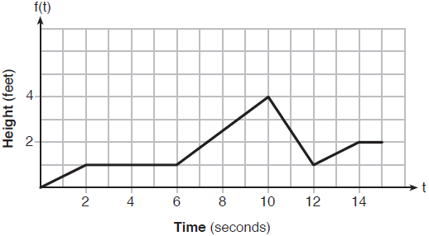

State all time intervals when the bee's rate of change is zero feet per second. Explain your reasoning.

29 Graph the function on the set of axes below.

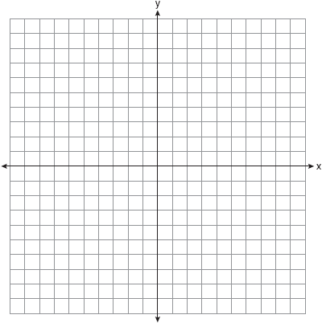

If , determine if when . Justify your answer.

30 Determine algebraically the zeros of .

31 Santina is considering a vacation and has obtained high-temperature data from the last two weeks for Miami and Los Angeles.

Miami | 76 | 75 | 83 | 73 | 60 | 66 | 76
Miami | 81 | 83 | 85 | 83 | 87 | 80 | 80

Los Angeles | 74 | 63 | 65 | 67 | 65 | 65 | 65
Los Angeles | 62 | 62 | 72 | 69 | 64 | 64 | 61

Which location has less variability in temperatures? Explain how you arrived at your answer.

32 Solve the quadratic equation below for the exact values of x.

33 Marilyn collects old dolls. She purchases a doll for $450. Research shows this doll's value will increase by 2.5% each year. Write an equation that determines the value, V, of the doll t years after purchase. Assuming the doll's rate of appreciation remains the same, will the doll's value be doubled in 20 years? Justify your reasoning.

34 The data given in the table below show some of the results of a study comparing the height of a certain breed of dog, based upon its mass.

Mass (kg) | 4.5 | 5 | 4 | 3.5 | 5.5 | 5 | 5 | 4 | 4 | 6 | 3.5 | 5.5
Height (cm) | 41 | 40 | 35 | 38 | 43 | 44 | 37 | 39 | 42 | 44 | 31 | 30

Write the linear regression equation for these data, where x is the mass and y is the height. Round all values to the nearest tenth. State the value of the correlation coefficient to the nearest tenth, and explain what it indicates.

35 Myranda received a movie gift card for $100 to her local theater. Matinee tickets cost $7.50 each and evening tickets cost $12.50 each. If x represents the number of matinee tickets she could purchase, and y represents the number of evening tickets she could purchase, write an inequality that represents all the possible ways Myranda could spend her gift card on movies at the theater. On the set of axes below, graph this inequality.

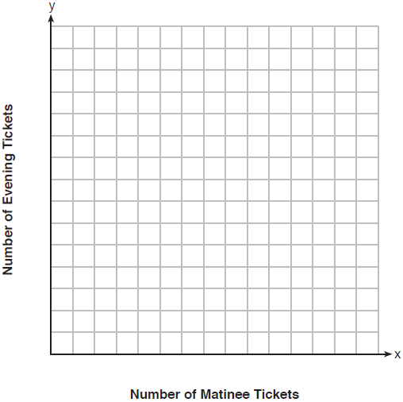

What is the maximum number of matinee tickets Myranda could purchase with her gift card? Explain your answer.

36 One spring day, Elroy noted the time of day and the temperature, in degrees Fahrenheit. His findings are stated below.
At 6 a.m., the temperature was 50°F. For the next 4 hours, the temperature rose 3° per hour. The next 6 hours, it rose 2° per hour. The temperature then stayed steady until 6 p.m. For the next 2 hours, the temperature dropped 1° per hour. The temperature then dropped steadily until the temperature was 56°F at midnight.
On the set of axes below, graph Elroy's data.
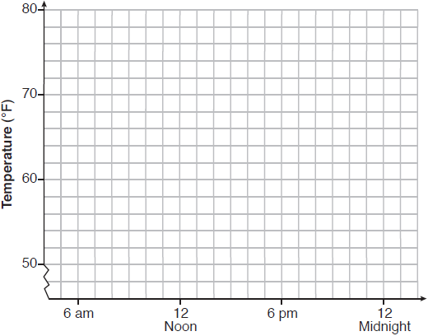
State the entire time interval for which the temperature was increasing. Determine the average rate of change, in degrees per hour, from 6:00 p.m. to midnight.

37 A recreation center ordered a total of 15 tricycles and bicycles from a sporting goods store. The number of wheels for all the tricycles and bicycles totaled 38. Write a linear system of equations that models this scenario, where t represents the number of tricycles and b represents the number of bicycles ordered. On the set of axes below, graph this system of equations.
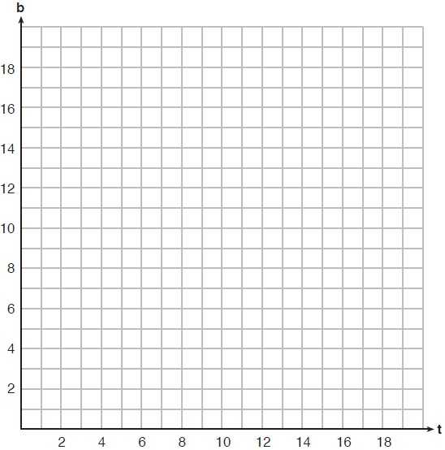

Based on your graph of this scenario, could the recreation center have ordered 10 tricycles? Explain your reasoning.
1 ANS: 2 PTS: 2 REF: 011901ai NAT: S.ID.B.6
TOP: Scatter Plots KEY: line of best fit

2 ANS: 1

PTS: 2 REF: 011902ai NAT: F.IF.A.2 TOP: Functional Notation

3 ANS: 3
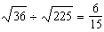 may be expressed as the ratio of two integers.

PTS: 2 REF: 011903ai NAT: N.RN.B.3 TOP: Operations with Radicals
KEY: classify

4 ANS: 1
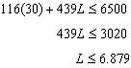

PTS: 2 REF: 011904ai NAT: A.CED.A.1 TOP: Modeling Linear Inequalities

5 ANS: 2
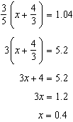

PTS: 2 REF: 011905ai NAT: A.REI.B.3 TOP: Solving Linear Equations
KEY: decimals

6 ANS: 1 PTS: 2 REF: 011906ai NAT: A.SSE.A.2
TOP: Factoring Polynomials KEY: quadratic

7 ANS: 4 PTS: 2 REF: 011907ai NAT: F.IF.A.1
TOP: Defining Functions KEY: mixed

8 ANS: 4 PTS: 2 REF: 011908ai NAT: A.REI.A.1
TOP: Identifying Properties

9 ANS: 3 PTS: 2 REF: 011909ai NAT: A.APR.B.3
TOP: Zeros of Polynomials

10 ANS: 3 PTS: 2 REF: 011910ai NAT: F.BF.B.3
TOP: Graphing Polynomial Functions

11 ANS: 3

PTS: 2 REF: 011911ai NAT: A.APR.A.1 TOP: Operations with Polynomials
KEY: subtraction

12 ANS: 4 PTS: 2 REF: 011912ai NAT: F.LE.A.2
TOP: Modeling Exponential Functions

13 ANS: 1

PTS: 2 REF: 011913ai NAT: F.IF.B.4 TOP: Graphing Quadratic Functions
KEY: context

14 ANS: 2
, ,

PTS: 2 REF: 011914ai NAT: F.IF.A.2 TOP: Domain and Range
KEY: limited domain

15 ANS: 1
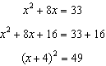

PTS: 2 REF: 011915ai NAT: A.REI.B.4 TOP: Solving Quadratics
KEY: completing the square

16 ANS: 3
, , ; , ,

PTS: 2 REF: 011916ai NAT: F.LE.A.3 TOP: Families of Functions

17 ANS: 4 PTS: 2 REF: 011917ai NAT: F.IF.A.2
TOP: Domain and Range KEY: graph

18 ANS: 3
,

PTS: 2 REF: 011918ai NAT: A.REI.D.11 TOP: Other Systems

19 ANS: 2 PTS: 2 REF: 011919ai NAT: F.LE.A.2
TOP: Sequences KEY: recursive

20 ANS: 2
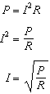

PTS: 2 REF: 011920ai NAT: A.CED.A.4 TOP: Transforming Formulas

21 ANS: 4

PTS: 2 REF: 011921ai NAT: F.IF.C.9 TOP: Comparing Functions

22 ANS: 3

PTS: 2 REF: 011922ai NAT: A.REI.C.6 TOP: Solving Linear Systems
KEY: substitution

23 ANS: 4

PTS: 2 REF: 011923ai NAT: A.SSE.B.3 TOP: Modeling Exponential Functions

24 ANS: 4 PTS: 2 REF: 011924ai NAT: N.Q.A.1
TOP: Conversions KEY: dimensional analysis

25 ANS:
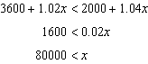

PTS: 2 REF: 011925ai NAT: A.REI.B.3 TOP: Solving Linear Inequalities

26 ANS:
Linear, because the function grows at a constant rate.

PTS: 2 REF: 011926ai NAT: F.LE.A.1 TOP: Families of Functions

27 ANS:
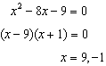 I factored the quadratic.

PTS: 2 REF: 011927ai NAT: A.REI.B.4 TOP: Solving Quadratics
KEY: factoring

28 ANS:
and because horizontal lines have zero slope.

PTS: 2 REF: 011928ai NAT: F.IF.B.6 TOP: Rate of Change

29 ANS:
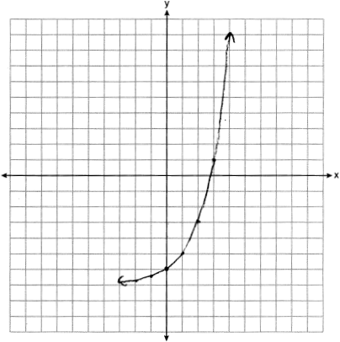 Yes, because .

PTS: 2 REF: 011929ai NAT: F.IF.C.7 TOP: Graphing Exponential Functions

30 ANS:
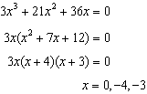

PTS: 2 REF: 011930ai NAT: A.APR.B.3 TOP: Zeros of Polynomials

31 ANS:
Los Angeles because range, IQR and are less.
 |  | Min | Q1 | Q3 | Max | Range | IQR
Miami | 7.2 | 60 | 75 | 83 | 87 | 27 | 8
Los Angeles | 3.6 | 61 | 63 | 67 | 74 | 13 | 4

PTS: 2 REF: 011931ai NAT: S.ID.A.2 TOP: Central Tendency and Dispersion

32 ANS:
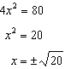

PTS: 2 REF: 011932ai NAT: A.REI.B.4 TOP: Solving Quadratics
KEY: taking square roots

33 ANS:
; No,

PTS: 4 REF: 011933ai NAT: A.CED.A.1 TOP: Modeling Exponential Functions

34 ANS:
This indicates a weak relationship between a dog’s height and mass.

PTS: 4 REF: 011934ai NAT: S.ID.B.6 TOP: Regression
KEY: linear with correlation coefficient

35 ANS:
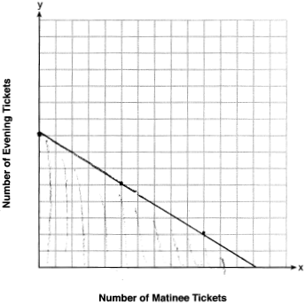13, because and .

PTS: 4 REF: 011935ai NAT: A.REI.D.12 TOP: Graphing Linear Inequalities

36 ANS:
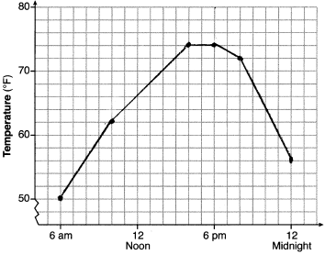, 6am-4pm, 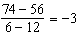

PTS: 4 REF: 011936ai NAT: F.IF.B.4 TOP: Relating Graphs to Events

37 ANS:
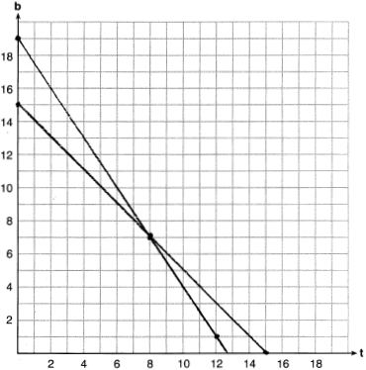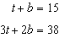 No, because according to the graph, 8 tricycles were ordered.

PTS: 6 REF: 011937ai NAT: A.REI.C.6 TOP: Graphing Linear Systems

