1 When solving the equation , Evan wrote as his first step. Which property justifies this step?
1) | subtraction property of equality | 3) | associative property of multiplication
2) | multiplication property of equality | 4) | distributive property of multiplication over subtraction

2 Jill invests $400 in a savings bond. The value of the bond, , in hundreds of dollars after x years is illustrated in the table below.

x | V(x)
0 | 4
1 | 5.4
2 | 7.29
3 | 9.84

Which equation and statement illustrate the approximate value of the bond in hundreds of dollars over time in years?
1) | and it grows. | 3) | and it grows.
2) | and it decays. | 4) | and it decays.

3 Alicia purchased H half-gallons of ice cream for $3.50 each and P packages of ice cream cones for $2.50 each. She purchased 14 items and spent $43. Which system of equations could be used to determine how many of each item Alicia purchased?
1) | 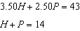 | 3) | 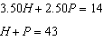
2) | 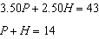 | 4) | 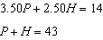

4 A relation is graphed on the set of axes below.

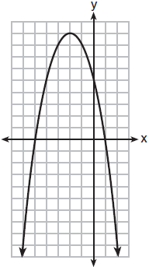

Based on this graph, the relation is
1) | a function because it passes the horizontal line test | 3) | not a function because it fails the horizontal line test
2) | a function because it passes the vertical line test | 4) | not a function because it fails the vertical line test

5 Ian is saving up to buy a new baseball glove. Every month he puts $10 into a jar. Which type of function best models the total amount of money in the jar after a given number of months?
1) | linear | 3) | quadratic
2) | exponential | 4) | square root

6 Which ordered pair would not be a solution to ?
1)
2)
3)
4)

7 Last weekend, Emma sold lemonade at a yard sale. The function represented the profit, , Emma earned selling c cups of lemonade. Sales were strong, so she raised the price for this weekend by 25 cents per cup. Which function represents her profit for this weekend?
1) |  | 3)
2) |  | 4)

8 The product of and is
1) | irrational because both factors are irrational | 3) | irrational because one factor is irrational
2) | rational because both factors are rational | 4) | rational because one factor is rational

9 Which expression is equivalent to ?
1) |  | 3)
2) |  | 4)

10 The graphs of and intersect at approximately
1) | , only | 3) | and
2) | , only | 4) | and

11 The expression represents the height, in meters, of a toy rocket t seconds after launch. The initial height of the rocket, in meters, is
1) | 0 | 3) | 4.9
2) | 2 | 4) | 50

12 If the domain of the function is , then the range is
1) |  | 3)
2) |  | 4)

13 Which polynomial is twice the sum of and ?
1) |  | 3)
2) |  | 4)

14 What are the solutions to the equation ?
1) | 1 and 7 | 3)
2) | and | 4)

15 A system of equations is shown below.
Equation A:
Equation B:
Which method eliminates one of the variables?
1) | Multiply equation A by and add the result to equation B. | 3) | Multiply equation A by 2 and equation B by and add the results together.
2) | Multiply equation B by 3 and add the result to equation A. | 4) | Multiply equation B by 5 and equation A by 4 and add the results together.

16 The 15 members of the French Club sold candy bars to help fund their trip to Quebec. The table below shows the number of candy bars each member sold.

Number of Candy Bars Sold
0 | 35 | 38 | 41 | 43
45 | 50 | 53 | 53 | 55
68 | 68 | 68 | 72 | 120

When referring to the data, which statement is false?
1) | The mode is the best measure of central tendency for the data. | 3) | The median is 53.
2) | The data have two outliers. | 4) | The range is 120.

17 Given the set , what is the solution of ?
1) |  | 3)
2) | 1, 2 | 4)

18 If the pattern below continues, which equation(s) is a recursive formula that represents the number of squares in this sequence?

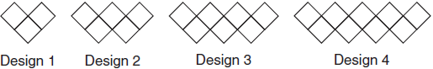
1) |  | 3) | 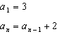
2) |  | 4) | 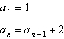

19 If the original function is shifted to the left 3 units to make the function , which expression would represent ?
1) |  | 3)
2) |  | 4)

20 First consider the system of equations 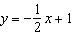 and . Then consider the system of inequalities 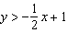 and . When comparing the number of solutions in each of these systems, which statement is true?
1) | Both systems have an infinite number of solutions. | 3) | The system of inequalities has more solutions.
2) | The system of equations has more solutions. | 4) | Both systems have only one solution.

21 Nora inherited a savings account that was started by her grandmother 25 years ago. This scenario is modeled by the function , where represents the value of the account, in dollars, t years after the inheritance. Which function below is equivalent to ?
1) |  | 3)
2) |  | 4)

22 The value of x which makes 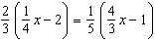 true is
1) |  | 3)
2) |  | 4)

23 Which quadratic function has the largest maximum over the set of real numbers?
1) |  | 3)
2) | 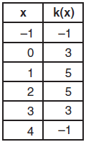 | 4) | 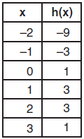

24 Voting rates in presidential elections from 1996-2012 are modeled below.

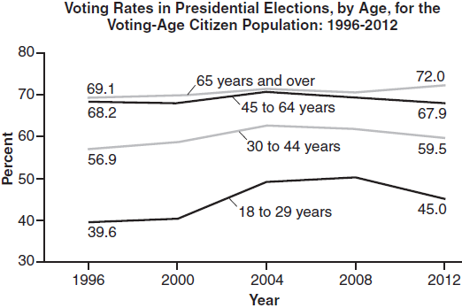

Which statement does not correctly interpret voting rates by age based on the given graph?
1) | For citizens 18-29 years of age, the rate of change in voting rate was greatest between years 2000-2004. | 3) | About 70% of people 45 and older voted in the 2004 election.
2) | From 1996-2012, the average rate of change was positive for only two age groups. | 4) | The voting rates of eligible age groups lies between 35 and 75 percent during presidential elections every 4 years from 1996-2012.

25 On the set of axes below, graph .

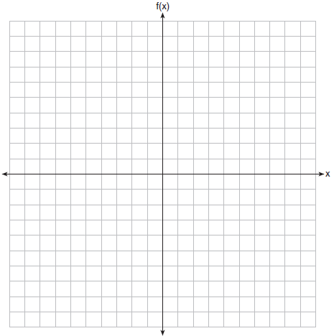

26 Determine all the zeros of , algebraically.

27 The distance traveled is equal to the rate of speed multiplied by the time traveled. If the distance is measured in feet and the time is measured in minutes, then the rate of speed is expressed in which units? Explain how you arrived at your answer.

28 Determine if the point is a solution to the system of inequalities graphed below. Justify your answer.

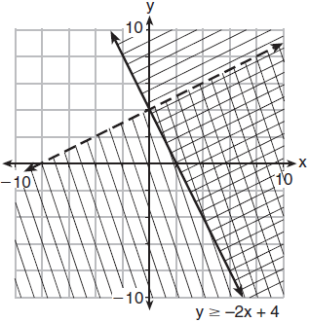

29 If the zeros of a quadratic function, F, are and 5, what is the equation of the axis of symmetry of F? Justify your answer.

30 The formula 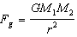 calculates the gravitational force between two objects where G is the gravitational constant, is the mass of one object, is the mass of the other object, and r is the distance between them. Solve for the positive value of r in terms of , G, , and .

31 At Mountain Lakes High School, the mathematics and physics scores of nine students were compared as shown in the table below.

Mathematics | 55 | 93 | 89 | 60 | 90 | 45 | 64 | 76 | 89
Physics | 66 | 89 | 94 | 52 | 84 | 56 | 66 | 73 | 92

State the correlation coefficient, to the nearest hundredth, for the line of best fit for these data. Explain what the correlation coefficient means with regard to the context of this situation.

32 The graph of the function is given below.

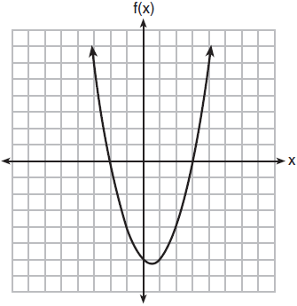

Could the factors of be and ? Based on the graph, explain why or why not.

33 Jim is a furniture salesman. His weekly pay is $300 plus 3.5% of his total sales for the week. Jim sells x dollars' worth of furniture during the week. Write a function, , which can be used to determine his pay for the week. Use this function to determine Jim's pay to the nearest cent for a week when his sales total is $8250.

34 Omar has a piece of rope. He ties a knot in the rope and measures the new length of the rope. He then repeats this process several times. Some of the data collected are listed in the table below.

Number of Knots | 4 | 5 | 6 | 7 | 8
Length of Rope (cm) | 64 | 58 | 49 | 39 | 31

State, to the nearest tenth, the linear regression equation that approximates the length, y, of the rope after tying x knots. Explain what the y-intercept means in the context of the problem. Explain what the slope means in the context of the problem.

35 The drama club is running a lemonade stand to raise money for its new production. A local grocery store donated cans of lemonade and bottles of water. Cans of lemonade sell for $2 each and bottles of water sell for $1.50 each. The club needs to raise at least $500 to cover the cost of renting costumes. The students can accept a maximum of 360 cans and bottles. Write a system of inequalities that can be used to represent this situation. The club sells 144 cans of lemonade. What is the least number of bottles of water that must be sold to cover the cost of renting costumes? Justify your answer.

36 A manager wanted to analyze the online shoe sales for his business. He collected data for the number of pairs of shoes sold each hour over a 14-hour time period. He created a graph to model the data, as shown below.

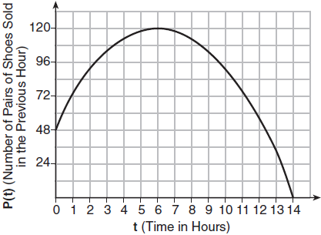

The manager believes the set of integers would be the most appropriate domain for this model. Explain why he is incorrect. State the entire interval for which the number of pairs of shoes sold is increasing. Determine the average rate of change between the sixth and fourteenth hours, and explain what it means in the context of the problem.

37 At Bea's Pet Shop, the number of dogs, d, is initially five less than twice the number of cats, c. If she decides to add three more of each, the ratio of cats to dogs will be · Write an equation or system of equations that can be used to find the number of cats and dogs Bea has in her pet shop. Could Bea's Pet Shop initially have 15 cats and 20 dogs? Explain your reasoning. Determine algebraically the number of cats and the number of dogs Bea initially had in her pet shop.
1 ANS: 4 PTS: 2 REF: 011801ai NAT: A.REI.A.1
TOP: Identifying Properties

2 ANS: 3
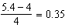

PTS: 2 REF: 011802ai NAT: F.LE.A.2 TOP: Modeling Exponential Functions

3 ANS: 1 PTS: 2 REF: 011803ai NAT: A.CED.A.3
TOP: Modeling Linear Systems

4 ANS: 2 PTS: 2 REF: 011804ai NAT: F.IF.A.1
TOP: Defining Functions KEY: graphs

5 ANS: 1 PTS: 2 REF: 011805ai NAT: F.LE.A.1
TOP: Families of Functions

6 ANS: 4
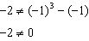

PTS: 2 REF: 011806ai NAT: A.REI.D.10 TOP: Identifying Solutions

7 ANS: 4

PTS: 2 REF: 011807ai NAT: F.BF.A.1 TOP: Modeling Linear Functions

8 ANS: 3

PTS: 2 REF: 011808ai NAT: N.RN.B.3 TOP: Operations with Radicals
KEY: classify

9 ANS: 3 PTS: 2 REF: 011809ai NAT: A.SSE.A.2
TOP: Factoring the Difference of Perfect Squares KEY: higher power

10 ANS: 3
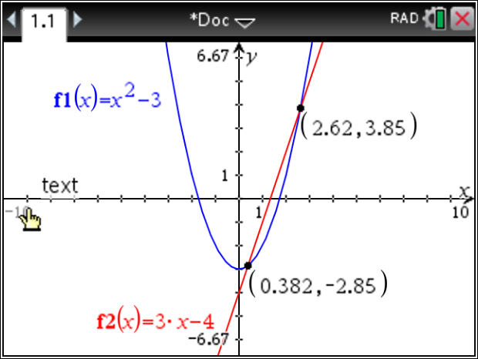

PTS: 2 REF: 011810ai NAT: A.REI.C.7 TOP: Quadratic-Linear Systems
KEY: algebraically

11 ANS: 2

PTS: 2 REF: 011811ai NAT: F.IF.B.4 TOP: Graphing Quadratic Functions
KEY: context

12 ANS: 3
, ,

PTS: 2 REF: 011812ai NAT: F.IF.A.2 TOP: Domain and Range
KEY: limited domain

13 ANS: 3 PTS: 2 REF: 011813ai NAT: A.APR.A.1
TOP: Operations with Polynomials KEY: addition

14 ANS: 1
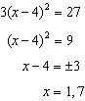

PTS: 2 REF: 011814ai NAT: A.REI.B.4 TOP: Solving Quadratics
KEY: taking square roots

15 ANS: 2 PTS: 2 REF: 011815ai NAT: A.REI.C.6
TOP: Solving Linear Systems

16 ANS: 1
1) The mode is a bit high.
2) , , 1.5 times the IQR of 27 is 40.5, , , so the data have two outliers.

PTS: 2 REF: 011816ai NAT: S.ID.A.3 TOP: Central Tendency and Dispersion

17 ANS: 2
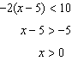

PTS: 2 REF: 011817ai NAT: A.REI.B.3 TOP: Interpreting Solutions

18 ANS: 3 PTS: 2 REF: 011818ai NAT: F.LE.A.2
TOP: Sequences KEY: recursive

19 ANS: 2 PTS: 2 REF: 011819ai NAT: F.BF.B.3
TOP: Graphing Polynomial Functions

20 ANS: 3 PTS: 2 REF: 011820ai NAT: A.REI.D.12
TOP: Graphing Systems of Linear Inequalities KEY: solution set

21 ANS: 4 PTS: 2 REF: 011821ai NAT: A.SSE.B.3
TOP: Modeling Exponential Functions

22 ANS: 4
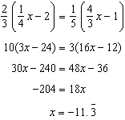

PTS: 2 REF: 011822ai NAT: A.REI.B.3 TOP: Solving Linear Equations
KEY: fractional expressions

23 ANS: 2
1) 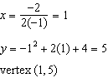; 2) 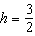 Using , 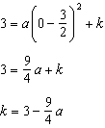; Using , 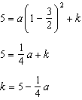 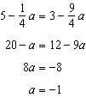 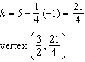; 3) vertex ; 4) Using 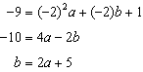 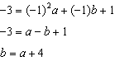 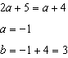 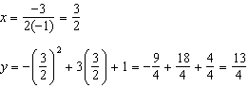 vertex 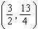

PTS: 2 REF: 011823ai NAT: F.IF.C.9 TOP: Comparing Functions

24 ANS: 2
From 1996-2012, the average rate of change was positive for three age groups.

PTS: 2 REF: 011824ai NAT: F.IF.B.6 TOP: Rate of Change

25 ANS:
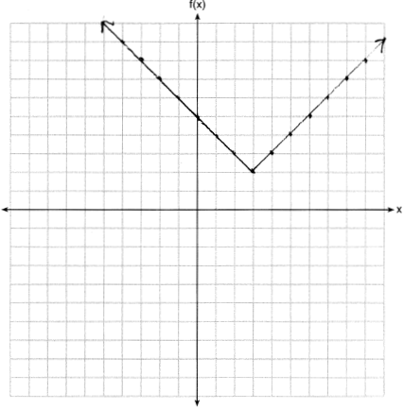

PTS: 2 REF: 011825ai NAT: F.IF.C.7 TOP: Graphing Absolute Value Functions

26 ANS:
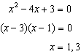

PTS: 2 REF: 011826ai NAT: A.APR.B.3 TOP: Zeros of Polynomials

27 ANS:
The rate of speed is expressed in 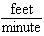 because 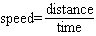.

PTS: 2 REF: 011827ai NAT: A.CED.A.2 TOP: Speed

28 ANS:
No, because the point does not satisfy the inequality 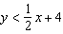. 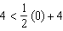 is not a true statement.

PTS: 2 REF: 011828ai NAT: A.REI.D.12 TOP: Graphing Systems of Linear Inequalities
KEY: solution set

29 ANS:
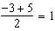

PTS: 2 REF: 011829ai NAT: F.IF.B.4 TOP: Graphing Quadratic Functions
KEY: no context

30 ANS:
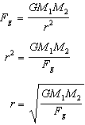

PTS: 2 REF: 011830ai NAT: A.CED.A.4 TOP: Transforming Formulas

31 ANS:
. The correlation coefficient suggests a strong positive correlation between a student’s mathematics and physics scores.

PTS: 2 REF: 011831ai NAT: S.ID.C.8 TOP: Correlation Coefficient

32 ANS:
Yes, because from the graph the zeroes of are and 3.

PTS: 2 REF: 011832ai NAT: F.IF.C.7 TOP: Graphing Quadratic Functions

33 ANS:

PTS: 4 REF: 011833ai NAT: F.BF.A.1 TOP: Modeling Linear Functions

34 ANS:
The y-intercept represents the length of the rope without knots. The slope represents the decrease in the length of the rope for each knot.

PTS: 4 REF: 011834ai NAT: S.ID.B.6 TOP: Regression
KEY: linear

35 ANS:
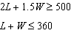 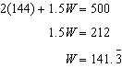 142 bottles of water must be sold to cover the cost of renting costumes.

PTS: 4 REF: 011835ai NAT: A.CED.A.3 TOP: Modeling Systems of Linear Inequalities

36 ANS:
The set of integers includes negative numbers, so is not an appropriate domain for time; for , the hourly rate is increasing, or for , the total numbers of shoes is increasing; 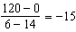, 15 fewer shoes were sold each hour between the sixth and fourteenth hours.

PTS: 4 REF: 011836ai NAT: F.IF.B.6 TOP: Rate of Change

37 ANS:
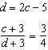; 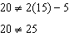 20 dogs is not five less than twice 15 cats 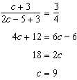

PTS: 6 REF: 011837ai NAT: A.CED.A.3 TOP: Modeling Linear Systems

