1 In the function , the minimum value occurs when x is
1) |  | 3)
2) | 2 | 4) | 4

2 The graph below was created by an employee at a gas station.

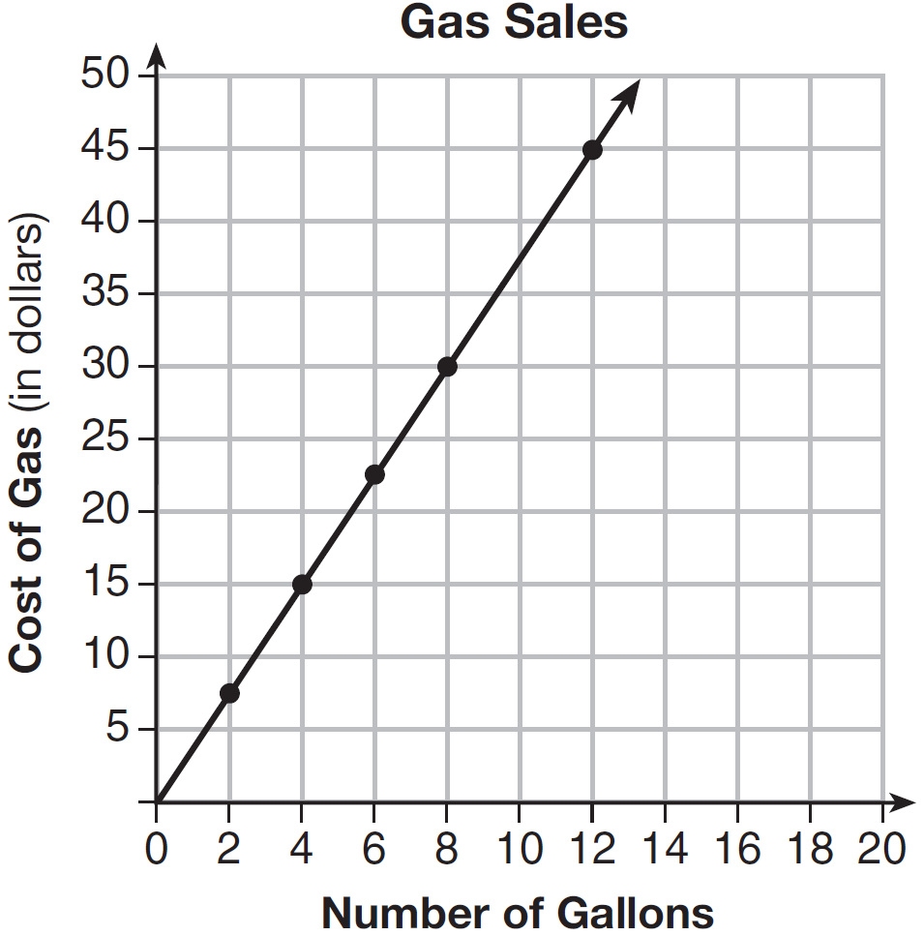

Which statement can be justified by using the graph?
1) | If 10 gallons of gas was purchased, $35 was paid. | 3) | For every 2 gallons of gas purchased, $5.00 was paid.
2) | For every gallon of gas purchased, $3.75 was paid. | 4) | If zero gallons of gas were purchased, zero miles were driven.

3 For a recently released movie, the function models the revenue earned, y, in millions of dollars each week, x, for several weeks after its release. Based on the equation, how much more money, in millions of dollars, was earned in revenue for week 3 than for week 5?
1) | 37.27 | 3) | 17.06
2) | 27.16 | 4) | 10.11

4 Given the following expressions:
I. 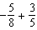 III. 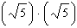
II. 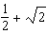 IV. 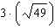
Which expression(s) result in an irrational number?
1) | II, only | 3) | I, III, IV
2) | III, only | 4) | II, III, IV

5 Which inequality is represented by the graph below?

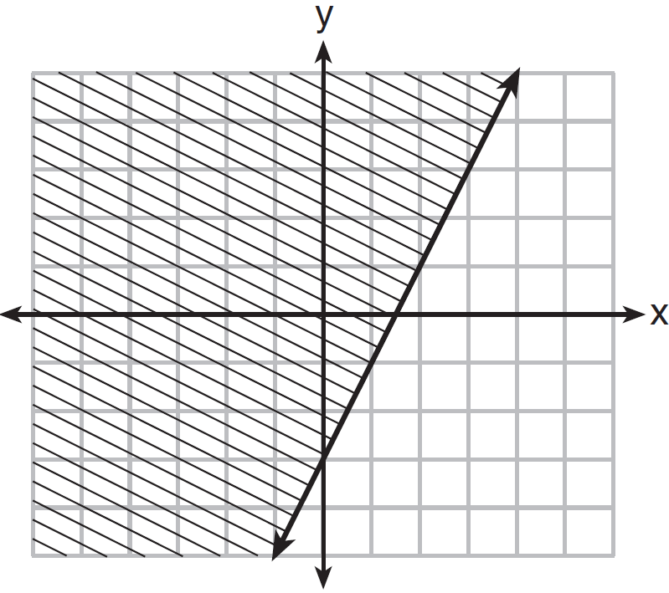
1) |  | 3)
2) |  | 4)

6 Michael borrows money from his uncle, who is charging him simple interest using the formula . To figure out what the interest rate, r, is, Michael rearranges the formula to find r. His new formula is r equals
1) | 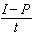 | 3)
2) | 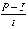 | 4)

7 Which equation is equivalent to ?
1) |  | 3)
2) |  | 4)

8 The equation is being used to calculate the amount of money in a savings account. What does 1.02 represent in this equation?
1) | 0.02% decay | 3) | 2% decay
2) | 0.02% growth | 4) | 2% growth

9 The zeros of the function are
1) | 3 and | 3) | and 1
2) | 3 and 1 | 4) | and

10 When is subtracted from , the result is
1) |  | 3)
2) |  | 4)

11 Joe has a rectangular patio that measures 10 feet by 12 feet. He wants to increase the area by 50% and plans to increase each dimension by equal lengths, x. Which equation could be used to determine x?
1) |  | 3)
2) |  | 4)

12 When factored completely, is
1) |  | 3)
2) |  | 4)

13 The table below shows the cost of mailing a postcard in different years. During which time interval did the cost increase at the greatest average rate?

Year | 1898 | 1971 | 1985 | 2006 | 2012
Cost (¢) | 1 | 6 | 14 | 24 | 35

1) | 1898-1971 | 3) | 1985-2006
2) | 1971-1985 | 4) | 2006-2012

14 When solving the equation by completing the square, which equation is a step in the process?
1) |  | 3)
2) |  | 4)

15 A construction company uses the function , where p is the number of people working on a project, to model the amount of money it spends to complete a project. A reasonable domain for this function would be
1) | positive integers | 3) | both positive and negative integers
2) | positive real numbers | 4) | both positive and negative real numbers

16 Which function is shown in the table below?
x | f(x)
0 | 1
1 | 3
2 | 9
3 | 27

1) |  | 3)
2) |  | 4)

17 Given the functions 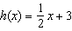 and , which value of x makes ?
1) |  | 3) | 3
2) | 2 | 4)

18 Which recursively defined function represents the sequence ?
1) |  | 3)
2) |  | 4)

19 The range of the function defined as is
1) |  | 3)
2) |  | 4)

20 The graph of is shown below.

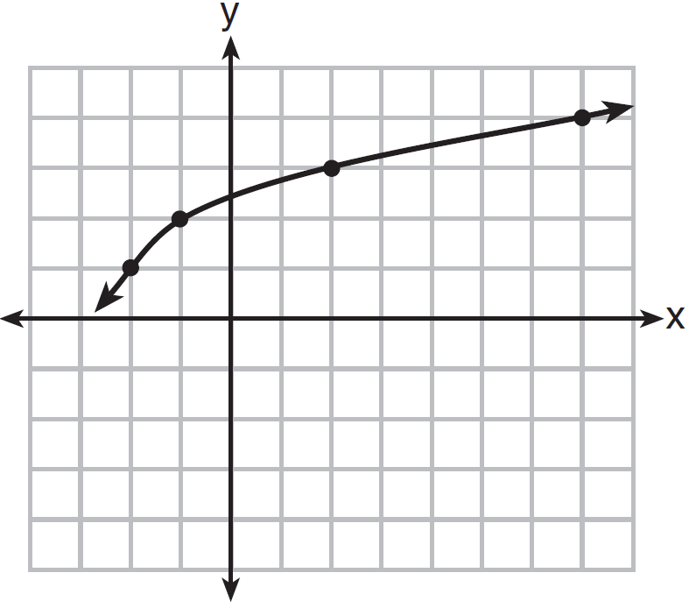

What is the graph of ?
1) | 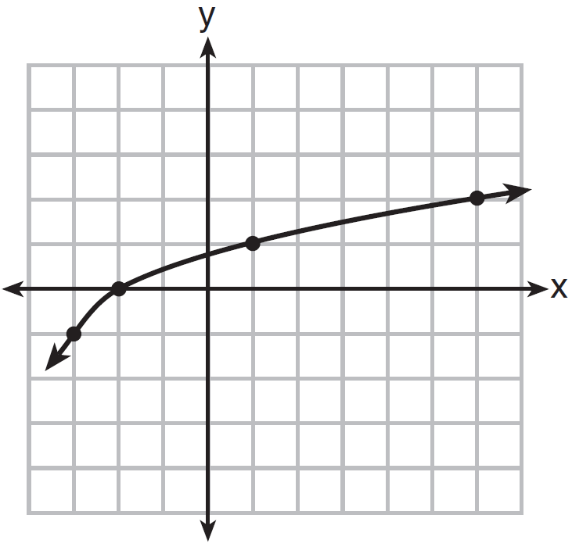 | 3) | 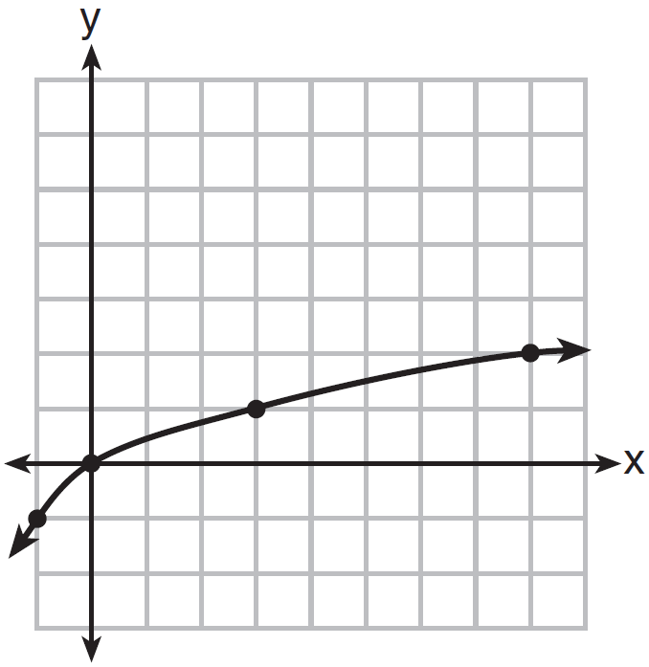
2) | 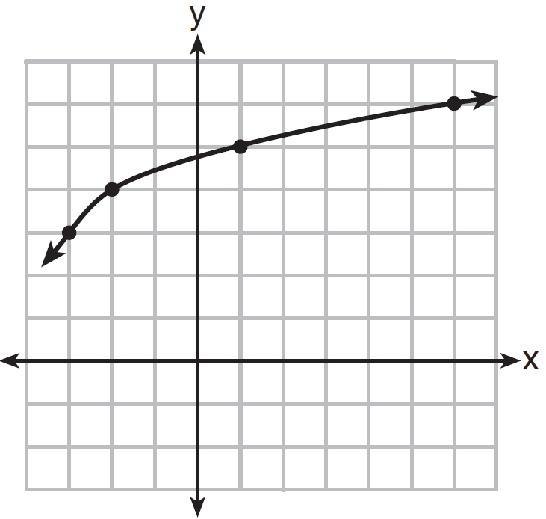 | 4) | 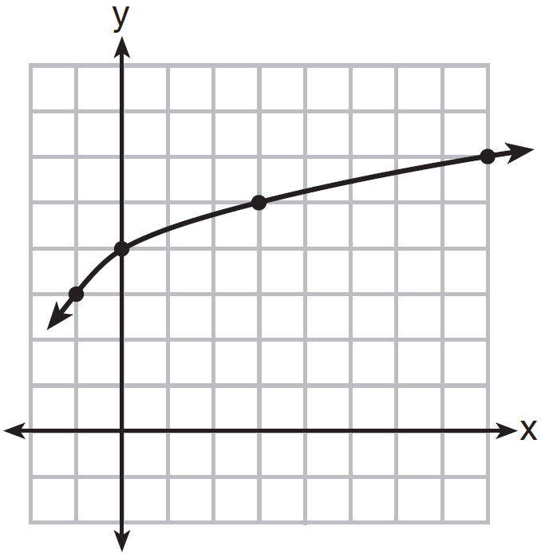

21 Which pair of equations could not be used to solve the following equations for x and y?
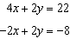
1) | 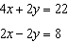 | 3) | 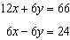
2) | 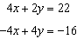 | 4) | 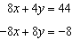

22 The graph representing a function is shown below.

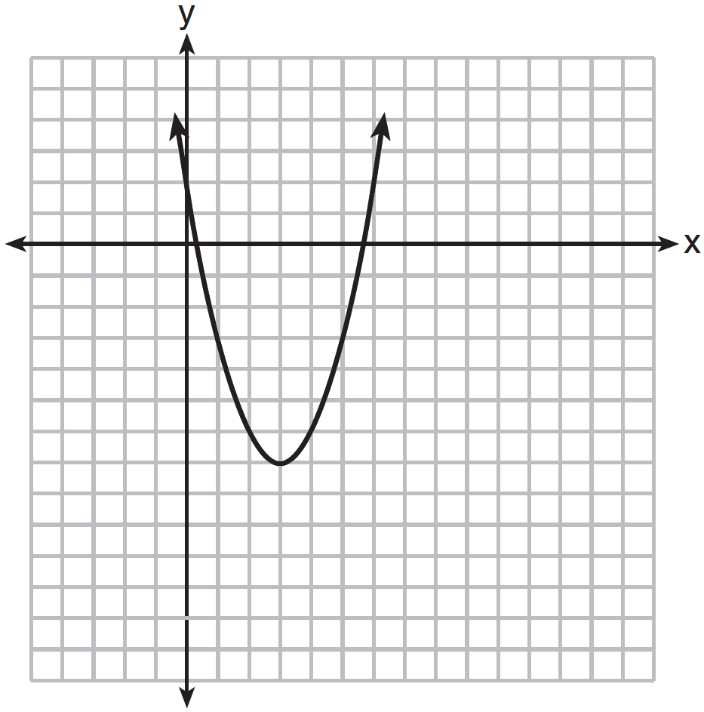

Which function has a minimum that is less than the one shown in the graph?
1) |  | 3)
2) |  | 4)

23 Grisham is considering the three situations below.
I. For the first 28 days, a sunflower grows at a rate of 3.5 cm per day.
II. The value of a car depreciates at a rate of 15% per year after it is purchased.
III. The amount of bacteria in a culture triples every two days during an experiment.
Which of the statements describes a situation with an equal difference over an equal interval?
1) | I, only | 3) | I and III
2) | II, only | 4) | II and III

24 After performing analyses on a set of data, Jackie examined the scatter plot of the residual values for each analysis. Which scatter plot indicates the best linear fit for the data?
1) | 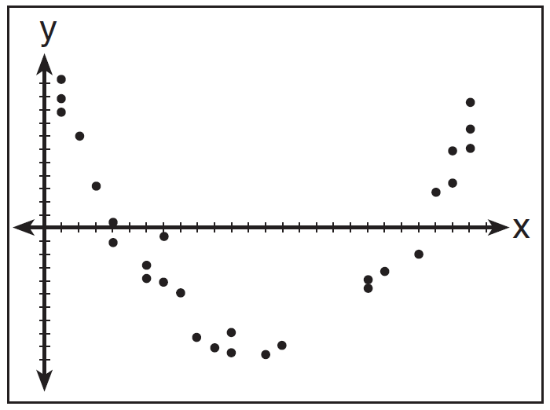 | 3) | 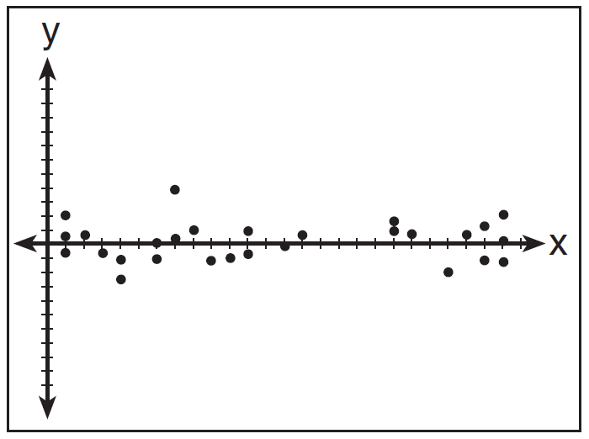
2) | 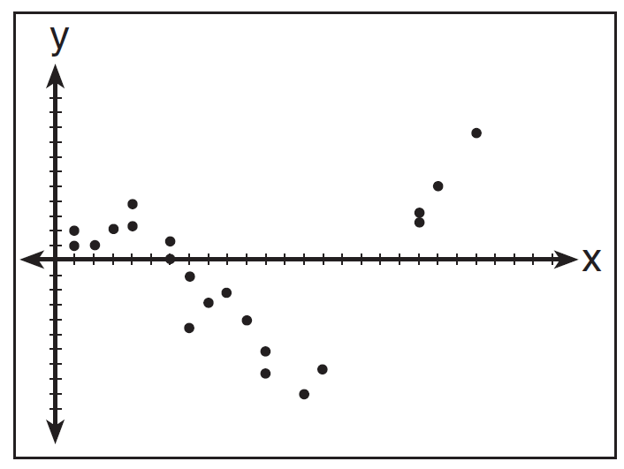 | 4) | 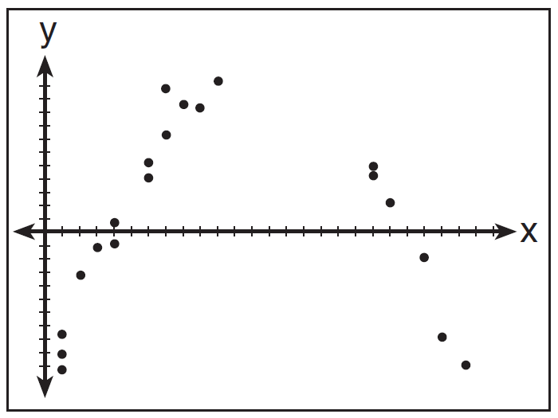

25 The function, , is shown in the table below.

x | t(x)
 | 10
 | 7.5
1 | 5
3 | 2.5
5 | 0

Determine whether is linear or exponential. Explain your answer.

26 Marcel claims that the graph below represents a function.

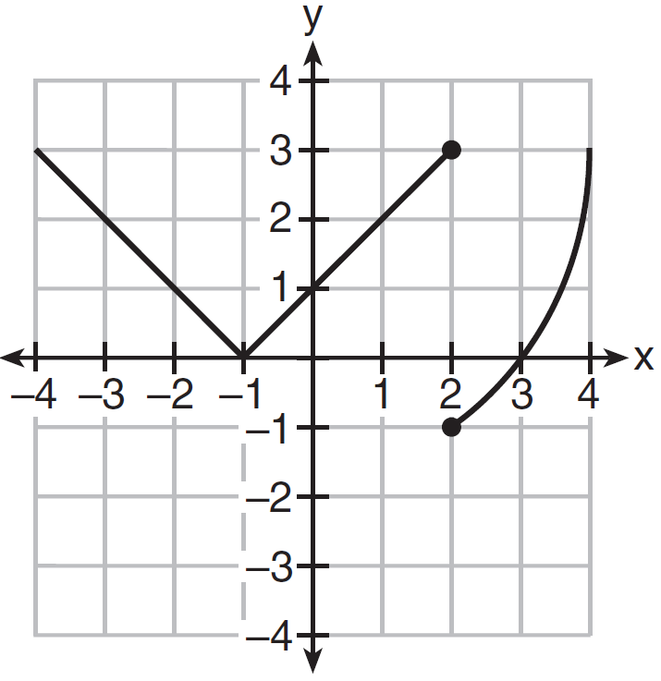

State whether Marcel is correct. Justify your answer.

27 Solve the equation for y:

28 The graph below shows the variation in the average temperature of Earth's surface from 1950-2000, according to one source.

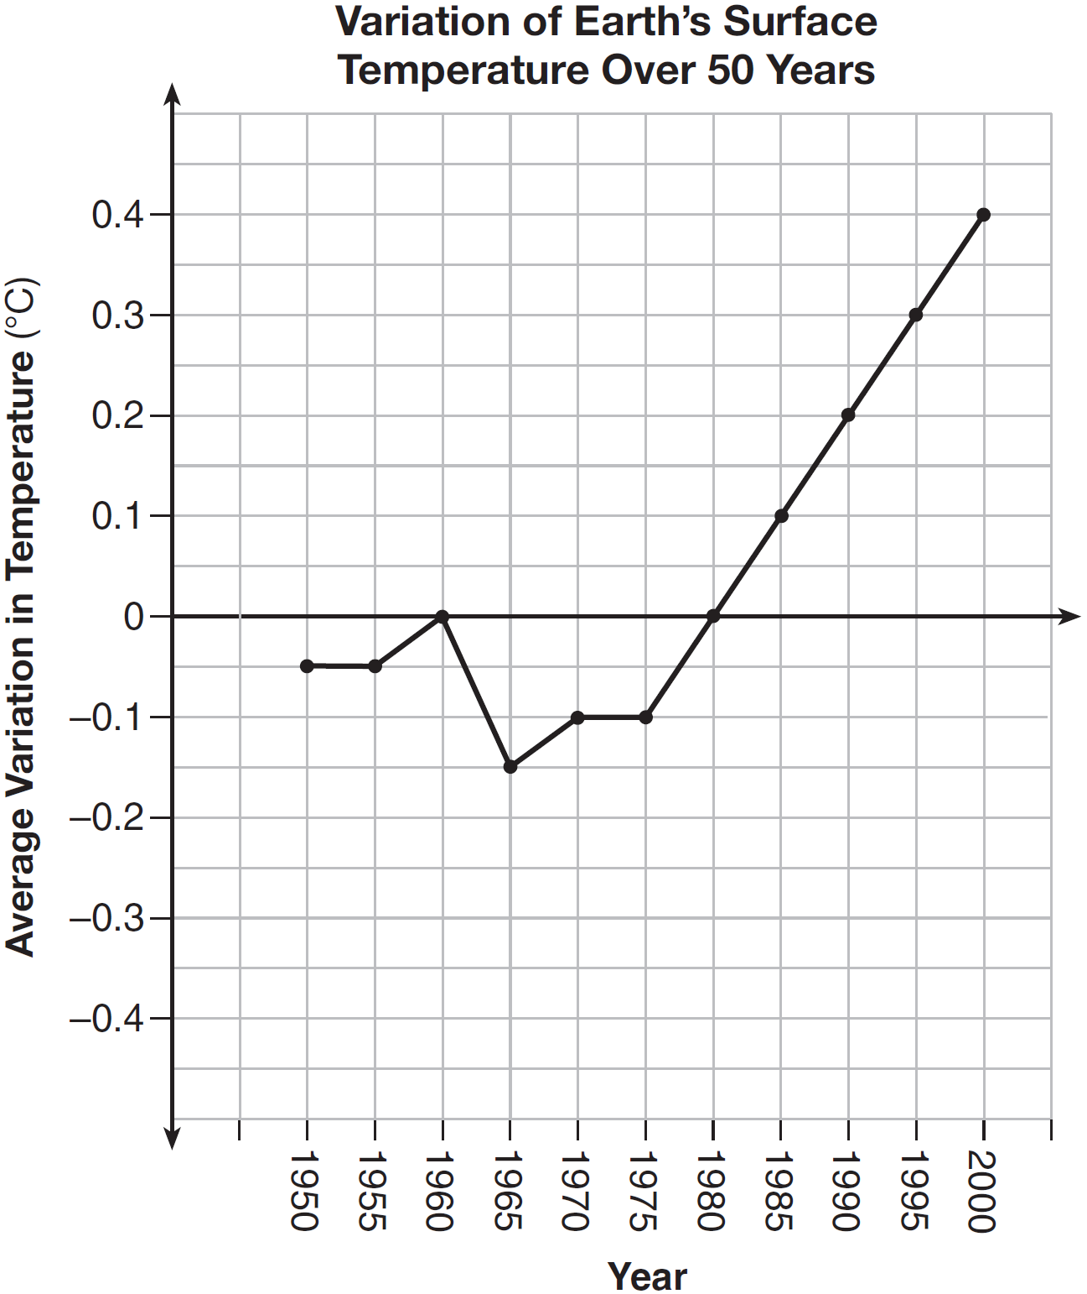

During which years did the temperature variation change the most per unit time? Explain how you determined your answer.

29 The cost of belonging to a gym can be modeled by , where is the total cost for m months of membership. State the meaning of the slope and y-intercept of this function with respect to the costs associated with the gym membership.

30 A statistics class surveyed some students during one lunch period to obtain opinions about television programming preferences. The results of the survey are summarized in the table below.

Programming Preferences
 | Comedy | Drama
Male | 70 | 35
Female | 48 | 42

Based on the sample, predict how many of the school's 351 males would prefer comedy. Justify your answer.

31 Given that , solve for x in terms of a and b:

32 Jacob and Jessica are studying the spread of dandelions. Jacob discovers that the growth over t weeks can be defined by the function . Jessica finds that the growth function over t weeks is . Calculate the number of dandelions that Jacob and Jessica will each have after 5 weeks. Based on the growth from both functions, explain the relationship between and .

33 Let represent the height of an object above the ground after t seconds. Determine the number of seconds it takes to achieve its maximum height. Justify your answer. State the time interval, in seconds, during which the height of the object decreases. Explain your reasoning.

34 Fred's teacher gave the class the quadratic function .
a) State two different methods Fred could use to solve the equation .
b) Using one of the methods stated in part a, solve for x, to the nearest tenth.

35 Erica, the manager at Stellarbeans, collected data on the daily high temperature and revenue from coffee sales. Data from nine days this past fall are shown in the table below.

 | Day  1 | Day  2 | Day  3 | Day  4 | Day  5 | Day  6 | Day  7 | Day  8 | Day  9
High  Temperature, t | 54 | 50 | 62 | 67 | 70 | 58 | 52 | 46 | 48
Coffee Sales, f(t) | $2900 | $3080 | $2500 | $2380 | $2200 | $2700 | $3000 | $3620 | $3720

State the linear regression function, , that estimates the day's coffee sales with a high temperature of t. Round all values to the nearest integer. State the correlation coefficient, r, of the data to the nearest hundredth. Does r indicate a strong linear relationship between the variables? Explain your reasoning.

36 A contractor has 48 meters of fencing that he is going to use as the perimeter of a rectangular garden. The length of one side of the garden is represented by x, and the area of the garden is 108 square meters. Determine, algebraically, the dimensions of the garden in meters.

37 The Reel Good Cinema is conducting a mathematical study. In its theater, there are 200 seats. Adult tickets cost $12.50 and child tickets cost $6.25. The cinema's goal is to sell at least $1500 worth of tickets for the theater. Write a system of linear inequalities that can be used to find the possible combinations of adult tickets, x, and child tickets, y, that would satisfy the cinema's goal. Graph the solution to this system of inequalities on the set of axes below. Label the solution with an S. Marta claims that selling 30 adult tickets and 80 child tickets will result in meeting the cinema's goal. Explain whether she is correct or incorrect, based on the graph drawn.

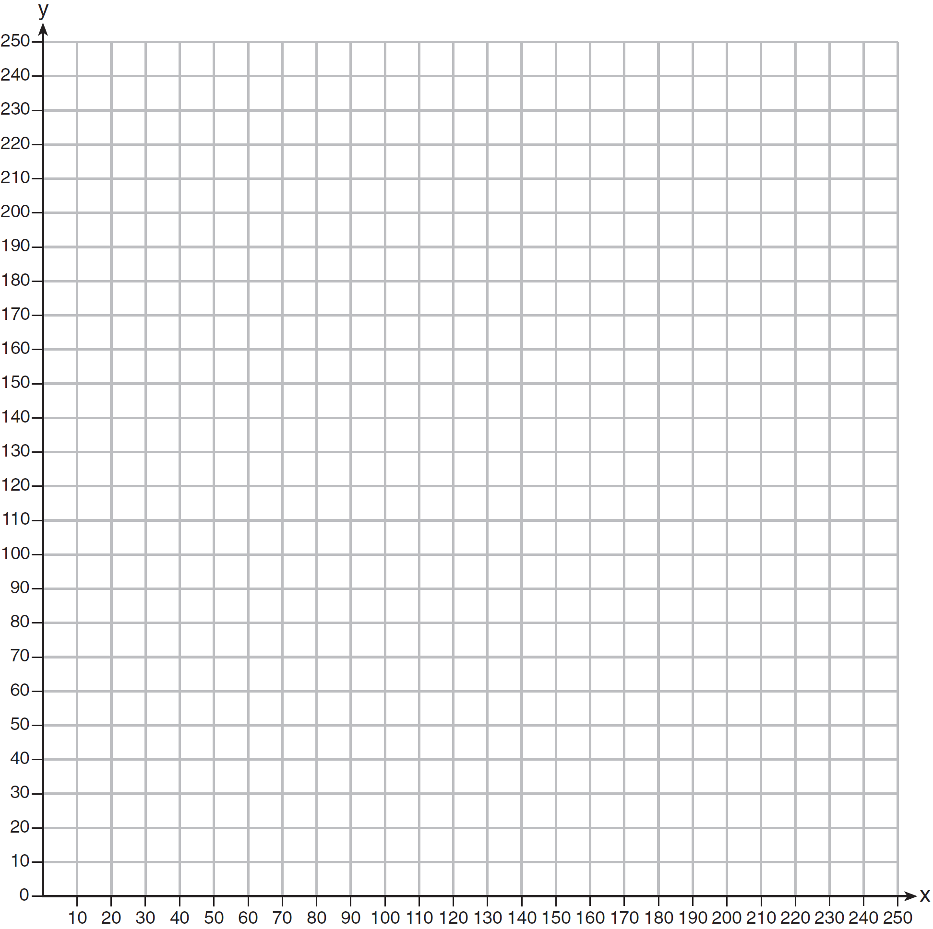

1 ANS: 2 PTS: 2 REF: 011601ai NAT: F.IF.C.8
TOP: Vertex Form of a Quadratic

2 ANS: 2 PTS: 2 REF: 011602ai NAT: A.CED.A.2
TOP: Graphing Linear Functions

3 ANS: 3

PTS: 2 REF: 011603ai NAT: F.IF.A.2 TOP: Evaluating Functions

4 ANS: 1
I. 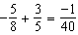; III. 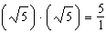; IV. 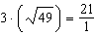

PTS: 2 REF: 011604ai NAT: N.RN.B.3 TOP: Operations with Radicals
KEY: classify

5 ANS: 2 PTS: 2 REF: 011605ai NAT: A.REI.D.12
TOP: Graphing Linear Inequalities

6 ANS: 3 PTS: 2 REF: 011606ai NAT: A.CED.A.4
TOP: Transforming Formulas

7 ANS: 4
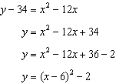

PTS: 2 REF: 011607ai NAT: F.IF.C.8 TOP: Vertex Form of a Quadratic

8 ANS: 4 PTS: 2 REF: 011608ai NAT: F.LE.B.5
TOP: Modeling Exponential Functions

9 ANS: 1
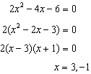

PTS: 2 REF: 011609ai NAT: A.APR.B.3 TOP: Zeros of Polynomials

10 ANS: 3

PTS: 2 REF: 011610ai NAT: A.APR.A.1 TOP: Operations with Polynomials
KEY: multiplication

11 ANS: 2 PTS: 2 REF: 011611ai NAT: A.CED.A.1
TOP: Geometric Applications of Quadratics

12 ANS: 3 PTS: 2 REF: 011612ai NAT: A.SSE.A.2
TOP: Factoring Polynomials KEY: higher power

13 ANS: 4
(1) 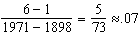 (2) 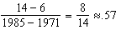 (3) 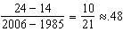 (4) 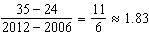

PTS: 2 REF: 011613ai NAT: F.IF.B.6 TOP: Rate of Change

14 ANS: 2
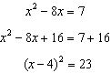

PTS: 2 REF: 011614ai NAT: A.REI.B.4 TOP: Solving Quadratics
KEY: completing the square

15 ANS: 1 PTS: 2 REF: 011615ai NAT: F.IF.B.5
TOP: Domain and Range

16 ANS: 4 PTS: 2 REF: 011616ai NAT: F.LE.A.2
TOP: Families of Functions

17 ANS: 1
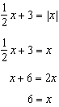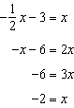

PTS: 2 REF: 011617ai NAT: A.REI.D.11 TOP: Other Systems

18 ANS: 3 PTS: 2 REF: 011618ai NAT: F.LE.A.2
TOP: Sequences KEY: recursive

19 ANS: 2 PTS: 2 REF: 011619ai NAT: F.IF.A.2
TOP: Domain and Range KEY: real domain, exponential

20 ANS: 1 PTS: 2 REF: 011620ai NAT: F.BF.B.3
TOP: Transformations with Functions KEY: bimodalgraph

21 ANS: 4 PTS: 2 REF: 011621ai NAT: A.REI.C.6
TOP: Solving Linear Systems

22 ANS: 3 PTS: 2 REF: 011622ai NAT: F.IF.C.9
TOP: Comparing Functions

23 ANS: 1 PTS: 2 REF: 011623ai NAT: F.LE.A.1
TOP: Families of Functions

24 ANS: 3
For a residual plot, there should be no observable pattern and a similar distribution of residuals above and below the x-axis.

PTS: 2 REF: 011624ai NAT: S.ID.B.6 TOP: Residuals

25 ANS:
Linear, because the function has a constant rate of change.

PTS: 2 REF: 011625ai NAT: F.LE.A.1 TOP: Families of Functions

26 ANS:
No, because the relation does not pass the vertical line test.

PTS: 2 REF: 011626ai NAT: F.IF.A.1 TOP: Defining Functions
KEY: graphs

27 ANS:
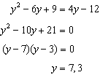

PTS: 2 REF: 011627ai NAT: A.REI.B.4 TOP: Solving Quadratics
KEY: factoring

28 ANS:
During 1960-1965 the graph has the steepest slope.

PTS: 2 REF: 011628ai NAT: F.IF.B.6 TOP: Rate of Change

29 ANS:
The slope represents the amount paid each month and the y-intercept represents the initial cost of membership.

PTS: 2 REF: 011629ai NAT: F.LE.B.5 TOP: Modeling Linear Functions

30 ANS:
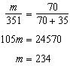

PTS: 2 REF: 011630ai NAT: S.ID.B.5 TOP: Frequency Tables
KEY: two-way

31 ANS:
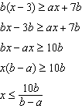

PTS: 2 REF: 011631ai NAT: A.REI.B.3 TOP: Solving Linear Inequalities

32 ANS:
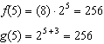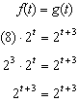

PTS: 2 REF: 011632ai NAT: A.SSE.B.3 TOP: Modeling Exponential Functions

33 ANS:
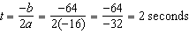. The height decreases after reaching its maximum at until it lands at 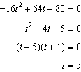

PTS: 4 REF: 011633ai NAT: F.IF.B.4 TOP: Graphing Quadratic Functions
KEY: context

34 ANS:
Two of the following: quadratic formula, complete the square, factor by grouping or graphically.
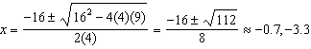

PTS: 4 REF: 011634ai NAT: A.REI.B.4 TOP: Solving Quadratics
KEY: quadratic formula

35 ANS:
This indicates a strong linear relationship because r is close to -1.

PTS: 4 REF: 011635ai NAT: S.ID.B.6 TOP: Regression
KEY: linear with correlation coefficient

36 ANS:
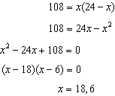

PTS: 4 REF: 011636ai NAT: A.CED.A.1 TOP: Geometric Applications of Quadratics

37 ANS:
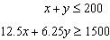 Marta is incorrect because 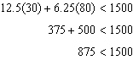
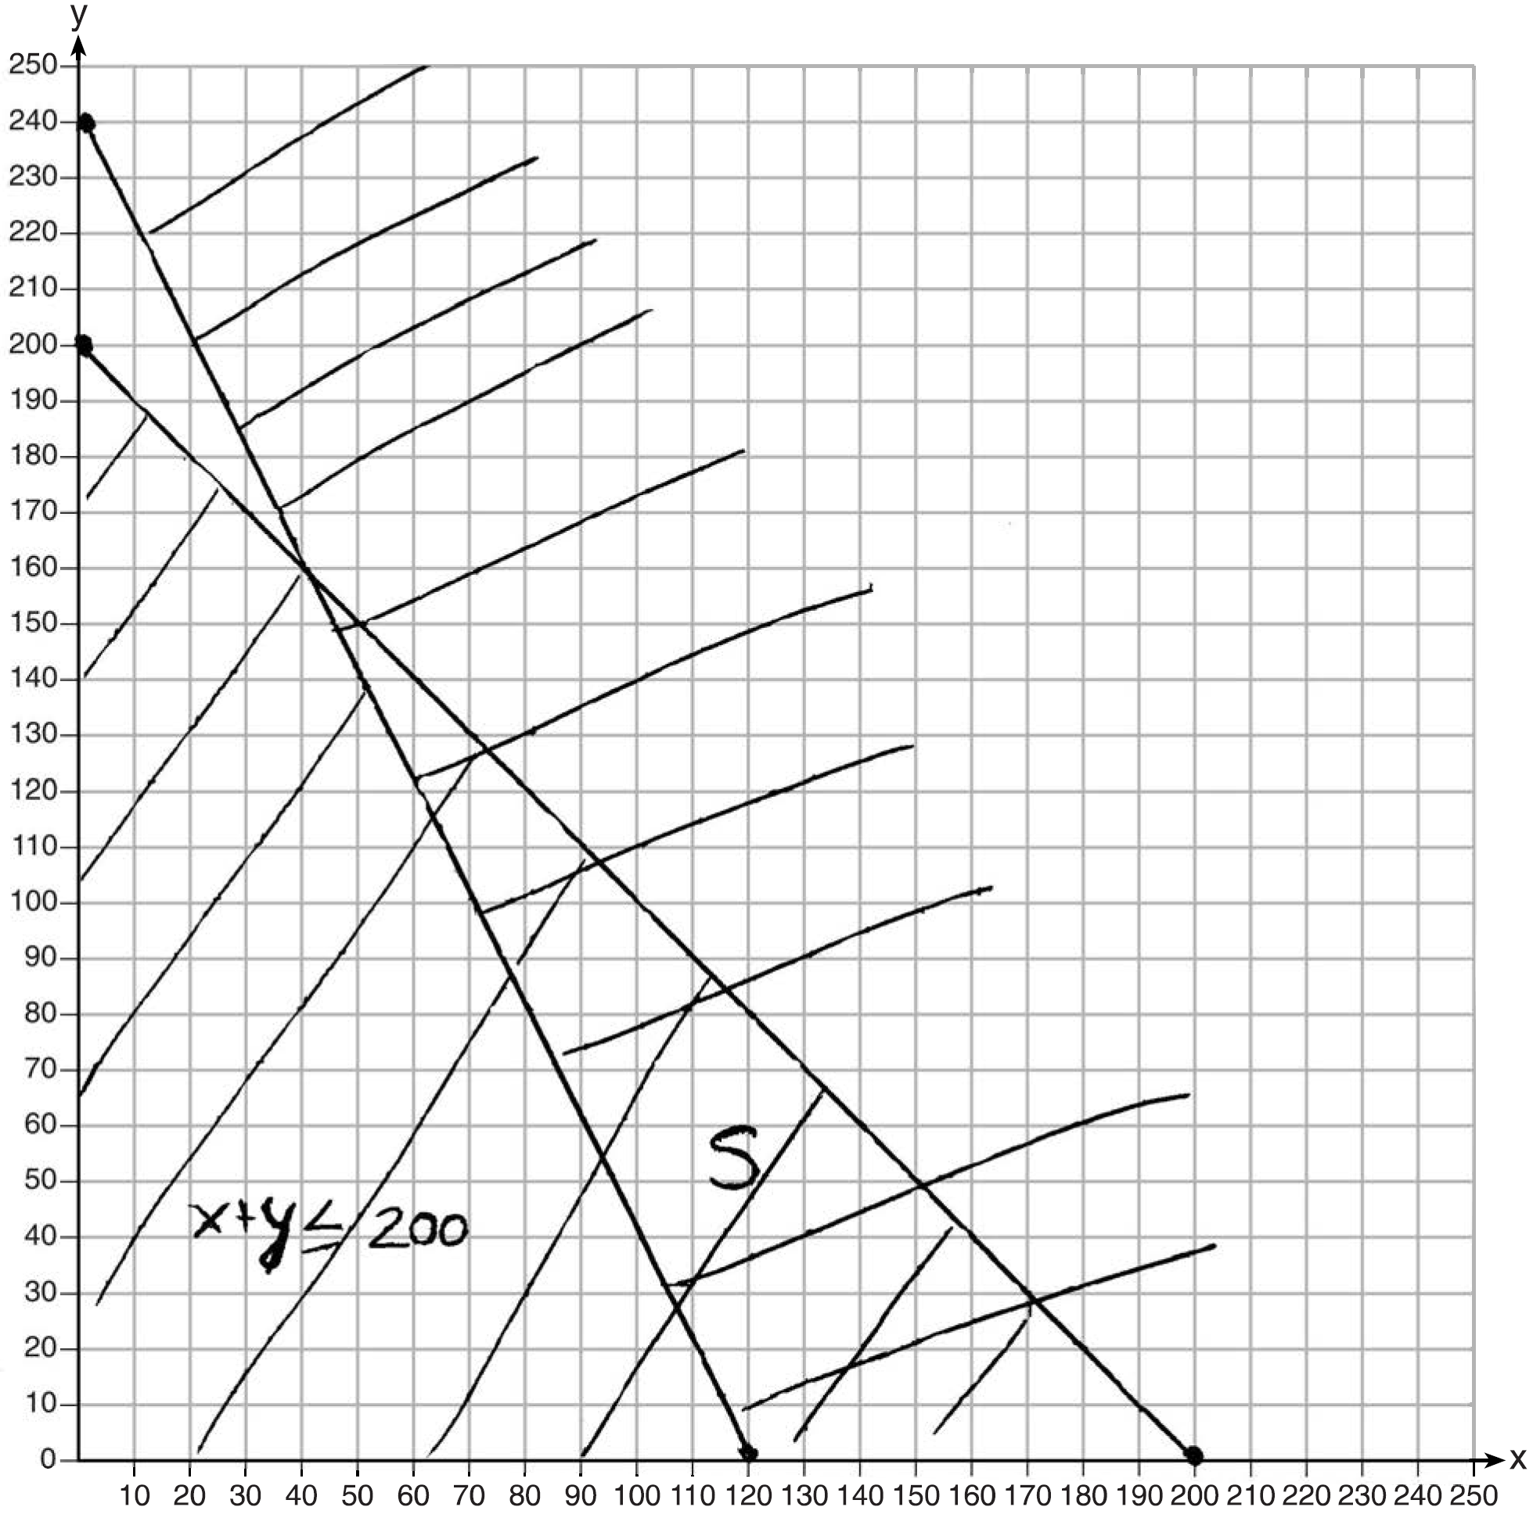

PTS: 6 REF: 011637ai NAT: A.REI.D.12 TOP: Graphing Systems of Linear Inequalities
KEY: graph

