1 The owner of a small computer repair business has one employee, who is paid an hourly rate of $22. The owner estimates his weekly profit using the function . In this function, x represents the number of
1) | computers repaired per week | 3) | customers served per week
2) | hours worked per week | 4) | days worked per week

2 Peyton is a sprinter who can run the 40-yard dash in 4.5 seconds. He converts his speed into miles per hour, as shown below.
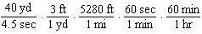
Which ratio is incorrectly written to convert his speed?
1) |  | 3) | 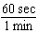
2) | 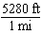 | 4) | 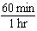

3 Which equation has the same solutions as
1) |  | 3)
2) |  | 4)

4 Krystal was given $3000 when she turned 2 years old. Her parents invested it at a 2% interest rate compounded annually. No deposits or withdrawals were made. Which expression can be used to determine how much money Krystal had in the account when she turned 18?
1) |  | 3)
2) |  | 4)

5 Which table of values represents a linear relationship?
1) | 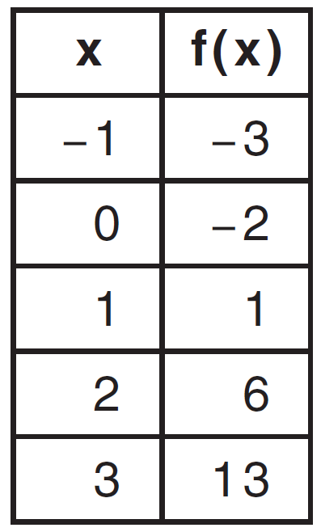 | 3) | 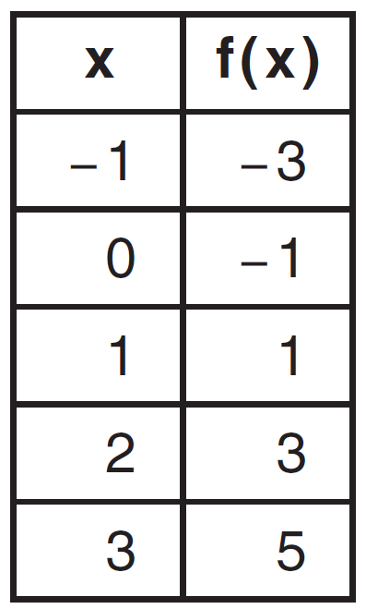
2) | 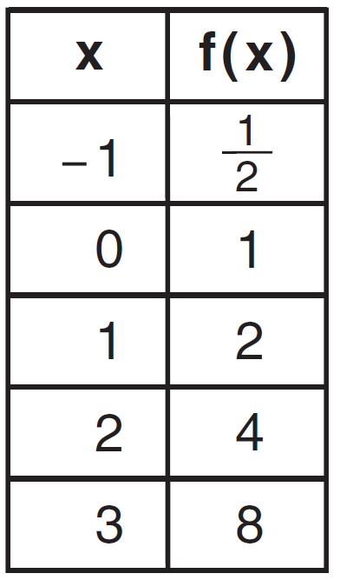 | 4) | 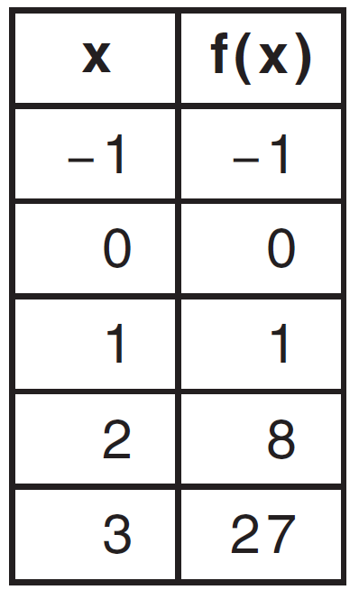

6 Which domain would be the most appropriate set to use for a function that predicts the number of household online-devices in terms of the number of people in the household?
1) | integers | 3) | irrational numbers
2) | whole numbers | 4) | rational numbers

7 The inequality 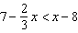 is equivalent to
1) |  | 3)
2) | 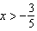 | 4) | 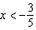

8 The value in dollars, , of a certain car after x years is represented by the equation . To the nearest dollar, how much more is the car worth after 2 years than after 3 years?
1) | 2589 | 3) | 15,901
2) | 6510 | 4) | 18,490

9 Which function has the same y-intercept as the graph below?

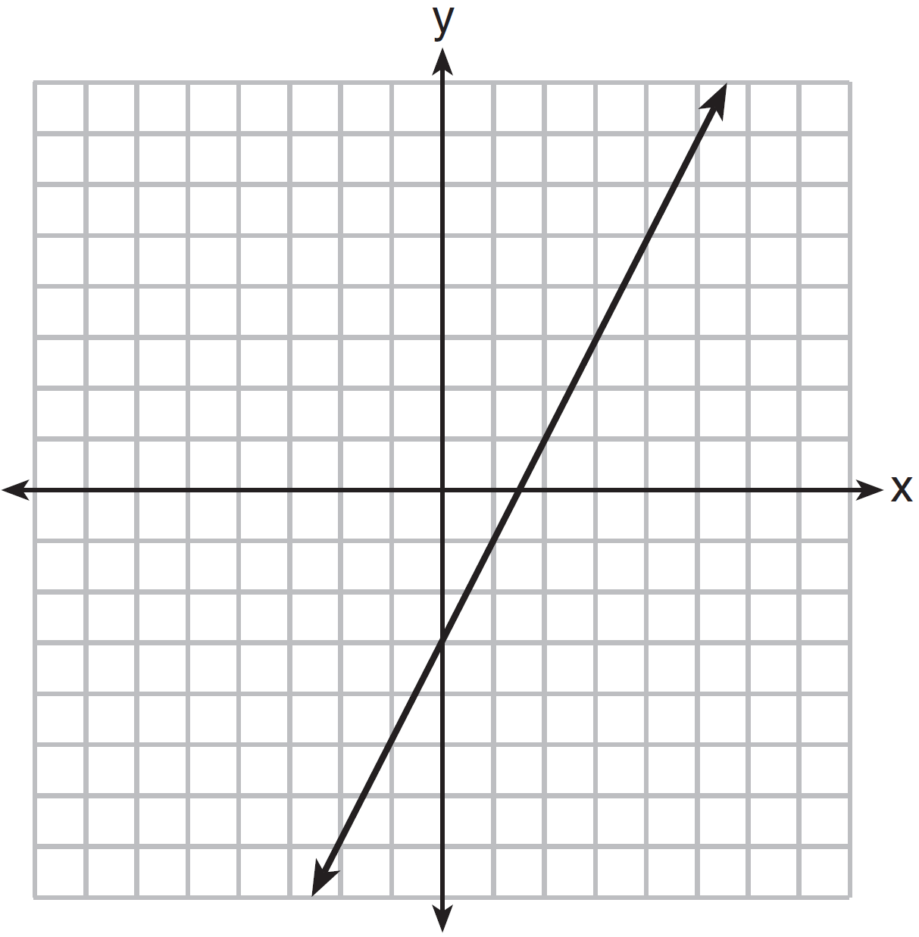
1) | 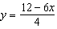 | 3)
2) |  | 4)

10 Fred is given a rectangular piece of paper. If the length of Fred's piece of paper is represented by and the width is represented by , then the paper has a total area represented by
1) |  | 3)
2) |  | 4)

11 The graph of a linear equation contains the points and . Which point also lies on the graph?
1) |  | 3)
2) |  | 4)

12 How does the graph of compare to the graph of ?
1) | The graph of is wider than the graph of , and its vertex is moved to the left 2 units and up 1 unit. | 3) | The graph of is narrower than the graph of , and its vertex is moved to the left 2 units and up 1 unit.
2) | The graph of is narrower than the graph of , and its vertex is moved to the right 2 units and up 1 unit. | 4) | The graph of is wider than the graph of , and its vertex is moved to the right 2 units and up 1 unit.

13 Connor wants to attend the town carnival. The price of admission to the carnival is $4.50, and each ride costs an additional 79 cents. If he can spend at most $16.00 at the carnival, which inequality can be used to solve for r, the number of rides Connor can go on, and what is the maximum number of rides he can go on?
1) | ; 3 rides | 3) | ; 14 rides
2) | ; 4 rides | 4) | ; 15 rides

14 Corinne is planning a beach vacation in July and is analyzing the daily high temperatures for her potential destination. She would like to choose a destination with a high median temperature and a small interquartile range. She constructed box plots shown in the diagram below.
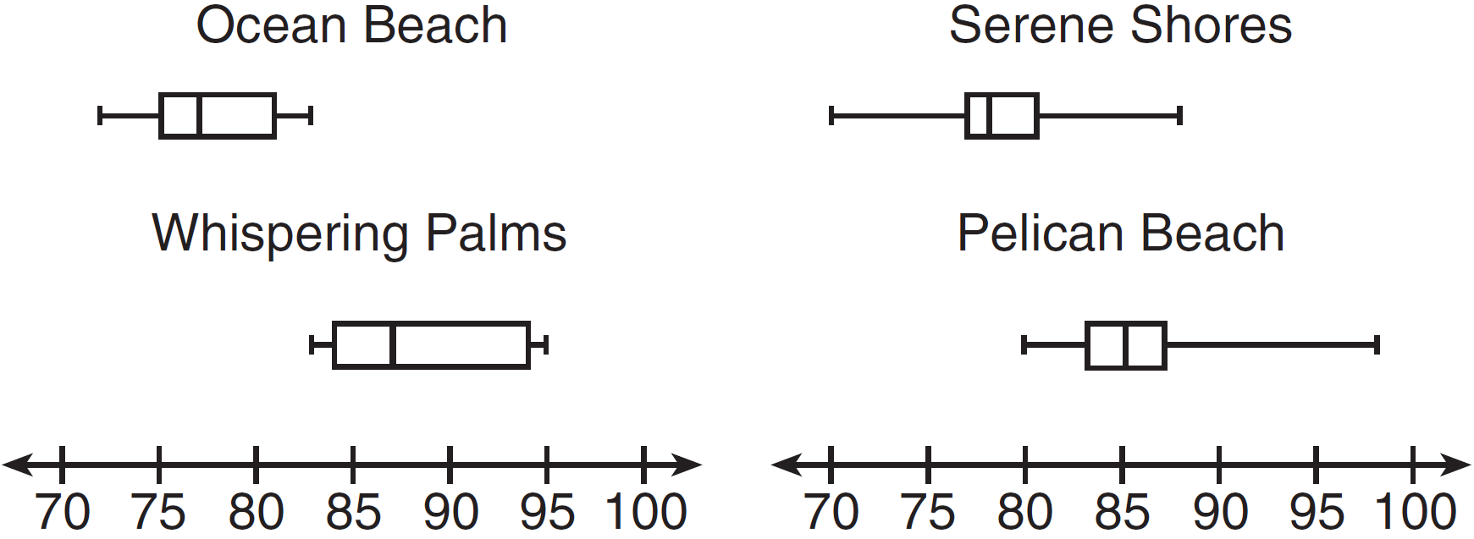
Which destination has a median temperature above 80 degrees and the smallest interquartile range?
1) | Ocean Beach | 3) | Serene Shores
2) | Whispering Palms | 4) | Pelican Beach

15 Some banks charge a fee on savings accounts that are left inactive for an extended period of time. The equation represents the value, y, of one account that was left inactive for a period of x years. What is the y-intercept of this equation and what does it represent?
1) | 0.98, the percent of money in the account initially | 3) | 5000, the amount of money in the account initially
2) | 0.98, the percent of money in the account after x years | 4) | 5000, the amount of money in the account after x years

16 The equation for the volume of a cylinder is . The positive value of r, in terms of h and V, is
1) | 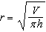 | 3)
2) |  | 4) | 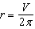

17 Which equation has the same solutions as ?
1) |  | 3)
2) |  | 4)

18 Two functions, and , are graphed on the same set of axes. Which statement is true about the solution to the system of equations?
1) | is the solution to the system because it satisfies the equation . | 3) | is the solution to the system because it satisfies both equations.
2) | is the solution to the system because it satisfies the equation . | 4) | , , and are the solutions to the system of equations because they all satisfy at least one of the equations.

19 Miriam and Jessica are growing bacteria in a laboratory. Miriam uses the growth function while Jessica uses the function , where n represents the initial number of bacteria and t is the time, in hours. If Miriam starts with 16 bacteria, how many bacteria should Jessica start with to achieve the same growth over time?
1) | 32 | 3) | 8
2) | 16 | 4) | 4

20 If a sequence is defined recursively by and for , then is equal to
1) | 1 | 3) | 5
2) |  | 4) | 17

21 An astronaut drops a rock off the edge of a cliff on the Moon. The distance, , in meters, the rock travels after t seconds can be modeled by the function . What is the average speed, in meters per second, of the rock between 5 and 10 seconds after it was dropped?
1) | 12 | 3) | 60
2) | 20 | 4) | 80

22 When factored completely, the expression is equivalent to
1) |  | 3)
2) |  | 4)

23 In 2013, the United States Postal Service charged $0.46 to mail a letter weighing up to 1 oz. and $0.20 per ounce for each additional ounce. Which function would determine the cost, in dollars, , of mailing a letter weighing z ounces where z is an integer greater than 1?
1) |  | 3)
2) |  | 4)

24 A polynomial function contains the factors x, , and . Which graph(s) below could represent the graph of this function?

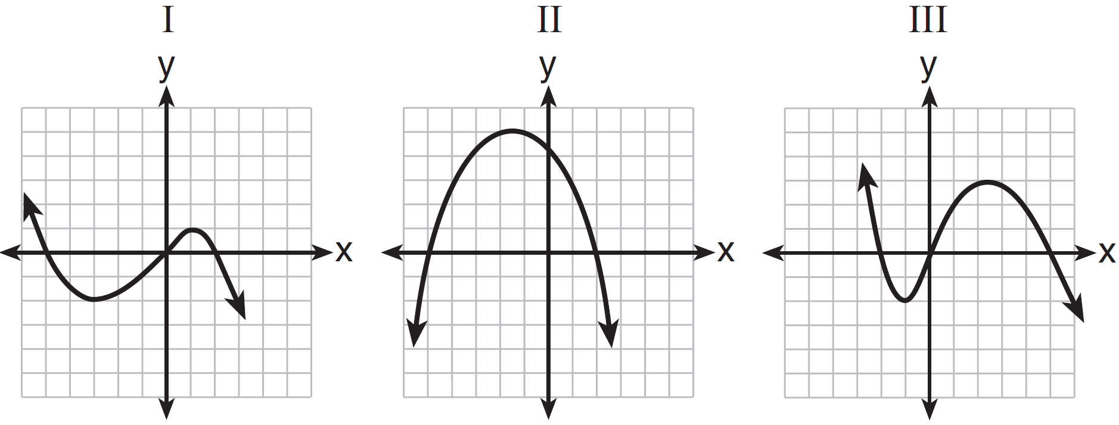
1) | I, only | 3) | I and III
2) | II, only | 4) | I, II, and III

25 Ms. Fox asked her class "Is the sum of 4.2 and rational or irrational?" Patrick answered that the sum would be irrational. State whether Patrick is correct or incorrect. Justify your reasoning.

26 The school newspaper surveyed the student body for an article about club membership. The table below shows the number of students in each grade level who belong to one or more clubs.
 | 1 Club | 2 Clubs | 3 or More Clubs
9th | 90 | 33 | 12
10th | 125 | 12 | 15
11th | 87 | 22 | 18
12th | 75 | 27 | 23

If there are 180 students in ninth grade, what percentage of the ninth grade students belong to more than one club?

27 A function is shown in the table below.

x | f(x)
 | 2
0
3 | 16

If included in the table, which ordered pair, or , would result in a relation that is no longer a function? Explain your answer.

28 Subtract from . Express the result as a trinomial.

29 Solve the equation algebraically for x.

30 Graph the following function on the set of axes below.
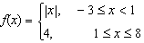
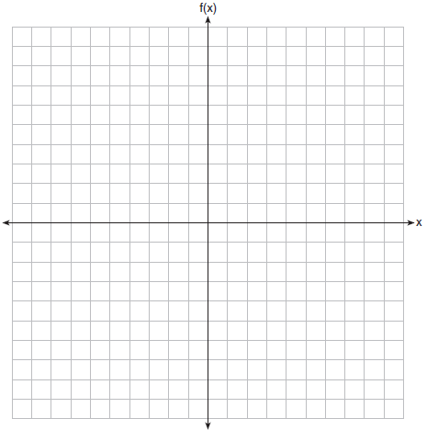

31 A gardener is planting two types of trees:
Type A is three feet tall and grows at a rate of 15 inches per year.
Type B is four feet tall and grows at a rate of 10 inches per year.
Algebraically determine exactly how many years it will take for these trees to be the same height.

32 Write an exponential equation for the graph shown below.
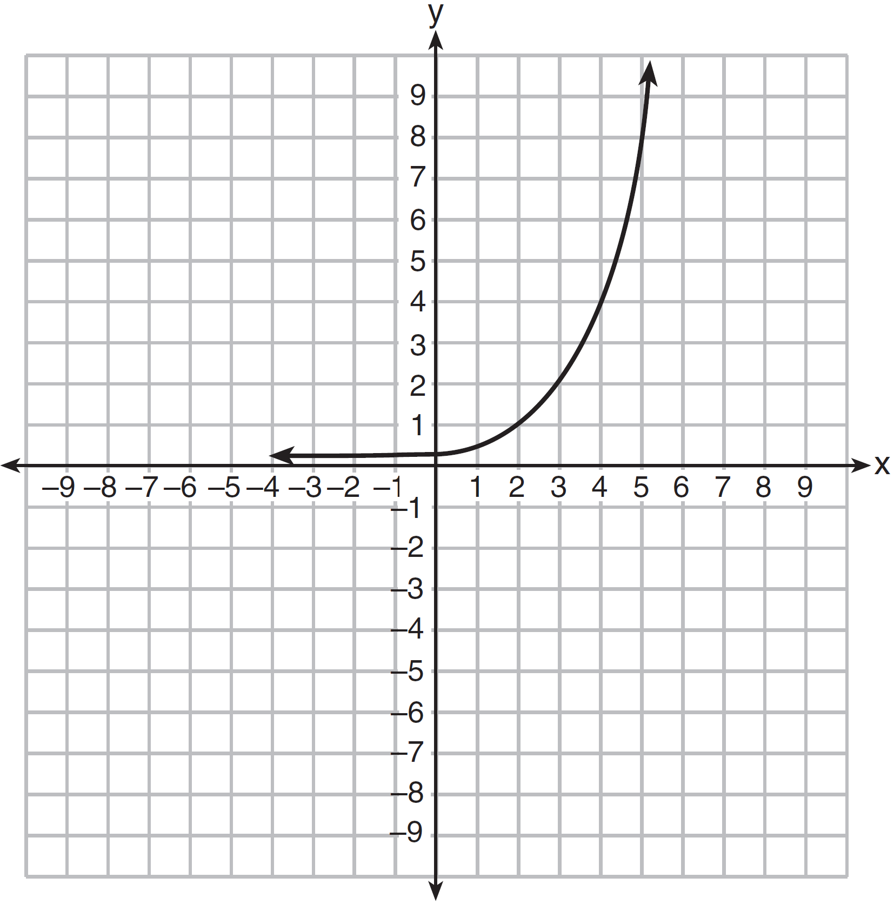

Explain how you determined the equation.

33 Jacob and Zachary go to the movie theater and purchase refreshments for their friends. Jacob spends a total of $18.25 on two bags of popcorn and three drinks. Zachary spends a total of $27.50 for four bags of popcorn and two drinks. Write a system of equations that can be used to find the price of one bag of popcorn and the price of one drink. Using these equations, determine and state the price of a bag of popcorn and the price of a drink, to the nearest cent.

34 The graph of an inequality is shown below.

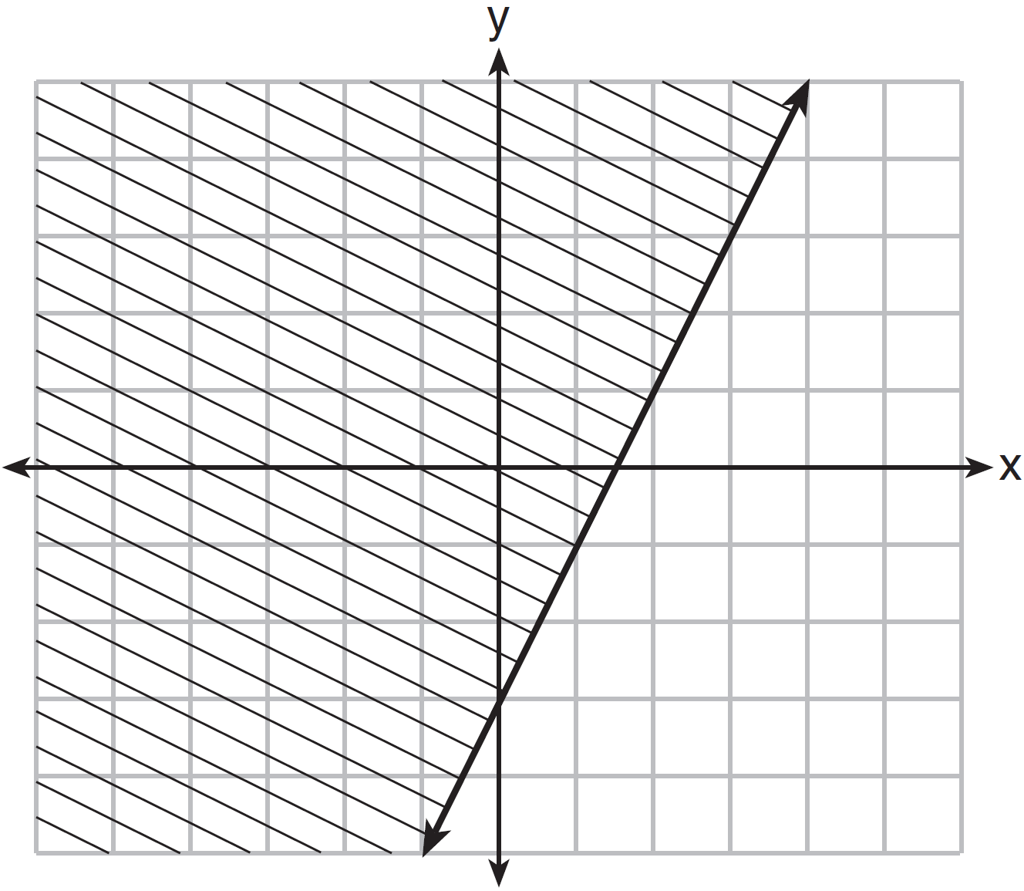

a) Write the inequality represented by the graph.
b) On the same set of axes, graph the inequality .
c) The two inequalities graphed on the set of axes form a system. Oscar thinks that the point is in the solution set for this system of inequalities. Determine and state whether you agree with Oscar. Explain your reasoning.

35 A nutritionist collected information about different brands of beef hot dogs. She made a table showing the number of Calories and the amount of sodium in each hot dog.

Calories per  Beef Hot Dog | Milligrams of Sodium  per Beef Hot Dog
186 | 495
181 | 477
176 | 425
149 | 322
184 | 482
190 | 587
158 | 370
139 | 322

a) Write the correlation coefficient for the line of best fit. Round your answer to the nearest hundredth.
b) Explain what the correlation coefficient suggests in the context of this problem.

36 a) Given the function , state whether the vertex represents a maximum or minimum point for the function. Explain your answer.
b) Rewrite in vertex form by completing the square.

37 New Clarendon Park is undergoing renovations to its gardens. One garden that was originally a square is being adjusted so that one side is doubled in length, while the other side is decreased by three meters. The new rectangular garden will have an area that is 25% more than the original square garden. Write an equation that could be used to determine the length of a side of the original square garden. Explain how your equation models the situation. Determine the area, in square meters, of the new rectangular garden.
1 ANS: 2 PTS: 2 REF: 011501ai NAT: F.LE.B.5
TOP: Modeling Linear Functions

2 ANS: 2 PTS: 2 REF: 011502ai NAT: N.Q.A.1
TOP: Conversions KEY: dimensional analysis

3 ANS: 4 PTS: 2 REF: 011503ai NAT: A.REI.B.4
TOP: Solving Quadratics KEY: factoring

4 ANS: 1 PTS: 2 REF: 011504ai NAT: F.BF.A.1
TOP: Modeling Exponential Functions

5 ANS: 3 PTS: 2 REF: 011505ai NAT: F.LE.A.1
TOP: Families of Functions

6 ANS: 2 PTS: 2 REF: 011506ai NAT: F.IF.B.5
TOP: Domain and Range

7 ANS: 1
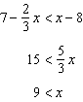

PTS: 2 REF: 011507ai NAT: A.REI.B.3 TOP: Solving Linear Inequalities

8 ANS: 1

PTS: 2 REF: 011508ai NAT: F.IF.A.2 TOP: Functional Notation

9 ANS: 4
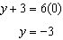

PTS: 2 REF: 011509ai NAT: F.IF.B.4 TOP: Graphing Linear Functions

10 ANS: 2 PTS: 2 REF: 011510ai NAT: A.APR.A.1
TOP: Operations with Polynomials KEY: multiplication

11 ANS: 4
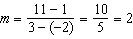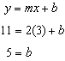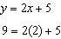

PTS: 2 REF: 011511ai NAT: A.REI.D.10 TOP: Writing Linear Equations
KEY: other forms

12 ANS: 2 PTS: 2 REF: 011512ai NAT: F.BF.B.3
TOP: Graphing Polynomial Functions

13 ANS: 3 PTS: 2 REF: 011513ai NAT: A.CED.A.1
TOP: Modeling Linear Inequalities

14 ANS: 4 PTS: 2 REF: 011514ai NAT: S.ID.A.2
TOP: Central Tendency and Dispersion

15 ANS: 3 PTS: 2 REF: 011515ai NAT: F.LE.B.5
TOP: Modeling Exponential Functions

16 ANS: 1 PTS: 2 REF: 011516ai NAT: A.CED.A.4
TOP: Transforming Formulas

17 ANS: 4
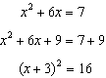

PTS: 2 REF: 011517ai NAT: A.REI.B.4 TOP: Solving Quadratics
KEY: completing the square

18 ANS: 3 PTS: 2 REF: 011518ai NAT: A.REI.D.11
TOP: Other Systems

19 ANS: 4
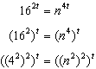

PTS: 2 REF: 011519ai NAT: A.SSE.B.3 TOP: Modeling Exponential Functions

20 ANS: 3
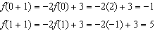

PTS: 2 REF: 011520ai NAT: F.IF.A.3 TOP: Sequences
KEY: recursive

21 ANS: 1
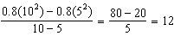

PTS: 2 REF: 011521ai NAT: F.IF.B.6 TOP: Rate of Change

22 ANS: 3 PTS: 2 REF: 011522ai NAT: A.SSE.A.2
TOP: Factoring the Difference of Perfect Squares KEY: higher power

23 ANS: 4 PTS: 2 REF: 011523ai NAT: F.BF.A.1
TOP: Modeling Linear Functions

24 ANS: 1 PTS: 2 REF: 011524ai NAT: A.APR.B.3
TOP: Graphing Polynomial Functions

25 ANS:
Correct. The sum of a rational and irrational is irrational.

PTS: 2 REF: 011525ai NAT: N.RN.B.3 TOP: Operations with Radicals
KEY: classify

26 ANS:
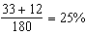

PTS: 2 REF: 011526ai NAT: S.ID.B.5 TOP: Frequency Tables
KEY: two-way

27 ANS:
, because then every element of the domain is not assigned one unique element in the range.

PTS: 2 REF: 011527ai NAT: F.IF.A.1 TOP: Defining Functions
KEY: ordered pairs

28 ANS:

PTS: 2 REF: 011528ai NAT: A.APR.A.1 TOP: Operations with Polynomials
KEY: subtraction

29 ANS:
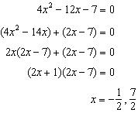

PTS: 2 REF: 011529ai NAT: A.REI.B.4 TOP: Solving Quadratics
KEY: factoring

30 ANS:
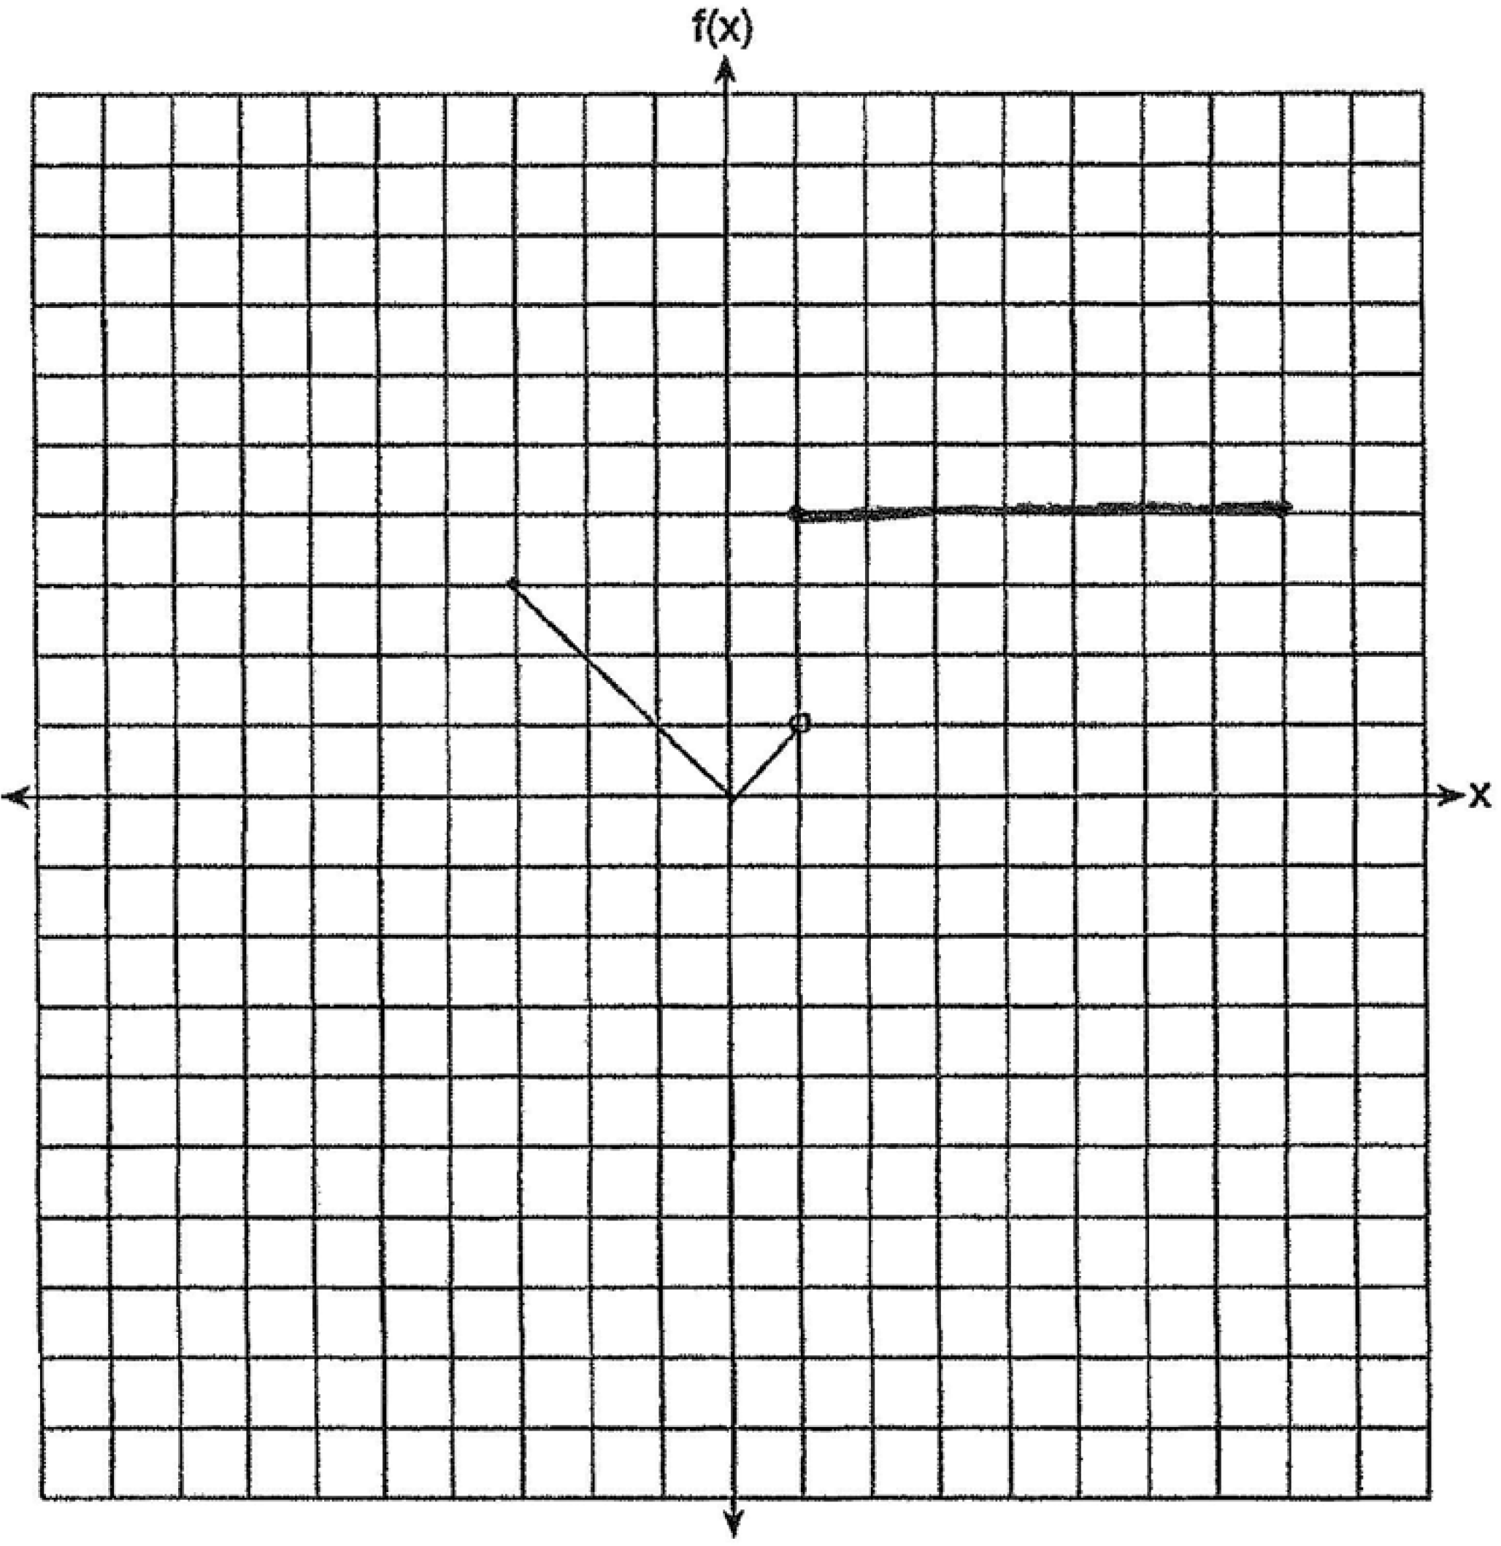

PTS: 2 REF: 011530ai NAT: F.IF.C.7 TOP: Graphing Piecewise-Defined Functions

31 ANS:
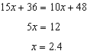

PTS: 2 REF: 011531ai NAT: A.CED.A.1 TOP: Modeling Linear Equations

32 ANS:
. I inputted the four integral values from the graph into my graphing calculator and determined the exponential regression equation.

PTS: 2 REF: 011532ai NAT: F.LE.A.2 TOP: Modeling Exponential Functions

33 ANS:
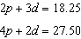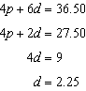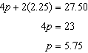

PTS: 4 REF: 011533ai NAT: A.CED.A.3 TOP: Modeling Linear Systems

34 ANS:
. 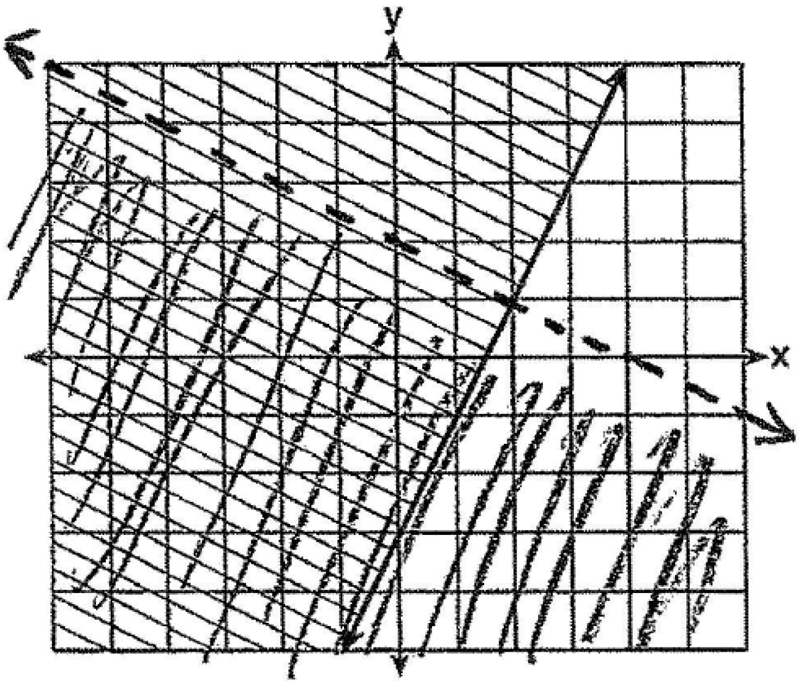 Oscar is wrong. is not true.

PTS: 4 REF: 011534ai NAT: A.REI.D.12 TOP: Graphing Systems of Linear Inequalities
KEY: graph

35 ANS:
. The correlation coefficient suggests that as calories increase, so does sodium.

PTS: 4 REF: 011535ai NAT: S.ID.C.8 TOP: Correlation Coefficient

36 ANS:
The vertex represents a maximum since . 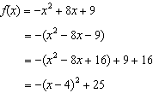

PTS: 4 REF: 011536ai NAT: F.IF.C.8 TOP: Vertex Form of a Quadratic

37 ANS:
Because the original garden is a square, represents the original area, represents the side decreased by 3 meters, represents the doubled side, and represents the new garden with an area 25% larger. 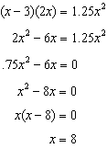

PTS: 6 REF: 011537ai NAT: A.CED.A.1 TOP: Geometric Applications of Quadratics

