1 The expression is equivalent to
1)
2)
3)
4)

2 If 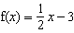 and , what is the value of ?
1)
2) | 3.5
3) | 3
4) | 6

3 What are the values of in the interval that satisfy the equation ?
1) | 60º, 240º
2) | 72º, 252º
3) | 72º, 108º, 252º, 288º
4) | 60º, 120º, 240º, 300º

4 A survey completed at a large university asked 2,000 students to estimate the average number of hours they spend studying each week. Every tenth student entering the library was surveyed. The data showed that the mean number of hours that students spend studying was 15.7 per week. Which characteristic of the survey could create a bias in the results?
1) | the size of the sample
2) | the size of the population
3) | the method of analyzing the data
4) | the method of choosing the students who were surveyed

5 Which graph represents the solution set of ?
1) | 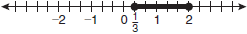
2) | 
3) | 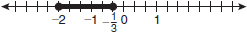
4) | 

6 Which function is not one-to-one?
1)
2)
3)
4)

7 In , , , and . What is the area of to the nearest square inch?
1) | 52
2) | 78
3) | 90
4) | 156

8 Which graph does not represent a function?
1) | 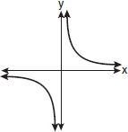
2) | 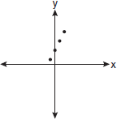
3) | 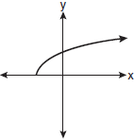
4) | 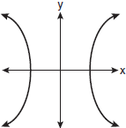

9 The expression is equivalent to
1) | 8
2) | 2
3)
4)

10 The expression is equivalent to
1)
2)
3)
4)

11 The value of the expression 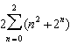 is
1) | 12
2) | 22
3) | 24
4) | 26

12 For which equation does the sum of the roots equal and the product of the roots equal ?
1)
2)
3)
4)

13 Which graph represents the equation ?
1) | 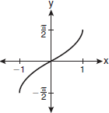
2) | 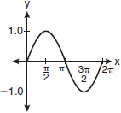
3) | 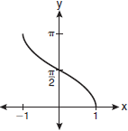
4) | 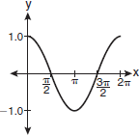

14 The expression 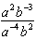 is equivalent to
1)
2)
3)
4)

15 The lengths of 100 pipes have a normal distribution with a mean of 102.4 inches and a standard deviation of 0.2 inch. If one of the pipes measures exactly 102.1 inches, its length lies
1) | below the 16th percentile
2) | between the 50th and 84th percentiles
3) | between the 16th and 50th percentiles
4) | above the 84th percentile

16 If a function is defined by the equation , which graph represents the inverse of this function?
1) | 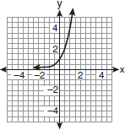
2) | 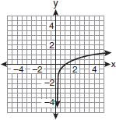
3) | 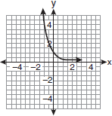
4) | 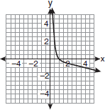

17 Factored completely, the expression is equivalent to
1)
2)
3)
4)

18 The expression is equivalent to
1)
2)
3)
4)

19 What is the fourth term in the expansion of ?
1)
2)
3)
4)

20 Written in simplest form, the expression 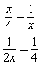 is equivalent to
1)
2)
3) | 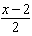
4) | 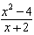

21 What is the solution of the equation ?
1) | 6.4
2) | 2.56
3)
4)

22 A circle has a radius of 4 inches. In inches, what is the length of the arc intercepted by a central angle of 2 radians?
1)
2) | 2
3)
4) | 8

23 What is the domain of the function ?
1)
2)
3)
4)

24 The table below shows the first-quarter averages for Mr. Harper’s statistics class.

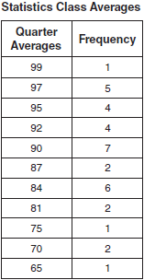

What is the population variance for this set of data?
1) | 8.2
2) | 8.3
3) | 67.3
4) | 69.3

25 Which formula can be used to determine the total number of different eight-letter arrangements that can be formed using the letters in the word DEADLINE?
1)
2)
3) | 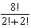
4) | 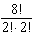

26 The graph below shows the function .

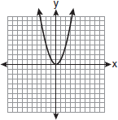

Which graph represents the function ?
1) | 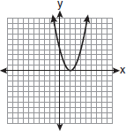
2) | 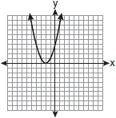
3) | 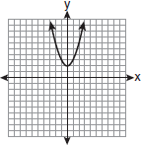
4) | 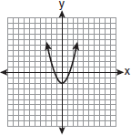

27 The equation may be rewritten as
1)
2)
3)
4)

28 Express 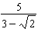 with a rational denominator, in simplest radical form.

29 Write an equation of the circle shown in the graph below.

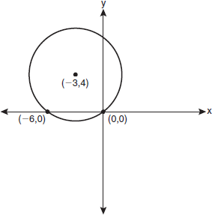

30 Solve for x: 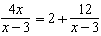

31 Find, to the nearest minute, the angle whose measure is 3.45 radians.

32 Matt places $1,200 in an investment account earning an annual rate of 6.5%, compounded continuously. Using the formula , where V is the value of the account in t years, P is the principal initially invested, e is the base of a natural logarithm, and r is the rate of interest, determine the amount of money, to the nearest cent, that Matt will have in the account after 10 years.

33 If is an angle in standard position and its terminal side passes through the point , find the exact value of .

34 Find the first four terms of the recursive sequence defined below.
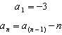

35 A committee of 5 members is to be randomly selected from a group of 9 teachers and 20 students. Determine how many different committees can be formed if 2 members must be teachers and 3 members must be students.

36 Solve by completing the square, expressing the result in simplest radical form.

37 Solve the equation algebraically for all values of x.

38 The table below shows the results of an experiment involving the growth of bacteria.

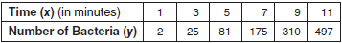

Write a power regression equation for this set of data, rounding all values to three decimal places. Using this equation, predict the bacteria’s growth, to the nearest integer, after 15 minutes.

39 Two forces of 25 newtons and 85 newtons acting on a body form an angle of 55°. Find the magnitude of the resultant force, to the nearest hundredth of a newton. Find the measure, to the nearest degree, of the angle formed between the resultant and the larger force.
1 ANS: 2

PTS: 2 REF: fall0901a2 STA: A2.N.9
TOP: Multiplication and Division of Complex Numbers

2 ANS: 3
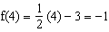.

PTS: 2 REF: fall0902a2 STA: A2.A.42 TOP: Compositions of Functions
KEY: numbers

3 ANS: 1
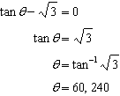. 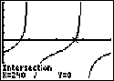.

PTS: 2 REF: fall0903a2 STA: A2.A.68 TOP: Trigonometric Equations
KEY: basic

4 ANS: 4
Students entering the library are more likely to spend more time studying, creating bias.

PTS: 2 REF: fall0904a2 STA: A2.S.2 TOP: Analysis of Data

5 ANS: 1
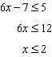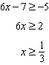

PTS: 2 REF: fall0905a2 STA: A2.A.1 TOP: Absolute Value Inequalities
KEY: graph

6 ANS: 4
(4) fails the horizontal line test. Not every element of the range corresponds to only one element of the domain.

PTS: 2 REF: fall0906a2 STA: A2.A.43 TOP: Defining Functions

7 ANS: 2
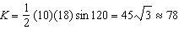

PTS: 2 REF: fall0907a2 STA: A2.A.74 TOP: Using Trigonometry to Find Area
KEY: basic

8 ANS: 4 PTS: 2 REF: fall0908a2 STA: A2.A.38
TOP: Defining Functions KEY: graphs

9 ANS: 2

PTS: 2 REF: fall0909a2 STA: A2.A.18 TOP: Evaluating Logarithmic Expressions

10 ANS: 3 PTS: 2 REF: fall0910a2 STA: A2.A.76
TOP: Angle Sum and Difference Identities KEY: simplifying

11 ANS: 3
n | 0 | 1 | 2
 |  |  |  | 12

PTS: 2 REF: fall0911a2 STA: A2.N.10 TOP: Sigma Notation
KEY: basic

12 ANS: 3
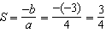. 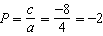

PTS: 2 REF: fall0912a2 STA: A2.A.21 TOP: Roots of Quadratics
KEY: basic

13 ANS: 3 PTS: 2 REF: fall0913a2 STA: A2.A.65
TOP: Graphing Trigonometric Functions

14 ANS: 1 PTS: 2 REF: fall0914a2 STA: A2.A.9
TOP: Negative and Fractional Exponents

15 ANS: 1
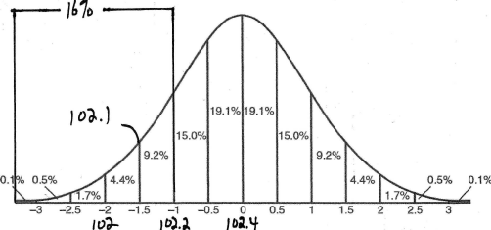

PTS: 2 REF: fall0915a2 STA: A2.S.5 TOP: Normal Distributions
KEY: interval

16 ANS: 2

PTS: 2 REF: fall0916a2 STA: A2.A.54 TOP: Graphing Logarithmic Functions

17 ANS: 4

PTS: 2 REF: fall0917a2 STA: A2.A.7 TOP: Factoring Polynomials
KEY: single variable

18 ANS: 4

PTS: 2 REF: fall0918a2 STA: A2.A.14 TOP: Operations with Radicals
KEY: with variables | index = 2

19 ANS: 1

PTS: 2 REF: fall0919a2 STA: A2.A.36 TOP: Binomial Expansions

20 ANS: 2
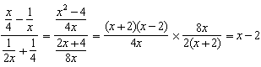

PTS: 2 REF: fall0920a2 STA: A2.A.17 TOP: Complex Fractions

21 ANS: 4
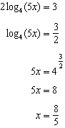

PTS: 2 REF: fall0921a2 STA: A2.A.28 TOP: Logarithmic Equations
KEY: advanced

22 ANS: 4

PTS: 2 REF: fall0922a2 STA: A2.A.61 TOP: Arc Length
KEY: arc length

23 ANS: 3 PTS: 2 REF: fall0923a2 STA: A2.A.39
TOP: Domain and Range KEY: real domain

24 ANS: 3
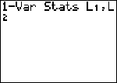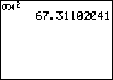

PTS: 2 REF: fall0924a2 STA: A2.S.4 TOP: Dispersion
KEY: variance

25 ANS: 4 PTS: 2 REF: fall0925a2 STA: A2.S.10
TOP: Permutations

26 ANS: 2 PTS: 2 REF: fall0926a2 STA: A2.A.46
TOP: Transformations with Functions and Relations

27 ANS: 4
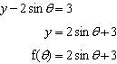

PTS: 2 REF: fall0927a2 STA: A2.A.40 TOP: Functional Notation

28 ANS:
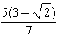. 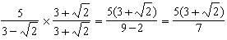

PTS: 2 REF: fall0928a2 STA: A2.N.5 TOP: Rationalizing Denominators

29 ANS:

PTS: 2 REF: fall0929a2 STA: A2.A.49 TOP: Writing Equations of Circles

30 ANS:
no solution. 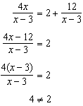

PTS: 2 REF: fall0930a2 STA: A2.A.23 TOP: Solving Rationals
KEY: rational solutions

31 ANS:
197º40’. 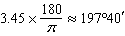. 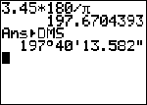

PTS: 2 REF: fall0931a2 STA: A2.M.2 TOP: Radian Measure
KEY: degrees

32 ANS:
2,298.65. 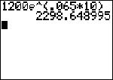

PTS: 2 REF: fall0932a2 STA: A2.A.12 TOP: Evaluating Exponential Expressions

33 ANS:
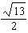. 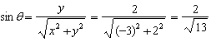. 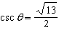.

PTS: 2 REF: fall0933a2 STA: A2.A.62 TOP: Determining Trigonometric Functions

34 ANS:

PTS: 2 REF: fall0934a2 STA: A2.A.33 TOP: Sequences

35 ANS:
41,040. 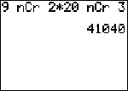

PTS: 2 REF: fall0935a2 STA: A2.S.12 TOP: Combinations

36 ANS:
. 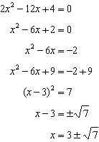

PTS: 4 REF: fall0936a2 STA: A2.A.24 TOP: Completing the Square

37 ANS:
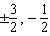. 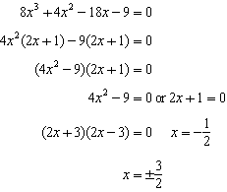

PTS: 4 REF: fall0937a2 STA: A2.A.26 TOP: Solving Polynomial Equations

38 ANS:
, 1,009.

PTS: 4 REF: fall0938a2 STA: A2.S.7 TOP: Power Regression

39 ANS:
101.43, 12. 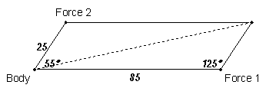 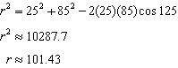. 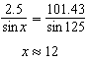

PTS: 6 REF: fall0939a2 STA: A2.A.73 TOP: Vectors

