1 If the roots of the quadratic equation are real, irrational, and unequal, then the value of the discriminant is
1) | equal to zero
2) | less than zero
3) | greater than zero and a perfect square
4) | greater than zero and not a perfect square

2 Factored completely, the expression is equivalent to
1)
2)
3)
4)

3 High school officials wanted to assess the need for a new diving board. They created a survey and distributed it to a large, diverse crowd at the State Swim Meet held at their school. Which characteristic of the survey is most likely to create a bias?
1) | the number of participants
2) | the height of the participants
3) | the way the set of data from the survey was analyzed
4) | the way the participants were selected to take the survey

4 Which expression is equivalent to ?
1)
2)
3)
4)

5 What is the product of the roots of the quadratic equation ?
1)
2) | 2
3)
4) | 4

6 In which method of data collection does the researcher intentionally intervene to arrange for a comparison of results?
1) | taking a survey
2) | making observations
3) | filling out a questionnaire
4) | conducting a controlled experiment

7 Which equation could be represented by the graph below?

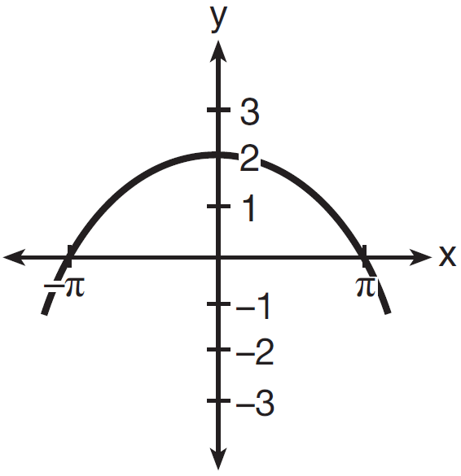
1) | 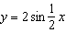
2) | 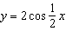
3) | 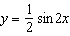
4) | 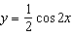

8 The first four terms of the sequence with and 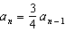 are
1)
2) | 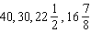
3)
4) | 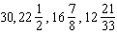

9 Which diagram represents an angle of radians in standard position?
1) | 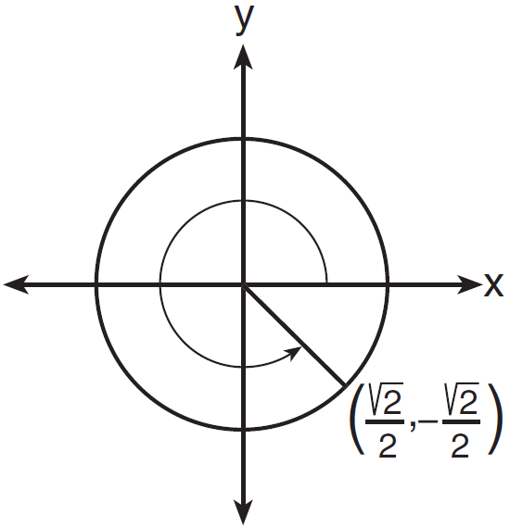
2) | 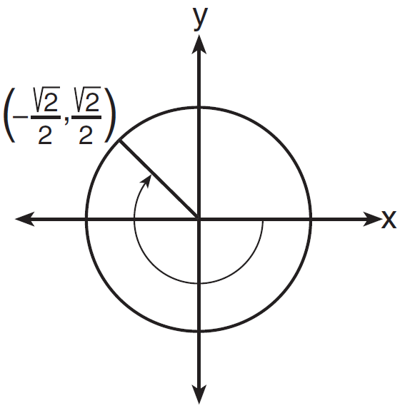
3) | 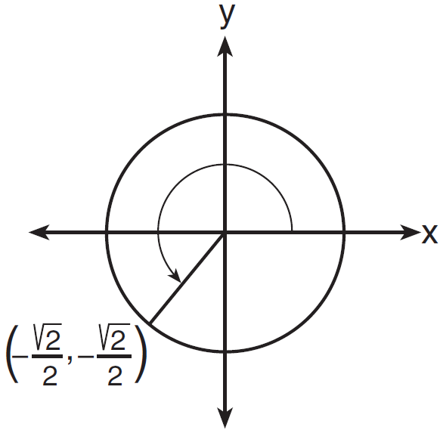
4) | 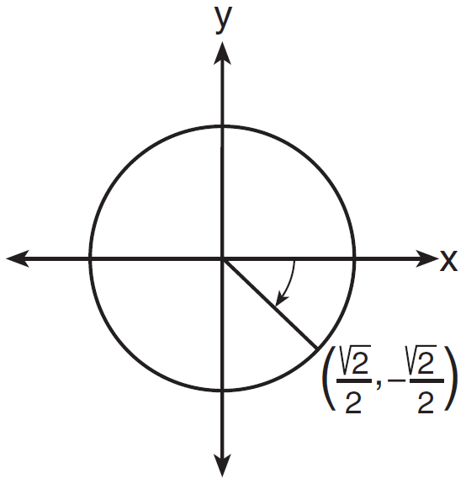

10 For all values for which the function is defined, the expression 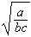 is equivalent to
1)
2) | 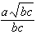
3)
4) | 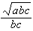

11 The expression 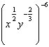 is equivalent to
1)
2)
3) | 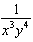
4)

12 The value of , where i is the imaginary unit, is
1) | 1
2) | -1
3) | i
4) | -i

13 Which expression has a value of ?
1)
2)
3)
4)

14 The solution set of is
1)
2)
3)
4)

15 Which relation is not a function?
1)
2)
3)
4)

16 The expression 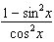 is equivalent to
1) | 1
2)
3)
4)

17 Which relation is one-to-one?
1)
2)
3)
4)

18 If and , then equals
1) | 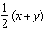
2) | 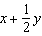
3)
4)

19 For a member of a certain species of bird, the probability of surviving to adulthood is . In a nest of five eggs, what is the probability, to the nearest hundredth, that at least four eggs will survive to adulthood?
1) | 0.23
2) | 0.29
3) | 0.63
4) | 0.94

20 In , , , and . How many distinct triangles can be created with these parameters?
1) | 1
2) | 2
3) | 3
4) | 0

21 Which expression could be used to determine the value of y in the equation ?
1)
2)
3)
4)

22 An electron travels along a circular path with a radius of 4.6 miles. What is the number of miles the electron traveled during an interval when the central angle formed by the electron’s path was 220°?
1) | 3.84
2) | 8.83
3) | 17.66
4) | 1012

23 Which statement about the function 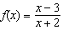 is true?
1) | Its domain does not include 2.
2) | Its domain does not include 3.
3) | Its range does not include 1.
4) | Its range does not include .

24 Which value of a correlation coefficient represents the strongest relationship between the two variables in a given linear regression model?
1) | -0.94
2) | 0
3) | 0.5
4) | 0.91

25 The fourth term of the expansion of is
1)
2)
3)
4)

26 What are the center and radius of the circle whose equation is ?
1) | and 1
2) | and 1
3) | and 3
4) | and 3

27 The product of and expressed in simplest radical form is
1)
2)
3)
4)

28 Jamal has forgotten his password for the school computers. He knows that it must be 4 characters long (only lowercase letters or digits). He also knows that his password begins with one of 26 letters and ends with a digit. Determine how many different 4-character passwords are possible for Jamal if no letter or digit may be repeated.

29 Emma’s parents deposited $5000 into a bank account during her freshman year. The account pays 5% interest compounded continuously using the formula , where A is the total amount accrued, P is the principal, r is the annual interest rate, and t is time, in years. Determine, to the nearest dollar, the amount in the account 4 years later.

30 Find the common difference in the arithmetic sequence, , in which and .

31 Solve the equation below algebraically for all values of in the interval .

32 Bacteria are being grown in a Petri dish in a biology lab. The number of bacteria in the culture after a given number of hours is shown in the table below.

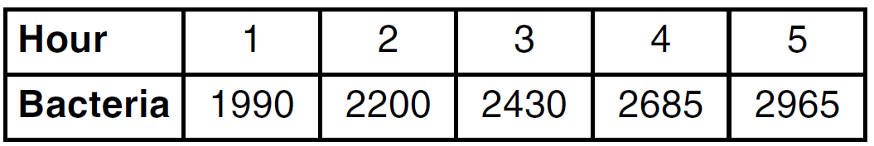

Assuming this exponential trend continues, is it reasonable to expect at least 3500 bacteria at hour 7? Justify your answer.

33 Express in simplest form: 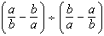

34 Determine the exact value of if P is an angle in standard position and its terminal side passes through the point .

35 Determine the number of degrees in radians.

36 Solve for x:

37 Determine algebraically the solution to .

38 The table below shows the number of hurricanes in the North Atlantic Ocean from 1990 to 2002.

Determine the interquartile range for this set of data. Determine the population variance for this set of data, to the nearest tenth.

39 The Bermuda Triangle on a map is a section of the Atlantic Ocean bordered by line segments stretching from Miami to Bermuda to Puerto Rico and back to Miami. The distance from Miami to Bermuda is 1042 miles; the distance from Bermuda to Puerto Rico is 2057 miles; and the distance from Puerto Rico to Miami is 1127 miles. Find the area contained within the Bermuda Triangle, to the nearest square mile.
1 ANS: 4 PTS: 2 REF: 081601a2 STA: A2.A.2
TOP: Using the Discriminant

2 ANS: 3

PTS: 2 REF: 081602a2 STA: A2.A.7
TOP: Factoring the Difference of Perfect Squares KEY: binomial

3 ANS: 4
The crowd includes people who are not connected with the high school.

PTS: 2 REF: 081603a2 STA: A2.S.2 TOP: Analysis of Data
KEY: bias

4 ANS: 3 PTS: 2 REF: 081604a2 STA: A2.A.76
TOP: Angle Sum and Difference Identities KEY: simplifying

5 ANS: 3
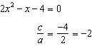

PTS: 2 REF: 081605a2 STA: A2.A.20 TOP: Roots of Quadratics

6 ANS: 4 PTS: 2 REF: 081606a2 STA: A2.S.2
TOP: Analysis of Data KEY: type

7 ANS: 2 PTS: 2 REF: 081607a2 STA: A2.A.72
TOP: Identifying the Equation of a Trigonometric Graph

8 ANS: 2
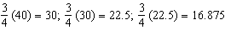

PTS: 2 REF: 081608a2 STA: A2.A.33 TOP: Sequences
KEY: term

9 ANS: 1 PTS: 2 REF: 081609a2 STA: A2.A.56
TOP: Determining Trigonometric Functions KEY: graphs

10 ANS: 4
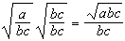

PTS: 2 REF: 081610a2 STA: A2.A.15 TOP: Rationalizing Denominators
KEY: index = 2

11 ANS: 1
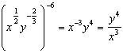

PTS: 2 REF: 081611a2 STA: A2.A.9 TOP: Negative and Fractional Exponents

12 ANS: 1

PTS: 2 REF: 081612a2 STA: A2.N.10 TOP: Sigma Notation
KEY: advanced

13 ANS: 1 PTS: 2 REF: 081613a2 STA: A2.A.59
TOP: Reciprocal Trigonometric Relationships

14 ANS: 4
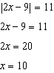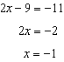

PTS: 2 REF: 081614a2 STA: A2.A.1 TOP: Absolute Value Equations

15 ANS: 4
is an ellipse.

PTS: 2 REF: 081615a2 STA: A2.A.38 TOP: Defining Functions

16 ANS: 1
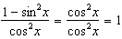

PTS: 2 REF: 081616a2 STA: A2.A.67 TOP: Simplifying Trigonometric Expressions

17 ANS: 3
passes the horizontal line test.

PTS: 2 REF: 081617a2 STA: A2.A.43 TOP: Defining Functions

18 ANS: 3

PTS: 2 REF: 081618a2 STA: A2.A.19 TOP: Properties of Logarithms
KEY: expressing logs algebraically

19 ANS: 2
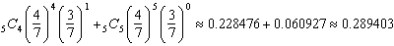

PTS: 2 REF: 081619a2 STA: A2.S.15 TOP: Binomial Probability
KEY: at least or at most

20 ANS: 1
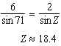. 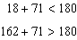

PTS: 2 REF: 081620a2 STA: A2.A.75 TOP: Law of Sines - The Ambiguous Case

21 ANS: 2
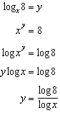

PTS: 2 REF: 081621a2 STA: A2.A.28 TOP: Logarithmic Equations
KEY: advanced

22 ANS: 3
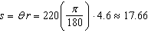

PTS: 2 REF: 081622a2 TOP: Arc Length KEY: arc length

23 ANS: 3
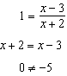

PTS: 2 REF: 081623a2 STA: A2.A.39 TOP: Domain and Range
KEY: real domain, rational

24 ANS: 1 PTS: 2 REF: 081624a2 STA: A2.S.8
TOP: Correlation Coefficient

25 ANS: 1

PTS: 2 REF: 081625a2 STA: A2.A.36 TOP: Binomial Expansions

26 ANS: 4
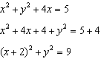

PTS: 2 REF: 081626a2 TOP: Equations of Circles

27 ANS: 4

PTS: 2 REF: 081627a2 STA: A2.N.2 TOP: Operations with Radicals

28 ANS:

PTS: 2 REF: 081628a2 STA: A2.S.10 TOP: Permutations

29 ANS:

PTS: 2 REF: 081629a2 STA: A2.A.12 TOP: Evaluating Exponential Expressions

30 ANS:
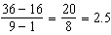

PTS: 2 REF: 081630a2 STA: A2.A.30 TOP: Sequences
KEY: difference or ratio

31 ANS:
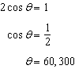

PTS: 2 REF: 081631a2 STA: A2.A.68 TOP: Trigonometric Equations
KEY: basic

32 ANS:
yes.

PTS: 2 REF: 081632a2 STA: A2.S.7 TOP: Regression
KEY: exponential

33 ANS:
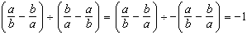

PTS: 2 REF: 081633a2 STA: A2.A.17 TOP: Complex Fractions

34 ANS:
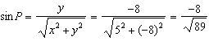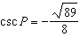

PTS: 2 REF: 081634a2 STA: A2.A.62 TOP: Determining Trigonometric Functions

35 ANS:
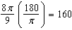

PTS: 2 REF: 081635a2 STA: A2.M.2 TOP: Radian Measure
KEY: degrees

36 ANS:
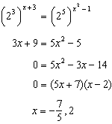
PTS: 4 REF: 081636a2 TOP: Exponential Equations
KEY: common base not shown

37 ANS:
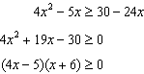 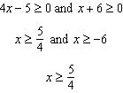 or 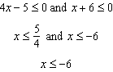
PTS: 4 REF: 081637a2 STA: A2.A.4 TOP: Quadratic Inequalities
KEY: one variable

38 ANS:
5, 7.8
PTS: 4 REF: 081638a2 STA: A2.S.4 TOP: Dispersion
KEY: interquartile range, variance

39 ANS:
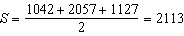
PTS: 6 REF: 081639a2 STA: A2.A.74 TOP: Heron’s Formula

