1 What are the zeros of the polynomial function graphed below?
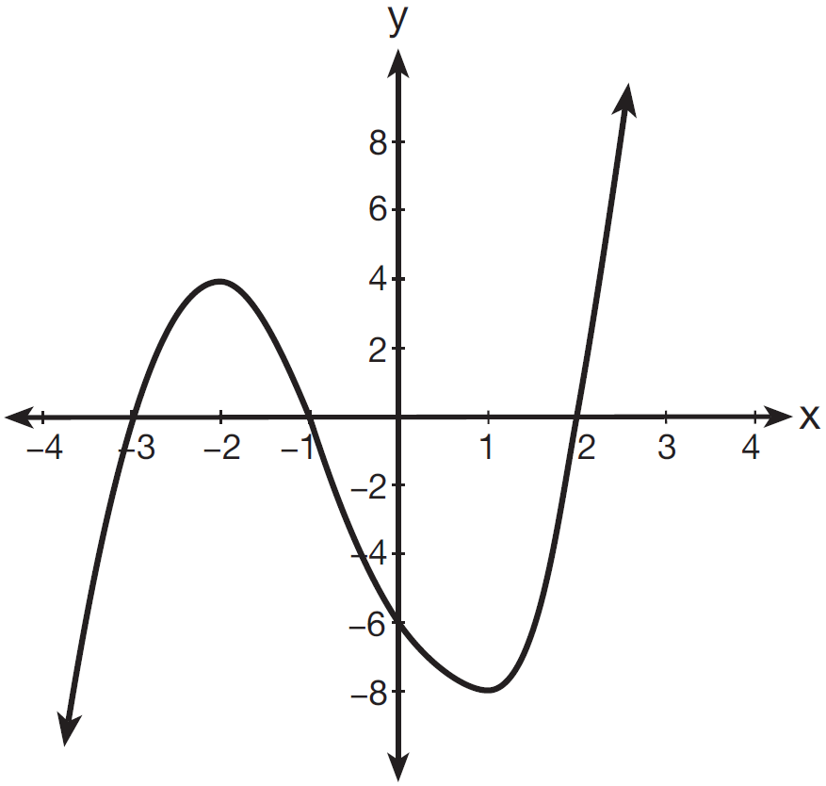
1)
2)
3)
4)

2 A study compared the number of years of education a person received and that person's average yearly salary. It was determined that the relationship between these two quantities was linear and the correlation coefficient was 0.91. Which conclusion can be made based on the findings of this study?
1) | There was a weak relationship.
2) | There was a strong relationship.
3) | There was no relationship.
4) | There was an unpredictable relationship.

3 What is the value of 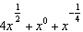 when ?
1)
2)
3)
4)

4 The expression is equivalent to
1) | 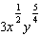
2) | 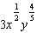
3) | 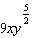
4) | 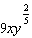

5 The exact value of is
1) | 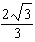
2) | 2
3) | 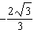
4)

6 Which statement about the equation is true?
1) | The product of the roots is .
2) | The product of the roots is .
3) | The sum of the roots is 3.
4) | The sum of the roots is .

7 A scholarship committee rewards the school's top math students. The amount of money each winner receives is inversely proportional to the number of scholarship recipients. If there are three winners, they each receive $400. If there are eight winners, how much money will each winner receive?
1) | $1067
2) | $400
3) | $240
4) | $150

8 What is the value of 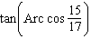?
1)
2)
3)
4)

9 The table below displays the number of siblings of each of the 20 students in a class.

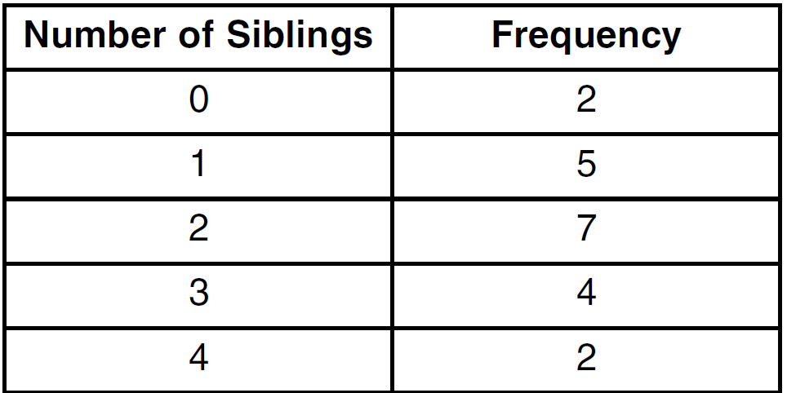

What is the population standard deviation, to the nearest hundredth, for this group?
1) | 1.11
2) | 1.12
3) | 1.14
4) | 1.15

10 An arithmetic sequence has a first term of 10 and a sixth term of 40. What is the 20th term of this sequence?
1) | 105
2) | 110
3) | 124
4) | 130

11 Yusef deposits $50 into a savings account that pays 3.25% interest compounded quarterly. The amount, A, in his account can be determined by the formula 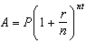, where P is the initial amount invested, r is the interest rate, n is the number of times per year the money is compounded, and t is the number of years for which the money is invested. What will his investment be worth in 12 years if he makes no other deposits or withdrawals?
1) | $55.10
2) | $73.73
3) | $232.11
4) | $619.74

12 How many distinct ways can the eleven letters in the word "TALLAHASSEE" be arranged?
1) | 831,600
2) | 1,663,200
3) | 3,326,400
4) | 5,702,400

13 A customer will select three different toppings for a supreme pizza. If there are nine different toppings to choose from, how many different supreme pizzas can be made?
1) | 12
2) | 27
3) | 84
4) | 504

14 Which values of x in the interval satisfy the equation ?
1)
2)
3)
4)

15 Expressed as a function of a positive acute angle, is equal to
1)
2)
3)
4)

16 Which equation represents a circle with its center at and that passes through the point ?
1)
2)
3)
4)

17 What is the domain of the function ?
1)
2)
3)
4)

18 The expression 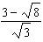 is equivalent to
1) | 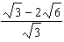
2) | 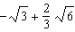
3) | 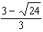
4) | 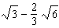

19 What is the period of the graph of the equation 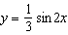?
1)
2) | 2
3)
4)

20 The first four terms of the sequence defined by 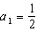 and are
1) | 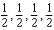
2) | 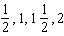
3) | 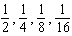
4) | 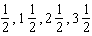

21 The scores on a standardized exam have a mean of 82 and a standard deviation of 3.6. Assuming a normal distribution, a student's score of 91 would rank
1) | below the 75th percentile
2) | between the 75th and 85th percentiles
3) | between the 85th and 95th percentiles
4) | above the 95th percentile

22 If 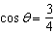, then what is ?
1)
2)
3)
4)

23 If , which statement is true?
1) | m and its inverse are both functions.
2) | m is a function and its inverse is not a function.
3) | m is not a function and its inverse is a function.
4) | Neither m nor its inverse is a function.

24 The expression is equivalent to
1)
2)
3)
4)

25 The ninth term of the expansion of is
1)
2)
3)
4)

26 Six people met at a dinner party, and each person shook hands once with everyone there. Which expression represents the total number of handshakes?
1)
2)
3)
4) | 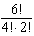

27 Which value of k will make 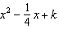 a perfect square trinomial?
1)
2)
3)
4)

28 Determine, to the nearest minute, the number of degrees in an angle whose measure is 2.5 radians.

29 Solve for x: 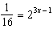

30 If and , determine in simplest form.

31 The probability of winning a game is . Determine the probability, expressed as a fraction, of winning exactly four games if seven games are played.

32 In a circle, an arc length of 6.6 is intercepted by a central angle of radians. Determine the length of the radius.

33 Show that 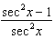 is equivalent to .

34 Solve algebraically for the exact values of x: 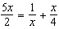

35 Simplify: 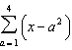.

36 In a triangle, two sides that measure 8 centimeters and 11 centimeters form an angle that measures . To the nearest tenth of a degree, determine the measure of the smallest angle in the triangle.

37 Solve the equation algebraically for all values of x.

38 Solve algebraically for x:

39 Solve algebraically, to the nearest hundredth, for all values of x:
1 ANS: 1 PTS: 2 REF: 081501a2 STA: A2.A.50
TOP: Solving Polynomial Equations

2 ANS: 2 PTS: 2 REF: 081502a2 STA: A2.S.8
TOP: Correlation Coefficient

3 ANS: 4
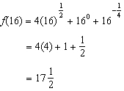

PTS: 2 REF: 081503a2 STA: A2.N.1 TOP: Negative and Fractional Exponents

4 ANS: 1
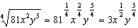

PTS: 2 REF: 081504a2 STA: A2.A.11 TOP: Radicals as Fractional Exponents

5 ANS: 1
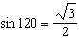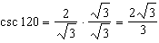

PTS: 2 REF: 081505a2 STA: A2.A.59 TOP: Reciprocal Trigonometric Relationships

6 ANS: 2
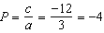

PTS: 2 REF: 081506a2 STA: A2.A.20 TOP: Roots of Quadratics

7 ANS: 4
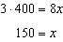

PTS: 2 REF: 081507a2 STA: A2.A.5 TOP: Inverse Variation

8 ANS: 1
If 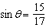, then 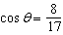. 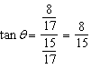

PTS: 2 REF: 081508a2 STA: A2.A.64 TOP: Using Inverse Trigonometric Functions
KEY: advanced

9 ANS: 2 PTS: 2 REF: 081509a2 STA: A2.S.4
TOP: Dispersion KEY: basic, group frequency distributions

10 ANS: 3
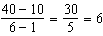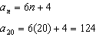

PTS: 2 REF: 081510a2 STA: A2.A.32 TOP: Sequences

11 ANS: 2
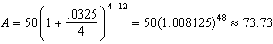

PTS: 2 REF: 081511a2 STA: A2.A.12 TOP: Evaluating Exponential Expressions

12 ANS: 1
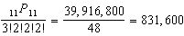

PTS: 2 REF: 081512a2 STA: A2.S.10 TOP: Permutations

13 ANS: 3

PTS: 2 REF: 081513a2 STA: A2.S.11 TOP: Combinations

14 ANS: 2
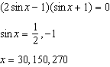

PTS: 2 REF: 081514a2 STA: A2.A.68 TOP: Trigonometric Equations
KEY: quadratics

15 ANS: 2 PTS: 2 REF: 081515a2 STA: A2.A.57
TOP: Reference Angles

16 ANS: 3

PTS: 2 REF: 081516a2 STA: A2.A.48 TOP: Equations of Circles

17 ANS: 3 PTS: 2 REF: 081517a2 STA: A2.A.39
TOP: Domain and Range KEY: real domain

18 ANS: 4
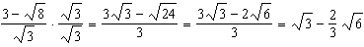
PTS: 2 REF: 081518a2 STA: A2.N.5 TOP: Rationalizing Denominators

19 ANS: 3
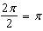
PTS: 2 REF: 081519a2 STA: A2.A.69
TOP: Properties of Graphs of Trigonometric Functions KEY: period

20 ANS: 1 PTS: 2 REF: 081520a2 STA: A2.A.33
TOP: Sequences

21 ANS: 4
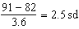
PTS: 2 REF: 081521a2 STA: A2.S.5 TOP: Normal Distributions
KEY: interval

22 ANS: 1
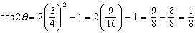
PTS: 2 REF: 081522a2 STA: A2.A.77 TOP: Double Angle Identities
KEY: evaluating

23 ANS: 2 PTS: 2 REF: 081523a2 STA: A2.A.44
TOP: Inverse of Functions KEY: ordered pairs

24 ANS: 4
PTS: 2 REF: 081524a2 STA: A2.N.6 TOP: Square Roots of Negative Numbers

25 ANS: 3 PTS: 2 REF: 081525a2 STA: A2.A.36
TOP: Binomial Expansions

26 ANS: 4 PTS: 2 REF: 081526a2 STA: A2.S.9
TOP: Differentiating Permutations and Combinations

27 ANS: 1
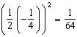
PTS: 2 REF: 081527a2 STA: A2.A.24 TOP: Completing the Square

28 ANS:
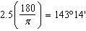
PTS: 2 REF: 081528a2 STA: A2.M.2 TOP: Radian Measure
KEY: degrees

29 ANS:
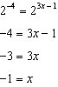
PTS: 2 REF: 081529a2 STA: A2.A.27 TOP: Exponential Equations
KEY: common base shown

30 ANS:
PTS: 2 REF: 081530a2 STA: A2.A.42 TOP: Compositions of Functions
KEY: variables

31 ANS:
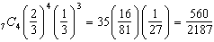
PTS: 2 REF: 081531a2 STA: A2.S.15 TOP: Binomial Probability
KEY: exactly

32 ANS:
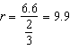
PTS: 2 REF: 081532a2 STA: A2.A.61 TOP: Arc Length
KEY: radius

33 ANS:
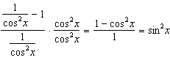
PTS: 2 REF: 081533a2 STA: A2.A.58 TOP: Reciprocal Trigonometric Relationships

34 ANS:
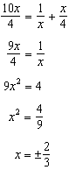
PTS: 2 REF: 081534a2 STA: A2.A.23 TOP: Solving Rationals
KEY: rational solutions

35 ANS:
PTS: 2 REF: 081535a2 STA: A2.N.10 TOP: Sigma Notation
KEY: advanced

36 ANS:
. The angle opposite the shortest side: 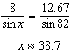
PTS: 4 REF: 081536a2 STA: A2.A.73 TOP: Law of Cosines
KEY: advanced

37 ANS:
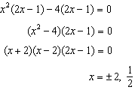
PTS: 4 REF: 081537a2 STA: A2.A.26 TOP: Solving Polynomial Equations

38 ANS:
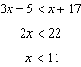 and 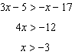
PTS: 4 REF: 081538a2 STA: A2.A.1 TOP: Absolute Value Inequalities

39 ANS:
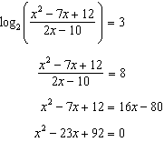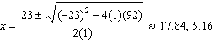
PTS: 6 REF: 081539a2 STA: A2.A.28 TOP: Logarithmic Equations
KEY: applying properties of logarithms

