1 The product of and is
1)
2)
3) | 14
4) | 4

2 What is the radian measure of an angle whose measure is ?
1)
2)
3)
4)

3 What are the domain and the range of the function shown in the graph below?

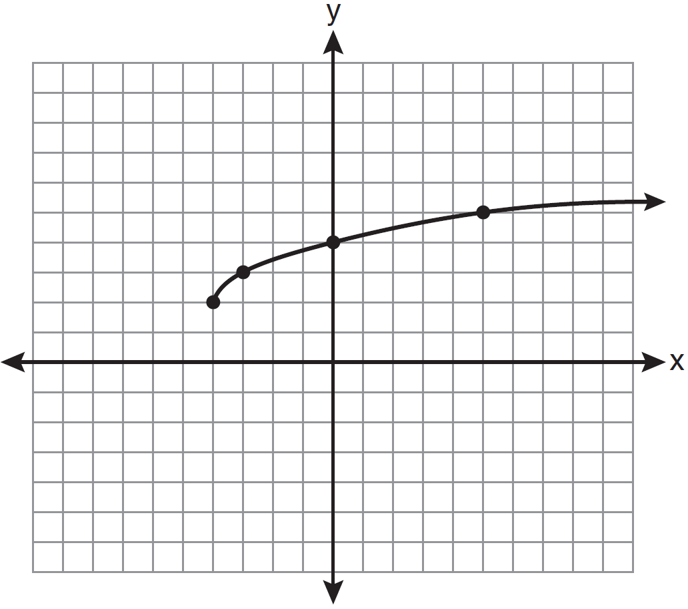
1)
2)
3)
4)

4 The expression is equivalent to
1)
2)
3)
4)

5 In which graph is coterminal with an angle of ?
1) | 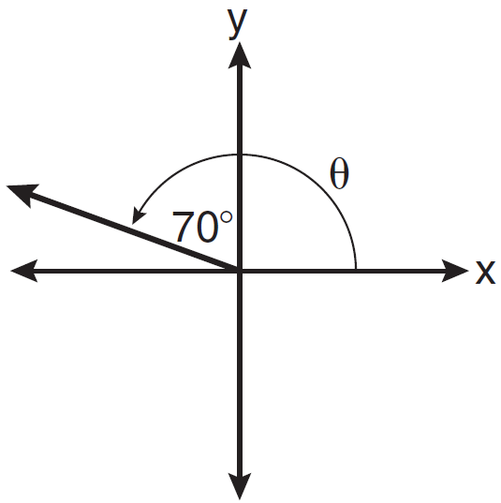
2) | 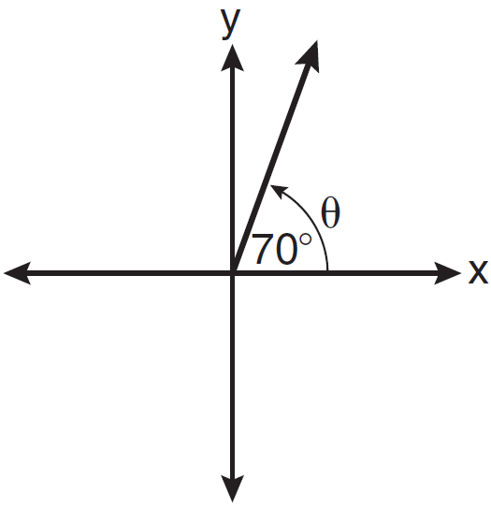
3) | 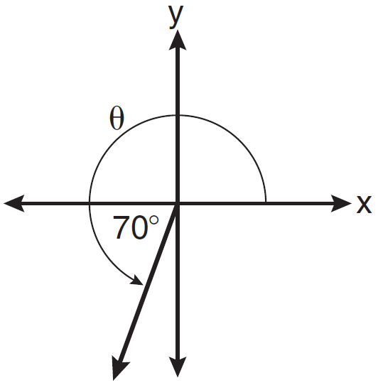
4) | 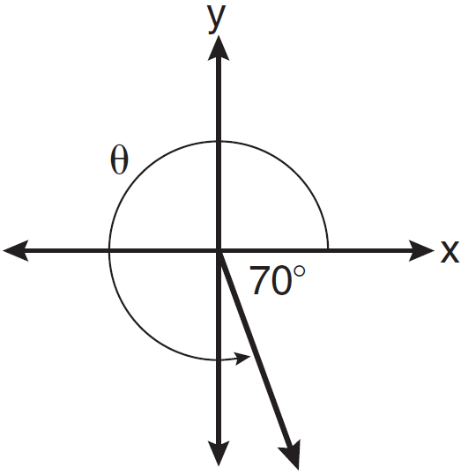

6 In , , , and . What are the two possible values for , to the nearest tenth?
1) | 73.7 and 106.3
2) | 73.7 and 163.7
3) | 78.3 and 101.7
4) | 78.3 and 168.3

7 What is the principal value of 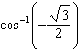?
1)
2)
3)
4)

8 What is the value of x in the equation ?
1) | 1
2)
3)
4)

9 The roots of the equation are
1) | and
2) | and 3
3) | 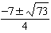
4) | 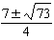

10 Which ratio represents in the diagram below?

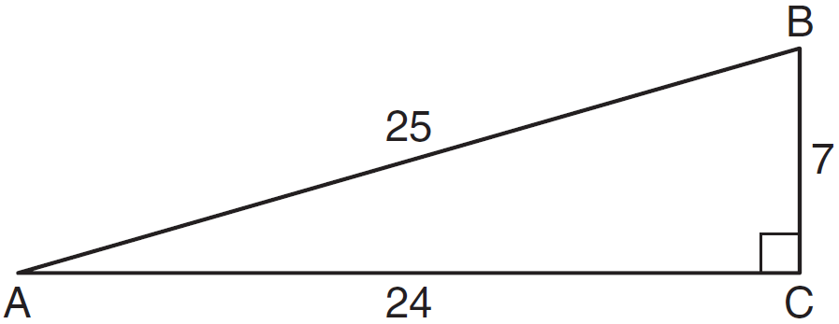
1)
2)
3)
4)

11 When simplified, the expression 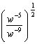 is equivalent to
1)
2)
3)
4)

12 The principal would like to assemble a committee of 8 students from the 15-member student council. How many different committees can be chosen?
1) | 120
2) | 6,435
3) | 32,432,400
4) | 259,459,200

13 An amateur bowler calculated his bowling average for the season. If the data are normally distributed, about how many of his 50 games were within one standard deviation of the mean?
1) | 14
2) | 17
3) | 34
4) | 48

14 What is a formula for the nth term of sequence B shown below?
1)
2)
3)
4)

15 Which values of x are in the solution set of the following system of equations?
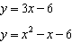
1)
2)
3)
4)

16 The roots of the equation are
1) | imaginary
2) | real, rational, and equal
3) | real, rational, and unequal
4) | real, irrational, and unequal

17 In , , , and . What is ?
1) | 22
2) | 38
3) | 60
4) | 120

18 When is divided by , the quotient is
1)
2)
3)
4) | 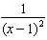

19 The fraction 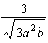 is equivalent to
1) | 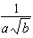
2)
3) | 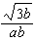
4)

20 Which graph represents a one-to-one function?
1) | 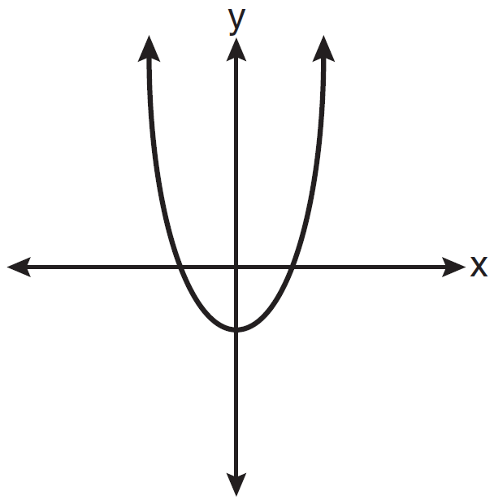
2) | 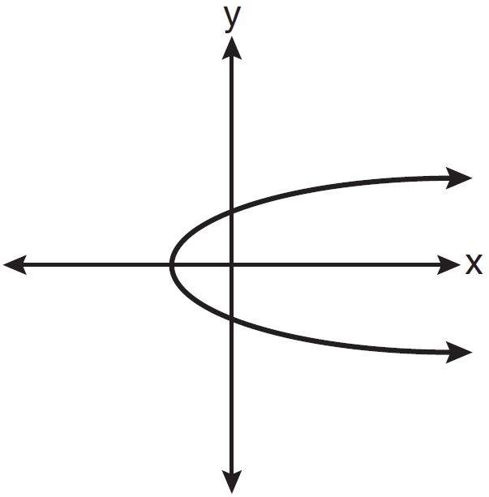
3) | 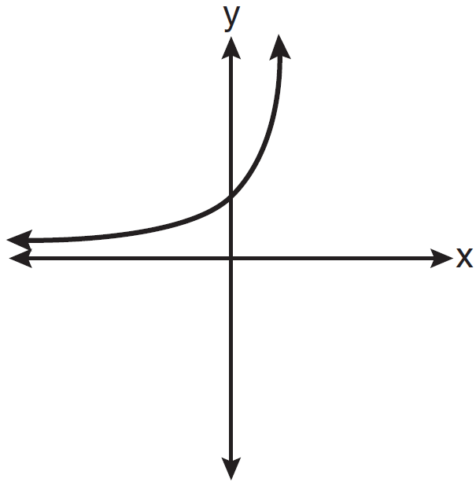
4) | 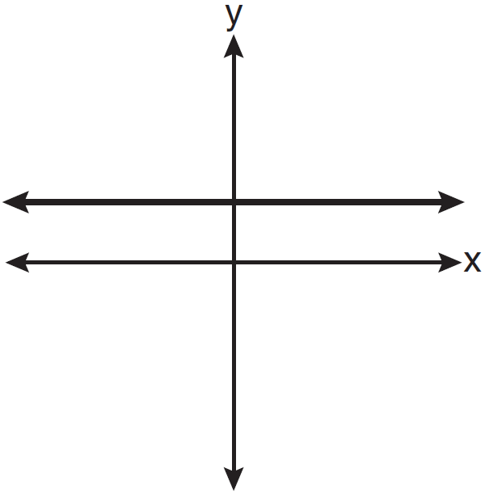

21 The sides of a parallelogram measure 10 cm and 18 cm. One angle of the parallelogram measures 46 degrees. What is the area of the parallelogram, to the nearest square centimeter?
1) | 65
2) | 125
3) | 129
4) | 162

22 The minimum point on the graph of the equation is . What is the minimum point on the graph of the equation ?
1)
2)
3)
4)

23 The graph of is shown below.

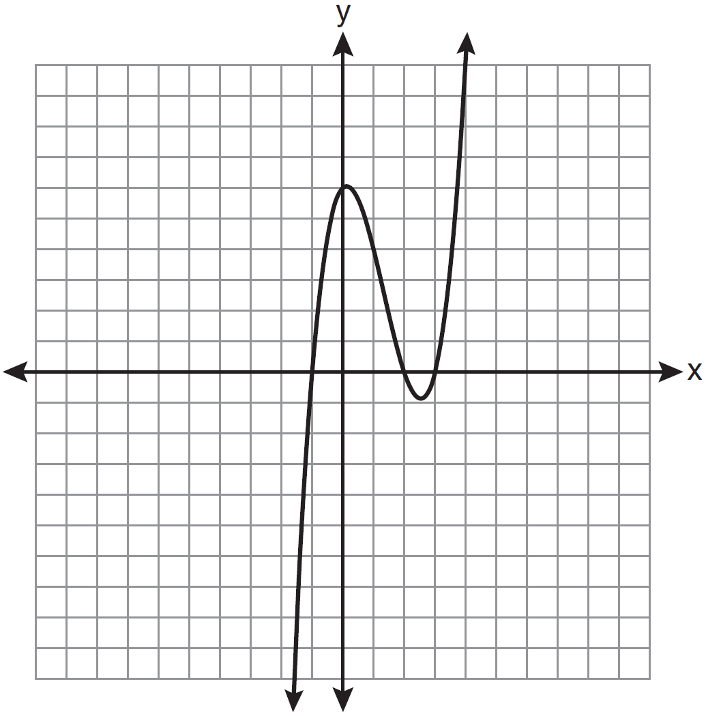

What is the product of the roots of the equation ?
1)
2)
3) | 6
4) | 4

24 What is the conjugate of ?
1)
2)
3)
4)

25 What is the common ratio of the geometric sequence whose first term is 27 and fourth term is 64?
1)
2)
3)
4)

26 Which graph represents one complete cycle of the equation ?
1) | 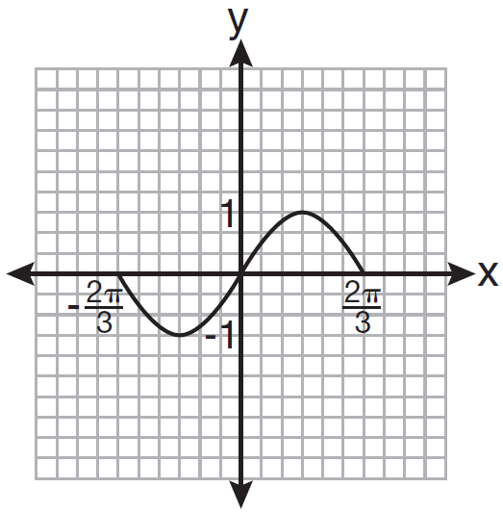
2) | 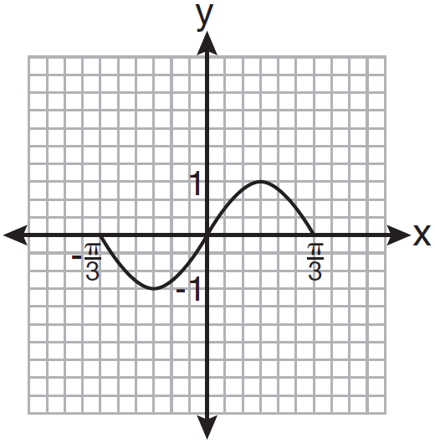
3) | 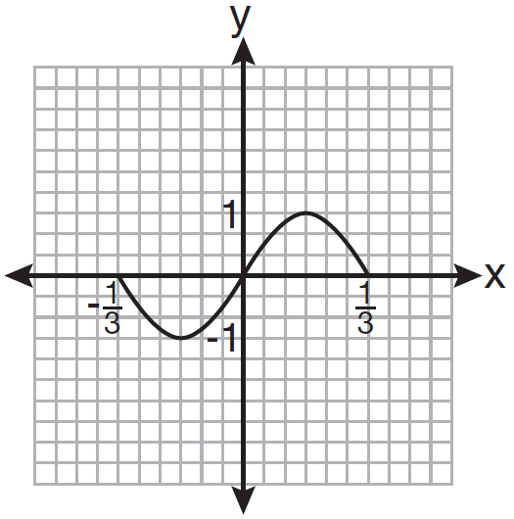
4) | 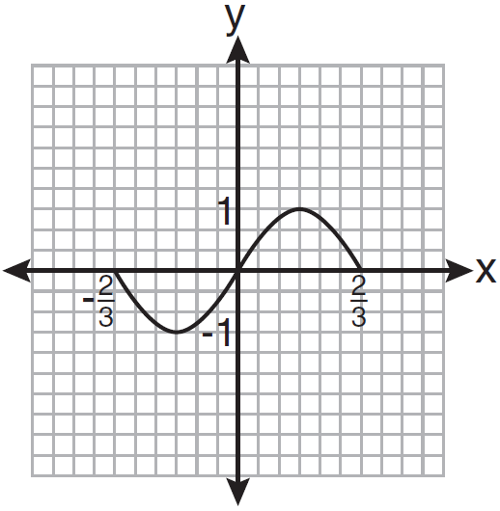

27 Which two functions are inverse functions of each other?
1) | and
2) | and
3) | and
4) | and 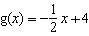

28 Factor completely:

29 Express the sum using sigma notation.

30 Howard collected fish eggs from a pond behind his house so he could determine whether sunlight had an effect on how many of the eggs hatched. After he collected the eggs, he divided them into two tanks. He put both tanks outside near the pond, and he covered one of the tanks with a box to block out all sunlight. State whether Howard's investigation was an example of a controlled experiment, an observation, or a survey. Justify your response.

31 The table below shows the number of new stores in a coffee shop chain that opened during the years 1986 through 1994.

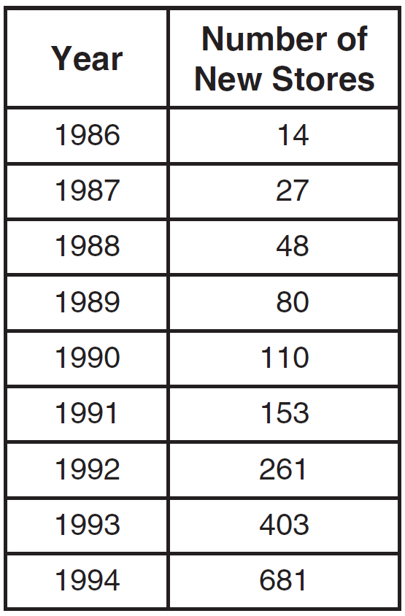

Using to represent the year 1986 and y to represent the number of new stores, write the exponential regression equation for these data. Round all values to the nearest thousandth.

32 Solve the equation algebraically for all values of C in the interval .

33 A circle shown in the diagram below has a center of and passes through point .

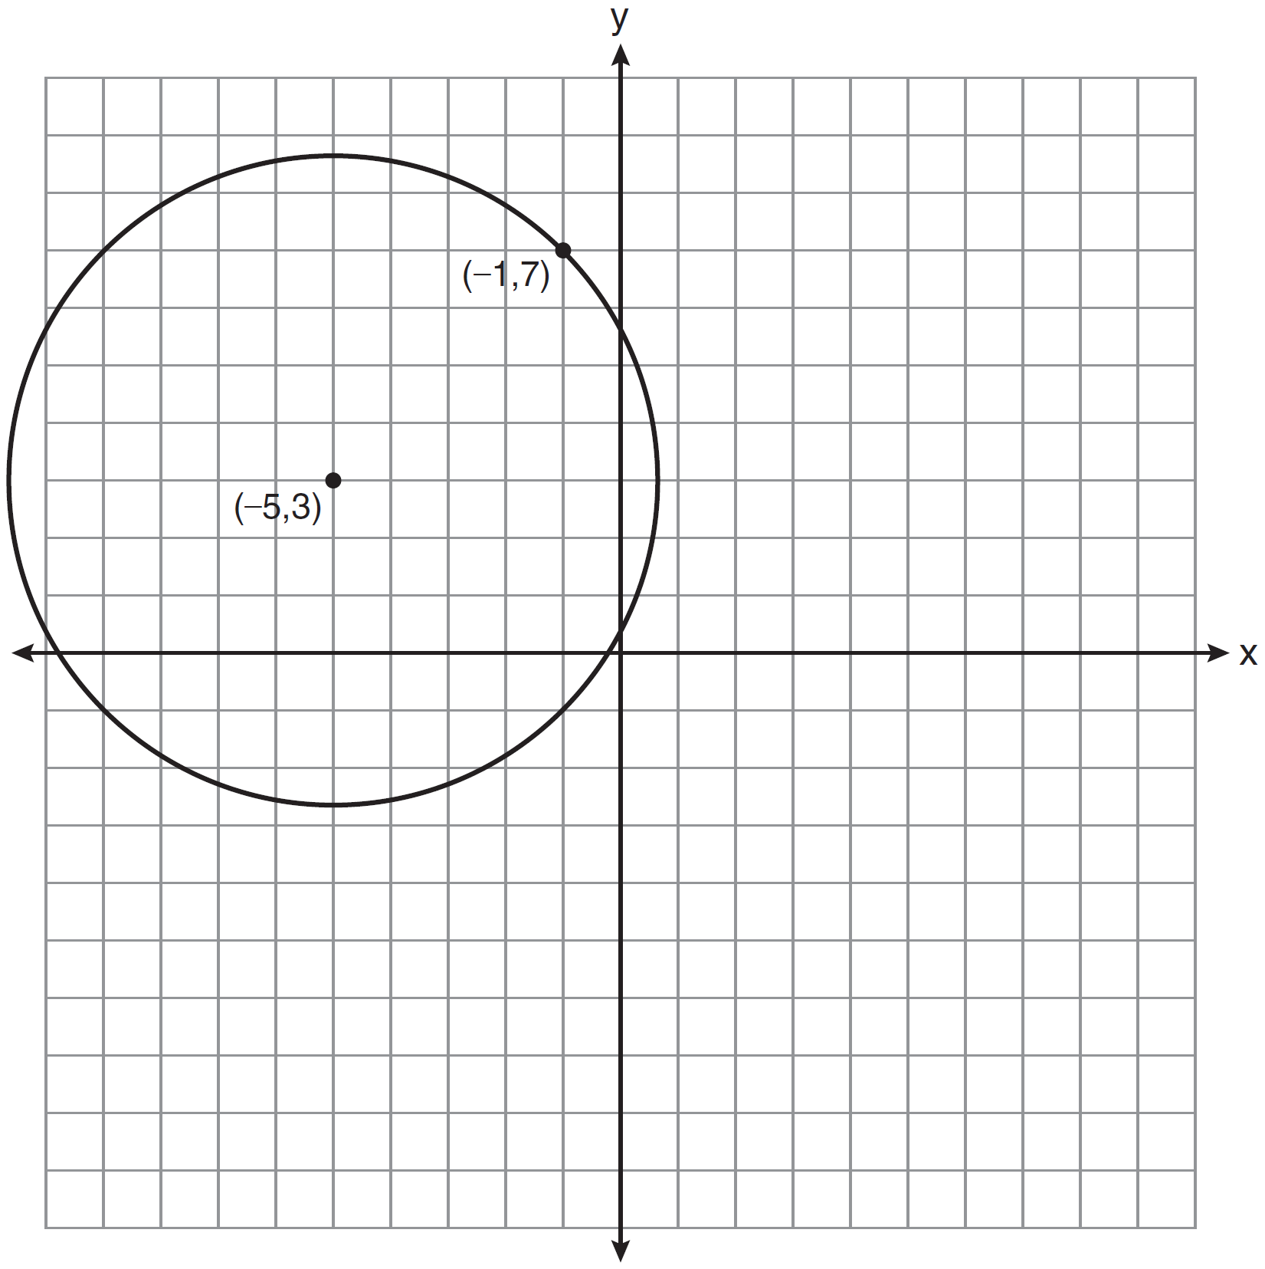

Write an equation that represents the circle.

34 Express 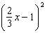 as a trinomial.

35 Find the total number of different twelve-letter arrangements that can be formed using the letters in the word PENNSYLVANIA.

36 Solve algebraically for x: 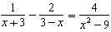

37 If 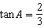 and 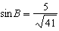 and angles A and B are in Quadrant I, find the value of .

38 A study shows that 35% of the fish caught in a local lake had high levels of mercury. Suppose that 10 fish were caught from this lake. Find, to the nearest tenth of a percent, the probability that at least 8 of the 10 fish caught did not contain high levels of mercury.

39 Solve algebraically for x: 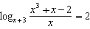
1 ANS: 4

PTS: 2 REF: 081001a2 STA: A2.N.4 TOP: Operations with Irrational Expressions
KEY: without variables | index = 2

2 ANS: 1
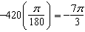

PTS: 2 REF: 081002a2 STA: A2.M.2 TOP: Radian Measure
KEY: radians

3 ANS: 2 PTS: 2 REF: 081003a2 STA: A2.A.51
TOP: Domain and Range

4 ANS: 1

PTS: 2 REF: 081004a2 STA: A2.N.7 TOP: Imaginary Numbers

5 ANS: 4 PTS: 2 REF: 081005a2 STA: A2.A.60
TOP: Unit Circle

6 ANS: 3
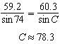

PTS: 2 REF: 081006a2 STA: A2.A.75 TOP: Law of Sines - The Ambiguous Case

7 ANS: 3 PTS: 2 REF: 081007a2 STA: A2.A.64
TOP: Using Inverse Trigonometric Functions KEY: basic

8 ANS: 4
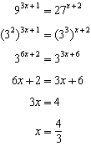.

PTS: 2 REF: 081008a2 STA: A2.A.27 TOP: Exponential Equations
KEY: common base not shown

9 ANS: 3
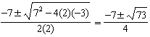

PTS: 2 REF: 081009a2 STA: A2.A.25 TOP: Quadratic Formula

10 ANS: 2 PTS: 2 REF: 081010a2 STA: A2.A.55
TOP: Trigonometric Ratios

11 ANS: 2
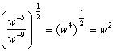

PTS: 2 REF: 081011a2 STA: A2.A.8 TOP: Negative and Fractional Exponents

12 ANS: 2

PTS: 2 REF: 081012a2 STA: A2.S.11 TOP: Combinations

13 ANS: 3

PTS: 2 REF: 081013a2 STA: A2.S.5 TOP: Normal Distributions
KEY: predict

14 ANS: 1
common difference is 2. 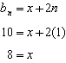

PTS: 2 REF: 081014a2 STA: A2.A.29 TOP: Sequences

15 ANS: 2
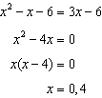

PTS: 2 REF: 081015a2 STA: A2.A.3 TOP: Quadratic-Linear Systems
KEY: equations

16 ANS: 4

PTS: 2 REF: 081016a2 STA: A2.A.2 TOP: Using the Discriminant
KEY: determine nature of roots given equation

17 ANS: 4
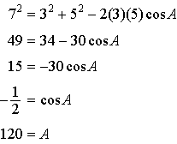

PTS: 2 REF: 081017a2 STA: A2.A.73 TOP: Law of Sines
KEY: angle, without calculator

18 ANS: 2
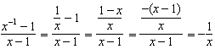

PTS: 2 REF: 081018a2 STA: A2.A.9 TOP: Negative Exponents

19 ANS: 3
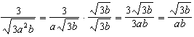

PTS: 2 REF: 081019a2 STA: A2.A.15 TOP: Rationalizing Denominators
KEY: index = 2

20 ANS: 3
(1) and (4) fail the horizontal line test and are not one-to-one. Not every element of the range corresponds to only one element of the domain. (2) fails the vertical line test and is not a function. Not every element of the domain corresponds to only one element of the range.

PTS: 2 REF: 081020a2 STA: A2.A.43 TOP: Defining Functions

21 ANS: 3

PTS: 2 REF: 081021a2 STA: A2.A.74 TOP: Using Trigonometry to Find Area
KEY: parallelograms

22 ANS: 1 PTS: 2 REF: 081022a2 STA: A2.A.46
TOP: Transformations with Functions and Relations

23 ANS: 2
The roots are .

PTS: 2 REF: 081023a2 STA: A2.A.50 TOP: Solving Polynomial Equations

24 ANS: 2 PTS: 2 REF: 081024a2 STA: A2.N.8
TOP: Conjugates of Complex Numbers

25 ANS: 3
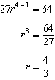

PTS: 2 REF: 081025a2 STA: A2.A.31 TOP: Sequences

26 ANS: 3
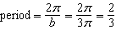

PTS: 2 REF: 081026a2 STA: A2.A.70 TOP: Graphing Trigonometric Functions
KEY: recognize

27 ANS: 3 PTS: 2 REF: 081027a2 STA: A2.A.44
TOP: Inverse of Functions KEY: equations

28 ANS:

PTS: 2 REF: 081028a2 STA: A2.A.7 TOP: Factoring Polynomials
KEY: multiple variables

29 ANS:
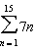

PTS: 2 REF: 081029a2 STA: A2.A.34 TOP: Sigma Notation

30 ANS:
Controlled experiment because Howard is comparing the results obtained from an experimental sample against a control sample.

PTS: 2 REF: 081030a2 STA: A2.S.1 TOP: Analysis of Data

31 ANS:

PTS: 2 REF: 081031a2 STA: A2.S.7 TOP: Exponential Regression

32 ANS:
45, 225 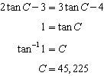

PTS: 2 REF: 081032a2 STA: A2.A.68 TOP: Trigonometric Equations
KEY: basic

33 ANS:

PTS: 2 REF: 081033a2 STA: A2.A.49 TOP: Writing Equations of Circles

34 ANS:
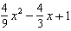. 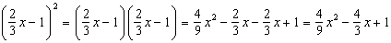

PTS: 2 REF: 081034a2 STA: A2.N.3 TOP: Operations with Polynomials

35 ANS:
39,916,800. 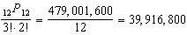

PTS: 2 REF: 081035a2 STA: A2.S.10 TOP: Permutations

36 ANS:
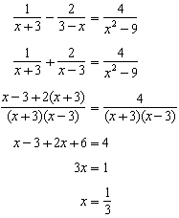

PTS: 4 REF: 081036a2 STA: A2.A.23 TOP: Solving Rationals
KEY: rational solutions

37 ANS:
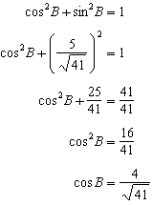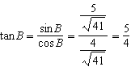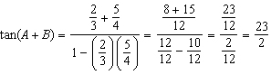

PTS: 4 REF: 081037a2 STA: A2.A.76 TOP: Angle Sum and Difference Identities
KEY: evaluating

38 ANS:
26.2%.
PTS: 4 REF: 081038a2 STA: A2.S.15 TOP: Binomial Probability
KEY: at least or at most

39 ANS:
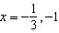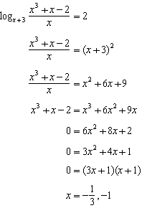
PTS: 6 REF: 081039a2 STA: A2.A.28 TOP: Logarithmic Equations
KEY: basic

