1 The expression 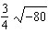 is equivalent to
1)
2)
3)
4)

2 In , , , and . What is the area of to the nearest tenth of a square unit?
1) | 90.7
2) | 181.4
3) | 256.5
4) | 362.7

3 The expression 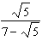 is equivalent to
1) | 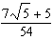
2) | 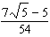
3) | 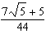
4) | 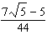

4 A multiple-choice test has 4 possible choices for each question. A person guesses on 10 questions. What is the probability the person gets exactly 8 questions correct?
1) | 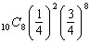
2) | 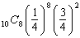
3) | 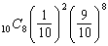
4) | 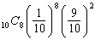

5 The summation 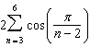 equals
1) | 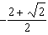
2)
3) | 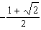
4)

6 The graph of a relation is shown below.

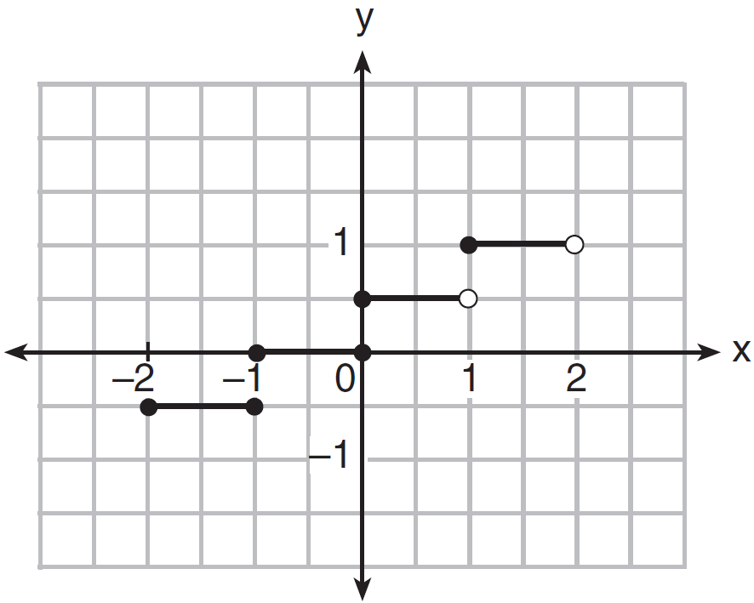

What is the domain of this relation?
1)
2) | 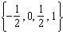
3)
4)

7 The Mathematics Club will select a president, a vice president, and a treasurer for the club. If there are 15 members in the club, how many different selections of a president, a vice president, and a treasurer are possible if each club member can be selected to only one position?
1) | 42
2) | 455
3) | 2730
4) | 3375

8 For which equation will ?
1)
2)
3)
4)

9 What is the product of and ?
1)
2)
3)
4)

10 A principal is concerned about the decline in the number of students who purchase food from the cafeteria. A survey was developed to assist the principal. The most appropriate method would be for the principal to randomly select 100 students from
1) | the junior class
2) | the student directory
3) | the Algebra 2/Trigonometry classes
4) | the students who are eating during fourth period lunch in the cafeteria

11 The solution of is
1)
2)
3)
4)

12 Which relation is not a function?
1)
2)
3)
4) | 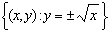

13 What does the correlation coefficient of on a linear regression indicate?
1) | The slope is positive.
2) | One variable causes the other.
3) | The scatterplot shows no association of the variables.
4) | One variable has a strong relationship with the other.

14 Which angle has the same terminal side as an angle of 155°?
1)
2)
3)
4)

15 For any power of i, the imaginary unit, where b is a whole number, equals
1) | 1
2)
3)
4)

16 What is the solution set of 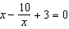?
1)
2)
3)
4)

17 In triangle ABC, if , , and , then can be
1) | an acute angle, only
2) | a right angle, only
3) | an obtuse angle, only
4) | either an acute or an obtuse angle

18 To the nearest thousandth, what is , in radian measure?
1) | 0.416
2) | 0.415
3) | 0.410
4) | 0.409

19 When 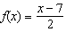, what is the value of ?
1)
2)
3) | 3
4)

20 What is the equation of the circle passing through the point whose center is at ?
1)
2)
3)
4)

21 If and , what is the value of the expression 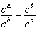, when ?
1) | 0
2) | 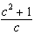
3)
4) | 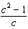

22 What is the fourth term in the expansion of ?
1)
2)
3)
4)

23 If the roots of a quadratic equation are real, irrational, and unequal, the discriminant could have a value of
1) | 1
2) | 0
3) | 8
4)

24 What is the nth term of the sequence ?
1)
2)
3)
4)

25 What is the sample standard deviation of the data in the table below, rounded to the nearest tenth?

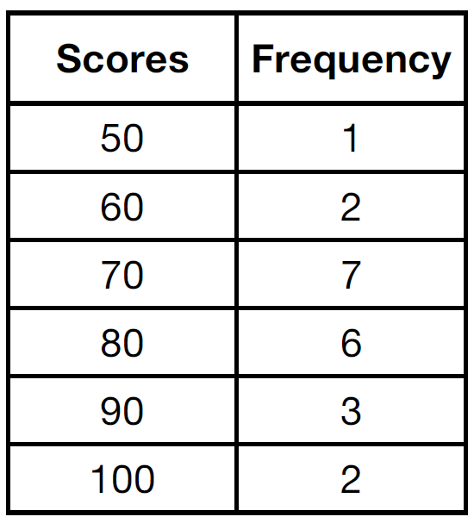
1) | 12.5
2) | 12.8
3) | 17.1
4) | 18.7

26 Which equation is not true?
1)
2)
3)
4)

27 Which quadratic equation has roots whose sum is and product is ?
1)
2)
3)
4)

28 Factor completely.

29 Five thousand dollars is invested at an interest rate of 3.5% compounded quarterly. No money is deposited or withdrawn from the account. Using the formula below, determine, to the nearest cent, how much this investment will be worth in 18 years.
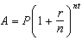
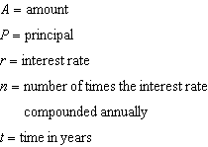

30 A colony of bacteria grows exponentially. The table below shows the data collected daily.

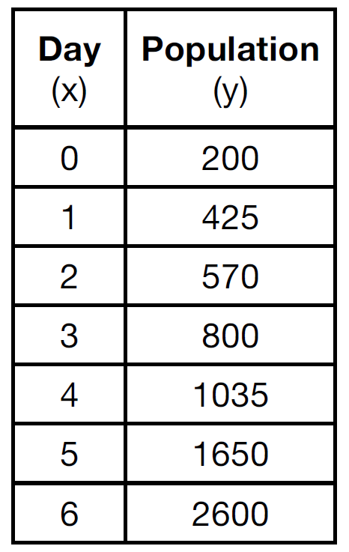

State the exponential regression equation for the data, rounding all values to the nearest hundredth.

31 Express 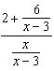 in simplest form, where and .

32 A central angle whose measure is radians intercepts an arc with a length of feet. Find the radius of the circle, in feet.

33 A sine function is graphed below.

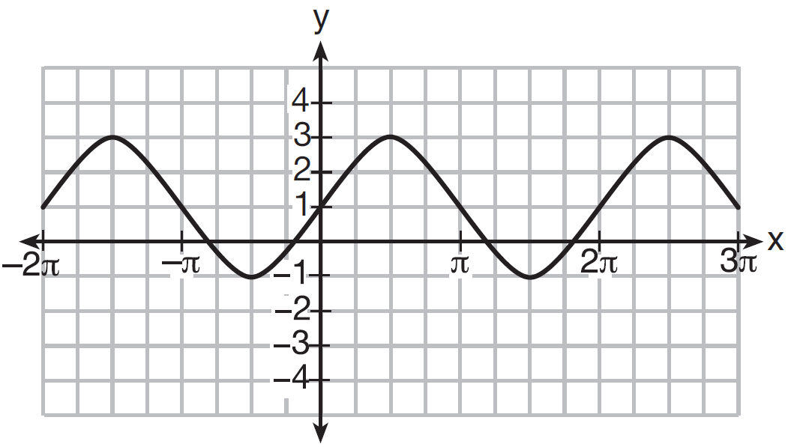

Determine and state the amplitude and period of this function.

34 On the Algebra 2/Trigonometry midterm at Champion High School, the scores of 210 students were normally distributed with a mean of 82 and a standard deviation of 4.2. Determine how many students scored between 79.9 and 88.3.

35 Given 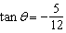 and 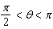, determine the exact value of the expression .

36 The lengths of the sides of a triangle are 6 cm, 11 cm, and 7 cm. Determine, to the nearest tenth of a degree, the measure of the largest angle of the triangle.

37 Solve algebraically for c: 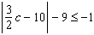

38 Solve for all values of in the interval .

39 Solve for p algebraically: 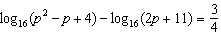

1 ANS: 1
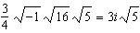

PTS: 2 REF: 061601a2 STA: A2.N.6 TOP: Square Roots of Negative Numbers

2 ANS: 2
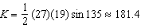

PTS: 2 REF: 061602a2 STA: A2.A.74 TOP: Using Trigonometry to Find Area
KEY: basic

3 ANS: 3
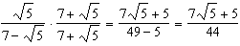

PTS: 2 REF: 061603a2 STA: A2.N.5 TOP: Rationalizing Denominators

4 ANS: 2 PTS: 2 REF: 061604a2 STA: A2.S.15
TOP: Binomial Probability KEY: modeling

5 ANS: 4

PTS: 2 REF: 061605a2 STA: A2.N.10 TOP: Sigma Notation
KEY: advanced

6 ANS: 3 PTS: 2 REF: 061606a2 STA: A2.A.51
TOP: Domain and Range KEY: graph

7 ANS: 3

PTS: 2 REF: 061607a2 STA: A2.S.10 TOP: Permutations

8 ANS: 3

PTS: 2 REF: 061608a2 STA: A2.A.41 TOP: Functional Notation

9 ANS: 1

PTS: 2 REF: 061609a2 STA: A2.N.3 TOP: Operations with Polynomials
KEY: multiplication

10 ANS: 2
To determine student interest, survey the widest range of students.

PTS: 2 REF: 061610a2 STA: A.S.3 TOP: Analysis of Data
KEY: bias

11 ANS: 1
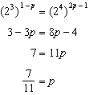

PTS: 2 REF: 061611a2 STA: A2.A.27 TOP: Exponential Equations
KEY: common base not shown

12 ANS: 4 PTS: 2 REF: 061612a2 STA: A2.A.38
TOP: Defining Functions

13 ANS: 4 PTS: 2 REF: 061613a2 STA: A2.S.8
TOP: Correlation Coefficient

14 ANS: 1

PTS: 2 REF: 061614a2 STA: A2.A.60 TOP: Unit Circle

15 ANS: 4 PTS: 2 REF: 061615a2 STA: A2.N.7
TOP: Imaginary Numbers

16 ANS: 1
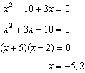

PTS: 2 REF: 061616a2 STA: A2.A.23 TOP: Solving Rationals
KEY: rational solutions

17 ANS: 4
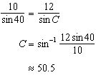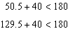

PTS: 2 REF: 061617a2 STA: A2.A.75 TOP: Law of Sines - The Ambiguous Case

18 ANS: 1
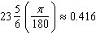

PTS: 2 REF: 061618a2 STA: A2.M.2 TOP: Radian Measure
KEY: radians

19 ANS: 3
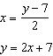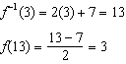

PTS: 2 REF: 061619a2 STA: A2.A.44 TOP: Inverse of Functions
KEY: equations

20 ANS: 3

PTS: 2 REF: 061620a2 STA: A2.A.48 TOP: Equations of Circles

21 ANS: 4
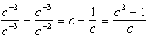

PTS: 2 REF: 061621a2 STA: A2.N.1 TOP: Negative and Fractional Exponents

22 ANS: 1

PTS: 2 REF: 061622a2 STA: A2.A.36 TOP: Binomial Expansions

23 ANS: 3 PTS: 2 REF: 061623a2 STA: A2.A.2
TOP: Using the Discriminant KEY: determine equation given nature of roots

24 ANS: 2 PTS: 2 REF: 061624a2 STA: A2.A.29
TOP: Sequences

25 ANS: 2 PTS: 2 REF: 061625a2 STA: A2.S.4
TOP: Dispersion KEY: basic, group frequency distributions

26 ANS: 1
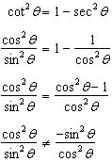

PTS: 2 REF: 061626a2 STA: A2.A.67 TOP: Simplifying Trigonometric Expressions

27 ANS: 4
sum of the roots, 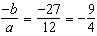. product of the roots, 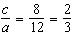

PTS: 2 REF: 061627a2 STA: A2.A.21 TOP: Roots of Quadratics
KEY: basic

28 ANS:
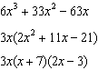

PTS: 2 REF: 061628a2 STA: A2.A.7 TOP: Factoring Polynomials
KEY: single variable

29 ANS:
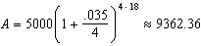

PTS: 2 REF: 061629a2 STA: A2.A.12 TOP: Evaluating Exponential Expressions

30 ANS:

PTS: 2 REF: 061630a2 STA: A2.S.7 TOP: Regression
KEY: exponential

31 ANS:
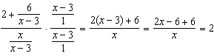

PTS: 2 REF: 061631a2 STA: A2.A.17 TOP: Complex Fractions

32 ANS:
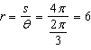

PTS: 2 REF: 061632a2 STA: A2.A.61 TOP: Arc Length
KEY: radius

33 ANS:
2,

PTS: 2 REF: 061633a2 STA: A2.A.69
TOP: Properties of Graphs of Trigonometric Functions KEY: period

34 ANS:

PTS: 2 REF: 061634a2 STA: A2.S.5 TOP: Normal Distributions
KEY: predict

35 ANS:
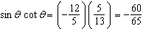

PTS: 2 REF: 061635a2 STA: A2.A.64 TOP: Using Inverse Trigonometric Functions
KEY: advanced

36 ANS:
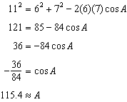

PTS: 4 REF: 061636a2 STA: A2.A.73 TOP: Law of Cosines
KEY: find angle

37 ANS:
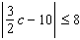 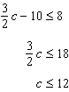 and 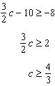

PTS: 4 REF: 061637a2 STA: A2.A.1 TOP: Absolute Value Inequalities

38 ANS:
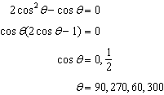

PTS: 4 REF: 061638a2 STA: A2.A.68 TOP: Trigonometric Equations
KEY: quadratics

39 ANS:
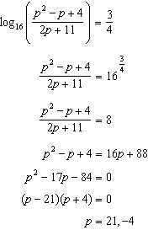

PTS: 6 REF: 061639a2 STA: A2.A.28 TOP: Logarithmic Equations
KEY: applying properties of logarithms

