1 Which list of ordered pairs does not represent a one-to-one function?
1)
2)
3)
4)

2 The terminal side of an angle measuring radians lies in Quadrant
1) | I
2) | II
3) | III
4) | IV

3 If and , what is the value of ?
1)
2)
3) | 25
4) | 129

4 The expression is equivalent to
1)
2)
3)
4)

5 If is solved by completing the square, one of the steps in the process is
1)
2)
3)
4)

6 Which expression is equivalent to 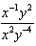?
1)
2)
3)
4)

7 What is the solution of the inequality ?
1)
2)
3)
4)

8 What is the area of a parallelogram that has sides measuring 8 cm and 12 cm and includes an angle of 120°?
1)
2)
3)
4)

9 The expression 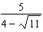 is equivalent to
1)
2) | 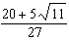
3)
4) | 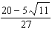

10 Given y varies inversely as x, when y is multiplied by , then x is multiplied by
1)
2) | 2
3)
4)

11 What is the total number of different nine-letter arrangements that can be formed using the letters in the word “TENNESSEE”?
1) | 3,780
2) | 15,120
3) | 45,360
4) | 362,880

12 What is the fourth term of the sequence defined by 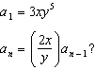
1)
2)
3)
4)

13 What is the solution set of ?
1)
2)
3)
4)

14 By law, a wheelchair service ramp may be inclined no more than 4.76°. If the base of a ramp begins 15 feet from the base of a public building, which equation could be used to determine the maximum height, h, of the ramp where it reaches the building’s entrance?
1) | 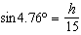
2) | 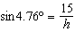
3) | 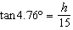
4) | 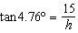

15 When 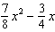 is subtracted from 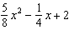, the difference is
1) | 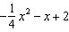
2) | 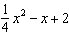
3) | 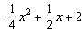
4) | 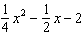

16 Which transformation of moves the graph 7 units to the left and 3 units down?
1)
2)
3)
4)

17 If , then x equals
1)
2)
3)
4)

18 Which value is in the domain of the function graphed below, but is not in its range?

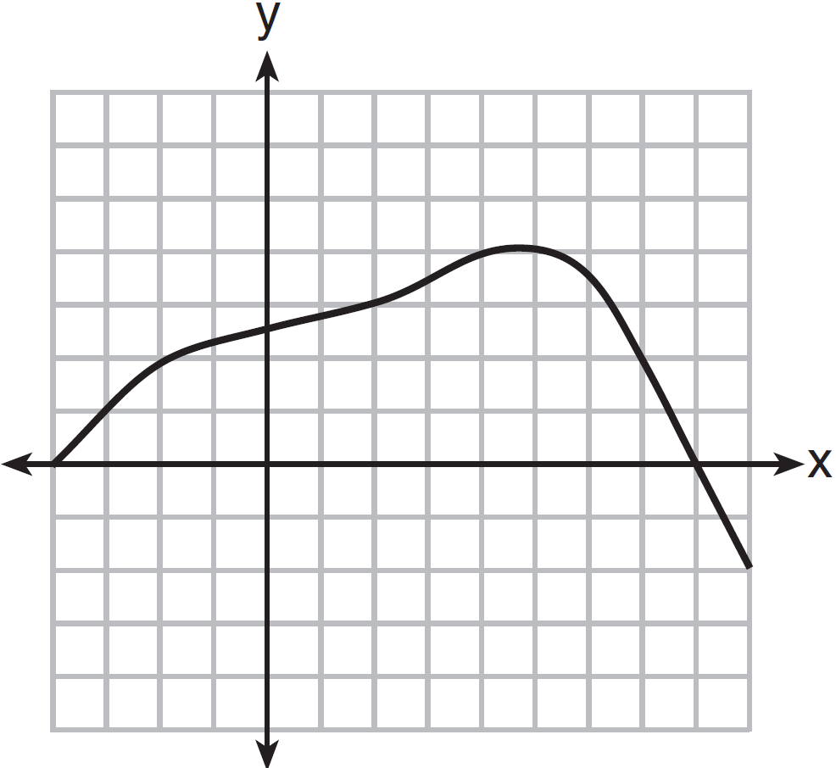
1) | 0
2) | 2
3) | 3
4) | 7

19 How many full cycles of the function appear in  radians?
1) | 1
2) | 2
3) | 3
4) | 4

20 A theater has 35 seats in the first row. Each row has four more seats than the row before it. Which expression represents the number of seats in the nth row?
1)
2)
3)
4)

21 What is the inverse of the function ?
1)
2)
3)
4)

22 The expression 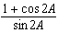 is equivalent to
1)
2)
3)
4)

23 A video-streaming service can choose from six half-hour shows and four one-hour shows. Which expression could be used to calculate the number of different ways the service can choose four half-hour shows and two one-hour shows?
1)
2)
3)
4)

24 The roots of are
1) | imaginary
2) | real, rational, and equal
3) | real, rational, and unequal
4) | real, irrational, and unequal

25 Circle O has a radius of 2 units. An angle with a measure of radians is in standard position. If the terminal side of the angle intersects the circle at point B, what are the coordinates of B?
1) | 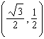
2) | 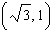
3) | 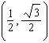
4) | 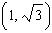

26 What is the value of 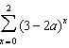?
1)
2)
3)
4)

27 A population, , of wild turkeys in a certain area is represented by the function , where x is the number of years since 2010. How many more turkeys will be in the population for the year 2015 than 2010?
1) | 46
2) | 49
3) | 51
4) | 68

28 Solve algebraically for x:

29 In triangle ABC, determine the number of distinct triangles that can be formed if , side , and side . Justify your answer.

30 The probability that Kay and Joseph Dowling will have a redheaded child is 1 out of 4. If the Dowlings plan to have three children, what is the exact probability that only one child will have red hair?

31 If , find the value of x.

32 Factor completely:

33 Express in simplest form.

34 Given the equation , state the sum and product of the roots.

35 Determine which set of data given below has the stronger linear relationship between x and y. Justify your choice.

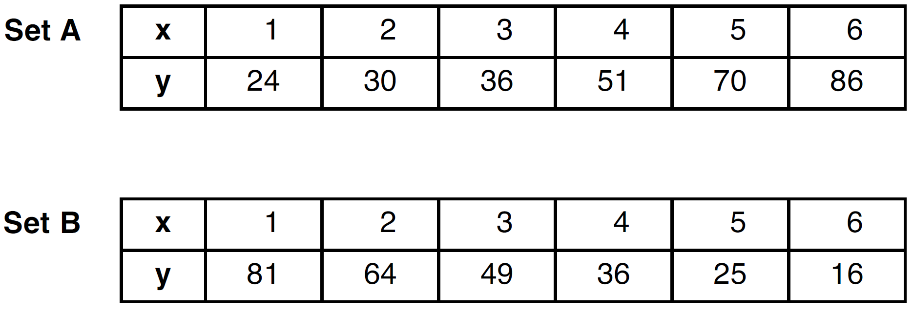

36 Find the measure of the smallest angle, to the nearest degree, of a triangle whose sides measure 28, 47, and 34.

37 Solve algebraically for x: 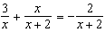

38 The table below shows the final examination scores for Mr. Spear’s class last year.

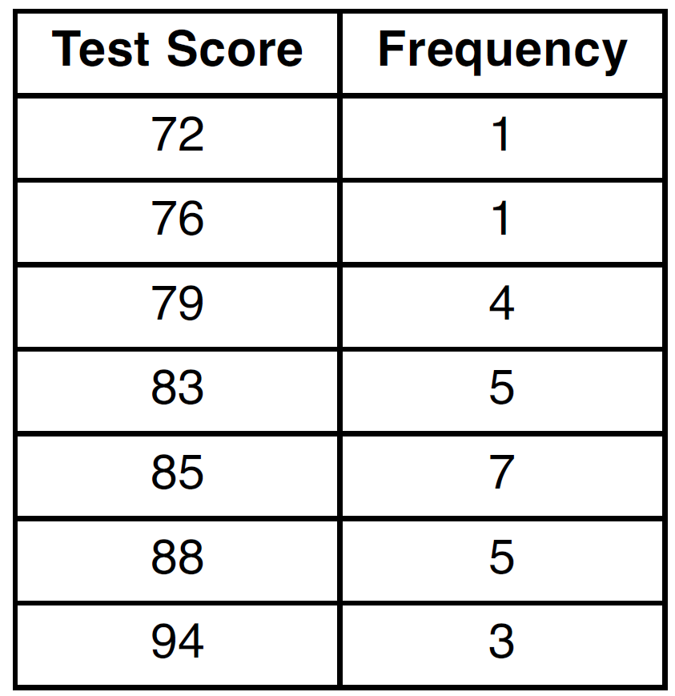

Find the population standard deviation based on these data, to the nearest hundredth. Determine the number of students whose scores are within one population standard deviation of the mean.

39 In the interval , solve the equation algebraically for all values of , to the nearest tenth of a degree.

1 ANS: 3 PTS: 2 REF: 061501a2 STA: A2.A.43
TOP: Defining Functions

2 ANS: 2 PTS: 2 REF: 061502a2 STA: A2.M.1
TOP: Radian Measure

3 ANS: 4

PTS: 2 REF: 061503a2 STA: A2.A.42 TOP: Compositions of Functions
KEY: numbers

4 ANS: 1

PTS: 2 REF: 061504a2 STA: A2.A.14 TOP: Operations with Radicals
KEY: with variables | index > 2

5 ANS: 3
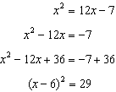

PTS: 2 REF: 061505a2 STA: A2.A.24 TOP: Completing the Square

6 ANS: 4 PTS: 2 REF: 061506a2 STA: A2.A.9
TOP: Negative Exponents

7 ANS: 2
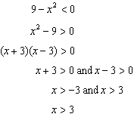or 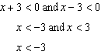

PTS: 2 REF: 061507a2 STA: A2.A.4 TOP: Quadratic Inequalities
KEY: one variable

8 ANS: 2
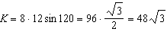

PTS: 2 REF: 061508a2 STA: A2.A.74 TOP: Using Trigonometry to Find Area
KEY: parallelograms

9 ANS: 1
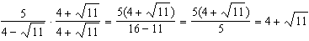

PTS: 2 REF: 061509a2 STA: A2.N.5 TOP: Rationalizing Denominators

10 ANS: 2 PTS: 2 REF: 061510a2 STA: A2.A.5
TOP: Inverse Variation

11 ANS: 1
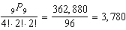

PTS: 2 REF: 061511a2 STA: A2.S.10 TOP: Permutations

12 ANS: 3
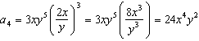

PTS: 2 REF: 061512a2 STA: A2.A.33 TOP: Sequences

13 ANS: 2
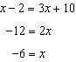 is extraneous. 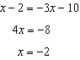

PTS: 2 REF: 061513a2 STA: A2.A.1 TOP: Absolute Value Equations

14 ANS: 3 PTS: 2 REF: 061514a2 STA: A2.A.55
TOP: Trigonometric Ratios

15 ANS: 3 PTS: 2 REF: 061515a2 STA: A2.N.3
TOP: Operations with Polynomials

16 ANS: 1 PTS: 2 REF: 061516a2 STA: A2.A.46
TOP: Transformations with Functions and Relations

17 ANS: 1
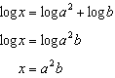

PTS: 2 REF: 061517a2 STA: A2.A.19 TOP: Properties of Logarithms
KEY: antilogarithms

18 ANS: 4 PTS: 2 REF: 061518a2 STA: A2.A.51
TOP: Domain and Range

19 ANS: 1
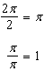

PTS: 2 REF: 061519a2 STA: A2.A.69
TOP: Properties of Graphs of Trigonometric Functions KEY: period

20 ANS: 4 PTS: 2 REF: 061520a2 STA: A2.A.29
TOP: Sequences

21 ANS: 2 PTS: 2 REF: 061521a2 STA: A2.A.44
TOP: Inverse of Functions KEY: equations

22 ANS: 1
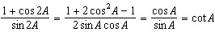

PTS: 2 REF: 061522a2 STA: A2.A.77 TOP: Double Angle Identities
KEY: simplifying

23 ANS: 3 PTS: 2 REF: 061523a2 STA: A2.S.9
TOP: Differentiating Permutations and Combinations

24 ANS: 3

PTS: 2 REF: 061524a2 STA: A2.A.2 TOP: Using the Discriminant
KEY: determine nature of roots given equation

25 ANS: 2
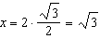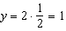

PTS: 2 REF: 061525a2 STA: A2.A.62 TOP: Determining Trigonometric Functions

26 ANS: 4

PTS: 2 REF: 061526a2 STA: A2.N.10 TOP: Sigma Notation
KEY: advanced

27 ANS: 3

PTS: 2 REF: 061527a2 STA: A2.A.12 TOP: Evaluating Exponential Expressions

28 ANS:
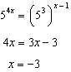

PTS: 2 REF: 061528a2 STA: A2.A.27 TOP: Exponential Equations
KEY: common base shown

29 ANS:
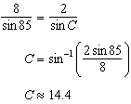 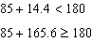 1 triangle

PTS: 2 REF: 061529a2 STA: A2.A.75 TOP: Law of Sines - The Ambiguous Case

30 ANS:
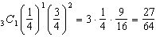

PTS: 2 REF: 061530a2 STA: A2.S.15 TOP: Binomial Probability
KEY: exactly

31 ANS:
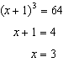

PTS: 2 REF: 061531a2 STA: A2.A.28 TOP: Logarithmic Equations
KEY: basic

32 ANS:
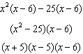

PTS: 2 REF: 061532a2 STA: A2.A.7 TOP: Factoring by Grouping

33 ANS:

PTS: 2 REF: 061533a2 STA: A2.N.7 TOP: Imaginary Numbers

34 ANS:
Sum 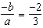. Product 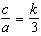

PTS: 2 REF: 061534a2 STA: A2.A.20 TOP: Roots of Quadratics

35 ANS:
Set B has the stronger linear relationship since r is higher.

PTS: 2 REF: 061535a2 STA: A2.S.8 TOP: Correlation Coefficient

36 ANS:
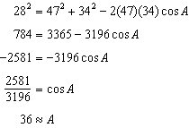

PTS: 4 REF: 061536a2 STA: A2.A.73 TOP: Law of Cosines
KEY: find angle

37 ANS:
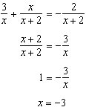

PTS: 4 REF: 061537a2 STA: A2.A.23 TOP: Solving Rationals
KEY: rational solutions

38 ANS:
5.17 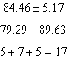

PTS: 4 REF: 061538a2 STA: A2.S.4 TOP: Dispersion
KEY: advanced, group frequency distributions

39 ANS:
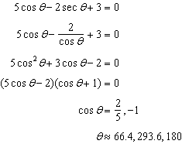

PTS: 6 REF: 061539a2 STA: A2.A.68 TOP: Trigonometric Equations
KEY: reciprocal functions

