1 Which survey is least likely to contain bias?
1) | surveying a sample of people leaving a movie theater to determine which flavor of ice cream is the most popular
2) | surveying the members of a football team to determine the most watched TV sport
3) | surveying a sample of people leaving a library to determine the average number of books a person reads in a year
4) | surveying a sample of people leaving a gym to determine the average number of hours a person exercises per week

2 The expression is equivalent to
1)
2)
3) | 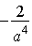
4) | 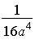

3 Two sides of a triangular-shaped sandbox measure 22 feet and 13 feet. If the angle between these two sides measures 55°, what is the area of the sandbox, to the nearest square foot?
1) | 82
2) | 117
3) | 143
4) | 234

4 Expressed in simplest form, is
1)
2)
3)
4)

5 Theresa is comparing the graphs of and . Which statement is true?
1) | The y-intercept of is , and the y-intercept of is .
2) | Both graphs have a y-intercept of , and is steeper for .
3) | Both graphs have a y-intercept of , and is steeper for .
4) | Neither graph has a y-intercept.

6 The solution set of the equation is
1)
2)
3)
4)

7 The expression 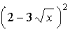 is equivalent to
1)
2)
3)
4)

8 Which step can be used when solving by completing the square?
1)
2)
3)
4)

9 Which graph represents a function?
1) | 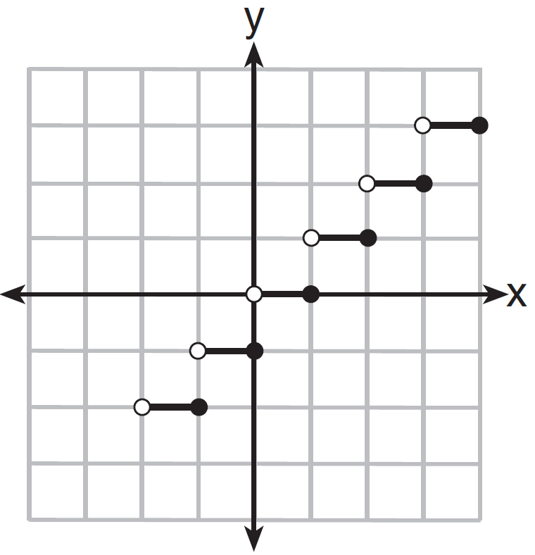
2) | 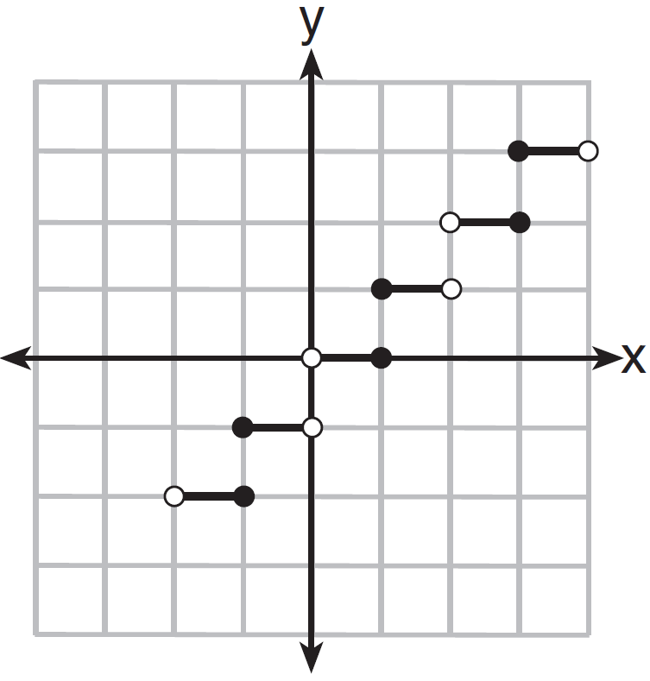
3) | 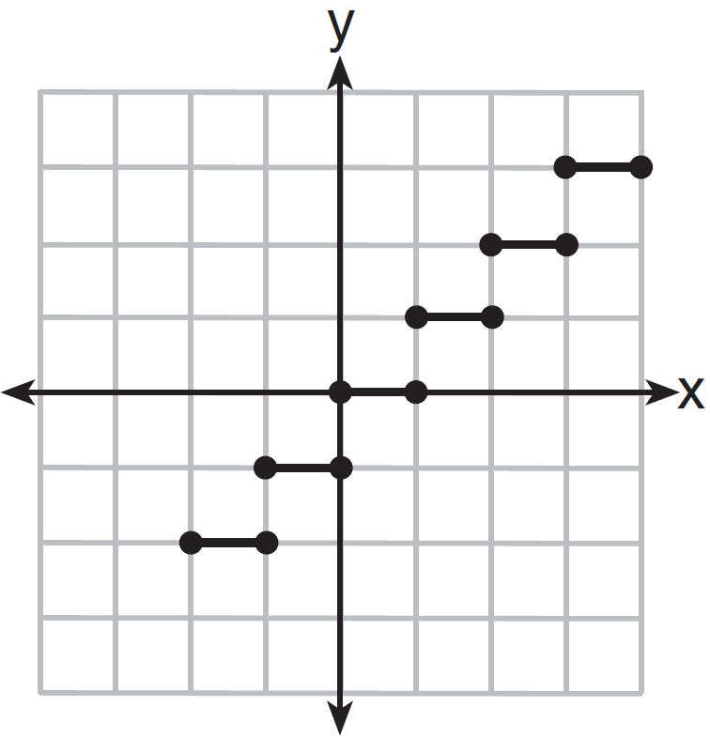
4) | 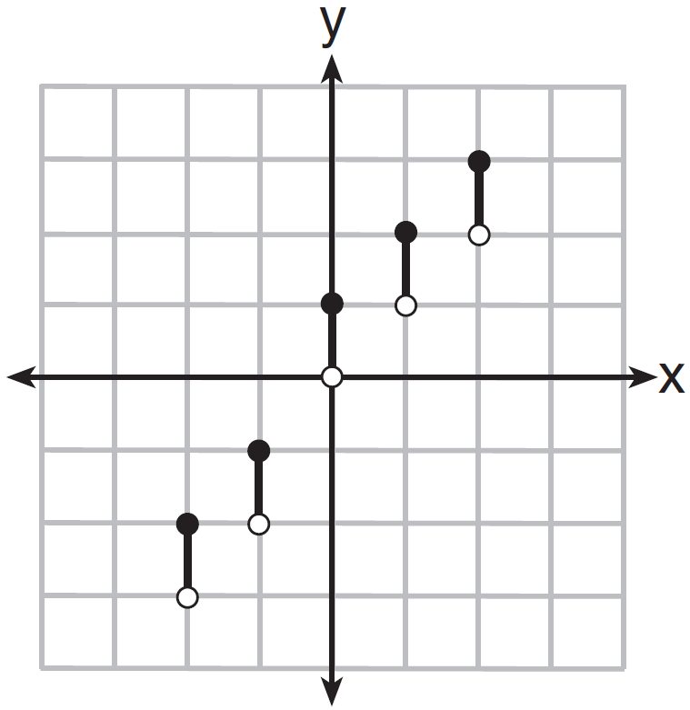

10 The expression 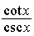 is equivalent to
1)
2)
3)
4)

11 What is the common difference of the arithmetic sequence below?
1)
2)
3) | 3
4)

12 If and , in which quadrant does the terminal side of angle lie?
1) | I
2) | II
3) | III
4) | IV

13 What is the period of the graph 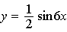?
1)
2)
3)
4)

14 What is the product of the roots of the quadratic equation ?
1) | 5
2)
3)
4)

15 What is the equation of the circle passing through the point and centered at ?
1)
2)
3)
4)

16 The formula to determine continuously compounded interest is , where A is the amount of money in the account, P is the initial investment, r is the interest rate, and t is the time, in years. Which equation could be used to determine the value of an account with an $18,000 initial investment, at an interest rate of 1.25% for 24 months?
1)
2)
3)
4)

17 What is the solution set of the equation 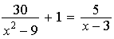?
1)
2)
3)
4)

18 The graph below shows the average price of gasoline, in dollars, for the years 1997 to 2007.

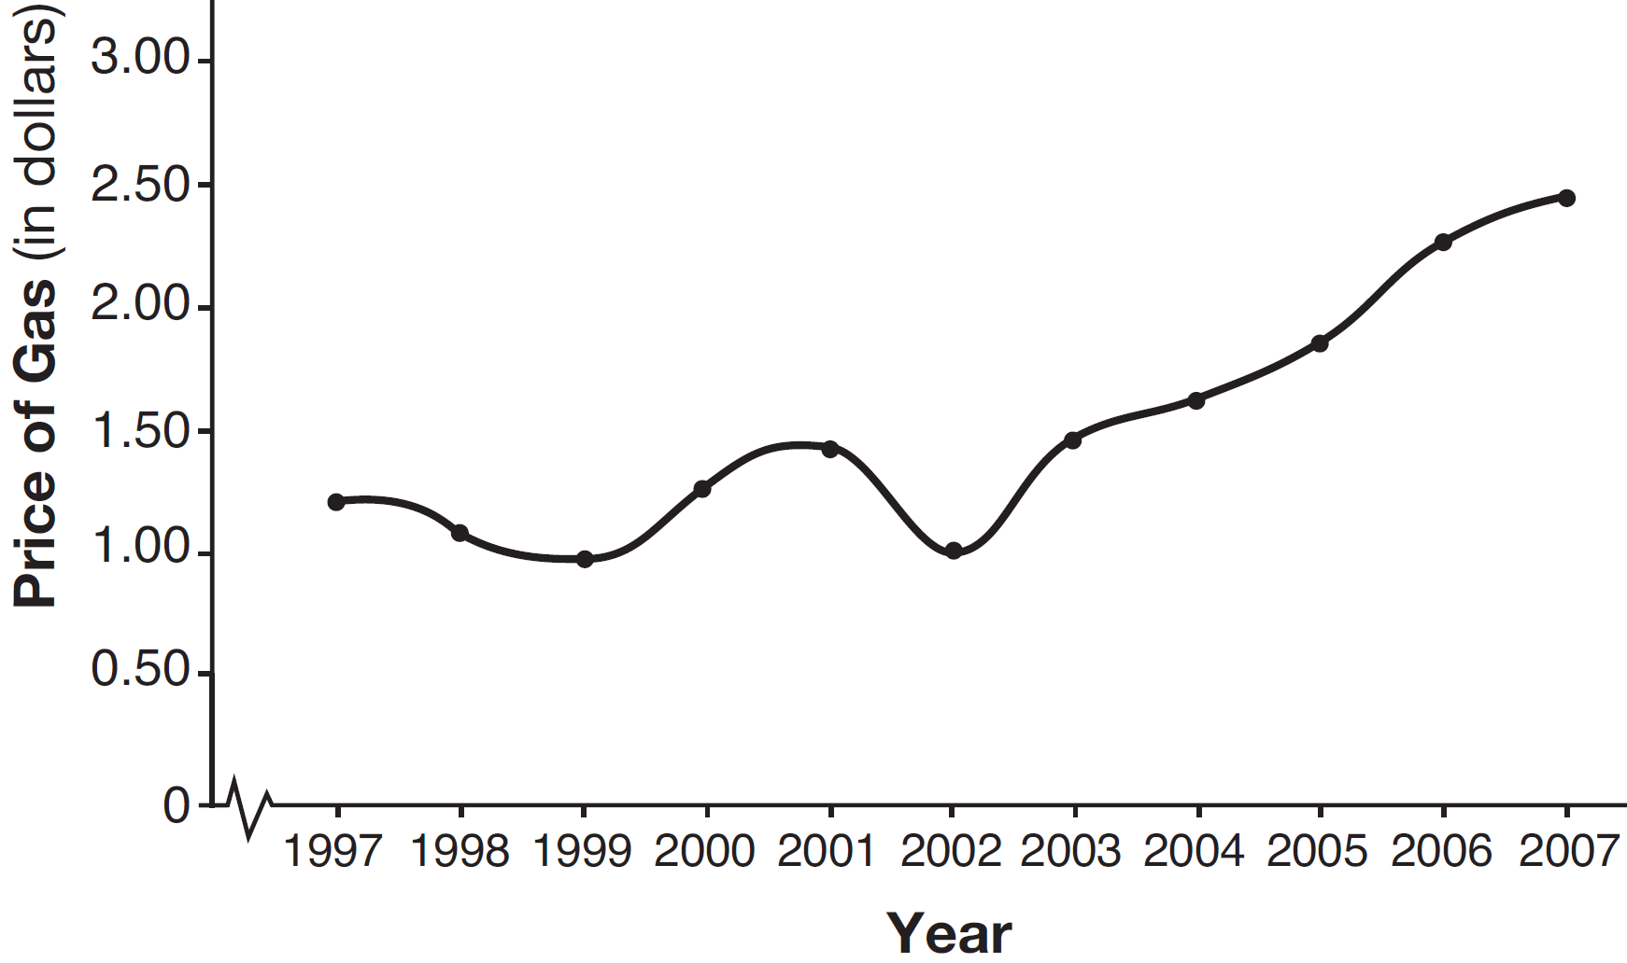

What is the approximate range of this graph?
1)
2)
3)
4)

19 If and , what is ?
1)
2)
3)
4)

20 A jogger ran mile on day 1, and mile on day 2, and miles on day 3, and miles on day 4, and this pattern continued for 3 more days. Which expression represents the total distance the jogger ran?
1) | 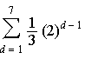
2) | 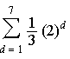
3) | 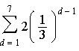
4) | 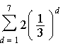

21 If and , then is
1)
2)
3)
4)

22 A school math team consists of three juniors and five seniors. How many different groups can be formed that consist of one junior and two seniors?
1) | 13
2) | 15
3) | 30
4) | 60

23 For which value of k will the roots of the equation be real and rational numbers?
1) | 1
2)
3) | 0
4) | 4

24 A cliff diver on a Caribbean island jumps from a height of 105 feet, with an initial upward velocity of 5 feet per second. An equation that models the height, , above the water, in feet, of the diver in time elapsed, t, in seconds, is . How many seconds, to the nearest hundredth, does it take the diver to fall 45 feet below his starting point?
1) | 1.45
2) | 1.84
3) | 2.10
4) | 2.72

25 The number of possible different 12-letter arrangements of the letters in the word “TRIGONOMETRY” is represented by
1) | 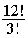
2) | 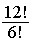
3) | 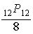
4) | 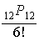

26 If , then equals
1)
2)
3)
4)

27 Which statement regarding the inverse function is true?
1) | A domain of is .
2) | The range of is .
3) | A domain of is .
4) | The range of is .

28 In a certain school, the heights of the population of girls are normally distributed, with a mean of 63 inches and a standard deviation of 2 inches. If there are 450 girls in the school, determine how many of the girls are shorter than 60 inches. Round the answer to the nearest integer.

29 The table below shows the concentration of ozone in Earth’s atmosphere at different altitudes. Write the exponential regression equation that models these data, rounding all values to the nearest thousandth.

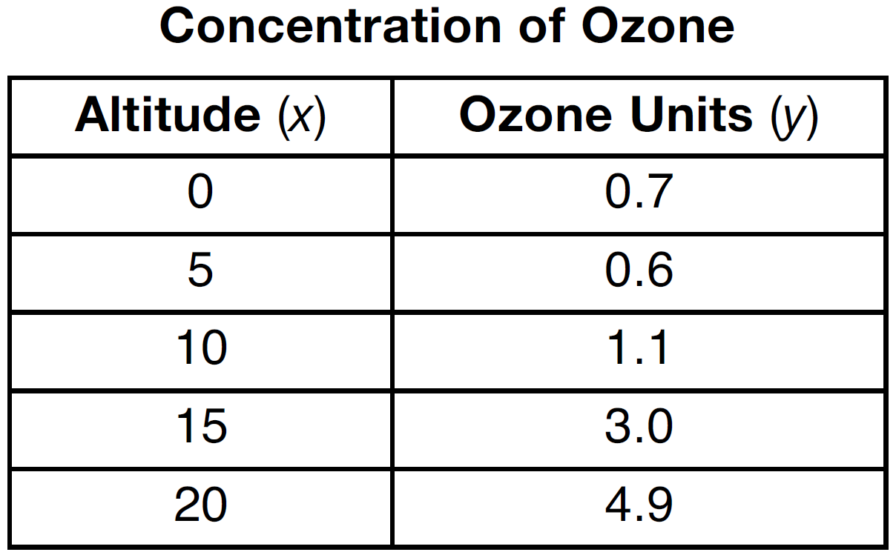

30 Solve algebraically.

31 Convert 2.5 radians to degrees, and express the answer to the nearest minute.

32 Multiply by its conjugate, and express the product in simplest form.

33 Solve algebraically for x: 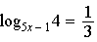

34 Solve algebraically for all values of x in .

35 The function is graphed on the set of axes below. On the same set of axes, graph .

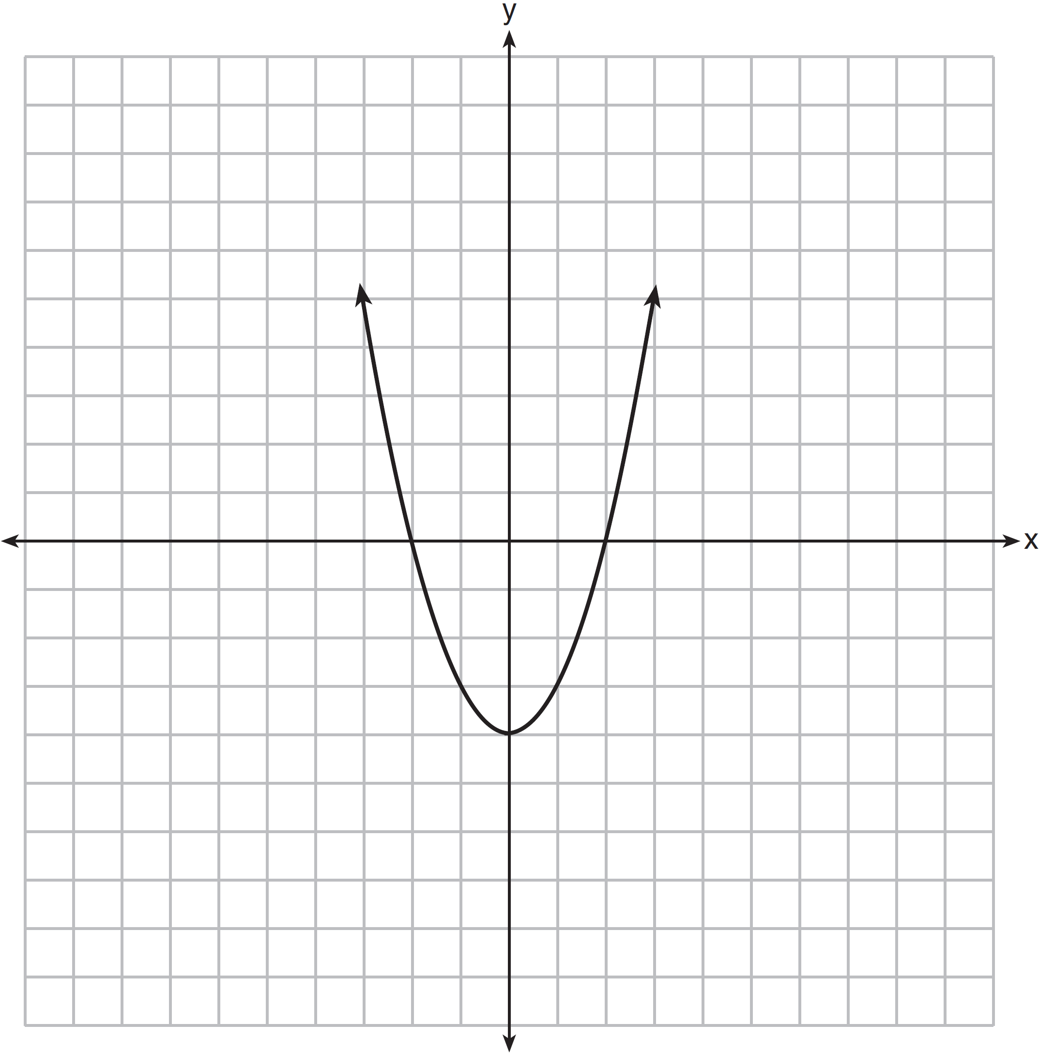

36 Express in simplest terms: 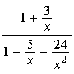

37 Solve algebraically.

38 Whenever Sara rents a movie, the probability that it is a horror movie is 0.57. Of the next five movies she rents, determine the probability, to the nearest hundredth, that no more than two of these rentals are horror movies.

39 Two forces of 40 pounds and 28 pounds act on an object. The angle between the two forces is 65°. Find the magnitude of the resultant force, to the nearest pound. Using this answer, find the measure of the angle formed between the resultant and the smaller force, to the nearest degree.
1 ANS: 1 PTS: 2 REF: 061401a2 STA: A2.S.2
TOP: Analysis of Data

2 ANS: 4 PTS: 2 REF: 061402a2 STA: A2.A.8
TOP: Negative and Fractional Exponents

3 ANS: 2
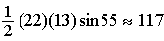

PTS: 2 REF: 061403a2 STA: A2.A.74 TOP: Using Trigonometry to Find Area
KEY: basic

4 ANS: 3

PTS: 2 REF: 061404a2 STA: A2.N.6 TOP: Square Roots of Negative Numbers

5 ANS: 3
As originally written, alternatives (2) and (3) had no domain restriction, so that both were correct.

PTS: 2 REF: 061405a2 STA: A2.A.52
TOP: Properties of Graphs of Functions and Relations

6 ANS: 2
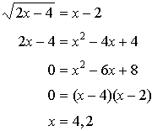

PTS: 2 REF: 061406a2 STA: A2.A.22 TOP: Solving Radicals
KEY: extraneous solutions

7 ANS: 3 PTS: 2 REF: 061407a2 STA: A2.N.4
TOP: Operations with Irrational Expressions
8 ANS: 1 PTS: 2 REF: 061408a2 STA: A2.A.24
TOP: Completing the Square

9 ANS: 1 PTS: 2 REF: 061409a2 STA: A2.A.38
TOP: Defining Functions KEY: graphs

10 ANS: 2
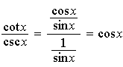

PTS: 2 REF: 061410a2 STA: A2.A.58 TOP: Reciprocal Trigonometric Relationships

11 ANS: 4 PTS: 2 REF: 061411a2 STA: A2.A.30
TOP: Sequences

12 ANS: 3 PTS: 2 REF: 061412a2 STA: A2.A.60
TOP: Finding the Terminal Side of an Angle

13 ANS: 2
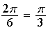

PTS: 2 REF: 061413a2 STA: A2.A.69
TOP: Properties of Graphs of Trigonometric Functions KEY: period

14 ANS: 4
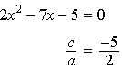

PTS: 2 REF: 061414a2 STA: A2.A.20 TOP: Roots of Quadratics

15 ANS: 4
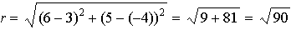

PTS: 2 REF: 061415a2 STA: A2.A.48 TOP: Equations of Circles

16 ANS: 3 PTS: 2 REF: 061416a2 STA: A2.A.12
TOP: Evaluating Exponential Expressions

17 ANS: 2
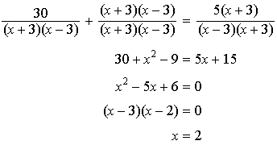 3 is an extraneous root.

PTS: 2 REF: 061417a2 STA: A2.A.23 TOP: Solving Rationals
KEY: rational solutions

18 ANS: 3 PTS: 2 REF: 061418a2 STA: A2.A.51
TOP: Domain and Range

19 ANS: 1

PTS: 2 REF: 061419a2 STA: A2.A.42 TOP: Compositions of Functions
KEY: variables

20 ANS: 1 PTS: 2 REF: 061420a2 STA: A2.A.34
TOP: Sigma Notation

21 ANS: 2
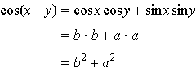

PTS: 2 REF: 061421a2 STA: A2.A.76 TOP: Angle Sum and Difference Identities
KEY: simplifying

22 ANS: 3

PTS: 2 REF: 061422a2 STA: A2.S.12 TOP: Combinations

23 ANS: 3

PTS: 2 REF: 061423a2 STA: A2.A.2 TOP: Using the Discriminant
KEY: determine equation given nature of roots

24 ANS: 2
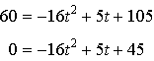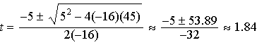

PTS: 2 REF: 061424a2 STA: A2.A.25 TOP: Quadratics with Irrational Solutions

25 ANS: 3

PTS: 2 REF: 061425a2 STA: A2.S.10 TOP: Permutations

26 ANS: 4

PTS: 2 REF: 061426a2 STA: A2.A.19 TOP: Properties of Logarithms
KEY: splitting logs

27 ANS: 4 PTS: 2 REF: 061427a2 STA: A2.A.63
TOP: Domain and Range

28 ANS:
Less than 60 inches is below 1.5 standard deviations from the mean.

PTS: 2 REF: 061428a2 STA: A2.S.5 TOP: Normal Distributions
KEY: predict

29 ANS:

PTS: 2 REF: 061429a2 STA: A2.S.7 TOP: Exponential Regression

30 ANS:
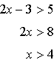 or 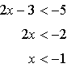

PTS: 2 REF: 061430a2 STA: A2.A.1 TOP: Absolute Value Inequalities

31 ANS:
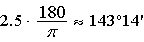

PTS: 2 REF: 061431a2 STA: A2.M.2 TOP: Radian Measure
KEY: degrees

32 ANS:

PTS: 2 REF: 061432a2 STA: A2.N.8 TOP: Conjugates of Complex Numbers

33 ANS:
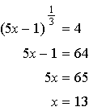

PTS: 2 REF: 061433a2 STA: A2.A.28 TOP: Logarithmic Equations
KEY: advanced

34 ANS:
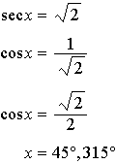

PTS: 2 REF: 061434a2 STA: A2.A.68 TOP: Trigonometric Equations
KEY: reciprocal functions

35 ANS:
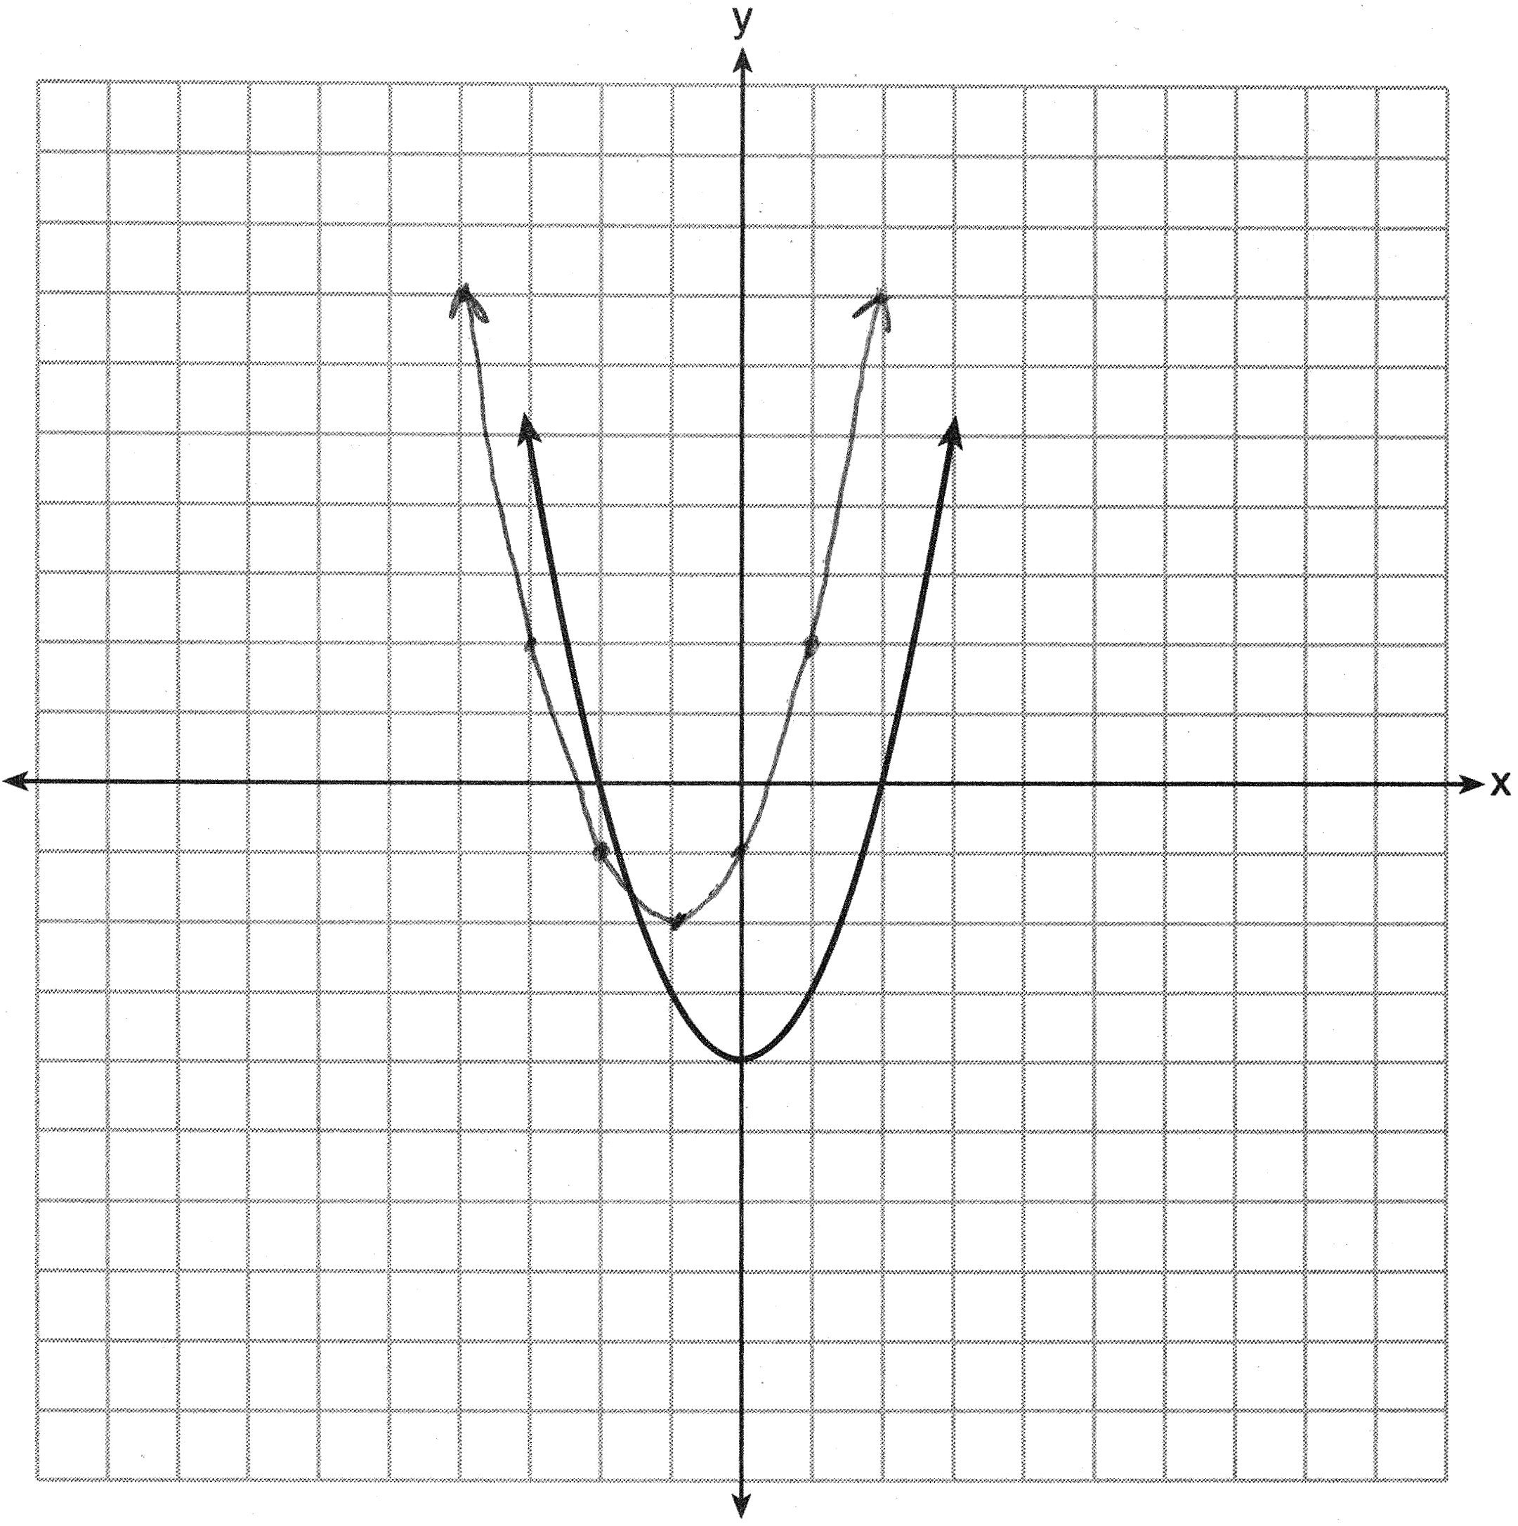

PTS: 2 REF: 061435a2 STA: A2.A.46
TOP: Transformations with Functions and Relations

36 ANS:
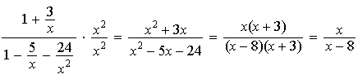

PTS: 4 REF: 061436a2 STA: A2.A.17 TOP: Complex Fractions

37 ANS:
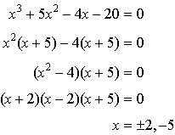

PTS: 4 REF: 061437a2 STA: A2.A.26 TOP: Solving Polynomial Equations

38 ANS:

PTS: 4 REF: 061438a2 STA: A2.S.15 TOP: Binomial Probability
KEY: at least or at most

39 ANS:
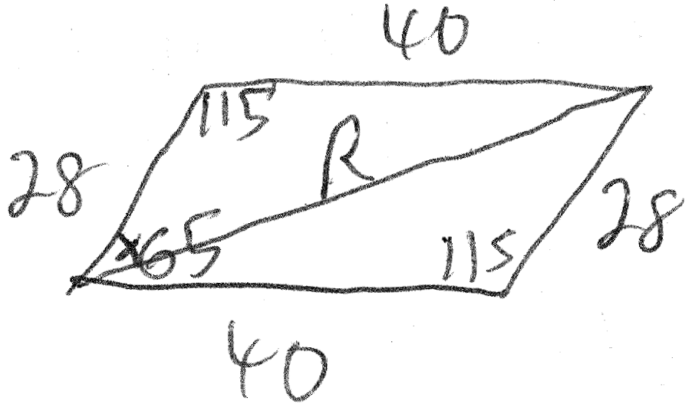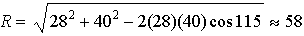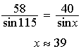

PTS: 6 REF: 061439a2 STA: A2.A.73 TOP: Vectors

