1 A market research firm needs to collect data on viewer preferences for local news programming in Buffalo. Which method of data collection is most appropriate?
1) | census
2) | survey
3) | observation
4) | controlled experiment

2 What is the number of degrees in an angle whose radian measure is ?
1) | 576
2) | 288
3) | 225
4) | 113

3 Which diagram represents a relation that is both one-to-one and onto?
1) | 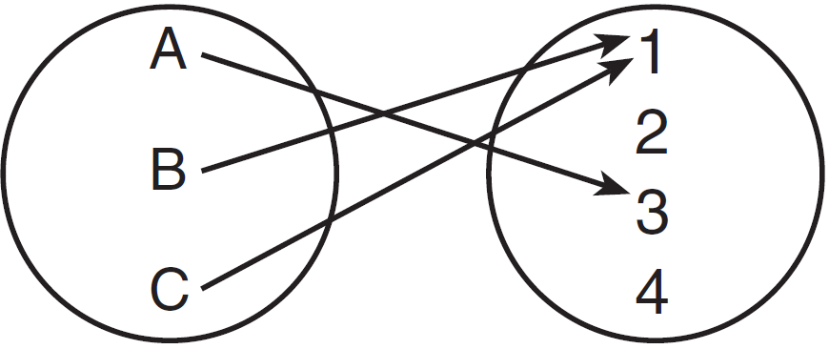
2) | 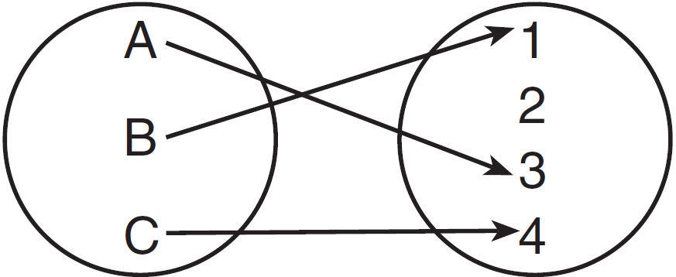
3) | 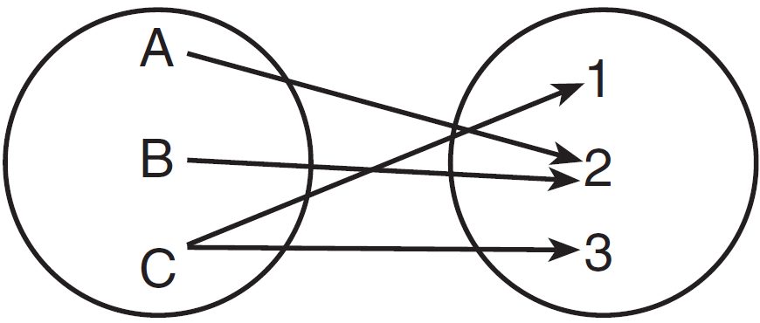
4) | 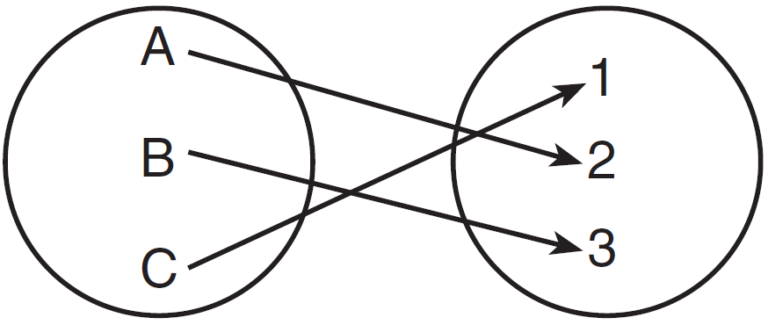

4 The sum of the first eight terms of the series is
1)
2)
3)
4)

5 The simplest form of 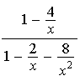 is
1)
2) | 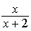
3)
4) | 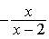

6 Which equation represents the graph below?

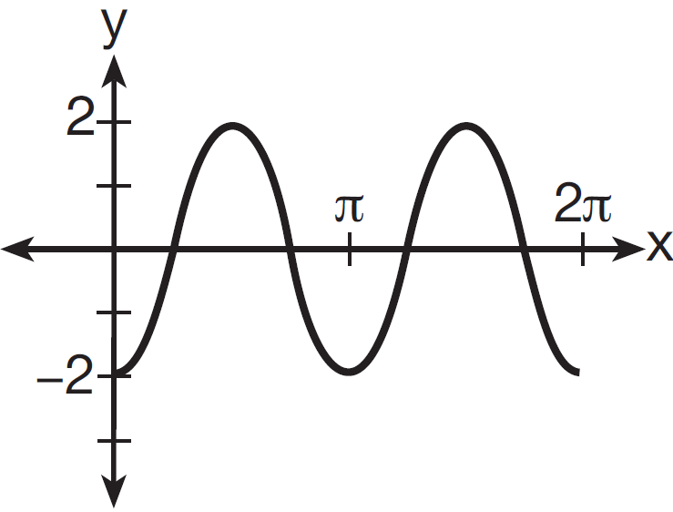
1)
2) | 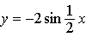
3)
4) | 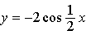

7 What is the graph of the solution set of ?
1) | 
2) | 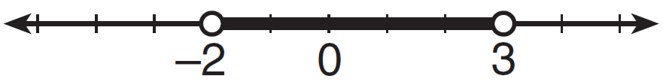
3) | 
4) | 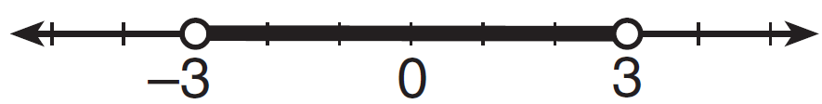

8 What is the range of the function shown below?

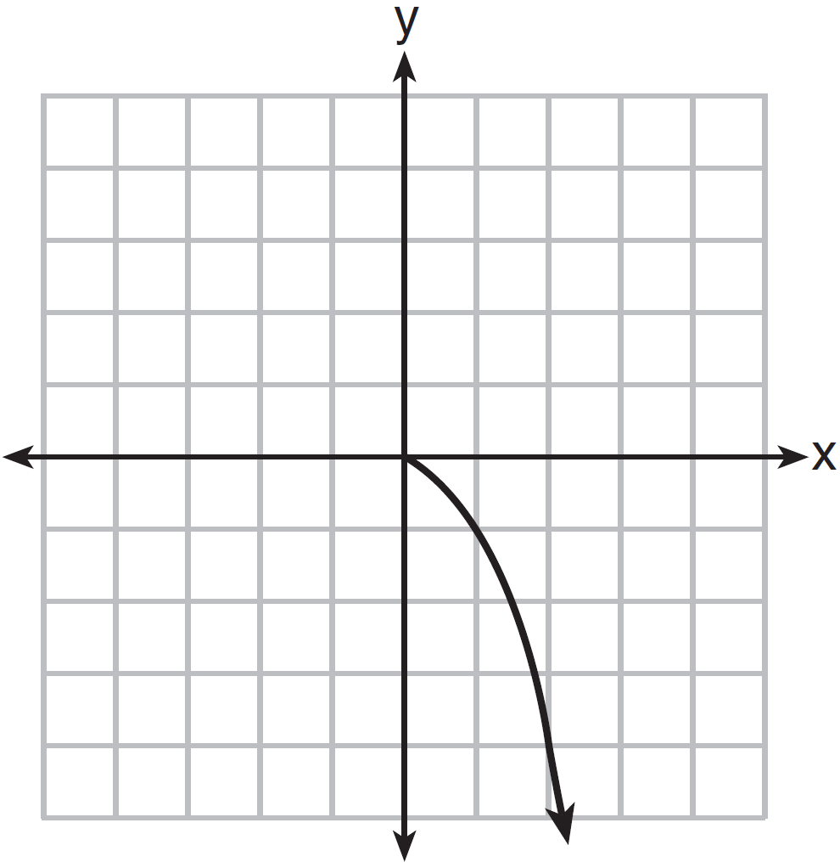
1)
2)
3)
4)

9 The expression is equivalent to
1)
2)
3)
4)

10 The points , 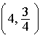, and lie on the graph of a function. If y is inversely proportional to the square of x, what is the value of d?
1) | 1
2)
3) | 3
4) | 27

11 In the right triangle shown below, what is the measure of angle S, to the nearest minute?

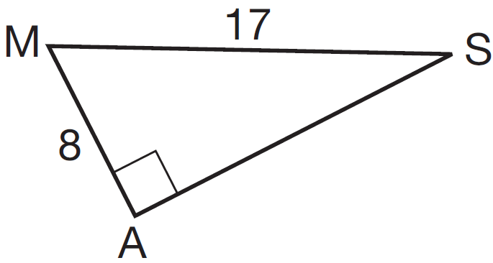
1)
2)
3)
4)

12 Which ordered pair is in the solution set of the system of equations shown below?
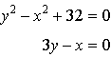
1)
2)
3)
4)

13 Susie invests $500 in an account that is compounded continuously at an annual interest rate of 5%, according to the formula , where A is the amount accrued, P is the principal, r is the rate of interest, and t is the time, in years. Approximately how many years will it take for Susie’s money to double?
1) | 1.4
2) | 6.0
3) | 13.9
4) | 14.7

14 If n is a negative integer, then which statement is always true?
1)
2) | 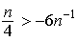
3)
4)

15 The expression 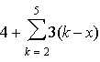 is equal to
1)
2)
3)
4)

16 Which value of r represents data with a strong positive linear correlation between two variables?
1) | 0.89
2) | 0.34
3) | 1.04
4) | 0.01

17 Which problem involves evaluating ?
1) | How many different four-digit ID numbers can be formed using 1, 2, 3, 4, 5, and 6 without repetition?
2) | How many different subcommittees of four can be chosen from a committee having six members?
3) | How many different outfits can be made using six shirts and four pairs of pants?
4) | How many different ways can one boy and one girl be selected from a group of four boys and six girls?

18 Which equation is represented by the graph below?

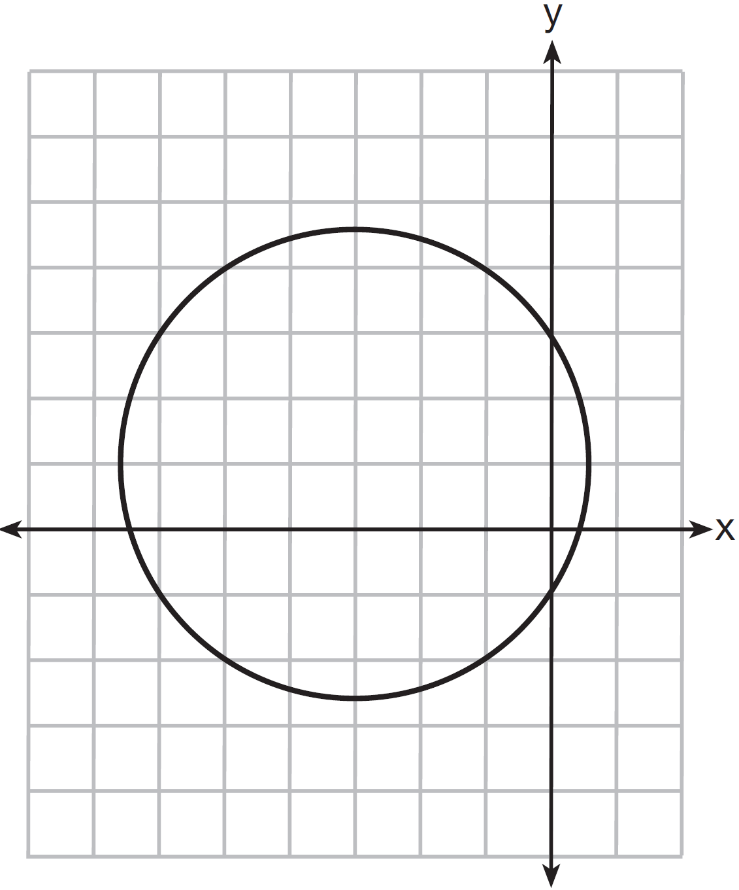
1)
2)
3)
4)

19 If , , and , the expression equals
1)
2)
3)
4)

20 An angle, P, drawn in standard position, terminates in Quadrant II if
1) | and
2) | and
3) | and
4) | and

21 The expression is equivalent to
1)
2)
3)
4)

22 In , p equals
1) | 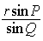
2) | 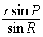
3) | 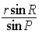
4) | 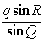

23 If 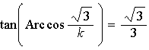, then k is
1) | 1
2) | 2
3)
4)

24 Which expression is equivalent to 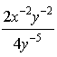?
1) | 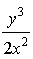
2) | 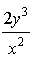
3) | 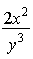
4) | 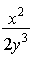

25 Expressed with a rational denominator and in simplest form, 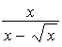 is
1) | 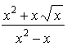
2)
3) | 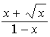
4) | 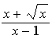

26 What is the common ratio of the sequence 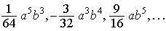?
1) | 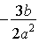
2) | 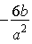
3) | 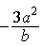
4) | 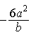

27 In , , , and . The measure of ?
1) | must be between 0° and 90°
2) | must equal 90°
3) | must be between 90° and 180°
4) | is ambiguous

28 Determine the sum and the product of the roots of the equation .

29 Solve algebraically for x: 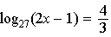

30 Find the number of possible different 10-letter arrangements using the letters of the word “STATISTICS.”

31 Express the product of cos 30° and sin 45° in simplest radical form.

32 Find, algebraically, the measure of the obtuse angle, to the nearest degree, that satisfies the equation .

33 If 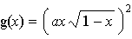, express in simplest form.

34 Express 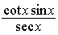 as a single trigonometric function, in simplest form, for all values of x for which it is defined.

35 On a multiple-choice test, Abby randomly guesses on all seven questions. Each question has four choices. Find the probability, to the nearest thousandth, that Abby gets exactly three questions correct.

36 Solve the equation below algebraically, and express the result in simplest radical form:
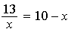

37 A ranch in the Australian Outback is shaped like triangle ACE, with , , and miles. Find the area of the ranch, to the nearest square mile.

38 Ten teams competed in a cheerleading competition at a local high school. Their scores were 29, 28, 39, 37, 45, 40, 41, 38, 37, and 48. How many scores are within one population standard deviation from the mean? For these data, what is the interquartile range?

39 Solve algebraically for all values of x:
1 ANS: 2 PTS: 2 REF: 061301a2 STA: A2.S.1
TOP: Analysis of Data

2 ANS: 2
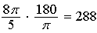

PTS: 2 REF: 061302a2 STA: A2.M.2 TOP: Radian Measure
KEY: degrees

3 ANS: 4 PTS: 2 REF: 061303a2 STA: A2.A.43
TOP: Defining Functions

4 ANS: 3
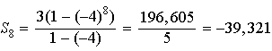

PTS: 2 REF: 061304a2 STA: A2.A.35 TOP: Summations
KEY: geometric

5 ANS: 2
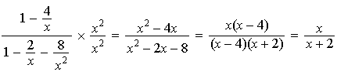

PTS: 2 REF: 061305a2 STA: A2.A.17 TOP: Complex Fractions

6 ANS: 3 PTS: 2 REF: 061306a2 STA: A2.A.72
TOP: Identifying the Equation of a Trigonometric Graph

7 ANS: 1
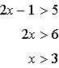. 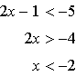

PTS: 2 REF: 061307a2 STA: A2.A.1 TOP: Absolute Value Inequalities
KEY: graph

8 ANS: 3 PTS: 2 REF: 061308a2 STA: A2.A.51
TOP: Domain and Range

9 ANS: 4

PTS: 2 REF: 061309a2 STA: A2.A.76 TOP: Angle Sum and Difference Identities
KEY: identities

10 ANS: 2
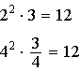. 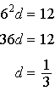

PTS: 2 REF: 061310a2 STA: A2.A.5 TOP: Inverse Variation

11 ANS: 2
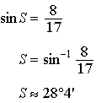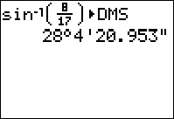

PTS: 2 REF: 061311a2 STA: A2.A.55 TOP: Trigonometric Ratios

12 ANS: 4
. 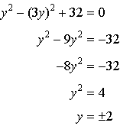.

PTS: 2 REF: 061312a2 STA: A2.A.3 TOP: Quadratic-Linear Systems
KEY: equations

13 ANS: 3
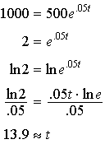

PTS: 2 REF: 061313a2 STA: A2.A.6 TOP: Exponential Growth

14 ANS: 3
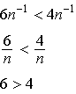. Flip sign when multiplying each side of the inequality by n, since a negative number.

PTS: 2 REF: 061314a2 STA: A2.N.1 TOP: Negative and Fractional Exponents

15 ANS: 4
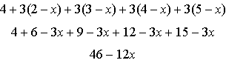

PTS: 2 REF: 061315a2 STA: A2.N.10 TOP: Sigma Notation
KEY: basic

16 ANS: 1 PTS: 2 REF: 061316a2 STA: A2.S.8
TOP: Correlation Coefficient

17 ANS: 1 PTS: 2 REF: 061317a2 STA: A2.S.9
TOP: Differentiating Permutations and Combinations

18 ANS: 4 PTS: 2 REF: 061318a2 STA: A2.A.49
TOP: Equations of Circles

19 ANS: 3
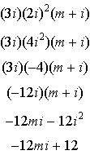

PTS: 2 REF: 061319a2 STA: A2.N.9
TOP: Multiplication and Division of Complex Numbers

20 ANS: 3
If , . If and ,

PTS: 2 REF: 061320a2 STA: A2.A.60 TOP: Finding the Terminal Side of an Angle

21 ANS: 3

PTS: 2 REF: 061321a2 STA: A2.A.19 TOP: Properties of Logarithms
KEY: splitting logs

22 ANS: 2 PTS: 2 REF: 061322a2 STA: A2.A.73
TOP: Law of Sines KEY: side, without calculator

23 ANS: 2
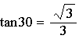. 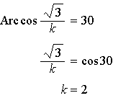

PTS: 2 REF: 061323a2 STA: A2.A.64 TOP: Using Inverse Trigonometric Functions
KEY: advanced

24 ANS: 1 PTS: 2 REF: 061324a2 STA: A2.A.9
TOP: Negative Exponents

25 ANS: 4
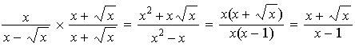

PTS: 2 REF: 061325a2 STA: A2.A.15 TOP: Rationalizing Denominators
KEY: index = 2

26 ANS: 2
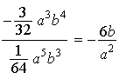

PTS: 2 REF: 061326a2 STA: A2.A.31 TOP: Sequences

27 ANS: 4
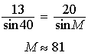. .

PTS: 2 REF: 061327a2 STA: A2.A.75 TOP: Law of Sines - The Ambiguous Case

28 ANS:
Sum 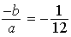. Product 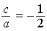

PTS: 2 REF: 061328a2 STA: A2.A.20 TOP: Roots of Quadratics

29 ANS:
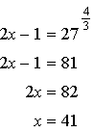

PTS: 2 REF: 061329a2 STA: A2.A.28 TOP: Logarithmic Equations
KEY: advanced

30 ANS:
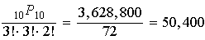

PTS: 2 REF: 061330a2 STA: A2.S.10 TOP: Permutations

31 ANS:
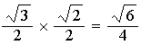

PTS: 2 REF: 061331a2 STA: A2.A.56 TOP: Determining Trigonometric Functions
KEY: degrees, common angles

32 ANS:
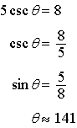

PTS: 2 REF: 061332a2 STA: A2.A.68 TOP: Trigonometric Equations
KEY: reciprocal functions

33 ANS:
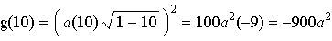

PTS: 2 REF: 061333a2 STA: A2.A.41 TOP: Functional Notation

34 ANS:
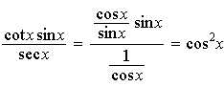

PTS: 2 REF: 061334a2 STA: A2.A.58 TOP: Reciprocal Trigonometric Relationships

35 ANS:
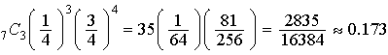

PTS: 2 REF: 061335a2 STA: A2.S.15 TOP: Binomial Probability
KEY: exactly

36 ANS:
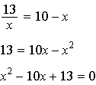. 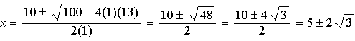

PTS: 4 REF: 061336a2 STA: A2.A.23 TOP: Solving Rationals
KEY: irrational and complex solutions

37 ANS:
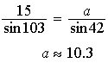. 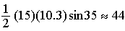

PTS: 4 REF: 061337a2 STA: A2.A.74 TOP: Using Trigonometry to Find Area
KEY: advanced

38 ANS:
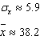. 6 scores are within a population standard deviation of the mean.

PTS: 4 REF: 061338a2 STA: A2.S.4 TOP: Dispersion
KEY: advanced

39 ANS:
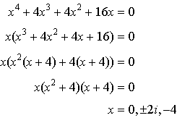

PTS: 6 REF: 061339a2 STA: A2.A.26 TOP: Solving Polynomial Equations

