1 What is the product of 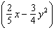 and 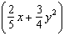?
1) | 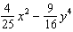
2) | 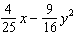
3) | 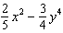
4)

2 What is the domain of the function shown below?

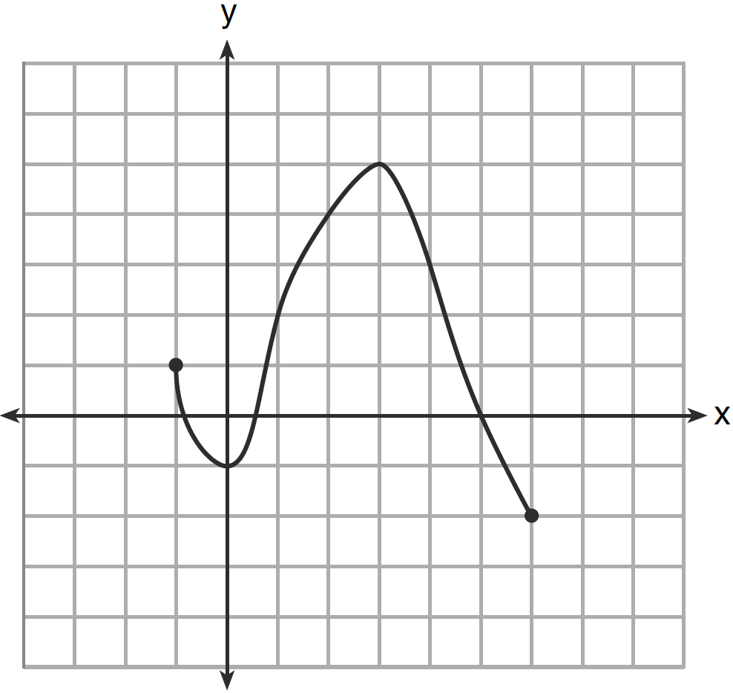
1)
2)
3)
4)

3 What is the solution set for in the interval ?
1)
2)
3)
4)

4 The expression is equivalent to
1)
2)
3)
4)

5 Which summation represents ?
1)
2) | 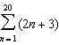
3) | 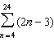
4) | 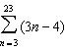

6 If , which diagram represents drawn in standard position?
1) | 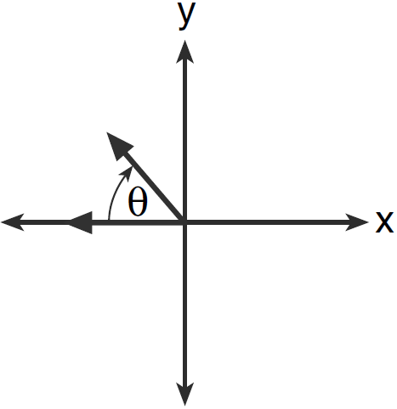
2) | 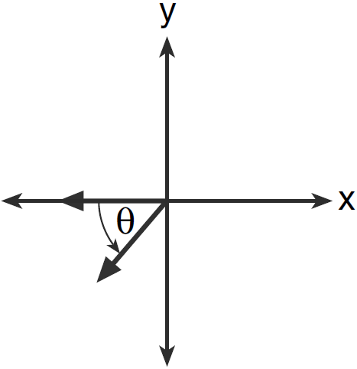
3) | 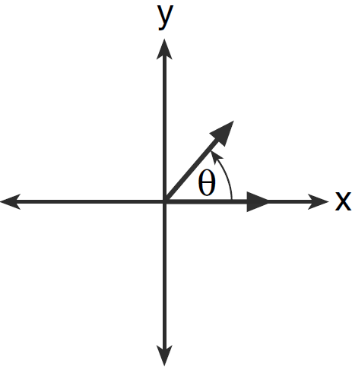
4) | 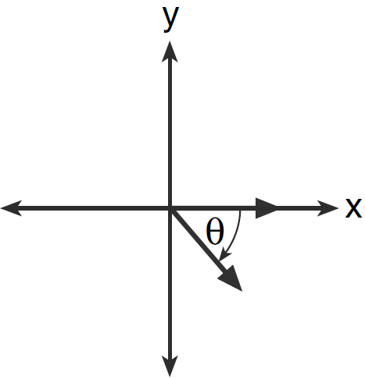

7 If 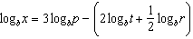, then the value of x is
1) | 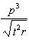
2) | 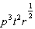
3) | 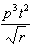
4) | 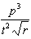

8 Which equation has roots with the sum equal to and the product equal to ?
1)
2)
3)
4)

9 Which graph represents the solution set of 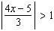?
1)
2)
3)
4)

10 Which expression is equivalent to 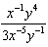?
1) | 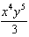
2) | 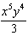
3)
4)

11 Which graph represents the function ?
1) | 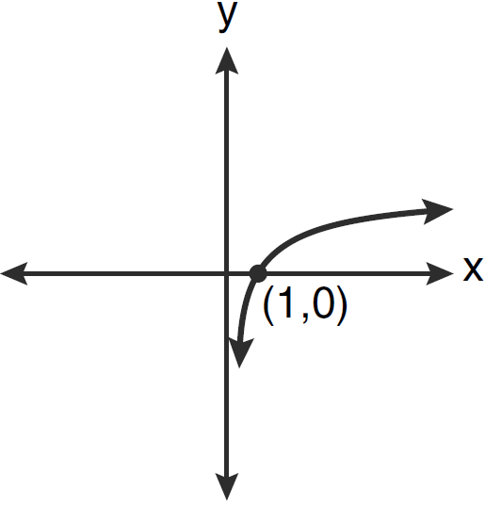
2) | 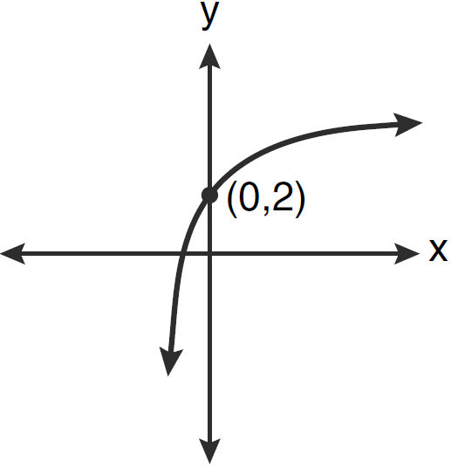
3) | 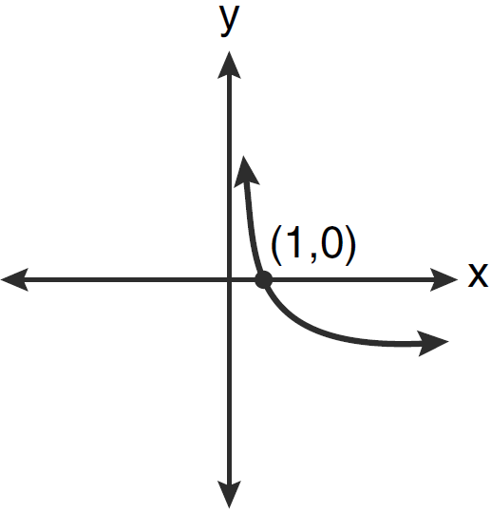
4) | 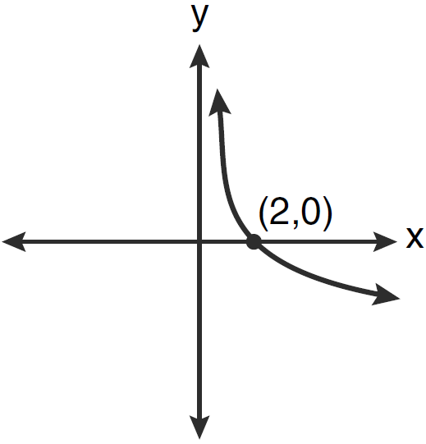

12 A circle is drawn to represent a pizza with a 12 inch diameter. The circle is cut into eight congruent pieces. What is the length of the outer edge of any one piece of this circle?
1)
2)
3)
4)

13 What is the solution set for the equation ?
1)
2)
3)
4)

14 When factored completely, equals
1)
2)
3)
4)

15 What is the middle term in the expansion of 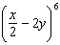?
1)
2) | 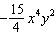
3)
4) | 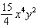

16 Which expression is equivalent to , given , , and ?
1)
2)
3)
4)

17 The value of rounded to four decimal places is
1)
2)
3) | 1.5012
4) | 1.5057

18 Which function is one-to-one?
1)
2)
3)
4)

19 The conjugate of the complex expression is
1)
2)
3)
4)

20 What is a positive value of 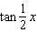, when ?
1) | 0.5
2) | 0.4
3) | 0.33
4) | 0.25

21 The table below displays the results of a survey regarding the number of pets each student in a class has. The average number of pets per student in this class is 2.

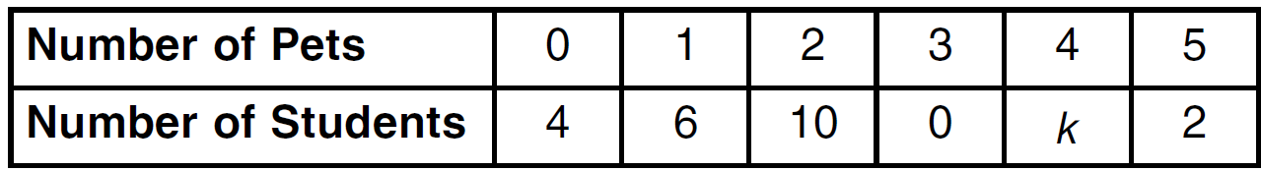

What is the value of k for this table?
1) | 9
2) | 2
3) | 8
4) | 4

22 How many negative solutions to the equation exist?
1) | 1
2) | 2
3) | 3
4) | 0

23 A study finds that 80% of the local high school students text while doing homework. Ten students are selected at random from the local high school. Which expression would be part of the process used to determine the probability that, at most, 7 of the 10 students text while doing homework?
1) | 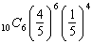
2) | 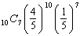
3) | 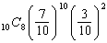
4) | 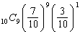

24 In which interval of is the inverse also a function?
1) | 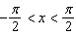
2) | 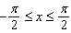
3)
4) | 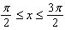

25 As shown in the table below, a person’s target heart rate during exercise changes as the person gets older.

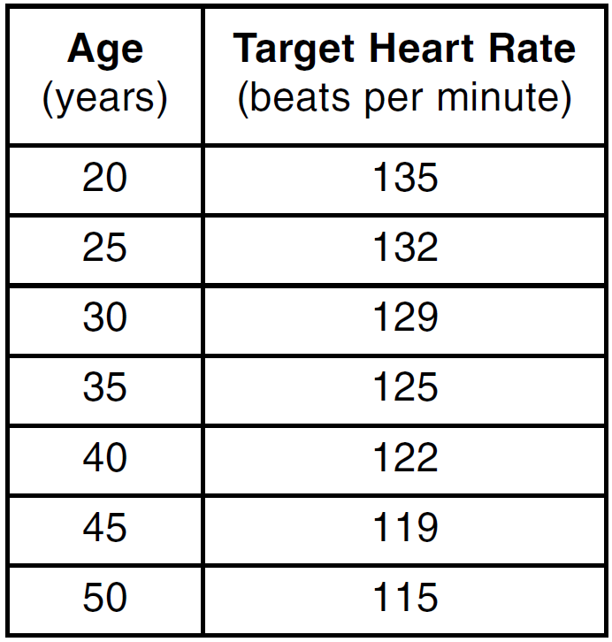

Which value represents the linear correlation coefficient, rounded to the nearest thousandth, between a person’s age, in years, and that person’s target heart rate, in beats per minute?
1)
2)
3) | 0.998
4) | 1.503

26 In , and . Two distinct triangles can be constructed if the measure of angle M is
1) | 35
2) | 40
3) | 45
4) | 50

27 If order does not matter, which selection of students would produce the most possible committees?
1) | 5 out of 15
2) | 5 out of 25
3) | 20 out of 25
4) | 15 out of 25

28 Determine the value of n in simplest form:

29 The formula for continuously compounded interest is , where A is the amount of money in the account, P is the initial investment, r is the interest rate, and t is the time in years. Using the formula, determine, to the nearest dollar, the amount in the account after 8 years if $750 is invested at an annual rate of 3%.

30 Express , in terms of .

31 A cup of soup is left on a countertop to cool. The table below gives the temperatures, in degrees Fahrenheit, of the soup recorded over a 10-minute period.

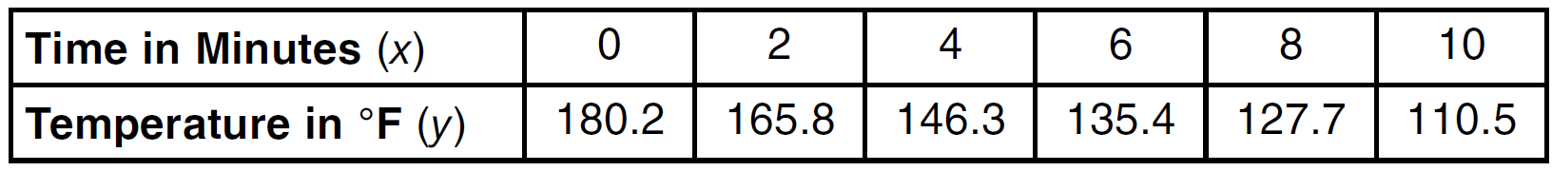

Write an exponential regression equation for the data, rounding all values to the nearest thousandth.

32 Find, to the nearest tenth, the radian measure of 216º.

33 Find the third term in the recursive sequence , where .

34 The two sides and included angle of a parallelogram are 18, 22, and 60°. Find its exact area in simplest form.

35 Write an equation for the graph of the trigonometric function shown below.

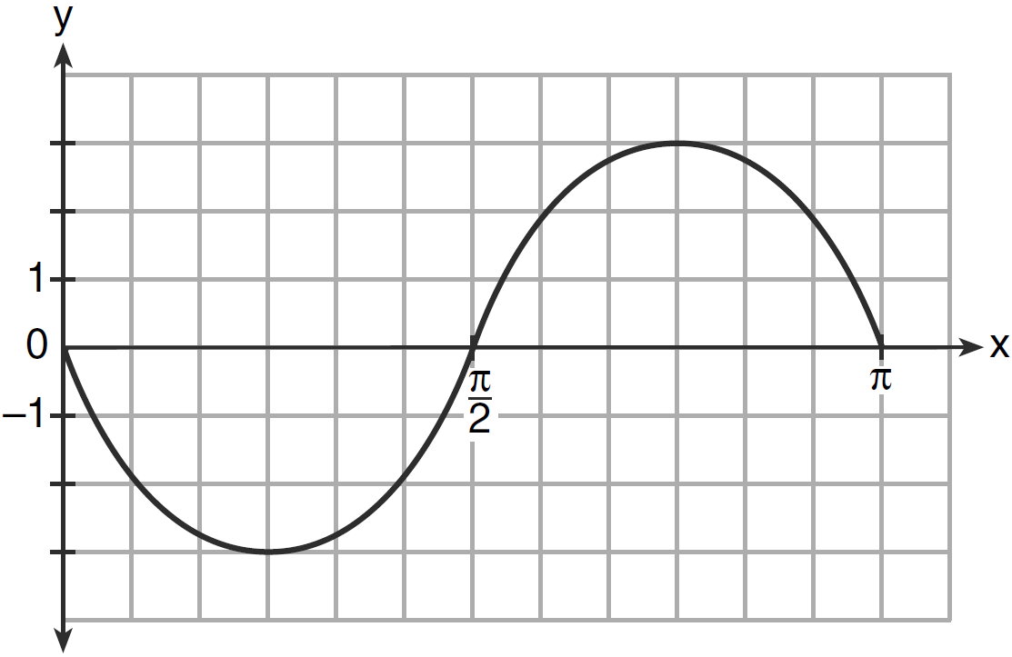

36 Express in simplest form: 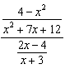

37 During a particular month, a local company surveyed all its employees to determine their travel times to work, in minutes. The data for all 15 employees are shown below.

25 55 40 65 29
45 59 35 25 37
52 30 8 40 55

Determine the number of employees whose travel time is within one standard deviation of the mean.

38 The measures of the angles between the resultant and two applied forces are 60° and 45°, and the magnitude of the resultant is 27 pounds. Find, to the nearest pound, the magnitude of each applied force.

39 Solve algebraically for all values of x: 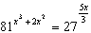
1 ANS: 1
The binomials are conjugates, so use FL.

PTS: 2 REF: 061201a2 STA: A2.N.3 TOP: Operations with Polynomials

2 ANS: 1 PTS: 2 REF: 061202a2 STA: A2.A.51
TOP: Domain and Range

3 ANS: 4
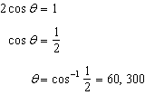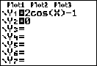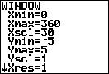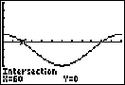

PTS: 2 REF: 061203a2 STA: A2.A.68 TOP: Trigonometric Equations
KEY: basic

4 ANS: 3

PTS: 2 REF: 061204a2 STA: A2.A.13 TOP: Simplifying Radicals
KEY: index > 2

5 ANS: 2 PTS: 2 REF: 061205a2 STA: A2.A.34
TOP: Sigma Notation

6 ANS: 4 PTS: 2 REF: 061206a2 STA: A2.A.60
TOP: Unit Circle

7 ANS: 4 PTS: 2 REF: 061207a2 STA: A2.A.19
TOP: Properties of Logarithms KEY: antilogarithms

8 ANS: 3
sum of the roots, 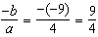. product of the roots, 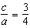

PTS: 2 REF: 061208a2 STA: A2.A.21 TOP: Roots of Quadratics
KEY: basic

9 ANS: 3
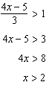 or 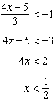

PTS: 2 REF: 061209a2 STA: A2.A.1 TOP: Absolute Value Inequalities
KEY: graph

10 ANS: 1 PTS: 2 REF: 061210a2 STA: A2.A.9
TOP: Negative Exponents

11 ANS: 1 PTS: 2 REF: 061211a2 STA: A2.A.54
TOP: Graphing Logarithmic Functions

12 ANS: 3
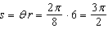

PTS: 2 REF: 061212a2 STA: A2.A.61 TOP: Arc Length
KEY: arc length

13 ANS: 1
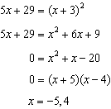. shows an extraneous solution.

PTS: 2 REF: 061213a2 STA: A2.A.22 TOP: Solving Radicals
KEY: extraneous solutions

14 ANS: 2
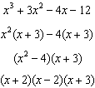

PTS: 2 REF: 061214a2 STA: A2.A.7 TOP: Factoring by Grouping

15 ANS: 3
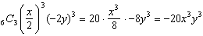

PTS: 2 REF: 061215a2 STA: A2.A.36 TOP: Binomial Expansions

16 ANS: 2 PTS: 2 REF: 061216a2 STA: A2.A.42
TOP: Compositions of Functions KEY: variables

17 ANS: 4
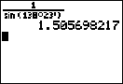

PTS: 2 REF: 061217a2 STA: A2.A.66 TOP: Determining Trigonometric Functions

18 ANS: 2 PTS: 2 REF: 061218a2 STA: A2.A.43
TOP: Defining Functions

19 ANS: 3 PTS: 2 REF: 061219a2 STA: A2.N.8
TOP: Conjugates of Complex Numbers

20 ANS: 1
If , then . 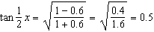.

PTS: 2 REF: 061220a2 STA: A2.A.77 TOP: Half Angle Identities

21 ANS: 4
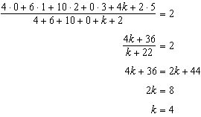

PTS: 2 REF: 061221a2 STA: A2.S.3 TOP: Average Known with Missing Data

22 ANS: 4
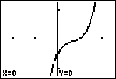

PTS: 2 REF: 061222a2 STA: A2.A.50 TOP: Solving Polynomial Equations

23 ANS: 1 PTS: 2 REF: 061223a2 STA: A2.S.15
TOP: Binomial Probability KEY: modeling

24 ANS: 3 PTS: 2 REF: 061224a2 STA: A2.A.63
TOP: Domain and Range

25 ANS: 1
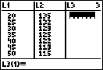. 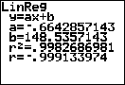

PTS: 2 REF: 061225a2 STA: A2.S.8 TOP: Correlation Coefficient

26 ANS: 1
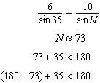

PTS: 2 REF: 061226a2 STA: A2.A.75 TOP: Law of Sines - The Ambiguous Case

27 ANS: 4
. . .

PTS: 2 REF: 061227a2 STA: A2.S.11 TOP: Combinations

28 ANS:
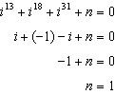

PTS: 2 REF: 061228a2 STA: A2.N.7 TOP: Imaginary Numbers

29 ANS:

PTS: 2 REF: 061229a2 STA: A2.A.12 TOP: Evaluating Exponential Expressions

30 ANS:
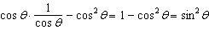

PTS: 2 REF: 061230a2 STA: A2.A.58 TOP: Reciprocal Trigonometric Relationships

31 ANS:

PTS: 2 REF: 061231a2 STA: A2.S.7 TOP: Exponential Regression

32 ANS:
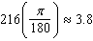

PTS: 2 REF: 061232a2 STA: A2.M.2 TOP: Radian Measure
KEY: radians

33 ANS:
. . .

PTS: 2 REF: 061233a2 STA: A2.A.33 TOP: Recursive Sequences

34 ANS:
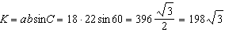

PTS: 2 REF: 061234a2 STA: A2.A.74 TOP: Using Trigonometry to Find Area
KEY: Parallelograms

35 ANS:
. The period of the function is , the amplitude is 3 and it is reflected over the x-axis.

PTS: 2 REF: 061235a2 STA: A2.A.72
TOP: Identifying the Equation of a Trigonometric Graph

36 ANS:
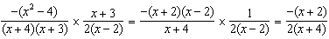

PTS: 4 REF: 061236a2 STA: A2.A.16 TOP: Multiplication and Division of Rationals
KEY: division

37 ANS:
. There are 8 scores between 25.1 and 54.9.

PTS: 4 REF: 061237a2 STA: A2.S.4 TOP: Dispersion
KEY: advanced

38 ANS:
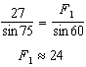. 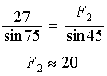. 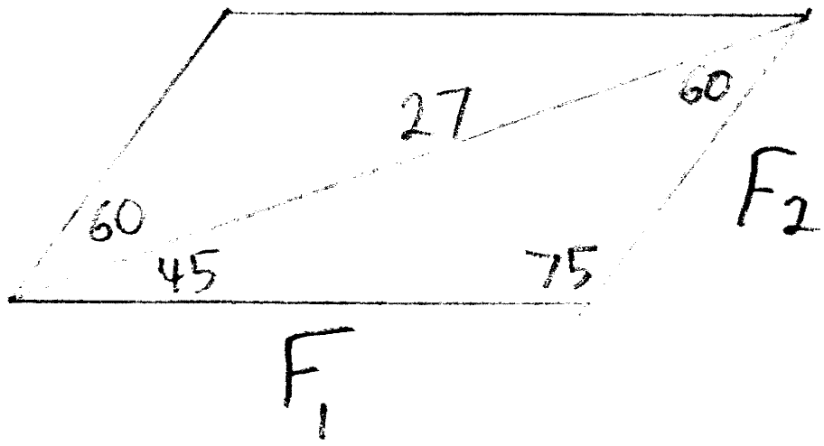

PTS: 4 REF: 061238a2 STA: A2.A.73 TOP: Vectors

39 ANS:
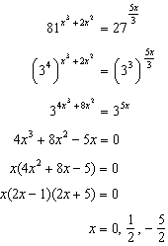

PTS: 6 REF: 061239a2 STA: A2.A.27 TOP: Exponential Equations
KEY: common base not shown

