1 A doctor wants to test the effectiveness of a new drug on her patients. She separates her sample of patients into two groups and administers the drug to only one of these groups. She then compares the results. Which type of study best describes this situation?
1) | census
2) | survey
3) | observation
4) | controlled experiment

2 If 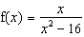, what is the value of ?
1)
2)
3)
4)

3 An auditorium has 21 rows of seats. The first row has 18 seats, and each succeeding row has two more seats than the previous row. How many seats are in the auditorium?
1) | 540
2) | 567
3) | 760
4) | 798

4 Expressed as a function of a positive acute angle, is equal to
1)
2)
3)
4)

5 The value of x in the equation is
1) | 1
2) | 2
3) | 5
4)

6 What is the value of x in the equation ?
1) | 1.16
2) | 20
3) | 625
4) | 1,024

7 The expression is equivalent to
1) | 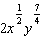
2)
3) | 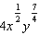
4)

8 Which equation is represented by the graph below?

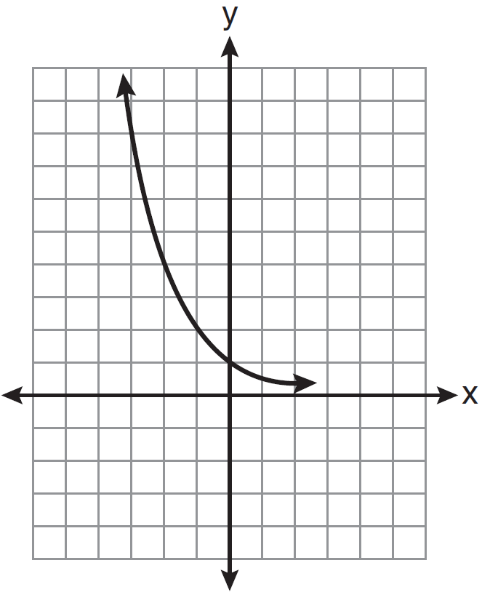
1)
2)
3)
4)

9 What is the fifteenth term of the geometric sequence ?
1)
2)
3)
4)

10 In , , , and , as shown in the diagram below. What is the , to the nearest degree?

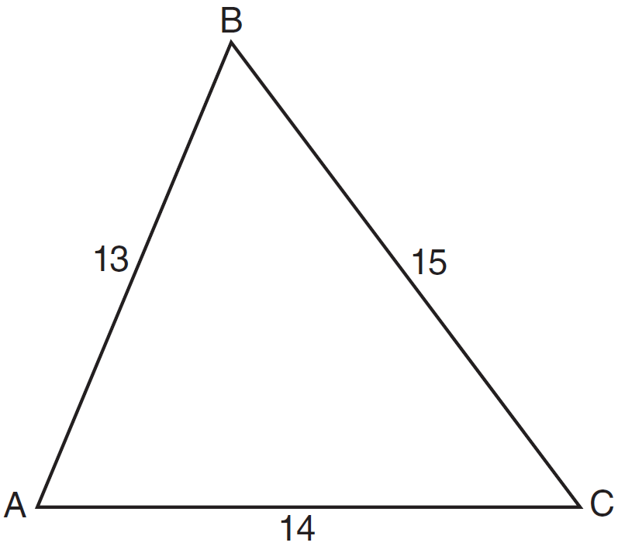
1) | 53
2) | 59
3) | 67
4) | 127

11 What is the period of the function ?
1)
2)
3)
4)

12 What is the range of ?
1)
2)
3)
4)

13 Ms. Bell's mathematics class consists of 4 sophomores, 10 juniors, and 5 seniors. How many different ways can Ms. Bell create a four-member committee of juniors if each junior has an equal chance of being selected?
1) | 210
2) | 3,876
3) | 5,040
4) | 93,024

14 Which graph represents a relation that is not a function?
1) | 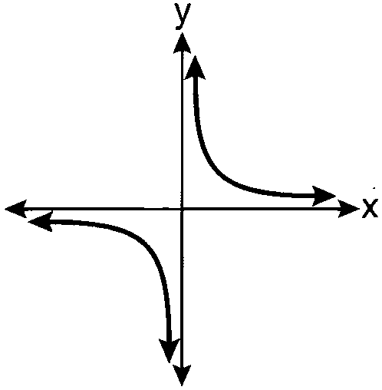
2) | 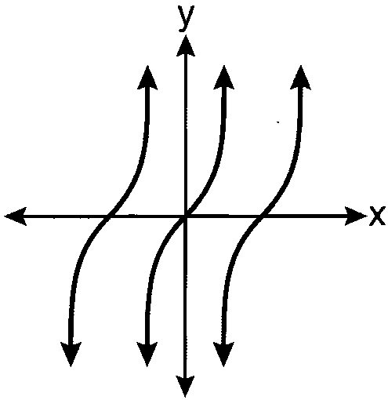
3) | 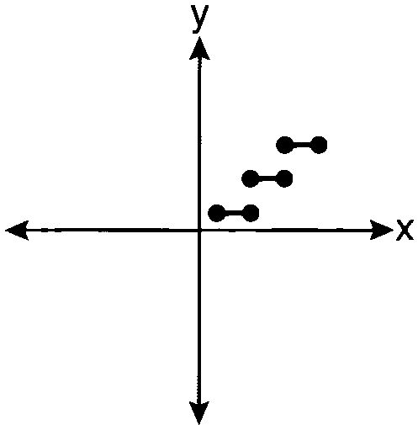
4) | 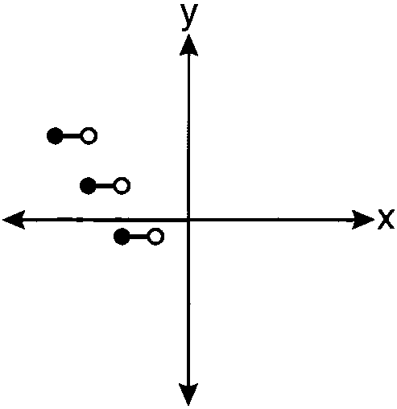

15 The value of to the nearest ten-thousandth is
1)
2)
3)
4)

16 The expression 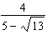 is equivalent to
1) | 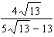
2) | 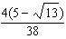
3) | 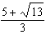
4) | 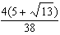

17 Akeem invests $25,000 in an account that pays 4.75% annual interest compounded continuously. Using the formula , where the amount in the account after t years, principal invested, and the annual interest rate, how many years, to the nearest tenth, will it take for Akeem’s investment to triple?
1) | 10.0
2) | 14.6
3) | 23.1
4) | 24.0

18 The value of the expression 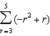 is
1)
2)
3) | 26
4) | 62

19 Which graph shows ?
1) | 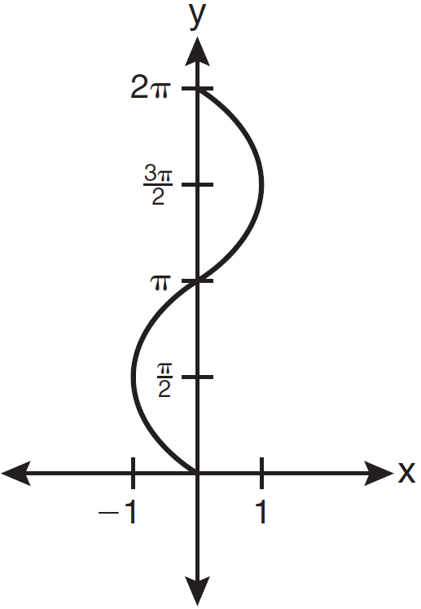
2) | 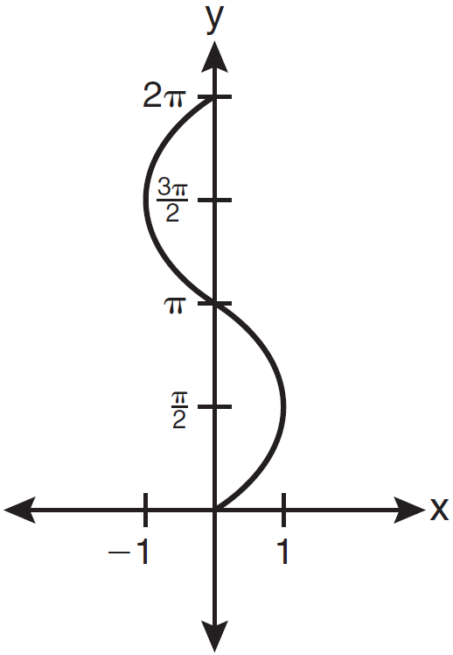
3) | 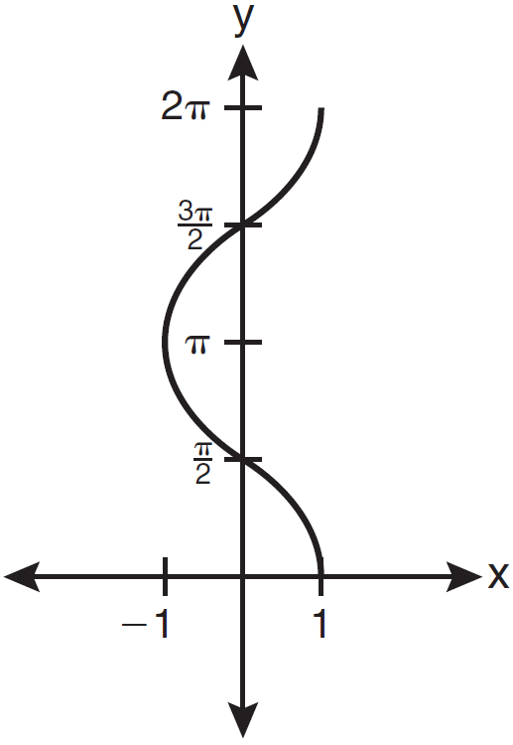
4) | 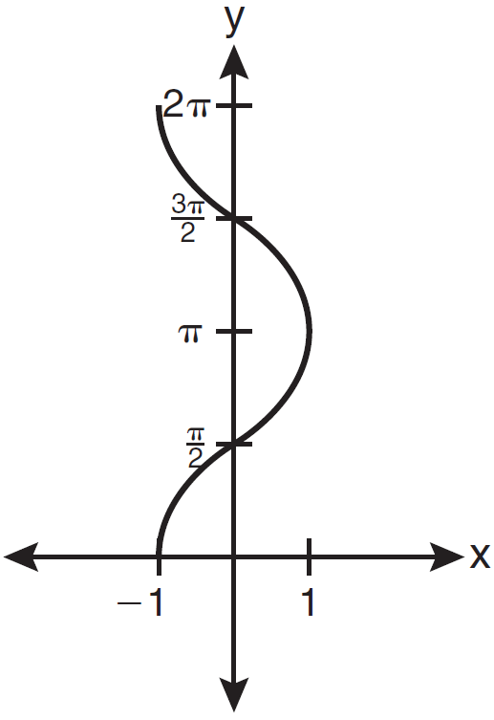

20 If 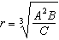, then can be represented by
1) | 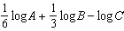
2)
3) | 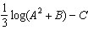
4) | 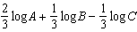

21 The solution set of is
1)
2)
3)
4)

22 Brian correctly used a method of completing the square to solve the equation . Brian’s first step was to rewrite the equation as . He then added a number to both sides of the equation. Which number did he add?
1)
2)
3)
4) | 49

23 The expression 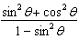 is equivalent to
1)
2)
3)
4)

24 The number of minutes students took to complete a quiz is summarized in the table below.

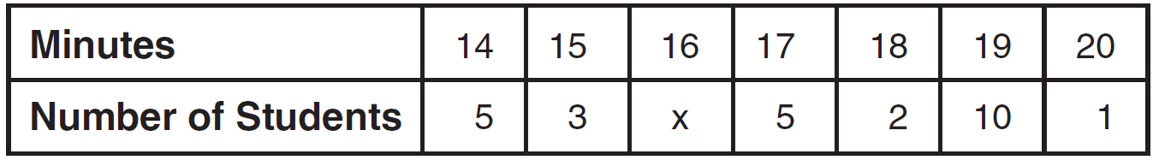

If the mean number of minutes was 17, which equation could be used to calculate the value of x?
1) | 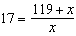
2) | 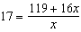
3) | 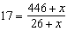
4) | 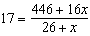

25 What is the radian measure of the smaller angle formed by the hands of a clock at 7 o’clock?
1)
2)
3)
4)

26 What is the coefficient of the fourth term in the expansion of ?
1)
2)
3) | 336
4) | 5,376

27 Samantha constructs the scatter plot below from a set of data.

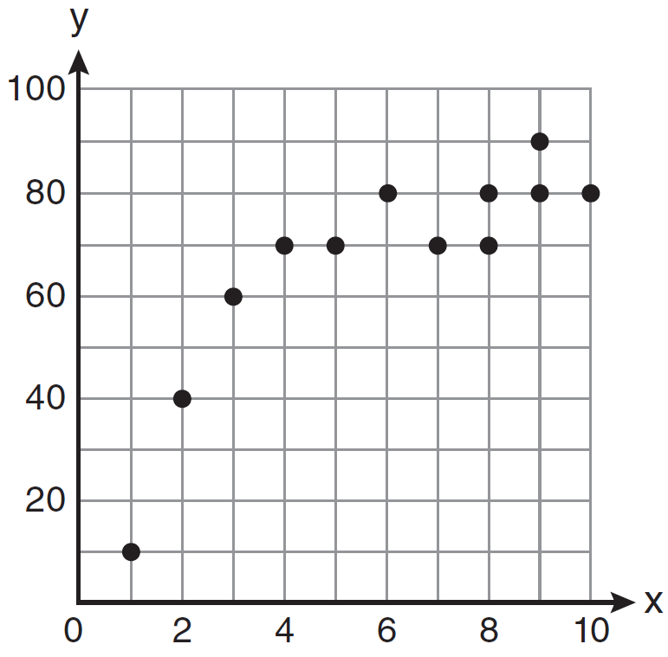

Based on her scatter plot, which regression model would be most appropriate?
1) | exponential
2) | linear
3) | logarithmic
4) | power

28 Express the product of 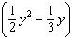 and 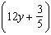 as a trinomial.

29 In a study of 82 video game players, the researchers found that the ages of these players were normally distributed, with a mean age of 17 years and a standard deviation of 3 years. Determine if there were 15 video game players in this study over the age of 20. Justify your answer.

30 Write a quadratic equation such that the sum of its roots is 6 and the product of its roots is .

31 Evaluate when and .

32 If , find .

33 Factor the expression completely.

34 Simplify the expression 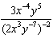 and write the answer using only positive exponents.

35 If and , determine the value of .

36 Express as a single fraction the exact value of .

37 Solve the inequality for x. Graph the solution on the line below.

38 The probability that a professional baseball player will get a hit is . Calculate the exact probability that he will get at least 3 hits in 5 attempts.

39 Solve the following systems of equations algebraically: 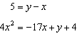
1 ANS: 4 PTS: 2 REF: 061101a2 STA: A2.S.1
TOP: Analysis of Data

2 ANS: 2
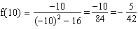
PTS: 2 REF: 061102a2 STA: A2.A.41 TOP: Functional Notation

3 ANS: 4
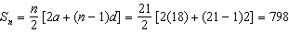
PTS: 2 REF: 061103a2 STA: A2.A.35 TOP: Summations
KEY: arithmetic

4 ANS: 2
PTS: 2 REF: 061104a2 STA: A2.A.57 TOP: Reference Angles

5 ANS: 2
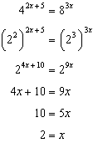.
PTS: 2 REF: 061105a2 STA: A2.A.27 TOP: Exponential Equations
KEY: common base not shown

6 ANS: 3
PTS: 2 REF: 061106a2 STA: A2.A.28 TOP: Logarithmic Equations
KEY: basic

7 ANS: 1
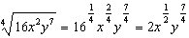
PTS: 2 REF: 061107a2 STA: A2.A.11 TOP: Radicals as Fractional Exponents

8 ANS: 2 PTS: 2 REF: 061108a2 STA: A2.A.52
TOP: Identifying the Equation of a Graph

9 ANS: 1
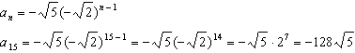
PTS: 2 REF: 061109a2 STA: A2.A.32 TOP: Sequences

10 ANS: 1
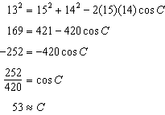
PTS: 2 REF: 061110a2 STA: A2.A.73 TOP: Law of Cosines
KEY: find angle

11 ANS: 2
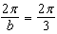
PTS: 2 REF: 061111a2 STA: A2.A.69
TOP: Properties of Graphs of Trigonometric Functions KEY: period

12 ANS: 4 PTS: 2 REF: 061112a2 STA: A2.A.39
TOP: Domain and Range KEY: real domain

13 ANS: 1
PTS: 2 REF: 061113a2 STA: A2.S.11 TOP: Combinations

14 ANS: 3 PTS: 2 REF: 061114a2 STA: A2.A.38
TOP: Defining Functions KEY: graphs

15 ANS: 2
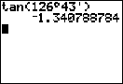
PTS: 2 REF: 061115a2 STA: A2.A.66 TOP: Determining Trigonometric Functions

16 ANS: 3
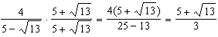
PTS: 2 REF: 061116a2 STA: A2.N.5 TOP: Rationalizing Denominators

17 ANS: 3
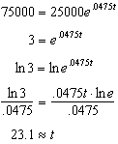
PTS: 2 REF: 061117a2 STA: A2.A.6 TOP: Exponential Growth

18 ANS: 1
n | 3 | 4 | 5

PTS: 2 REF: 061118a2 STA: A2.N.10 TOP: Sigma Notation
KEY: basic

19 ANS: 3 PTS: 2 REF: 061119a2 STA: A2.A.65
TOP: Graphing Trigonometric Functions

20 ANS: 4 PTS: 2 REF: 061120a2 STA: A2.A.19
TOP: Properties of Logarithms KEY: splitting logs

21 ANS: 3
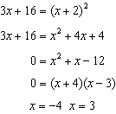. is an extraneous solution.

PTS: 2 REF: 061121a2 STA: A2.A.22 TOP: Solving Radicals
KEY: extraneous solutions

22 ANS: 2 PTS: 2 REF: 061122a2 STA: A2.A.24
TOP: Completing the Square

23 ANS: 3
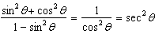

PTS: 2 REF: 061123a2 STA: A2.A.58 TOP: Reciprocal Trigonometric Relationships

24 ANS: 4 PTS: 2 REF: 061124a2 STA: A2.S.3
TOP: Central Tendency

25 ANS: 3
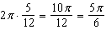

PTS: 2 REF: 061125a2 STA: A2.M.1 TOP: Radian Measure

26 ANS: 1

PTS: 2 REF: 061126a2 STA: A2.A.36 TOP: Binomial Expansions

27 ANS: 3 PTS: 2 REF: 061127a2 STA: A2.S.6
TOP: Regression

28 ANS:
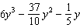. 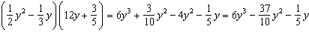

PTS: 2 REF: 061128a2 STA: A2.N.3 TOP: Operations with Polynomials

29 ANS:
no. over 20 is more than 1 standard deviation above the mean.

PTS: 2 REF: 061129a2 STA: A2.S.5 TOP: Normal Distributions
KEY: predict

30 ANS:
, 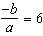. 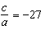. If then and

PTS: 4 REF: 061130a2 STA: A2.A.21 TOP: Roots of Quadratics
KEY: basic

31 ANS:

PTS: 2 REF: 061131a2 STA: A2.A.12 TOP: Evaluating Exponential Expressions

32 ANS:
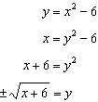. is not a function.

PTS: 2 REF: 061132a2 STA: A2.A.44 TOP: Inverse of Functions
KEY: equations

33 ANS:

PTS: 2 REF: 061133a2 STA: A2.A.7
TOP: Factoring the Difference of Perfect Squares KEY: binomial

34 ANS:
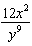. 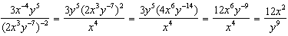

PTS: 2 REF: 061134a2 STA: A2.A.9 TOP: Negative Exponents

35 ANS:
7. . .

PTS: 2 REF: 061135a2 STA: A2.A.42 TOP: Compositions of Functions
KEY: numbers

36 ANS:
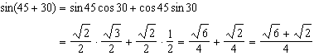

PTS: 4 REF: 061136a2 STA: A2.A.76 TOP: Angle Sum and Difference Identities
KEY: evaluating

37 ANS:
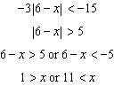.

PTS: 2 REF: 061137a2 STA: A2.A.1 TOP: Absolute Value Inequalities
KEY: graph

38 ANS:
. 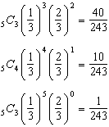

PTS: 4 REF: 061138a2 STA: A2.S.15 TOP: Binomial Probability
KEY: at least or at most

39 ANS:
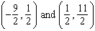. 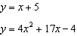. 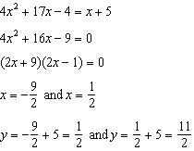

PTS: 6 REF: 061139a2 STA: A2.A.3 TOP: Quadratic-Linear Systems
KEY: equations

