1 What is the common difference of the arithmetic sequence ?
1)
2)
3) | 3
4) | 9

2 What is the number of degrees in an angle whose radian measure is ?
1) | 150
2) | 165
3) | 330
4) | 518

3 If and , what is the value of the expression ?
1)
2)
3)
4)

4 Four points on the graph of the function are shown below.
Which equation represents ?
1)
2)
3)
4)

5 The graph of is shown below.

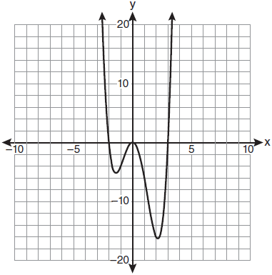

Which set lists all the real solutions of ?
1)
2)
3)
4)

6 In simplest form, is equivalent to
1)
2)
3)
4)

7 Twenty different cameras will be assigned to several boxes. Three cameras will be randomly selected and assigned to box A. Which expression can be used to calculate the number of ways that three cameras can be assigned to box A?
1)
2)
3)
4)

8 Factored completely, the expression is equivalent to
1)
2)
3)
4)

9 The solutions of the equation are
1) | 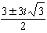
2) | 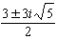
3) | 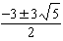
4) | 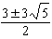

10 The expression is equivalent to
1) | 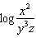
2) | 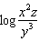
3) | 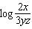
4) | 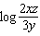

11 The expression 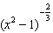 is equivalent to
1)
2) | 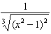
3)
4) | 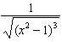

12 Which expression is equivalent to 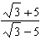?
1) | 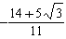
2) | 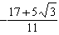
3) | 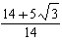
4) | 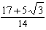

13 Which relation is not a function?
1)
2)
3)
4)

14 If is acute and 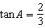, then
1) | 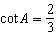
2) | 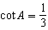
3) | 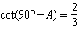
4) | 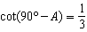

15 The solution set of is
1)
2)
3)
4)

16 The equation is equivalent to
1)
2)
3)
4)

17 Which graph best represents the inequality ?
1) | 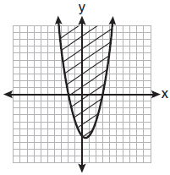
2) | 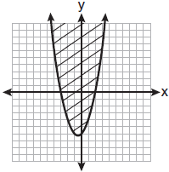
3) | 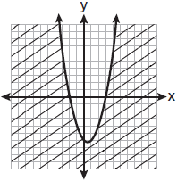
4) | 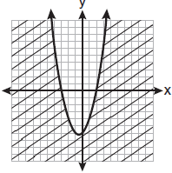

18 The solution set of the equation is
1)
2)
3)
4)

19 The product of and is equivalent to
1) | 1
2)
3)
4)

20 Which equation is represented by the graph below?

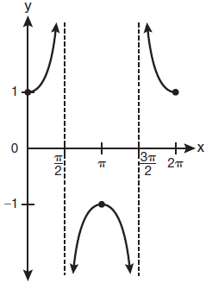
1)
2)
3)
4)

21 Which value of r represents data with a strong negative linear correlation between two variables?
1)
2)
3)
4)

22 The function is defined in such a way that is a function. What can be the domain of ?
1)
2)
3) | 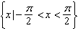
4) | 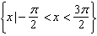

23 In the diagram below of right triangle KTW, , , and .

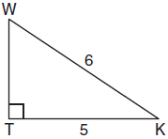

What is the measure of , to the nearest minute?
1)
2)
3)
4)

24 The expression is equivalent to
1)
2)
3)
4)

25 Mrs. Hill asked her students to express the sum using sigma notation. Four different student answers were given. Which student answer is correct?
1) | 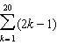
2) | 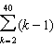
3) | 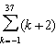
4) | 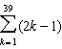

26 What is the formula for the nth term of the sequence ?
1) | 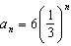
2) | 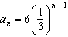
3) | 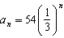
4) | 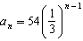

27 What is the period of the function 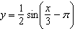?
1)
2)
3)
4)

28 Use the discriminant to determine all values of k that would result in the equation having equal roots.

29 The scores of one class on the Unit 2 mathematics test are shown in the table below.

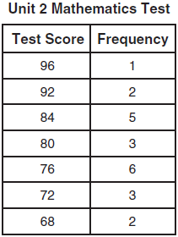

Find the population standard deviation of these scores, to the nearest tenth.

30 Find the sum and product of the roots of the equation .

31 The graph of the equation 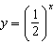 has an asymptote. On the grid below, sketch the graph of and write the equation of this asymptote.

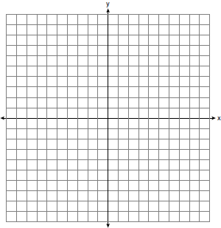

32 Express in simplest radical form.

33 On the unit circle shown in the diagram below, sketch an angle, in standard position, whose degree measure is 240 and find the exact value of .

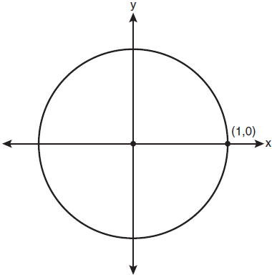

34 Two sides of a parallelogram are 24 feet and 30 feet. The measure of the angle between these sides is . Find the area of the parallelogram, to the nearest square foot.

35 Express in simplest form: 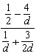

36 The members of a men’s club have a choice of wearing black or red vests to their club meetings. A study done over a period of many years determined that the percentage of black vests worn is 60%. If there are 10 men at a club meeting on a given night, what is the probability, to the nearest thousandth, that at least 8 of the vests worn will be black?

37 Find all values of in the interval that satisfy the equation .

38 The letters of any word can be rearranged. Carol believes that the number of different 9-letter arrangements of the word “TENNESSEE” is greater than the number of different 7-letter arrangements of the word “VERMONT.” Is she correct? Justify your answer.

39 In a triangle, two sides that measure 6 cm and 10 cm form an angle that measures . Find, to the nearest degree, the measure of the smallest angle in the triangle.
1 ANS: 3 PTS: 2 REF: 061001a2 TOP: Sequences

2 ANS: 2
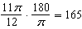

PTS: 2 REF: 061002a2 TOP: Radian Measure
KEY: degrees

3 ANS: 3
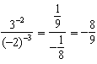

PTS: 2 REF: 061003a2 TOP: Negative and Fractional Exponents

4 ANS: 1 PTS: 2 REF: 061004a2 TOP: Identifying the Equation of a Graph

5 ANS: 4 PTS: 2 REF: 061005a2 TOP: Solving Polynomial Equations

6 ANS: 3

PTS: 2 REF: 061006a2 TOP: Square Roots of Negative Numbers

7 ANS: 3 PTS: 2 REF: 061007a2
TOP: Differentiating Permutations and Combinations

8 ANS: 4

PTS: 2 REF: 061008a2 TOP: Factoring Polynomials
KEY: single variable

9 ANS: 4
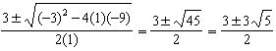

PTS: 2 REF: 061009a2 TOP: Quadratic Formula

10 ANS: 1
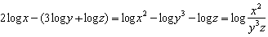

PTS: 2 REF: 061010a2 TOP: Properties of Logarithms

11 ANS: 2 PTS: 2 REF: 061011a2 TOP: Fractional Exponents as Radicals

12 ANS: 1
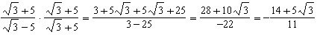

PTS: 2 REF: 061012a2 TOP: Rationalizing Denominators

13 ANS: 1 PTS: 2 REF: 061013a2 TOP: Defining Functions

14 ANS: 3
Cofunctions tangent and cotangent are complementary

PTS: 2 REF: 061014a2 TOP: Cofunction Trigonometric Relationships

15 ANS: 3
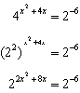. 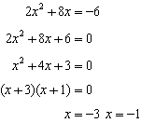

PTS: 2 REF: 061015a2 TOP: Exponential Equations
KEY: common base shown

16 ANS: 2
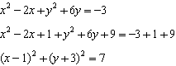

PTS: 2 REF: 061016a2 TOP: Equations of Circles

17 ANS: 1
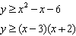

PTS: 2 REF: 061017a2 TOP: Quadratic Inequalities
KEY: two variables

18 ANS: 1 PTS: 2 REF: 061018a2 TOP: Solving Radicals
KEY: extraneous solutions

19 ANS: 1 PTS: 2 REF: 061019a2 TOP: Imaginary Numbers

20 ANS: 3
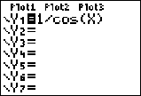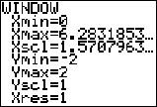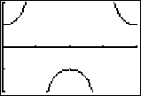

PTS: 2 REF: 061020a2 TOP: Graphing Trigonometric Functions

21 ANS: 2 PTS: 2 REF: 061021a2 TOP: Correlation Coefficient

22 ANS: 3 PTS: 2 REF: 061022a2 TOP: Domain and Range

23 ANS: 1
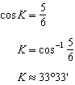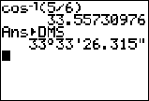

PTS: 2 REF: 061023a2 TOP: Trigonometric Ratios

24 ANS: 1

PTS: 2 REF: 061024a2 TOP: Double Angle Identities
KEY: simplifying

25 ANS: 1 PTS: 2 REF: 061025a2 TOP: Sigma Notation

26 ANS: 4 PTS: 2 REF: 061026a2 TOP: Sequences

27 ANS: 4
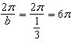

PTS: 2 REF: 061027a2 TOP: Properties of Graphs of Trigonometric Functions
KEY: period

28 ANS:
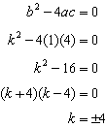

PTS: 2 REF: 061028a2 TOP: Using the Discriminant
KEY: determine equation given nature of roots

29 ANS:
7.4

PTS: 2 REF: 061029a2 TOP: Dispersion KEY: basic, group frequency distributions

30 ANS:
Sum 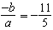. Product 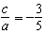

PTS: 2 REF: 061030a2 TOP: Roots of Quadratics

31 ANS:
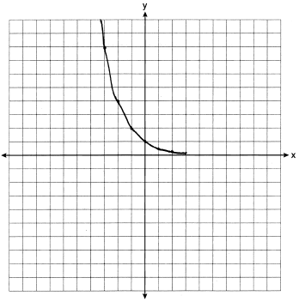

PTS: 2 REF: 061031a2 TOP: Graphing Exponential Functions

32 ANS:

PTS: 2 REF: 061032a2 TOP: Operations with Radicals

33 ANS:
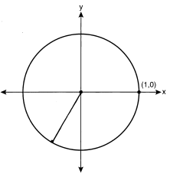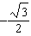

PTS: 2 REF: 061033a2 TOP: Unit Circle

34 ANS:

PTS: 2 REF: 061034a2 TOP: Using Trigonometry to Find Area
KEY: parallelograms

35 ANS:
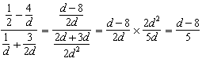

PTS: 2 REF: 061035a2 TOP: Complex Fractions

36 ANS:
0.167.

PTS: 4 REF: 061036a2 TOP: Binomial Probability
KEY: at least or at most

37 ANS:
0, 60, 180, 300. 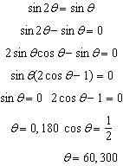

PTS: 4 REF: 061037a2 TOP: Trigonometric Equations
KEY: double angle identities

38 ANS:
No. TENNESSEE: 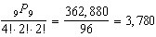. VERMONT:

PTS: 4 REF: 061038a2 TOP: Permutations

39 ANS:
33. . is opposite the shortest side. 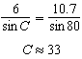

PTS: 6 REF: 061039a2 TOP: Law of Cosines
KEY: advanced

