1 What is 510° expressed in radian measure?
1) | 2.83
2)
3)
4)

2 Four surveys are described below. Which survey methodology would lead to the least biased conclusion?
1) | One hundred randomly chosen heart surgeons were polled by telephone about how to get children to eat healthier foods.
2) | A country and western radio station asked one hundred of its listeners to call a telephone number and answer a question about rap music.
3) | From calls made to one hundred randomly generated telephone numbers, people replied to a question about television shows they watch.
4) | The first one hundred people who left the World of Baseball Bookstore replied to a question about the importance of baseball to society.

3 When factored completely, is equivalent to
1)
2)
3)
4)

4 Which ordered pair is a solution to the system below?
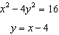
1)
2)
3)
4)

5 Three freshmen, five sophomores, and four juniors are on the school’s chess team. The coach must select three students to attend the citywide tournament. Which expression could be used to determine how many different groups of three students can be made from this team?
1)
2)
3)
4)

6 A survey of high school girls found that the mean number of text messages sent per day by the girls was 62, with a standard deviation of 12. If a normal distribution is assumed, which interval represents the number of texts sent by 68.2% of the girls?
1) | 38–86
2) | 44–80
3) | 50–74
4) | 56–68

7 The expression 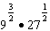 is equivalent to
1)
2)
3)
4) | 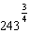

8 The ratio 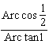 is equal to
1)
2)
3)
4)

9 Which summation will not produce ?
1)
2) | 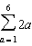
3) | 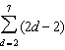
4) | 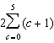

10 The expression 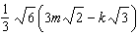 is equivalent to
1)
2)
3)
4)

11 If , then x equals
1)
2)
3)
4)

12 Which relation is not a function?
1)
2)
3)
4)

13 What is the area of parallelogram ABCD if , , and ?
1) | 15
2) | 30
3)
4)

14 The maximum point on the graph of the equation is . What is the maximum point on the graph of the equation ?
1)
2)
3)
4)

15 The formula of the nth term of the sequence is
1)
2)
3)
4)

16 The expression 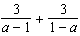 is equivalent to
1) | 0
2) | 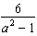
3) | 6
4) | 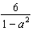

17 The product of 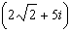 and 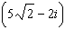 is
1) | 30
2)
3)
4)

18 Which quadratic equation has roots with a sum of and a product of ?
1)
2)
3)
4)

19 The range of the function is
1)
2)
3)
4)

20 The graph of the equation passes through the point
1)
2)
3)
4)

21 If 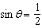 and terminates in Quadrant II, what is the value of ?
1)
2)
3)
4) | 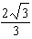

22 A circle has a radius of 12 units. For this circle, which expression incorrectly states the length of the arc intercepted by the given central angle?
1) | 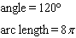
2) | 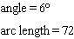
3) | 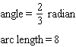
4) | 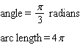

23 How many different four-letter arrangements can be made from the letters in the word “CHAIRS,” if the same letter may be used only once?
1) | 360
2) | 420
3) | 720
4) | 840

24 The sets below represent test scores for two students in Mrs. Silvio’s trigonometry class.
Michelle: {71, 68, 84, 88}
Valerie: {78, 82, 76, 80}
Which statement correctly describes the relationship between the two students’ test scores?
1) | Michelle’s mean test score is greater and her test scores have a greater interquartile range.
2) | Michelle’s population standard deviation is greater, but her range is smaller.
3) | Valerie’s mean test score is greater and her interquartile range is greater.
4) | Valerie’s mean test score is greater, but her population standard deviation is smaller.

25 A support wire 20 meters long runs from the top of a utility pole to a point on the ground 17 meters from the base of the pole. What is the measure, to the nearest minute, of the angle formed by the pole and the wire?
1)
2)
3)
4)

26 If and 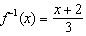, then equals
1) | x
2)
3) | 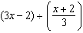
4) | 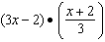

27 The graph of is shown below. Which graph represents ?
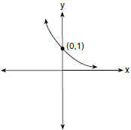
1) | 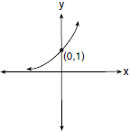
2) | 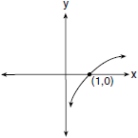
3) | 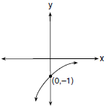
4) | 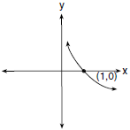

28 The number of bacteria that grow in a petri dish is approximated by the function , where t is time, in minutes. Use this model to approximate, to the nearest integer, the number of bacteria present after one half-hour.

29 Determine the exact value of 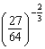 as a fraction in simplest form.

30 State the conjugate of expressed in simplest form.

31 Express 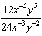 in simplest form, using only positive exponents.

32 In a theater with 30 rows, the number of seats in a row increases by two with each successive row. The front row has 15 seats. Find the total seating capacity of the theater.

33 Given and , express as a polynomial in simplest form.

34 Sketch an angle of 250° in standard position and then express cos 250° as a cosine function of a positive acute angle.

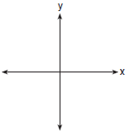

35 Solve the inequality algebraically for x.

36 The table below shows the minimum hourly wage, in U.S. dollars, for selected years since 1955.

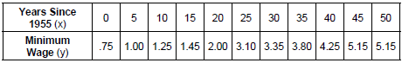

Write the linear regression equation for this set of data, rounding all values to three decimal places. State the strength and direction indicated by the correlation coefficient.

37 Solve the system of equations algebraically for x and y: 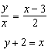

38 A rocket is shot vertically into the air. Its height, h, at any time, t, in seconds, can be modeled by the equation . Determine algebraically, the number of seconds it will take the rocket to reach a height of 529 feet.

39 Forces of 22 pounds and 43 pounds act on an object at an angle of 52°. Determine, to the nearest pound, the magnitude of the resultant force. Find, to the nearest degree, the angle between the smaller force and the resultant force.

1 ANS: 3
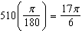

PTS: 2 REF: 011701a2 STA: A2.M.2 TOP: Radian Measure
KEY: radians

2 ANS: 3 PTS: 2 REF: 011702a2 STA: A2.S.2
TOP: Analysis of Data KEY: bias

3 ANS: 4

PTS: 2 REF: 011703a2 STA: A2.A.7 TOP: Factoring Polynomials
KEY: higher power

4 ANS: 2
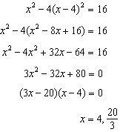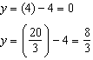

PTS: 2 REF: 011704a2 STA: A2.A.3 TOP: Quadratic-Linear Systems
KEY: algebraically

5 ANS: 1 PTS: 2 REF: 011705a2 STA: A2.S.9
TOP: Differentiating Permutations and Combinations

6 ANS: 3
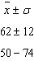

PTS: 2 REF: 011706a2 STA: A2.S.5 TOP: Normal Distributions
KEY: interval

7 ANS: 2
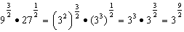

PTS: 2 REF: 011707a2 STA: A2.A.8 TOP: Negative and Fractional Exponents

8 ANS: 3
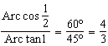

PTS: 2 REF: 011708a2 STA: A2.A.64 TOP: Using Inverse Trigonometric Functions
KEY: basic

9 ANS: 1 PTS: 2 REF: 011709a2 STA: A2.A.34
TOP: Sigma Notation

10 ANS: 1
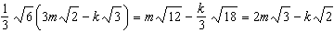

PTS: 2 REF: 011710a2 STA: A2.A.14 TOP: Operations with Radicals
KEY: with variables | index = 2

11 ANS: 3
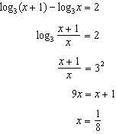

PTS: 2 REF: 011711a2 STA: A2.A.28 TOP: Logarithmic Equations
KEY: applying properties of logarithms

12 ANS: 4 PTS: 2 REF: 011712a2 STA: A2.A.38
TOP: Defining Functions

13 ANS: 2
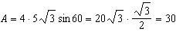

PTS: 2 REF: 011713a2 STA: A2.A.74 TOP: Using Trigonometry to Find Area
KEY: parallelograms

14 ANS: 4 PTS: 2 REF: 011714a2 STA: A2.A.46
TOP: Transformations with Functions

15 ANS: 4 PTS: 2 REF: 011715a2 STA: A2.A.29
TOP: Sequences

16 ANS: 1
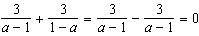

PTS: 2 REF: 011716a2 STA: A2.A.16 TOP: Addition and Subtraction of Rationals

17 ANS: 2

PTS: 2 REF: 011717a2 TOP: Operations with Complex Numbers

18 ANS: 3
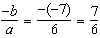. 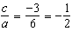

PTS: 2 REF: 011718a2 STA: A2.A.21 TOP: Roots of Quadratics
KEY: basic

19 ANS: 4 PTS: 2 REF: 011719a2 STA: A2.A.39
TOP: Domain and Range KEY: real domain, absolute value

20 ANS: 1 PTS: 2 REF: 011720a2 TOP: Graphing Exponential Functions

21 ANS: 1
If and terminates in Quadrant II, 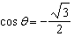. 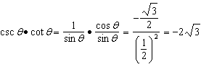

PTS: 2 REF: 011721a2 TOP: Determining Trigonometric Functions

22 ANS: 2
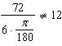
PTS: 2 REF: 011722a2 STA: A2.A.61 TOP: Arc Length
KEY: arc length

23 ANS: 1
PTS: 2 REF: 011723a2 STA: A2.S.10 TOP: Permutations

24 ANS: 4
 |  | IQR |  | Range
Michelle | 77.8 | 16.5 | 8.4 | 20
Valerie | 79 | 4 | 2.2 | 6

PTS: 2 REF: 011724a2 TOP: Central Tendency and Dispersion

25 ANS: 4
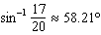

PTS: 2 REF: 011725a2 STA: A2.A.55 TOP: Trigonometric Ratios

26 ANS: 1
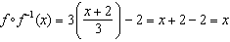

PTS: 2 REF: 011726a2 STA: A2.A.45 TOP: Inverse of Functions

27 ANS: 4 PTS: 2 REF: 011727a2 STA: A2.A.44
TOP: Inverse of Functions KEY: graphs

28 ANS:
PTS: 2 REF: 011728a2 STA: A2.A.12 TOP: Evaluating Exponential Expressions

29 ANS:
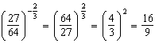
PTS: 2 REF: 011729a2 STA: A2.N.1
TOP: Evaluating Expressions with Negative/Fractional Exponents

30 ANS:
PTS: 2 REF: 011730a2 STA: A2.N.8 TOP: Conjugates of Complex Numbers

31 ANS:
PTS: 2 REF: 011731a2 STA: A2.A.9 TOP: Negative Exponents

32 ANS:
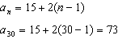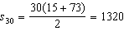
PTS: 2 REF: 011732a2 STA: A2.A.35 TOP: Series

33 ANS:
PTS: 2 REF: 011733a2 STA: A2.A.42 TOP: Compositions of Functions
KEY: variables

34 ANS:
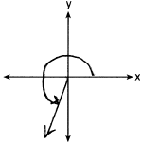
PTS: 2 REF: 011734a2 STA: A2.A.57 TOP: Reference Angles

35 ANS:
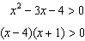. 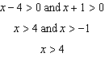 or 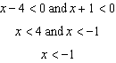
PTS: 2 REF: 011735a2 STA: A2.A.4 TOP: Quadratic Inequalities
KEY: one variable

36 ANS:
high, positive correlation
PTS: 4 REF: 011736a2 TOP: Regression KEY: linear

37 ANS:
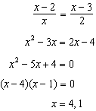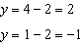
PTS: 4 REF: 011737a2 STA: A2.A.3 TOP: Other Systems
KEY: AII

38 ANS:
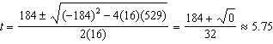
PTS: 4 REF: 011738a2 STA: A2.A.25 TOP: Solving Quadratics
KEY: quadratic formula

39 ANS:
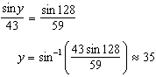
PTS: 6 REF: 011739a2 STA: A2.A.73 TOP: Vectors

