1 A survey is to be conducted in a small upstate village to determine whether or not local residents should fund construction of a skateboard park by raising taxes. Which segment of the population would provide the most unbiased responses?
1) | a club of local skateboard enthusiasts
2) | senior citizens living on fixed incomes
3) | a group opposed to any increase in taxes
4) | every tenth person 18 years of age or older walking down Main St.

2 Which angle does not terminate in Quadrant IV when drawn on a unit circle in standard position?
1)
2)
3)
4)

3 The expression 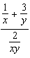 is equivalent to
1)
2) | 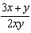
3)
4) | 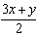

4 Which relation does not represent a function?
1) | 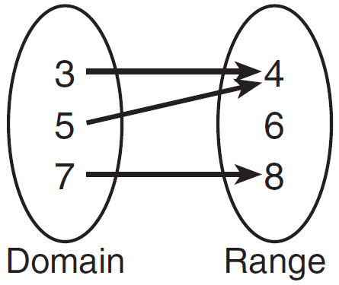
2) | 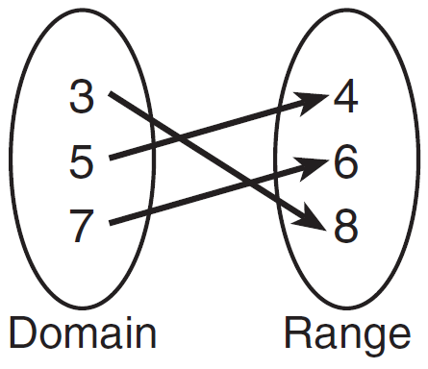
3) | 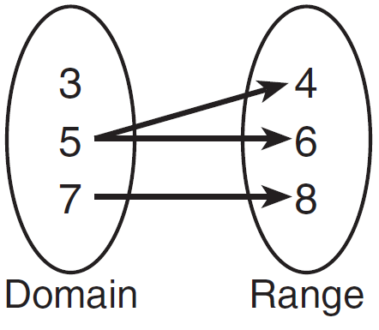
4) | 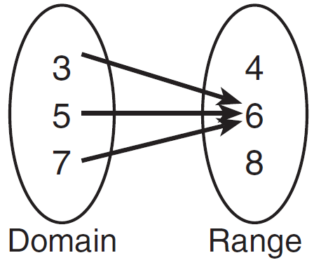

5 In the diagram below, the spinner is divided into eight equal regions.
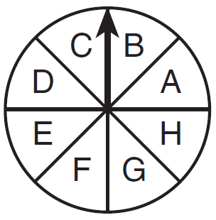
Which expression represents the probability of the spinner landing on B exactly three times in five spins?
1) | 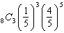
2) | 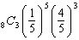
3) | 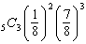
4) | 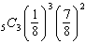

6 The expression is equivalent to
1) | 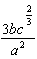
2) | 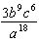
3) | 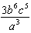
4) | 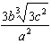

7 The amount of money in an account can be determined by the formula , where P is the initial investment, r is the annual interest rate, and t is the number of years the money was invested. What is the value of a $5000 investment after 18 years, if it was invested at 4% interest compounded continuously?
1) | $9367.30
2) | $9869.39
3) | $10,129.08
4) | $10,272.17

8 What is 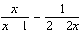 expressed as a single fraction?
1) | 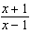
2) | 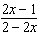
3) | 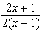
4) | 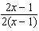

9 What is the total number of points of intersection of the graphs of the equations and ?
1) | 1
2) | 2
3) | 3
4) | 0

10 Given the sequence:
Which expression can be used to determine the common difference of this sequence?
1)
2)
3) | 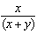
4) | 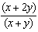

11 In a circle with a diameter of 24 cm, a central angle of radians intercepts an arc. The length of the arc, in centimeters, is
1)
2)
3)
4)

12 Which graph is the solution to the inequality ?
1) | 
2)
3) | 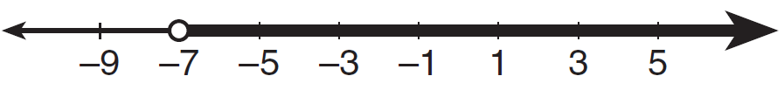
4) | 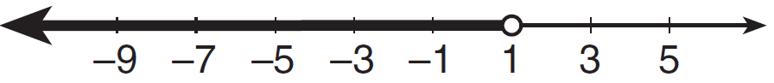

13 What is the sum of the roots of the equation ?
1)
2) | 2
3)
4)

14 The scores of 1000 students on a standardized test were normally distributed with a mean of 50 and a standard deviation of 5. What is the expected number of students who had scores greater than 60?
1) | 1.7
2) | 23
3) | 46
4) | 304

15 If 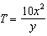, then is equivalent to
1)
2)
3)
4)

16 Which statement regarding correlation is not true?
1) | The closer the absolute value of the correlation coefficient is to one, the closer the data conform to a line.
2) | A correlation coefficient measures the strength of the linear relationship between two variables.
3) | A negative correlation coefficient indicates that there is a weak relationship between two variables.
4) | A relation for which most of the data fall close to a line is considered strong.

17 What is the value of 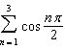?
1) | 1
2)
3) | 0
4)

18 The roots of the equation are
1) | imaginary
2) | real, rational, equal
3) | real, rational, unequal
4) | real, irrational, unequal

19 If , then is equal to
1)
2)
3)
4)

20 The expression is equivalent to
1)
2)
3)
4)

21 If the terminal side of angle passes through point , what is the value of ?
1)
2)
3)
4)

22 When the inverse of is sketched, its domain is
1)
2) | 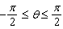
3)
4)

23 What is the third term of the recursive sequence below?
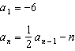
1)
2)
3)
4)

24 What is the equation of a circle with its center at and passing through the point ?
1)
2)
3)
4)

25 If angles A and B are complementary, then equals
1)
2)
3)
4)

26 The legs of a right triangle are represented by and . The length of the hypotenuse of the right triangle is represented by
1)
2)
3)
4)

27 What are the amplitude and the period of the graph represented by the equation 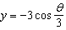?
1) | amplitude: ; period:
2) | amplitude: ; period:
3) | amplitude: 3; period:
4) | amplitude: 3; period:

28 Solve algebraically for x:

29 Factor completely:

30 Solve algebraically for the exact value of x:

31 Determine how many eleven-letter arrangements can be formed from the word "CATTARAUGUS."

32 Express in radian measure, to the nearest hundredth.

33 Determine the area, to the nearest integer, of shown below.

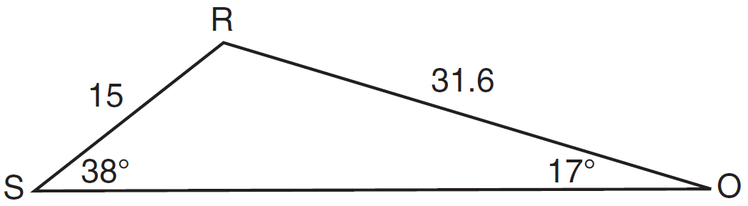

34 Prove that the equation shown below is an identity for all values for which the functions are defined:

35 Find the difference when 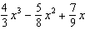 is subtracted from 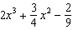.

36 Find the exact roots of by completing the square.

37 The table below gives the relationship between x and y.

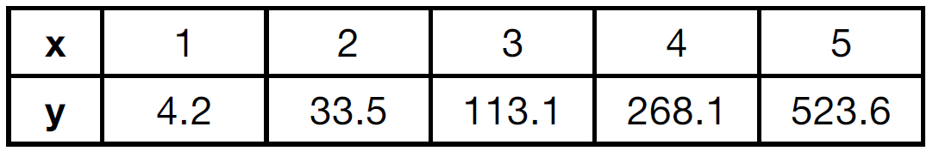

Use exponential regression to find an equation for y as a function of x, rounding all values to the nearest hundredth. Using this equation, predict the value of x if y is 426.21, rounding to the nearest tenth. [Only an algebraic solution can receive full credit.]

38 Solve the equation algebraically for all values of x in the interval .

39 Given: , , , , , , , , and

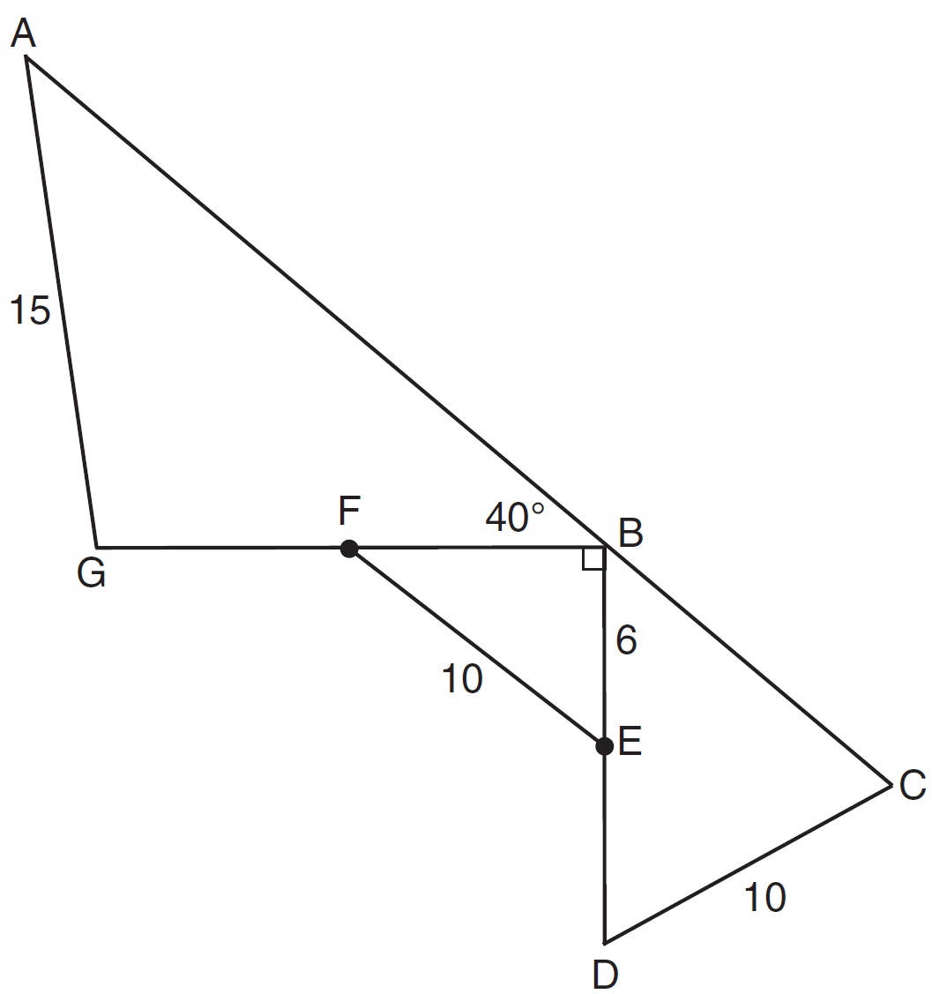

Find to the nearest tenth. Find BC to the nearest tenth.

1 ANS: 4 PTS: 2 REF: 011601a2 STA: A2.S.2
TOP: Analysis of Data

2 ANS: 1
, which terminates in Quadrant I.

PTS: 2 REF: 011602a2 STA: A2.A.60 TOP: Unit Circle

3 ANS: 4
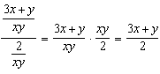

PTS: 2 REF: 011603a2 STA: A2.A.17 TOP: Complex Fractions

4 ANS: 3 PTS: 2 REF: 011604a2 STA: A2.A.38
TOP: Defining Functions KEY: ordered pairs

5 ANS: 4 PTS: 2 REF: 011605a2 STA: A2.S.15
TOP: Binomial Probability KEY: modeling

6 ANS: 1
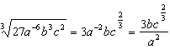

PTS: 2 REF: 011606a2 STA: A2.A.11 TOP: Radicals as Fractional Exponents

7 ANS: 4

PTS: 2 REF: 011607a2 STA: A2.A.12 TOP: Evaluating Exponential Expressions

8 ANS: 3
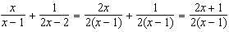

PTS: 2 REF: 011608a2 STA: A2.A.16 TOP: Addition and Subtraction of Rationals

9 ANS: 2
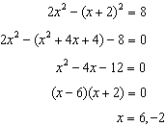

PTS: 2 REF: 011609a2 STA: A2.A.3 TOP: Quadratic-Linear Systems
KEY: equations

10 ANS: 2 PTS: 2 REF: 011610a2 STA: A2.A.30
TOP: Sequences

11 ANS: 3
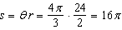

PTS: 2 REF: 011611a2 STA: A2.A.61 TOP: Arc Length
KEY: arc length

12 ANS: 2
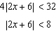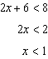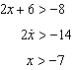

PTS: 2 REF: 011612a2 STA: A2.A.1 TOP: Absolute Value Inequalities
KEY: graph

13 ANS: 2
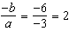

PTS: 2 REF: 011613a2 STA: A2.A.20 TOP: Roots of Quadratics

14 ANS: 2
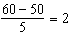 standards above the mean or 2.3%

PTS: 2 REF: 011614a2 STA: A2.S.5 TOP: Normal Distributions
KEY: predict

15 ANS: 1
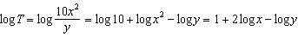

PTS: 2 REF: 011615a2 STA: A2.A.19 TOP: Properties of Logarithms
KEY: splitting logs

16 ANS: 3 PTS: 2 REF: 011616a2 STA: A2.S.8
TOP: Correlation Coefficient

17 ANS: 2
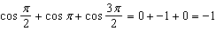

PTS: 2 REF: 011617a2 STA: A2.N.10 TOP: Sigma Notation
KEY: advanced

18 ANS: 4

PTS: 2 REF: 011618a2 STA: A2.A.2 TOP: Using the Discriminant
KEY: determine nature of roots given equation

19 ANS: 3

PTS: 2 REF: 011619a2 STA: A2.A.41 TOP: Functional Notation

20 ANS: 3

PTS: 2 REF: 011620a2 STA: A2.N.7 TOP: Imaginary Numbers

21 ANS: 2
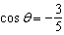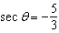

PTS: 2 REF: 011621a2 STA: A2.A.62 TOP: Determining Trigonometric Functions

22 ANS: 4 PTS: 2 REF: 011622a2 STA: A2.A.63
TOP: Domain and Range

23 ANS: 1
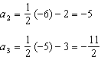

PTS: 2 REF: 011623a2 STA: A2.A.33 TOP: Sequences

24 ANS: 3

PTS: 2 REF: 011624a2 STA: A2.A.48 TOP: Equations of Circles

25 ANS: 3
Cofunctions secant and cosecant are complementary

PTS: 2 REF: 011625a2 STA: A2.A.58 TOP: Cofunction Trigonometric Relationships

26 ANS: 1

PTS: 2 REF: 011626a2 STA: A2.A.14 TOP: Operations with Radicals
KEY: with variables | index = 2

27 ANS: 4 PTS: 2 REF: 011627a2 STA: A2.A.69
TOP: Properties of Graphs of Trigonometric Functions KEY: period

28 ANS:
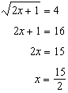

PTS: 2 REF: 011628a2 STA: A2.A.22 TOP: Solving Radicals
KEY: basic

29 ANS:

PTS: 2 REF: 011629a2 STA: A2.A.7 TOP: Factoring by Grouping

30 ANS:
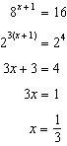

PTS: 2 REF: 011630a2 STA: A2.A.28 TOP: Logarithmic Equations
KEY: basic

31 ANS:
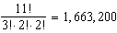

PTS: 2 REF: 011631a2 STA: A2.S.10 TOP: Permutations

32 ANS:
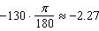

PTS: 2 REF: 011632a2 STA: A2.M.2 TOP: Radian Measure
KEY: radians

33 ANS:
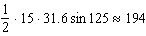

PTS: 2 REF: 011633a2 STA: A2.A.74 TOP: Using Trigonometry to Find Area
KEY: advanced

34 ANS:
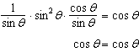

PTS: 2 REF: 011634a2 STA: A2.A.67 TOP: Proving Trigonometric Identities

35 ANS:
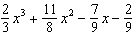

PTS: 2 REF: 011635a2 STA: A2.N.3 TOP: Operations with Polynomials
KEY: subtraction

36 ANS:
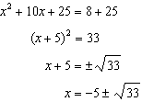

PTS: 4 REF: 011636a2 STA: A2.A.24 TOP: Completing the Square

37 ANS:
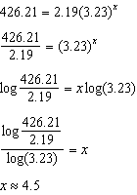

PTS: 4 REF: 011637a2 STA: A2.S.7 TOP: Exponential Regression

38 ANS:
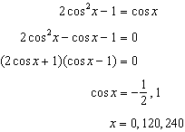

PTS: 4 REF: 011638a2 STA: A2.A.68 TOP: Trigonometric Equations
KEY: double angle identities

39 ANS:
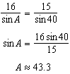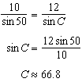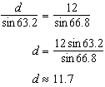

PTS: 6 REF: 011639a2 STA: A2.A.73 TOP: Law of Sines
KEY: advanced

