1 In , , , and . Which statement can be used to determine the numerical value of h?
1)
2)
3)
4)

2 The table of values below can be modeled by which equation?

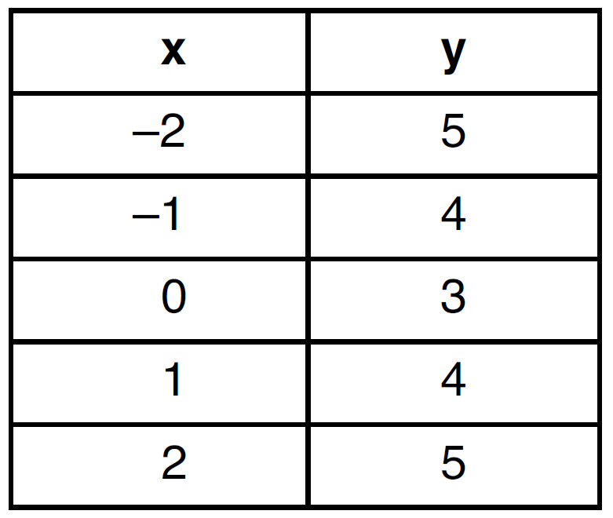
1)
2)
3)
4)

3 The equation where and is equivalent to
1)
2)
3)
4)

4 Which expression is equivalent to the sum of the sequence ?
1) | 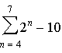
2) | 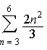
3) | 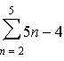
4) | 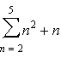

5 An investment is earning 5% interest compounded quarterly. The equation represents the total amount of money, A, where P is the original investment, r is the interest rate, t is the number of years, and n represents the number of times per year the money earns interest. Which graph could represent this investment over at least 50 years?
1) | 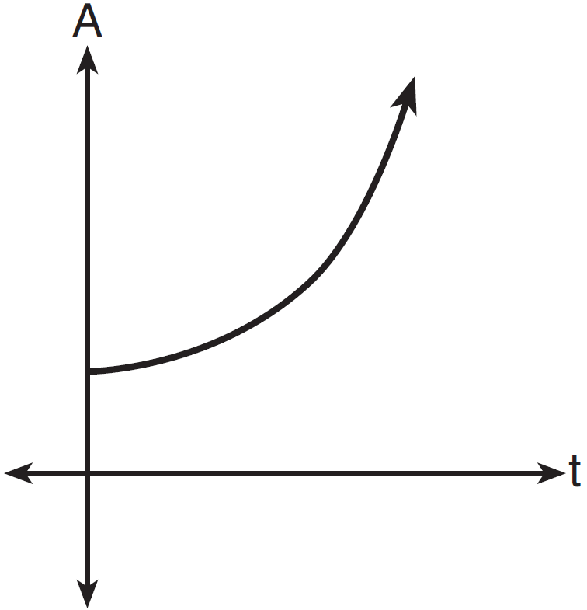
2) | 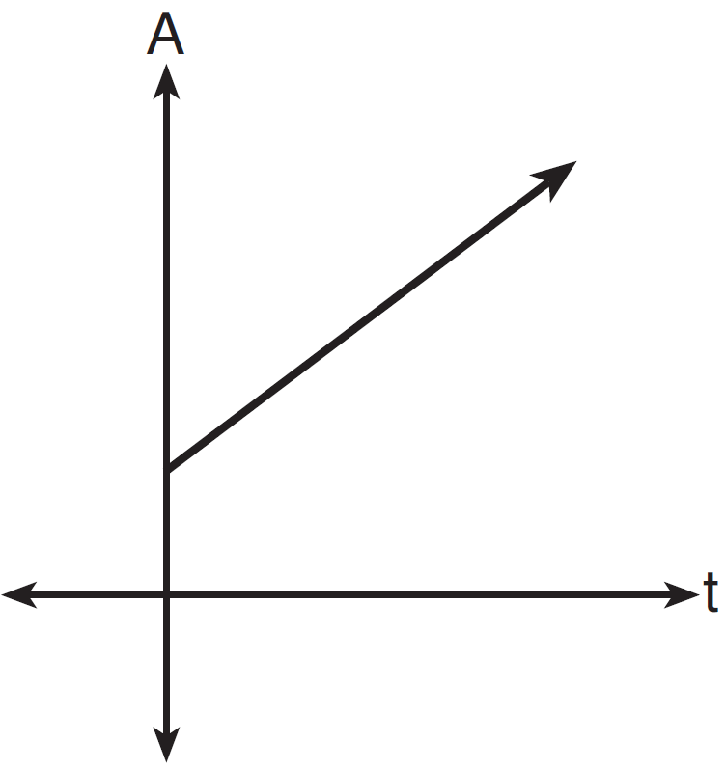
3) | 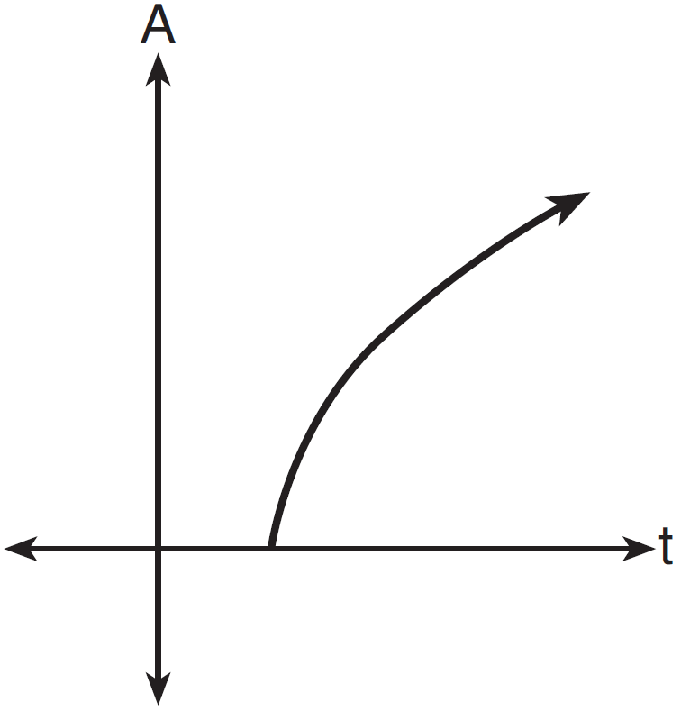
4) | 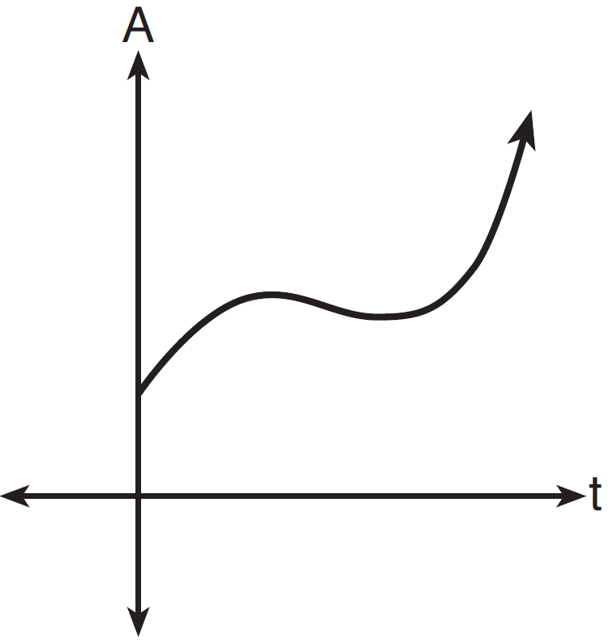

6 Which equation has real, rational, and unequal roots?
1)
2)
3)
4)

7 Which statement is true about the graphs of f and g shown below?

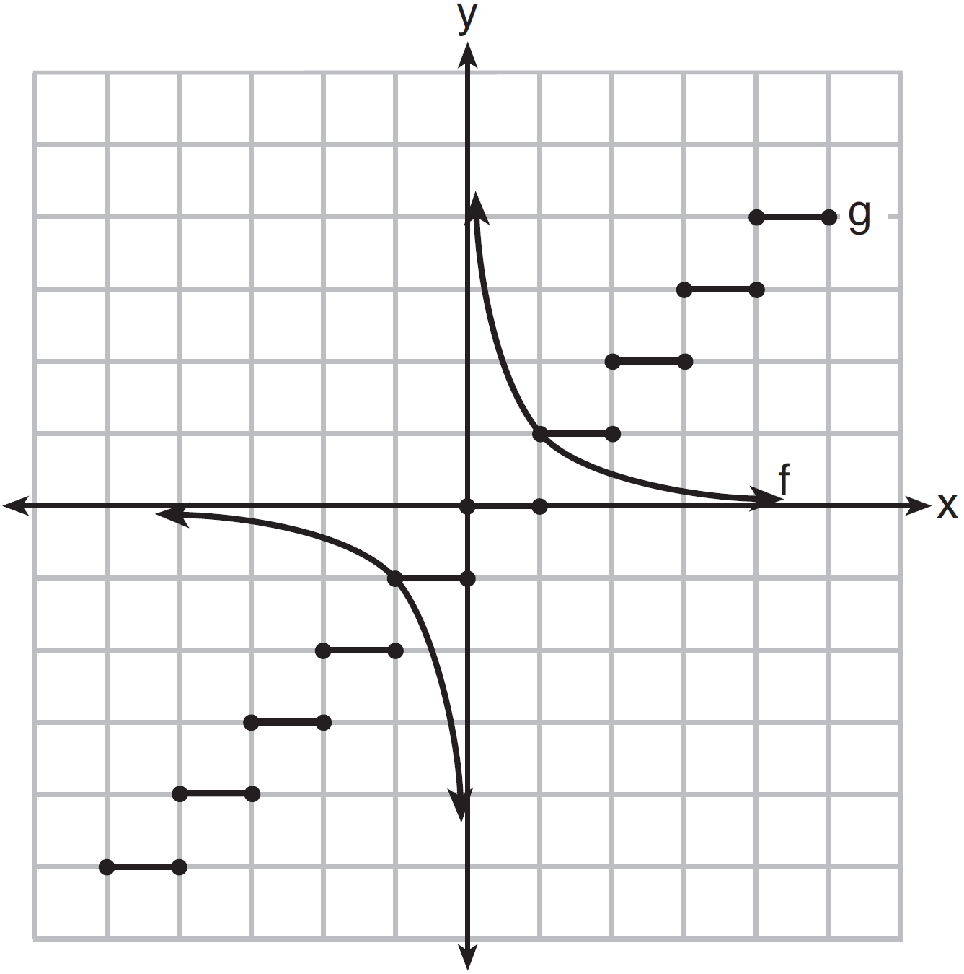
1) | f is a relation and g is a function.
2) | f is a function and g is a relation.
3) | Both f and g are functions.
4) | Neither f nor g is a function.

8 The common ratio of the sequence 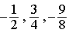 is
1)
2)
3)
4)

9 How many different ways can teams of four members be formed from a class of 20 students?
1) | 5
2) | 80
3) | 4,845
4) | 116,280

10 If 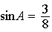, what is the value of ?
1) | 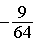
2)
3)
4)

11 When factored completely, the expression is equivalent to
1)
2)
3)
4)

12 When is multiplied by its conjugate, the result is
1)
2)
3) | 5
4) | 13

13 A circle with center O and passing through the origin is graphed below.

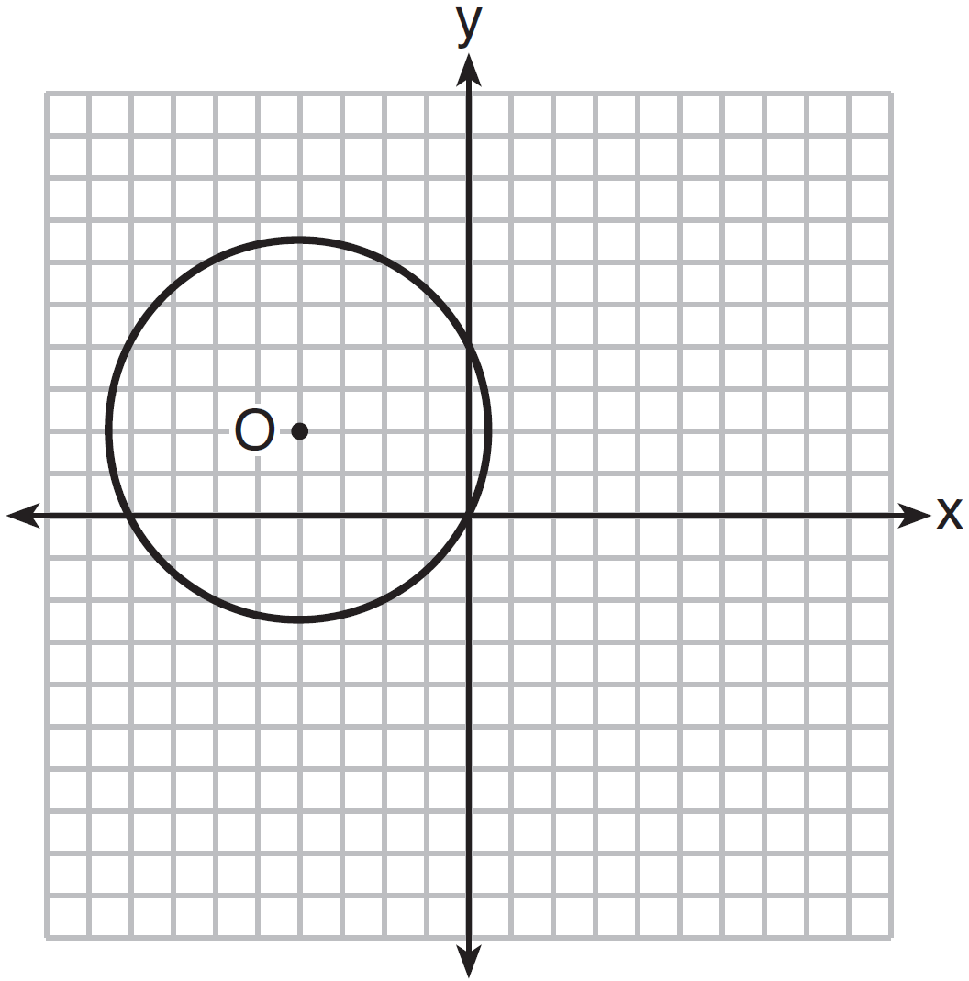

What is the equation of circle O?
1)
2)
3)
4)

14 Which expression is equivalent to ?
1) | 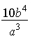
2) | 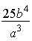
3) | 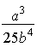
4) | 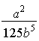

15 Which trigonometric expression does not simplify to 1?
1)
2)
3)
4)

16 What is the product of 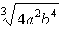 and 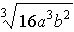?
1) | 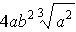
2)
3) | 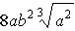
4)

17 What is the product of the roots of ?
1)
2)
3)
4)

18 How many different 11-letter arrangements are possible using the letters in the word “ARRANGEMENT”?
1) | 2,494,800
2) | 4,989,600
3) | 19,958,400
4) | 39,916,800

19 What is the third term in the expansion of ?
1)
2)
3)
4)

20 Angle is in standard position and is a point on the terminal side of . What is the value of ?
1)
2)
3) | 0
4) | undefined

21 The domain of 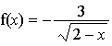 is the set of all real numbers
1) | greater than 2
2) | less than 2
3) | except 2
4) | between and 2

22 Which equation could be used to solve 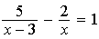?
1)
2)
3)
4)

23 How many distinct triangles can be constructed if , side , and side ?
1) | one acute triangle
2) | one obtuse triangle
3) | two triangles
4) | none

24 The expression 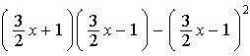 is equivalent to
1) | 0
2)
3) | 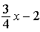
4)

25 The table below shows five numbers and their frequency of occurrence.

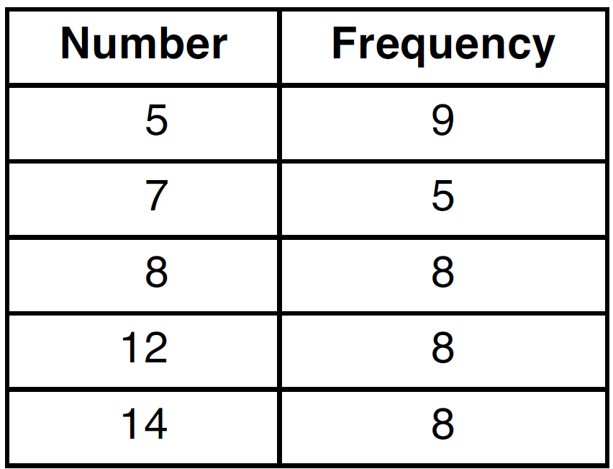

The interquartile range for these data is
1) | 7
2) | 5
3) | 7 to 12
4) | 6 to 13

26 A wheel has a radius of 18 inches. Which distance, to the nearest inch, does the wheel travel when it rotates through an angle of radians?
1) | 45
2) | 23
3) | 13
4) | 11

27 If , then equals
1)
2)
3)
4)

28 If p and q vary inversely and p is 25 when q is 6, determine q when p is equal to 30.

29 Express in simplest form: 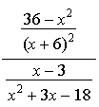

30 Solve algebraically for x, rounded to the nearest hundredth.

31 Determine, to the nearest minute, the degree measure of an angle of 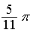 radians.

32 The probability of Ashley being the catcher in a softball game is . Calculate the exact probability that she will be the catcher in exactly five of the next six games.

33 If x is a real number, express in simplest form.

34 On a test that has a normal distribution of scores, a score of 57 falls one standard deviation below the mean, and a score of 81 is two standard deviations above the mean. Determine the mean score of this test.

35 The area of a parallelogram is 594, and the lengths of its sides are 32 and 46. Determine, to the nearest tenth of a degree, the measure of the acute angle of the parallelogram.

36 The table below shows the amount of a decaying radioactive substance that remained for selected years after 1990.

Write an exponential regression equation for this set of data, rounding all values to the nearest thousandth. Using this equation, determine the amount of the substance that remained in 2002, to the nearest integer.

37 Use the recursive sequence defined below to express the next three terms as fractions reduced to lowest terms.
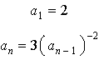

38 The periodic graph below can be represented by the trigonometric equation where a, b, and c are real numbers.

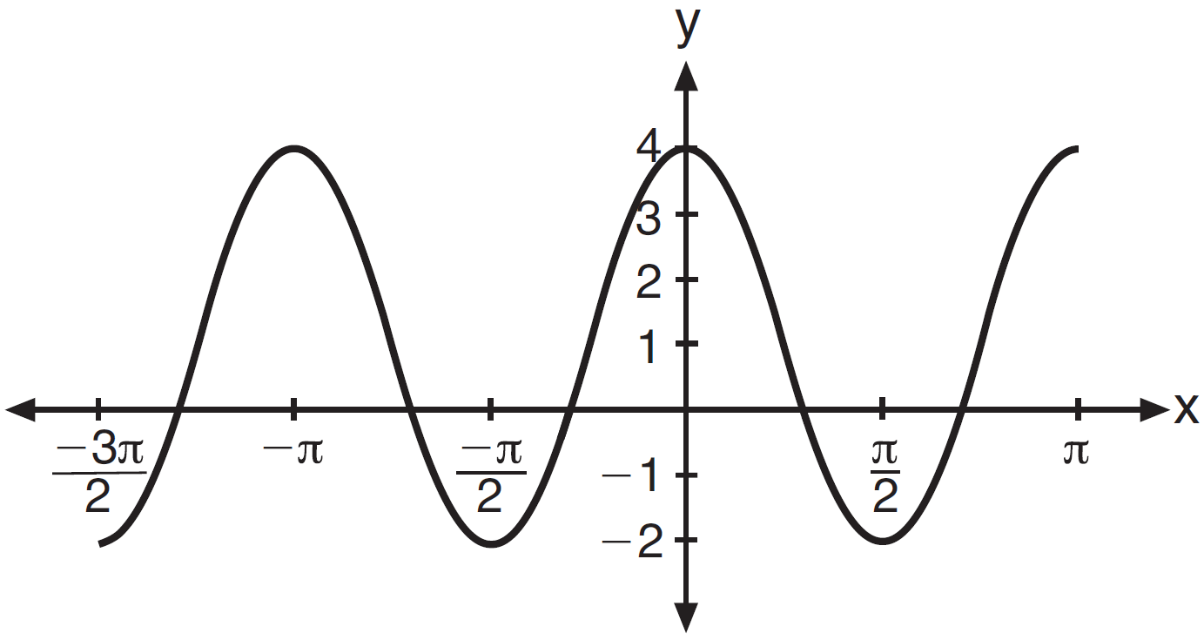

State the values of a, b, and c, and write an equation for the graph.

39 A homeowner wants to increase the size of a rectangular deck that now measures 14 feet by 22 feet. The building code allows for a deck to have a maximum area of 800 square feet. If the length and width are increased by the same number of feet, find the maximum number of whole feet each dimension can be increased and not exceed the building code. [Only an algebraic solution can receive full credit.]

1 ANS: 2 PTS: 2 REF: 011501a2 STA: A2.A.73
TOP: Law of Cosines KEY: side, without calculator

2 ANS: 2 PTS: 2 REF: 011502a2 STA: A2.A.52
TOP: Identifying the Equation of a Graph

3 ANS: 3 PTS: 2 REF: 011503a2 STA: A2.A.28
TOP: Logarithmic Equations KEY: basic

4 ANS: 4 PTS: 2 REF: 011504a2 STA: A2.A.34
TOP: Sigma Notation

5 ANS: 1 PTS: 2 REF: 011505a2 STA: A2.A.53
TOP: Graphing Exponential Functions

6 ANS: 2

PTS: 2 REF: 011506a2 STA: A2.A.2 TOP: Using the Discriminant

7 ANS: 2 PTS: 2 REF: 011507a2 STA: A2.A.38
TOP: Defining Functions KEY: graphs

8 ANS: 1
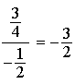

PTS: 2 REF: 011508a2 STA: A2.A.31 TOP: Sequences

9 ANS: 3

PTS: 2 REF: 011509a2 STA: A2.S.11 TOP: Combinations

10 ANS: 3
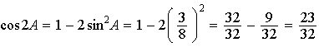

PTS: 2 REF: 011510a2 STA: A2.A.77 TOP: Double Angle Identities
KEY: evaluating

11 ANS: 2
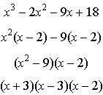

PTS: 2 REF: 011511a2 STA: A2.A.7 TOP: Factoring by Grouping

12 ANS: 4

PTS: 2 REF: 011512a2 STA: A2.N.9
TOP: Multiplication and Division of Complex Numbers

13 ANS: 4 PTS: 2 REF: 011513a2 STA: A2.A.49
TOP: Equations of Circles

14 ANS: 2
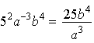

PTS: 2 REF: 011514a2 STA: A2.A.9 TOP: Negative Exponents

15 ANS: 3
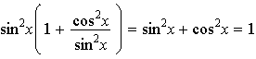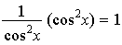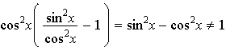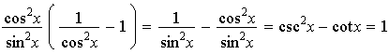

PTS: 2 REF: 011515a2 STA: A2.A.67 TOP: Proving Trigonometric Identities

16 ANS: 1
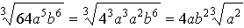

PTS: 2 REF: 011516a2 STA: A2.N.2 TOP: Operations with Radicals

17 ANS: 3
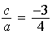

PTS: 2 REF: 011517a2 STA: A2.A.20 TOP: Roots of Quadratics

18 ANS: 1
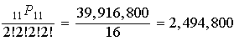

PTS: 2 REF: 011518a2 STA: A2.S.10 TOP: Permutations

19 ANS: 1

PTS: 2 REF: 011519a2 STA: A2.A.36 TOP: Binomial Expansions

20 ANS: 2
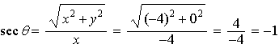

PTS: 2 REF: 011520a2 STA: A2.A.62 TOP: Determining Trigonometric Functions

21 ANS: 2 PTS: 2 REF: 011521a2 STA: A2.A.39
TOP: Domain and Range KEY: real domain

22 ANS: 3
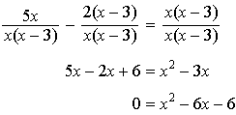

PTS: 2 REF: 011522a2 STA: A2.A.23 TOP: Solving Rationals
KEY: irrational and complex solutions

23 ANS: 4
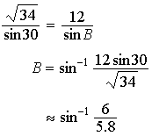

PTS: 2 REF: 011523a2 STA: A2.A.75 TOP: Law of Sines - The Ambiguous Case

24 ANS: 4
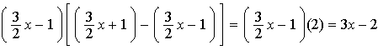

PTS: 2 REF: 011524a2 STA: A2.N.3 TOP: Operations with Polynomials

25 ANS: 2

PTS: 2 REF: 011525a2 STA: A2.S.4 TOP: Dispersion
KEY: range, quartiles, interquartile range, variance

26 ANS: 2
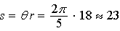

PTS: 2 REF: 011526a2 STA: A2.A.61 TOP: Arc Length
KEY: arc length

27 ANS: 4
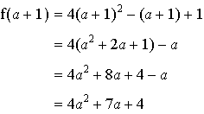

PTS: 2 REF: 011527a2 STA: A2.A.41 TOP: Functional Notation

28 ANS:
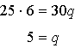

PTS: 2 REF: 011528a2 STA: A2.A.5 TOP: Inverse Variation

29 ANS:
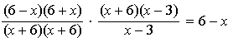

PTS: 2 REF: 011529a2 STA: A2.A.16 TOP: Multiplication and Division of Rationals
KEY: division

30 ANS:
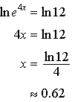

PTS: 2 REF: 011530a2 STA: A2.A.27 TOP: Exponential Equations
KEY: without common base

31 ANS:
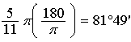

PTS: 2 REF: 011531a2 STA: A2.M.2 TOP: Radian Measure
KEY: degrees

32 ANS:
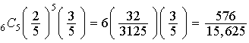

PTS: 2 REF: 011532a2 STA: A2.S.15 TOP: Binomial Probability
KEY: exactly

33 ANS:

PTS: 2 REF: 011533a2 STA: A2.N.9
TOP: Multiplication and Division of Complex Numbers

34 ANS:
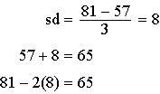

PTS: 2 REF: 011534a2 STA: A2.S.5 TOP: Normal Distributions
KEY: mean and standard deviation

35 ANS:
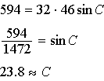

PTS: 2 REF: 011535a2 STA: A2.A.74 TOP: Using Trigonometry to Find Area
KEY: Parallelograms

36 ANS:
PTS: 4 REF: 011536a2 STA: A2.S.7 TOP: Exponential Regression

37 ANS:
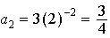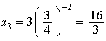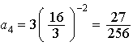
PTS: 4 REF: 011537a2 STA: A2.A.33 TOP: Recursive Sequences

38 ANS:
.
PTS: 2 REF: 011538a2 STA: A2.A.72
TOP: Identifying the Equation of a Trigonometric Graph

39 ANS:
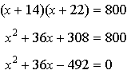 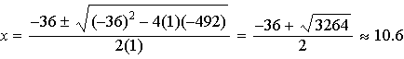 10 feet increase.
PTS: 6 REF: 011539a2 STA: A2.A.25 TOP: Quadratics with Irrational Solutions

