1 What is the common difference in the sequence , , , ?
1)
2)
3)
4)

2 Which expression is equivalent to 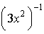?
1) | 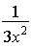
2)
3) | 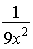
4)

3 If 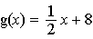 and 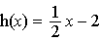, what is the value of ?
1) | 0
2) | 9
3) | 5
4) | 4

4 The expression 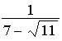 is equivalent to
1) | 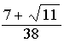
2) | 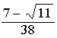
3) | 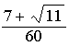
4) | 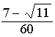

5 The expression 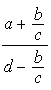 is equivalent to
1) | 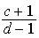
2) | 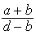
3) | 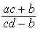
4) | 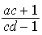

6 A school cafeteria has five different lunch periods. The cafeteria staff wants to find out which items on the menu are most popular, so they give every student in the first lunch period a list of questions to answer in order to collect data to represent the school. Which type of study does this represent?
1) | observation
2) | controlled experiment
3) | population survey
4) | sample survey

7 Which relation is both one-to-one and onto?
1) | 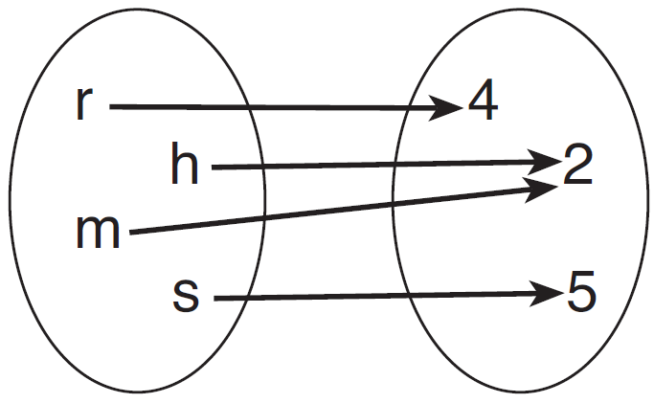
2) | 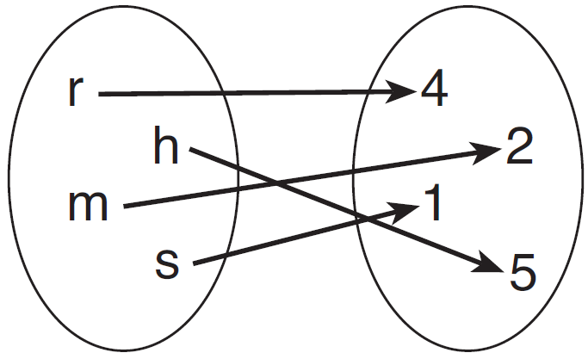
3) | 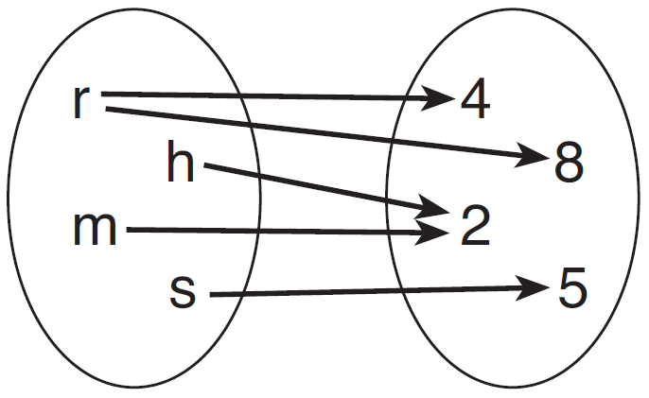
4) | 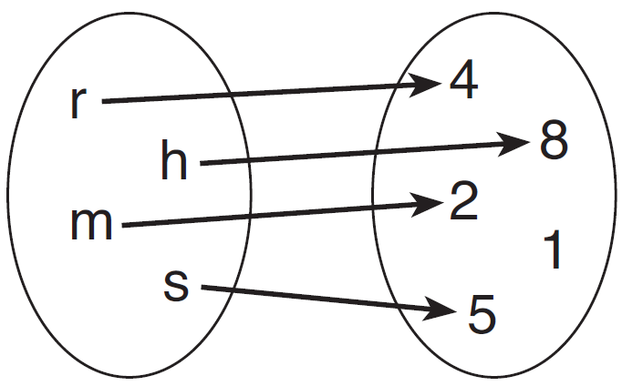

8 Max solves a quadratic equation by completing the square. He shows a correct step:
What are the solutions to his equation?
1)
2)
3)
4)

9 Which expression represents the total number of different 11-letter arrangements that can be made using the letters in the word “MATHEMATICS”?
1) | 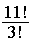
2) | 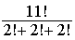
3) | 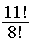
4) | 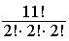

10 If $5000 is invested at a rate of 3% interest compounded quarterly, what is the value of the investment in 5 years? (Use the formula 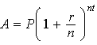, where A is the amount accrued, P is the principal, r is the interest rate, n is the number of times per year the money is compounded, and t is the length of time, in years.)
1) | $5190.33
2) | $5796.37
3) | $5805.92
4) | $5808.08

11 The roots of the equation are
1) | real, rational, and equal
2) | real, rational, and unequal
3) | real, irrational, and unequal
4) | imaginary

12 If d varies inversely as t, and when , what is the value of t when ?
1) | 8
2) | 2
3)
4)

13 If 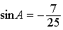 and terminates in Quadrant IV, equals
1) | 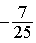
2) | 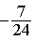
3) | 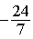
4) | 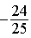

14 Which expression is equivalent to 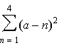?
1)
2)
3)
4)

15 What are the coordinates of the center of a circle whose equation is ?
1)
2)
3)
4)

16 For 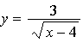, what are the domain and range?
1) | and
2) | and
3) | and
4) | and

17 A math club has 30 boys and 20 girls. Which expression represents the total number of different 5-member teams, consisting of 3 boys and 2 girls, that can be formed?
1)
2)
3)
4)

18 What is the product of the roots of if one of the roots is 7?
1) | 21
2)
3)
4)

19 In , , , and . How many distinct triangles can be drawn given these measurements?
1) | 1
2) | 2
3) | 3
4) | 0

20 Liz has applied to a college that requires students to score in the top 6.7% on the mathematics portion of an aptitude test. The scores on the test are approximately normally distributed with a mean score of 576 and a standard deviation of 104. What is the minimum score Liz must earn to meet this requirement?
1) | 680
2) | 732
3) | 740
4) | 784

21 The expression 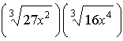 is equivalent to
1)
2)
3) | 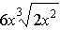
4)

22 Which sketch shows the inverse of , where ?
1) | 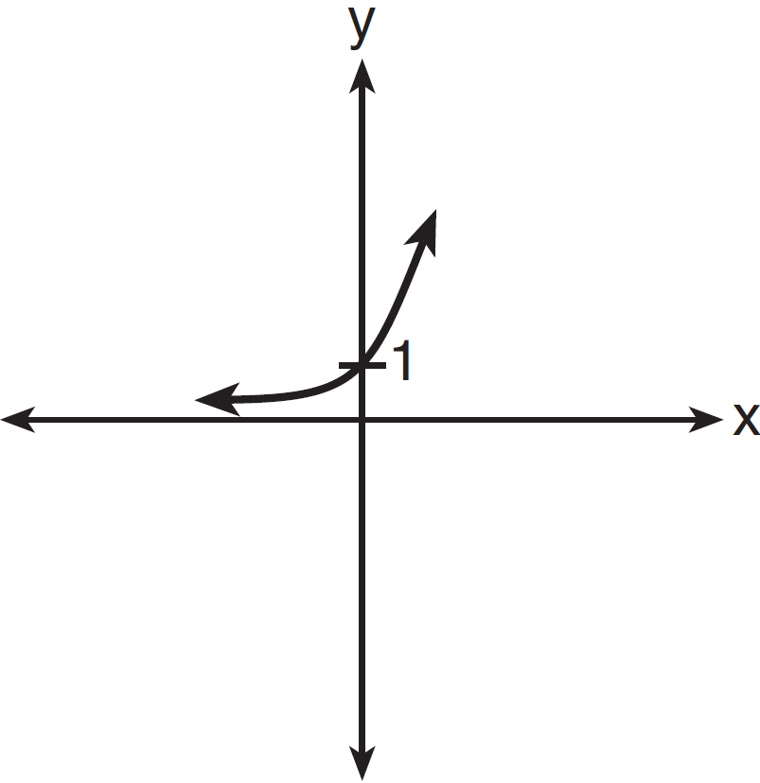
2) | 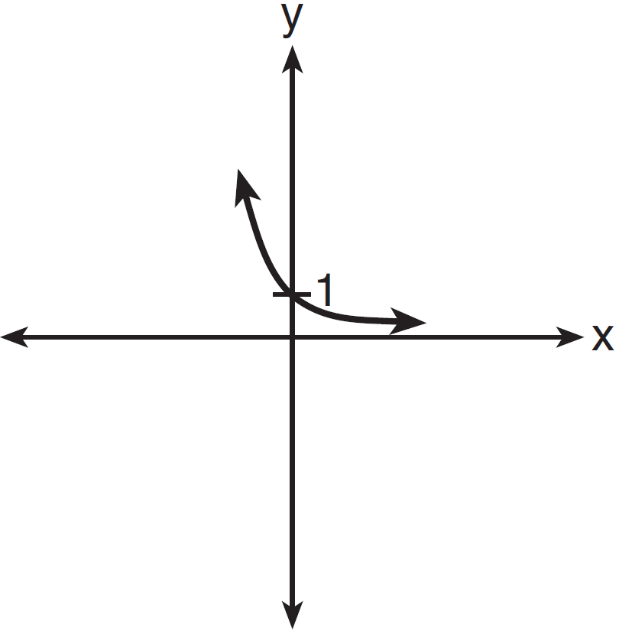
3) | 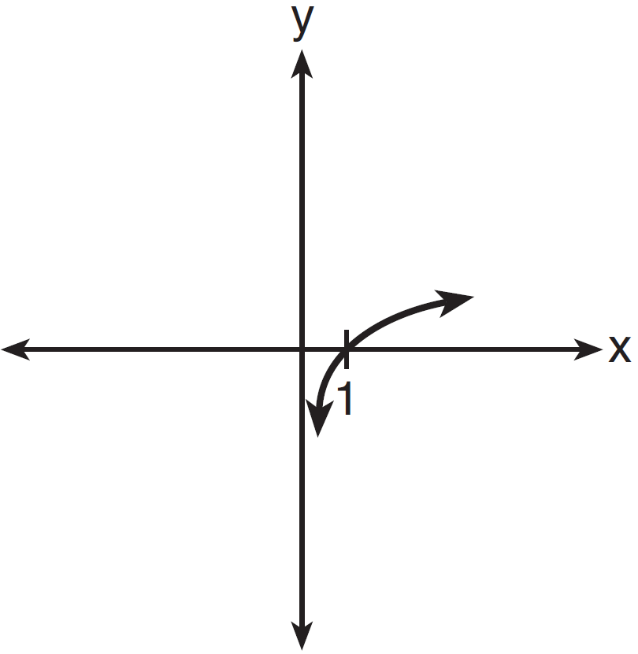
4) | 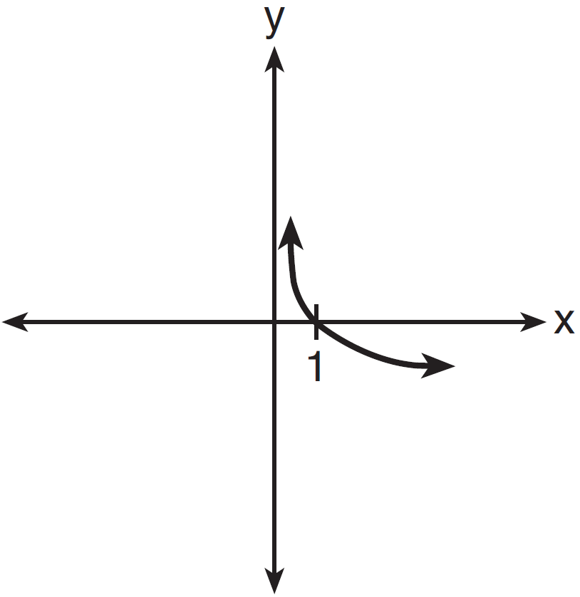

23 The expression 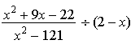 is equivalent to
1)
2) | 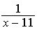
3)
4) | 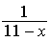

24 Which graph represents the solution set of 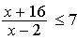?
1)
2)
3)
4)

25 Which equation represents a graph that has a period of ?
1) | 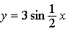
2)
3) | 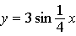
4)

26 The expression is equivalent to
1)
2)
3)
4)

27 Approximately how many degrees does five radians equal?
1) | 286
2) | 900
3)
4)

28 Show that is an identity.

29 Find, to the nearest tenth of a square foot, the area of a rhombus that has a side of 6 feet and an angle of 50°.

30 The following is a list of the individual points scored by all twelve members of the Webster High School basketball team at a recent game:
Find the interquartile range for this set of data.

31 Determine algebraically the x-coordinate of all points where the graphs of and intersect.

32 Solve algebraically for x.

33 Express in simplest form.

34 In an arithmetic sequence, and . Determine a formula for , the term of this sequence.

35 Circle O shown below has a radius of 12 centimeters. To the nearest tenth of a centimeter, determine the length of the arc, x, subtended by an angle of 83°50'.

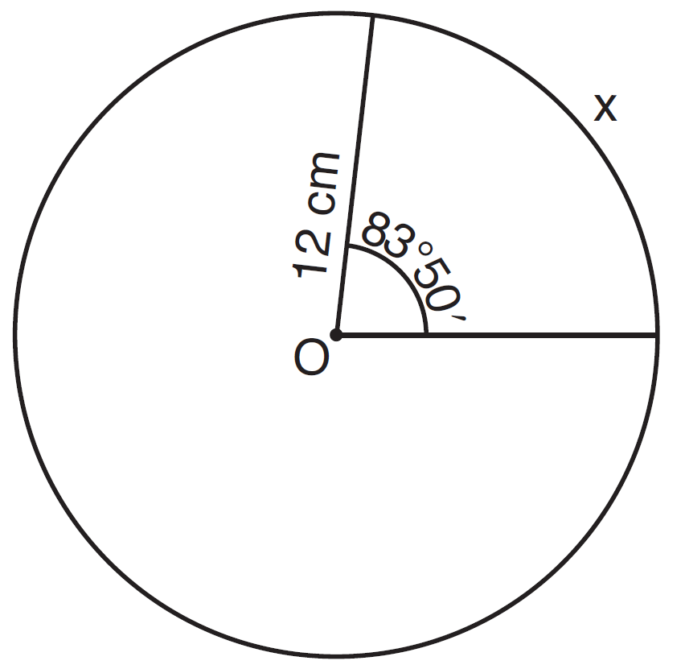

36 Solve algebraically for all exact values of x in the interval :

37 Because Sam’s backyard gets very little sunlight, the probability that a geranium planted there will flower is 0.28. Sam planted five geraniums. Determine the probability, to the nearest thousandth, that at least four geraniums will flower.

38 Two sides of a parallelogram measure 27 cm and 32 cm. The included angle measures 48°. Find the length of the longer diagonal of the parallelogram, to the nearest centimeter.

39 Solve algebraically for all values of x:

1 ANS: 1

PTS: 2 REF: 011401a2 STA: A2.A.30 TOP: Sequences

2 ANS: 1 PTS: 2 REF: 011402a2 STA: A2.A.8
TOP: Negative and Fractional Exponents

3 ANS: 3
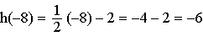. 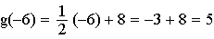

PTS: 2 REF: 011403a2 STA: A2.A.42 TOP: Compositions of Functions
KEY: numbers

4 ANS: 1
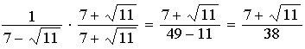

PTS: 2 REF: 011404a2 STA: A2.N.5 TOP: Rationalizing Denominators

5 ANS: 3
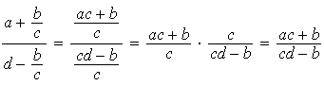

PTS: 2 REF: 011405a2 STA: A2.A.17 TOP: Complex Fractions

6 ANS: 4 PTS: 2 REF: 011406a2 STA: A2.S.1
TOP: Analysis of Data

7 ANS: 2 PTS: 2 REF: 011407a2 STA: A2.A.43
TOP: Defining Functions

8 ANS: 2
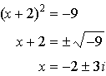

PTS: 2 REF: 011408a2 STA: A2.A.24 TOP: Completing the Square

9 ANS: 4 PTS: 2 REF: 011409a2 STA: A2.S.10
TOP: Permutations

10 ANS: 3
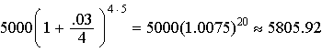

PTS: 2 REF: 011410a2 STA: A2.A.12 TOP: Evaluating Exponential Expressions

11 ANS: 2

PTS: 2 REF: 011411a2 STA: A2.A.2 TOP: Using the Discriminant
KEY: determine nature of roots given equation

12 ANS: 3
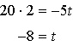

PTS: 2 REF: 011412a2 STA: A2.A.5 TOP: Inverse Variation

13 ANS: 2
If , 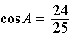, and 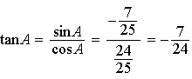

PTS: 2 REF: 011413a2 STA: A2.A.64 TOP: Using Inverse Trigonometric Functions
KEY: advanced

14 ANS: 4
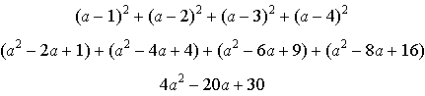

PTS: 2 REF: 011414a2 STA: A2.N.10 TOP: Sigma Notation
KEY: advanced

15 ANS: 3
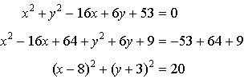

PTS: 2 REF: 011415a2 STA: A2.A.47 TOP: Equations of Circles

16 ANS: 1 PTS: 2 REF: 011416a2 STA: A2.A.39
TOP: Domain and Range KEY: real domain

17 ANS: 2 PTS: 2 REF: 011417a2 STA: A2.S.9
TOP: Differentiating Permutations and Combinations

18 ANS: 3
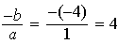. If the sum is 4, the roots must be 7 and .

PTS: 2 REF: 011418a2 STA: A2.A.21 TOP: Roots of Quadratics
KEY: advanced

19 ANS: 2
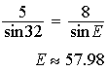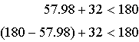

PTS: 2 REF: 011419a2 STA: A2.A.75 TOP: Law of Sines - The Ambiguous Case

20 ANS: 2
Top

PTS: 2 REF: 011420a2 STA: A2.S.5 TOP: Normal Distributions
KEY: predict

21 ANS: 4
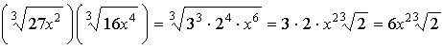

PTS: 2 REF: 011421a2 STA: A2.N.2 TOP: Operations with Radicals

22 ANS: 3 PTS: 2 REF: 011422a2 STA: A2.A.54
TOP: Graphing Logarithmic Functions

23 ANS: 4
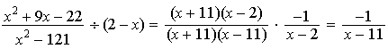

PTS: 2 REF: 011423a2 STA: A2.A.16 TOP: Multiplication and Division of Rationals
KEY: Division

24 ANS: 3
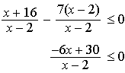 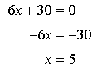 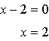. Check points such that , , and . If , 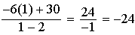, which is less than 0. If , 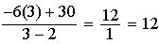, which is greater than 0. If , 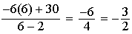, which is less than 0.

PTS: 2 REF: 011424a2 STA: A2.A.23 TOP: Rational Inequalities

25 ANS: 1
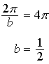

PTS: 2 REF: 011425a2 STA: A2.A.69
TOP: Properties of Graphs of Trigonometric Functions KEY: period

26 ANS: 4
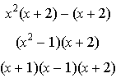

PTS: 2 REF: 011426a2 STA: A2.A.7 TOP: Factoring by Grouping

27 ANS: 1
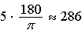

PTS: 2 REF: 011427a2 STA: A2.M.2 TOP: Radian Measure
KEY: degrees

28 ANS:
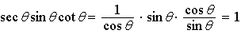

PTS: 2 REF: 011428a2 STA: A2.A.58 TOP: Reciprocal Trigonometric Relationships

29 ANS:

PTS: 2 REF: 011429a2 STA: A2.A.74 TOP: Using Trigonometry to Find Area
KEY: Parallelograms

30 ANS:
and . .

PTS: 2 REF: 011430a2 STA: A2.S.4 TOP: Dispersion
KEY: range, quartiles, interquartile range, variance

31 ANS:
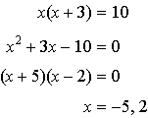

PTS: 2 REF: 011431a2 STA: A2.A.3 TOP: Quadratic-Linear Systems
KEY: equations

32 ANS:
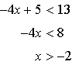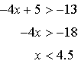

PTS: 2 REF: 011432a2 STA: A2.A.1 TOP: Absolute Value Inequalities

33 ANS:

PTS: 2 REF: 011433a2 STA: A2.N.7 TOP: Imaginary Numbers

34 ANS:
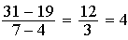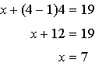

PTS: 2 REF: 011434a2 STA: A2.A.29 TOP: Sequences

35 ANS:
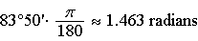

PTS: 2 REF: 011435a2 STA: A2.A.61 TOP: Arc Length
KEY: arc length

36 ANS:
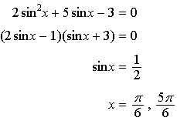

PTS: 4 REF: 011436a2 STA: A2.A.68 TOP: Trigonometric Equations
KEY: quadratics

37 ANS:

PTS: 4 REF: 011437a2 STA: A2.S.15 TOP: Binomial Probability
KEY: at least or at most

38 ANS:
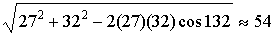

PTS: 4 REF: 011438a2 STA: A2.A.73 TOP: Law of Cosines
KEY: applied

39 ANS:
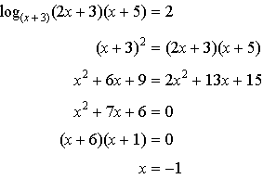 is extraneous

PTS: 6 REF: 011439a2 STA: A2.A.28 TOP: Logarithmic Equations
KEY: applying properties of logarithms

