1 What is the equation of the graph shown below?

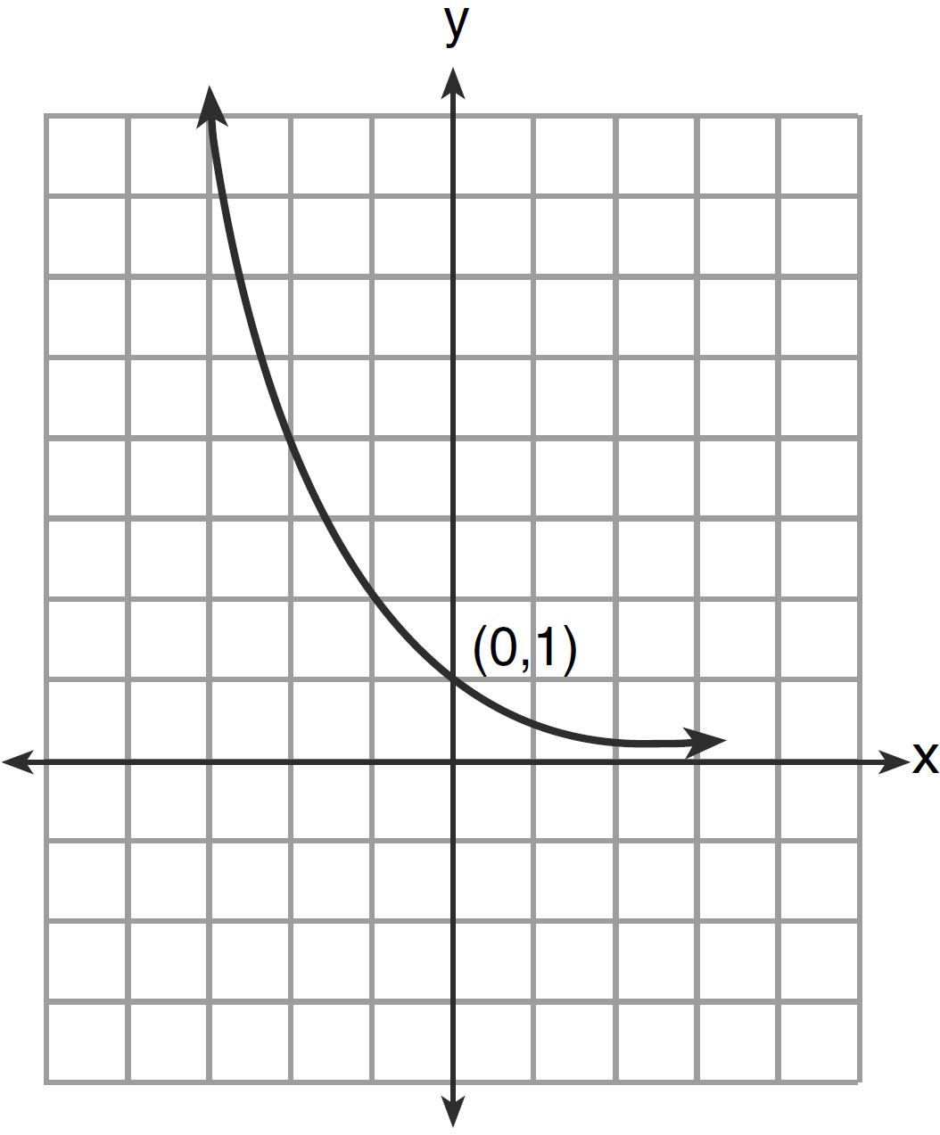
1)
2)
3)
4)

2 Which ordered pair is a solution of the system of equations shown below? 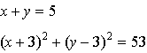
1)
2)
3)
4)

3 The relationship between t, a student’s test scores, and d, the student’s success in college, is modeled by the equation . Based on this linear regression model, the correlation coefficient could be
1) | between and 0
2) | between 0 and 1
3) | equal to
4) | equal to 0

4 What is the common ratio of the geometric sequence shown below?
1)
2) | 2
3)
4)

5 Given the relation , which value of k will result in the relation not being a function?
1) | 1
2) | 2
3) | 3
4) | 4

6 Which expression is equivalent to 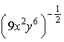?
1) | 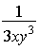
2)
3) | 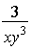
4) | 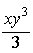

7 In a certain high school, a survey revealed the mean amount of bottled water consumed by students each day was 153 bottles with a standard deviation of 22 bottles. Assuming the survey represented a normal distribution, what is the range of the number of bottled waters that approximately 68.2% of the students drink?
1)
2)
3)
4)

8 What is the fourth term in the binomial expansion ?
1)
2)
3)
4)

9 Which value of k satisfies the equation ?
1)
2)
3)
4) | 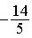

10 There are eight people in a tennis club. Which expression can be used to find the number of different ways they can place first, second, and third in a tournament?
1)
2)
3)
4)

11 If 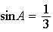, what is the value of ?
1)
2)
3)
4)

12 In the interval , is undefined when x equals
1) | 0º and 90º
2) | 90º and 180º
3) | 180º and 270º
4) | 90º and 270º

13 If 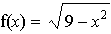, what are its domain and range?
1) | domain: ; range:
2) | domain: ; range:
3) | domain: ; range:
4) | domain: ; range:

14 When is subtracted from , the difference is
1)
2)
3)
4)

15 In the diagram below, the length of which line segment is equal to the exact value of ?

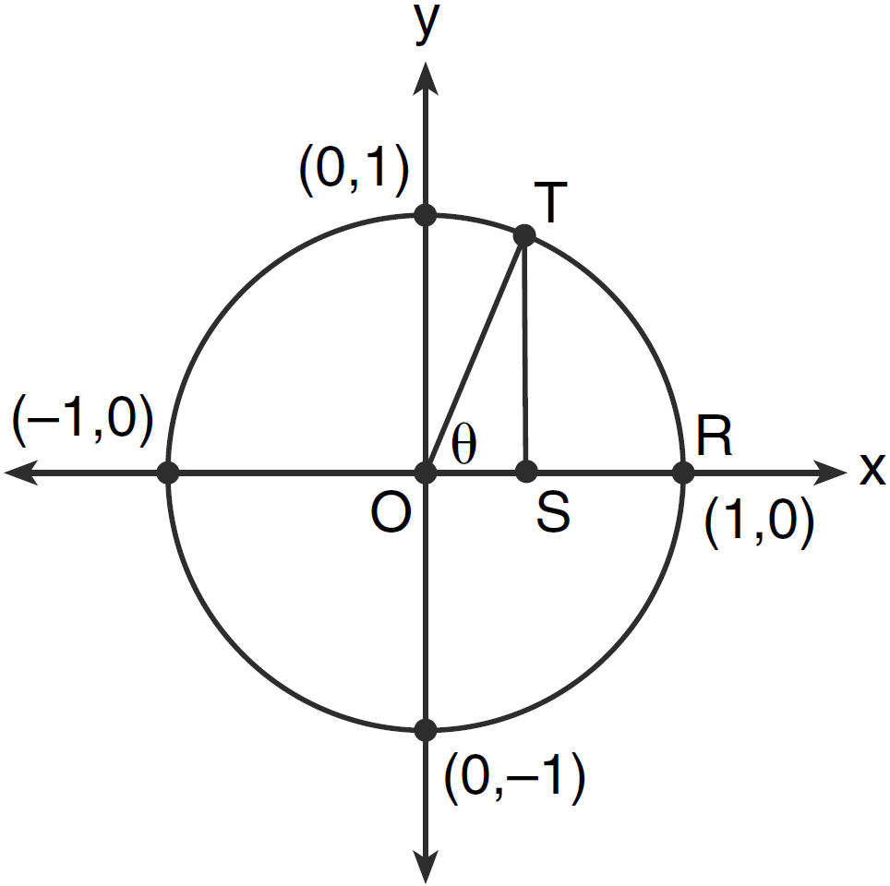
1)
2)
3)
4)

16 The area of triangle ABC is 42. If and , the length of is approximately
1) | 5.1
2) | 9.2
3) | 12.0
4) | 21.7

17 When factored completely, the expression is equivalent to
1)
2)
3)
4)

18 The value of is equivalent to
1)
2)
3)
4)

19 The sum of 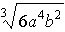 and 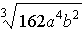, expressed in simplest radical form, is
1) | 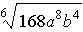
2) | 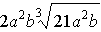
3) | 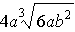
4)

20 Which equation is represented by the graph below?

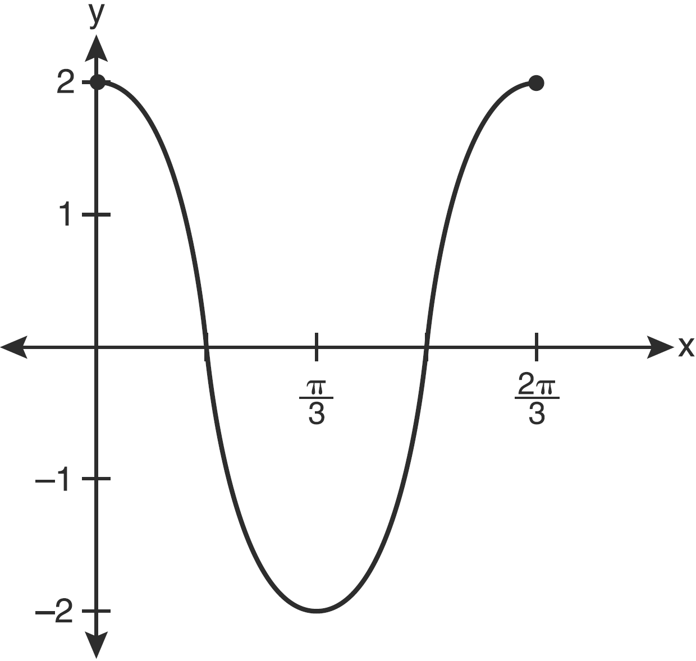
1)
2)
3) | 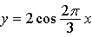
4) | 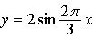

21 The quantities p and q vary inversely. If when , and when , then x equals
1) | and 5
2)
3) | and 4
4)

22 What is the solution set of the equation when ?
1)
2)
3)
4)

23 The discriminant of a quadratic equation is 24. The roots are
1) | imaginary
2) | real, rational, and equal
3) | real, rational, and unequal
4) | real, irrational, and unequal

24 How many different six-letter arrangements can be made using the letters of the word “TATTOO”?
1) | 60
2) | 90
3) | 120
4) | 720

25 Expressed in simplest form, 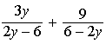 is equivalent to
1) | 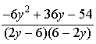
2) | 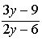
3)
4)

26 If and , the expression 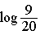 is equivalent to
1)
2)
3)
4) | 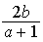

27 The expression is equivalent to
1) | 0
2)
3)
4)

28 Determine the sum of the first twenty terms of the sequence whose first five terms are 5, 14, 23, 32, 41.

29 Determine the sum and the product of the roots of .

30 If , find the smallest positive value of a, in degrees.

31 The heights, in inches, of 10 high school varsity basketball players are 78, 79, 79, 72, 75, 71, 74, 74, 83, and 71. Find the interquartile range of this data set.

32 Solve the equation and express the answer in simplest radical form.

33 The number of bacteria present in a Petri dish can be modeled by the function , where N is the number of bacteria present in the Petri dish after t hours. Using this model, determine, to the nearest hundredth, the number of hours it will take for N to reach 30,700.

34 Determine the solution of the inequality . [The use of the grid below is optional.]



35 Convert 3 radians to degrees and express the answer to the nearest minute.

36 Solve algebraically for all values of x:

37 The data collected by a biologist showing the growth of a colony of bacteria at the end of each hour are displayed in the table below.

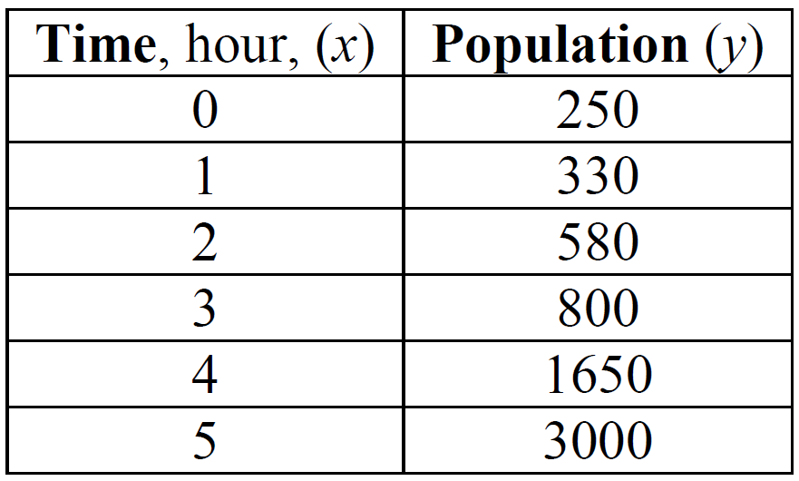

Write an exponential regression equation to model these data. Round all values to the nearest
thousandth. Assuming this trend continues, use this equation to estimate, to the nearest ten, the number of bacteria in the colony at the end of 7 hours.

38 As shown in the diagram below, fire-tracking station A is 100 miles due west of fire-tracking station B. A forest fire is spotted at F, on a bearing 47° northeast of station A and 15° northeast of station B. Determine, to the nearest tenth of a mile, the distance the fire is from both station A and station B. [N represents due north.]

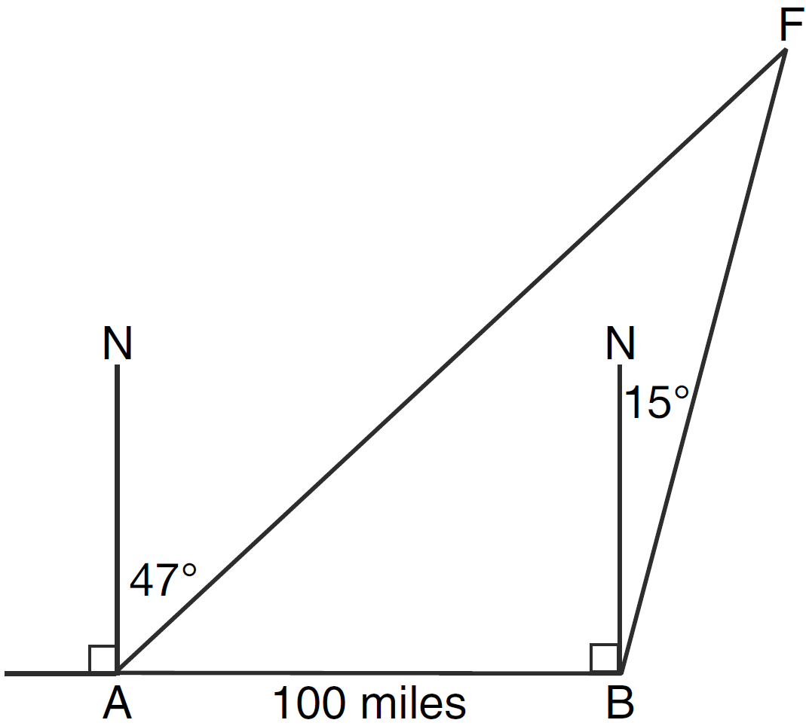

39 Solve algebraically for x: 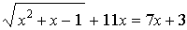

1 ANS: 2 PTS: 2 REF: 011301a2 STA: A2.A.52
TOP: Identifying the Equation of a Graph

2 ANS: 3
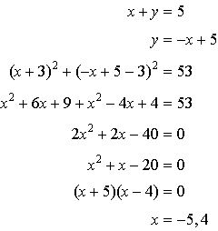. 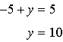

PTS: 2 REF: 011302a2 STA: A2.A.3 TOP: Quadratic-Linear Systems
KEY: equations

3 ANS: 2
Since the coefficient of is greater than 0, .

PTS: 2 REF: 011303a2 STA: A2.S.8 TOP: Correlation Coefficient

4 ANS: 3
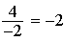

PTS: 2 REF: 011304a2 STA: A2.A.31 TOP: Sequences

5 ANS: 3 PTS: 2 REF: 011305a2 STA: A2.A.37
TOP: Defining Functions

6 ANS: 1 PTS: 2 REF: 011306a2 STA: A2.A.8
TOP: Negative and Fractional Exponents

7 ANS: 2
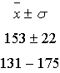

PTS: 2 REF: 011307a2 STA: A2.S.5 TOP: Normal Distributions
KEY: interval

8 ANS: 3

PTS: 2 REF: 011308a2 STA: A2.A.36 TOP: Binomial Expansions

9 ANS: 4
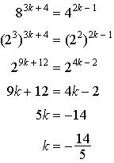.

PTS: 2 REF: 011309a2 STA: A2.A.27 TOP: Exponential Equations
KEY: common base not shown

10 ANS: 1 PTS: 2 REF: 011310a2 STA: A2.S.9
TOP: Differentiating Permutations and Combinations

11 ANS: 4
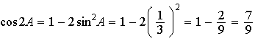

PTS: 2 REF: 011311a2 STA: A2.A.77 TOP: Double Angle Identities
KEY: evaluating

12 ANS: 4 PTS: 2 REF: 011312a2 STA: A2.A.56
TOP: Determining Trigonometric Functions KEY: degrees, common angles

13 ANS: 1 PTS: 2 REF: 011313a2 STA: A2.A.39
TOP: Domain and Range KEY: real domain

14 ANS: 1 PTS: 2 REF: 011314a2 STA: A2.N.3
TOP: Operations with Polynomials

15 ANS: 2 PTS: 2 REF: 011315a2 STA: A2.A.55
TOP: Trigonometric Ratios

16 ANS: 3
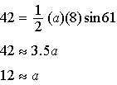

PTS: 2 REF: 011316a2 STA: A2.A.74 TOP: Using Trigonometry to Find Area
KEY: basic

17 ANS: 3
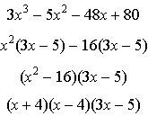

PTS: 2 REF: 011317a2 STA: A2.A.7 TOP: Factoring by Grouping

18 ANS: 1

PTS: 2 REF: 011318a2 STA: A2.A.76 TOP: Angle Sum and Difference Identities
KEY: identities

19 ANS: 3
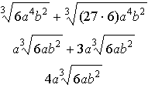

PTS: 2 REF: 011319a2 STA: A2.N.2 TOP: Operations with Radicals

20 ANS: 1 PTS: 2 REF: 011320a2 STA: A2.A.72
TOP: Identifying the Equation of a Trigonometric Graph

21 ANS: 1
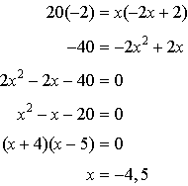

PTS: 2 REF: 011321a2 STA: A2.A.5 TOP: Inverse Variation

22 ANS: 3
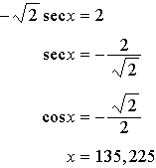

PTS: 2 REF: 011322a2 STA: A2.A.68 TOP: Trigonometric Equations
KEY: reciprocal functions

23 ANS: 4 PTS: 2 REF: 011323a2 STA: A2.A.2
TOP: Using the Discriminant KEY: determine nature of roots given equation

24 ANS: 1
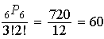

PTS: 2 REF: 011324a2 STA: A2.S.10 TOP: Permutations

25 ANS: 3
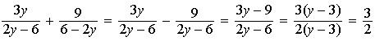

PTS: 2 REF: 011325a2 STA: A2.A.16 TOP: Addition and Subtraction of Rationals

26 ANS: 2
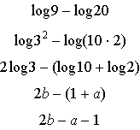

PTS: 2 REF: 011326a2 STA: A2.A.19 TOP: Properties of Logarithms
KEY: expressing logs algebraically

27 ANS: 4

PTS: 2 REF: 011327a2 STA: A2.N.9
TOP: Multiplication and Division of Complex Numbers

28 ANS:
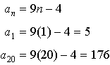. 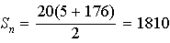

PTS: 2 REF: 011328a2 STA: A2.A.35 TOP: Summations
KEY: arithmetic

29 ANS:
. Sum 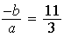. Product 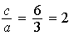

PTS: 2 REF: 011329a2 STA: A2.A.20 TOP: Roots of Quadratics

30 ANS:
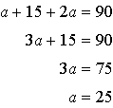

PTS: 2 REF: 011330a2 STA: A2.A.58 TOP: Cofunction Trigonometric Relationships

31 ANS:
Ordered, the heights are 71, 71, 72, 74, 74, 75, 78, 79, 79, 83. and . .

PTS: 2 REF: 011331a2 STA: A2.S.4 TOP: Dispersion
KEY: range, quartiles, interquartile range, variance

32 ANS:
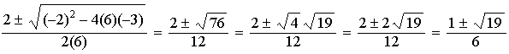

PTS: 2 REF: 011332a2 STA: A2.A.25 TOP: Quadratics with Irrational Solutions

33 ANS:
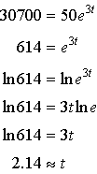

PTS: 2 REF: 011333a2 STA: A2.A.6 TOP: Exponential Growth

34 ANS:
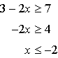 or 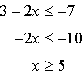

PTS: 2 REF: 011334a2 STA: A2.A.1 TOP: Absolute Value Inequalities
KEY: graph

35 ANS:
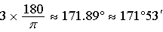. 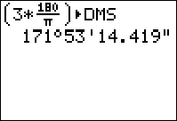

PTS: 2 REF: 011335a2 STA: A2.M.2 TOP: Radian Measure
KEY: degrees

36 ANS:
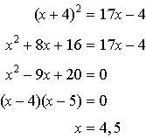
PTS: 4 REF: 011336a2 STA: A2.A.28 TOP: Logarithmic Equations
KEY: basic

37 ANS:
.
PTS: 4 REF: 011337a2 STA: A2.S.7 TOP: Exponential Regression

38 ANS:
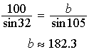. 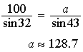
PTS: 4 REF: 011338a2 STA: A2.A.73 TOP: Law of Sines
KEY: basic

39 ANS:
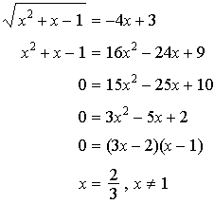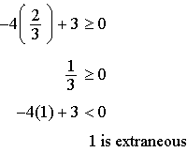
PTS: 6 REF: 011339a2 STA: A2.A.22 TOP: Solving Radicals
KEY: extraneous solutions

