1 The yearbook staff has designed a survey to learn student opinions on how the yearbook could be improved for this year. If they want to distribute this survey to 100 students and obtain the most reliable data, they should survey
1) | every third student sent to the office
2) | every third student to enter the library
3) | every third student to enter the gym for the basketball game
4) | every third student arriving at school in the morning

2 What is the sum of the first 19 terms of the sequence ?
1) | 1188
2) | 1197
3) | 1254
4) | 1292

3 Which expression, when rounded to three decimal places, is equal to ?
1) | 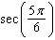
2)
3) | 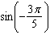
4)

4 If and 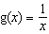, then 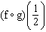 is equal to
1)
2)
3)
4) | 4

5 A population of rabbits doubles every 60 days according to the formula 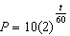, where P is the population of rabbits on day t. What is the value of t when the population is 320?
1) | 240
2) | 300
3) | 660
4) | 960

6 What is the product of 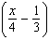 and 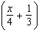?
1) | 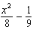
2) | 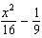
3) | 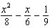
4) | 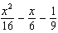

7 Which is a graph of ?
1) | 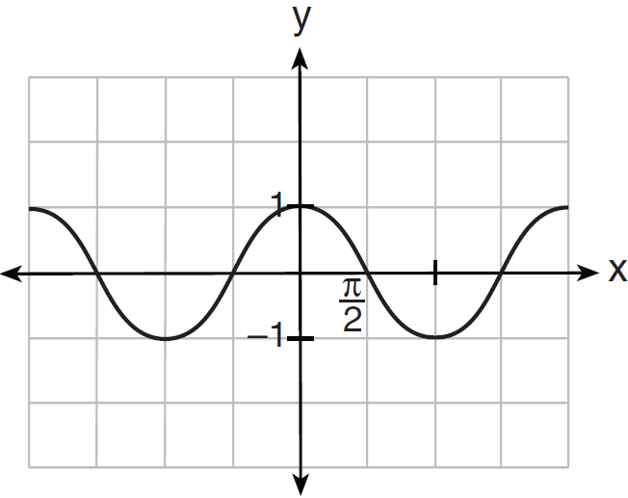
2) | 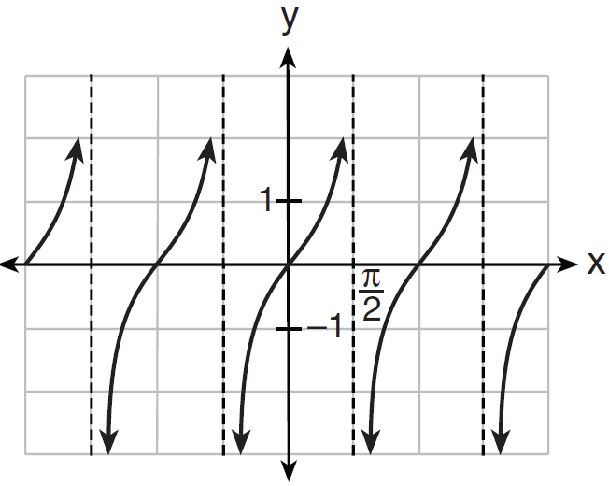
3) | 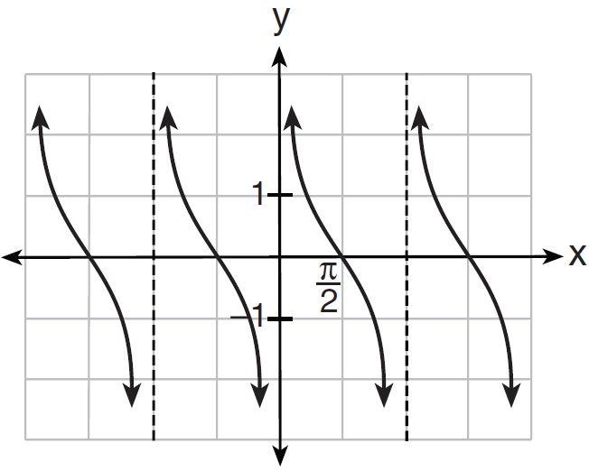
4) | 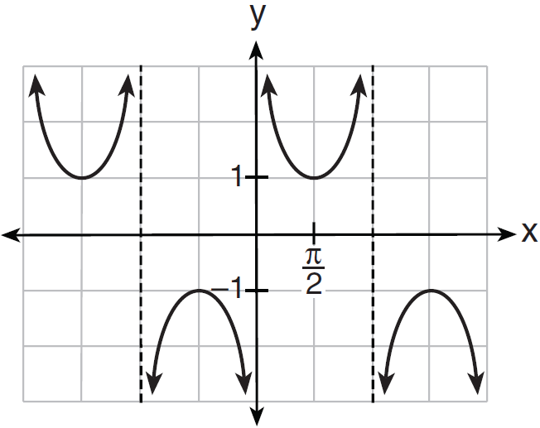

8 Which expression always equals 1?
1)
2)
3)
4)

9 What are the sum and product of the roots of the equation ?
1) | 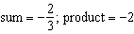
2) | 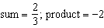
3) | 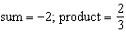
4) | 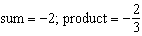

10 Given with , , and , what type of triangle can be drawn?
1) | an acute triangle, only
2) | an obtuse triangle, only
3) | both an acute triangle and an obtuse triangle
4) | neither an acute triangle nor an obtuse triangle

11 When is divided by , the quotient equals
1) | 1
2)
3)
4)

12 If the amount of time students work in any given week is normally distributed with a mean of 10 hours per week and a standard deviation of 2 hours, what is the probability a student works between 8 and 11 hours per week?
1) | 34.1%
2) | 38.2%
3) | 53.2%
4) | 68.2%

13 What is the conjugate of 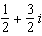?
1) | 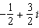
2) | 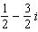
3) | 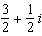
4) | 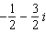

14 Given angle A in Quadrant I with 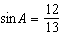 and angle B in Quadrant II with 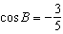, what is the value of ?
1)
2)
3)
4)

15 Which expression represents the third term in the expansion of ?
1)
2)
3)
4)

16 What is the solution set of the equation ?
1)
2)
3)
4)

17 A sequence has the following terms: , , , . Which formula represents the nth term in the sequence?
1)
2)
3)
4)

18 In parallelogram BFLO, , , and . If diagonal is drawn, what is the area of ?
1) | 11.4
2) | 14.1
3) | 22.7
4) | 28.1

19 Which statement about the graph of the equation is not true?
1) | It is asymptotic to the x-axis.
2) | The domain is the set of all real numbers.
3) | It lies in Quadrants I and II.
4) | It passes through the point .

20 What is the number of degrees in an angle whose measure is 2 radians?
1)
2)
3) | 360
4) | 90

21 A spinner is divided into eight equal sections. Five sections are red and three are green. If the spinner is spun three times, what is the probability that it lands on red exactly twice?
1)
2)
3)
4)

22 What is the range of ?
1)
2)
3)
4)

23 Which calculator output shows the strongest linear relationship between x and y?
1) | 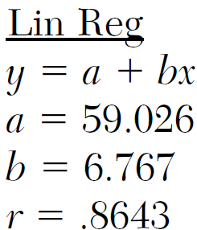
2) | 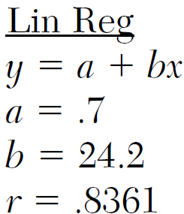
3) | 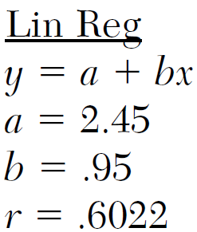
4) | 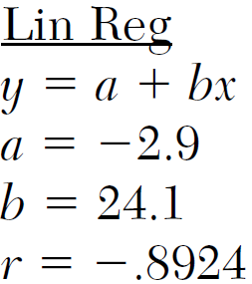

24 If , then expressed in terms of is equivalent to
1) | 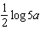
2) | 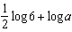
3)
4)

25 Which function is one-to-one?
1)
2)
3)
4)

26 If p varies inversely as q, and when 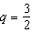, what is the value of p when 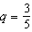?
1) | 25
2) | 15
3) | 9
4) | 4

27 Which equation is graphed in the diagram below?

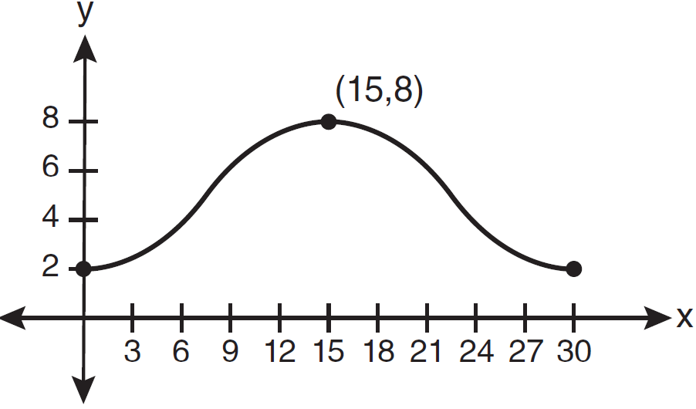
1) | 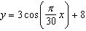
2) | 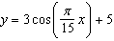
3) | 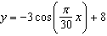
4) | 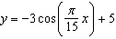

28 Find the solution of the inequality , algebraically.

29 Solve algebraically for x:

30 Evaluate: 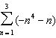

31 Express in simplest form: 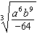

32 A blood bank needs twenty people to help with a blood drive. Twenty-five people have volunteered. Find how many different groups of twenty can be formed from the twenty-five volunteers.

33 On the axes below, for , graph .

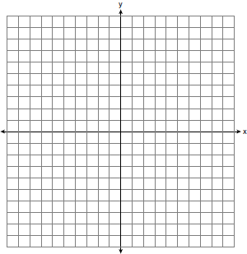

34 Write an equation of the circle shown in the diagram below.

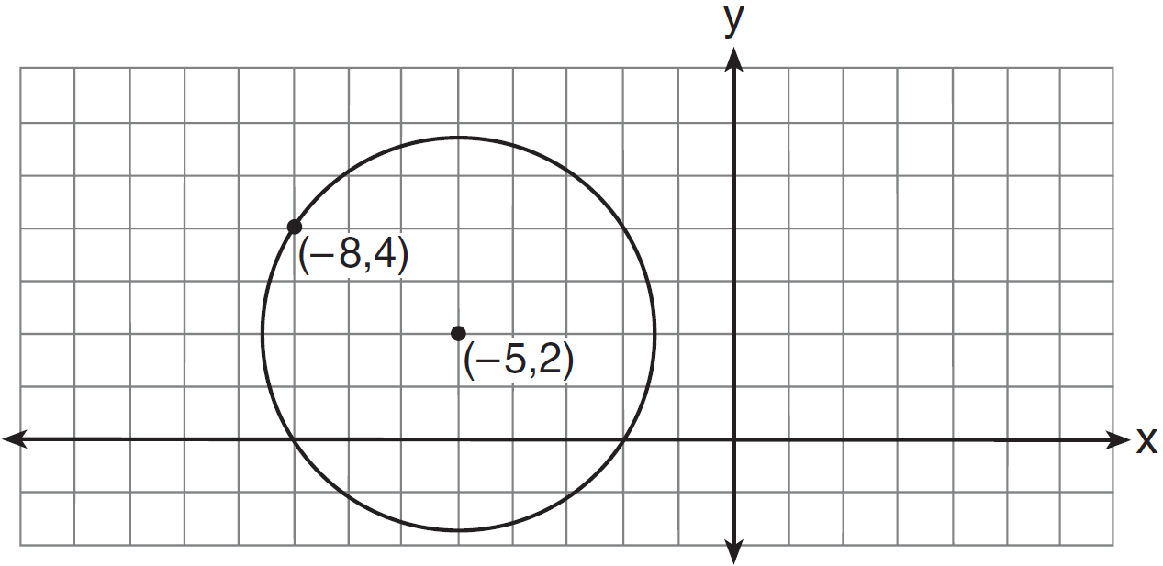

35 Express the exact value of , with a rational denominator.

36 The diagram below shows the plans for a cell phone tower. A guy wire attached to the top of the tower makes an angle of 65 degrees with the ground. From a point on the ground 100 feet from the end of the guy wire, the angle of elevation to the top of the tower is 32 degrees. Find the height of the tower, to the nearest foot.

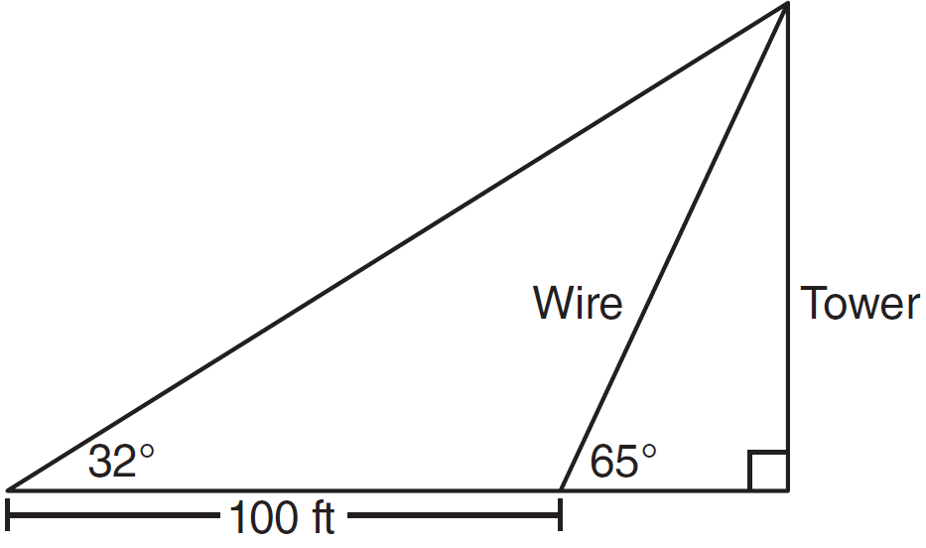

37 If and 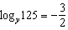, find the numerical value of , in simplest form.

38 A population of single-celled organisms was grown in a Petri dish over a period of 16 hours. The number of organisms at a given time is recorded in the table below.

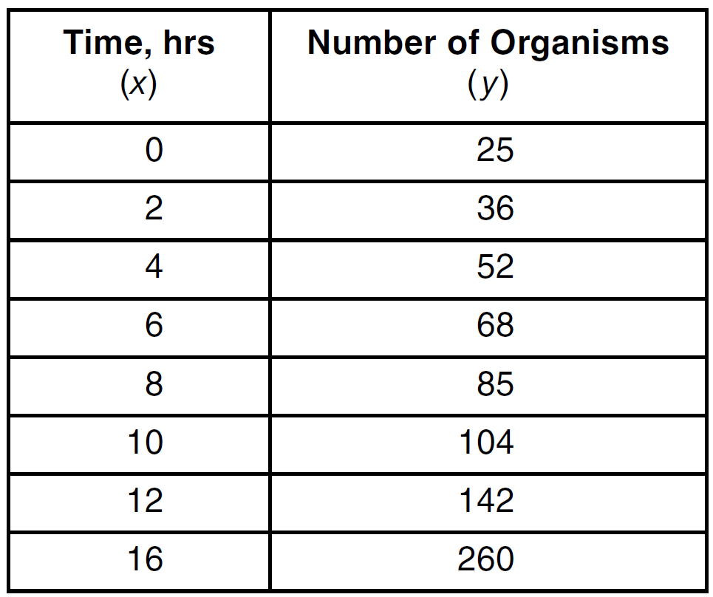

Determine the exponential regression equation model for these data, rounding all values to the nearest ten-thousandth. Using this equation, predict the number of single-celled organisms, to the nearest whole number, at the end of the 18th hour.

39 Perform the indicated operations and simplify completely: 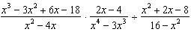
1 ANS: 4 PTS: 2 REF: 011201a2 STA: A2.S.2
TOP: Analysis of Data

2 ANS: 3
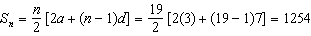

PTS: 2 REF: 011202a2 STA: A2.A.35 TOP: Summations
KEY: arithmetic

3 ANS: 1
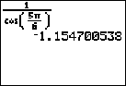

PTS: 2 REF: 011203a2 STA: A2.A.66 TOP: Determining Trigonometric Functions

4 ANS: 4
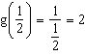.

PTS: 2 REF: 011204a2 STA: A2.A.42 TOP: Compositions of Functions
KEY: numbers

5 ANS: 2
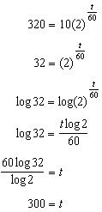

PTS: 2 REF: 011205a2 STA: A2.A.6 TOP: Exponential Growth

6 ANS: 2
The binomials are conjugates, so use FL.

PTS: 2 REF: 011206a2 STA: A2.N.3 TOP: Operations with Polynomials

7 ANS: 3
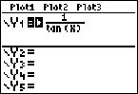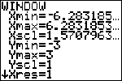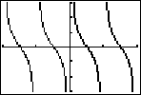

PTS: 2 REF: 011207a2 STA: A2.A.71 TOP: Graphing Trigonometric Functions

8 ANS: 2 PTS: 2 REF: 011208a2 STA: A2.A.67
TOP: Proving Trigonometric Identities

9 ANS: 2
sum: 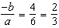. product: 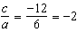

PTS: 2 REF: 011209a2 STA: A2.A.20 TOP: Roots of Quadratics

10 ANS: 1
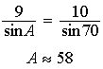. is possible. is not possible.

PTS: 2 REF: 011210a2 STA: A2.A.75 TOP: Law of Sines - The Ambiguous Case

11 ANS: 2
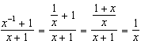

PTS: 2 REF: 011211a2 STA: A2.A.9 TOP: Negative Exponents

12 ANS: 3

PTS: 2 REF: 011212a2 STA: A2.S.5 TOP: Normal Distributions
KEY: probability

13 ANS: 2 PTS: 2 REF: 011213a2 STA: A2.N.8
TOP: Conjugates of Complex Numbers

14 ANS: 1
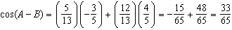

PTS: 2 REF: 011214a2 STA: A2.A.76 TOP: Angle Sum and Difference Identities
KEY: evaluating

15 ANS: 3

PTS: 2 REF: 011215a2 STA: A2.A.36 TOP: Binomial Expansions

16 ANS: 3
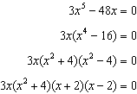

PTS: 2 REF: 011216a2 STA: A2.A.26 TOP: Solving Polynomial Equations

17 ANS: 4
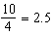

PTS: 2 REF: 011217a2 STA: A2.A.29 TOP: Sequences

18 ANS: 1
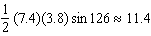

PTS: 2 REF: 011218a2 STA: A2.A.74 TOP: Using Trigonometry to Find Area
KEY: basic

19 ANS: 4 PTS: 2 REF: 011219a2 STA: A2.A.52
TOP: Properties of Graphs of Functions and Relations

20 ANS: 1
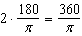

PTS: 2 REF: 011220a2 STA: A2.M.2 TOP: Radian Measure
KEY: degrees

21 ANS: 4
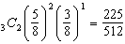

PTS: 2 REF: 011221a2 STA: A2.S.15 TOP: Binomial Probability
KEY: spinner

22 ANS: 2 PTS: 2 REF: 011222a2 STA: A2.A.39
TOP: Domain and Range KEY: real domain

23 ANS: 1
(4) shows the strongest linear relationship, but if , . The Regents announced that a correct solution was not provided for this question and all students should be awarded credit.

PTS: 2 REF: 011223a2 STA: A2.S.8 TOP: Correlation Coefficient

24 ANS: 2
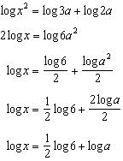

PTS: 2 REF: 011224a2 STA: A2.A.19 TOP: Properties of Logarithms
KEY: splitting logs

25 ANS: 2 PTS: 2 REF: 011225a2 STA: A2.A.43
TOP: Defining Functions

26 ANS: 1
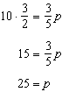

PTS: 2 REF: 011226a2 STA: A2.A.5 TOP: Inverse Variation

27 ANS: 4
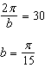

PTS: 2 REF: 011227a2 STA: A2.A.72
TOP: Identifying the Equation of a Trigonometric Graph

28 ANS:
or . 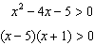. 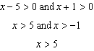 or 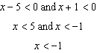

PTS: 2 REF: 011228a2 STA: A2.A.4 TOP: Quadratic Inequalities
KEY: one variable

29 ANS:
7. 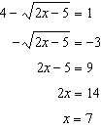

PTS: 2 REF: 011229a2 STA: A2.A.22 TOP: Solving Radicals
KEY: basic

30 ANS:
. 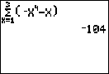

PTS: 2 REF: 011230a2 STA: A2.N.10 TOP: Sigma Notation
KEY: basic

31 ANS:
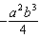

PTS: 2 REF: 011231a2 STA: A2.A.13 TOP: Simplifying Radicals
KEY: index > 2

32 ANS:

PTS: 2 REF: 011232a2 STA: A2.S.11 TOP: Combinations

33 ANS:
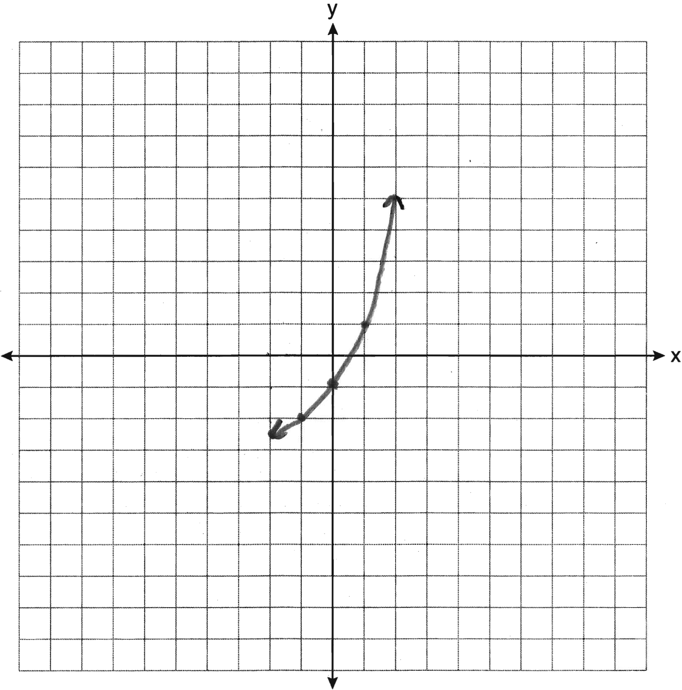

PTS: 2 REF: 011234a2 STA: A2.A.53 TOP: Graphing Exponential Functions

34 ANS:
.
PTS: 2 REF: 011234a2 STA: A2.A.49 TOP: Writing Equations of Circles

35 ANS:
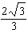. If 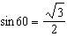, then 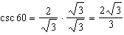
PTS: 2 REF: 011235a2 STA: A2.A.59 TOP: Reciprocal Trigonometric Relationships

36 ANS:
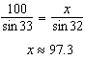. 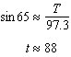
PTS: 4 REF: 011236a2 STA: A2.A.73 TOP: Law of Sines
KEY: advanced

37 ANS:
800. . 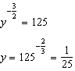. 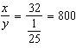

PTS: 4 REF: 011237a2 STA: A2.A.28 TOP: Logarithmic Equations
KEY: advanced

38 ANS:
.

PTS: 4 REF: 011238a2 STA: A2.S.7 TOP: Exponential Regression

39 ANS:
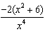. 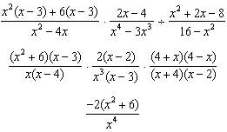

PTS: 6 REF: 011239a2 STA: A2.A.16 TOP: Multiplication and Division of Rationals

